UNIT –I

Business Communication
The word “Communication” has come from the Latin word “communis”, which means common. Thus, communication signifies sharing of ideas in common. The dictionary meaning of communication is to convey or exchange information and share ideas.
It is a process through which two or more persons transmit or exchange thoughts and ideas among themselves. According to W. H. Newman and C. F. Summer, “Communication is an exchange of facts, ideas, opinions or emotions by two or more persons.”
Communication is the process of transmitting information and understanding from one person to another or from one unit to other unit with a view to getting the desired response from the receiver. Through this process two or more persons exchange ideas and understanding among themselves to achieve the desired effect in the behaviour of another person.
It is a two-way channel for transmitting ideas, feelings, plans, commands, instructions, reports and suggestions that influence the attitude towards an organisation’s objectives. The communicator’s goal is to convey the meanings or ideas without distortion. Success of the leader and the enterprise depends upon adequacy of communication.
It is the responsibility of the managers to establish and maintain the channels whereby they can convey their own thinking and policies to the subordinates, and can receive their reactions and an account of their problems.
“Communication is the sum total of all the things one person does when he wants to create understanding in the mind of another. It is a bridge of meaning. It involves a systematic and continuous process of telling, listening and understanding.”

Features of Business Communication
Business Communication has certain features or characteristics which enable us to distinguish it from other communication.

Business communication is goal-oriented

Business communication has a definite and practical purpose which is instrumental in initiating the process. This purpose is practical as it changes with time and needs.

Business communication is all pervasive and inevitable
Business communication is essential socially, psychologically, formally or informally within and without the organization. Therefore it is believed that-‘Business communication is the life-blood of the organization”.

Business communication is dynamic
The methods, means and type of communication keep changing according to the changing situations in business. A manager in a day communicates differently when taking an interview, when attending a meeting, when briefing a subordinate, when negotiating or when resolving a conflict. At times manager adopts assertive style or authoritative or even cooperative style of communication. Therefore, communication is contextual and ever-changing.

Communication is continuous
Though communication is dynamic yet it does not end. Once a predetermined objective is achieved communication reaches another level to achieve another objective. For instance, an organization invites application for the vacant posts; communication moves to the next stage when screening of the applicants takes place. After screening and short listing, the next stage is interviews. Once the selection process is over communication takes place to train the newly appointed employees. This establishes the fact that business communication is continuous; it never ends but adapts itself to the situation. Therefore, it is also said that communication is flexible.

Business communication is time-bound
Communication in a business organization varies with time. Every objective, assignment or project is to be achieved in a stipulated time period. For instance, the companies manufacturing electronic goods change their marketing and sales strategies every festive season, in the pre-budget as well as post budget period. They offer discounts, attractive offers during the festive season to entice the consumer. During the pre-budget period these companies attract the consumers to buy the goods before the price hike.

Business communication is based on internal and external organizational activities
In an organization, routine work is carried out through internal and external activities. Internal organizational activities are carried out within the confines of the organisation like training, meeting, instructing whereas, external activities relate the organization with other organizations, government, consumers, masses. Collaboration of two companies, one company taking over the other or the manufacturing company hiring an external agency to advertise and market the manufactured products are examples of external business activities.

Business communication flows in a fixed direction
Information either formal or informal an organization floats in a specific direction. In formal communication, the information flows in vertical, horizontal or crosswise direction. Informal communication can be cluster chain, single chain, etc.

Importance or Role of Business Communication
Business communication occurs between two or more parties to exchange business related information. The success of a business depends on the efficacy of business communication. For this, communication is regarded as the lifeblood of business. The role or importance of business communication is discussed below:
- Exchanging information: Communication is mainly the exchange of information between two or more parties. Through communication, organizations exchange information with internal and external parties. Communication also brings dynamism in organizational activities and helps in attaining goals.
- Preparing plans and policies: Communication helps in preparing organizational plans and policies. Realistic plans and policies require adequate and relevant information. The managers collect required information from reliable sources through communication.
- Execution of plans and plaices: For timely implementation of plans and policies, managers must disseminate those in the whole organization. In order to disseminate the plans and policies to the internal and external parties, managers rely on communication.
- Increasing employee’s efficiency: Communication also helps in increasing the efficiency of employees. With the help of communication, organizational objectives, plans, policies, rules, directives and other complex matters explain to the employees that broaden their knowledge and thus help them to be efficient.\
- Achieving goals: Effective communication helps the employees at all levels to be conscious and attentive. It ensures timely accomplishment of jobs and easy achievement of goals.
- Solving problems: Through various communication channels, the managers can be informed of various routine and non-time problems of the organization and accordingly they take the necessary actions of steps to solve the problems.
- Making decisions: Making timely decisions requires updated information. Through effective communication, managers can collect information from different corners and can make the right decisions.
- Improving industrial relation: Industrial relation is the relation between workers and management in the workplace. Good industrial relation is always desired for business success. Communication plays a vital role in creating and maintaining good industrial relation.
- Publicity of goods and services: In the modern age, business is becoming highly competitive. Almost very competing manufacturer produces products of common consumption. However, all of them cannot sell equally well. The organization that can communicate better, can also sell better.
- Removing controversies: Effective communication allows smooth flow of information among various parties involved in the negotiation or transaction. As a result, conflicts, controversies and disagreements can be resolved easily.
- Enhancing employee satisfaction: If there is free and fair flow of information in the organization, it will certainly bring mutual understanding between management and workers. Such understanding enhances the satisfaction of employees.
- Enhancing loyalty: Effective communication helps the managers to be aware of the performance of their subordinates. In such a situation, the subordinates try to show their good performance. Later on, if management praises their performance, it will enhance employees’ loyalty.

Purposes of Communication:
i. To inform
ii. To reassure
iii. To teach
iv. To deliver news, whether good or bad
v. To understand
vi. To explain
vii. To persuade
viii. To transact
ix. To organize
x. To control
xi. To co-ordinate
xii. To direct…
Forms of Business Communication
Business communication can be classified by its structure, direction of flow of information, modes of communication and response.
- Based on Structure
  - Formal
  - Informal
- Based on the Medium of Communication
  - Verbal
  - Non-Verbal
- Based on Flow of Direction
  - Upward
  - Downward
  - Horizontal
  - Diagonal
- Based on Response
  - One-Way
  - Two-Way

Based on Structure

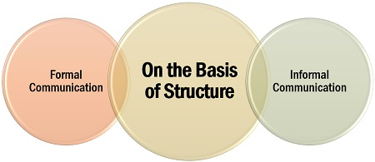

Formal Communication
It is a regular and organised channel of work-related communication within a company, where the employees have to coordinate through a proper medium among themselves

Informal Communication
It is an unofficial form of communication arising out of friendship or casual relations, where the discussions may or may not be related to the work or the organisation.

Based on the Medium of Communication
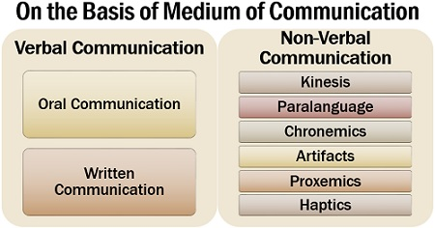
The way a message is framed and the channel used for sending information to the receiver determines the following forms of communication:

Verbal Communication
Transmission of information which is enclosed in words whether written or said is known as verbal communication.
A message framed in words when spoken to the receiver is termed as oral communication. It includes face to face interaction, calls, voice calls, video calls, a recorded message, etc.
Whereas, when the sender drafts a message in words for the receiver to read, it is called written communication. For example; a letter, an email, brochures, circulars, notice, message chat, etc.

Non-Verbal Communication
As we say ‘actions speak louder than words’, expressing information other than words is known as non-verbal communication. Any communication remains incomplete without the use of non-verbal means.

Based on Flow of Direction
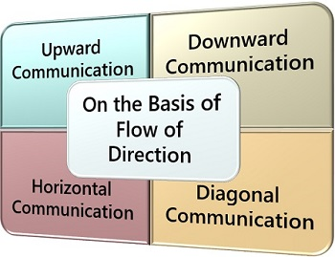

Upward Communication
In upward communication, the sub-ordinates share their problems, suggestions and ideas with their seniors.

Downward Communication
When the seniors pass on orders, instructions, policies, rules, norms, etc. to their subordinates, it is known as downward communication.

Horizontal Communication
When communication takes place among two people holding a similar position in the organisation, it is known as horizontal communication. For example; A sales manager provides the sales revenue sheet to the finance manager.

Diagonal Communication
When the senior of a particular department shares some information with the subordinate of the other department and vice-versa. For example; a human resource manager warns a sales executive for excessive leaves.

Based on Response
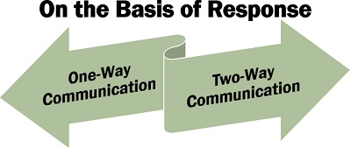
Communication in an organisation can be differentiated as per the need for response or feedback.
Following are the two types of business communication, based on the response:

One-Way Communication
In one-way communication, the sender passes on the information to the receiver without seeking any feedback or response. For example; an advertisement for a particular product on television.

Two-Way Communication
When the sender shares some information with the receiver, and in return, the receiver responds to such information, it is known as two-way communication. For example; the manager discusses the problem of low productivity with the team, and they give reasons for the same.

Business Communication Process
Business Communication Process has been defined as transferring of a thought or idea from one persone or group of persons to another person or group of persons so that it can be understood and acted upon and Business Communication Process is the system by which a message goes to the sender from the receiver in an organized way.
ACCORDING TO MR. KREITNER, BUSINESS COMMUNICATION PROCESS IS A CHAIN MADE UP OF IDENTIFIABLE LINKS. THIS CHAIN INCLUDES SENDER, MESSAGE, ENCODING, RECEIVER, DECODING AND FEEDBACK.”
ACCORDING TO S.K. KAPUR, “THE COMMUNICATION PROCESS IS THE METHOD BY WHICH THE SENDER TRANSFERS INFORMATION AND UNDERSTANDING TO THE RECEIVER.”
we can define Business Communication as the method by which sender and receiver exchange necessary information. Different writers have showed Business Communication process in different ways through different models. The communication process is shown below through the modern model of communication.
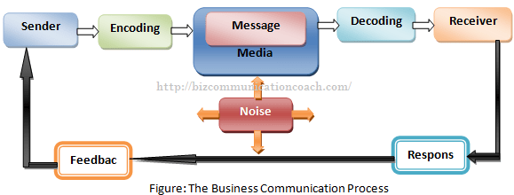

Sender: Sender is the person or party who sends the message or idea to the receiver. Sender is the source of any communication and communication takes place based on him. in our example, Unilever Bangladesh Ltd. is the sender.
Encoding: Encoding means the process of putting thought into symbolic form which can be understood by another person to whom the sender wants to communicate the idea. In other word, encoding means converting the idea into a understandable message. In our example, Unilever advertising agency assembles words and illustrations into an advertisement that will convey the intended message.
Message: Message is the set of symbols that the sender transmits to the receiver through the media or channel. We exchange messages in oral, written and symbolic form. In our example, message is the actual advertisement of Lux given by Unilever.
Media: Media refers to the specific communication channel through which the message moves from sender to receiver. It bridges the gap between the sender and the receiver. We use different types of media for transmitting messages like letter, newspapers, radio, TV, telephone, fax, e-mail etc. in our example; media means television and specific television program that Unilever selects.
Decoding: Decoding is the process by which the receiver assigns meaning to the symbols encoded by the sender. According to Bovee and Others, “Decoding is the process of interpreting a message to arrive at the senders meaning.” Communication will be more effective if decoding matches clearly with encoding. In our example, the consumer watched the advertisement of Lux and interprets the words and illustrations it contains.
Receiver: Receiver is the person or party who receives the message sent by the other party (sender). In our example, receiver is the audience who watches the advertisement of Lux soap.
Response: Response is the reaction of the receiver after being exposed to the message. it is the action or reaction of the receiver after getting the message. The response may be immediate or deferred, favorable or unfavorable. In our example, the responses of advertisement of Lux may be consumer likes Lux better, likely to purchase Lux soap next time etc.
Feedback: The observation of the receiver’s response is called feedback. In other words, the part of the receiver’s response communicated back to the sender is called feedback. Actually, it is the amount of response of the receiver that reaches to the senders. In our example, the feedback may be that consumers praise or criticize Unilever advertising its products. Feedback is extremely important for making two-way communication effective. It enables the sender to evaluate the effectiveness of the message.
Noise: The last element of Business Communication Process is noise. Noise is the unplanned static or distortion during the communication process that results in the receiver’s getting a different message than the sender sends. It is the disturbance occurred in the process of transferring the information. Noise may occur in any of the steps in the communication process. In our example, the audience or consumer may have poor TV reception or may be distracted by family members while watching the advertisement.

Seven Cs in Effective Communication

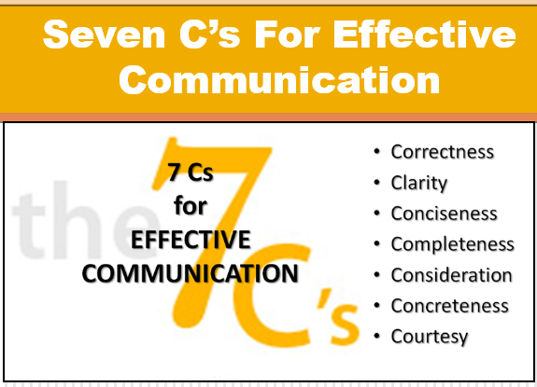

A communication to be effective requires the following seven Cs:

1. Completeness:
The first criteria of an effective communication are its completeness. The message or the context of the communication should contain all facts required for proper reaction by the recipient. A complete communication clarifies all possible questions and helps to take proper decision.

2. Conciseness:
The subject-matter of the communication should be brief and short in nature. No unnecessary elaboration is to be made in a communication. Words used in a communication should be appropriate and expression should be precise. Repetition should be avoided. Concise message saves time of both the sender and the receiver.

3. Consideration:
While making communication the sender should consider the social and cultural background, education, age, emotions, etc. of the recipient and modify language, change attitude and approach accordingly.

4. Concreteness:
Concrete communication refers to exchange of specific, definite and exact information instead of vague and general information. It is convincing and acceptable to the recipient as there is no ambiguity in it.

5. Courtesy:
A courteous approach should be present in an effective communication. The sender of the message should be alert in respect of dignity, respect and honour of the receiver. Care should be taken so that the communication may not hurt, injure, belittle or irritate the receiver in any way. Sender will also be respected in turn as honour begets honour.

6. Clarity:
Clarity must be maintained in communication. The idea contained in the message should be expressed clearly. There will remain no confusion in respect of the meaning of the message. The sender and the receiver of the message will understand it identically.

7. Correctness:
Effective communication should be correct in spelling, construction of sentence and use of language. Grammatical mistakes must be avoided. Dictionary, computerised spelling checker, etc. may be used to make the message error free. Revision of the text is needed to avoid any careless omission. A correct message creates good impact on the receiver and enhances prestige of the sender.

Principles of Effective Business Communication
The general principles for effective business communication may be outlined as follows:
1. Clarity:
The communication process, in order to serve the purpose, must ensure clarity of communication. A business communication possesses clarity when it is expressed in a language and transmitted in a way that will be comprehended by the receiver.
The basic objective of communication is to bring two minds together, and this can be possible only when what the sender means is understood by the receiver in the same way. So, the communication should be clear and simple in easy understandable language.
2. Adequacy:
The goal in communication is to ensure an optimum flow of information. It should be enough to cover the field. The process of communication must ensure that all those of messages that are needed by the various individuals in the organisation in connection with the effective discharge of their official duties must flow up to them and, further, that this flow in respect of different types of messages must be adequate.
3. Attention:
The message, when received, should be properly understood in its meaning and content with full attention. In spite of clarity of expression, the well-composed message may appear to be very difficult and, as such, may not be understood because of our half-hearted attention.
So, the receiver’s full attention and concentration over the message listening or reading should be considered to be very essential for proper understanding of the message communicated. If the message receives due recognition and understanding at the hands of the recipients, the communicator will feel much encouraged in his efforts.
4. Timing:
The utility of any message to the receiver is markedly affected by its timeliness. The process of communication should, therefore, not only ensure that the message reaches the receiver but also that it reaches to him/her when he/she requires it. It is possible that a person may require some time to compile an information having diversified and complex contents.A suitable time span should be allowed for the purpose of considering urgency and time requirement of the information.
5. Integrity:
This principle demands that the business communication should support the organisational structure and objectives. A communication is a means and a tool for securing and maintaining co-operation between the superiors and subordinates needed to meet the enterprise objectives.
6. Strategic Use of Informal Organisation:
Informal organisation originates from the need for transmitting information. It continues with or without the approval of the managers and may have constructive or destructive ends. So, it should be the duty of a manager to use it constructively as a means of communication.
7. Balance between Adaptability and Uniformity:
The smooth working of an organisation depends in part upon uniformity. Yet adaptability should be resorted to when different situations and individuals are involved. Orders and reports may be communicated through the systems that provide opportunity for adaptation to specific situations.
8. Interest and Acceptance:
The purpose of a business communication is to secure a positive response. The person communicated to should be interested in the message and accept it. Downward communication is more effective if morale is good, and upward communication gets through when the superior is a good listener.
While applying the principles of communication, it should be remembered that they can seldom be enforced. So, voluntary acceptance of these principles by all members of the organisation is to be tried.
9. Courtesy:
Courtesy should be maintained at all costs in any communication. In business communication, especially, courtesy is a sign of a good organisation. Use of polite language, apology for a mistake, thanking for a favour, answering a letter without delay, etc. are some of the examples of courtesy in business communication.
10. Conciseness:
Business communication, to be effective, should be concise. Only necessary facts are to be stated avoiding repetitions.
11. Channel:
Use of direct and shortest channel saves the subject-matter of the communication from distortion. Care should be taken in this regard.
12. Feedback:
A communication is complete when feedback is received from the recipient. The ultimate objective of communication is fulfilled through this principle.
13. Two-way Communication:
One-way communication is not desirable. It cannot fulfill the purpose of business communication. Both the sender and the receiver should communicate with each other. It helps the feedback process.

Benefits of Effective Communication

Communication is a process of exchange of information, facts, ideas, thoughts, opinions between two or more persons or group of persons. When the communication is clear, complete, concise, correct and fully understood by the recipient, it is known as ‘Effective – Communication’. If the communication is vague, incomplete, incorrect and difficult to understand, it may be termed as ‘Ineffective Communication’.
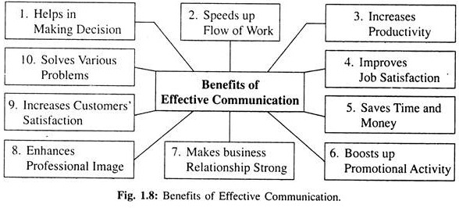

The benefits of effective business communications are:

1. Helps in Making Decision:
A decision, in order to be correct and appropriate, must be based on adequate and correct information which only effective communication can bring together.

2. Speeds up Flow of Work:
Flow of work is not obstructed if orders, instructions, suggestions, etc. are communicated properly and timely.

3. Increases Productivity:
Effective communication allows the team of workers to concentrate on their respective jobs removing confusion from their minds. It increases their ability, efficiency and quality of performance which ultimately leads to higher productivity.

4. Improves Job Satisfaction:
Effective communication among the employees and the supervisor in a workplace can boost up job satisfaction at both the ends. The employees think that they are essential to the organisation and on the other hand, the supervisor also feels satisfied that his orders are carried out by the employees.
When the employees know clearly what to do, when to do and about the reward of their performance they can accomplish their jobs efficiently. They remain satisfied and loyal to their higher authority.

5. Saves Time and Money:
If a communication is not understood properly further conversation will be needed for clarity involving extra time and money. Effective communication saves time and money by preventing multiple communication. Selection of appropriate means of communication from among various methods (e.g. telephone, mobile phone, e-mail, fax, letter, face to face conversation, etc.) as per requirement can save both time and money.

6. Boosts up Promotional Activity:
Goods and services are brought to the knowledge of the consumers through communication and promotional activities (e.g. advertisement, use of different media, etc.) are made effective through it.

7. Makes Business Relationship Strong:
Fruitful communication with outside people and organisations (e.g. creditors, banks, insurance companies, co-business managers, etc.) make a healthy relationship with all concerned.

8. Enhances Professional Image:
The way an organisation communicates casts on impression of its efficiency on the communicate. Good communication signifies good and professionally efficient organisation.

9. Increases Customers’ Satisfaction:
Customers’ satisfaction is a vital aspect of consideration for a business organisation. The existence and growth of a business largely depends upon it. Effective communication is necessary in achieving confidence of the customers. It clarifies all the queries (regarding products, services, availability, prices, quality, variety, etc.) of the customers and makes them happy and satisfied.

10. Solves Various Problems:
Innumerable problems (e.g. gossip, rumors, conflict, mistrust among the employees, managers etc.) crop up in a business organisation due to poor communication or no communication. Effective communication can solve the problems easily. It establishes a link between the managers and the employees. The relationship between them is eased and various problems and grievances are removed.

