UNIT- 2

Corporate Communication

‘Corporate Organisation’ means an organisation formed by some people, having a separate entity and perpetual succession.
A company, statutory corporation, co-operative ventures, etc. are considered to be corporate organisations because these are registered and have separate legal entity and perpetual existence.
Generally such organisations are not small they are medium or large in size. Therefore, exchange of information and news with a large number of people within and outside the organisation is required to be made.
Various departments and employees of the organisations are connected through communication network by phones, face-to-face discussion, e-mail, fax, memos, etc. to convey orders, instructions and information, to supervise and evaluate performance, to understand and perform individual job, to identify and solve a problem and, ultimately, to fulfill the objectives of the organisation.
External communication with the customers, vendors, distributors, competitors, investors, government agencies, etc., through letters, reports, memos, phones, faxes, websites, internet, etc., are made to introduce, negotiate, co-ordinate, explain, interact, discuss and to develop co-operation and understanding.
Therefore, corporate communication refers to a process of communication through which the managers, supervisors and executives exchange their views, opinions, feelings, etc. with the subordinates and employees in any corporate organisation and negotiate with the outside world with a view to fulfilling the objectives of the organisation.

Characteristics of Corporate Communication:
The various characteristics of corporate communication are mentioned below:

1. Formal Communication:
Most of the corporate communications are formal in nature. Orders, instructions, information, suggestions, etc. are sent, maintaining formal procedure in a systematic way. If has to pass through several organisational stages.

2. Informal Communication:
The size and structure of a corporate organisation being large and complex, informal communication or grapevine communication among different groups of employees takes place side by side with formal communication.

3. Internal and External Communication:
Exchange of information with a large number of people within and outside the business is required in corporate communication. Internal communication with the managers and employees, and external communication with the customers, vendors, distributors, competitors, investors, government offices, etc. are made.

4. Oral and Written Communication:
While oral communication is used for closer and internal communication with the employees, written communication is made with the outsiders and distant people.

5. Wide Coverage:
Corporate organisations are large and a wide range of people are required to be covered in communication. People within the organisation at different levels in different departments and a large number of people outside the organisation are required to be communicated within the course of running the activities of the organisation.

6. Means of Communication:
Phones, face-to-face conversation, e-mail, fax, telegrams, memos, website, internet, video conference, etc. are used as the mediums or channels of corporate communication.

7. Feedback:
As in the case of other communication, feedback is an essential element of successful corporate communication. It is a two-way process of sending information and receiving response. Through feedback the sender can know the reaction’ of the recipient and take necessary action.

8. Long-term System:
Corporate organisation has a perpetual existence. So, corporate communication is not a temporary arrangement. It is a long-term system or process. Communication is carried out continuously through a stable process.

9. Continuous Flow of Communication:
In a corporate organisation, flow of communication is continuous and uninterrupted; continuous due to the organisation’s perpetual existence, and uninterrupted owing to following the formal or official channel.

10. Reliable Information:
In a corporate organisation, information is collected through various sources and decisions are taken after necessary scanning, scrutinizing, etc. to make the information dependable and correct.

Importance of Corporate Communication

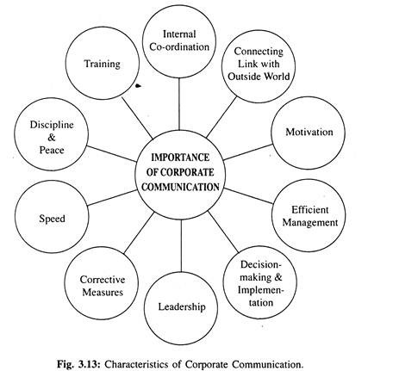
Communication has an important role to play in the corporate world. With the increase in the complexities of activities in modern business, its importance is growing day-by-day. To achieve the objectives of the organisation, co-ordination among the persons and departments within the organisation and establishment of connecting link with the outside world are very much necessary.

1. Internal Co-ordination:
To fulfill the objectives of the organisation, co-ordination among the employees is necessary and to co-ordinate various activities communication is essential. Corporate organisation being large in size, division of work and specialisation in activities are the characteristics of such organisation. Communication helps to co-ordinate such activities and to develop co-operation.

2. Connecting Link with the Outside World:
In a corporate organisation, communication with the external people, such as customers, vendors, investors, competitors, government departments, etc. are essential. Even connecting links with the foreign counterparts and centres are necessary for proper functioning of the organisation.

3. Motivation:
Communication helps to motivate the employees to obey the orders and directives of the management authority. The feedback of the employees also enlightens the managers. The interaction between the managers and the employees improves the relation between them and encourages all to devote themselves fully to achieve the objectives of the organisation.

4. Efficient Management:
Communication works as a lubricant to increase the efficiency of management is applicable to corporate organisations more appropriately. Communication supplies the managers and employees with the information, co-ordinates and motivates the employees.
This results in co-operation and better performance, resolves conflicts, builds confidence and ultimately develops efficient management. The managers, supervisors and executives get instructions, orders, messages, etc. from their superiors through communication, become aware of their duties and responsibilities and exact performance from their subordinates. Thus, communication stimulates efficient management.

5. Decision-making and Implementation:
The success of any corporate organisation depends largely upon decision-making. Right decision-making, again, depends upon correct and timely information which is obtained through communication. Again, implementation of the decision requires proper communication.
The managers convey the procedure of implementing the decision through communication channels and evaluate the work of the employees. Thus, corporate communication has a meaningful role in decision-making and its implementation.

6. Leadership:
The manager communicates orders and instructions to the subordinates, who, in turn, carry out the instructions and sometimes send feedback in the form of suggestions, grievances and complaints. The manager tries to remove the inconvenience as far as possible. The entire process establishes the basis of leadership.

7. Corrective Measures:
In a corporate organisation the number of employees is large. Everybody’s performance may not achieve required standard and some corrective measures may become necessary. Such measures against the employees not performing their duties properly can also be taken through communication. Communication thus protects the interest of the organisation.

8. Speed:
Speed is the key word of today’s corporate world. Modern technologies have made communication faster. Now, no one has to wait for weeks or months for a reply letter. E-mail, fax, internet, etc. have made communication almost instant. Immediate flow of information helps in taking correct decision in time and anticipates solution to a probable problem.

9. Discipline and Peace:
Maintenance of discipline in large corporate sector is difficult. Control over a large number of managers and employees is not an easy task. But regular communication (Two-way) between the management authority and the workers creates a healthy human relation and sense of co-operation, assistance and unity. Thus, peace is established and discipline is maintained within the organisation.

10. Training:
Communication is necessary in imparting training to the managers, supervisors, executives and general employees to upgrade their knowledge and skill of performance in order to meet the needs of the changing corporate world.
This may include training in the field of science and technology, up-gradation of technical know-how, development of management skill, and even a training in learning a language for communication.

Guidelines for Effective Corporate Communication
Corporate communication to be effective should follow some guidelines stated below:

1. It should be simple. Jargon and buzz words create confusion and difficulty in understanding.
2. It should be concise. Repetition of words and unnecessary explanation are to be avoided. It should be kept in mind that more communication is not necessarily better communication.
3. It should be clear in meaning and free from ambiguity.
4. The message should be courteous, no matter whether it is being sent to the subordinates, to the superiors, or to the peer persons. It is to be remembered that courtesy begets courtesy.
5. The communication should give correct information in proper time and in right manner.
6. It should be complete in all respects. Before communicating one should check whether the following ‘5 Whs’ are answered: Who, What, Where, When and Why.
7. Corporate communication should be consistent to the norms of the organisation. It should keep track of the previous communication and maintain a continuity.
8. Metaphors, analogy or examples are sometimes necessary to bring out the meaning of communication easily. So, appropriate use of these is recommended for better communication.
9. Repetition of the key message is necessary in some cases. To become sure about the success, the communicator sometimes repeats the key message.
10. An effective communication should have proper feedback. Two-way communication should be encouraged.
11. Proper planning before communication is necessary. The success of the entire communication process depends largely on planning in advance.
12. Last but not the least, effective channels should be chosen and established to make the corporate communication successful.

FORMAL AND INFORMAL COMMUNICATION

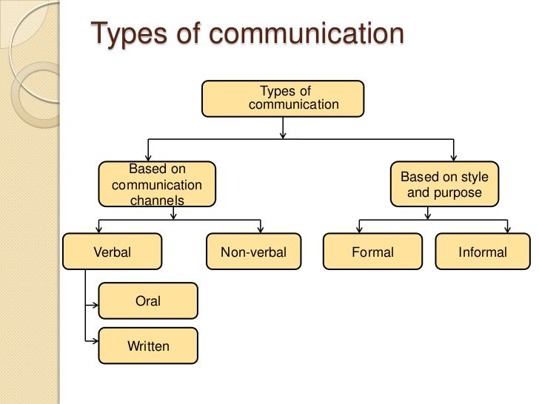
Formal Communication
Formal communication refers to the flow of official information through proper, predefined channels and routes. The flow of information is controlled and needs deliberate effort to be properly communicated. Formal communication follows a hierarchical structure and chain of command. The structure is typically top down, from leaders in various departments and senior staff in the organization, which funnel down to lower level employees. Employees are bound to follow formal communication channels while performing their duties. Formal communication is considered effective as it is a timely and systematic flow of communication.

Advantages of formal communication
- When you want to finalize policy and want to decide a course to adopt, then formal communication is more effective
- Formal communication can help in establishing procedures and ensuring that the steps are followed.
- Any promises or any official plans need to be formally documented so that they can be referred to later.
Types of Formal Communication
- Memos
- Intranet
- Meetings
- Conferences
- Formal One-on-Ones
- Bulletin Boards
- Handouts
- Letters
- Presentations
- Speeches
- Notice Boards
- Organizational blogs
- Emails from managers and leaders

Informal Communication
In comparison, informal communication refers to communication which is multi-dimensional. Informal communication moves freely within the organization and is not bound by pre-defined channels and communication routes. Informal communication is particularly quick. Informal communication is far more relational than formal communication and is by nature, a very natural form of communication as people interact with each other freely and can talk about a diverse range of topics, often extending outside of their work duties. Due to the inherent nature of informal communication, it moves a lot faster and does not have a paper trail.

Informal communication in the workplace is often called the ‘grapevine’ and generally begins with employees through social relations. In many cases informal communications can turn to formal communication if they are added in to the formal communication information flow of a company.
Informal communication is considered effective as employees can discuss work-related issues which saves the organization time and money. It also helps to build more productive and healthy relationships in the workforce.
Types of informal communication
- Gossip- In the gossip chain, one person seeks and tells the information to everyone.
- Single Strand – a form of informal communication wherein each person communicates with the next in a single sequence.
- Cluster - a very common form of informal communication, in cluster networks a person will receive information and choose to pass it on to their cluster network or keep the information to themselves. Each individual will pass on the information to the next cluster network
- Probability Chain – each individual randomly tells another individual the same piece of information.
Advantages of informal communication
- informal communication helps the “Open door policy” and makes people more confident and forthcoming with their ideas and creativity.
- Informal communication does not incite fear into peoples mind
- Informal talks encourage people to share their problems.

Communication network
Communication network, the structure and flow of communication and information between individuals within a group. Within many groups (e.g., in a typical office), formal and informal communication is often characterized by a top-down hierarchical pattern, in which members direct communication to others at the same level or below but not above.
A communication network is the pattern of directions in which information flows in the organization. Channels of communication (networks by which information flows) are either formal networks or informal networks. Formal networks follow the authority chain and are limited to task-related communications. The informal network (grapevine) is free to move in any direction, skip authority levels, and is as likely to satisfy group members' social needs as it is to facilitate task accomplishments.

Types of Communication Networks
Some popular networks of communication observed in a formal organisation might be, as described below:

(i) Y network
(ii) Wheel network
(iii) Chain network
(iv) Circle network
(v) All channel or star network.

1. Y network:

Here A is the main person who communicates or transfers our information with B, C, and D. It
follows the formal chain of authority where an upward and downward type of communication takes place in the organizational hierarchy. In this, an individual can easily communicate with both superior and subordinates.

Characteristics of the Y network:
(i) Sequential in nature.
(ii) Centralization process.
(iii) Flexible in nature.

2. Wheel Network:
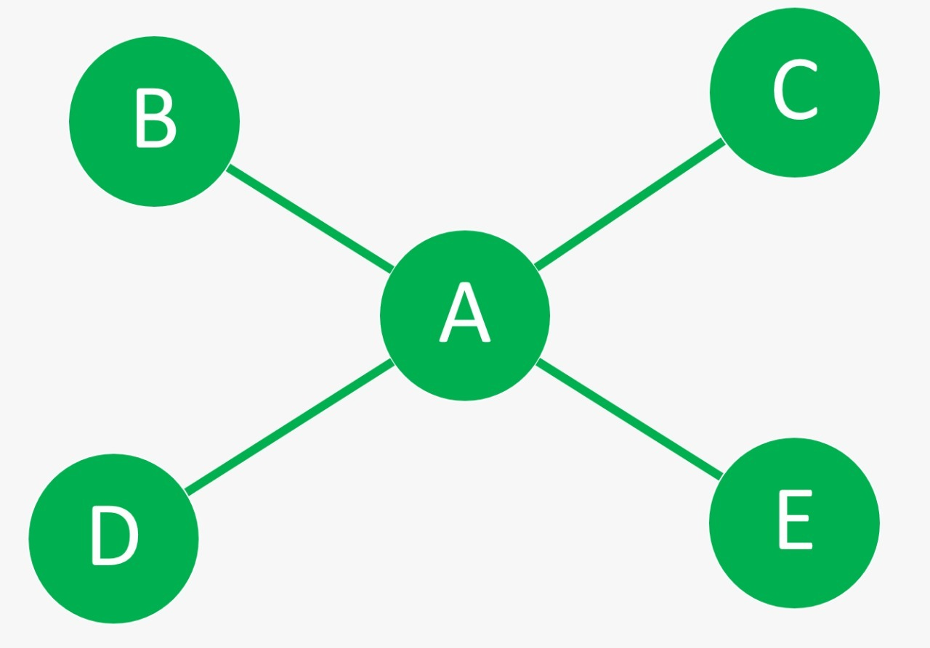
In this network, all information, and messages flow through A, who is at the center at the wheel. A communicates with other members of the group like B, C, D, and E, while members cannot communicate with each other.
This network of communication is found in highly formal organization structures where the task-aimed approach to leadership is preferred to employee-oriented approach.
The employer (senior) communicates the information to employees while the employees (junior) do not communicate amongst themselves.
Characteristics of Wheel Network:
(i) Information passes only from authority.
(ii) Less chance of misunderstanding.
(iii) Follow the process of goal-oriented approach.

3. Chain network:

Chain network is similar to the Y network, chain network mostly follows a formal chain of command or authority where the information flows vertically upwards or downwards.
A manager and employee communicate with each other through the vertical chain of authority or command, both upwards and downwards. Information perversion is not likely to take place but a communication system becomes time-consuming.
Characteristics of Chain Network:
(i) Equal to the Y network.
(ii) Follow the process of the formal channel of authority.
(iii) Step-by-step process.

4. Circle network:

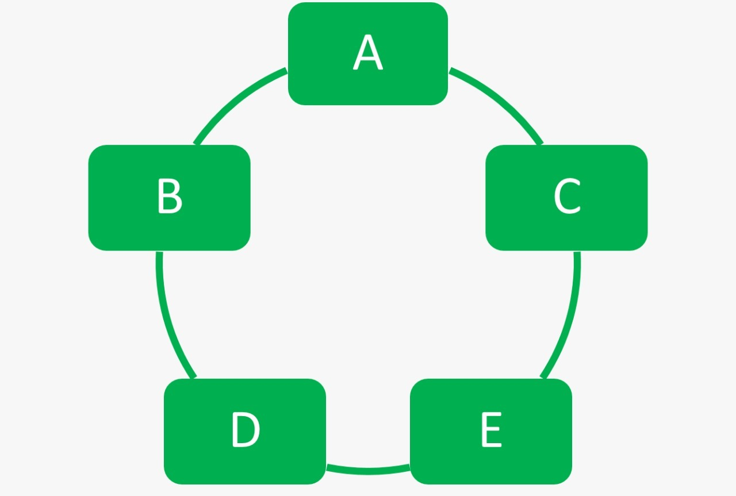
This circle network is similar to a chain network except that information flows in a circular form or direction rather than vertical form or direction. A can communicate simultaneously with two different persons, B, and C but to communicate with D, he has to pass the information with through B or C, and E.
All five individuals cannot directly communicate with each other. In this network, the lowest level of worker can communicate with the top level of manager. (A could be the top level of manager and C could be the lowest level of worker).
In this network, the formal channel of command is not followed.

Characteristics of Circle Network:
(i) Equal to the chain network.
(ii) In this channel, a person can talk to two people at the same time.

5. All channel or star network:

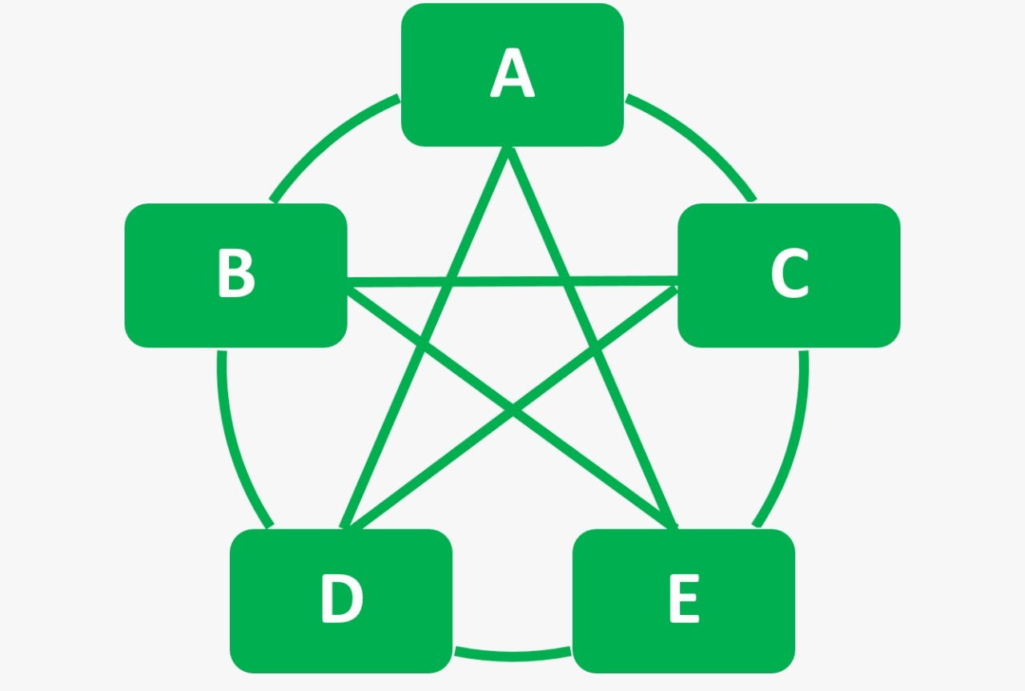
All the individuals in this network communicate with each other freely, permanently, and regularly.
It follows the informal channel of command or communication and provides optimum satisfaction to our individuals. Information flows very fast, though there may be a problem of coordination.
There is a single path of communication in a single-channel network for a particular position and information flows through that path only to various persons. There is usually an official path of better communication where information transfers “through proper channel” between the manager and the employee. All information transfers through concerned managers or employees only.
Characteristics of Star Network:
(i) Only important information flows through this path.
(ii) It reduces the chances of miscommunication.
(iii) Superior control the activities of subordinates through effective communication networks.

Grapevine Communication

If communication is done without maintaining the formalities prescribed by the organization, it is called informal communication. The basis of informal communication is personal or informal relationship between the members of a group. It is also known as grapevine that takes place when the people of an organization or group, especially of same level or rank gather or meet tighter and discuss informally.
According to Bovee and Others, “Grapevine is an informal interpersonal channel of information not officially sanctioned by the organization.
In the opinion of R.W. Griffin, “The grapevine is an informal communication network that can permeate an organization.”
Newstrom and K. Davis said, “Grapevine is an informal system that arises spontaneously from the social interaction of the organization.” Business Communication

Types of Grapevine
- Single Strand Chain
- Gossip Chain:
- Probability Chain
- Cluster Chain
- Single Strand Chain: The single strand chain involves the passing of information through a line of persons to the ultimate recipient. In the figure, the person A tells B, who tells C, who tells D, and so on, till the information has reached most of the persons involved or concerned.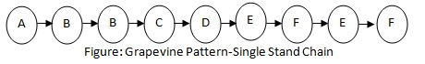

- Gossip Chain: In the gossip chain, one person seeks and tells the information to everyone. This chain is just like the wheel where one person stays at the centre and the information passes along the spokes of the wheel to others stationed on the rim. In the following figure, A is at the center and passes the information to others staying on the rim of the wheel.
- Probability Chain: The probability chain is a random process in which someone transmits the information to others in accordance with the laws of probability and then these others tell still others in a similar way. This chain may also be called random process. The probability chain is shown below-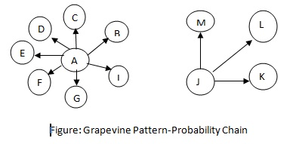
- Cluster Chain: In the cluster chain, a person tells the information to the selected persons who may in turn relay (pass) the information to other selected persons. Most of the information communication follows this chain.
- 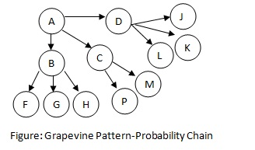

Barriers in Business Communication
Anything that hinders the process of communication at any of these levels is a barrier to communication Barriers to communication can be defined as the aspects or conditions that interfere with effective exchange of ideas or thoughts.
According to Dr. Suruj Kumar Debnath, defined, “Barriers to communication mean obstacles to the process of communication.
In the opinion of Louise E. Boone and Others, “Communication barriers are the problems that arise at every stage of the communication process and have the potential to create misunderstanding and confusion.
According to C. B. Mamoria, “Communication, when it is impeded and does not reach the receiver is often somewhat ineffective and the impediments are known as barriers.”

CLASSIFICATION OF BARRIERS
- PHYSICAL BARRIERS
- SEMANTIC AND LANGUAGE BARRIERS
- SOCIO-PSYCHOLOGICAL BARRIERS
- ORGANIZATIONAL BARRIERS
- CROSS-CULTURAL BARRIERS

- PHYSICAL BARRIERS
- Faulty Organizational Structure
- Large working area
- Closed office doors
- Separate areas for people of different status
- It forbids team member from effective interaction with each other

- Noise
- Physical noise (outside disturbance)
- Psychological noise (inattentiveness)
- Written noise (bad handwriting/typing)
- Visual noise (late arrival of employees)

- Time and Distance
- Improper Time
- Defects in Medium of communication
- Network Facilities
- Mechanical Breakdowns

- Information Overload
- Piling up of tasks due to improper time management.
- Excess number of people assigned for same task
- Work overload/Information duplication.

- SEMANTIC AND LANGUAGE BARRIERS
- SIMILAR SOUNDING WORDS
These words are known as Homophones
Pronunciation - Same
Spelling - Diffrent
Meaning- Different

Examples:
- pale/pail
- alter/altar
- buy/bye/by
- rain/reign

- WORDS HAVE MULTIPLE PRONUNCIATIONS
These words are known as Homographs
Spelling Same

Pronunciation - Diffrent

Meaning - Diffrent

Examples • The bandage was wound around the wound.
• We must polish the Polish furniture
. • He could lead if he would get the lead out.

- WORDS HAVE MULTIPLE MEANING
These Words are also known as homonyms
Spelling - Same
Pronunciation -Same
Meaning -Different

Examples • Never desert your friends in the desert.
• Close the window before the bee gets too close
- DENOTATIONS AND CONNOTATIONS
- Denotation: The literal meaning of a word
- Connotaions: The emotions and associations connected to a word
– Favourable Connotation: 'honest', 'noble', 'sincere’
– Unfavourable Connotation: 'cowardly', 'slow', 'incompetent‘
Examples: They gave us cheap stuff. At this shop, they sell things cheap
LANGUAGE BARRIERS
- Different Languages
- No Clarity in Speech
- Using Jargons
- Not being specific

- SOCIO-PSYCHOLOGICAL BARRIERS - Psychological barriers can be described as the cause of distorted communication because of human psychology problems.
Attitude and opinions:
- Emotions
- Filtering and distortion of message
- Status difference
- In attention
- Closed mind
- Fields of experience

- CROSS-CULTURAL BARRIERS
- Language
- Values
- Social Relation
- Concept of time
- Concept of space
- Gestures
- ORGANISATIONAL BARRIERS
- Loss or distortion of messages as they pass from one level to another
- Filtering of information according to one’s understanding/interpretation
- Messages not read completely or not understood correctly
- Deliberate withholding of information from peers perceived as rivals
- Information gap if upper level does not know the true state of affairs
- Lack of communication policy
- Authoritarian attitude of management
- Poorly Defined Authority and Responsibility
- Too Many Levels in Organization Structure
- Insufficient Communication Training

Overcoming Communication Barriers
- Active listening
Select the appropriate channel for the message
Make a special effort to understand each other's perspective
Organizational Actions Create a climate of trust and openness
Develop and use formal information channels in all directions
Encourage the use of multiple channels including formal and informal
communications The organizational structure should fit communication needs

GROUP DISCUSSION

What is a Group?
A group, in the context of organizational communication, is defined as a collection of individuals who interact with each other, accept expectations and obligations as members of the group and share a common identity. Group activities have certain advantages and disadvantages.

What Is a Discussion?
A discussion is understood as an activity of sitting and talking about a specific subject. The word ‘discuss’ has been derived from the latin root ‘discutere’, which means to shake or strike. Thus ‘discussion’ refers to thoroughly shaking up the subject, that is, examining it thoroughly to reach a conclusion.

What is a Group Discussion?
Group discussions are a very important aspect of group communication. Group discussions are a creative and dynamic activity which stimulates reflective thinking among the members. Group discussions may be defined as an activity in which a small number of persons meet face to face and exchange and share ideas freely or attempt to reach a decision on a common issue.
Group discussions are unstructured and less formal compared to meetings or conferences wherein specific roles are assigned to the participants. In a group discussion, an individual’s thought process is influenced by the views and opinions of the other members. It also depends on where and in which direction the mood of the discussion moves. In a group discussion, each participant is free to speak his views. A successful discussion involves both listening and speaking . Group discussion is an important activity in academic, business and administrative spheres. It is a systematic and purposeful interactive oral process. Here the exchange of ideas, thoughts and feelings take place through oral communication. The exchange of ideas takes place in a systematic and structured way. The participants sit facing each other almost in a semi-circle and express their views on the given topic/issue/problem.

Characteristics of Group Discussions
Some of the salient features common to all group discussions are as follows:
(i) Interface: A basic feature of group discussions is the interaction among the various members of the group. They see, hear and communicate with each other orally by paying attention to each other.
(ii) Leader and Members: Group discussions are effective only when there is a group of members and a leader. The leader has to summarize facts and information, integrate them, stimulate thinking and agree to a unanimous solution of the problem. The members of the group become actively related to each other in their respective roles.
(iii) Participation: The effectiveness and efficiency of a group discussion depend, to a large extent, upon the active participation of the members.
(iv) Interpersonal Attraction: Another characteristic feature of a group discussion is interpersonal attraction. As long as interaction continues, the likes, dislikes, behavior and temperament of members are known to each other. Among them, empathy develops and as such they share each others problems.
(v) Pressure to Conform: In a group discussion, there is always an element of pressure to conform to norms. The pre-defined and established standards are always enforced and followed.
(vi) Conflict: A conflict is a difference or disagreement among the members of the group, which often arise during deliberations and discussions. A conflict is inevitable and usually develops when alternative solutions are present. It can stimulate the members to find new solutions to the problem. Thus, conflict is not necessarily bad. But if it arises due to the political behavior of the members it will have dysfunctional consequences.

Purpose of Group Discussions
Group discussions may serve various purposes. Some of them are:
(i) To reach a solution on an issue of concern
(ii) To generate new ideas or new approaches to solving a problem
(iii) For selecting candidates after the written test for employment or for admission to educational institutes
(iv) To provide us with an avenue to train ourselves in various interpersonal skills

Advantages of Group Discussions
The advantages of group discussions are as follows:
(i) It provides a deeper understanding of the subject.
(ii) It improves the ability to think critically.
(iii) It provides different approaches to solving a problem.
(iv) It helps the group in taking a decision.
(v) It gives an opportunity to hear the opinions of other persons.
(vi) It enables a participant to put across his/her viewpoint.
(vii) It enhances confidence in speaking.
(viii) It can change your opinion and show you things from a different perspective.

Types of Group Discussions
Group Discussions can be divided into 3 kinds:
A) Topical Group Discussions, which are based on current affairs or ‘static’ matters – for example, a GD on the topic of the recent demonetisation of Rs 500 and Rs 1000 notes would be the former, whereas a GD on whether India should adopt a presidential model of democracy would be the latter, as it has no limitation of a time frame.
B) Case-studies, which present the group with a complex business situation that requires a decision to be made. Such cases usually have multiple problems embedded in the given situation, and both the individual participants and the group are required to analyse the situation, identify the problems, and suggest a way out.
C) Abstract Group Discussions, which are called so because they offer us no definite framework of the topic, and hence no definite direction to take in the discussion. Instead, the participants are required to interpret the topic in their own ways and demonstrate innovative thinking in doing so. Such topics could be single-worded, such as ‘Blue’, or a short cryptic sentence, or even an image.

