FINANCIAL MANAGEMENT
UNIT-5
BBA-2nd YEAR

Forms of Dividends
A dividend is generally considered to be a cash payment issued to the holders of company stock. However, there are several types of dividends, some of which do not involve the payment of cash to shareholders. These dividend types are:

Cash Dividend
The cash dividend is by far the most common of the dividend types used. On the date of declaration, the board of directors resolves to pay a certain dividend amount in cash to those investors holding the company’s stock on a specific date. The date of record is the date on which dividends are assigned to the holders of the company’s stock. On the date of payment, the company issues dividend payments.

Stock Dividend
A stock dividend is the issuance by a company of its common stock to its common shareholders without any consideration. If the company issues less than 25 percent of the total number of previously outstanding shares, then treat the transaction as a stock dividend. If the transaction is for a greater proportion of the previously outstanding shares, then treat the transaction as a stock split. To record a stock dividend, transfer from retained earnings to the capital stock and additional paid-in capital accounts an amount equal to the fair value of the additional shares issued. The fair value of the additional shares issued is based on their fair market value when the dividend is declared.

Property Dividend
A company may issue a non-monetary dividend to investors, rather than making a cash or stock payment. Record this distribution at the fair market value of the assets distributed. Since the fair market value is likely to vary somewhat from the book value of the assets, the company will likely record the variance as a gain or loss. This accounting rule can sometimes lead a business to deliberately issue property dividends in order to alter their taxable and/or reported income.

Scrip Dividend
A company may not have sufficient funds to issue dividends in the near future, so instead it issues a scrip dividend, which is essentially a promissory note (which may or may not include interest) to pay shareholders at a later date. This dividend creates a note payable.

Liquidating Dividend
When the board of directors wishes to return the capital originally contributed by shareholders as a dividend, it is called a liquidating dividend, and may be a precursor to shutting down the business. The accounting for a liquidating dividend is similar to the entries for a cash dividend, except that the funds are considered to come from the additional paid-in capital account.

Types of Dividend Policy

Four types of dividend policy
There are basically 4 types of dividend policy. Let us discuss them on by one:

Regular dividend policy
In this type of dividend policy the investors get dividend at usual rate. Here the investors are generally retired persons or weaker section of the society who want to get regular income. This type of dividend payment can be maintained only if the company has regular earning.
Merits of Regular dividend policy:
- It helps in creating confidence among the shareholders.
- It stabilizes the market value of shares.
- It helps in marinating the goodwill of the company.
- It helps in giving regular income to the shareholders.

Stable dividend policy
The payment of certain sum of money is regularly paid to the shareholders. It is of three types-
(a) Constant dividend per share: here reserve fund is created to pay fixed amount of dividend in the year when the earning of the company is not enough. It is suitable for the firms having stable earning.
(b) Constant payout ratio: it means the payment of fixed percentage of earning as dividend every year.
(c) Stable rupee dividend + extra dividend: it means the payment of low dividend per share constantly + extra dividend in the year when the company earns high profit.
Merits of stable dividend policy:
- It helps in creating confidence among the shareholders.
- It stabilizes the market value of shares.
- It helps in marinating the goodwill of the company.
- It helps in giving regular income to the shareholders.

Irregular dividend
As the name suggests here the company does not pay regular dividend to the shareholders. The company uses this practice due to following reasons:
- Due to uncertain earning of the company.
- Due to lack of liquid resources.
- The company sometime afraid of giving regular dividend.
- Due to not so much successful business.

No dividend
The company may use this type of dividend policy due to requirement of funds for the growth of the company or for the working capital requirement.

FACTORS AFFECTING DIVIDEND POLICY
A company needs to analyze certain factors before framing their dividend policy.
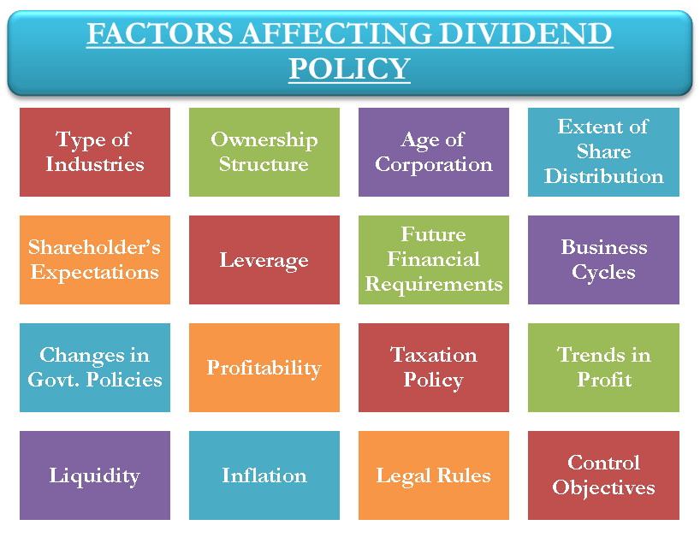
The following are the various factors/determinants that impact the dividend policy of a company:
(i) Type of Industry
The nature of the industry to which the company belongs has an important effect on the dividend policy. Industries, where earnings are stable, may adopt a consistent dividend policy as opposed to the industries where earnings are uncertain and uneven. They are better off in having a conservative approach to dividend payout.
(ii) Ownership Structure
The ownership structure of a company also impacts the policy. A company with a higher promoter’ holdings will prefer a low dividend payout as paying out dividends may cause a decline in the value of the stock. Whereas, a high institutional ownership Determinants of Dividend Decisions will favor a high dividend payout as it helps them to increase the control over the management.
(iii) Age of Corporation
Newly formed companies will have to retain major part of their earnings for further growth and expansion. Thus, they have to follow a conservative policy unlike established companies, which can pay higher dividends from their reserves.
(iv) The Extent of Share Distribution
A company with a large number of shareholders will have a difficult time in getting them to agree to a conservative policy. On the other hand, a closely held company has more chances of succeeding to finalize conservative dividend payouts.
(v) Different Shareholders’ Expectations
Another factor that impacts the policy is the diversity in the type of shareholders a company has. A different group of shareholders will have different expectations. A retired shareholder will have a different requirement vis-a-vis a wealthy investor. The company needs to clearly understand the different expectations and formulate a successful dividend policy. Psychologically, cash dividend will give more satisfaction to shareholder in comparison to capital appreciation.
(vi) Leverage
A company having more leverage in their financial structure and consequently, more interest payments may to decide for a low dividend payout, so as to increase their net worth and to make sure that it can make payment of financial charges even in case of earning of the company is falling. Whereas a company utilizing more of own financing will prefer high dividends.
(vii) Future Financial Requirements / Reinvestment Opportunity
Dividend payout will also depend on the future requirements for the additional capital. A company having profitable investment opportunities is justified in retaining the earnings. However, a company with no capital requirements should opt for a higher dividend.
(viii) Business Cycles
When the company experiences a boom, it is prudent to save up and make reserves for dips. Such reserves will help a company to maintain dividend even in depressing markets to retain and attract more shareholders.
(ix) Changes in Government Policies
There could be the change in the dividend policy of a company due to the imposed changes by the government. The Indian government had put temporary restrictions on companies to pay dividends during 1974-75.
(x) Profitability
The profitability of a firm is reflected in net profit ratio and ratio of profit to total assets. A highly profitable company have a capacity to pays higher dividends and a company with less profits will adopt a conservative dividend policy.
(xi) Taxation Policy
The corporate taxes will affect dividend policy, either directly or indirectly. The taxes directly reduce the residual earnings after tax available for the shareholders. If dividend income is taxable in the hands of investor and capital gain is exempt, then company may retain its earning so as to increase price per share, which ultimately gives higher return to investors’ and vice versa. Further if it is possible that bifurcate all shareholders into high tax bracket or low tax bracket, accordingly dividend policy can be framed. Finally, objective is to give maximum return to shareholders.
(xii) Trends of Profits
Even if the company has been profitable over the years, the trend should be properly analyzed to find the average earnings of the company. This average number should be then studied in relation to the general economic conditions. This will help in opting for a conservative policy if a depression is approaching.
(xiii) Liquidity
Liquidity has a direct relation with the dividend policy. Many a times, company having high profit, may have majority of profit blocked in working capital or it may acquired assets. In that case its liquidity is poor. In that case company should pay less dividend. High dividend payment is possible only if company has good earning and sound liquidity.
(xiv) Legal Rules
There are certain legal restrictions on the companies for dividend payments. It is legal to pay a dividend only if the capital is not reduced post payment. These rules are in place to protect creditors’ interest. Most importantly providing depreciation is mandatory before making payment of dividend. Depreciation is to be provided at minimum rates provided. Providing depreciation is very important because with that company is able to retain an amount of profit for replacement of fixed assets in future.
(xv) Inflation
Inflationary environments compel companies to retain major part of their earnings and indulge in lower dividends. As the prices rise, the companies need to increase their capital reserves for their purchases of fixed assets. In case of inflationary situation, same quantity of closing stock will have more valuation, so payment of tax also increase.
(xvi) Control Objectives
The firms aiming for more control in the hands of current shareholders prefer a conservative dividend payout policy. It is imperative to pay fewer dividends to retain more control and the earnings in the company.
In a nutshell, the management of a company is completely free to frame the required dividend policy. There are no obligations to be adhered to. So, the company needs to judiciously weight all the above-mentioned factors and formulate a balanced dividend policy. A dividend policy can also be revised in the wake of changes in any of the factors.

Dividend Models: Walter and Gordon’s Model

Walter’s Model
Professor James E. Walterargues that the choice of dividend policies almost always affects the value of the enterprise. His model shows clearly the importance of the relationship between the firm’s internal rate of return (r) and its cost of capital (k) in determining the dividend policy that will maximize the wealth of shareholders.

Walter’s model is based on the following assumptions:-
- The firm finances all investment through retained earnings; that is debt or new equity is not issued;
- The firm’s internal rate of return (r), and its cost of capital (k) are constant;
- All earnings are either distributed as dividend or reinvested internally immediately.
- Beginning earnings and dividends never change. The values of the earnings pershare (E), and the divided per share (D) may be changed in the model to determine results, but any given values of E and D are assumed to remain constant forever in determining a given value.
- The firm has a very long or infinite life.
Walter’s formula to determine the market price per share (P) is as follows:
P = D/K +r(E-D)/K/K
The above equation clearly reveals that the market price per share is the sum of the present value of two sources of income-
(i) The present value of an infinite stream of constant dividends, (D/K) and
(ii) The present value of the infinite stream of stream gains.
[r (E-D)/K/K]

Criticism
Walter’s model is quite useful to show the effects of dividend policy on an all equity firm under different assumptions about the rate of return. However, the simplified nature of the model can lead to conclusions which are net true in general, though true for Walter’s model.
The criticisms on the model are as follows:
- Walter’s model of share valuation mixes dividend policy with investment policy of the firm. The model assumes that the investment opportunities of the firm are financed by retained earnings only and no external financing debt or equity is used for the purpose when such a situation exists either the firm’s investment or its dividend policy or both will be sub-optimum. The wealth of the owners will maximize only when this optimum investment in made.
- Walter’s model is based on the assumption that r is constant. In fact decreases as more investment occurs. This reflects the assumption that the most profitable investments are made first and then the poorer investments are made.
The firm should step at a point where r = k. This is clearly an erroneous policy and fall to optimize the wealth of the owners.
- A firm’s cost of capital or discount rate, K, does not remain constant; it changes directly with the firm’s risk. Thus, the present value of the firm’s income moves inversely with the cost of capital. By assuming that the discount rate, K is constant, Walter’s model abstracts from the effect of risk on the value of the firm.

Gordon’s Model
One very popular model explicitly relating the market value of the firm to dividend policy is developed by Myron Gordon.

Assumptions of Gordon’s model
Gordon’s model is based on the following assumptions.
- The firm is an all Equity firm
- No external financing is available
- The internal rate of return (r) of the firm is constant.
- The appropriate discount rate (K) of the firm remains constant.
- The firm and its stream of earnings are perpetual
- The corporate taxes do not exist.
- The retention ratio (b), once decided upon, is constant. Thus, the growth rate (g) = br is constant forever.
- K > br = g if this condition is not fulfilled, we cannot get a meaningful value for the share.

Miller- Modigliani (MM) Hypothesis
The MM, in their first paper (in 1958) advocated that the relationship between leverage and the cost of capital is explained by the net operating income approach. They argued that in the absence of taxes, a firm’s market value and the cost of capital remains invariant to the capital structure changes. The arguments are based on the following assumptions:-
(a) Capital markets are perfect and thus there are no transaction costs.
(b) The average expected future operating earnings of a firm are represented by subjective random variables.
(c) Firms can be categorized into “equivalent return” classes and that all firms within a class have the same degree of business risk.
(d) They also assumed that debt, both firm’s and individual’s is riskless.(e) Corporate taxes are ignored.

Proposition I
The value of any firm is established by capitalizing its expected net operating income (If Tax = 0)
VL = VU = EBIT
- The value of a firm is independent of its leverage.
- The weighted cost of capital to any firm, levered or not is
(a) Completely independent of its capital structure and
(b) Equal to the cost of equity to an unlevered firm in the same risk class.

Proposition II
The cost of equity to a levered firm is equal to
(a) The cost of equity to an unlevered firm in the same risk class plus
(b) A risk premium whose size depends on both the differential between the cost of equity and debt to an unlevered firm and the amount of leverage used.
As a firm’s use of debt increases, its cost of equity also rises. The MM showed that a firm’s value is determined by its real assets, not the individual securities and thus capital structure decisions are irrelevant as long as the firm’s investment decisions are taken as given. This proposition allows for complete separation of the investment and financial decisions. It implies that any firm could use the capital budgeting procedures without worrying where the money for capital expenditure comes from. The proposition is based on the fact that, if we have two streams of cash, A and B, then the present value of A +B is equal to the present value of A plus the present value of B. This is the principle of value additivity. The value of an asset is therefore preserved regardless of the nature of the claim against it. The value of the firm therefore is determined by the assets of the firm and not the proportion of debt and equity issued by the firm.
The MM further supported their arguments by the idea that investors are able to substitute personal for corporate leverage, thereby replicating any capital structure the firm might undertake. They used the arbitrage process to show that two firms alike in every respect except for capital structure must have the same total value. If they don’t, arbitrage process will drive the total value of the two firms together.

Determinants of Dividend Policy
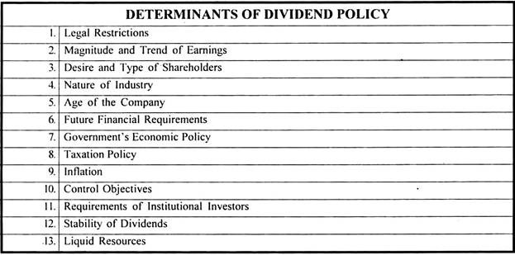

1. Legal Restrictions:
Legal provisions relating to dividends as laid down in sections 93,205,205A, 206 and 207 of the Companies Act, 1956 are significant because they lay down a framework within which dividend policy is formulated.
These provisions require that dividend can be paid only out of current profits or past profits after providing for depreciation or out of the moneys provided by Government for the payment of dividends in pursuance of a guarantee given by the Government.
The Companies (Transfer of Profits to Reserves) Rules, 1975 require a company providing more than ten per cent dividend to transfer certain percentage of the current year’s profits to reserves. Companies Act, further, provides that dividends cannot be paid out of capital, because it will amount to reduction of capital adversely affecting the security of its creditors.

2. Magnitude and Trend of Earnings:
The amount and trend of earnings is an important aspect of dividend policy. It is rather the starting point of the dividend policy. As dividends can be paid only out of present or past year’s profits, earnings of a company fix the upper limits on dividends.
The dividends should, generally, be paid out of current year’s earnings only as the retained earnings of the previous years become more or less a part of permanent investment in the business to earn current profits. The past trend of the company’s earnings should also be kept in consideration while making the dividend decision.

3. Desire and Type of Shareholders:
Although, legally, the discretion as to whether to declare dividend or not has been left with the Board of Directors, the directors should give the importance to the desires of shareholders in the declaration of dividends as they are the representatives of shareholders. Desires of shareholders for dividends depend upon their economic status.
Investors, such as retired persons, widows and other economically weaker persons view dividends as a source of funds to meet their day-to-day living expenses. To benefit such investors, the companies should pay regular dividends. On the other hand, a wealthy investor in a high income tax bracket may not benefit by high current dividend incomes.
Such an investor may be interested in lower current dividends and high capital gains. It is difficult to reconcile these conflicting interests of the different type of shareholders, but a company should adopt its dividend policy after taking into consideration the interests of its various groups of shareholders.

4. Nature of Industry:
Nature of industry to which the company is engaged also considerably affects the dividend policy. Certain industries have a comparatively steady and stable demand irrespective of the prevailing economic conditions. For instance, people used to drink liquor both in boom as well as in recession. Such firms expect regular earnings and hence can follow a consistent dividend policy.
On the other hand, if the earnings are uncertain, as in the case of luxury goods, conservative policy should be followed. Such firms should retain a substantial part of their current earnings during boom period in order to provide funds to pay adequate dividends in the recession periods.
Thus, industries with steady demand of their products can follow a higher dividend payout ratio while cyclical industries should follow a lower payout ratio.

5. Age of the Company:
The age of the company also influences the dividend decision of a company. A newly established concern has to limit payment of dividend and retain substantial part of earnings for financing its future growth and development, while older companies which have established sufficient reserves can afford to pay liberal dividends.

6. Future Financial Requirements:
It is not only the desires of the shareholders but also future financial requirements of the company that have to be taken into consideration while making a dividend decision. The management of a concern has to reconcile the conflicting interests of shareholders and those of the company’s financial needs.
If a company has highly profitable investment opportunities it can convince the shareholders of the need for limitation of dividend to increase the future earnings and stabilise its financial position.
But when profitable investment opportunities, do not exist then the company may not be justified in retaining substantial part of its current earnings. Thus, a concern having few internal investment opportunities should follow high payout ratio as compared to one having more profitable investment opportunities.

7. Government’s Economic Policy:
The dividend policy of a firm has also to be adjusted to the economic policy of the Government as was the case when the Temporary Restriction on Payment of Dividend Ordinance was in force. In 1974 and 1975, companies were allowed to pay dividends not more than 33 per cent of their profits or 12 per cent on the paid-up value of the shares, whichever was lower.

8. Taxation Policy:
The taxation policy of the Government also affects the dividend decision of a firm. A high or low rate of business taxation affects the net earnings of company (after tax) and thereby its dividend policy. Similarly, a firm’s dividend policy may be dictated by the income-tax status of its shareholders.
If the dividend income of shareholders is heavily taxed being in high income bracket, the shareholders may forego cash dividend and prefer bonus shares and capital gains.

9. Control Objectives:
When a company pays high dividends out of its earnings, it may result in the dilution of both control and earnings for the existing shareholders. As in case of a high dividend pay-out ratio, the retained earnings are insignificant and the company will have to issue new shares to raise funds to finance its future requirements.
The control of the existing shareholders will be diluted if they cannot buy the additional shares issued by the company.
Similarly, issue of new shares shall cause increase in the number of equity shares and ultimately cause a lower earnings per share and their price in the market. Thus, under these circumstances to maintain control of the existing shareholders, it may be desirable to declare lower dividends and retain earnings to finance the firm’s future requirements.

10. Stability of Dividends:
Stability of dividends is another important guiding principle in the formulation of a dividend policy. Stability of dividend simply refers to the payment of dividend regularly and shareholders, generally, prefer payment of such regular dividends.
Some companies follow a policy of constant dividend per share while others follow a policy of constant payout ratio and while there are some other who follows a policy of constant low dividend per share plus an extra dividend in the years of high profits.
A policy of constant dividend per share is most suitable to concerns whose earnings are expected to remain stable over a number of years or those who have built-up sufficient reserves to pay dividends in the years of low profits.
The policy of constant payout ratio, i.e., paying a fixed percentage of net earnings every year may be supported by a firm because it is related to the firm’s ability to pay dividends. The policy of constant low dividend per share plus some extra dividend in years of high profits is suitable to the firms having fluctuating earnings from year to year.

