UNIT-1

AUDITING

Meaning of Auditing:
Auditing, therefore, is an examination of the books of accounts and vouchers of the business by an independent person who should be qualified for the job, in order to ascertain their accuracy.

Objectives of Auditing:
The basic objective with which auditing is done are:
1. Verification of accounts and statements.
2. Detection of errors or frauds.
3. Prevention of errors or frauds.
There are two main objectives of Auditing. Primary and Secondary objective, let us understand both the objectives one by one.

Primary Objective
The main objective of an auditor is to report to owners that the financial accounts give an accurate view of the situation of the company’s activities.

Secondary Objective
The secondary objective is also known as incidental objective as it is related to the fulfillment of the primary purpose.
The incidental objectives of auditing are as follows:
- Detection and prevention of scams
- Discovery and prevention of mistakes
The auditor is given a free hand to the books, accounts, statements enabling him to thoroughly check them and if satisfied to certify that books have been properly drawn up and represent a true view of the financial position of the business. He gives his special attention to the direction of errors which may be innocently or intentionally committed.

Advantages of Auditing:
Auditing has several advantages which are given as follows:
1. It detects errors and frauds with suggestions for their prevention.
2. To avoid such mistakes being committed the accounts are kept up-to-date.
3. The parties feel confident of the audit report because it was done by an independent person or body.
4. Accounts as audited stand authentic.
5. The auditors are competent persons in the fields of accounts and financial laws so can render advice to management.

Classification of Auditing:Auditing is classified into two:
1. Continuous or detailed.
2. Periodical or final audits.
1. Continuous Audit:
This is useful in case of big companies with larger business which have scope for keeping the audit staff busy year round or auditors may attend to auditing at intervals fixed or otherwise, and perform an interim audit.
2. Periodical or Final Auditing:
After the completion of the financial year audit work is undertaken which goes on continuously till its completion. This system is the most satisfying from the auditors point of view

DIFFERENT TYPES OF AUDIT (CHART)

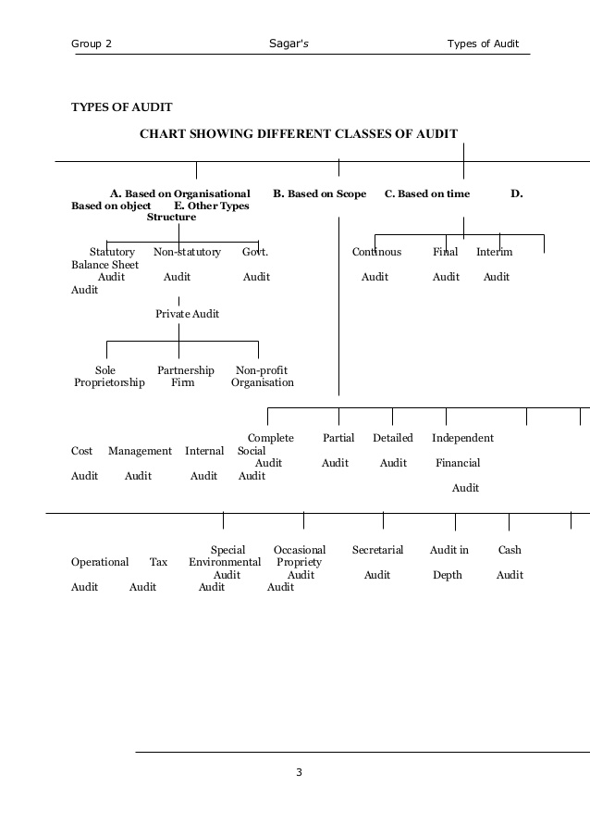

Audit Programme
An audit program is a set of directions that the auditor and its team members need to follow for the proper execution of the audit. After preparing an audit plan, the auditor allocates the work and prepares a program which contains steps that the audit team needs to follow while conducting an audit. Thus, an auditor prepares a program that contains detailed information about various steps and audit procedures to be followed by the audit.

Advantages of the Audit Programme
- An audit program helps in ensuring that all-important areas are considered while conducting the audit.
- An audit program helps an auditor in the allocation of work among its team members according to their skills and competency.
- It enhances the accountability of audit team members towards work performed by them
- An audit program also reduces the scope for misunderstanding among team members regarding the performance of audit work.
- It helps the auditor in checking the status of audit work, its progress, how much it is left for performance while conducting the audit.

Disadvantages of Audit Programme
- Rigidity: There is no set standard audit program that can be applied in the case of every entity. However, programs differ for different types of entities. Every entity has its own problems. Therefore, we cannot apply for a single audit program in the case of all business entities.
- Reduces the Initiative of Efficient Staff: – A program reduces the initiatives of efficient and competent staff. Thus, staff members cannot make changes in the audit plan and cannot make suggestions to it.
- Audit Work becomes Mechanical: The program becomes mechanical when it ignores other aspects like internal control.
- Overlooking New Areas: A program may overlook the new areas. With the change in time and technology, new problems may arise which an audit program may not consider.

Contents of an Audit Programme
The following are the details of an audit programme:

1. Name of the client.

2. Nature of operations and business of client.

3. Review of system of internal check.

4. Date of commencement of audit work.

5. Duration of audit work.

6. Accounting system followed in client organization.

7. Review the report of the previous auditor.

8. Review the remarks, instructions or objections raised in the previous audit report.

9. Examine the various ledger accounts and subsidiary books.

10. Examine the statutory books and registers, profit and loss account, and balance sheet.

Objectives Of Audit Programs:

Audit program is the detail work plan of audit. So, it has the following objectives:

1. Audit program helps to check systematically the books of accounts which helps to conduct fair audit.

2. Audit program specifies the time period clearly, which helps to complete the work of audit in less time.

3. Assistant should sign after the completion of work which specifies the responsibility and accountability of staffs . It also helps to prove the completion of task.

4. Review of proposed scope of audit preparing proper plan.
5. Audit program shows the way to the new staffs to perform work of audit.
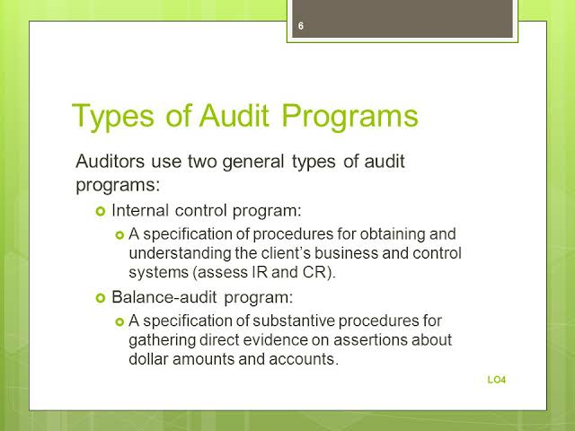

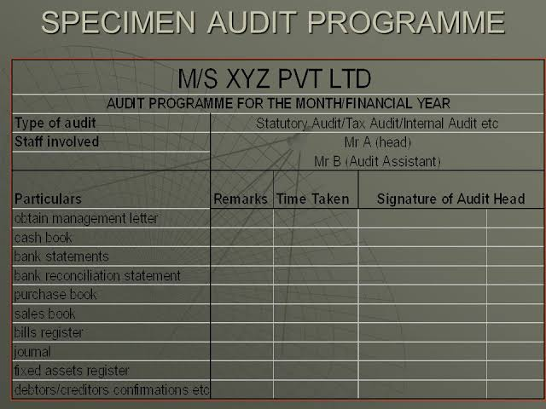

AUDIT NOTEBOOK

Definition of Audit Note Book
According to E.L. Kohler,
“Audit note book is a record, used chiefly in recurring audits, containing data of work done and comments outside the regular subject matter of working papers. It generally contains such items as the audit programme, notations showing how sections of the audit are carried out during successive examinations, information needed for the auditor’s office and for staff administration, personnel assignment, time requirements and notations for use in succeeding examination”.

Contents of Audit Note Book
An audit notebook generally consists of the following information:
1. The nature of the business and summary of important documents relating to the constitution of the business such as Memorandum of Association, Articles of Association or Partnership Deed, etc.
2. A list of the books of accounts maintained.
3. Particulars as to the system of accounts followed and the system of internal check in force.
5. Progress of audit work together with the dates on which the work was undertaken and completed.
6. Extracts from correspondence with different authorities.
7. Audit programme
8. Allocation of work among different audit staff.
9. All queries which have not been clarified so far.
10. Lists of missing receipts, vouchers, bills, etc.
Advantages of Audit Note Book
Some the advantages of audit note book are given below:
1. Audit note book enables the auditor to record important points, which arise during the course of his audit; otherwise he might forget these points.
2. An auditor can produce this book as a documentary evidence in a suit filed against him for negligence or misfeasance.
3. It facilitates the preparation of the audit report.
4. It can help in making an assessment of the work of audit clerks.
5. It provides a key to evaluate the efficiency of the audit staff.

Disadvantages of Audit Note Book
There are, however, certain disadvantages of audit note book. They are as follows:
1. Very often, it creates misunderstanding between the client staff and the audit staff.
2. If it is not properly and carefully prepared it cannot be used as evidence against the auditor for negligence.
3. It develops a fault finding attitude in the minds of the staff of the audit.
4. Audit staff has to depend too much upon the client’s staff for its preparation.

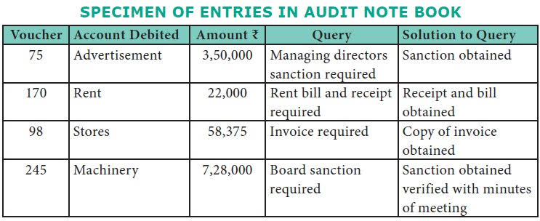

ROUTINE CHECKING

Routine checking is the regular monitoring of business accounts, books and ledgers to determine how the business is functioning and to detect any errors that may have occurred, either accidentally or fraudulently. A business woman uses a tablet computer while looking at financial documents at a desk.

Advantages of Routine checking
The following are the advantages by employing routine checking -
- In the books of accounts all the original entries will be checked; so all the errors and frauds can be detected easily.
- All the entries and posting will be tested. Routine checking helps to conduct final audit because all the balancing and totals have already been checked.
- There is no separate staffs are not needed because it is a regular process.
- Routine checking is easy to perform and ensures that a business is operating to its full potential. If errors are detected, it could also potentially save the business concern money, especially if fraud is involved.
- The checking of castings and postings done in routine checking is the very basis upon which the final results of audit depend. Hence, it helps in the checking of final accounts ultimately.
- Routine checking is a simple job which can be done easily by a person with an ordinary knowledge of accounts.

Disadvantages of Routine checking
- Routine checking can be more expensive for the company as compare to other type of audit, and it is very difficult task for the employee who must perform it.
- There only few cases of frauds can be detected by routine checking. Some more items of fraud cannot be brought to change.
- In routine checking, here appears to be a much of difficulty in tracing out compensating errors and errors of principle.
- Routine checking is not considered it is only important in the audit of a business where self-balancing system is used.
- The work of routine checking is given to new or employee who has any accounting. Knowledge they do not consider it which one is material and as important matter.
- The disadvantage of routine checking is that planned frauds are not disclosed as to know. The responsibility of fraud lies on management of the entity.
- The disadvantage of routine checking is that errors of principle are not disclosed in the books. The audited accounts may fail to provide true and fair view.
- The work is routine checking is boring and time consuming.
- Routine checking is a mechanical test nature, so the staff that performs checking does not any has inspiration or improvements so that there are chances of leaving errors and frauds.
- Routine checking can only detect small errors and frauds but not the planned frauds.
- Routine checking is not needed where small size business entity.

TEST CHECKING
Meaning of Test Checking
Test checking is a process of selecting and checking of a few transactions from a large volume of transactions. If the entries checked are found to be correct then the auditor assumes that the remaining entries are also correct.

PRECAUTIONS OF TEST CHECKING
1. INTERNAL CONTROL: Auditor must review system of internal control before doing test checking. He cannot apply test checking when he finds that the internal control system is either ineffective or defective.
2. SAMPLE: The sample items selected from whole data must be representative. The selection can be made by any method. The entire data must be presented in the form of sample.
3. SURPRISE TESTING: The auditor should embrace the part of surprise in choice of take a look at. The accounting employees should be unaware of take a look at checking in order that he shouldn’t build arrangement, for take a look at checking.
4. EVERY TYPE OF TRANSACTION: The auditor should choose each kind of group action in take a look at checking. There’s got to embrace every kind of dealing within the sample.
5. . CASH BOOK: The cashbook entries should not be used for take a look at checking. There is want of cent percent checking of all things showing in money book. The management over money is crucial for economical business operating.
6. THROUGHOUT THE YEAR: The ‘take a look at checking’ will be applied to any or all things showing within the books throughout the year.
7. REVIEW: The system of take a look at checking ought to be reviewed from time to time to introduce enhancements.

TRANSACTIONS NOT SUITABLE FOR TEST CHECKING
1. OPENING ENTRIES: It should be noted that opening entries are passed at the start of the year. These items require cent percent checking: There is no need to apply test checking.
2. CLOSING ENTRIES: These entries are recorded at the end of the year. There are few entries for closing the revenue accounts. Test checking is not suitable for closing entries..
3. MANAGEMENT REMUNERATION: The management remuneration is not fit for test checking. It can be checked on hundred percent bases. The concept of materiality does not relate to remuneration.
4. PROFIT & LOSS ITEMS: The Profit and Loss items are checked on cent percent basis. The test checking cannot be applied to profit and loss account items. The true and fair view is possible after thorough checking.
5. BALANCE SHEET ITEMS: The balance sheet items are checked on cent percent basis. There is no need of test checking of assets and liabilities appearing in balance sheet. The facts can be disclosed after thorough checking.
6. DEPRECIATION: The depreciation on fixed assets is charged every year. The amount of depreciation is not fit for test checking. The auditor must apply the rule of cent percent checking on depreciation.

ADVANTAGES OF TEST CHECKING
1. TIME SAVING: The advantage of take a look at checking is offered within the form of your time saving. A sample thing is checked and remaining items square measure treated as checked. During this method there’s saving in time in take a look at checking.
2. ACCURATE BOOKS: The take a look at checking is beneficial to notice the accuracy of accounting books and different record. There’s a requirement of error free books. The take a look at checking could be a step within the right direction to prove accuracy.
3. STAFF EFFICIENCY: The potency of accounting employees improves attributable to take a look at checking. The weakness of worker is rumored to the management. The workers try and improve their work by overcoming their deficiencies.
4. TIMELY REPORT: The good thing about take a look at checking is that timely report may be submitted to management. The big variety of figures may be checked in brief amount of your time in order that there’s no delay.
5. MANY AUDITS: Take a look at checking is beneficial to complete several audits in one year. It saves sufficient time that may be accustomed check the books of recent purchasers. The auditor is in a position to lift additional financial gain.

DISADVANTAGES OF TEST CHECKING
1. ERRORS ARE NOT DISCLOSED: The demerit of test checking is that errors are not making known by it. In the existence of errors true and fair view is not possible. No doubt the location of errors is the duty of management but affects the audit work
.
2. PLANNED FRAUDS ARE NOT DISCLOSED: The demerit of test checking is that planned frauds may not be disclosed. The fraud discovery is the responsibility of management. The audited accounts cannot show the true and fair view when fraud exists in books.
3. RESPONSIBILITY CAN NOT BE SHIFTED: The demerit of test checking is that auditor cannot shift his responsibility to others. The errors and frauds can be discovered through cent’ per cent checking. So auditor is responsible for test checking.
4. REPORT MAY FAIL TO DISCLOSE TRUE POSITION: The audit report may fail to disclose true and fair view of business matters. After test checking the auditor signs the report. The auditor is responsible for audit report based on test checking.

UNIT 2

Internal Control
Definition: Internal Control can be defined as a system designed, introduced and maintained by the company’s management and top-level executives, to provide a substantial degree of assurance in achieving business objective, while complying with the policies and laws, safeguarding the assets, maintaining efficiency and effectiveness in regular operations and reliability of financial statements.

Objectives of Internal Control System
- To ensure that the business transactions take place as per the general and specific authorisation of the management.
- To make sure that there is a sequential and systematic recording of every transaction
- To provide security to the company’s assets from unauthorised use.
- To evaluate the system of accounting for complete authorisation of the transactions.
- To review the working of the organization and the loopholes in the operations and take necessary steps for its correction.
- To ensure there is the optimum utilization of the firm’s resources, i.e. men, material, machine and money.
- To find out whether the financial statements are in alignment with the accounting concepts and principles.

Types of Internal Control System
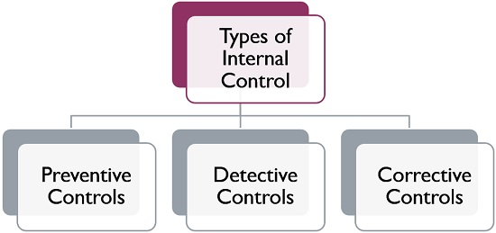
- Preventive Controls: These controls are introduced in the firm to stop errors and irregularities from taking place.
- Detective Controls: These controls are implemented to reveal errors and irregularities, once they take place.
- Corrective Controls: These controls are designed to take corrective action for removing errors and irregularities after they are detected.
The type of internal control system implemented in the organization will be based on the company’s nature and requirements.
Internal Control System is important for every organization, for efficient management as well as it also assist in the company’s audit. It includes all the processes and methods to help the company in reaching its ultimate objective.

Advantages of Internal Control System (ICS)
1. Safeguarding client’s assets against:
a) Misuse
b) Misappropriation
c) Manipulations
d) Abuse of the Company’s assets (for reasons that will not benefit the Company)
e) Facilitates optimal use of the Company’s assets.

2. Reduces Audit Fees. This is because less audit work is needed and less audit staff.
Increased efficiency through management supervision and a defined organisation chart. Routine and automatic checks also increase efficiency.

3. Chances of errors and frauds are minimized.

4. This ensures minimum losses, facilitates audit work and hence early reports and attainment of budgeted performance.

5. Facilitates up to date records.

6. It boosts morale of staff through motivation of supervision. This may lead to high output and high profitability.

Disadvantages of Internal Control System (ICS)

1. ICS is expensive to install and maintain. For example, the physical control security systems require qualified personnel to maintain them and constant servicing.

2. ICS could lead to a problem of over reliance on the ICS. This may lead to relaxation in supervision and allow manipulation of accounts and assets.

3. Rigid implementation may lead to a slowdown in the operation of the business.

4. The ICS requires continuous updating as the organization changes, if not the ICS may become increasingly obsolete.

5. Use of wrong controls may expose the Company to more problems, e.g. errors and frauds. These are more easily perpetrated if the ICS used is inappropriate.

INTERNAL CHECK SYSTEM
Internal Check is an integral function of the internal control system. It is an arrangement of duties of the staff members in such a way that the work performed by one person is automatically and independently checked by the other.

Objectives Of Internal Check System

Following are the main objectives of Internal Check −
- To protect business from carelessness, inefficiency and fraud.
- To ensure and produce adequate and reliable accounting information.
- To keep moral pressure over staff.
- To minimize the chances of errors and frauds and to detect them easily on early stage if it is committed.
- To divide the work in such a way that no business transaction should be left unrecorded.
- To fix the responsibility of every clerk according to the division of work.

Principles of Internal Check
Let us now understand the principles of Internal Check −
- Responsibility − Allocation of business work amongst the various staff members should be done in such a way that their duties and responsibilities should be judiciously and clearly divided.
- Automatic check − Automatic checking of work of one employee by another forms part of a good Internal Check system.
- Rotation − Transfer or rotation of employees from one seat to another must be followed under good system of internal control.
- Supervision − Prescribed procedures and Internal Check should be strictly supervised.
- Safeguard − To safeguard files, securities, cheque books is also recommended in Internal Check.
- Formal Sanction − Without formal sanction, no deviation should be allowed from the established procedures.
- Reliance − Under good system, too much reliability on one employee should not be there.
- Review − From time to time, system of Internal Check should be reviewed to introduce improvement.
Advantages of internal check system:
1. Protect the assets
2. Implement the management policies
3. Detects errors and frauds
4. Increases the accuracy and reliability
5. regulate the work of staffs
6. Helps to prepare plans
7. Boost morale of employees

Disadvantages of internal check system:
- Expensive
- Human elements
- Unusual transactions
- Reasonable assurance

GENERAL PRINCIPLES OF INTERNAL CHECK SYSTEM FOR FEW TRANSACTIONS

- ICS with regard to material
- ICS with regard to wage payment
- ICS with regard to purchase
- ICS with regard to sales
- ICS with regard to cash receipts
- ICS with regard to cash payments

AUDIT PROCEDURES

Audit procedures are the processes, technique, and methods that auditors perform to obtain audit evidence which enables them to make a conclusion on the set audit objective and express their opinion. Sometimes we call audit procedures as audit programs. These two terms are referring to the same thing.

TYPES OF AUDIT PROCEDURE
  - COMPLIANCE PROCEDURE
A compliance audit is a comprehensive review of an organization's adherence to regulatory guidelines. Audit reports evaluate the strength and thoroughness of compliance preparations, security policies, user access controls and risk management procedures over the course of a compliance audit

  - SUBSTANTIVE PROCEDURE
A substantive procedure is a process, step, or test that creates conclusive evidence regarding the completeness, existence, disclosure, rights, or valuation (the five audit assertions) of assets and/or accounts on the financial statements

VOUCHING
Definition: Vouching, widely recognized as “the backbone of auditing,” is a component of an audit seeking to authenticate the transactions recorded in a firm’s book of accounts. When an accounting transaction is vouched, it is tested and verified by presenting relevant documentary evidence.

OBJECTIVES OF VOUCHING
1. To Detect Errors And Frauds

2. To Know The Truth Of Account
.
3. To Find The Unrecorded Transactions

4. To Know That All The Transactions Are Authorized

5. To Know That Only The Business Transactions Are Recorded

VOUCHING OF DIFFERENT TYPES OF TRANSACTIONS
- Vouching of cash book
- Vouching of trading transactions
- Vouching of Impersonal ledger

Vouching of Cash Receipts (Debit Side of Cash Book)
We will discuss the cash receipt which are placed on the debit side of cash book for following items −

Opening Balance of Cash Book
Opening balance of cash book represents cash in hand at the start of the year and should verified from the balance sheet of last financial year.

Cash Received from Debtors
Consider the following points for verification of cash received from debtors −
- The carbon copies or counterfoils of cash receipt book should be verified.
- Cash receipt should be serially numbered.
- Cash received should be entered on the same date when the cash is actually received.
- The discount allowed to customers should be properly authorized by a responsible officer.
- Correspondence with customer and ledger account should be tallied.
Following are the different ways used for misappropriation of cash −
- Cash received from customer not recorded in books and no cash receipt may be issued.
- Issuance of receipt for lesser amounts than amount actually received.

Repayment of Loan by Others
Repayment of loan by others may be verified in the following ways −
- Calculation of interest received and interest should be credited to interest received account.
- Verification from bank statement if directly deposited by party into bank.
- Checking of carbon copies or counterfoils of cash receipts.
- To ensure that there should be no violation of Income Tax rules as payment of loan exceeding Rs. 20,000/- cannot be repaid in cash. It should be through Cheques, Demand Draft, NEFT, RTGS or any other available banking channels.

Rent Received
- To check rental agreement or lease deed.
- In case where the rental income is received from more than one property, separate account for each property should be maintained.
- The Auditor should verify that the rent for all the twelve month is received or not.
- The amount of rent should be verified from the rent deed or the lease deed.
- If TDS (Tax Deducted at Source) is deducted by the party, there should be proper accounting of TDS.

Vouching of Cash Payments (Credit Side of Cash Book)
All the payment made to creditors, expenses incurred in cash and all other payments done appear on the credit side of cash book and the Auditor is required to vouch cash payments because chances of cash misappropriation are very high.
Following points need to be considered for different types of cash payment −

Opening Balance
The opening balance of cash book can never be credited because cash of company cannot be in negative but the credit bank balance represents the overdraft account from bank or utilization of cash credit limit as sanctioned from bank.

Payment to Creditors
Payment to creditors may be examined by the following −
- Receipt issued by the creditors.
- If the creditor is paid amount as full and final settlement, the balance amount, if any stands in the ledger account of the creditor; this amount should be credited to discount received.
- If any advance payment is made to creditor that should be clearly mention.
- Statement of account of creditor.

Payment of Salaries
Depending upon the adequacy of internal control system in an organization Auditor will decide his audit Program. It is very important for Auditor to check the following −
- Attendance record of employee and salary register.
- Appointment letter of new employees.
- Comparison of current month salary with last month’s salary and if there is any abnormal change in amount, Auditor should verify the same.
- Alteration in amount of deductions on account of advance, loan, fine, funds, insurance, TDS, etc.

Purchase of Plant and Machinery
The Auditor should pay attention to the following −
- Purchase invoice of machinery.
- Freight inward charges, installation charges, erection and commissioning charges should be capitalized.
- Treatment of Excise duty according to the excise rules.

Purchase of Land & Building
Purchase of Land and Building can be vouched as follows −
- Study of Lease hold agreement, if land is purchased on lease hold basis.
- Payment should be as per lease term.
- All the expenses incurred to acquire lease hold property should be debited to respective property account.
- Auditor should study the conveyance deeds in case property is purchased under free hold basis.
- For verification of payment, the Auditor can check the payment receipt and the conveyance deed.

Internal Control System for Cash Transactions
Following are the main features of a good internal control system −
- All cash received should be accounted for immediately.
- All received cheques should be crossed immediately on receipt.
- Cash receipt should be issued to debtors and daily reconciliation of account should be done where the debtors pay cash on daily basis.
- All cash receipts should be deposited in bank on a daily basis.
- Bank reconciliation account should be prepared on a regular basis.
- Payments other than petty payments should be done through crossed cheques.
- Cash receipt should be obtained for every cash payment to creditors.
- Cash expenses should be duly supported by proper and genuine bills or vouchers

VERIFICATION
Meaning
Verification means the act of assuring the correctness of value of assets and liabilities in the organization. It refers to the examination of proof of title and their existence or confirmation of assets and liabilities on the date of Balance Sheet. It usually indicates verification of assets of any organization, which can be done by examination of values, ownership, existence, possession of any assets and also ensures that the assets are free from any charge. In simple words, verification means, ‘proving the truth or confirmation’.

Definition
Spicer and Pegler defines Verification as, “An inquiry into the value, ownership and title, existence and possession and the presence of any charge on the asset”.
Objectives
The objectives of verification are as follows:
1. To show the correct value of assets and liabilities.
2. To know whether the Balance Sheet exhibits a true and fair view of the state of affairs of the business.
3. To find out the ownership, possession and title of the assets appearing in the Balance Sheet.
4. To find out whether assets are in existence.
5. To detect frauds and errors, if any while recording assets in the books of the concern.
6. To verify the arithmetic accuracy of the accounts.
7. To ensure that the assets have been properly recorded.

Auditor’s Duty Regarding Verification
The auditor of a business is required to report in concrete terms that the Balance Sheet exhibits a true and fair view of the state of its affairs. In other words, he has to examine and ascertain the correctness of the money value of assets and liabilities appearing in the Balance Sheet and this examination is known as verification of assets and liabilities. Therefore, an auditor has to keep in mind the following points while verifying the assets:
• Ensuring the existence of assets.
• Acquiring the assets for business.
• Legal ownership and possession of the assets.
• Ensuring the proper valuation of assets.
• Ensuring that the assets are free from any charge.

Verification and Valuation of Individual Intangible Assets
The Procedure of Verification and Valuation of individual Intangible Assets are explained in the following ways:

AUDITOR'S DUTY IN VERIFICATION OF GOODWILL
• Ascertain that the company is justified in creating goodwill in its books of account.
• Where goodwill is generated in own business, the auditor's should verify the particulars of expenses debited to Goodwill account.
• In a partnership firm, the partnership deed should be verified by the auditor. He may also verify the changes made in the goodwill account from time to time based on the provisions made in the partnership deed.

AUDITOR'S DUTY IN VALUATION OF GOODWILL
• Auditor should confirm himself that goodwill has not been shown in excess of its cost price.
• Examine that the sum paid for goodwill does not exceed the difference between the total purchase consideration and the value of net tangible assets acquired.
• He should see that it is valued as per method stated in partnership deed, purchase or agreement.
• Goodwill may appear in the Balance Sheet at cost less amounts written off.
• The amortization period and method of amortization should be reviewed at the end of each financial year.
• An intangible asset should be eliminated in the books of accounts when no future economic benefits are expected from its use.

Verification and Valuation of Liabilities

Verification and Valuation of Trade Creditors
1. The correctness of liabilities depends upon the correctness of purchases. Hence, the auditor should compare the percentage of gross profits to purchase with that of the previous years to verify the correctness of purchases.
2. The auditor should obtain a Schedule of creditors and verify them with the balances of ledger accounts and statements of account received from creditors.
3. He should check the Purchases Book and Purchases Returns Book with the help of invoices, credit notes, etc. He should also check the postings into the Ledger.
4. He should see that all the purchases made during the year have been accounted for especially at the end of the year.
5. He should examine the discount allowed to creditors during the period and see that these substantiate the credit balances.

Verification and Valuation of Loans
1. The auditor should verify the existence of loans, if any. In case of a company he should examine the correspondence, contracts, and Directors’ Minute Book.

2. The auditor should ascertain the terms of loan, amount of loan, period and nature of loan, etc. by referring to the loan agreement.

3. He should confirm the balances of the unpaid loans directly from the creditors of the company with the permission of his client.

4. In case of loans or overdrafts taken from a bank, an agreement with the bank and a certificate to that effect should be obtained and examined.

5. The auditor should see whether the interest due has been paid or not. If the interest is due, he should see whether the same has been clearly shown as liability therein.

