FUNDAMENTAL OF E-COMMERCE
UNIT-1

BBA- N (606)

E- Commerce: Meaning, Nature and Concept

ELECTRONIC COMMERCE
E-commerce is a transaction of buying or selling online. Electronic commerce draws on technologies such as mobile commerce, electronic funds transfer, supply chain management, Internet marketing, online transaction processing, electronic data interchange (EDI), inventory management systems, and automated data collection systems.
Modern electronic commerce typically uses the World Wide Web for at least one part of the transaction’s life cycle although it may also use other technologies such as e-mail. Typical e-commerce transactions include the purchase of online books (such as Amazon) and music purchases (music download in the form of digital distribution such as iTunes Store), and to a less extent, customized/personalized online liquor store inventory services.
There are three areas of e-commerce:
(i) Online retailing,
(ii) Electric markets, and
(iii) Online auctions. E-commerce is supported by electronic business.
Nature of E- Commerce
It has also been described as a “fusion of telecommunications and computing technology to conduct business. That is the creation and management of relationships between buyers and sellers, facilitated by an interactive and pervasive electronic medium”. Some of the main reasons for the increase in electronic trading are:-
(I) The drive to reduce the costs;
(II) Easy accessibility to the Internet;
(III) The lack of regulation on the Internet;
(IV) Access to global markets for vendors;
(V) Greater choice and potentially lower prices for purchasers;
(VI) Lower inventory costs for vendors;
(VII) The ability to enter new markets more easily.
Examples of E-Commerce
Ecommerce can take on a variety of forms involving different transactional relationships between businesses and consumers, as well as different objects being exchanged as part of these transactions.
- Retail: The sale of a product by a business directly to a customer without any intermediary.
- Wholesale: The sale of products in bulk, often to a retailer that then sells them directly to consumers.
- Drop shipping: The sale of a product, which is manufactured and shipped to the consumer by a third party.
- Crowd funding: The collection of money from consumers in advance of a product being available in order to raise the start-up capital necessary to bring it to market.
- Subscription: The automatic recurring purchase of a product or service on a regular basis until the subscriber chooses to cancel.
- Physical products: Any tangible good that requires inventory to be replenished and orders to be physically shipped to customers as sales are made.
- Digital products: Downloadable digital goods, templates, and courses, or media that must be purchased for consumption or licensed for use.
- Services: A skill or set of skills provided in exchange for compensation. The service provider’s time can be purchased for a fee.

Benefits, Limitations And Barriers of e-commerce

BENEFITS OF E-COMMERCE:
Today, e-Commerce has revolutionized the way companies are doing business. Now, consumers can purchase almost anything online 24*7 a day and get an ultimate shopping experience.
Before you opt for an e-Commerce business, have a look on its comprehensive benefits that you can enjoy:

Convenience & Easiness:
For many people in the world, e-Commerce becomes one of the preferred ways of shopping as they enjoy their online because of its easiness and convenience. They are allowed to buy products or services from their home at any time of day or night.
The best thing about it is buying options that are quick, convenient and user-friendly with the ability to transfer funds online. Because of its convenience, consumers can save their lots of time as well as money by searching their products easily and making purchasing online.

Offer Product Datasheets:
Consumers can also get description and details from an online product catalog. For your customers, it is very much important to get information about the product no matter whether the time of day and day of the week. Through information, your customers and prospects are making decision to purchase your products or not.

Attract New Customers with Search Engine Visibility:
As we all know that physical retail is run by branding and relationships. But, online retail is also driving by traffic that comes from search engines. For customers, it is not very so common to follow a link in the search engine results and land up on an ecommerce website that they never heard of.

Comprise Warranty Information:
No matter whether you are looking to choose including warranty information with product descriptions and datasheets or providing it from within an ecommerce shopping cart, you need to make sure that customers must be aware of important terms and conditions that are associated with their purchase.

Decreasing cost of inventory Management:
With e-commerce business, the suppliers can decrease the cost of managing their inventory of goods that they can automate the inventory management using web-based management system. Indirectly, they can save their operational costs.

Keep Eye on Consumers’ Buying Habit:
The best thing is e-commerce retailers can easily keep a constant eye on consumers’ buying habits and interests to tailors their offer suit to consumers’ requirements. By satisfying their needs constantly, you can improve your ongoing relationship with them and build long-lasting relationships.

Competence:
For effective business transactions, e-commerce is an efficient and competence method. Setting-up cost is extremely low as compare to expanding your business with more brick and mortar locations. Very few licenses and permits are required to start-up an online business than physical store. You can save your lots of money by using fewer employees to perform operations like billing customers, managing inventory and more.

Allow Happy Customers to Sell Your Products:
With lots of customers’ reviews and product ratings, you can easily increase your sells as new customers find that your products are good and effective. Make sure that you mention your clients’ testimonials, reviews and product ratings as such things can help your new customers to purchase your products.

Selling Products Across the World:
If you are running a physical store, it will be limited by the geographical area that you can service, but with an e-Commerce website, you can sell your products and services across the world. The entire world is your playground, where you can sell your complete range of products without any geographical limits. Moreover, the remaining limitation of geography has dissolved by mcommerce that is also known as mobile commerce.

Stay open 24*7/365:
One of the most important benefits that ecommerce merchants can enjoy is store timings are now 24/7/365 as they can run e-commerce websites all the time. By this way, they can increase their sales by boosting their number of orders. However, it is also beneficial for customers as they can purchase products whenever they want no matter whether it is early morning or mid-night.

Economy:
Now, you don’t have to invest your money in the physical store, insurance or infrastructure as all you need is a wonderful idea, unique products and well-designed website to reach your precious customers to sell your products and services. We can say that this makes an e-commerce a lot more economical and reasonable.

Boost Brand Awareness:
As like e-commerce business can help B2B organizations to get new customers, so it will be helpful for e-commerce businesses to boost their brand awareness in the market. Developing pages that can be indexed by search engines crawlers is one of the best ways to enhance your website’ search engine optimization and enhance the target audience on your site.

Decrease Costs:
One of the most positive things about eCommerce is that you can decrease the costs of your business. Below are some of the costs that you can reduce by opting for ecommerce.

Advertising & Marketing Cost:
If you opt for ecommerce, you don’t have to spend your money on advertising and marketing. However, organic search engine traffic, social media traffic and pay-per-click are some of the advertising channels that are cost-effective.

Personnel:
A complete automation of check-out, billing, inventory management, payments and other type of operational costs lower the total number of employees that you require to run your ecommerce business.

Eliminate Travel Cost:
Now, customers do not have to travel long distances to reach their desired stores as ecommerce allows them to visit the e-store anytime without traveling. With few mouse clicks, customers can make their purchase and have wonderful shopping experience.

Offer Huge Information:
One of the best benefits of ecommerce for customers is they can get huge information that is not possible in a physical store. We all know that it is quite difficult to equip employees to respond to customers who are looking for information on different product lines.

Analytics:
We can say that business 2 business offers an excellent platform to organizations to launch their complete range of analytics campaign. Through ecommerce, organizations can easily calculate and evaluate sales effectiveness, customer effectiveness, marketing campaigns, product mix, customer engagement and more.

Expand Market for Niche Products:
It is difficult for buyers and sellers to find each other in the physical world, but it becomes very easy for them with the inception of e-store. Customers can search their required products on the web and can purchase it from any corner of the world. No matter what kind of product customers are looking, they can find all types of products without any hassle.

Scalability:
With effective ecommerce solution, you and your organization grow and scale easily to meet market demand as well as customer requirements by introducing different sales channels and reaching market segments.

Ability of Multi-site:
With ecommerce platform, it becomes easy for businesses to launch channel specific and particular brand ecommerce website. This ability enables you to provide co-branded websites for your specific customers and allows for websites catering to specific international spectators.

LIMITATION OF E-COMMERCE:
- Security: the security risk in ecommerce can be
- client / server risk
- data transfer and transaction risk
- virus risk
- High start up cost:
The various components of cost involved with ecommerce are:-
- Connection: - connection cost to the internet.
- Hardware / software: - this includes cost of sophisticated computer, modular, routers, etc.
- Maintenance: - this includes cost involve in training of employees and maintenance of web-pages.
- Legal issues:- these issues arises when the customer data is fall in the hands of strangers.
- Lack of skilled personnel:- there is difficulty in finding skilled www developers and knowledgeable professionals to manage and a maintain customer on line.
- Loss contact with customers:- Sometimes customers feels that they does not have received sufficient personal attention.
- Uncertainty and lack of information: - most of the companies has never used any electronic means of communication with its customers as the internet is an unknown mode for them.
- Some business process may never be available to ecommerce:- Some items such as foods, high cost items such as jewellery may be impossible to be available on the internet.

BARRIERS TO E-COMMERCE:
5 Biggest barriers to e-commerce-
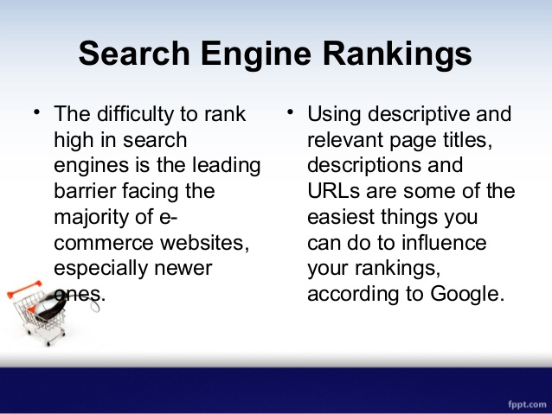

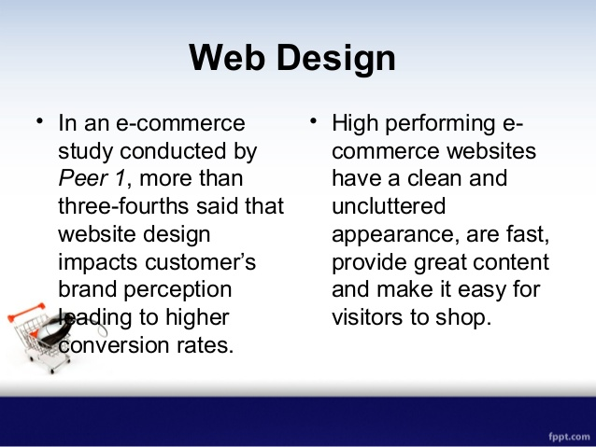
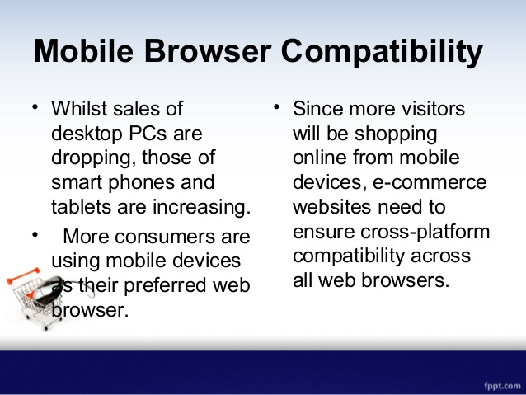
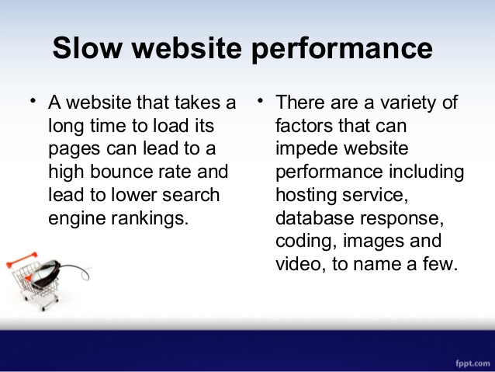

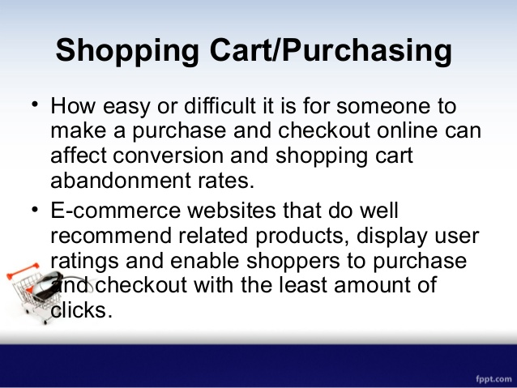

Traditional commerce
Traditional commerce refers to the practice of selling products and services within a single industry and in some cases, within a specific geographical area. Traditional commerce relies on operating business hours during a specific period of time and requires housing inventory or occupying a retail store.
In contrast to e-commerce that relies on online sales, drop shipments and 24 hour access for consumers, traditional commerce relies more on local consumers interacting with sales executives, managers, customer service personnel and accountants personally versus through electronic mediums.
Businesses deemed as traditional commerce handle advertising, inventory shipping and creation of products and services in-house with a staff of employees in close proximity. Traditional commerce does not typically share information with competitors whereas e-commerce prices, specials and inventory are ready available online for consumers and competitors.
Traditional commerce often relies on face to face interaction with consumers and thrives based on word of mouth, networking and customer referrals for new and repeat business. Personal interaction is a key component of businesses experience success with traditional commerce. Many businesses network within the community, establish rapport with city leaders and chambers of commerce and sponsor local events and sports teams to develop a relationship with the community to draw in business.
Traditional Commerce or Commerce is a part of business, which encompasses all those activities that facilitate exchange. Two kinds of activities are included in commerce, i.e. trade and auxiliaries to trade. The term trade refers to the buying and selling of goods and services for cash or kind and auxiliaries to trade, implies all those activities like banking, insurance, transportation, advertisement, insurance, packaging, and so on, that helps in the successful completion of exchange between parties.
In finer terms, commerce encompasses all those activities that simplify the exchange of goods and services, from manufacturer to the final consumer. When the goods are produced, it does not reach to the customer directly rather it has to pass from various activities, which are included under commerce. Its main function is to satisfy the wants of consumers by making goods available to them, at the right time and place.
 | Traditional Commerce | e-Commerce
Meaning | Traditional commerce is a branch of business which focuses on the exchange of products and services, and includes all those activities which encourages exchange, in some way or the other. | e-Commerce means carryng out commercial transactions or exchange of information, electronically on the internet.
Processing of Transactions | Manual | Automatic
Accessibility | Limited Time | 24×7×365
Physical inspection | Goods can be inspected physically before purchase. | Goods cannot be inspected physically before purchase.
Customer interaction | Face-to-face | Screen-to-face
Scope of business | Limited to particular area. | Worldwide reach
Information exchange | No uniform platform for exchange of information. | Provides a uniform platform for information exchange.
Resource focus | Supply side | Demand side
Business Relationship | Linear | End-to-end
Marketing | One way marketing | One-to-one marketing
Payment | Cash, cheque, credit card, etc. | Credit card, fund transfer etc.
Delivery of goods | Instantly | Takes time

Electronic Commerce, Types of E-Commerce

Electronic Commerce
Electronic commerce, or e-commerce, (also written as e-Commerce) is a type of business model, or segment of a larger business model, that enables a firm or individual to conduct business over an electronic network, typically the internet. Electronic commerce operates in all four of the major market segments: business to business, business to consumer, consumer to consumer, and consumer to business. It can be thought of as a more advanced form of mail-order purchasing through a catalogue.

TYPES OF E-COMMERCE
There are 6 basic types of e-commerce
1.Business-to-Business (B2B)
2.Business-to-Consumer (B2C)
3.Consumer-to-Consumer (C2C)
4.Consumer-to-Business (C2B)
5.Business-to-Administration (B2A)
6.Consumer-to-Administration (C2A)
- Business-to-Business (B2B)
Business-to-Business (B2B) e-commerce encompasses all electronic transactions of goods or services conducted ​​between companies. Producers and traditional commerce wholesalers typically operate with this type of electronic commerce.

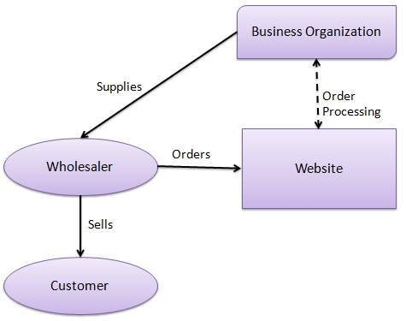
FIGURE:- B2B COMMUNICATION.
- Business-to-Consumer (B2C)
The Business-to-Consumer type of e-commerce is distinguished by the establishment of electronic business relationships between businesses and final consumers. It corresponds to the retail section of e-commerce, where traditional retail trade normally operates.
These types of relationships can be easier and more dynamic, but also more sporadic or discontinued. This type of commerce has developed greatly, due to the advent of the web, and there are already many virtual stores and malls on the Internet, which sell all kinds of consumer goods, such as computers, software, books, shoes, cars, food, financial products, digital publications, etc.
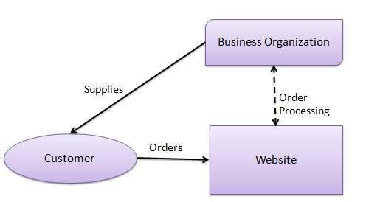
FIGURE:- B2C COMMUNICATION
- Consumer-to-Consumer (C2C)
Consumer-to-Consumer (C2C) type e-commerce encompasses all electronic transactions of goods or services conducted ​​between consumers. Generally, these transactions are conducted through a third party, which provides the online platform where the transactions are actually carried out.
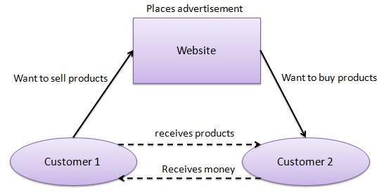
FIGURE:- C2C COMMUNICATION.
- Consumer-to-Business (C2B)
In C2B there is a complete reversal of the traditional sense of exchanging goods. This type of e-commerce is very common in crowd sourcing based projects. A large number of individuals make their services or products available for purchase for companies seeking precisely these types of services or products.
Examples of such practices are the sites where designers present several proposals for a company logo and where only one of them is selected and effectively purchased. Another platform that is very common in this type of commerce are the markets that sell royalty-free photographs, images, media and design elements, such as Stock photo.
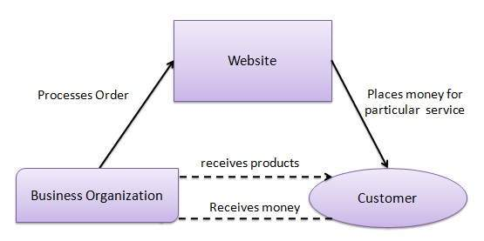
FIGURE:- C2B COMMUNICATION
- Business-to-Administration (B2A)
This part of e-commerce encompasses all transactions conducted online between companies and public administration. This is an area that involves a large amount and a variety of services, particularly in areas such as fiscal, social security, employment, legal documents and registers, etc. These types of services have increased considerably in recent years with investments made in e-government.
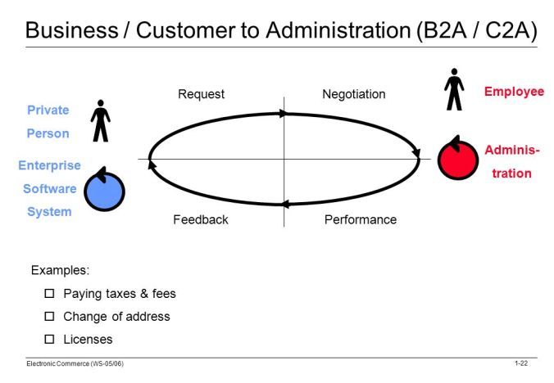
FIGURE:- B2A/C2A COMMUNICATION

- Consumer-to-Administration (C2A)
The Consumer-to-Administration model encompasses all electronic transactions conducted between individuals and public administration.
Examples of applications include:
Education – disseminating information, distance learning, etc.
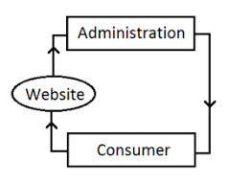
Social Security – through the distribution of information, making payments, etc.
Taxes – filing tax returns, payments, etc.
Health – appointments, information about illnesses, payment of health services, etc.
Both models involving Public Administration (B2A and C2A) are strongly associated to the idea of efficiency and easy usability of the services provided to citizens by the government, with the support of information and communication technologies.

Basic requirements of e-Commerce
The rise of mobile shopping and ecommerce has spawned a multi-billion dollar industry. If your small business is ready to get a piece of the action and begin selling your products online, pay extra attention to the following:
Brand Identity
Your page should immediately shout who you are and what you offer, so customers know they’ve come to the right place. Your company logo and colors promote recognition and trust: customers who are familiar with your brand will feel more comfortable on your site.

Customer Experience
The goal of your ecommerce website is to drive customers to conversion, therefore, everything about your ecommerce site should be user-oriented. While online shoppers have gotten pretty savvy, you still need to compensate for the fact that visitors cannot physically touch or interact with your products. You should have multiple, high-quality images of your product offerings and a section for customer reviews and expert recommendations from third-party sources.
Search Bar
The search bar should always be in the same place so it’s easy to find. A common home for the search bar is in the upper right corner. If you can, use suggestive search to offer items similar to (or accessories for) whatever’s being searched. Also, use corrective search so if someone misspells a word they’ll see a suggested selection instead of an error message.
User-Friendly Design
People love shopping on Amazon because (in addition to having pretty much everything) the site is incredibly easy to use. There are multiple ways to find what you are looking for and the buying process is completely intuitive. While you probably don’t have the funds to build as sophisticated a platform as they have, you can make the most out of what you do possess. Invest in quality search functionality and avoid overcomplicating things with unnecessary features.
Marketing Support
Your ecommerce site may be beautifully designed, but it’s worthless if it doesn’t draw traffic. Complement your ecommerce design efforts with appropriate marketing plans. Cultivate a healthy social media presence and research which SEO methods may be right for your business.
How To Build A Culture Of High Expectations
Smart Shopping Cart & Streamlined Payment System
Every ecommerce site needs a way to capture online payments easily and instantly. If you don’t provide a simple, streamlined payment system, potential customers will shop elsewhere. Invest in solid software that allows you to integrate online, retail, and mobile payments into a single system. Further, your shopping cart should remain intact so your customer doesn’t have to start shopping all over again if she steps off your page momentarily. Nearly a quarter of shoppers will leave their cart to come back later, sometimes on a different device, to make the purchase.
Make Customer Service a Priority
The best way to keep your online customers satisfied, and to make sure that your brand doesn’t lose any value, is to invest significantly in customer service. Depending on who you are, the lack of face-to-face interaction with customers is a significant drawback to online shopping experiences, be sure to offer online shoppers multiple ways to contact you, and support each of those channels with helpful and prompt service.
The future of commerce is digital. Even if your brick and mortar storefront is thriving, don’t miss the opportunity to establish your brand online. Giving special consideration to these elements will create a strong foundation for digital success.

10 Key Ecommerce Website Requirements and Essential Features

1. Enhanced Shopping Cart
Fact: “More than 74% of online shoppers abscond before completing an online transaction due to complex check-out process”
Unexpected costs like extra shipping or taxes, lengthy check-out process, security-related issue and unclear returns policy make things complex.
Requirement: Having a simple navigation page helps identify and organize your buyers’ products easily. You can also use a guest checkout option to enable a fast and easy checkout process. Moreover, implementing Security Badges like SSL certificate increases the user trust in your brand.
Feature: An enhanced shopping cart with a secured single page check-out avoids complexity and improves customer conversion rate.

2. Flexible Return Policy
Fact: “42% of online shoppers have returned an item they bought online and also 63% of online shoppers said that they would not purchase if they couldn’t find the return policy.”
There’s no way to avoid returning the product. After all, people can’t see, touch, or try the products before they buy them—they’re making their decision based on your product’s photography, description and reviews.
Sometimes the product won’t work out as expected, and there is always the possibility of a manufacturing defect or damage during the delivery process.
Requirement: There should be an easy way for the customers to return or exchange an item they are not happy with.
Feature: Make your return policy easy to find and understand. Drafting a flexible and trustworthy return policy can boost sales.

3. Mobile-Friendly Website
Fact: “Mobile commerce sales comprised 63.5% of the total sales in ecommerce in 2018.”
The increasing mobile phone usage has had a massive impact on the growth of ecommerce as it allows consumers to instantly make purchases wherever they may be.
Requirement: Ecommerce stores that are not optimized for mobile devices force your customers to zoom in and out to because of improper visualization while navigating to another page. So, it is highly recommended to optimize your site for mobile phones, tablets, etc.
Feature: Creating a mobile-friendly website and using responsive design is one of the best ways to drive more mobile traffic to your site.

4. Highly Customizable Themes
Fact: “38% of people will leave a website if they find the layout unattractive or too difficult to use.”
Always the appearance makes your brand stand out from other brands, so it’s necessary to have high-quality customizable themes and templates.
Requirement: Themes must support the website owners to edit the content of the products and manage the portfolios. It should include blog posts to promote the product. Also, it should reflect the product niche or business vertical.
Feature: Customizable themes will help save time and money while building your online store. Since custom themes include all the essential features, more functionalities can be added depending on the need.

5. Content management system
Fact: “Nearly 55% of marketers’ top priority will be blog content creation.”
Nowadays, customers want to know and interact with the brand at multiple touchpoints. They also want to know the story behind the creation of the brand.
Requirements: Blogging and product description help buyers learn about products and platforms in a detailed manner. So, it’s necessary for you to provide a highly clear and relevant content about the product.
Feature: Content management system allows your customers to know about the story behind your brand creation.

6. Email Marketing tools
Fact: “86% of professionals prefer to use email when communicating for business purposes and 75% of Gmail users access their emails on a mobile device.”
Email marketing remains one of the most important and effective ways for a business to connect with customers.
Requirements: Frequent communication with the customers helps to make them continue shopping on your site for a long time. Sometimes sending individual promotion emails with an item related to their ordered history will maximize the chance of buying that product.
Feature: Since personalized emails bring more customer conversion rate, having an integrated email marketing tool will be a handy solution.

7. Social media integration
Fact: “30% of online shoppers say they would be likely to purchase from a social media network like Facebook, Pinterest, Instagram, Twitter or Snapchat.”
Today, social media platforms have become an integral part of the success behind every business.
Requirement: One of the easiest ways of reaching customers is through social media. Your social media pages should be integrated into your website to allow promoting your products through posts, and personalized messages.
Feature: Using the in-built social media integration tool is the easiest and cost-effective way to promote products to a large group of audience.

8. Third-party shipment integration
Fact: “More than three-quarters of online shoppers would like their orders shipped on the same day.”
Most of the customer expects no shipping charge or less shipping charges and expect trusted delivery services.
Requirement: Once customers placed their order, there should be detailed information regarding the shipment which includes delivery time, order status, and documentation like invoice and bills. Shipment services must provide continuous tracking and frequent communication regarding any new update.
Feature: When the store provides seamless shipping and fast delivery, the customer will like to use the services frequently. Integrating third-party shipment providers that offer dedicated service in your target market is the best option.

9. Customer Support and Interface
Fact: “When it comes to making a purchase, 64% of customers find customer experience more important than price.”
According to the Guardian, by 2020, the quality of customer experience provided by a brand will be more important than price and product as a key differentiator.
Requirements: To engages and retain customers on your website, there should be an intuitive user interface that can provide your clients with a fast and convenient shopping experience.
Feature: Good customer experience helps to retain your existing buyers and increase sales. Providing an easy-to-use interface will let your customers get immediate support when needed.

10. Product comparison and user-generated reviews
Facts: “46% of consumers want product comparisons and 42% of customers want more testimonials. Along those same lines, 69% of online shoppers want more reviews.”
Customers are more likely to purchase a product if they know how to use it or know how it worked for others.
Requirement: To make shopping a fruitful experience, it is necessary to provide additional information beyond product descriptions. So, it is necessary to have detailed and effective testimonials about the product along with the existing user’s review and comment on the product.

