FUNDAMENTAL OF E-COMMERCE
UNIT-4
BBA- N (606)

ELECTRONIC DATA INTERCHANGE
Electronic data interchange (EDI) is the concept of businesses communicating electronically certain information that was traditionally communicated on paper. The two classic examples of such information are purchase orders and invoices. Standards for EDI exist to facilitate parties transacting such instruments without having to make special arrangements.
EDI has existed for more than 30 years, and there are many EDI standards (including X12, EDIFACT, ODETTE, etc.), some of which address the needs of specific industries or regions. It also refers specifically to a family of standards.
In 1996, the National Institute of Standards and Technology defined electronic data interchange as “the computer-to-computer interchange of strictly formatted messages that represent documents other than monetary instruments.
EDI implies a sequence of messages between two parties, either of whom may serve as originator or recipient. The formatted data representing the documents may be transmitted from originator to recipient via telecommunications or physically transported on electronic storage media.” It distinguishes mere electronic communication or data exchange, specifying that “in EDI, the usual processing of received messages is by computer only.
Human intervention in the processing of a received message is typically intended only for error conditions, for quality review, and for special situations. For example, the transmission of binary or textual data is not EDI as defined here unless the data are treated as one or more data elements of an EDI message and are not normally intended for human interpretation as part of online data processing.EDI can be formally defined as the transfer of structured data, by agreed message standards, from one computer system to another without human intervention.

COMPONENTS OF EDI
The following components and tools are necessary for performing EDI ARE-
- Trade Agreement
A legally binding trade agreement between you and your trading partner.
- Standard Document Format
The standard agreed upon format for the document to be electronically transmitted.
- EDI Translation Management Software
Software used to convert the document from your application’s format into the agreed upon standard format. For optimum performance the translation software should be on the same platform as your business application.
- Communications Software
A programming tool that enables you to write communications protocols, or a separate application. It can be a module to the translator or a separate software application.
- Modem
A hardware device used to transmit electronic information between computer systems. The higher the baud rate, the faster the communications will be.
- VAN
Stands for Value Added Network. A network to which you can connect to transmit data from one computer systems to another. One network can act as agate way to another.
- Point-to-Point
A direct communication link from one computer to another. Some trading partners offer a direct connection to their EDI computer. Trading partners may opt for this method of communication instead of using a VAN.

ADVANTAGES OF EDI
- Save Money
The cost of paper and paper processing is incredibly high compared to a properly implemented EDI program. RJR Nabisco estimates that processing a paper purchase order costs the company $70. Processing an EDI purchase order reduces the cost to amere 93 cents.
- End Repetition
If your trading partner wants a copy of a document, instead of calling you they simply check their mailbox. This results in a great time savings from not having to copy and fax/mail copies of business documents.
- Save Time
EDI also saves time over paper processing since the transfer of information from computer to computer is automatic. There is no need to rekey information with EDI. And the chance for error drops to near zero, with no data entry.

EDI COMMUNICATION PROCESS
By moving from a paper-based exchange of business document to one that is electronic, businesses enjoy major benefits such as reduced cost, increased processing speed, reduced errors and improved relationships with business partners. Learn more about the benefits of EDI here.
Each term in the definition is significant
Computer-to-computer– EDI replaces postal mail, fax and email. While email is also an electronic approach, the documents exchanged via email must still be handled by people rather than computers. Having people involved slows down the processing of the documents and also introduces errors. Instead, EDI documents can flow straight through to the appropriate application on the receiver’s computer (e.g., the Order Management System) and processing can begin immediately. A typical manual process looks like this, with lots of paper and people involvement:
Manual EDI (Electronic Data Interchange) Document Exchange
The EDI process looks like this — no paper, no people involved:
EDI (Electronic Data Interchange) Document Exchange
Business documents – These are any of the documents that are typically exchanged between businesses. The most common documents exchanged via EDI are purchase orders, invoices and advance ship notices. But there are many, many others such as bill of lading, customs documents, inventory documents, shipping status documents and payment documents.
Standard format– Because EDI documents must be processed by computers rather than humans, a standard format must be used so that the computer will be able to read and understand the documents. A standard format describes what each piece of information is and in what format (e.g., integer, decimal, mmddyy). Without a standard format, each company would send documents using its company-specific format and, much as an English-speaking person probably doesn’t understand Japanese, the receiver’s computer system doesn’t understand the company-specific format of the sender’s format.
There are several EDI standards in use today, including ANSI, EDIFACT, TRADACOMS and ebXML. And, for each standard there are many different versions, e.g., ANSI 5010 or EDIFACT version D12, Release A. When two businesses decide to exchange EDI documents, they must agree on the specific EDI standard and version.
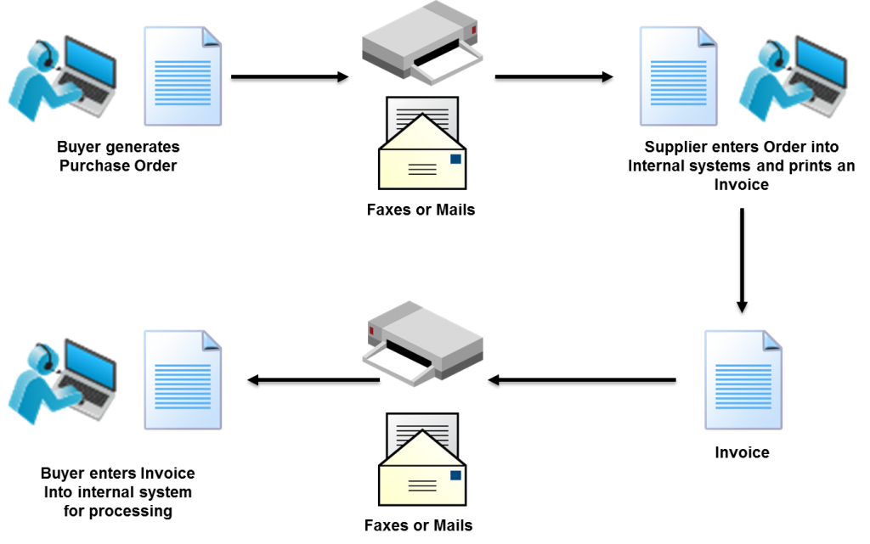
Businesses typically use an EDI translator – either as in-house software or via an EDI service provider – to translate the EDI format so the data can be used by their internal applications and thus enable straight through processing of documents.
Business partners – The exchange of EDI documents is typically between two different companies, referred to as business partners or trading partners. For example, Company A may buy goods from Company B. Company A sends orders to Company B. Company A and Company B are business partners.

Steps the Sender Must Take:
Document Preparation
Information necessary to produce a business document (purchase order, invoice, etc.) is collected in an electronic file.

Outbound Translation
The electronic file is converted by the sender’s translation software into the standard format (following ASC X12 standards and Rail Industry Guidelines).

Outbound Communication
The sender’s computer connects to a VAN. Upon successful receipt, the VAN processes and routes the transaction to the electronic mailbox of the receiver.

Steps the Receiver Must Take:
Inbound communication
The receiver’s computer connects with the VAN and receives any files waiting in its electronic “in” box.
Inbound translation
The receiver’s translation software “maps” or translates the electronic file from the ASC X12 standard message format into a format that the receiver’s internal system can understand.
Document processing
The receiver’s internal document processing system takes over and the newly received document is handled according to normal internal procedures.
Several common EDI formats are listed below:
- cXML.
- xCBL.
- ebXML.
- CSV.
- ANSI X12.
- EDIFACT.
- EDIFICE (Information Technology)
- EDITRANS (Transportation)
- ETIS (Telecommunications)

Types of EDI
Below is an outline of the different methods available:

Direct EDI/Point-to-point
Brought to prominence by Wal-Mart, direct EDI, sometimes called point-to-point EDI, establishes a single connection between two business partners. In this approach, you connect with each business partner individually. It offers control for the business partners and is most commonly used between larger customers and suppliers with a lot of daily transactions.

EDI via VAN
Value Added Networks (VANs) are private networks where electronic business documents are exchanged between partners. The VAN provider manages the network and provides companies with mailboxes where they can send and receive EDI documents.

EDI via AS2
AS2 is an Internet communications protocol that enables data to be transmitted securely over the Internet. EDI via AS2 delivers the functionality of EDI with the ubiquity of Internet access.
.

Web EDI
Unlike EDI via AS2, Web EDI conducts EDI using a standard Internet browser. Organisations use different online forms to exchange information with business partners. Web EDI makes EDI easy and affordable for small- and medium-sized organisations and companies that have only occasional need to utilise such a service.

Mobile EDI
Users have commonly accessed EDI either by a private network such as Value Added Network or the Internet in order to send and receive EDI-related business documents. Mobile EDI has had limited adoption, in part due to security concerns with mobile devices across an EDI infrastructure, but mainly due to the mobile devices themselves. The quality and size of the screen of most devices has been relatively poor until recently. There is a growing industry for developing software applications or ‘apps’ for downloading onto mobile devices and it will be only be a matter of time before you will be able to download supply chain and EDI related apps from private or corporate app stores.

EDI Outsourcing
EDI Outsourcing (also referred to as Managed Services) is a fast-growing option that enables companies to use external resources to manage their EDI environment on a day-to-day basis. This is in part driven by companies wanting to integrate to back office business systems such as Enterprise Resource Planning (ERP) platforms. Many companies do not have the internal resources to undertake this type of work so they outsource it instead.

