UNIT - I

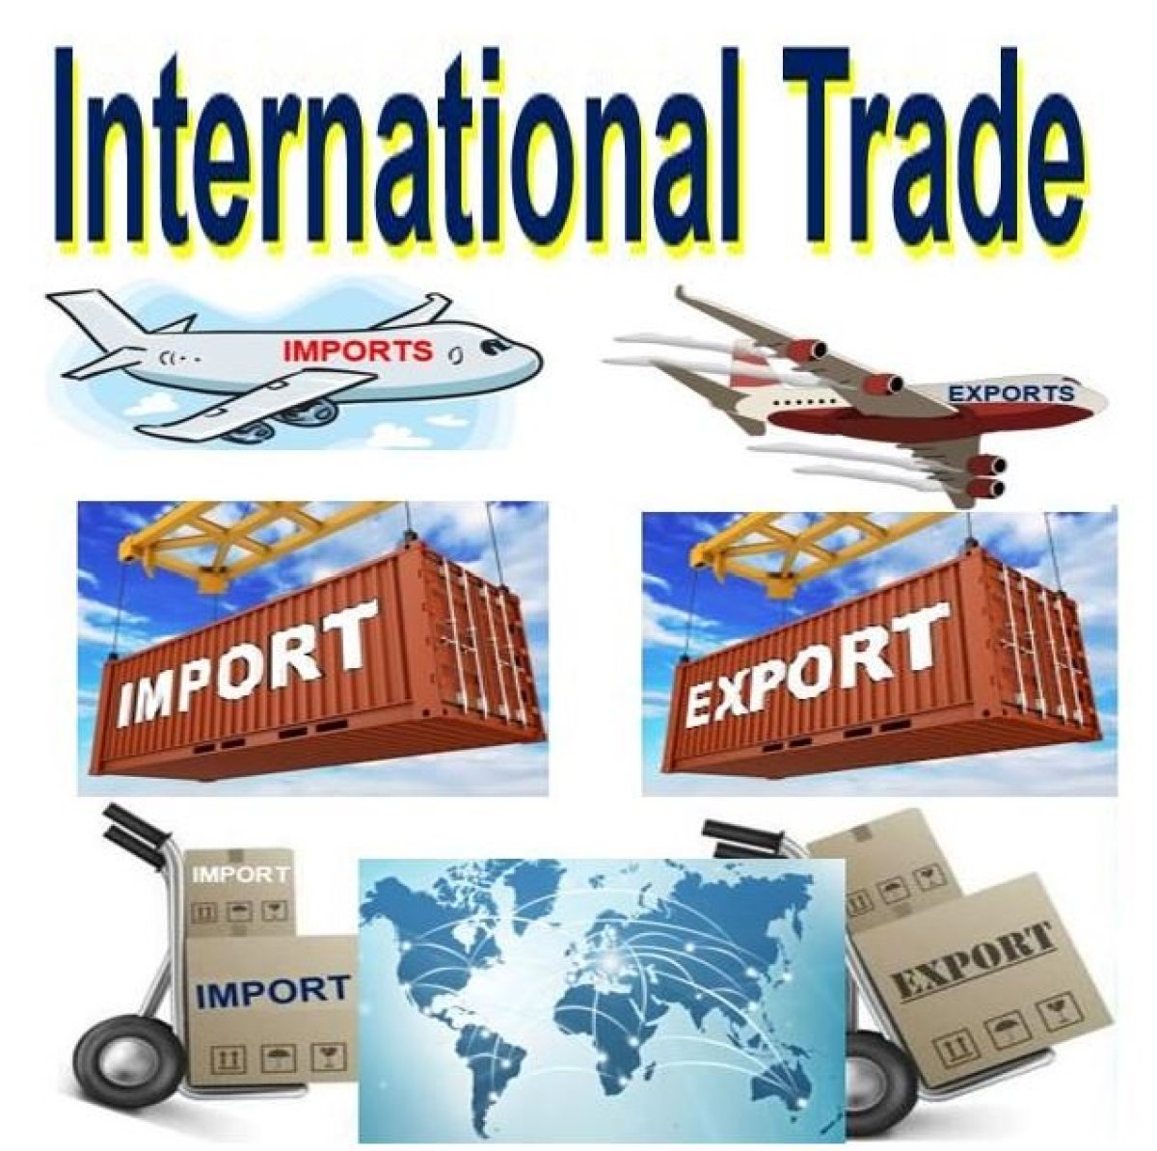

Meaning and Definition of Foreign Trade or International Trade

Foreign trade is exchange of capital, goods, and services across international borders or territories. In most countries, it represents a significant share of gross domestic product (GDP). While international trade has been present throughout much of history, its economic, social, and political importance has been on the rise in recent centuries.
All countries need goods and services to satisfy wants of their people. Production of goods and services requires resources. Every country has only limited resources. No country can produce all the goods and services that it requires. It has to buy from other countries what it cannot produce or can produce less than its requirements. Similarly, it sells to other countries the goods which it has in surplus quantities. India too, buys from and sells to other countries various types of goods and services.
International trade means trade between the two or more countries. International trade involves different currencies of different countries and is regulated by laws, rules and regulations of the concerned countries. Thus, International trade is more complex.
According to Wasserman and Haltman, “International trade consists of transaction between residents of different countries”.
According to Anatol Marad, “International trade is a trade between nations”.
According to Eugeworth, “International trade means trade between nations”.
Industrialization, advanced transportation, globalization, multinational corporations, and outsourcing are all having a major impact on the international trade system. Increasing international trade is crucial to the continuance of globalization. Without international trade, nations would be limited to the goods and services produced within their own borders.

Features of International Trade

The following are the distinguishing features of international trade:

(1) Immobility of Factors: The degree of immobility of factors like labour and capital is generally greater between countries than within a country. Immigration laws, citizenship, qualifications, etc. often restrict the international mobility of labour.

(2) Heterogeneous Markets: In the international economy, world markets lack homogeneity on account of differences in climate, language, preferences, habit, customs, weights and measures, etc. The behaviour of international buyers in each case would, therefore, be different.

(3) Different National Groups:
International trade takes place between differently cohered groups. The socio-economic environment differs greatly among different nations.
(4) Different Political Units: International trade is a phenomenon which occurs amongst different political units.

(5) Different National Policies and Government Intervention: Economic and political policies differ from one country to another. Policies pertaining to trade, commerce, export and import, taxation, etc., also differ widely among countries though they are more or less uniform within the country. Tariff policy, import quota system, subsidies and other controls adopted by governments interfere with the course of normal trade between one country and another.

(6) Different Currencies: Another notable feature of international trade is that it involves the use of different types of currencies. So, each country has its own policy in regard to exchange rates and foreign exchange.

Advantages of International Trade:

The following are the major gains claimed to be emerging from international trade:

(1) Optimum Allocation: International specialisation and geographical division of labour leads to the optimum allocation of world’s resources, making it possible to make the most efficient use of them.

(2) Gains of Specialisation: Each trading country gains when the total output increases as a result of division of labour and specialisation. These gains are in the form of more aggregate production, larger number of varieties and greater diversity of qualities of goods that become available for consumption in each country as a result of international trade.

(3) Enhanced Wealth: Increase in the exchangeable value of possessions, means of enjoyment and wealth of each trading country.

(4) Larger Output: Enlargement of world’s aggregate output.

(5) Welfare Contour: Increase in the world’s prosperity and economic welfare of each trading nation.

(6) Cultural Values: Cultural exchange and ties among different countries develop when they enter into mutual trading.

(7) Better International Politics: International trade relations help in harmonising international political relations.

(8) Dealing with Scarcity: A country can easily solve its problem of scarcity of raw materials or food through imports.

(9) Advantageous Competition: Competition from foreign goods in the domestic market tends to induce home producers to become more efficient to improve and maintain the quality of their products.

(10) Larger size of Market: Because of foreign trade, when a country’s size of market expands, domestic producers can operate on a larger scale of production which results in further economies of scale and thus can promote development. Synchronised application of investment to many industries simultaneously become possible. This helps industrialisation of the country along with balanced growth.

Disadvantages of International Trade

When a country places undue reliance on foreign trade, there is a likelihood of the following disadvantages:

1. Exhaustion of Resources: When a country has larger and continuous exports, her essential raw materials and minerals may get exhausted, unless new resources are tapped or developed (e.g., the near-exhausting oil resources of the oil-producing countries).

2. Blow to Infant Industry: Foreign competition may adversely affect new and developing infant industries at home.

3. Dumping: Dumping tactics resorted to by advanced countries may harm the development of poor countries.

4. Diversification of Savings: A high propensity to import may cause reduction in the domestic savings of a country. This may adversely affect her rate of capital formation and the process of growth.

5. Declining Domestic Employment: Under foreign trade, when a country tends to specialize in a few products, job opportunities available to people are curtailed.

6. Over Interdependence: Foreign trade discourages self-sufficiency and self-reliance in an economy. When countries tend to be interdependent, their economic independence is jeopardised. For instance, for these reasons, there is no free trade in the world. Each country puts some restrictions on its foreign trade under its commercial and political policies

International trade theory

Adam Smith and David Ricardo gave the classical theories of international trade.
According to the theories given by them, when a country enters in foreign trade, it benefits from specialization and efficient resource allocation.
The foreign trade also helps in bringing new technologies and skills that lead to higher productivity.
Theory of Mercantilism

Mercantilism is the term that was popularized by Adam Smith, Father of Economics, in his book, The Wealth of Nations. Western European economic policies were greatly dominated by this theory. The theory of mercantilism holds that countries should encourage export and discourage import.
It states that a country’s wealth depends on the balance of export minus import. According to this theory, government should play an important role in the economy for encouraging export and discouraging import by using subsidies and taxes, respectively. In those days, gold was used for trading goods between countries.
Thus, export was treated as good as it helped in earning gold, whereas, import was treated as bad as it led to the outflow of gold. If a nation has abundant gold, then it is considered to be a wealthy nation. If all the countries follow this policy, there may be conflicts, as no one would promote import. The theory of mercantilism believed in selfish trade that is a one-way transaction and ignored enhancing the world trade. Mercantilism was called as a zero-sum game as only one country benefitted from it.
Theory of Absolute Advantage

Given by Adam Smith in 1776, the theory of absolute advantage stated that a country should specialize in those products, which it can produce efficiently. This theory assumes that there is only one factor of production that is labor.
Adam Smith stated that under mercantilism, it was impossible for nations to become rich simultaneously. He also stated that wealth of the countries does not depend upon the gold reserves, but upon the goods and services available to their citizens.
Adam Smith wrote in The Wealth of Nations, ”If a foreign country can supply us with a commodity cheaper than we ourselves can make it, better buy it of them with some part of the produce of our own industry, employed in a way in which we have some advantage”.
He stated that trade would be beneficial for both the countries if country A exports the goods, which it can produce with lower cost than country B and import the goods, which country B can produce with lower cost than it.
An example can be used to prove this theory. Suppose there are two countries A and B, which produce tea and coffee with equal amount of resources that is 200 laborers. Country A uses 10 laborers to produce 1 ton of tea and 20 laborers to produce 1 ton of coffee. Country B uses 25 units of laborers to produce tea and 5 units of laborers to produce 1 ton of coffee.
This is shown in Table
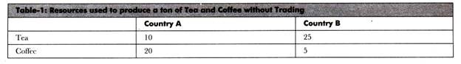
It can be seen from Table-2 that country A has absolute advantage in producing tea as it can produce 1 ton of tea by using less laborers as compared to country B. On the other hand, country B has absolute advantage in producing coffee as it can produce 1 ton of coffee by employing less laborers in comparison to country A.
Now, if there is no trade between these countries and resources (in this case there are total 200 laborers) are being used equally to produce tea and coffee, country A would produce 10 tons of tea and 5 tons of coffee and country B would produce 4 tons of tea and 20 tons of coffee. Thus, total production without trade is 39 tons (14 tons of tea and 25 tons of coffee).
Table shows the production without the trade between country A and country B:
If both the countries trade with each other and specialize in goods in which they have absolute advantage, the total production would be higher. Country A would produce 20 tons of tea with 200 units of laborers; whereas, country B would produce 40 tons of coffee with 200 units of laborers. Thus, total production would be 60 units (20 tons of tea and 40 tons of coffee).
The production of tea and coffee after trade is shown in Table-
Without specialization, total production of countries was 39 tons, which becomes 60 tons after specialization. Therefore, the theory of absolute advantages shows that trade would be beneficial for both the countries.

Theory of Comparative Advantage

Many questions may come in mind after reading the absolute advantage theory that what would happen if a country has absolute advantage in all the products or no absolute advantage in any of the product. How such a country would benefit from trade? The answers of these questions was given by David Ricardo in his theory of comparative advantage, which states that trade can be beneficial for two countries if one country has absolute advantage in all the products and the other country has no absolute advantage in any of the products.
According to Ricardo, “…a nation, like a person, gains from the trade by exporting the goods or services in which it has its greatest comparative advantage in productivity and importing those in which it has the least comparative advantage. ”
This theory assumes that labor as the only factor of production in two countries, zero transport cost, and no trade barriers within the countries. Let us understand this theory with the help of an example.
Suppose there are two countries A and B, producing two commodities wheat and wine with labor as the only factor of production. Now assume that both the countries have 200 laborers and they use 100 laborers to produce wheat and 100 laborers to produce wine.
Table shows the production of wheat and wine in Country X and Country Y before trade:
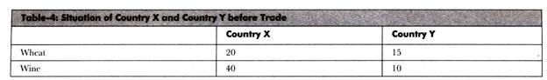
Table-4 depicts that country X can produce 20 units; whereas, country Y can produce 15 units of wheat by using 100 laborers. In addition, country X can produce 40 units; whereas, country’ Y can produce 10 units of wine by employing 100 laborers.
Thus, country X has absolute advantage in producing both the products. As already discussed, country X employs same number of laborers (100 laborers in production of each good) in producing both wine and wheat; however, the production of wine is more than the production of wheat.
It shows that country’ X has comparative advantage in producing wine. Similarly, country Y also employs same number of laborers (100 laborers in production of each good) in manufacturing wheat and wine; however, its production of wheat is more than the wine. It indicates that country Y has comparative advantage in manufacturing wheat.
For example, country X has decided to produce 60 units of wine by employing 150 laborers. It uses 50 laborers to produce 10 units of wheat. On the other hand, country Y has decided to use all the 200 laborers to produce 30 units of wheat. It would not produce any unit of wine.
This data is represented in Table-
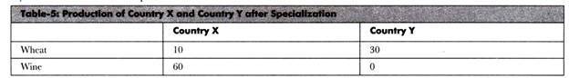
Now, country X exchanges 14 units of wine with 14 units of wheat produced by country Y.
The situation of both the countries after trade is shown in Table-
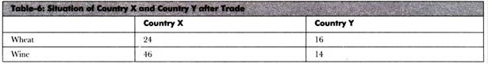
It can be observed from Table-6 that both the countries have gained from trade. Before trade, country X has 20 units of wheat and 40 units of wine; however, after trade, country Y has 24 units of wheat and 46 units of wine.
On the other hand, country Y has 15 units of wheat and 10 units of wine before trade; however, it has 16 units of wheat and 14 units of wine after trade. Therefore, comparative advantage explains that trade can create benefit for both the countries even if one country has absolute advantage in the production of both the goods.
Product Life Cycle Theory
In the 1970s, Raymond Vernon introduced the notion of using a product’s life cycle to explain global trade patterns, in the field of marketing. According to theory, as the demand for a newly created product grows, the home country starts exporting it to other nations. Where when the demand grows, local manufacturing plants are opened to meet the request. And the scenario covers the whole globe time to time, thus making that product a standardization.
You can take the example of computers in consideration to understand how this works. The earlier personal computers appeared in 1970’s available only in a few countries and from 1980’s to 1990’s, the product was moving through the stage of maturity where the production spread to many other nations. And now in 21st century, every third house has a PC in it.
Global Strategic Rivalry Theory
The continuous evolutionary behavior of international trade theories brings us back in the 1980’s where Kalvin Lancaster and Paul Krugman introduced the concept of strategies, based on global level rivalries, targeting multinational corporations and the struggle needed in achieving higher advantages as compared to other international companies.
According to the concept, a new firm needs to optimize a few factors that will lead the brand in overcoming all the barriers to success and gaining an influential recognition in that global market. In all these factors, a thorough research and timed developmental steps are crucial. Whereas, having the complete ownership rights of intellectual properties is also necessary. Furthermore, the introduction of unique and useful methods for manufacturing as well as controlling the access to raw material will also come handy in the way.
National Competitive Advantage Theory
Michael Porter in 1990’s suggested that the success of any business in international trade depends on upgradable and innovational capacities of the industry as well as four other factors, which determine how that firm is going to perform in this global level race. The main concept behind this theory gives the feel of holding factor proportion as well as many other international trade theories in it.

Drivers of International Business

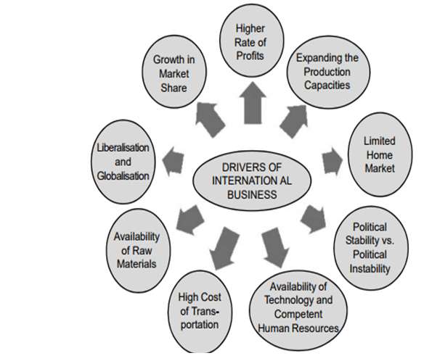
- Higher Rate of Profits: The basic objective of the business is to achieve profits. When the domestic markets don’t promise a higher rate of profits, business firms search for foreign markets where there is a scope for a higher rate of the profits. Therefore the objective of profit affects & motivates the business to expand operations to the foreign countries. For example, Hewlett Packard in the USA earns more than half of its profits from the foreign markets as compared to that of domestic markets.
- Expanding the Production Capacities beyond the Demand of Domestic Country: Some of the domestic companies expand their production capacities more than the demand for the product in the domestic countries. In such cases, these companies are forced to sell their extra production in foreign developed countries. Toyota of Japan is an example.
- Limited Home Market: When a size of the home market is limited either due to the smaller size of the population or due to the lower purchasing power of all people or both, the companies internationalize their operations. For example, most of the Japanese automobiles & electronics firms entered the USA, Europe & even African markets due to the smaller size of the home market. ITC entered the European market due to the lower purchasing power of the Indians with regard to high-quality cigarettes.
- Political Stability vs. Political Instability: The Political stability doesn’t simply mean that the continuation of the same party in power, but it means that continuation of the same policies of the Government for a quite long period. It is viewed that the USA is a politically stable country; countries like the UK, France, Germany, Italy & Japan are also politically stable. Most of the African countries & some of the Asian countries are politically unstable countries. Business firms prefer to enter the politically stable countries & are restrained from locating their own business operations in politically unstable countries. In fact, business firms shift their operations from politically unstable countries to politically stable countries.
- Availability of Technology & Competent Human Resources: The Availability of advanced technology & competent human resources in some countries act like pulling factors for business firms from other countries. For example, American & European companies, in recent years, have been depended on Indian companies for the software products & the services through their business process outsourcing (BPO). This is due to the cost of human resources in India is almost/approximately 10 to 15 times less compared to the US & European labor markets.
- High Cost of Transportation: Initially the companies enter foreign countries for their marketing operations. But the home companies in any country enjoy their higher profit margins as compared to the foreign firms on account of the cost of transportation of the products. Under such conditions, the foreign companies are inclined to increase their profit margin by locating their manufacturing facilities in foreign countries through Foreign Direct Investment (FDI) route to satisfy the demand of either one of the countries or the group of neighboring countries. For example, Mobil which was supplying petroleum products to Ethiopia, Kenya, Eritrea, Sudan etc., from its refineries in Saudi Arabia, established its refinery facilities in Eritrea in order to reduce the cost of transportation.
- Availability of Raw Materials: The source of highly qualitative raw materials & bulk raw materials is a major factor in attracting companies from various foreign countries. For example, Vedanta Resources is a London Stock Exchange (LSE) listed UK based company operating principally in India due to the availability of raw materials such as iron ore, copper, zinc & lead.

Benefits of International Business

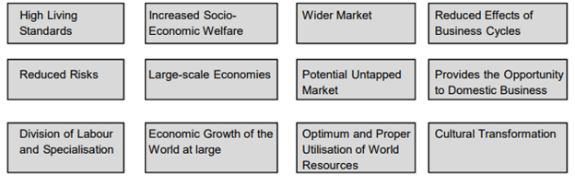
- High Living Standards: Comparative cost theory indicates that the countries which have the advantages of raw materials, human resources, natural resources & climatic conditions in producing particular goods can produce the products at low-cost & also of high quality. Customers in various countries can buy more products with the same amount of money. In turn, it can also enhance the living standards of the people through enhanced purchasing power & by consuming high-quality products.
- Increased Socio-Economic Welfare: International business enhances consumption level, the economic welfare of the people of the trading countries. For example, the people of China are now enjoying a variety of products from various countries like Coca-Cola, McDonald’s range of products, electronic products of Japan & coffee from Brazil. Thus the Chinese consumption levels & socio-economic welfare has enhanced.
- Wider Market: International business widens the market &increases the market size. Therefore, the companies need not depend on the demand for the product in a single country or customer’s tastes & the preferences of a single country. Due to the enhanced market Air France now mostly depends on the demand for air travel of the customers from the countries other than France. This is factual in case of most of the MNCs like Toyota, Honda, Xerox & Coca-Cola.
- Reduced Effects of Business Cycles: The stages of the business cycles vary from country to country. Therefore, MNCs shift from the country experiencing a recession to the country experiencing ‘boom’ conditions. This enables international firms to escape recessionary conditions.
- Reduced Risks: Both commercial & political risks are reduced for the companies engaged in the international business due to spread in the different countries. Multinationals which were operating in erstwhile USSR were affected only partly due to their safer operations in other countries. But the domestic companies of the then USSR collapsed entirely.
- Large-scale Economies: Multinational companies due to wider &larger markets produce larger quantities, which provide the benefits of large-scale economies like reduced cost of production, availability of expertise, quality etc.
- Potential Untapped Markets: International business provides the chance of exploring & exploiting the potential markets which are untapped so far. These markets provide an opportunity for selling the product at a higher price than in the domestic markets. For example, Bata sells shoes in the UK at £ 100 (approx. Rs. 8000) whose price is around Rs. 1200 in India.
- Provides the Opportunity to Domestic Business: International Business firms provide opportunities for domestic companies. These opportunities comprise technology, management expertise, market intelligence, product developments, etc. For example, Japanese firms like Honda, Yamaha, and Suzuki & Kawasaki have a combined to form Joint Ventures with Indian companies to form a Hero Honda, Birla Yamaha, Maruti Suzuki & Kawasaki Bajaj to share the technology & the product development expertise.
- Division of Labour & Specialization: International business leads to division of labor &specialization. For example, Brazil specializes in coffee, Kenya in tea, Japan in automobiles & electronics, India in textile garments etc.
- Economic Growth of the World at large: Specialization, a division of labor, enhancement of productivity, posing challenges, development to meet them, innovations & creations to meet the competition leads to the overall economic growth of the world nations. The International business particularly helped the Asian countries like Japan, Taiwan, Korea, Philippines, Singapore, Malaysia & the United Arab Emirates.
- Optimum & Proper Utilization of World Resources: the international business provides for the flow of the raw materials, natural resources & human resources from the countries where they are in excess supply to those countries where they are in short supply or need most. For example the flow of human resources from India, consumer goods from the UK, France, Italy & Germany to developing countries. This, in turn, helps in the optimum & proper utilization of world resources.
- Cultural Transformation: International business benefits are not purely economic or commercial; they are even social &cultural. These days, we observe that the West is slowly tending towards the East & vice versa. It does mean that the good cultural factors & values of the East are acquired by the West & vice versa. Therefore there is a close cultural transformation & integration.

RESTRAINING FORCES OF INTERNATIONAL TRADE
1.Distance:
Due to long distance between different countries, it is difficult to establish quick and close trade contacts between traders. Buyers and sellers rarely meet one another and personal contact is rarely possible.
There is a great time lag between placement of order and receipt of goods from foreign countries. Distance creates higher costs of transportation and greater risks.
2. Different languages:
Different languages are spoken and written in different countries. Price lists and catalogs are prepared in foreign languages. Advertisements and correspondence also are to be done in foreign languages.
A trader wishing to buy or sell goods abroad must know the foreign language or employ somebody who knows that language.
3. Difficulty in transportation and communication:
Dispatch and receipt of goods takes a longer time and involves considerable expenses. During the war and natural calamities, transportation of goods becomes even more difficult. Similarly, the costs of sending or receiving information are very high.
4. Risk in transit:
Foreign trade involves much greater risk than home trade. Goods have to be transported over long distances and they are exposed to perils of the sea. Many of these risks can be covered through marine insurance but increases the cost of goods.
5. Lack of information about foreign businessmen:
In the absence of direct and close relationship between buyers and sellers, special steps are necessary to verify the creditworthiness of foreign buyers. It is difficult to obtain reliable information concerning the financial position and business standing of the foreign traders. Therefore, credit risk is high.
6. Import and export restrictions:
Every country charges customs duties on imports to protect its home industries. Similarly, tariff rates are put on exports of raw materials. Importers and exporters have to face tariff restrictions.
They are required to fulfill several customs formalities and rules. Foreign trade policy, procedures, rules and regulations differ from country to country and keep on changing from time to time.

7. Documentation:
Both exporters and importers have to prepare several documents which involve expenditure of time and money.
8. Study of foreign markets:
Every foreign market has its own characteristics. It has requirements, customs, weights and measures, marketing methods, etc., of its own. An extensive study of foreign markets is essential for success in foreign trade. It is very difficult to collect accurate and up to date information about foreign markets.
9. Problems in payments:
Every country has its own currency and the rate at which one currency can be exchanged for another (called exchange rate) keeps on fluctuating change in exchange rate create additional risk.
Remittance of money for payments in foreign trade involves much time and expense. Due to wide time gap between dispatch of goods and receipt of payment, there is greater risk of bad debts.
10. Frequent market changes:
It is difficult to anticipate changes in demand and supply conditions abroad. Prices in international markets may change frequently. Such changes are due to entry of new competitors, changes in buyers’ preferences, changes in import duties and freight rates, fluctuations in exchange rates, etc.

RECENT TRENDS IN WORLD TRADE

Current trends are towards the increasing foreign trade and interdependence of firms, markets and countries.

1) Forced Dynamism: International trade is forced to succumb to trends that shape the global political, cultural, and economic environment. International trade is a complex topic, because the environment it operates in is constantly changing. First, businesses are constantly pushing the frontiers of economic growth, technology, culture, and politics which also change the surrounding global society and global economic context. Secondly, factors external to international trade (e.g., developments in science and information technology) are constantly forcing international trade to change how they operate.

2) Cooperation among Countries: Countries cooperate with each other in thousands of ways through international organisations, treaties, and consultations. Such cooperation generally encourages the globalization of business by eliminating restrictions on it and by outlining frameworks that reduce uncertainties about what companies will and will not be allowed to do. Countries cooperate:

i) To gain reciprocal advantages,
ii) To attack problems they cannot solve alone, and
iii) To deal with concerns that lie outside anyone’s territory.
Agreements on a variety of commercially related activities, such as transportation and trade, allow nations to gain reciprocal advantages. For example, groups of countries have agreed to allow foreign airlines to land in and fly over their territories, such as Canada’s and Russia’s agreements commencing in 2001 to allow polar over flights that will save five hours between New York and Hong Kong.
Groups of countries have also agreed to protect the property of foreign-owned companies and to permit foreign-made goods and services to enter their territories with fewer restrictions. In addition, countries cooperate on problems they cannot solve alone, such as by coordinating national eco­nomic programs (including interest rates) so that global economic conditions are minimally disrupted, and by restricting imports of certain products to protect endangered species.
Finally, countries set agreements on how to commercially exploit areas outside any of their territories. These include outer space (such as on the transmission of television programs), non-coastal areas of oceans and seas (such as on exploitation of minerals), and Antarctica (for example, limits on fishing within its coastal waters).
3) Liberalization of Cross-border Movements:Every country restricts the movement across its borders of goods and services as well as of the resources, such as workers and capital, to produce them. Such restrictions make international trade cumbersome; further, because the restrictions may change at any time, the ability to sustain international trade is always uncertain. However, governments today impose fewer restrictions on cross-border movements than they did a decade or two ago, allowing companies to better take advantage of international opportunities. Governments have decreased restrictions because they believe that:
i) So-called open economies (having very few international restrictions) will give consumers better access to a greater variety of goods and services at lower prices,
ii) Producers will become more efficient by competing against foreign companies, and
iii) If they reduce their own restrictions, other countries will do the same.
4) Transfer of Technology: Technology transfer is the process by which commercial technology is disseminated. This will take the form of a technology transfer transaction, which may or may not be a legally binding contract, but which will involve the communication, by the transferor, of the relevant knowledge to the recipient. It also includes non-commercial technology transfers, such as those found in international cooperation agreements between developed and developing states. Such agreements may relate to infrastructure or agricultural development, or to international; cooperation in the fields of research, education, employment or transport.
5) Growth in Emerging Markets: The growth of emerging markets (e.g., India, China, Brazil, and other parts of Asia and South America especially) has impacted international trade in every way. The emerging markets have simultaneously increased the potential size and worth of current major international trade while also facilitating the emergence of a whole new generation of innovative companies. According to “A special report on innovation in emerging markets” by The Economist magazine, “The emerging world, long a source of cheap la, now rivals the rich countries for business innovation”.

