Financial & Management Accounting

Unit -2 (II)

Definition of Trading Account
In the income statement, trading account represents the first part, which is prepared to know the gross result, i.e. profit (loss) for the period. The account shows the outcome of trading activities, i.e. the profit earned or loss suffered on purchase or sale of goods.
The account consists of two sides; debit side indicates direct expenses and credit side is for direct incomes. Direct expenses which are incurred by the organization, to bring goods into the condition, fit for sale. Such expenses include fuel, power, freight, insurance, carriage inward, consumption of stores, etc. On the other hand, direct incomes refers to income from the activities that are earned from the sale of goods.

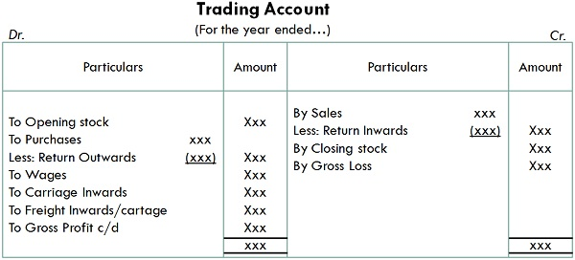
Definition of Profit & Loss Account
Profit and loss account is a part of the financial statement, which takes into account operating and non-operating revenues and expenses incurred, during an accounting period. It ascertains, net profit earned or loss sustained by the business.
Profit & Loss account is prepared after the preparation of trading account, with the help of trial balance. The balance of trading account is transferred to this account, which acts as the initial point, after which all expenses and losses are debited, and all incomes and gains are credited to this account.
When the debit side of the account exceed the credit side, it is a net loss, and when the credit side is more than the debit one, the result is net profit. The balance (net profit or net loss) is transferred to the capital account, on the balance sheet.

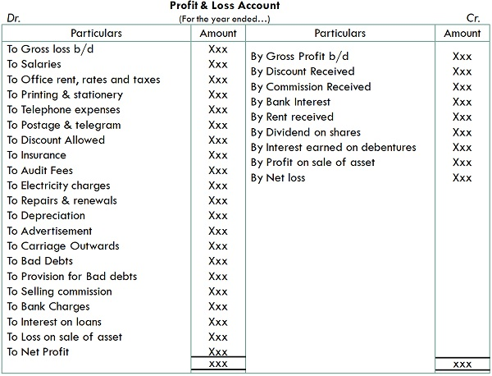
Balance Sheet
Balance Sheet is part of any financial statement which provides the financial condition on a given date. An entity’s balance sheet provides a lot of information which can be used to analyze the financial stability and business performance. The balance sheet is a report version of the accounting equation that is balance sheet equation where assets always equate liabilities plus shareholder’s capital. Investors and creditors generally look at the balance sheet and infer as to how efficiently a company can use its resources and how effectively it can finance them.

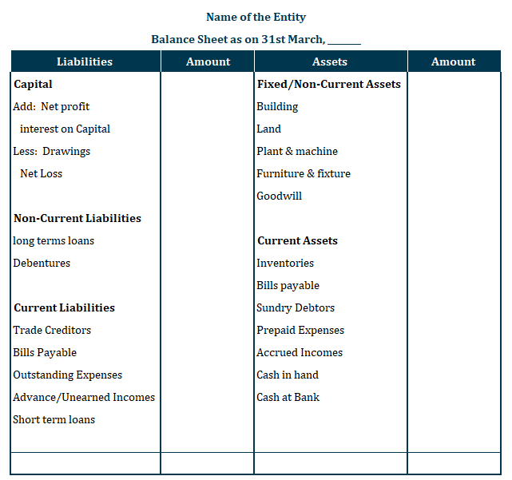

Illustration:-
The following balances were extracted from the books of Thomas as on 31st March, 2018

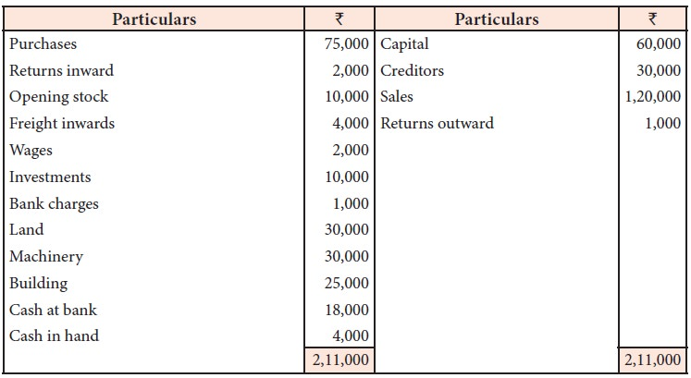

Additional information:
i. Closing stock Rs. 9,000
ii. Provide depreciation @ 10% on machinery
iii. Interest accrued on investment Rs. 2,000
Prepare trading account, profit and loss account and balance sheet.

Solution

