Financial & Management Accounting

Unit-5

Working Capital
In an ordinary sense, working capital denotes the amount of funds needed for meeting day-to-day operations of a concern.
This is related to short-term assets and short-term sources of financing. Hence it deals with both, assets and liabilities—in the sense of managing working capital it is the excess of current assets over current liabilities. In this article we will discuss about the various aspects of working capital.
The nature of working capital is as discussed below:
- It is used for purchase of raw materials, payment of wages and expenses.
- It changes form constantly to keep the wheels of business moving.
- Working capital enhances liquidity, solvency, creditworthiness and reputation of the enterprise.
- It generates the elements of cost namely: Materials, wages and expenses.
- It enables the enterprise to avail the cash discount facilities offered by its suppliers.
- It helps improve the morale of business executives and their efficiency reaches at the highest climax.
- It facilitates expansion programmes of the enterprise and helps in maintaining operational efficiency of fixed assets.

Concept of Working Capital:
The funds invested in current assets are termed as working capital. It is the fund that is needed to run the day-to-day operations. It circulates in the business like the blood circulates in a living body. Generally, working capital refers to the current assets of a company that are changed from one form to another in the ordinary course of business, i.e. from cash to inventory, inventory to work in progress (WIP), WIP to finished goods, finished goods to receivables and from receivables to cash.
There are two concepts in respect of working capital:
(i) Gross working capital and
(ii) Networking capital.
Gross Working Capital:
The sum total of all current assets of a business concern is termed as gross working capital. So,
Gross working capital = Stock + Debtors + Receivables + Cash.
Net Working Capital:
The difference between current assets and current liabilities of a business concern is termed as the Net working capital.
Hence,
Net Working Capital = Stock + Debtors + Receivables + Cash – Creditors – Payables.

Need for Working Capital:
Working capital plays a vital role in business. This capital remains blocked in raw materials, work in progress, finished products and with customers.

OPERATING CYCLE
The duration of time required to complete the sequence of events right from purchase of raw material / goods for cash to the realization of sales in cash is called the operating cycle, working capital cycle or cash cycle.
This cycle can be said to be at the heart of the need for working capital. In the words of O.M. Joy: “The operating cycle refers to the length of time necessary to complete the following cycle of events.”
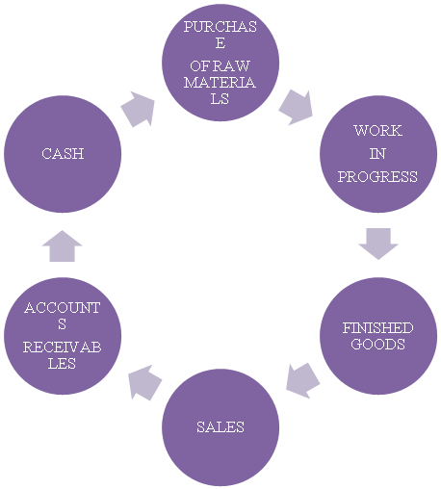
The above operating cycle in figure relates to a manufacturing firm where cash is needs to purchase raw materials and convert raw materials into work-in-process is converted into finished goods. Finished goods will be sold for cash or credit and ultimately debtors will be realized.

The needs for working capital are as given below:
- Adequate working capital is needed to maintain a regular supply of raw materials, which in turn facilitates smoother running of production process.
- Working capital ensures the regular and timely payment of wages and salaries, thereby improving the morale and efficiency of employees.
- Working capital is needed for the efficient use of fixed assets.
- In order to enhance goodwill a healthy level of working capital is needed. It is necessary to build a good reputation and to make payments to creditors in time.
- Working capital helps avoid the possibility of under-capitalization.
- It is needed to pick up stock of raw materials even during economic depression.
vii. Working capital is needed in order to pay fair rate of dividend and interest in time, which increases the confidence of the investors in the firm.

Importance of Working Capital:
It is said that working capital is the lifeblood of a business. Every business needs funds in order to run its day-to-day activities.
The importance of working capital can be better understood by the following:
- It helps measure profitability of an enterprise. In its absence, there would be neither production nor profit.
- Without adequate working capital an entity cannot meet its short-term liabilities in time.
- A firm having a healthy working capital position can get loans easily from the market due to its high reputation or goodwill.
- Sufficient working capital helps maintain an uninterrupted flow of production by supplying raw materials and payment of wages.
- Sound working capital helps maintain optimum level of investment in current assets.
- It enhances liquidity, solvency, credit worthiness and reputation of enterprise.

Assessment and Computation of Working Capital Requirement
In case of a small-scale enterprise, the important factors determining the requirements of working capital are as follows:

1. Sales:
Among the various factors, size of the sales is one of the important factors in determining the amount of working capital. In order to increase sales volume, the enterprise needs to maintain its current assets. In the course of period, the enterprise becomes in the position to keep a steady ratio of its current assets to annual sales. As a result, the turnover ratio, i.e., current assets to turnover increases reducing the length of operating cycle. Thus, less the operating cycle period, less will be requirements for working capital and vice versa.

2. Length of Operating Cycle:
Conversion of cash through various stages viz., raw material, semi-processed goods, finished goods, sales, debtors and bills receivables into cash takes a certain period of time that is known as ‘length of operating cycle’. Longer the operating cycle time, the more is the working capital required.
For example, heavy engineering needs relatively more working capital than a rice mill or cotton spinning mill or a steel rolling mill. Thus, it follows that depending upon the length of working cycle, the requirement for working capital varies from enterprise to enterprise.

3. Nature of Business
The requirement of working capital also varies among the enterprises depending upon the nature of the business. For instance, trading companies require more working capital than manufacturing companies. This is because that the trading business requires large quantities of goods to be held in stock and also carry large amounts of working capital than manufacturing concerns.
In both these types of businesses, the value of current assets is 80% to 90% of the value of total assets. The investment in current assets is relatively smaller in the case of hotels and restaurants because they mostly have cash sales, and only small amounts of debtors’ balances.

4. Terms of Credit
Another important factor that determines the amount of working capital requirements relates to the terms of credit allowed to the customers. For instance, an enterprise may allow only 15 days credit, while another may allow 90 days credit to its customers. Besides, an enterprise may extend credit facilities to its all customers, while another enterprise in the same business may extend credit only to select and those too reliable customers only.
Then, the requirements for working capital will naturally be more if the credit period is longer and credit facilities are extended to all customers, no matter reliable or non-reliable they are. This is because there will be longer balance of debtors and that too for a relatively longer period which will obviously demand for more capital.
On the contrary, if supplies of raw materials are available on favourable conditions or terms of credit i.e., the payment will be made after a relatively longer period of time, the requirement for working capital will be correspondingly smaller.

5. Seasonal Variations
The seasonal enterprises, i.e., the enterprise whose operations pick up seasonally may require more working capital to meet their increased operations during the particular season. A popular example of seasonal enterprise may be sugar factory whose operations are highly seasonal.
- Turnover of Inventories
If inventories are large in size but turnover is slow, the small-scale enterprise will need more working capital. On the contrary, if inventories are small but their turnover is quick, the enterprise will need a small amount of working capital.

7. Nature of Production Technology
In case of labour intensive technology, the unit will need more amount to pay the wages and, therefore, will require more working capital. On the other hand, if the production technology is capital- intensive, the enterprise will have to make less payment for expenses like wages. As a result, enterprise will require less working capital.

8. Contingencies
If the demand for and price of the products of small- scale enterprises are subject to wide variations or fluctuations, the contingency provisions will have to be made for meeting the fluctuations. This will obviously increase the requirements for working capital of the small enterprises. While one can add certain other factors to this list, the said factors appear to be the major ones in determining the requirement of working capital of a small-scale enterprise.

Assessment of Working Capital:
The requirement for working capital of a small-scale enterprise needs to be assessed correctly as far as possible. Because, as we mentioned earlier both under and over working capitals are harmful for the enterprise. For example, over-estimation of working capital would result in blockage of scarce funds in idle assets.
On the other hand, under-assessment of working capital would deprive the enterprise of profitable opportunities. It is here that the concept of operating cycle of working capital reveals its sharpness. Let us explain it with an example.
Suppose the operating cycle of a small-scale enterprise is of four months. It means that the cycle of operations is repeated three times in a year. This further means that the enterprise would need an amount of working capital equal to one-third of the operating expenses of the whole last year.
This is best expressed by the following formula:
Total Working Capital Requirement = Total Operating Expenses in the Last Year/Number of Operating Cycles in the Year
In addition, if the prices go up in the coming year, a certain percentage for such contingencies will also be added to above working capital calculated so.

Method # 1. Percentage of Sales Method:
This method of estimating working capital requirements is based on the assumption that the level of working capital for any firm is directly related to its sales value. If past experience indicates a stable relationship between the amount of sales and working capital, then this basis may be used to determine the requirements of working capital for future period.
Thus, if sales for the year 2007 amounted to Rs 30,00,000 and working capital required was Rs 6,00,000; the requirement of working capital for the year 2008 on an estimated sales of Rs 40,00,000 shall be Rs 8,00,000; i.e. 20% of Rs 40,00,000.
The individual items of current assets and current liabilities can also be estimated on the basis of the past experience as a percentage of sales. This method is simple to understand and easy to operate but it cannot be applied in all cases because the direct relationship between sales and working capital may not be established.

Method # 2. Regression Analysis Method (Average Relationship between Sales and Working Capital)
This method of forecasting working capital requirements is based upon the statistical technique of estimating or predicting the unknown value of a dependent variable from the known value of an independent variable. It is the measure of the average relationship between two or more variables, i.e.; sales and working capital, in terms of the original units of the data.

Method # 3. Cash Forecasting Method
This method of estimating working capital requirements involves forecasting of cash receipts and disbursements during a future period of time. Cash forecast will include all possible sources from which cash will be received and the channels in which payments are to be made so that a consolidated cash position is determined.
This method is similar to the preparation of a cash budget. The excess of receipts over payments represents surplus of cash and the excess of payments over receipts causes deficit of cash or the amount of working capital required.

Method # 4. Operating Cycle Method
This method of estimating working capital requirements is based upon the operating cycle concept of working capital. The cycle starts with the purchase of raw material and other resources and ends with the realization of cash from the sale of finished goods.
It involves purchase of raw materials and stores, its conversion into stock of finished goods through work-in-process with progressive increment of labour and service costs, conversion of finished stock into sales, debtors and receivables, realization of cash and this cycle continues again from cash to purchase of raw material and so on. The speed/time duration required to complete one cycle determines the requirement of working capital – longer the period of cycle, larger is the requirement of working capital and vice-versa.
The requirements of working capital be estimated as follows:
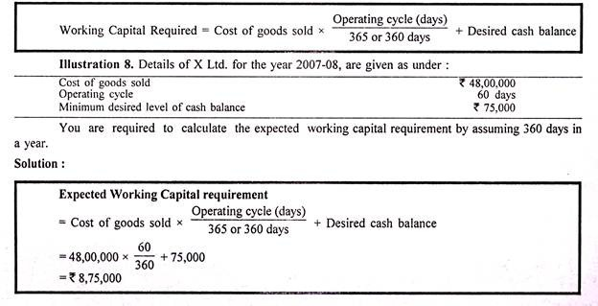

Types of Working Capital, Determinants of Working Capital

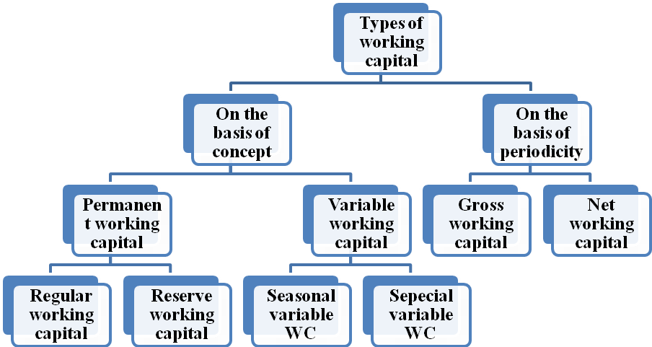

(a) Gross Working Capital:
Gross working capital refers to the amount of funds invested in various components of current assets. It consists of raw materials, work in progress, debtors, finished goods, etc.
(b) Net Working Capital:
The excess of current assets over current liabilities is known as Net working capital. The principal objective here is to learn the composition and magnitude of current assets required to meet current liabilities.
(c) Positive Working Capital:
This refers to the surplus of current assets over current liabilities.
(d) Negative Working Capital:
Negative working capital refers to the excess of current liabilities over current assets.
(e) Permanent Working Capital:
The minimum amount of working capital which even required during the dullest season of the year is known as Permanent working capital.
(f) Temporary or Variable Working Capital:
It represents the additional current assets required at different times during the operating year to meet additional inventory, extra cash, etc.
It can be said that Permanent working capital represents minimum amount of the current assets required throughout the year for normal production whereas Temporary working capital is the additional capital required at different time of the year to finance the fluctuations in production due to seasonal change. A firm having constant annual production will also have constant Permanent working capital and only Variable working capital changes due to change in production caused by seasonal changes. (See Figure 7.1.)
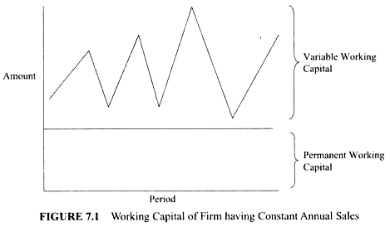
Similarly, a growth firm is the firm having unutilized capacity, however, production and operation continues to grow naturally. As its volume of production rises with the passage of time so also does the quantum of the Permanent working capital.
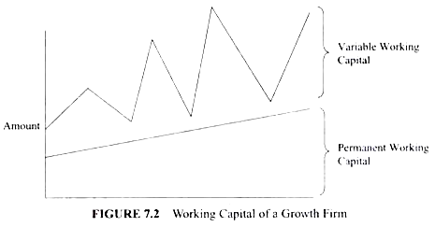

Determinants of Working Capital
(A) Current Assets:
These assets are generally realized within a short period of time, i.e. within one year.
Current assets include:
(a) Inventories or Stocks
(i) Raw materials
(ii) Work in progress
(iii) Consumable Stores
(iv) Finished goods
(b) Sundry Debtors
(c) Bills Receivable
(d) Pre-payments
(e) Short-term Investments
(f) Accrued Income and
(g) Cash and Bank Balances

(B) Current Liabilities:
Current liabilities are those which are generally paid in the ordinary course of business within a short period of time, i.e. one year.
Current liabilities include:
(a) Sundry Creditors
(b) Bills Payable
(c) Accrued Expenses
(d) Bank Overdrafts
(e) Bank Loans (short-term)
(f) Proposed Dividends
(g) Short-term Loans
(h) Tax Payments Due

