Financial & Management Accounting

Assignment- 3
Q.1) Given below are the balances extracted from the books of Nagarajan as on 31st March, 2016.
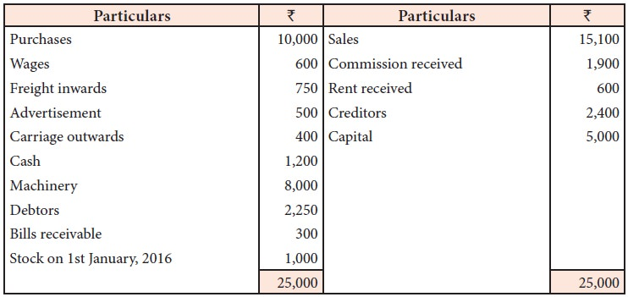
Prepare the trading and profit and loss account for the year ended 31st March, 2016 and the balance sheet as on that date after adjusting the following:

i. Commission received in advance Rs. 400
ii. Advertisement paid in advance Rs. 150
iii. Wages outstanding Rs. 200
iv. Closing stock on 31st March 2016, Rs. 2,100

Q.2) Consider the following balances extracted from the books of Jain as on 31st December, 2016.
Prepare the final accounts.
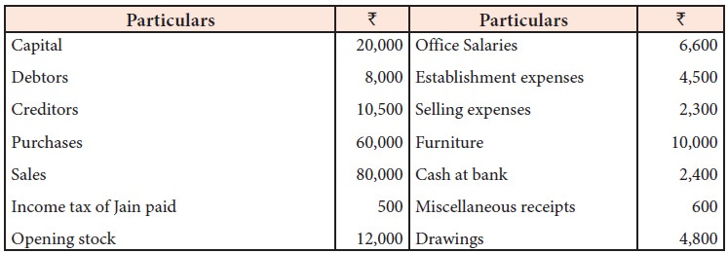

Adjustments
i. Salaries outstanding for December, 2016 amounted to Rs. 600
ii. Provide depreciation on furniture @ 10% p.a.
iii. Provide interest on capital for the year @ 5% p.a.
iv. Stock on 31st December, 2016 Rs. 14,000.

Q.3) Given below are the balances of Pandian as on 31st March, 2016.
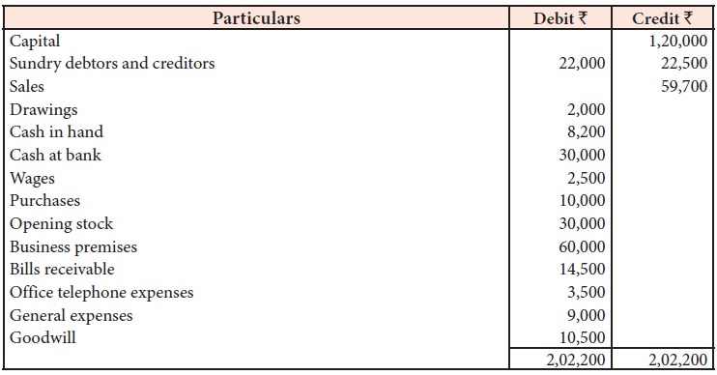

Adjustments:
i. The stock value at the end of the accounting period was Rs. 5,000
ii. Interest on capital at 6% is to be provided
iii. Interest on drawing at 5% is to be provided
iv. Write off bad debts amounting to Rs. 2,000
v. Create provision for bad and doubtful debts on sundry debtors @ 10%
vi. Prepare final accounts for the year ended 31st March, 2016.

