BUSINESS ENVIRONMENT
NOTES- UNIT 1

VAISHNAVI VERMA
ASSISTANT PROFESSOR
VISION INSTITUTE OF MANAGEMENT
KANPUR

BUSINESS ENVIRONMENT-UNIT 1
The word business simply means “The state of being busy“. It confines its study only to those human activities in relation to exchange of goods and services for money.
The purpose of exchange of goods and services is to satisfy human wants. A number of authors and authorities have attempted to define the term business in so many ways. However, all definitions focus their attention on one particular aspect i.e., “satisfaction of human wants“.

Nature of Business
The important characteristics of business are given below:
- Sale, Transfer or Exchange of Goods and Services for Value
Business is concerned with sale, transfer / sale of goods and services for a value. Production or purchase of goods or services for personal consumption is obviously outside the scope of business because, there is no sale or transfer for value. Therefore, production or purchase for one’s own consumption is not a business activity. On the other hand, if he produces for others it is considered as a business activity.
- Continuity of Dealings
The exchange of goods and services should be undertaken continuously. A casual transaction does not constitute business. If a person sells his Television set and gains some profit thereon, it does not constitute business. But if he regularly deals with T.V. sets, then such an act is treated as business.
- Profit Motive
Profit is the ultimate aim of any business. It may have other motives also. But if this motive is absent, it is not a business activity at all.
- Uncertainty and Risks
Profit for any business depends not only on the factors over which the businessman has control but also on factors over which he has no control or less control. Thus, all activities of business carry some element of risk and uncertainty in respect of business success.

Scope of Business
The Scope of “Business” is wider than that of the terms “Trade” and “Commerce“. The terms trade and commerce are often used synonymously. This usage is not correct.
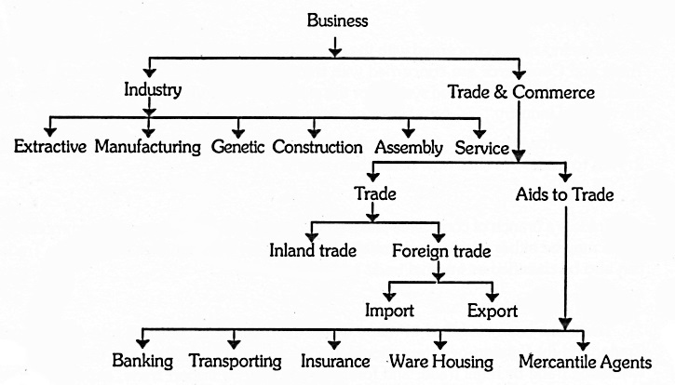
Trade is one of the branches of commerce. It is concerned with exchange of goods and services. It performs the function of acting as an intermediary and thereby it transfers goods from the producer to the consumer. On the other hand, commerce is a wider term. It includes “Trade” as well as, Aids to trade i.e. the various activities which facilitate trade.
The term business may be classified into Industry and Trade and commerce. Industry is referred to as production of goods and materials while Trade and commerce refers to distribution of goods and materials manufactured. The image below gives a clear-cut picture of the nature and scope of business.

Components of Business
- Industry
The word “Industry” refers to that part of business activities which is apprehensive with the extraction, production or fabrication of products. The products which are raised, produced or processed by an industry may either be used by the ultimate consumer or by another concern for further production. If the goods produced by an industry are consumed by the final customers, these are named as ‘consumer’s goods’ e.g. clothes. If the goods are used for further production of wealth they are called producer’s or capital goods. In case the goods produced by an industry are further processed into finished products by another concern they are called as intermediate goods. i.e Plastic.
Types of Industry:
On the basis activity industry is further classified into various types are as under:-
- Extractive Industries
Extractive industries are those industries which extract, raise or fabricate raw materials from above or beneath surface of the earth. i.e. Mining, fisheries forestry, agriculture.
- Genetic Industries
Those industries which are engaged in reproducing and multiplying certain species of animals and plants and selling them in the market for profit are named as genetic industries. i.e. Cattle breeding farms, poultry farms, plant nurseries.
- Constructive Industries
Constructive industries as the name signifies are engaged in the construction of building, canals, brides, dams, roads etc.
- Manufacturing Industries
Manufacturing industries are those which are concerned of converting raw material or semi finished products into finished products. E.g. Shoes Company, Textiles Mills.
- Service Industries
Service industries are usually engaged in the manufacturing of intangible goods which cannot be seen or touched by naked eye. The service of professionals such as doctors, lawyers is examples of service industries.
- Commerce
The second element that comes in the scope of business is Commerce. It is a very important component of business and is concerned with the buying and selling of goods. It includes all the activities which are connected to the transfer of goods from the place of production to the ultimate consumers. The whole ranges of commerce activities are classified are as under:-
Trade
The process of buying and selling of goods is called Trade. It is the exchange of goods and services among buyers and sellers in which both the parties are benefited. Trade is classified into two types.
- Internal Trade
The process of buying and selling of goods within the edge of a country is called internal trade.
1- Wholesale Trade. The process of purchase of goods in huge quantity from producers and their resale to retailers is known as wholesale trade. The retailer then further sells these goods to the final consumers.
2- Retail Trade. The retailer sale the goods and services to the ultimate consumers is known as Retail Trade.
- External Trade:
The purchase and sale of goods between two countries are called external trade. It is also called foreign trade. There are two types of external Trade.
- Import Trade ii. Export Trade.
Aid to Trade
The activities which help in the purchase of goods and services are called aids to trade. The aids which are compulsory for the development of the trade are as follows:-
- Transport
The different ways of transport help in carrying goods from the places of production to centers of utilization e.g. Railways, ships, airlines etc.
- Insurance
Insurance is very essential aid to trade. The risk of damage of goods due to fire, flood, earthquake or other causes us covered by insurance.
- Warehousing
Warehousing is a kind of storeroom. Nowadays most of the goods are produce in anticipation of demand. They are stored in safe places and are released as and when demanded in the market. Warehousing thus helps in overcoming the barrier of time and creates time utility.
- Banking
The commercial banks play a vital role in financing the different trade activities. They are funding the traders for stock holding and transportation of goods. They also support the buyers and sellers of goods in receiving and making payments, both at the national and worldwide level. The credit facility in the form of cash credit, overdrafts and loans is provided to the traders.
- Advertisement
Selling of goods is the most difficult problem for the producer. Advertisement regarding the product through newspapers, magazines, radio and television has greatly helped the consumers in choosing the goods of their taste. So advertisements play a vital role in increasing sale of goods.
Business:
Business may be defined as an activity involving regular production or purchase of goods and services for sale, transfer and exchange with an object of earning profit.
We find people like mill owners, transporters, bankers, traders, tailors, taxi operators etc. doing business. All of them are engaged in an activity of manufacturing or trading (buying and selling) or providing some service. They have invested their money, bear the risks involved and work for earning some profit. Thus,
Purpose of Business:
The nature of business is best understood on the basis of its characteristics or features which are as follows:
- Business is an economic activity
- It includes the activities of production or purchase and distribution.
- It deals in goods and services.
- It implies regularity of transactions.
- It aims at earning profits through the satisfaction of human wants.
- It involves risk; it is not certain that adequate profit will be earned.
- It creates utilities.
- It serves a social purpose by improving people’s standard of living.
- Objectives Of Business :
- Success in business depends on proper formulation of its objectives. Objectives must be clear, and attainable. Thus, the objectives of business may be classified as –
- (a) Economic objectives
- (b) Social objectives
- (c) Human objectives
- (d) National objectives
- (e) Global objectives
- Now let us discuss these objectives in detail.
- (a) Economic objectives of a business refer to the objective of earning profit and those which have a direct impact on the profit-earning objective of business.
- Some of the main economic objectives of business are:
- (i) Earning of adequate profits;
- (ii) Exploring new markets and creation of more customers;
- (iii) Growth and expansion of business operation;
- (iv)Making innovations and improvements in goods and services; and
- (v) Making use of available resources in the best possible manner.
- (b) Social objectives of business are those, which are desired to be achieved for the benefit of the society.
- Some of the major social objectives are:
- (I) production and supply of quality goods and services to the society;
- (ii) Making goods available at reasonable prices;
- (iii) Avoidance of unfair practices like hoarding, black-marketing, over-charging, etc.;
- (iv) Contributing towards the general welfare and upliftment of the society;
- (v) Ensuring fair return to the investors;
- (vi) Taking steps in the direction of consumer education; and
- (vii) Conserving natural resources and wild life and protecting the environment.
- (c) Human objectives of business primarily refer to the objectives aimed at safeguarding the interest of its employees and their welfare.
- Some of the major human objectives are:
- (i) providing fair remuneration and incentives to the employees;
- (ii) arrangement of better working conditions and proper work environment for the employees;
- (iii) providing job satisfaction by making the jobs interesting and challenging, putting the right persons in right job;
- (iv) providing the employees with more and more promotional opportunities;
- (v) organizing training and development programs for the growth of the employees; and
- (vi) providing employment to the backward classes of the society and people who are physically and mentally challenged.
- (d) National objectives of business are the objectives of fulfilling the national goals and aspirations.
- Some of the National objectives are:
- (i) creation of employment opportunities;
- (ii) promotion of social justice;
- (iii) produce and supply goods in accordance with the national interest and priorities;
- (iv) payment of taxes and other dues honestly and regularly;
- (v) helping the state in maintaining law and order by promoting good industrial relations; and
- (vi) implementing government’s economic and financial policies framed from time to time.
- (e) Global objectives of business are the objectives of facing the challenges of global market.
- Some of the global objectives are:
- (i) making available globally competitive goods and services; and
- (ii) reducing disparities among rich and poor nations by expanding its operations.
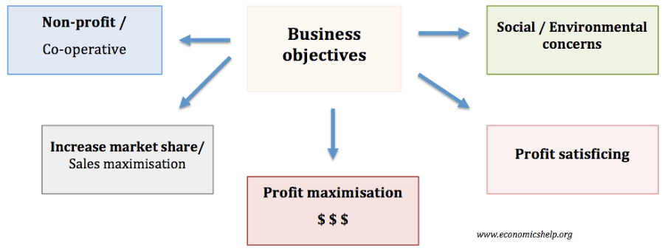

Economic Objectives of Business-
We learned in the previous topic that business is an economic activity. Hence, its purpose is to show economic results. Let’s understand the economic objectives of the business. They are as follows:

1] Profit Earning
Business is a set of activities undertaken with the prospect of sale for the purpose of earning a profit. Profit is the extra income over the expenses. The main objective of any business is to earn a profit. Just as a plant cannot survive without water, similarly a business cannot sustain without profit.
Profit is necessary for growing and expanding business activities. Profit guarantee a consistent stream of capital for the modernization and augmentation of business activities in the future. Profits likewise show the scale of stability, efficiency, and advancement of the business organization.

2] Market Share / Creation of Customers
In the words of Drucker, “There is only one valid definition of business purpose; to create a customer. “ Profits are not generated out of thin air. They are the result of the hard work of the businessman to satisfy the needs of the customers.
In the long run, the survival of the business completely depends upon the market share captured by the business. The creation of good and satisfaction of the needs of the customer is a crucial purpose of the business. So to generate profit and demand, the business must supply premium quality and give value for money products.

3] Innovation & Utilization of Resources
Innovation normally means to change processes or creating more effective processes, products and ideas. Nowadays, business is ever-changing and dynamic. To keep up with the growing competition a businessman has to introduce efficient design, latest trends, upgraded machinery, new techniques, etc.
Large corporations invest a humongous amount of capital in their Research & Development department to boost innovation. Whereas, on the parallel lines, utilization of resources is a proper use of workforce, raw material, capital and technology used in the business. A business has limited resources and that’s why its main objective is to put these resources to correct divisions.

4] Increasing Productivity
Productivity is a scale to measure the efficiency of the business activity. It is usually the last objective but just as important because productivity is measured by the output given by the activities. It is the end result of any business activity. Each business must go for more prominent productivity – to guarantee its survival and development. This goal can be accomplished by decreasing wastages and making proficient utilization of machines and supplies, HR, cash and so forth.

Social Objectives of Business
According to Dayton Hudson “The business of business is serving society, not just making money.” Business is one of the pillars on which the society stands. Therefore, it is a part of the society. In fact, it cannot thrive without the resources from the society. The business earns its income from the sale of products and services to the society. It is mandatory on the part of the business to take care of the social factors. The necessary social objectives of a business are as follows:

1] Providing Goods & Services at Reasonable Prices
Business exists in the first place to satisfy the needs of the society. It’s the first and major social objective of the business. Products and services ought to be of better quality and these ought to be provided at sensible costs. It is additionally the social commitment of business to keep away from misbehaviors like boarding, Black promoting and manipulative advertising.

2] Employment Generation
One of the major problem today’s generation facing is unemployment. Business generates employment. Therefore, it is the social objective of a business to give chances to beneficial employment to individuals of the society. In a nation like India, unemployment has turned into a critical issue.

3] Fair Remuneration to Employees
The business does not run on its own but the people are responsible for the success and failure of the business. The people on the inside of the business are more valuable i.e. employees. They are an asset of the business and make a ground-breaking contribution to the business. They must be given reasonable pay for their work.
Notwithstanding wages and salary, a significant piece of profits ought to be distributed among them in acknowledgment of their commitments. Such sharing of benefits will expand the inspiration and proficiency of employees.

4] Community Service
Business must give back something to the society. As a result, the Library, dispensary, educational foundations and so on which a business can make and help in the advancement of society are created. Business enterprises can build schools, colleges, libraries, hospitals, sports bodies and research institutions. They can help non-government organizations (NGOs) like CRY, Help Age, and others which render services to weaker sections of society.

Economics Objectives of Business
Business is an enterprise which makes, distributes or provides any goods or services to the community and as a result earns profit. These two major activities constitute economic objectives of a business, these are divided into the following points.
Normal Satisfactory Profit. It is a common belief that money chasing is the only objective of a business. True maximization is the common prevailing norm among the whole business community. To run the business successfully it is necessary to earn profit.
Creation of Customers. Customers are the ultimate source of happiness to a business. Customers are the source of revenue and profit. If they continue to come, do not alter the patronage, are satisfied with goods, services, business dealings and behavior. They usually stick to the business and tell their relatives and friends about the business they have good relations. It is a chain reaction. Infact a satisfied customer is an asset who always is expected to bring more and more customers. More customers mean a good turnover and a good turnover means a fair amount of profit to the business.
Creation of new customers is the ultimate objective of any business and there is no substitute. This can be better done by educative and repetitive advertisement and by satisfying the customers who are patronizing so that they may stick and ask other to follow them.
Innovation. Innovation is again an important objective of a business. In this, complex and competitive industrial and commercial world everyone tries to woo the customer. It will help the business to attract more customers if it tries to innovate in its field of activities. Innovation of goods and services customers policies, production quality, service facility etc. all need innovation.
Business activities are essentially measured in terms of money, all measurements must show profit. Money flowing in and profit are the two measuring rods of the success of a business, but at best these two can only be called a motivating force for the enterpriser.

Social Objectives of Business
Supply of Quality Goods and Fair Prices. The community pays for goods and services the business offers to it. In turn the community expects that the business will adhere to the standard. Of quality which is necessary to satisfy its wants and business will also ensure that whatever is being made available to the community is being made available at competitive and fair price. A consumer surplus to the buyer and normal satisfactory profit to the business go side by side and both are complementary. In fact this sis norm of a business unless this is not ensured the survival and development of the business may not assure in this complex business world.
Fair Deal to Workers. Wherever they are working for living the workers should be motivated to work for the organization so as to make the organization forehead amidst fierce when the business is able to attract best talent towards its organization. It is because of this business has to meet the needs of workers and make them a satisfied lot. A fair deal to workers helps the business in this direction.
Fair Return to Investors. Profit to investors must be ensured which should be fair one according to the prevailing market conditions. This is an important objective. Investors provide working capital as well as fixed capital to the business. Business therefore, must aim to allow them a fair amount of return so that their interest must remain in the business.
Fair Deal to Suppliers. Supplier supply the raw materials with the help of which goods are manufactured. Supplier supply all other components and accessories to the manufacturing organization, which in turn ensures smooth and timely production. Similarly suppliers supply the goods to a commercial venture for onward supply to the ultimate consumers. Whatever may be the type of business the suppliers form the basis of the entire business community. They expect a fair deal, that is, payment in time, regular placement of orders, ethical business dealing sand continuity. Thus the business has to ensure in its own interest as the supplier is the basic link between the business and community. They too are to be kept satisfied particularly at a time when there is a paucity of qualitative supply of goods – whether industrial or commercial.

3 Types of Business
There are three major types of businesses:

1. Service Business
A service type of business provides intangible products (products with no physical form). Service type firms offer professional skills, expertise, advice, and other similar products.
Examples of service businesses are: salons, repair shops, schools, banks, accounting firms, and law firms.

2. Merchandising Business
This type of business buys products at wholesale price and sells the same at retail price. They are known as "buy and sell" businesses. They make profit by selling the products at prices higher than their purchase costs.
A merchandising business sells a product without changing its form. Examples are: grocery stores, convenience stores, distributors, and other resellers.

3. Manufacturing Business
Unlike a merchandising business, a manufacturing business buys products with the intention of using them as materials in making a new product. Thus, there is a transformation of the products purchased.
A manufacturing business combines raw materials, labor, and overhead costs in its production process. The manufactured goods will then be sold to customers.

Hybrid Business
Hybrid businesses are companies that may be classified in more than one type of business. A restaurant, for example, combines ingredients in making a fine meal (manufacturing), sells a cold bottle of wine (merchandising), and fills customer orders (service).

Forms of Business Organization
These are the basic forms of business ownership:

1. Sole Proprietorship
A sole proprietorship is a business owned by only one person. It is easy to set-up and is the least costly among all forms of ownership. The owner faces unlimited liability; meaning, the creditors of the business may go after the personal assets of the owner if the business cannot pay them.
The sole proprietorship form is usually adopted by small business entities.

2. Partnership
A partnership is a business owned by two or more persons who contribute resources into the entity. The partners divide the profits of the business among themselves.
In general partnerships, all partners have unlimited liability. In limited partnerships, creditors cannot go after the personal assets of the limited partners.

3. Corporation
A corporation is a business organization that has a separate legal personality from its owners. Ownership in a stock corporation is represented by shares of stock.
The owners (stockholders) enjoy limited liability but have limited involvement in the company's operations. The board of directors, an elected group from the stockholders, controls the activities of the corporation.
In addition to those basic forms of business ownership, these are some other types of organizations that are common today:

Limited Liability Company
Limited liability companies (LLCs) in the USA, are hybrid forms of business that have characteristics of both a corporation and a partnership. An LLC is not incorporated; hence, it is not considered a corporation. But, the owners enjoy limited liability like in a corporation. An LLC may elect to be taxed as a sole proprietorship, a partnership, or a corporation.

Cooperative
A cooperative is a business organization owned by a group of individuals and is operated for their mutual benefit. The persons making up the group are called members. Cooperatives may be incorporated or unincorporated.
Some examples of cooperatives are: water and electricity (utility) cooperatives, cooperative banking, credit unions, and housing cooperatives.
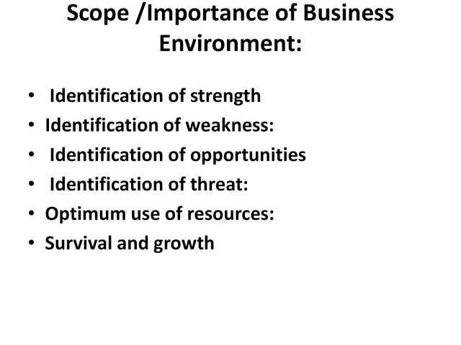

Nature of Business Environment:
The nature of Business Environment is simply and better explained by the following approaches:
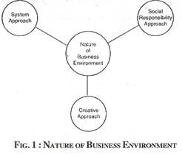
(i) System Approach:
In original, business is a system by which it produces goods and services for the satisfaction of wants, by using several inputs, such as, raw material, capital, labour etc. from the environment.
ADVERTISEMENTS:
(ii) Social Responsibility Approach:
In this approach business should fulfill its responsibility towards several categories of the society such as consumers, stockholders, employees, government etc.
(iii) Creative Approach:
As per this approach, business gives shape to the environment by facing the challenges and availing the opportunities in time. The business brings about changes in the society by giving attention to the needs of the people.

Significance of Business Environment:
Business Environment refers to the “Sum total of conditions which surround man at a given point in space and time. In the past, the environment of man consisted of only the physical aspects of the planet Earth (air, water and land) and the biotic communities. But in due course of time and advancement of society, man extended his environment through his social, economic and political function.”
In a globalised economy, the business environment plays an important role in almost all business enterprises. The significance of business environment is explained with the help of the following points:
(i) Help to understand internal Environment:
It is very much important for business enterprise to understand its internal environment, such as business policy, organisation structure etc. In such case an effective management information system will help to predict the business environmental changes.
(ii) Help to Understand Economic System:
The different kinds of economic systems influence the business in different ways. It is essential for a businessman and business firm to know about the role of capitalists, socialist and mixed economy.
(iii) Help to Understand Economic Policy:
Economic policy has its own importance in business environment and it has an important place in business. The business environment helps to understand government policies such as, export-import policy, price policy; monetary policy, foreign exchange policy, industrial policy etc. have much effect on business.
(iv) Help to Understand Market Conditions:
It is necessary for an enterprise to have the knowledge of market structure and changes taking place in it. The knowledge about increase and decrease in demand, supply, monopolistic practices, government participation in business etc., is necessary for an enterprise.
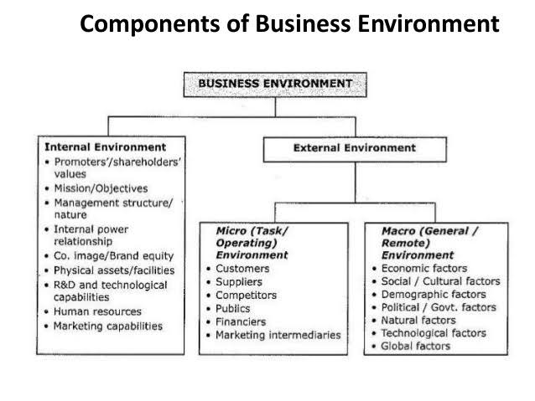
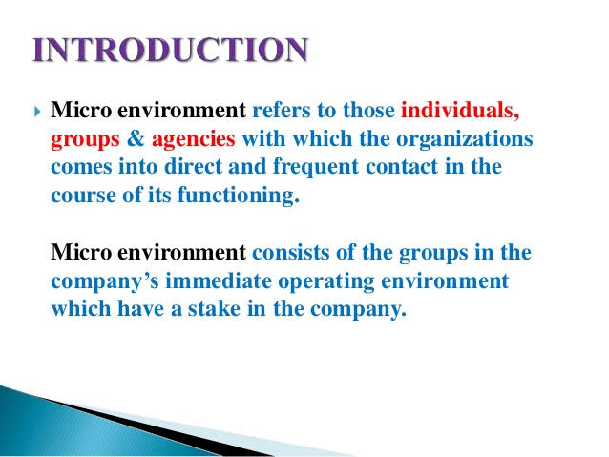

Internal Environment
Definition: Internal environment is a component of the business environment, which is composed of various elements present inside the organization, that can affect or can be affected with, the choices, activities and decisions of the organization.

Factors Influencing Internal Environment
The factors which are under the control of the organization, but can influence business strategy and other decisions are termed as internal factors. It includes:
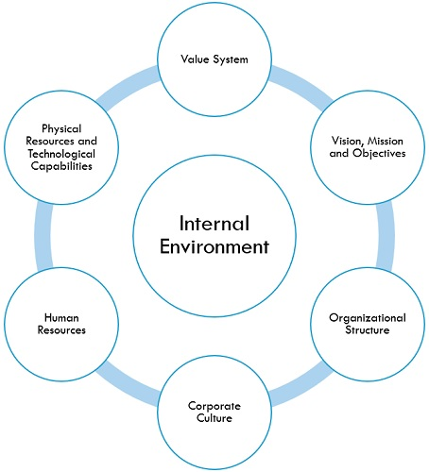
- Value System: Value system consists of all those components that are a part of regulatory frameworks, such as culture, climate, work processes, management practices and norms of the organization. The employees should perform the activities within the purview of this framework.
- Vision, Mission and Objectives: The company’s vision describes its future position, mission defines the company’s business and the reason for its existence and objectives implies the ultimate aim of the company and the ways to reach those ends.
- Organizational Structure: The structure of the organization determines the way in which activities are directed in the organization so as to reach the ultimate goal. These activities include the delegation of the task, coordination, the composition of the board of directors, level of professionalization, and supervision. It can be matrix structure, functional structure, divisional structure, bureaucratic structure, etc.
- Corporate Culture: Corporate culture or otherwise called an organizational culture refers to the values, beliefs and behaviour of the organization that ascertains the way in which employees and management communicate and manage the external affairs.
- Human Resources: Human resource is the most valuable asset of the organization, as the success or failure of an organization highly depends on the human resources of the organization.
- Physical Resources and Technological Capabilities: Physical resources refers to the tangible assets of the organization that play an important role in ascertaining the competitive capability of the company. Further, technological capabilities imply the technical know-how of the organization.
Internal environmental factors have a direct impact on a firm. Further, these factors can be altered as per the needs and situation, so as to adapt accordingly in the dynamic business environment.

Micro Environment
The micro-component of the external environment is also known as the task environment. It comprises of external forces and factors that are directly related to the business. These include suppliers, market intermediaries, customers, partners, competitors and the public
- Suppliers include all the parties which provide resources needed by the organisation.
- Market intermediaries include parties involved in distributing the product or service of the organisation.
- Partners are all the separate entities like advertising agencies, market research organisations, banking and insurance companies, transportation companies, brokers, etc. which conduct business with the organisation.
- Customers comprise of the target group of the organisation.
- Competitors are the players in the same market who targets similar customers as that of the organisation.
- Public is made up of any other group that has an actual or potential interest or affects the company’s ability to serve its customers.

Macro Environment
The macro component of the marketing environment is also known as the broad environment. It constitutes the external factors and forces which affect the industry as a whole but don’t have a direct effect on the business. The macro-environment can be divided into 6 parts.

Demographic Environment
The demographic environment is made up of the people who constitute the market. It is characterised as the factual investigation and segregation of the population according to their size, density, location, age, gender, race, and occupation.

Economic Environment
The economic environment constitutes factors which influence customers’ purchasing power and spending patterns. These factors include the GDP, GNP, interest rates, inflation, income distribution, government funding and subsidies, and other major economic variables.

Physical Environment
The physical environment includes the natural environment in which the business operates. This includes the climatic conditions, environmental change, accessibility to water and raw materials, natural disasters, pollution etc.

Technological Environment
The technological environment constitutes innovation, research and development in technology, technological alternatives, innovation inducements also technological barriers to smooth operation. Technology is one of the biggest sources of threats and opportunities for the organisation and it is very dynamic.

Political-Legal Environment
The political & Legal environment includes laws and government’s policies prevailing in the country. It also includes other pressure groups and agencies which influence or limit the working of the industry and/or the business in the society.

Social-Cultural Environment
The social-cultural aspect of the macro-environment is made up of the lifestyle, values, culture, prejudice and beliefs of the people. This differs in different regions.
BASIS FOR COMPARISON | MICRO ENVIRONMENT | MACRO ENVIRONMENT
Meaning | Micro environment is defined as the nearby environment, under which the firm operates. | Macro environment refers to the general environment, that can affect the working of all business enterprises.
Elements | COSMIC, i.e. Competitors, Organization itself, Suppliers, Market, Intermediaries and Customers. | PESTLE, i.e. Population & Demographic, Economic, Socio-Cultural, Technological, Legal & Political and Environmental.
Nature of elements | Specific | General
Are these factors controllable? | Yes, but to some extent only | No
Influence | Directly and Regularly | Indirectly and Distantly
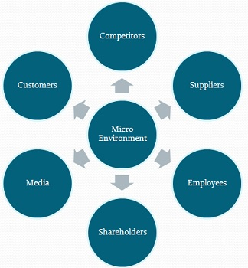
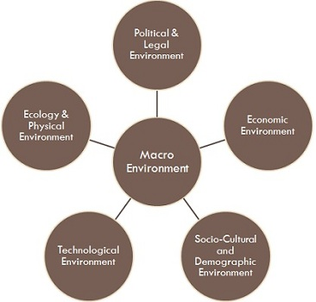

Organizational Structure
An organizational structure is defined as “a system used to define a hierarchy within an organization. It identifies each job, its function and where it reports to within the organization.” A structure is then developed to establish how the organization operates to execute its goals.
There are many types of organizational structures. There’s the more traditional functional structure, the divisional structure, the matrix structure and the flatarchy structure. Each organizational structure comes with different advantages and disadvantages and may only work for companies or organizations in certain situations or at certain points in their life cycles.

Types of Organizational Structures
- Functional
The functional structure is based on an organization being divided up into smaller groups with specific tasks or roles. For example, a company could have a group working in information technology, another in marketing and another in finance.
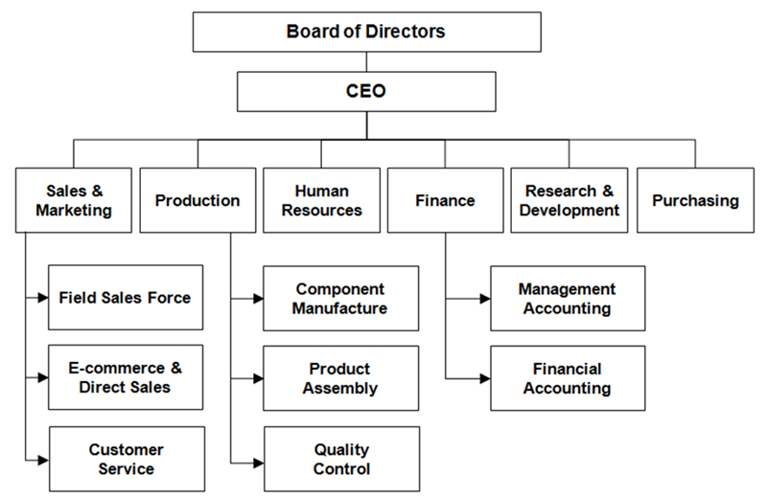
Each department has a manager or director who answers to an executive a level up in the hierarchy who may oversee multiple departments. One such example is a director of marketing who supervises the marketing department and answers to a vice president who is in charge of the marketing, finance and IT divisions.
An advantage of this structure is employees are grouped by skill set and function, allowing them to focus their collective energies on executing their roles as a department.
One of the challenges this structure presents is a lack of inter-departmental communication, with most issues and discussions taking place at the managerial level among individual departments. For example, one department working with another on a project may have different expectations or details for its specific job, which could lead to issues down the road.
- Divisional
Larger companies that operate across several horizontal objectives sometimes use a divisional organizational structure.
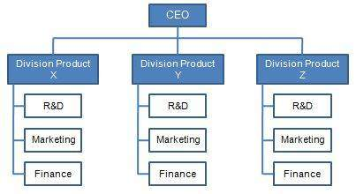
This structure allows for much more autonomy among groups within the organization. One example of this is a company like General Electric. GE has many different divisions including aviation, transportation, currents, digital and renewable energy, among others.
Under this structure, each division essentially operates as its own company, controlling its own resources and how much money it spends on certain projects or aspects of the division.
- Matrix
A hybrid organizational structure, the matrix structure is a blend of the functional organizational structure and the projectized organizational structure.
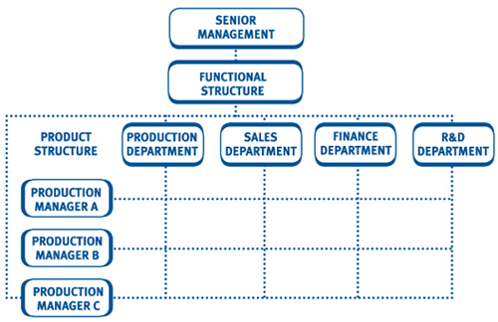
In the matrix structure, employees may report to two or more bosses depending on the situation or project. For example, under normal functional circumstances, an engineer at a large engineering firm could work for one boss, but a new project may arise where that engineer’s expertise is needed. For the duration of that project, the employee would also report to that project’s manager, as well as his or her boss for all other daily tasks.
The matrix structure is challenging because it can be tough reporting to multiple bosses and knowing what to communicate to them. That’s why it’s very important for the employees to know their roles, responsibilities and work priorities.
Advantages of this structure is that employees can share their knowledge across the different functional divisions, allowing for better communication and understanding of each function’s role. And by working across functions, employees can broaden their skills and knowledge, leading to professional growth within the company.
- Flatarchy
While the previous three types of organizational structures may work for some organizations, another hybrid organizational structure may be better for startups or small companies.
Blending a functional structure and a flat structure results in a flatarchy organizational structure, which allows for more decision making among the levels of an organization and, overall, flattens out the vertical appearance of a hierarchy.
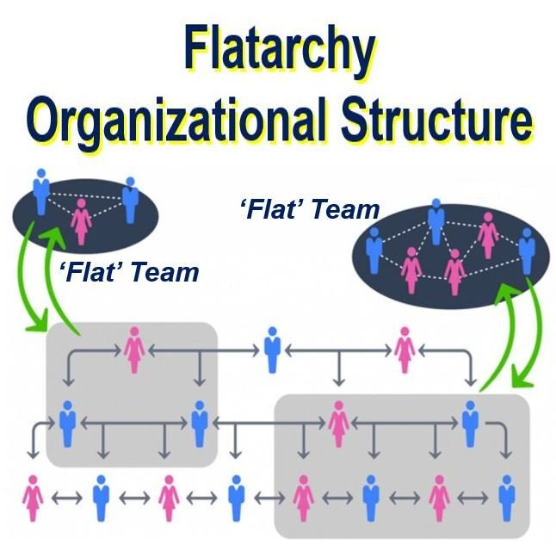
The best example of this structure within a company is if the organization has an internal incubator or innovation program. Within this system, the company can operate in an existing structure, but employees at any level are encouraged to suggest ideas and run with them, potentially creating new flat teams. Lockheed Martin, according to Forbes, was famous for its skunkworks project, which helped develop the design of a spy plane.
A benefit of this system is it allows for more innovation company-wide, as well as eliminating red tape that could stall innovation in a functional structure. As for the negatives, the structure could be confusing and inconvenient if everyone involved doesn’t agree on how the structure should be organized.
Organizational Resources represent all resources available to the organization and necessary for the performance of its activities. In this resource are included:
- Human Resources: represent all people (as well as their qualifications and capacities) that cooperate with the organization and are currently their main asset.
- Material and Technological Resources: include all of the equipments and tools used by the organization, the manufacturing and administrative facilities, technologies and processes used in the production and management, among many others.
- Financial Resources represent the monetary funds held by the organization (or the capacity to obtain them) and that can be used in the financing of the current activity or in the attainment of new investments.
- Market image and credibility abroad: represents the positioning of the organization and its brands, that is, what the consumers think about the goods or services produced by the organization.

Company Image
Company Image is the perception held about an organization by the various stake holders in the company (like investors, customers, vendors & government), public and the society at large. It need not reflect the actual position but rather it is a view that the society has about the company. It is simply the impression that comes to the mind when one comes across the name of the company.
One of the onerous tasks on the field for marketing professionals is to project this image and thereby hit the target market. It can be done in various ways – by branding promotion, launching advertisement campaigns, interaction with media, communication with customers at different levels etc.
For example let us consider ITC which attempts to build an image of being a socially responsible company. Through its various initiatives like solid waste management, using energy from renewable sources, getting their hotels to be LEED® certified etc.
How to project a good company image?
So, how should you go about altering that brand image, or creating a new one from scratch? Let’s go over some of the basics…
(i) Create a recognizable, tangible brand
First thing’s first; in order to have any success with your company’s image you need to create a brand that is both identifiable and real – something that your customers will instantly recognize and connect with, encouraging them to seek you out whenever they’re thirsty, in need of financial advice, or looking for a new appliance. Think Coca Cola and you’ll no doubt hum the jingle to yourself, or find you’re very strongly drawn to the color red all of a sudden… Your character, and the personality and color scheme that you choose to assign to your brand are what will speak to the market, so you need to think big, or go home. A half-hearted effort at this point will do little to further your reputation, after all.
(ii) Think carefully about the language you use
It doesn’t matter how good your product or service is, nobody is going to look twice if your literature is sloppy, or your public presence is half-hearted. You don’t have to be a walking dictionary to succeed in business, but taking the time to prepare marketing material, online content, and speeches with the correct grammar and spelling will ensure you’re given a second look. Would you want to give your business to a company that hadn’t bothered to proofread its own marketing material first, or listen to a speech peppered with errors? The chances are your prospective clients wouldn’t either. Such care will ensure your company is always thought of in high regard; if you pay close attention to your wording, you’re likely to be very passionate about your product.
(iii) Consider the wheel that you’re behind
We said that image is everything and it really is; that includes the type of car you drive, too. You see, while you may think of it as a means of getting from A to B, the company vehicle you’re regularly seen in will say so much about you, both as an individual, and as the face of a company. Whether we want to admit it or not we’re rather good at judging people based on the wheels they park in front of their house or workplace, so imagine what prospective clients will think when they see that rust bucket taking up valuable curb space…
The good news is that you needn’t spend all of your company’s profits on a chauffeur driven limo, or the latest sports car to make a good impression – in fact, choosing an understated set of wheels can actually work in your favor. Think company car, think reliable, strong, and businesslike, such as a Mazda, or similarly trustworthy brand; you want your clients to know they’re in a safe pair of hands when they turn to you, and for them to view your car as symbol of your commitment to the job, rather than a status symbol.
There are, of course, other ways to project a good company image; watching your conduct when you use social media, paying attention to your clothing and accessories every day, and taking the time to network in order to further your business’s reach are just some of the additional ways that you can ensure your company goes places. Remember, image is everything; your company needs you.
The Brand Equity refers to the additional value that a consumer attaches with the brand that is unique from all the other brands available in the market. In other words, Brand Equity means the awareness, perception, loyalty of a customer towards the brand.
E.g., The additional value a customer is willing to pay for Uncle Chips against any local chips brand available with the shopkeeper.
Brand Equity is the goodwill that a brand has gained over time.
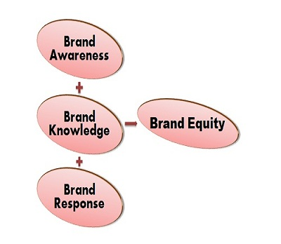
Brand Equity can be seen in the way the customer thinks, feels, perceives the product along with its price and market position and also the way brand commands profit and market share for the organization as a whole.

Customer Brand Equity can be studied in 3 different ways:
- The Different Responses of a customer towards the product or service helps in determining the brand equity. The way customer thinks about the brand and considers it to be different from the other brands will generate a positive response for that brand and will contribute to its goodwill.
g., Customer, have a positive response towards Mac laptops because of its anti- virus software.
- The responses can be generated only if customers have sufficient knowledge about the brand; thus, Brand Knowledge is essential to determine the brand equity. The Brand knowledge includes the thoughts, feelings, information, experiences, etc. that establish an association with the brand.
g., Brand Association reflects the knowledge about the product such as woodland is recognized for its rough and tough styling.
- The different customer’s response that adds to the brand value depends solely on the Marketing of a Brand. The strong brand results in substantial revenues for the organization and better understanding about the product among the customers.
Thus, the marketers basically study the Customer-Based Approach wherein they study the response of a customer towards the brand that can be reflected in their frequency of purchase. It focuses on customer’s perception i.e. what they have read, felt, thought, seen about the brand and how it has helped them to satisfy their urge of need.

Macro Factor
Demographic Economic Technological Cultural Political Natural Legal
- Demographic Environment
Demographic Environment relates to the human population with reference to its size, education, sex ratio, age, occupation, income, status etc. Business deals with people so they have to study in detail the various components of demographic environment.
Demographic environment differs from country to country. Demographic factors like size of the population, age composition, density of population, rural-urban distribution, family size, income level, status etc. have significant implications on business.
For example: If the population is large, then the demand for goods and services will be more. It will have favourable effect on the business. In the same way educational level is also an important factor affecting business.
- Natural Environment
Resource availability like land, water and mineral is the fundamental factor in the development of business organization. It includes natural resources, weather, climatic conditions, port facilities, topographical factors such as soil, sea, rivers, rainfall etc.
Every business unit must look for these factors before choosing the location for their business.
The natural environment largely determines the functioning of a business firm. Natural environment has a great influence on the working of a business. The business organization should consider the natural factors before starting their operations.
Natural calamities like flood, drought, cyclone, Tsunami etc. can also affect the business environment.
- Political Environment
The political environment in a country influences the legislations and government rules and regulations under which a firm operates.
Political environment means influence exerted by:
(a) Legislature
This includes parliament, legislative assemblies. They are the law making bodies that frame rules and regulations.
(b) Executives:
They include government beurocracy who implements the decision.
(c) The Judiciary
It includes Supreme Court, High Court who sees whether the decisions taken and implemented by the executive are within the constitutional framework. They are also known as dispute settlement bodies.
Legislature, executives and judiciary are the important pillars of political environment. A stable progressive and healthy political environment is very necessary for the growth and development of business.
- Social Environment
The Social forces link to factors that affect society’s basic values, preferences and behavior. The basis for these factors is formed by the fact that people are part of a society and cultural group that shape their beliefs and values. Many cultural blunders occur due to the failure of businesses in understanding foreign cultures. For instance, symbols may carry a negative meaning in another culture.
- Cultural Environment
Culture involves knowledge, values, belief, morals, laws, customs, traditions etc. Culture passes from one generation to another through institutions like family, schools, and colleges. Business is an integral part of the social system.
Society is largely influenced by the culture and in turn culture influence the business firm. Culture shapes the attitude and behaviour of the society. Any change in the cultural factor affects the business in large. Business should be organized and governed, taking into consideration various values and norms of the society.
- Economic Environment
Economic environment consists of economic factors that influence the functioning of a business unit. These factors include economic system, economic policies, trade cycle, economic resources, gross national product, corporate profits, inflation rate, employment, balance of payments, interest rates, consumer income etc. Economic environment is dynamic and complex in nature
A business firm closely interacts with economic environment that consist of:
(a) Economic conditions in the market i.e. demand and supply factors
(b) Economic policies of the government: monetary policy, fiscal policy, industrial policy, trade policy, foreign investment policy etc.
Economic system prevailing in the country also affects the business growth. Every country has different economic system. The economic system includes capitalism, socialism, and mixed economy. Business depends upon economic environment for their inputs and also for market. Changes in the economic factors can adversely affect the working of a business firm.
- Technological Environment
Technology has brought about far reaching changes in the methods of production, quality of goods, productivity, and packaging. There is a constant technological development-taking place.
The business firm must constantly monitor the changes in the technological environment, which may have a considerable impact on the working of a business. It also indicates the pace of research and development and progress made in introducing modern technology in production.
Technology provides capital intensive but cost effective alternative to traditional labour-intensive methods. In a competitive business environment technology is the key to development. Technology helps to run the business better and faster.
- International Environment
International managers face intense and constant challenges that require training and understanding of the foreign environment. Managing a business in a foreign country requires managers to deal with a large variety of cultural and environmental differences.
- Legal Environment
The state sets the formal rules, laws and regulations for the country’s operational system. It creates a framework of rules and regulations within which a business has to operate. The business should have complete knowledge of laws and policies to run the business effectively. Some of the laws are:
(a) Consumer protection Act-1986
(b) Factories Act-1948
(c) Workers compensation Act-1923
(d) FEMA Act-1999
(e) The Companies Act-1956
(f) The Environment protection Act-1986

