VISION INSTITUTE OF MANAGEMENT
C PROGRAMMING
BCA 1st YEAR/2nd SEM
UNIT-5(INTRODUCTION C PREPROCESSOR)

C PREPROCESSOR
The C Preprocessor is not a part of the compiler, but is a separate step in the compilation process. In simple terms, a C Preprocessor is just a text substitution tool and it instructs the compiler to do required pre-processing before the actual compilation. We'll refer to the C Preprocessor as CPP.

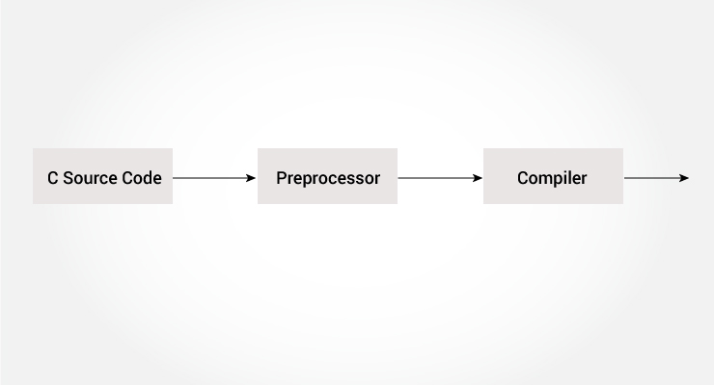

The C Preprocessor is a macro Preprocessor (allows you to define macros) that transforms your program before it is compiled. These transformations can be the inclusion of header file, macro expansions etc.

All Preprocessor commands begin with a hash symbol (#). It must be the first nonblank character, and for readability, a Preprocessor directive should begin in the first column. The following section lists down all the important Preprocessor directives –

S.No. | Directive & Description
1 | #define  Substitutes a Preprocessor macro.
2 | #include  Inserts a particular header from another file.
3 | #undef  Undefines a Preprocessor macro.
4 | #ifdef  Returns true if this macro is defined.
5 | #ifndef  Returns true if this macro is not defined.
6 | #if  Tests if a compile time condition is true.
7 | #else  The alternative for #if.
8 | #elif  #else and #if in one statement.
9 | #endif  Ends preprocessor conditional.
10 | #error  Prints error message.

All preprocessing directives begin with a # symbol. For example,

#define PI 3.14

Some of the common uses of C preprocessor are:

Including Header Files: #include
The #include preprocessor is used to include header files to C programs. For example,

#include <stdio.h>

Here, stdio.h is a header file. The #include preprocessor directive replaces the above line with the contents of stdio.h header file.
That's the reason why you need to use #include <stdio.h> before you can use functions like scanf() and printf().

You can also create your own header file containing function declaration and include it in your program using this preprocessor directive.
#include "my_header.h"

Macros using #define
A macro is a fragment of code that is given a name. You can define a macro in C using the #define preprocessor directive.

Here's an example.
#define c 299792458 // speed of light

Here, when we use c in our program, it is replaced with 299792458.

Example 1: #define preprocessor
#include <stdio.h>
#define PI 3.1415

int main()
{
float radius, area;
printf("Enter the radius: ");
scanf("%f", &radius);

// Notice, the use of PI
area = PI*radius*radius;

printf("Area=%.2f",area);
return 0;
}

Function like Macros
You can also define macros that work in a similar way like a function call. This is known as function-like macros. For example,
#define circleArea(r) (3.1415*(r)*(r))

Every time the program encounters circleArea(argument), it is replaced by (3.1415*(argument)*(argument)).
Suppose, we passed 5 as an argument then, it expands as below:
circleArea(5) expands to (3.1415*5*5)

Example 2: Using #define preprocessor
#include <stdio.h>
#define PI 3.1415
#define circleArea(r) (PI*r*r)

int main() {
float radius, area;

printf("Enter the radius: ");
scanf("%f", &radius);
area = circleArea(radius);
printf("Area = %.2f", area);

return 0;
}

Conditional Compilation
In C programming, you can instruct preprocessor whether to include a block of code or not. To do so, conditional directives can be used.
It's similar to if statement with one major difference.
The if statement is tested during the execution time to check whether a block of code should be executed or not whereas, the conditionals are used to include (or skip) a block of code in your program before execution.

Uses of Conditional
- use different code depending on the machine, operating system
- compile same source file in two different programs
- to exclude certain code from the program but to keep it as reference for future purpose

How to use conditional?
To use conditional, #ifdef, #if, #defined, #else and #elseif directives are used.

#ifdef Directive
#ifdef MACRO
// conditional codes
#endif
Here, the conditional codes are included in the program only if MACRO is defined.

#if, #elif and #else Directive
#if expression
// conditional codes
#endif
Here, expression is an expression of integer type (can be integers, characters, arithmetic expression, macros and so on).
The conditional codes are included in the program only if the expression is evaluated to a non-zero value.

The optional #else directive can be used with #if directive.

#if expression
conditional codes if expression is non-zero
#else
conditional if expression is 0
#endif

You can also add nested conditional to your #if...#else using #elif
#if expression
// conditional codes if expression is non-zero
#elif expression1
// conditional codes if expression is non-zero
#elif expression2
// conditional codes if expression is non-zero
#else
// conditional if all expressions are 0
#endif

#defined
The special operator #defined is used to test whether a certain macro is defined or not. It's often used with #if directive.

#if defined BUFFER_SIZE && BUFFER_SIZE >= 2048
// codes

Predefined Macros
Here are some predefined macros in C programming.
Macro | Value
__DATE__ | A string containing the current date
__FILE__ | A string containing the file name
__LINE__ | An integer representing the current line number
__STDC__ | If follows ANSI standard C, then the value is a nonzero integer
__TIME__ | A string containing the current date.

Example : Get current time using __TIME__
The following program outputs the current time using __TIME__ macro.

#include <stdio.h>
int main()
{
printf("Current time: %s",__TIME__);
}

Output
Current time: 19:54:39

C Preprocessors
As the name suggests Preprocessors are programs that process our source code before compilation. There are a number of steps involved between writing a program and executing a program in C. Let us have a look at these steps before we actually start learning about Preprocessors.

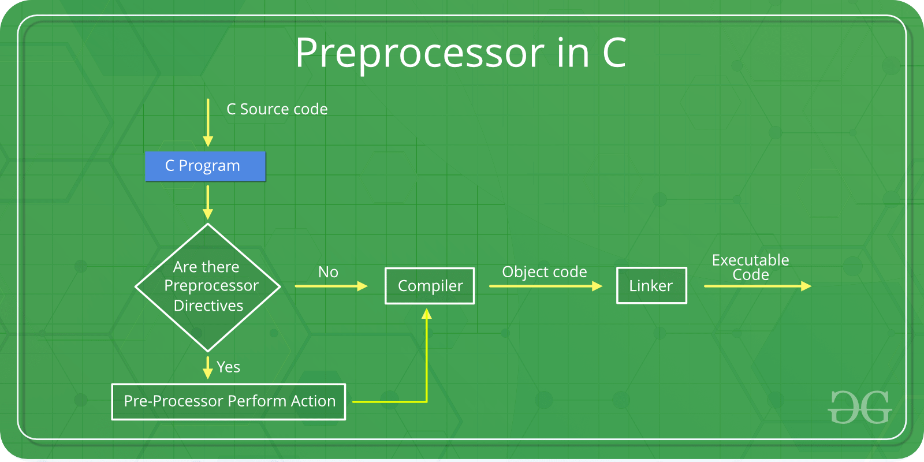

You can see the intermediate steps in the above diagram. The source code written by programmers is stored in the file program.c. This file is then processed by preprocessors and an expanded source code file is generated named program. This expanded file is compiled by the compiler and an object code file is generated named program .obj. Finally, the linker links this object code file to the object code of the library functions to generate the executable file program.exe.
Preprocessor programs provide preprocessors directives which tell the compiler to preprocess the source code before compiling. All of these preprocessor directives begin with a ‘#’ (hash) symbol. This (‘#’) symbol at the beginning of a statement in a C/C++ program indicates that it is a pre-processor directive. We can place these preprocessor directives anywhere in our program. Examples of some preprocessor directives are: #include, #define, #ifndef etc.

There are 4 main types of preprocessor directives:
- Macros
- File Inclusion
- Conditional Compilation
- Other directives

File Inclusion: This type of preprocessor directive tells the compiler to include a file in the source code program. There are two types of files which can be included by the user in the program:

- Header File or Standard files: These files contains definition of pre-defined functions like printf(), scanf() etc. These files must be included for working with these functions. Different function are declared in different header files. For example standard I/O functions are in ‘iostream’ file whereas functions which perform string operations are in ‘string’ file.

Syntax:

#include< file_name >

where file_name is the name of file to be included. The ‘<‘ and ‘>’ brackets tells the compiler to look for the file in standard directory.

- user defined files: When a program becomes very large, it is good practice to divide it into smaller files and include whenever needed. These types of files are user defined files. These files can be included as:

#include"filename"

Bitwise Operators in C

In arithmetic-logic unit (which is within the CPU), mathematical operations like: addition, subtraction, multiplication and division are done in bit-level. To perform bit-level operations in C programming, bitwise operators are used.
Operators | Meaning of operators
& | Bitwise AND
| | Bitwise OR
^ | Bitwise XOR
~ | Bitwise complement
<< | Shift left
>> | Shift right

Bitwise AND operator &
The output of bitwise AND is 1 if the corresponding bits of two operands is 1. If either bit of an operand is 0, the result of corresponding bit is evaluated to 0.
Let us suppose the bitwise AND operation of two integers 12 and 25-
12 = 00001100 (In Binary)
25 = 00011001 (In Binary)

Bit Operation of 12 and 25
00001100
& 00011001
________
00001000 = 8 (In decimal)

Example #1: Bitwise AND
#include <stdio.h>
int main()
{
int a = 12, b = 25;
printf("Output = %d", a&b);
return 0;
}
Output
Output = 8

Bitwise OR operator |
The output of bitwise OR is 1 if at least one corresponding bit of two operands is 1. In C Programming, bitwise OR operator is denoted by |.
12 = 00001100 (In Binary)
25 = 00011001 (In Binary)

Bitwise OR Operation of 12 and 25
00001100
| 00011001
________
00011101 = 29 (In decimal)

Example #2: Bitwise OR
#include <stdio.h>
int main()
{
int a = 12, b = 25;
printf("Output = %d", a|b);
return 0;
}

Output
Output = 29

Bitwise XOR (exclusive OR) operator ^
The result of bitwise XOR operator is 1 if the corresponding bits of two operands are opposite. It is denoted by ^.
12 = 00001100 (In Binary)
25 = 00011001 (In Binary)

Bitwise XOR Operation of 12 and 25
00001100
^ 00011001
________
00010101 = 21 (In decimal)

Example #3: Bitwise XOR
#include <stdio.h>
int main()
{
int a = 12, b = 25;
printf("Output = %d", a^b);
return 0;
}
Output
Output = 21

Bitwise complement operator ~
Bitwise compliment operator is an unary operator (works on only one operand). It changes 1 to 0 and 0 to 1. It is denoted by ~.
35 = 00100011 (In Binary)

Bitwise complement Operation of 35
~ 00100011
________
11011100 = 220 (In decimal)

Twist in bitwise complement operator in C Programming
The bitwise complement of 35 (~35) is -36 instead of 220, but why?
For any integer n, bitwise complement of n will be -(n+1). To understand this, you should have the knowledge of 2's complement.

2's Complement
Two's complement is an operation on binary numbers. The 2's complement of a number is equal to the complement of that number plus 1. For example:
Decimal Binary 2's complement
0 00000000 -(11111111+1) = -00000000 = -0(decimal)
1 00000001 -(11111110+1) = -11111111 = -256(decimal)
12 00001100 -(11110011+1) = -11110100 = -244(decimal)
220 11011100 -(00100011+1) = -00100100 = -36(decimal)

Note: Overflow is ignored while computing 2's complement.
The bitwise complement of 35 is 220 (in decimal). The 2's complement of 220 is -36. Hence, the output is -36 instead of 220.

Bitwise complement of any number N is -(N+1). Here's how:
bitwise complement of N = ~N (represented in 2's complement form)
2'complement of ~N= -(~(~N)+1) = -(N+1)

Example #4: Bitwise complement
#include <stdio.h>
int main()
{
printf("Output = %d\n",~35);
printf("Output = %d\n",~-12);
return 0;
}

Output
Output = -36
Output = 11

Shift Operators in C programming
There are two shift operators in C programming:
- Right shift operator
- Left shift operator.

Right Shift Operator
Right shift operator shifts all bits towards right by certain number of specified bits. It is denoted by >>.
212 = 11010100 (In binary)
212>>2 = 00110101 (In binary) [Right shift by two bits]
212>>7 = 00000001 (In binary)
212>>8 = 00000000
212>>0 = 11010100 (No Shift)

Left Shift Operator
Left shift operator shifts all bits towards left by certain number of specified bits. It is denoted by <<.
212 = 11010100 (In binary)
212<<1 = 110101000 (In binary) [Left shift by one bit]
212<<0 =11010100 (Shift by 0)
212<<4 = 110101000000 (In binary) =3392(In decimal)

Example #5: Shift Operators
#include <stdio.h>
int main()
{
int num=212, i;
for (i=0; i<=2; ++i)
printf("Right shift by %d: %d\n", i, num>>i);

printf("\n");

for (i=0; i<=2; ++i)
printf("Left shift by %d: %d\n", i, num<<i);

return 0;
}

Right Shift by 0: 212
Right Shift by 1: 106
Right Shift by 2: 53

Left Shift by 0: 212
Left Shift by 1: 424
Left Shift by 2: 848

