CONSUMER BEHAVIOUR
NOTES-UNIT 1, 2 for BBA 2nd Year students

VAISHNAVI VERMA
ASSISTANT PROFESSOR
VISION INSTITUTE OF MANAGEMENT
KANPUR

UNIT-1

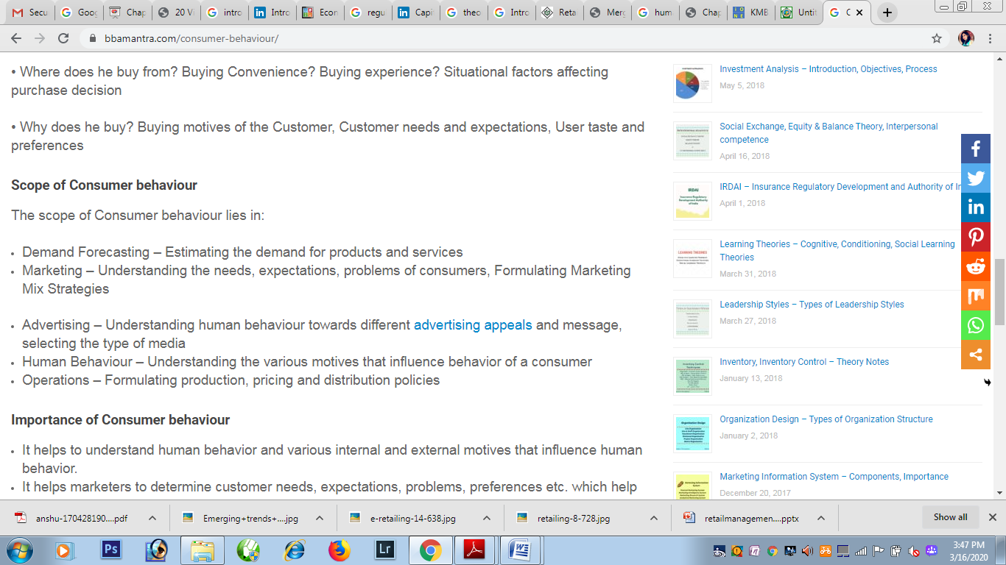
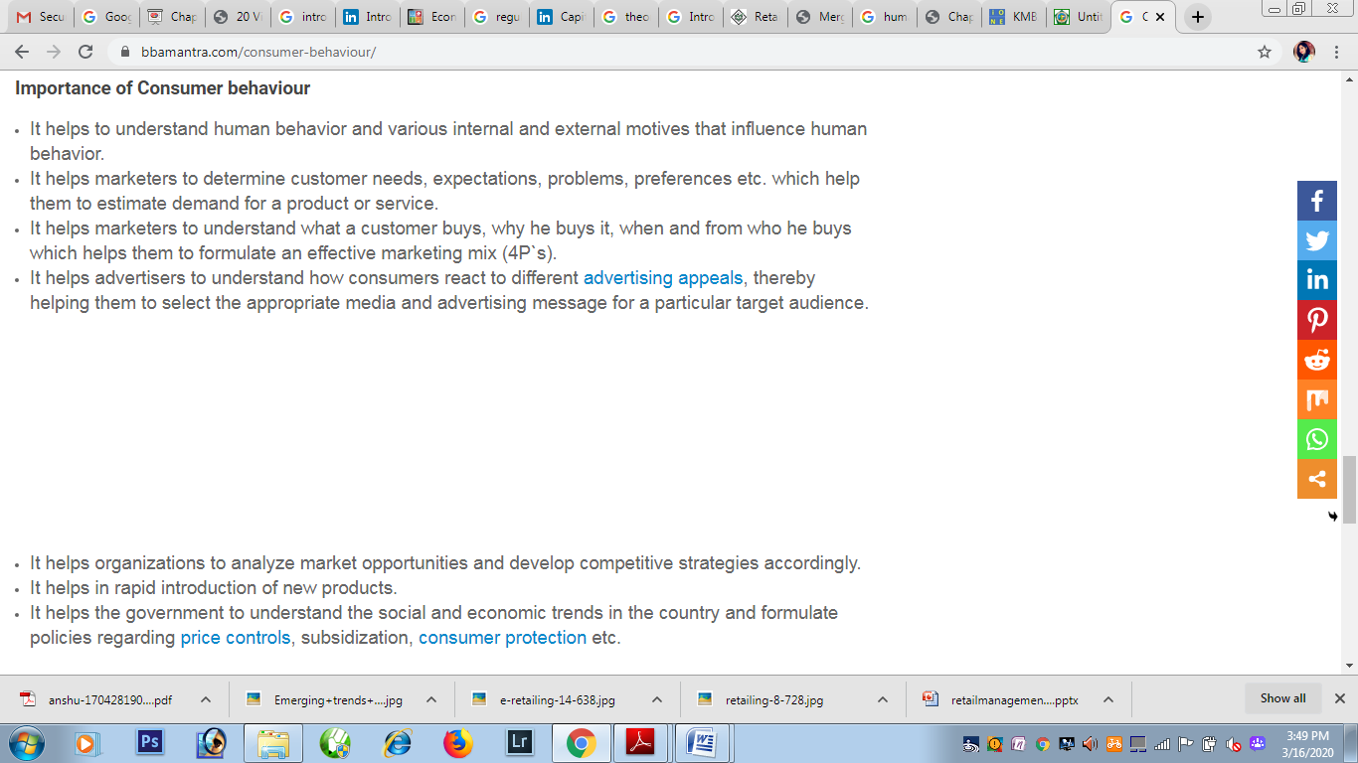

The following consumer research process −
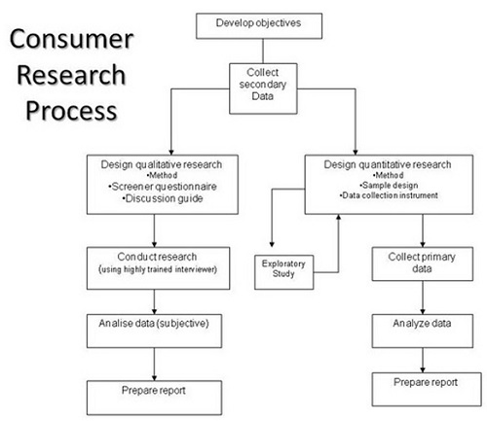

Developing Research Objectives
The first step in the consumer research process is developing the research objectives which involves defining the purposes and objectives to ensure an appropriate design. A statement of objective helps to define the type and level of information needed.

Collect Secondary Data
There are two distinct sources of secondary data − internal and external. Always seek internal sources first. Most go straight to Google without considering the fact that data might exist within the organization itself. This can sometimes be in the ‘heads’ of the personnel.

External Sources
External sources are numerous. Consumer Generated Media (CGM), especially, has grown in importance as a data source. The key is to avoid spending too much time following ‘blind alleys’. This is where the time and cost can escalate sharply.
- Directories
- Country information
- Published marketing research reports
- News sources
- CGM (Newsgroups, blogs, groups)
- Internet – single search engines, and multiple search engines

Primary Research
Primary research is basically the original research. Here you yourself collect the information through various tools available. In primary research, you don’t tend to depend on any third parties. You may conduct interviews or surveys, observe, or even directly go to the object for collecting information.

Quantitative Research
A quantitative research study is comprised of research design, the data collection methods, instruments to be used, and the sample design.
Following are the three basic designs or approaches used for quantitative design −
- Observational Research − In this method of observational research, the people or customers are observed effectively when they purchase a particular product. It helps the researcher to gain in-depth understanding of the relationship between the people and products by observing them while purchasing and using the product.
- Experimentation − Experimentation is a type of research where only certain variables are manipulated while others are kept constant in order to encourage the change in the constant variable
- Surveys − A survey is a method of research in which an interviewer interacts with respondents to obtain facts, opinions and attitudes.
Following are the various survey methods which are generally used −
- Personal interview survey
- Telephone survey
- Mail surveys
- Online surveys
- Quantitative research data collection instruments

Data Collection Instruments for Quantitative Research Data
Questionnaire and Attitude Scale − For quantitative research the primary data collection instrument is a questionnaire and the most frequent one is attitude scale which is used to capture evaluative data.
Following are the important methods of data collection in the qualitative design techniques which are used in the initial stages of research.
- In-Depth Interview − Depth interview is conducted in length and in a non-structured manner where the interviewer is highly trained and minimizes his own participation in the discussion once the general subject is discussed.
- Focus Group − Focus group involves many respondents who interact with the analyst in a group discussion and focuses on a particular product.

Projective Techniques
Projective techniques are best used to understand the motives of people when they are unconsciously rational.
The analyst generally analyzes and reports his findings based on the responses received in qualitative research whereas in quantitative analysis, the researchers oversees the complete research, analyses the open ended questions, classifies the responses and systematically tabulate them.
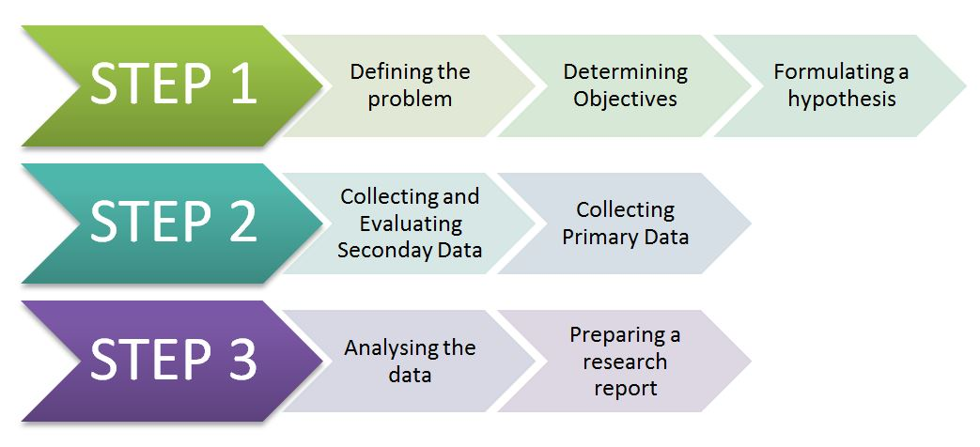
Consumer Research Process is the type of basic research conducted to know the tastes and preferences of the customers so that the company can market the products according to their changing tastes and preferences. So, The Consumer Research Process Notes includes various Steps like:-
- Identification or Formulation of problems or opportunities,
- Establishing the Design for Market Research,
- Choosing a Basic Techniques of Research,
- Select the Best Sampling Procedure,
- Collection of Data,
- Analysis of Data,
- Preparing the Report.

1.Identification Or Formulation of Problems or Opportunities-
This is the first consumer research process and it means to do research for analyzing and formulating the problems and opportunities of consumer behavior. This step will help to identify the causes, benefits, objectives, and remedial measures to solve the problem. Consumer Research Process Example– Technological Advancement, Tastes, and Preferences, and high unemployment rate.

2. Establishing the Design for Market Research-
This is the secondary consumer research process and it means,
(a) It is a planned theme made by the researchers to follow to answer the research objectives,
(b) It is an approach technique to identify the solution of a particular problem,
(c) It helps researchers for doing market research with two forms-

(i) Descriptive Design-
In descriptive design, the researchers find the answers to related questions. It is calculated by Mean, Median, and, Mode of the data collected. For eg– 30% of the persons said they like Virat Kohli.

(ii) Casual Design-
In casual design, we will examine the one variable with another and second variable. It can be calculated by regression analysis to formulate the combination of two or more variables. For eg– the older the respondent, the more he/she likes Virat Kohli.
However, the casual design approach is based on the cause and effect relationship.

3. Choosing a Basic Techniques of Research-
This is the third consumer research process and it means choosing a word determines the targeting. It includes various techniques for solving the problems:

(i) Market Survey-
The survey is an essential part of the research and by which the researchers can acquire the market data, trends, and changing factors. Thus, the survey also helps to define the structure of market challenges and opportunities.

(ii) Observations-
Observation includes cellular data by which the researchers observe the source of data’s and factors which are collected through the market surveys. They observe the collected forms of data and then placed a design format for our research.

4. Select the Best Sampling Procedures-
This is the fourth consumer research process and it means the sample is a subset or sub-part of the individual term. In this, there are two types of sampling will be used, first is probability and second is non-probability.
We can give the information related to the population and number of respondents which constitutes sample size.

5. Collection of Data-
This is the fifth consumer research process and it means data collection is proper of systematic order to gather the necessary information collected by the various sources. The researchers will collect data from various sources:
(i) Creating surveys in a particular target market for acquiring the necessary information related to their problems.
(ii) Through direct marketing (from website surveys, email marketing surveys, creating ads for surveys and so on.
(iii) Through market mediators and government reports,
(iv) Through personal interaction of public.

6. Analysis of Data-
This is the sixth consumer research process and it means observation of data, it consists or analyzes the particular data and transform into meaningful or objective information.
The collected data is analyzed using statistical tools such as Standard deviation, correlation, regression, Keyes square test, e-test, f-test, and ANOVA (Analysis of Variants).

7. Preparing the Report-
This is the seventh consumer research process and it means in this last process step, the researchers should communicate their reports to the team and managers (in the form of oral or written).
And, in this, the researchers made the report of market research for solving the queries and find the answers to a particular problem. The reports also contain various points like:
- Approval Letter,
- Table of Contents,
- List of Examples,
- Methodology research,
- Research Goal,
- Techniques,
- Results,
- Hypothesis,
- Conclusions.
A consumer`s behaviour varies owing to the many factors that influence consumer behaviour. Consumer Behaviour Models have been developed to substantiate the various factors that influence consumer behavior and their decision making process.

UNIT-2
Ten Consumer Behaviour Models
The ten Consumer Behaviour models explained below are:
- Pavlovian Model
- Economic Model
- Input, Process, Output Model
- Psychological Model
- Howarth Sheth Model
- Sociological Model
- Family Decision making model
- Engel-Blackwell-Kollat Model
- Industrial Buying Model
- Nicosia Model

Consumer Behaviour Models – Pavlovian Model
Ivan Pavlov, a famous Psychologist, devised this consumer behaviour model and the model is named after him. Ivan Pavlov conducted experiments to determine the change in behaviour with the help of Dogs. He conditioned the dog`s mind to receive a piece of meat every time a bell is rung and measured the extent of change in behaviour on the basis of levels of saliva secretion in dogs.
Learning was defined as the changes in behavior which are developed through practice and personal experience. The learning process consisted of Drive, Drives and Reinforcement. While a drive refers to a strong internal stimuli which demands an action, drives are inborn psychological needs arising out of thirst, physical pleasures, hunger and pain that create a stimuli that gives out a triggering and non-triggering cues. The triggering (activate the decision process) and non-triggering cues (Only influence the decision process) help to create a response (purchase or do not purchase) which gets reinforced over time in a conditional pattern. Pavlovian Model is purely based on psychology and has been widely accepted around the world.

Consumer Behaviour Models – Economic Model
According to Economic model of consumer behaviour, consumers try to maximize the utility from products on the basis of law of diminishing marginal utility. The desire of consumers to obtain maximum gains by spending a minimum amount acts as the core for the derivation of this model.
The economic model assumes that there is close similarity between the behaviour of buyers and that a homogenous buying pattern is exhibited in the market. The model is based on Income effect, Substitution effect and Price effect.
- Income Effect substantiates that when a person earns more income, he will have more money to spend and so he will purchase more.
- Substitution Effect substantiates the fact that if a substitute product is available at a cheaper cost, then the product in question will be less preferred or less utilized by people.
- Price Effect suggests that when the price of a product is less, consumers tend to purchase more quantity of that product.

Consumer Behaviour Models – Input, Process, Output Model
The input, process, output Model focuses on the product that is being marketed, the environmental forces and family background of the consumer. Factors that act as inputs and outputs in this model are:
Inputs are the marketing efforts in terms of product, price, place, promotion taken by an organization and the environmental forces such as family, reference groups, culture, social class etc. that influence the decision making process of a consumer. These factors which act as inputs trigger the consumer to identify his needs and ensure that the consumer gets the intention to purchase products after careful evaluation of the factors.
Process is concerned with the purchase process. A consumer goes through various steps like need recognition, awareness, evaluation and purchase in order to make a buying decision. While a satisfied customer acts as the brand ambassador exerting influence on future purchases, a dis-satisfied customer acts as a negative reference point spoiling the marketing efforts of the company to promote the product.
Outputs refer to the consumer’s response to the marketing efforts of the organization. Some responses that consumers display are regarding:
- Buying decision
- Choice of Product
- Choice of Brand
- Choice of Dealer or Store
- Purchase timing and amount
- Post Purchase behavior

Consumer Behaviour Models – Psychological Model
- The Psychological Model is based on the famous psychologist A.H. Maslow’s theory of Hierarchy of Needs. The psychological model divides the needs into Psychological Needs, Safety and Security Needs, Social Needs, Ego Needs and Self Actualization Needs. This division of needs is termed as Hierarchy of Needs.
According to this model, the behaviour of consumers gets motivated by their needs and consumer needs never ceases to exist but arise one after another with passing time. A consumer acts according to the strongest need at a particular time, he strives to satisfy the basic needs first and then moves on to a higher level of needs and tries to satisfy them. This process continues till he reaches the highest level in the hierarchy of needs.

Consumer Behaviour Models – Howarth Sheth Model
Howarth Sheth Model substantiates the complexity involved in consumer behavior and takes into consideration various factors like attitudes of consumer, their perception levels and learning capacity that influence consumer behaviour. This model is based on four variables that are:
- Inputs Parameters
- Constructs that are related to perception and learning
- Output Parameters
- Variables that are external or exogenous in nature.
Input Parameters
As per Howarth Sheth Model, inputs are provided by three types of Stimuli namely, Significative Stimuli, Symbolic Stimuli and Social Stimuli that are essential to make a purchase decision.
While a Significative Stimuli refers to the tangible product characteristics like uniqueness, quality, stock availability, price and service effectiveness, a Symbolic Stimuli refers to perception of an individual about a particular product characteristic. Social Stimuli takes into consideration all factors that belong to the societal group to which a consumer belongs. Some factors related to Social Stimuli are reference groups, family and background and consumer`s financial status in the society.
Perceptual and Learning Constructs
Constructs or Psychological variables like Motivation, Attitude, Learning and Perception influence the decision making process of a consumer. When a consumer receives a stimuli and interprets it, the interpretation is influenced by two factors that are stimulus ambiguity and perceptual bias. A stimulus ambiguity occurs when a consumer cannot fully interpret a stimuli while a perceptual bias occurs when an individual manipulates the stimuli according to his needs and experience. These two factors influence a consumer to evaluate a product or brand as good or bad and develop the confidence to purchase it.
Output Parameters
Output in Howarth Sheth Model refers to the final purchase decision and satisfaction or dissatisfaction levels of a consumer after making a purchase. High satisfaction results in elevated brand performance while dissatisfaction leads to lower brand performance.
External or Exogenous variables
External or Exogenous variables refer to the indirect influence exerted on the decision making process of consumers by factors such as financial status, social class, necessity to purchase and personality traits of individuals.
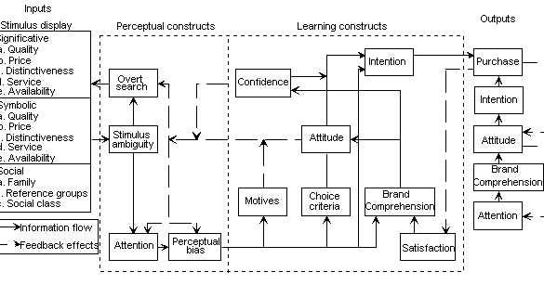
All four factors are dependent on each other and influence the decision making process of a consumer.

Consumer Behaviour Models – Sociological Model
The Sociological Model of Consumer Behavior is closely related to the society and the versatile groups involved in the same. These groups can be classified into Primary and secondary ones. Primary groups consist of close acquaintances, friends, relatives and family members. Secondary group consists of any member in the society, his personality type and requirements based on the same. Sociological Model focuses mainly on the lifestyle and related product requirements of consumers in the society in a holistic manner.

Consumer Behaviour Models – Family Decision making model
The role every member of a family plays in the purchase decision is unique. There are six types of members in a family structure who exert influence over the purchasing decision of the others in the family. They are:
- The User
- The Influencer
- The Preparer
- The Gatekeeper
- The Buyer
- The Decider
The User is the person in the family who plans to use the product being purchased. The user may be a single person in the family or the whole family. For instance, if the purchase decision pertains to a car or television, it may be used by all family members. When a purchase decision pertains to buying a mobile phone or a laptop, it may be for a single person in the family.
The Influencer is the person who keeps the family members updated about products and services new to the market. He convinces them to go in for the same. His influence plays a crucial role in the ultimate decision taken by the family members
The Preparer is the person who gives a product its final shape in which it is actually going to be used by the users in the family. Raw vegetables used for cooking food is an example for the Preparer role where one who cooks is involved in the process.
The Gatekeeper is a person in the family who influences the family members to go in for products which they feel will be useful to them. They safeguard the gates disallowing any product or service information that they dislike from reaching their family members. They help the family in decision making by filtering information or product attributes to make a purchase decision.
The Buyer is the person who actually buys the product. Irrespective of the different kinds of influences exerted by other member of the family, the person playing the role of the Buyer makes the final purchase of the product or service
The Decider is the person in the family who has the money power to buy a product or service chosen for purchase. Family members playing this role have an upper hand in the purchase decision.
Family Decision making Model thus takes into account the many roles played by members of a family and their influence in decision making pertaining to purchase of products and services.
Consumer Behaviour Models – Engel-Blackwell-Kollat Model
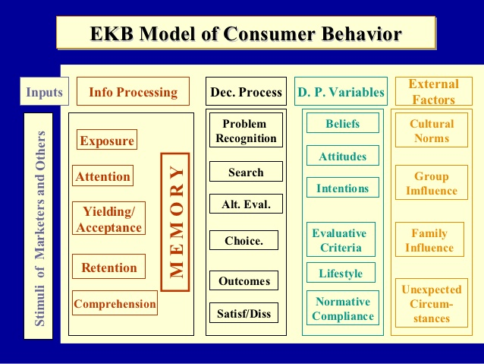
Engel-Blackwell-Kollat Model is based upon four key components namely Information processing (IP), Central Control Unit (CCU), Decision Making process and influences exerted by the environment.
Information Processing (IP) is dependent on many factors which act as stimuli both from a marketing and non-marketing perspective, it consists of four components that are exposure, attention, comprehension and retention. Information Processing focuses on the message to which the consumer is constantly exposed (exposure). When the message instantly grabs the attention of the consumer (attention), the next logical step for him is to comprehend about the same in the rational manner (comprehension). When all of the activities happen in the perfect manner the message is retained in the memory of the consumer (retention).
Central Control Unit (CCU) is based on four factors that are psychological in nature.
- Previous experience of the consumers and their acquaintances about the product
- Criteria based on which a consumer evaluates a product
- Changing mindsets of consumers and
- Personality of the consumer based on which he or she takes the purchase decision.
A consumer processes and interprets all the information on the basis of the above four factors.
The Decision process consists of recognizing the problem, internal and external information search, evaluating the alternatives available and finally purchasing the product. This component deals with the post purchase satisfaction levels as well as dissatisfaction levels which play a crucial role in the future decision making process of the consumers.
The Environmental influences consists of all those factors that may favour or disfavour the purchase decision like:
- Income level of consumers
- Financial status and social class in the society
- Family Influences and other societal factors etc.
Consumer Behaviour Models – Industrial Buying Model
Industrial Buying Model deals with the cumbersome process involved in making purchase decisions in a typical industrial set up. The decision making process related to purchase in an Industrial setup involves many Departments that are concerned with the same in a direct or indirect manner. This model highlights three crucial characteristics involved in purchase decisions by Industries.
- Individuals who hail from different backgrounds, possessing varying psychological outlook are involved in the decision making process
- Joint decision making is inevitable in an Industrial setup
- Decisions pertaining to a purchase may lead to opinion clashes between concerned departments or individuals before an amicable solution is found
Individuals in decision making capacities may be from various departments in an organization. Some Departments concerned are Research and Development Department, Quality Control Department, Finance Department, Manufacturing Department and Technical Support Department amongst the many others. The committee that is formed for making purchase related decision may comprise individuals who
- Have different perceptions
- Hail from varying backgrounds
- Have differing satisfaction levels related to past experience
- Obtain information from different sources
- Search experience that is totally dependent on their skills
The purchase decision in an Industrial setup is dependent on many factors. These factors may be specifically related to products or to the organization that manufactures the concerned products. The product specific factors are the kind of purchase done by consumers, probable risks involved in choosing a particular alternative and the pressure pertaining to the timely delivery of product. The Organization Specific factors focus on solving problems that arise due to the purchase decision from time to time, the persuasion and bargaining issues connected with the same and other factors pertaining to situations that may arise every now and then.
Consumer Behaviour Models – Nicosia Model
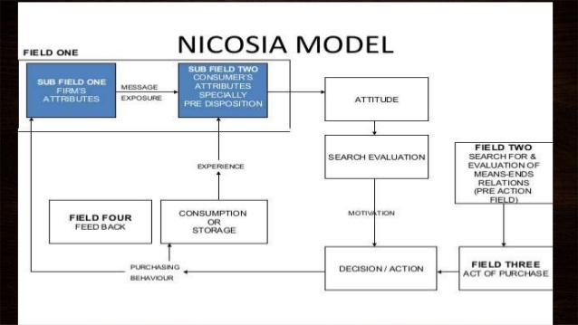
Nicosia Model deals with the level of exposure a consumer gets with respect to the purchase decision. This model is based on four fields such that the output of one field acts as the input of second field and so on.
The First field divided into two sub fields namely:
Sub-field one consists of:
- Product Attributes
- Firm`s Attributes
While subfield two consists of:
- Pre-disposition or existing attitude of a consumer towards the product
- The attributes exhibited by the organization whose products are to be purchased.
The Second Field consists of consumer research and evaluation.
The Third Field is concerned with the buying decision of the consumer.
The Fourth Field is concerned with the post purchase behavior, use of product, its storage and consumption. The consumer who is satisfied with a product or service tends to stock the product for regular or future usage and develops a positive attitude. On the contrary, a dis-satisfied customer tends to develop a negative attitude towards the product or the business house.
The feedback from Fourth Field acts as input for field one. Feedback from field four compels a firm to change the product attributes which in turn act as in put for field two. A change in product attributes bring a change in consumers perception about the product and hence may affect his buying decision and subsequently his post purchase behavior.

