VISION INSTITUTE OF MANAGEMENT
COMPUTER GRAPHICS & MULTIMEDIA APPLICATIONS
BCA 2nd YEAR(4th SEM)
UNIT-1(Introduction)

Computer Graphics:

It is difficult to display an image of any size on the computer screen. This method is simplified by using Computer graphics. Graphics on the computer are produced by using various algorithms and techniques. This tutorial describes how a rich visual experience is provided to the user by explaining how all these processed by the computer.

Introduction of Computer Graphics:
Computer Graphics involves technology to access. The Process transforms and presents information in a visual form. The role of computer graphics insensible. In today life, computer graphics has now become a common element in user interfaces, T.V. commercial motion pictures.
Computer Graphics is the creation of pictures with the help of a computer. The end product of the computer graphics is a picture it may be a business graph, drawing, and engineering.
In computer graphics, two or three-dimensional pictures can be created that are used for research. Many hardware devices algorithm has been developing for improving the speed of picture generation with the passes of time. It includes the creation storage of models and image of objects. These models for various fields like engineering, mathematical and so on.
Today computer graphics is entirely different from the earlier one. It is not possible. It is an interactive user can control the structure of an object of various input devices.

Definition of Computer Graphics:
It is the use of computers to create and manipulate pictures on a display device. It comprises of software techniques to create, store, modify, represents pictures.

Why computer graphics used?
Suppose a shoe manufacturing company want to show the sale of shoes for five years. For this vast amount of information is to store. So a lot of time and memory will be needed. This method will be tough to understand by a common man. In this situation graphics is a better alternative. Graphics tools are charts and graphs. Using graphs, data can be represented in pictorial form. A picture can be understood easily just with a single look.
Interactive computer graphics work using the concept of two-way communication between computer users. The computer will receive signals from the input device, and the picture is modified accordingly. Picture will be changed quickly when we apply command.
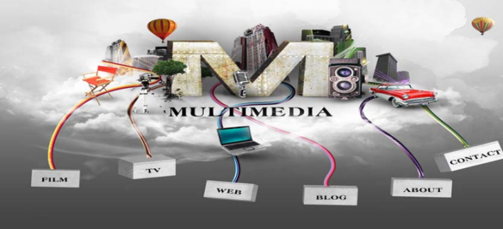

- Application of Computer Graphics:
1. Education and Training: Computer-generated model of the physical, financial and economic system is often used as educational aids. Model of physical systems, physiological system, population trends or equipment can help trainees to understand the operation of the system.
For some training applications, particular systems are designed. For example Flight Simulator.
Flight Simulator: It helps in giving training to the pilots of airplanes. These pilots spend much of their training not in a real aircraft but on the ground at the controls of a Flight Simulator.
- Application of Computer Graphics:
1. Education and Training: Computer-generated model of the physical, financial and economic system is often used as educational aids. Model of physical systems, physiological system, population trends or equipment can help trainees to understand the operation of the system.
For some training applications, particular systems are designed. For example Flight Simulator.
Flight Simulator: It helps in giving training to the pilots of airplanes. These pilots spend much of their training not in a real aircraft but on the ground at the controls of a Flight Simulator.

Advantages:
- Fuel Saving
- Safety
- Ability to familiarize the training with a large number of the world's airports.
2. Use in Biology: Molecular biologist can display a picture of molecules and gain insight into their structure with the help of computer graphics.
3. Computer-Generated Maps: Town planners and transportation engineers can use computer-generated maps which display data useful to them in their planning work.
4. Architect: Architect can explore an alternative solution to design problems at an interactive graphics terminal. In this way, they can test many more solutions that would not be possible without the computer.
5. Presentation Graphics: Example of presentation Graphics are bar charts, line graphs, pie charts and other displays showing relationships between multiple parameters. Presentation Graphics is commonly used to summarize
- Financial Reports
- Statistical Reports
- Mathematical Reports
- Scientific Reports
- Economic Data for research reports
- Managerial Reports
- Consumer Information Bulletins
- And other types of reports
6. Computer Art: Computer Graphics are also used in the field of commercial arts. It is used to generate television and advertising commercial.
7. Entertainment: Computer Graphics are now commonly used in making motion pictures, music videos and television shows.
8. Visualization: It is used for visualization of scientists, engineers, medical personnel, business analysts for the study of a large amount of information.
9. Educational Software: Computer Graphics is used in the development of educational software for making computer-aided instruction.
10. Printing Technology: Computer Graphics is used for printing technology and textile design.
- Interactive and Passive Graphics:

(a) Non-Interactive or Passive Computer Graphics:
In non-interactive computer graphics, the picture is produced on the monitor, and the user does not have any controlled over the image, i.e., the user cannot make any change in the rendered image. One example of its Titles shown on T.V.
Non-interactive Graphics involves only one-way communication between the computer and the user, User can see the produced image, and he cannot make any change in the image.

(b) Interactive Computer Graphics:
In interactive Computer Graphics user have some controls over the picture, i.e., the user can make any change in the produced image. One example of it is the ping-pong game.
Interactive Computer Graphics require two-way communication between the computer and the user. A User can see the image and make any change by sending his command with an input device.

Advantages:
- Higher Quality
- More precise results or products
- Greater Productivity
- Lower analysis and design cost
- Significantly enhances our ability to understand data and to perceive trends.

Working of Interactive Computer Graphics:
The modern graphics display is very simple in construction. It consists of three components:
- Frame Buffer or Digital Memory
- A Monitor likes a home T.V. set without the tuning and receiving electronics.
- Display Controller or Video Controller: It passes the contents of the frame buffer to the monitor.
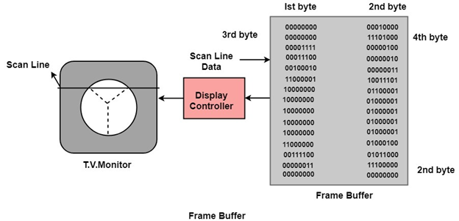

Frame Buffer: A digital frame buffer is large, contiguous piece of computer memory used to hold or map the image displayed on the screen.
- At a minimum, there is 1 memory bit for each pixel in the raster. This amount of memory is called a bit plane.
- A 1024 x 1024 element requires 2²⁰ (2¹⁰=1024;2²⁰=1024 x 1024)sq.raster or 1,048,576 memory bits in a single bit plane.
- The picture is built up in the frame buffer one bit at a time.
- ∵ A memory bit has only two states (binary 0 or 1), a single bit plane yields a black and white (monochrome display).
- As frame buffer is a digital device write raster CRT is an analog device.

Properties of Video Monitor:
1. Persistence: Persistence is the duration of phosphorescence. Different kinds of phosphors are available for use in CRT. Besides color, a major difference between phosphor in their persistence how they continue to emit light after the electron beam is removed.
2. Resolution: Use to describe the number of pixels that are used on display image.
3. Aspect Ratio: It is the ratio of width to its height. Its measure is unit in length or number of pixels.
Aspect Ratio =width unit/height unit
Graphic Systems

Display Processor:
It is interpreter or piece of hardware that converts display processor code into pictures. It is one of the four main parts of the display processor
Parts of Display Processor-
- Display File Memory
- Display Processor
- Display Generator
- Display Console

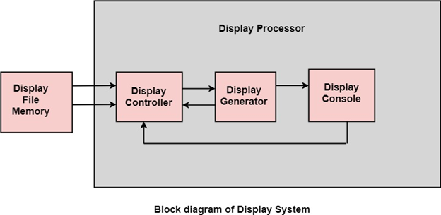

Display File Memory: It is used for generation of the picture. It is used for identification of graphic entities.
Display Controller:
- It handles interrupt
- It maintains timings
- It is used for interpretation of instruction.
Display Generator:
- It is used for the generation of character.
- It is used for the generation of curves.
Display Console: It contains CRT, Light Pen, and Keyboard and deflection system.
The raster scan system is a combination of some processing units. It consists of the control processing unit (CPU) and a particular processor called a display controller. Display Controller controls the operation of the display device. It is also called a video controller.
Working: The video controller in the output circuitry generates the horizontal and vertical drive signals so that the monitor can sweep. Its beam across the screen during raster scans.
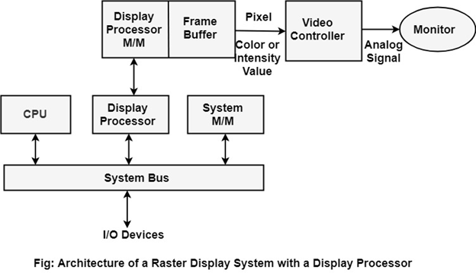

As fig showing that 2 registers (X register and Y register) are used to store the coordinate of the screen pixels. Assume that y values of the adjacent scan lines increased by 1 in an upward direction starting from 0 at the bottom of the screen to y_{max} at the top and along each scan line the screen pixel positions or x values are incremented by 1 from 0 at the leftmost position to x_{max} at the rightmost position.
The origin is at the lowest left corner of the screen as in a standard Cartesian coordinate system.
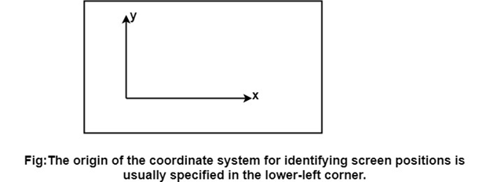

At the start of a Refresh Cycle:
X register is set to 0 and y register is set to y_{max}. This (x, y') address is translated into a memory address of frame buffer where the color value for this pixel position is stored.
The controller receives this color value (a binary no) from the frame buffer, breaks it up into three parts and sends each element to a separate Digital-to-Analog Converter (DAC).
These voltages, in turn, controls the intensity of 3 e-beam that are focused at the (x, y) screen position by the horizontal and vertical drive signals.
This process is repeated for each pixel along the top scan line, each time incrementing the X register by Y.
As pixels on the first scan line are generated, the X register is incremented throughx_{max}.
Then x register is reset to 0, and y register is decremented by 1 to access the next scan line.
Pixel along each scan line is then processed, and the procedure is repeated for each successive scan line units pixels on the last scan line (y=0) are generated.
For a display system employing a color look-up table frame buffer value is not directly used to control the CRT beam intensity.
It is used as an index to find the three pixel-color value from the look-up table. This lookup operation is done for each pixel on every display cycle.
As the time available to display or refresh a single pixel in the screen is too less, accessing the frame buffer every time for reading each pixel intensity value would consume more time what is allowed:
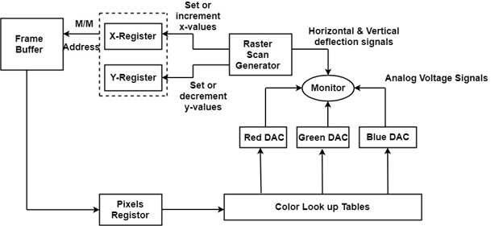

Multiple adjacent pixel values are fetched to the frame buffer in single access and stored in the register.
After every allowable time gap, the one-pixel value is shifted out from the register to control the warm intensity for that pixel.
The procedure is repeated with the next block of pixels,and so on, thus the whole group of pixels will be processed.

Display Devices:
The most commonly used display device is a video monitor. The operation of most video monitors based on CRT (Cathode Ray Tube). The following display devices are used:
- Refresh Cathode Ray Tube
- Random Scan and Raster Scan
- Color CRT Monitors
- Direct View Storage Tubes
- Flat Panel Display

Cathode Ray Tube (CRT):
CRT stands for Cathode Ray Tube. CRT is a technology used in traditional computer monitors and televisions. The image on CRT display is created by firing electrons from the back of the tube of phosphorus located towards the front of the screen.
Once the electron heats the phosphorus, they light up, and they are projected on a screen. The color you view on the screen is produced by a blend of red, blue and green light.
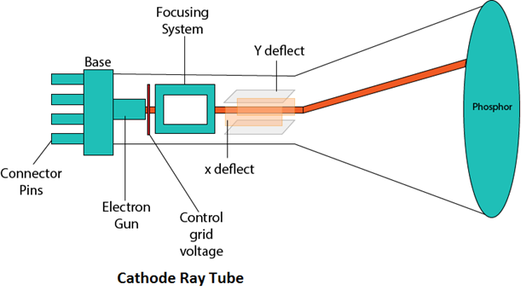

Components of CRT:
Main Components of CRT are:
1. Electron Gun: Electron gun consisting of a series of elements, primarily a heating filament (heater) and a cathode. The electron gun creates a source of electrons which are focused into a narrow beam directed at the face of the CRT.
2. Control Electrode: It is used to turn the electron beam on and off.
3. Focusing system: It is used to create a clear picture by focusing the electrons into a narrow beam.
4. Deflection Yoke: It is used to control the direction of the electron beam. It creates an electric or magnetic field which will bend the electron beam as it passes through the area. In a conventional CRT, the yoke is linked to a sweep or scan generator. The deflection yoke which is connected to the sweep generator creates a fluctuating electric or magnetic potential.
5. Phosphorus-coated screen: The inside front surface of every CRT is coated with phosphors. Phosphors glow when a high-energy electron beam hits them. Phosphorescence is the term used to characterize the light given off by a phosphor after it has been exposed to an electron beam.

Random Scan and Raster Scan Display:

Random Scan Display:
Random Scan System uses an electron beam which operates like a pencil to create a line image on the CRT screen. The picture is constructed out of a sequence of straight-line segments. Each line segment is drawn on the screen by directing the beam to move from one point on the screen to the next, where its x & y coordinates define each point. After drawing the picture. The system cycles back to the first line and design all the lines of the image 30 to 60 time each second. The process is shown in fig:
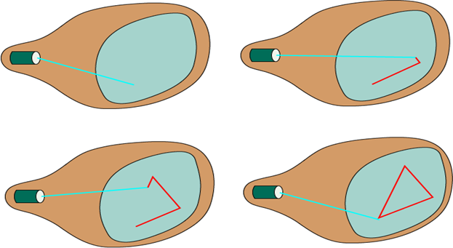

Random-scan monitors are also known as vector displays or stroke-writing displays or calligraphic displays.

Advantages:
- A CRT has the electron beam directed only to the parts of the screen where an image is to be drawn.
- Produce smooth line drawings.
- High Resolution

Disadvantages:
- Random-Scan monitors cannot display realistic shades scenes.

Raster Scan Display:
A Raster Scan Display is based on intensity control of pixels in the form of a rectangular box called Raster on the screen. Information of on and off pixels is stored in refresh buffer or Frame buffer. Televisions in our house are based on Raster Scan Method. The raster scan system can store information of each pixel position, so it is suitable for realistic display of objects. Raster Scan provides a refresh rate of 60 to 80 frames per second.
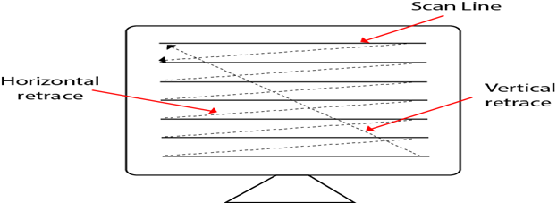
Types of Scanning or travelling of beam in Raster Scan
- Interlaced Scanning
- Non-Interlaced Scanning
In Interlaced scanning, each horizontal line of the screen is traced from top to bottom. Due to which fading of display of object may occur. This problem can be solved by Non-Interlaced scanning. In this first of all odd numbered lines are traced or visited by an electron beam, then in the next circle, even number of lines are located.
For non-interlaced display refresh rate of 30 frames per second used. But it gives flickers. For interlaced display refresh rate of 60 frames per second is used.

Advantages:
- Realistic image
- Million Different colors to be generated
- Shadow Scenes are possible.

Disadvantages:
- Low Resolution
- Expensive

Differentiate between Random and Raster Scan Display:

Random Scan | Raster Scan
1. It has high Resolution | 1. Its resolution is low.
2. It is more expensive | 2. It is less expensive
3. Any modification if needed is easy | 3.Modification is tough
4. Solid pattern is tough to fill | 4.Solid pattern is easy to fill
5. Refresh rate depends or resolution | 5. Refresh rate does not depend on the picture.
6. Only screen with view on an area is displayed. | 6. Whole screen is scanned.
7. Beam Penetration technology come under it. | 7. Shadow mark technology came under this.
8. It does not use interlacing method. | 8. It uses interlacing
9. It is restricted to line drawing applications | 9. It is suitable for realistic display.

Direct View Storage Tubes:
DVST terminals also use the random scan approach to generate the image on the CRT screen. The term "storage tube" refers to the ability of the screen to retain the image which has been projected against it, thus avoiding the need to rewrite the image constantly.
Function of guns: Two guns are used in DVST
- Primary guns: It is used to store the picture pattern.
- Flood gun or Secondary gun: It is used to maintain picture display.

Advantage:
- No refreshing is needed.
- High Resolution
- Cost is very less

Disadvantage:
- It is not possible to erase the selected part of a picture.
- It is not suitable for dynamic graphics applications.
- If a part of picture is to modify, then time is consumed.

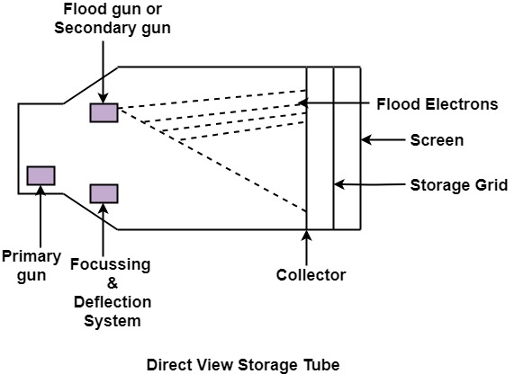

INPUT/ OUTPUT DEVICES-

Input Devices:

The Input Devices are the hardware that is used to transfer transfers input to the computer. The data can be in the form of text, graphics, sound, and text. Output device display data from the memory of the computer. Output can be text, numeric data, line, polygon, and other objects.

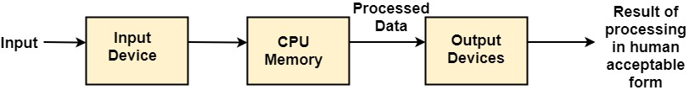
These Devices include:
- Keyboard
- Mouse
- Trackball
- Space ball
- Joystick
- Light Pen
- Digitizer
- Touch Panels
- Voice Recognition
- Image Scanner

Output Devices:
It is an electromechanical device, which accepts data from a computer and translates them into form understand by users.
Following are Output Devices:
- Printers
- Plotters

Printers:
Printer is the most important output device, which is used to print data on paper.
Types of Printers: There are many types of printers which are classified on various criteria as shown in fig:
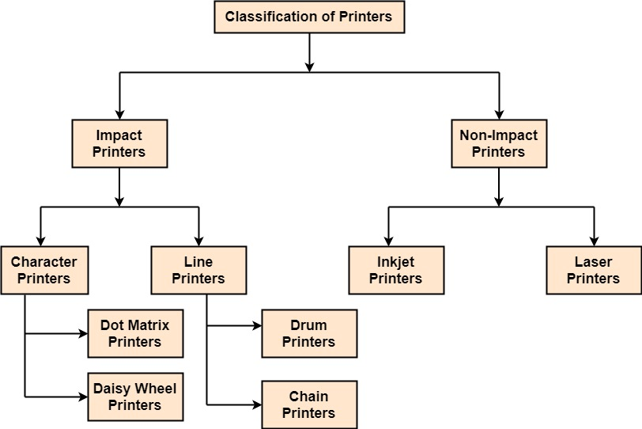
1. Impact Printers: The printers that print the characters by striking against the ribbon and onto the papers are known as Impact Printers.
These Printers are of two types:
- Character Printers
- Line Printers
2. Non-Impact Printers: The printers that print the characters without striking against the ribbon and onto the papers are called Non-Impact Printers. These printers print a complete page at a time, therefore, also known as Page Printers.
Page Printers are of two types:
- Laser Printers
- Inkjet Printers

Plotters:
Plotters are a special type of output device. It is suitable for applications:
- Architectural plan of the building.
- CAD applications like the design of mechanical components of aircraft.
- Many engineering applications.

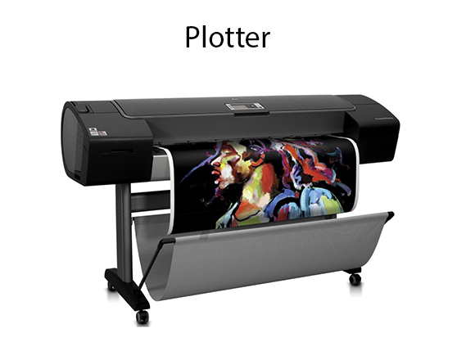

Advantage:
- It can produce high-quality output on large sheets.
- It is used to provide the high precision drawing.
- It can produce graphics of various sizes.
- The speed of producing output is high.
SCAN CONVERSION LINES

Scan Conversion Definition:
It is a process of representing graphics objects a collection of pixels. The graphics objects are continuous. The pixels used are discrete. Each pixel can have either on or off state.
The circuitry of the video display device of the computer is capable of converting binary values (0, 1) into a pixel on and pixel off information. 0 is represented by pixel off. 1 is represented using pixel on. Using this ability graphics computer represent picture having discrete dots.
Any model of graphics can be reproduced with a dense matrix of dots or points. Most human beings think graphics objects as points, lines, circles, ellipses. For generating graphical object, many algorithms have been developed.

Advantage of developing algorithms for scan conversion:
- Algorithms can generate graphics objects at a faster rate.
- Using algorithms memory can be used efficiently.
- Algorithms can develop a higher level of graphical objects.

Examples of objects which can be scan converted
- Point
- Line
- Sector
- Arc
- Ellipse
- Rectangle
- Polygon
- Characters
- Filled Regions
The process of converting is also called as rasterization. The algorithms implementation varies from one computer system to another computer system. Some algorithms are implemented using the software. Some are performed using hardware or firmware. Some are performed using various combinations of hardware, firmware, and software.

Pixel or Pel:
The term pixel is a short form of the picture element. It is also called a point or dot. It is the smallest picture unit accepted by display devices. A picture is constructed from hundreds of such pixels. Pixels are generated using commands. Lines, circle, arcs, characters; curves are drawn with closely spaced pixels. To display the digit or letter matrix of pixels is used.
The closer the dots or pixels are, the better will be the quality of picture. Closer the dots are, crisper will be the picture. Picture will not appear jagged and unclear if pixels are closely spaced. So the quality of the picture is directly proportional to the density of pixels on the screen.
Pixels are also defined as the smallest addressable unit or element of the screen. Each pixel can be assigned an address as shown in fig:
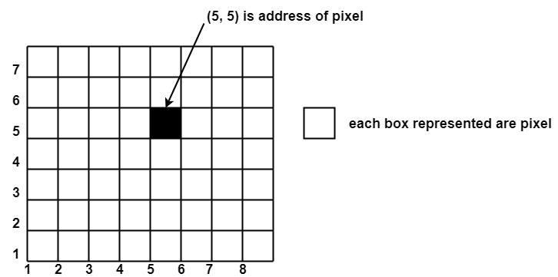

Different graphics objects can be generated by setting the different intensity of pixels and different colors of pixels. Each pixel has some co-ordinate value. The coordinate is represented using row and column.
P (5, 5) used to represent a pixel in the 5th row and the 5th column. Each pixel has some intensity value which is represented in memory of computer called a frame buffer.

DDA Algorithm
DDA stands for Digital Differential Analyzer. It is an incremental method of scan conversion of line. In this method calculation is performed at each step but by using results of previous steps.
Suppose at step i, the pixels is (x_{i},y_{i})
The line of equation for step i
y_{i}=mx_{i+b}......................equation 1
Next value will be
y_{i+1}=m_{xi+1}+b.................equation 2
m =
y_{i+1}-y_{i}=∆y.......................equation 3
y_{i+1}-x_{i}=∆x......................equation 4
y_{i+1}=y_{i}+∆y
∆y=m∆x
y_{i+1}=y_{i}+m∆x
∆x=∆y/m
x_{i+1}=x_{i}+∆x
x_{i+1}=x_{i}+∆y/m
Case1: When |M|<1 then (assume that x₁<x₂₎
_{x= x1,y=y1 set ∆x=1}
_{yi+1=y1+m, x=x+1}
_{Until x = x2</x}
Case2: When |M|<1 then (assume that y₁<y₂₎
x= x1,y=y1 set ∆y=1
xi+1=1/M, y=y+1
Until y → y2</y

Advantage:
- It is a faster method than method of using direct use of line equation.
- This method does not use multiplication theorem.
- It allows us to detect the change in the value of x and y ,so plotting of same point twice is not possible.
- This method gives overflow indication when a point is repositioned.
- It is an easy method because each step involves just two additions.

Disadvantage:
- It involves floating point additions rounding off is done. Accumulations of round off error cause accumulation of error.
- Rounding off operations and floating point operations consumes a lot of time.
- It is more suitable for generating line using the software. But it is less suited for hardware implementation.

DDA Algorithm:
Step1: Start Algorithm
Step2: Declare x₁, y1, x2, y2, dx, dy, x, y as integer variables.
Step3: Enter value of x₁, y1, x2, y2.
Step4: Calculate dx = x₂-x₁
Step5: Calculate dy = y₂-y₁
Step6: If ABS (dx) > ABS (dy)
Then step = abs (dx)
Else
Step7: x_{inc}=dx/step
y_{inc}=dy/step
assign x = x₁
assign y = y₁
Step8: Set pixel (x, y)
Step9: x = x + x_{inc}
y = y + y_{inc}
Set pixels (Round (x), Round (y))
Step10: Repeat step 9 until x = x₂
Step11: End Algorithm
Example: If a line is drawn from (2, 3) to (6, 15) with use of DDA. How many points will needed to generate such line?
Solution: P₁ (2,3) P₁₁ (6,15)
x₁=2
y₁=3
x₂= 6
y₂=15
dx = 6 - 2 = 4
dy = 15 - 3 = 12
m = dy/dx=12/4=3
For calculating next value of x takes x=x+1/m
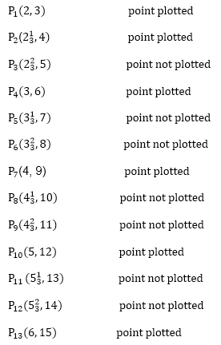

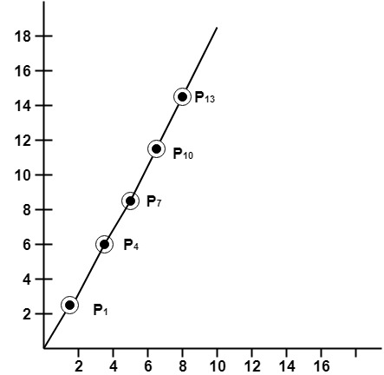

Bresenham's Line Algorithm-
This algorithm is used for scan converting a line. It was developed by Bresenham. It is an efficient method because it involves only integer addition, subtractions, and multiplication operations. These operations can be performed very rapidly so lines can be generated quickly.
In this method, next pixel selected is that one who has the least distance from true line.
The method works as follows:
Assume a pixel P₁'(x₁', y1’), then select subsequent pixels as we work our way to the night, one pixel position at a time in the horizontal direction toward P₂'(x₂', y2’).
Once a pixel in choose at any step
The next pixel is
- Either the one to its right (lower-bound for the line)
- One top its right and up (upper-bound for the line)
The line is best approximated by those pixels that fall the least distance from the path between P₁', P2’
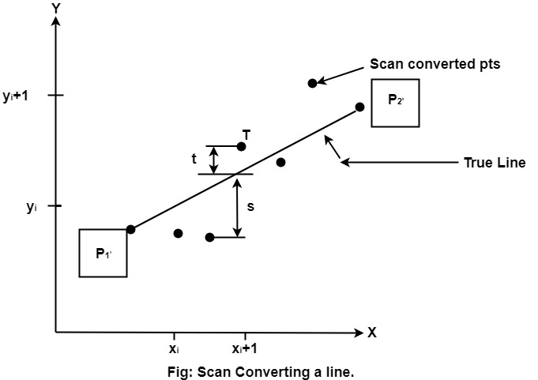

Advantage:
1. It involves only integer arithmetic, so it is simple.
2. It avoids the generation of duplicate points.
3. It can be implemented using hardware because it does not use multiplication and division.
4. It is faster as compared to DDA (Digital Differential Analyzer) because it does not involve floating point calculations like DDA Algorithm.

Disadvantage:
- This algorithm is meant for basic line drawing only Initializing is not a part of Bresenham's line algorithm. So to draw smooth lines, you should want to look into a different algorithm.

Bresenham's Line Algorithm:
Step1: Start Algorithm
Step2: Declare variable x₁, x2, y1, y2, d, i1, i2, dx, dy
Step3: Enter value of x₁, y1, x2, y2
where x₁, y1are coordinates of starting point
and x₂, y2 are coordinates of Ending point
Step4: Calculate dx = x₂-x₁
Calculate dy = y₂-y₁
Calculate i₁=2*dy
Calculate i₂=2*(dy-dx)
Calculate d=i₁-dx
Step5: Consider (x, y) as starting point and x_{end}as maximum possible value of x.
If dx < 0
Then x = x₂
y = y₂
x_{end}=x₁
If dx > 0
Then x = x₁
y = y₁
x_{end}=x₂
Step6: Generate point at (x,y)coordinates.
Step7: Check if whole line is generated.
If x > = x_{end}
Stop.
Step8: Calculate co-ordinates of the next pixel
If d < 0
Then d = d + i₁
If d ≥ 0
Then d = d + i₂
Increment y = y + 1
Step9: Increment x = x + 1
Step10: Draw a point of latest (x, y) coordinates
Step11: Go to step 7
Step12: End of Algorithm
Example: Starting and Ending position of the line are (1, 1) and (8, 5). Find intermediate points.
Solution: x₁=1
y₁=1
x₂=8
y₂=5
dx= x₂-x₁=8-1=7
dy=y₂-y₁=5-1=4
I₁=2* ∆y=2*4=8
I₂=2*(∆y-∆x)=2*(4-7)=-6
d = I₁-∆x=8-7=1
x | y | d=d+I₁ or I₂
1 | 1 | d+I₂=1+(-6)=-5
2 | 2 | d+I₁=-5+8=3
3 | 2 | d+I₂=3+(-6)=-3
4 | 3 | d+I₁=-3+8=5
5 | 3 | d+I₂=5+(-6)=-1
6 | 4 | d+I₁=-1+8=7
7 | 4 | d+I₂=7+(-6)=1
8 | 5
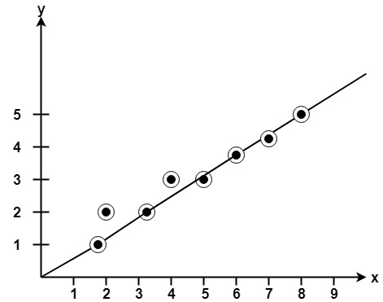

Program to implement Bresenham's Line Drawing Algorithm:

#include<stdio.h>
#include<graphics.h>
void drawline(int x0, int y0, int x1, int y1)
{
int dx, dy, p, x, y;
dx=x1-x0;
dy=y1-y0;
x=x0;
y=y0;
p=2*dy-dx;
while(x<x1)
{
if(p>=0)
{
putpixel(x,y,7);
y=y+1;
p=p+2*dy-2*dx;
}
else
{
putpixel(x,y,7);
p=p+2*dy;}
x=x+1;
}
}
int main()
{
int gdriver=DETECT, gmode, error, x0, y0, x1, y1;
initgraph(&gdriver, &gmode, "c:\\turboc3\\bgi");
printf("Enter co-ordinates of first point: ");
scanf("%d%d", &x0, &y0);
printf("Enter co-ordinates of second point: ");
scanf("%d%d", &x1, &y1);
drawline(x0, y0, x1, y1);
return 0;
}

OUTPUT:
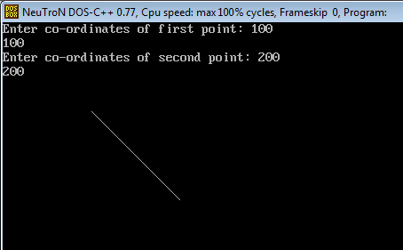

MidPoint Circle Algorithm:
It is based on the following function for testing the spatial relationship between the arbitrary point (x, y) and a circle of radius r centered at the origin:
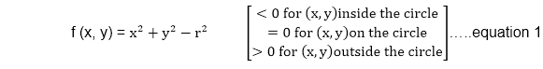
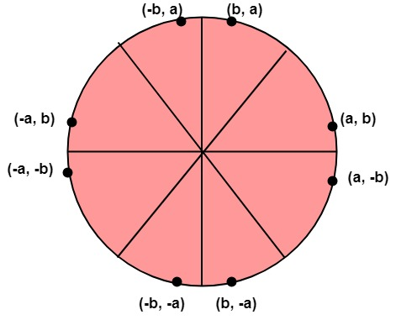

Algorithm:
Step1: Put x =0, y =r in equation 2
we have p=1-r
Step2: Repeat steps while x ≤ y
Plot (x, y)
If (p<0)
Then set p = p + 2x + 3
Else
p = p + 2(x-y)+5
y =y - 1 (end if)
x =x+1 (end loop)
Step3: End

Program to draw a circle using Midpoint Algorithm:

#include <graphics.h>
#include <stdlib.h>
#include <math.h>
#include <stdio.h>
#include <conio.h>
#include <iostream.h>

class bresen
{
float x, y,a, b, r, p;
public:
void get ();
void cal ();
};
void main ()
{
bresen b;
b.get ();
b.cal ();
getch ();
}
Void bresen :: get ()
{
cout<<"ENTER CENTER AND RADIUS";
cout<< "ENTER (a, b)";
cin>>a>>b;
cout<<"ENTER r";
cin>>r;
}
void bresen ::cal ()
{
/* request auto detection */
int gdriver = DETECT,gmode, errorcode;
int midx, midy, i;
/* initialize graphics and local variables */
initgraph (&gdriver, &gmode, " ");
/* read result of initialization */
errorcode = graphresult ();
if (errorcode ! = grOK) /*an error occurred */
{
printf("Graphics error: %s \n", grapherrormsg (errorcode);
printf ("Press any key to halt:");
getch ();
exit (1); /* terminate with an error code */
}
x=0;
y=r;
putpixel (a, b+r, RED);
putpixel (a, b-r, RED);
putpixel (a-r, b, RED);
putpixel (a+r, b, RED);
p=5/4)-r;
while (x<=y)
{
If (p<0)
p+= (4*x)+6;
else
{
p+=(2*(x-y))+5;
y--;
}
x++;
putpixel (a+x, b+y, RED);
putpixel (a-x, b+y, RED);
putpixel (a+x, b-y, RED);
putpixel (a+x, b-y, RED);
putpixel (a+x, b+y, RED);
putpixel (a+x, b-y, RED);
putpixel (a-x, b+y, RED);
putpixel (a-x, b-y, RED);
}
}

OUTPUT:
