VISION INSTITUTE OF MANAGEMENT
COMPUTER GRAPHICS & MULTIMEDIA APPLICATION
BCA 2nd YEAR/4th SEM
UNIT 2

Raster-Scan Displays
Raster Scan Displays are most common type of graphics monitor which employs CRT. It is based on television technology. In raster scan system electron beam sweeps across the screen, from top to bottom covering one row at a time. A pattern of illuminated pattern of spots is created by turning beam intensity on and off as it moves across each row. A memory area called refresh buffer or frame buffer stores picture definition. This memory area holds intensity values for all screen points. Stored intensity values are restored from frame buffer and painted on screen taking one row at a time. Each screen point is referred to as pixels.
In raster scan systems refreshing is done at done at a rate of 60-80 frames per second. Refresh rates are also sometimes described in units of cycles per second / Hertz (Hz). At the end of each scan line, electron beam begins to display next scan line after returning to left side of screen. The return to the left of screen after refresh of each scan line is known as horizontal retrace of electron beam. At the end of each frame electron beam returns to top left corner and begins the next frame.

Raster-Scan Display Processor:
An important function of display process is to digitize a picture definition given in an application program into a set of pixel-intensity values for storage in refresh buffer. This process is referred to as scan conversion. The purpose of display processors is to relieve the CPU from graphics jobs.
Display processors can perform various other tasks like: creating different line styles, displaying colour areas, etc. Typically display processors are utilized to interface input devices, such as mouse, joysticks.
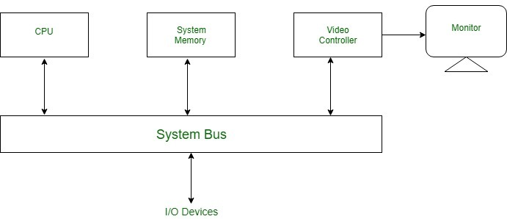

What Is a Video Controller?
A video controller, often referred to as a video or graphics card, is a key hardware component that allows computers to generate graphic information to any video display devices, such as a monitor or projector. They are also known as graphics or video adapters. Some modern computers do not include video cards, but rather have graphics processing units directly integrated into the computer's motherboard.

Older Video Controllers
A video controller, once more commonly referred to as a video display controller, were used in older models of home-computers during the 1980s; they were also used in some early video game system consoles. Their main function as an integrated circuit in a video signal generator was to produce television video signals in computers or game systems. Although they could generate graphics, older video controller models did not have specialized hardware accelerators that created 2D and 3D images.

Evolution of the Video Controller
Modern video controllers are installed with hardware accelerators that create both 2D and 3D images. They also offer various functions beyond accelerated image rendering, such as TV output and the ability to hook up to several monitors. Although many computers' motherboards are already integrated with graphics processing units, you can disable the integrated graphics chip via the computer's BIOS to install a higher-performance video controller via the accelerated graphics port. For a modern video controller to function properly in a computer, a computer needs to have four essential units: a functioning motherboard, a processor that generates the power that a video controller needs to perform its tasks, enough memory to distribute the images created by the GPU and a screen or monitor to properly display these images.

GPU
As the brain of a computer's motherboard is the CPU, video controllers have their own unique "centres," referred to as the graphics processing unit, although the GPU is also referred to as the visual processing unit. The GPU's specialized electronic circuit is designed specifically to translate data into graphic images and performs complex mathematical calculations in order to do so. GPUs are also embedded into mobile phones and game consoles.

Advanced Video Cards
A modern video controller, more frequently referred to as a video card, are installed into expansion slots onto the motherboard of a computer. The parts of a modern video card include power supply connectors, a cooling fan, a GPU, and typically also have a PCIe interface, Graphics Double Data Rate version 5 memory, a display port, a digital video interface and an HDMI interface. While some video cards have only one port for connection, other advanced cards have multiple ports that connect to additional televisions and monitors. Advanced 3D graphics cards, which are more expensive than the average consumer graphics card, allow consumers to preview modeling viewpoints more fluidly. For example, both AMD Radeon and Nvidia release popular graphics cards used by gamers. At the time of publication, the specs for a high-performance video card made by AMD is the Radeon video card, which has 4GB of memory, 1250 MHz memory clock speed and 320GB per-second memory bandwidth. For graphic artists, many computers come with GPU-accelerated apps, such as Microsoft's DirectX or Nvida's close integration with the Autodesk suite. Rather than utilizing a video card slot, GPU-accelerated programs are integrated into the CPU.
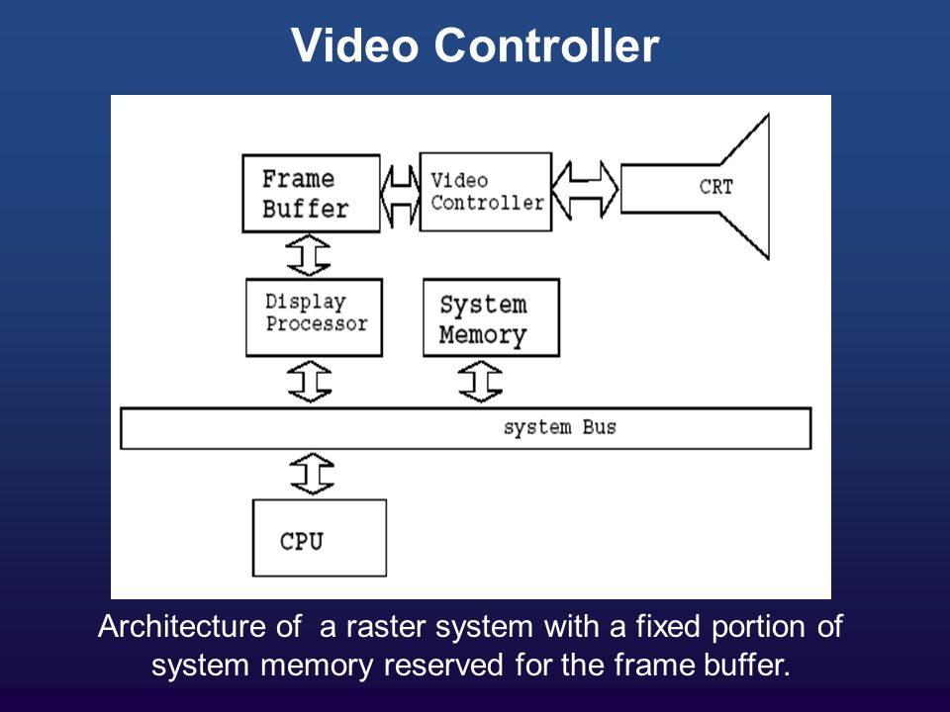

Display Processor in Computer Graphics
Display Processor is the interpreter or a hardware that converts display processor code into picture. The Display Processor converts the digital information from CPU to analogy values. The main purpose of the Digital Processor is to free the CPU from most of the graphic chores. The Display Processor digitize a picture definitions given in an application program into a set of pixel intensity values for storage in the frame buffer. This digitization process is called Scan Conversion.

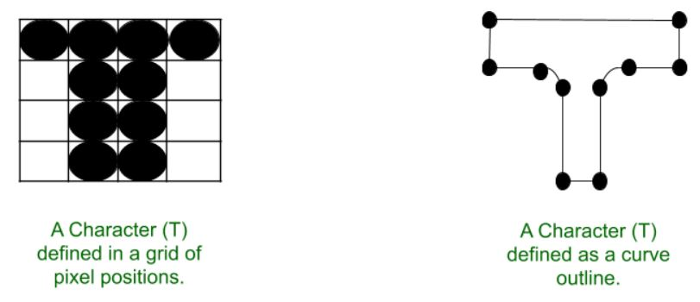

Features of Display Processor:
- Display processors includes functions such as generating various line styles, displaying color area and performing transformations and manipulations on display object.

- Display Processor was used before the GPU (Graphics Display Processor).

- Video Controller is the most widely used Display device that is based on CRT (Cathode Ray Tube).

- In addition with the system memory, Display Processor have a separate memory area.

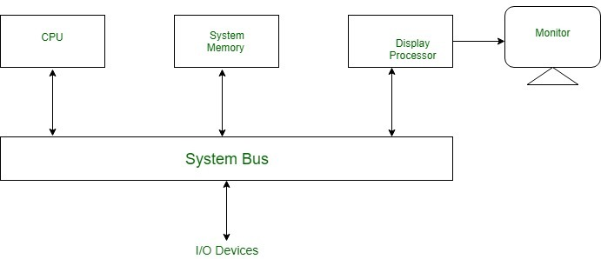

Display Devices:
There are large number of Display Devices available to free the CPU from graphic chores:

- Refresh Cathode Ray Tube
- Random Scan and Raster Scan
- Color CRT Monitors
- Direct View Storage Tubes
- Flat Panel Display
- Lookup Table

Image Scanner
It is an input device. The data or text is written on paper. The paper is feeded to scanner. The paper written information is converted into electronic format; this format is stored in the computer. The input documents can contain text, handwritten material, picture extra.
By storing the document in a computer document became safe for longer period of time. The document will be permanently stored for the future. We can change the document when we need. The document can be printed when needed.
Scanning can be of the black and white or colored picture. On stored picture 2D or 3D rotations, scaling and other operations can be applied.

Types of image Scanner:
1. Flat Bed Scanner: It resembles a photocopy machine. It has a glass top on its top. Glass top in further covered using a lid. The document to be scanned is kept on glass plate. The light is passed underneath side of glass plate. The light is moved left to right. The scanning is done the line by line. The process is repeated until the complete line is scanned. Within 20-25 seconds a document of 4" * 6" can be scanned.
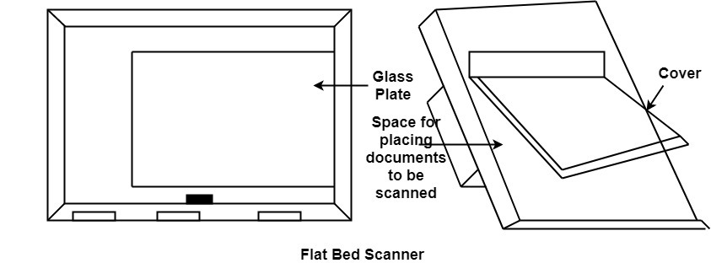

2. Hand Held Scanner: It has a number of LED's (Light Emitting Diodes) the LED's are arranged in the small case. It is called a Hand held Scanner because it can be kept in hand which performs scanning. For scanning the scanner is moved over document from the top towards the bottom. Its light is on, while we move it on document. It is dragged very slowly over document. If dragging of the scanner over the document is not proper, the conversion will not correct.

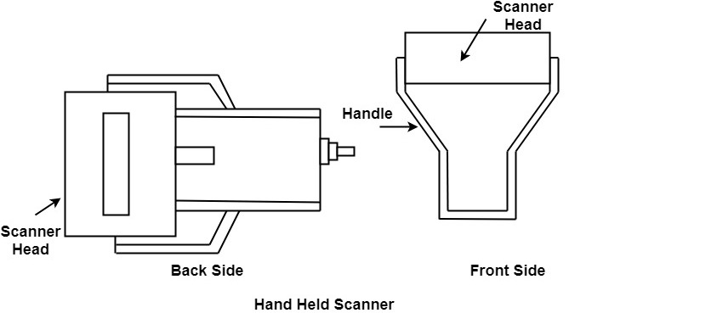

Three Dimensional Graphics
The three-dimensional transformations are extensions of two-dimensional transformation. In 2D two coordinates are used, i.e., x and y whereas in 3D three co-ordinates x, y, and z are used.
For three dimensional images and objects, three-dimensional transformations are needed. These are translations, scaling, and rotation. These are also called as basic transformations are represented using matrix. More complex transformations are handled using matrix in 3D.
The 2D can show two-dimensional objects. Like the Bar chart, pie chart, graphs. But some more natural objects can be represented using 3D. Using 3D, we can see different shapes of the object in different sections.
In 3D when a translation is done we need three factors for rotation also, it is a component of three rotations. Each can be performed along any three Cartesian axis. In 3D also we can represent a sequence of transformations as a single matrix.
Computer Graphics uses CAD. CAD allows manipulation of machine components which are 3 Dimensional. It also provides automobile bodies, aircraft parts study. All these activities require realism. For realism 3D is required. In the production of a realistic 3D scene from 2D is tough. It require three dimension, i.e., depth.

3D Geometry
Three dimension system has three axis x, y, z. The orientation of a 3D coordinate system is of two types. Right-handed system and left-handed system.
In the right -handed system thumb of right- hand points to positive z-direction and left- hand system thumb point to negative two directions. Following figure show right-hand orientation of the cube.
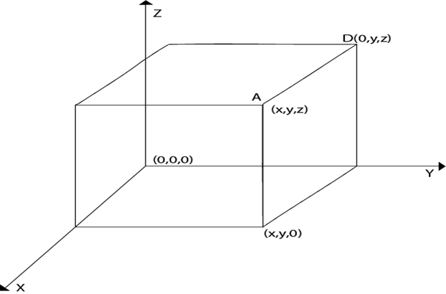

Using right-handed system co-ordinates of corners A, B, C, D of the cube
Point A x, y, z
Point B x, y, 0
Point C 0, y, 0
Point D 0, y, z
Producing realism in 3D: The three-dimensional objects are made using computer graphics. The technique used for two Dimensional displays of three Dimensional objects is called projection. Several types of projection are available, i.e.,
- Parallel Projection
- Perspective Projection
- Orthographic Projection
1. Parallel Projection: In this projection point on the screen is identified within a point in the three-dimensional object by a line perpendicular to the display screen. The architect Drawing, i.e., plan, front view, side view, elevation are nothing but lines of parallel projections.
2. Perspective Projection: This projection has a property that it provides idea about depth. Farther the object from the viewer, smaller it will appear. All lines in perspective projection converge at a center point called as the center of projection.
3. Orthographic Projection: It is simplest kind of projection. In this, we take a top, bottom, side view of the object by extracting parallel lines from the object.

Three Dimensional Models
The techniques for generating different images of a solid object depend upon the type of object. Two viewing techniques are available for viewing three-dimensional objects.
- Geometry: It is concerned with measurements. Measurement is the location of a point concerning origin or dimension of an object.
- Topological Information: It is used for the structure of a solid object. It is mainly concerned with the formation of polygons with the help of points of objects or the creation of the object with polygons.

Clipping:
When we have to display a large portion of the picture, then not only scaling & translation is necessary, the visible part of picture is also identified. This process is not easy. Certain parts of the image are inside, while others are partially inside. The lines or elements which are partially visible will be omitted.
For deciding the visible and invisible portion, a particular process called clipping is used. Clipping determines each element into the visible and invisible portion. Visible portion is selected. An invisible portion is discarded.

Types of Lines:
Lines are of three types:
- Visible: A line or lines entirely inside the window is considered visible
- Invisible: A line entirely outside the window is considered invisible
- Clipped: A line partially inside the window and partially outside is clipped. For clipping point of intersection of a line with the window is determined.
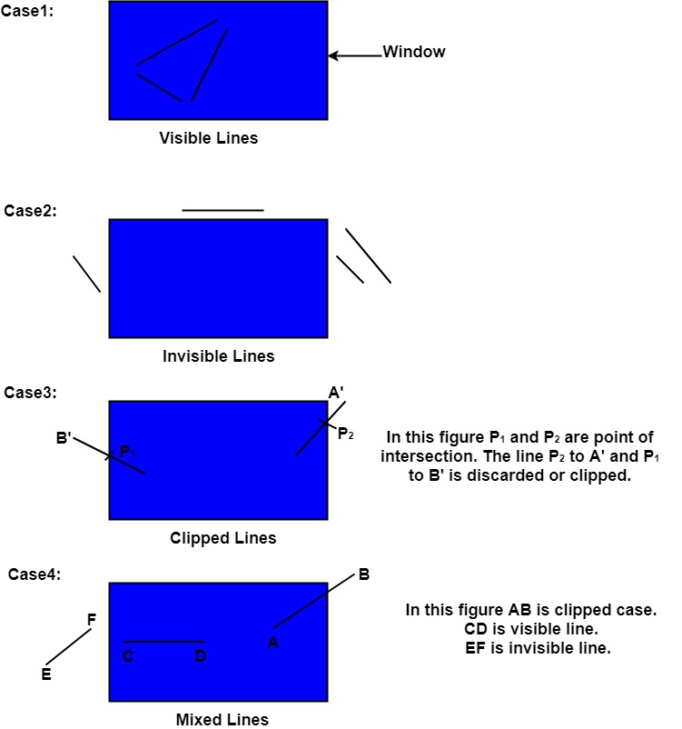

Clipping can be applied through hardware as well as software. In some computers, hardware devices automatically do work of clipping. In a system where hardware clipping is not available software clipping applied.
Following figure show before and after clipping-
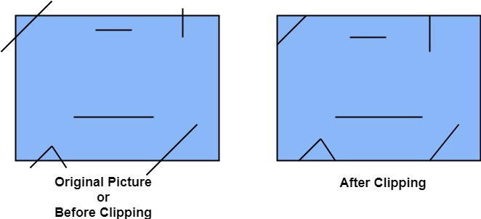

Applications of clipping:
- It will extract part we desire.
- For identifying the visible and invisible area in the 3D object.
- For creating objects using solid modeling.
- For drawing operations.
- Operations related to the pointing of an object.
- For deleting, copying, moving part of an object.
Clipping can be applied to world co-ordinates. The contents inside the window will be mapped to device co-ordinates. Another alternative is a complete world co-ordinates picture is assigned to device co-ordinates, and then clipping of viewport boundaries is done.

Types of Clipping:
- Point Clipping
- Line Clipping
- Area Clipping (Polygon)
- Curve Clipping
- Text Clipping
- Exterior Clipping

Mid-Point Subdivision Line Clipping Algorithm:
It is used for clipping line. The line is divided in two parts. Mid points of line is obtained by dividing it in two short segments. Again division is done, by finding midpoint. This process is continued until line of visible and invisible category is obtained. Let (x_{i},y_{i}) are midpoint
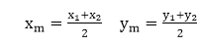

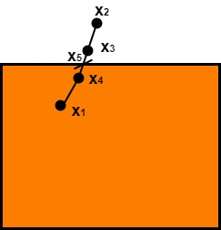

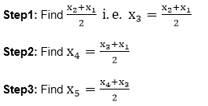
x₅ lie on point of intersection of boundary of window

Advantage of midpoint subdivision Line Clipping:
It is suitable for machines in which multiplication and division operation is not possible. Because it can be performed by introducing clipping divides in hardware.

Algorithm of midpoint subdivision Line Clipping:
Step1: Calculate the position of both endpoints of the line
Step2: Perform OR operation on both of these endpoints
Step3: If the OR operation gives 0000
then
Line is guaranteed to be visible
else
Perform AND operation on both endpoints.
If AND ≠ 0000
then the line is invisible
else
AND=6000
then the line is clipped case.
Step4: For the line to be clipped. Find midpoint
X_{m}=(x₁+x₂)/2
Y_{m}= (y₁+y₂)/2
X_{m} is midpoint of X coordinate.
Y_{m} is midpoint of Y coordinate.
Step5: Check each midpoint, whether it nearest to the boundary of a window or not.
Step6: If the line is totally visible or totally rejected not found then repeat step 1 to 5.
Step7: Stop algorithm.
Example: Window size is (-3, 1) to (2, 6). A line AB is given having co-ordinates of A (-4, 2) and B (-1, 7). Does this line visible. Find the visible portion of the line using midpoint subdivision?
Solution:
Step1: Fix point A (-4, 2)
