VISION INSTITUTE OF MANAGEMENT
COMPUTER GRAPHICS & MULTIMEDIA APPLICATION
BCA 2nd YEAR/4th SEM
UNIT 3

Introduction of Transformations
Computer Graphics provide the facility of viewing object from different angles. The architect can study building from different angles i.e.
- Front Evaluation
- Side elevation
- Top plan
A Cartographer can change the size of charts and topographical maps. So if graphics images are coded as numbers, the numbers can be stored in memory. These numbers are modified by mathematical operations called as Transformation.
The purpose of using computers for drawing is to provide facility to user to view the object from different angles, enlarging or reducing the scale or shape of object called as Transformation.
Two essential aspects of transformation are given below:
- Each transformation is a single entity. It can be denoted by a unique name or symbol.
- It is possible to combine two transformations, after connecting a single transformation is obtained, e.g., A is a transformation for translation. The B transformation performs scaling. The combination of two is C=AB. So C is obtained by concatenation property.
There are two complementary points of view for describing object transformation.
- Geometric Transformation: The object itself is transformed relative to the coordinate system or background. The mathematical statement of this viewpoint is defined by geometric transformations applied to each point of the object.
- Coordinate Transformation: The object is held stationary while the coordinate system is transformed relative to the object. This effect is attained through the application of coordinate transformations.
An example that helps to distinguish these two viewpoints:
The movement of an automobile against a scenic background we can simulate this by
- Moving the automobile while keeping the background fixed-(Geometric Transformation)
- We can keep the car fixed while moving the background scenery- (Coordinate Transformation)

Types of Transformations:
- Translation
- Scaling
- Rotating
- Reflection
- Shearing

Note: Translation, Scaling, and Rotation are also called as Basic Transformations.

Translation
It is the straight line movement of an object from one position to another is called Translation. Here the object is positioned from one coordinate location to another.

Translation of point:
To translate a point from coordinate position (x, y) to another (x₁ y₁), we add algebraically the translation distances T_{x} and T_{y} to original coordinate.
x₁=x+T_{x}
y₁=y+T_{y}
The translation pair (T_{x},T_{y}) is called as shift vector.
Translation is a movement of objects without deformation. Every position or point is translated by the same amount. When the straight line is translated, then it will be drawn using endpoints.
For translating polygon, each vertex of the polygon is converted to a new position. Similarly, curved objects are translated. To change the position of the circle or ellipse its center coordinates are transformed, then the object is drawn using new coordinates.
Let P is a point with coordinates (x, y). It will be translated as (x¹ y¹).
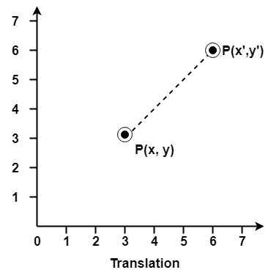
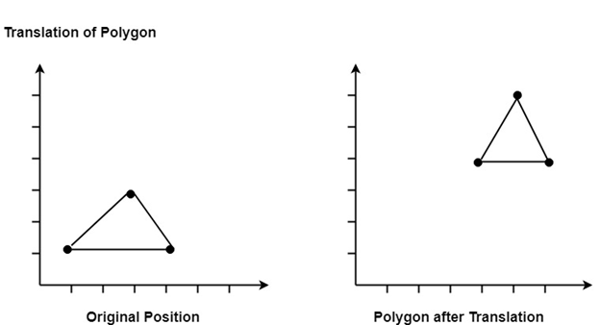

Matrix for Translation:
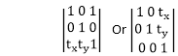

Scaling:
It is used to alter or change the size of objects. The change is done using scaling factors. There are two scaling factors, i.e. S_{x} in x direction S_{y} in y-direction. If the original position is x and y. Scaling factors are S_{x} and S_{y} then the value of coordinates after scaling will be x¹ and y₁.
If the picture to be enlarged to twice its original size then S_{x} = S_{y} =2. If S_{x} and S_{y} are not equal then scaling will occur but it will elongate or distort the picture.
If scaling factors are less than one, then the size of the object will be reduced. If scaling factors are higher than one, then the size of the object will be enlarged.
If S_{x} and S_{y} are equal it is also called as Uniform Scaling. If not equal then called as Differential Scaling. If scaling factors with values less than one will move the object closer to coordinate origin, while a value higher than one will move coordinate position farther from origin.
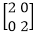
Enlargement: If T₁ = , If (x₁ y₁)is original position and T₁is translation
vector then (x₂ y₂) are coordinated after scaling.
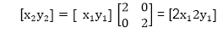
The image will be enlarged two times
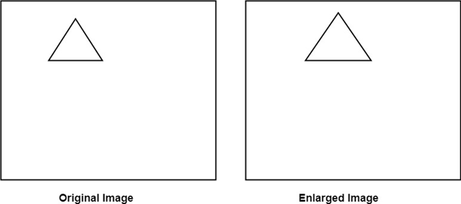
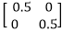
Reduction: If T₁= , , If (x₁ y₁) is original position and T₁ is translation
vector, then (x₂ y₂) are coordinates after scaling.
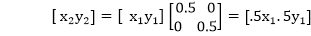
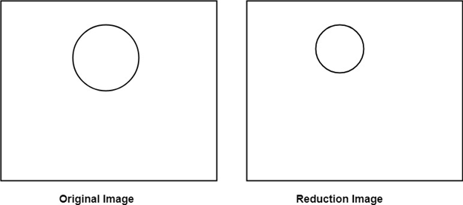
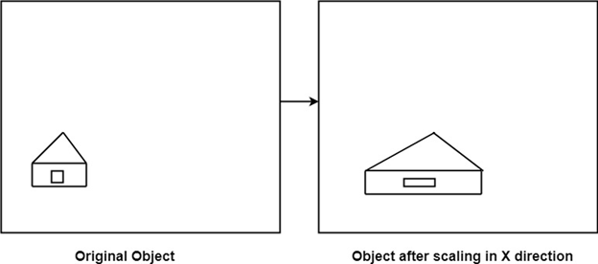
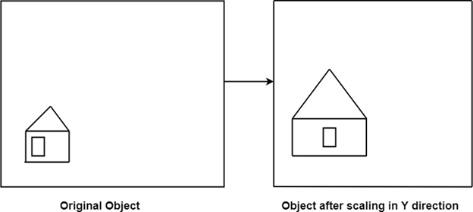

Matrix for Scaling:
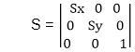
Example: Prove that 2D Scaling transformations are commutative i.e, S₁ S₂=S₂ S₁.
Solution: S₁ and S₂ are scaling matrices
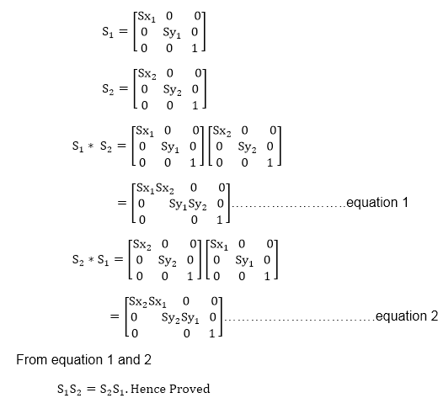

Rotation:
It is a process of changing the angle of the object. Rotation can be clockwise or anticlockwise. For rotation, we have to specify the angle of rotation and rotation point. Rotation point is also called a pivot point. It is print about which object is rotated.

Types of Rotation:
- Anticlockwise
- Counter clockwise
The positive value of the pivot point (rotation angle) rotates an object in a counter-clockwise (anti-clockwise) direction.
The negative value of the pivot point (rotation angle) rotates an object in a clockwise direction.
When the object is rotated, then every point of the object is rotated by the same angle.
Straight Line: Straight Line is rotated by the endpoints with the same angle and redrawing the line between new endpoints.
Polygon: Polygon is rotated by shifting every vertex using the same rotational angle.
Curved Lines: Curved Lines are rotated by repositioning of all points and drawing of the curve at new positions.
Circle: It can be obtained by center position by the specified angle.
Ellipse: Its rotation can be obtained by rotating major and minor axis of an ellipse by the desired angle.
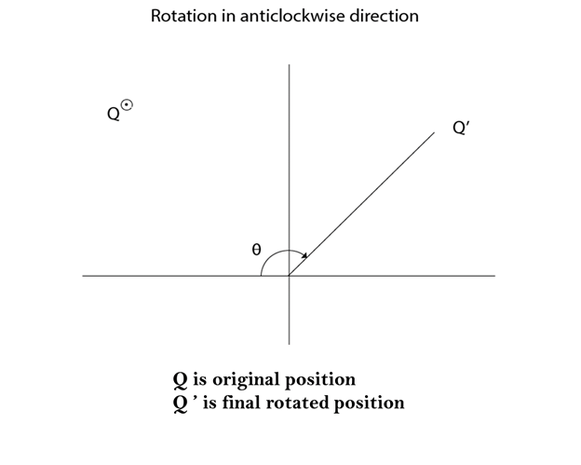
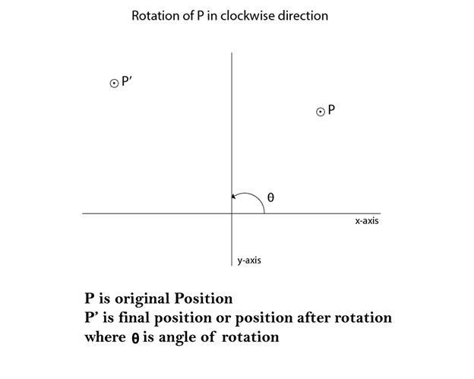
Matrix for rotation is a clockwise direction-
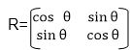
Matrix for rotation is an anticlockwise direction-
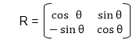
Matrix for homogeneous co-ordinate rotation (clockwise)-
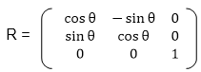

Matrix for homogeneous co-ordinate rotation (anticlockwise)-
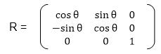
Rotation about an arbitrary point: If we want to rotate an object or point about an arbitrary point, first of all, we translate the point about which we want to rotate to the origin. Then rotate point or object about the origin, and at the end, we again translate it to the original place. We get rotation about an arbitrary point.
Example: The point (x, y) is to be rotated
The (x_{c} y_{c}) is a point about which counterclockwise rotation is done
Step1: Translate point (x_{c ,} y_{c}) to origin
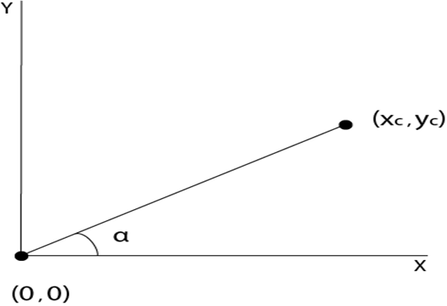
Step2: Rotation of (x, y) about the origin
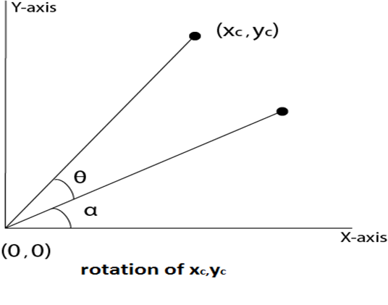

Step3: Translation of center of rotation back to its original position
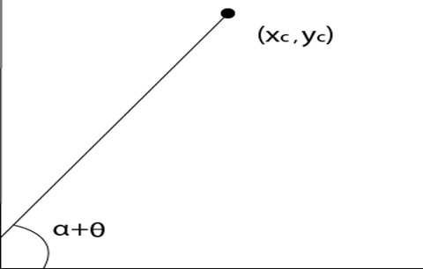
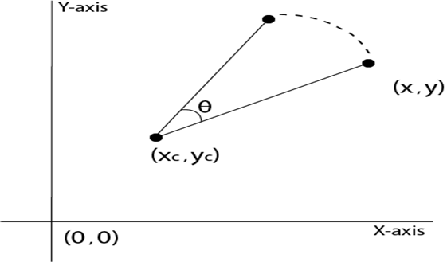

Example1: Prove that 2D rotations about the origin are commutative i.e. R₁ R₂=R₂ R₁.
Solution: R₁ and R₂are rotation matrices
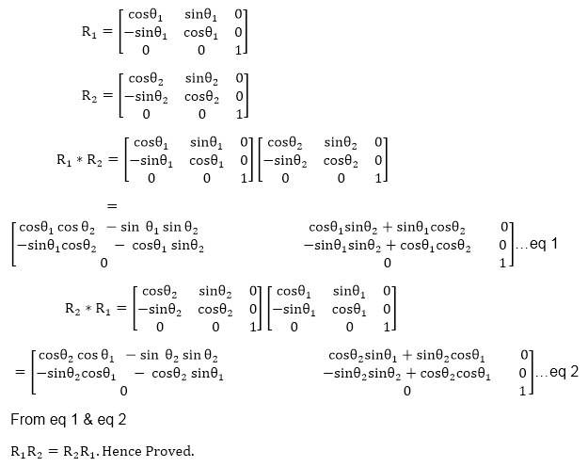

Example2: Rotate a line CD whose endpoints are (3, 4) and (12, 15) about origin through a 45° anticlockwise direction.
Solution: The point C (3, 4)
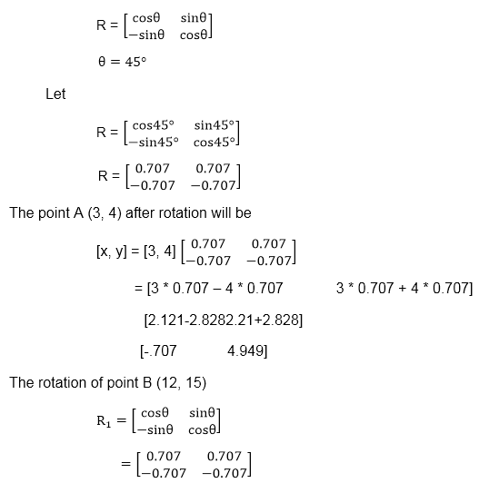
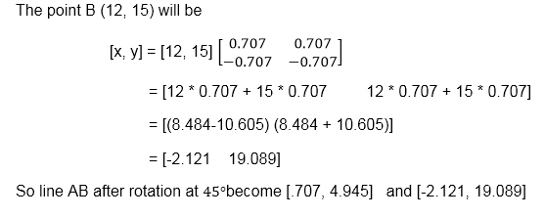
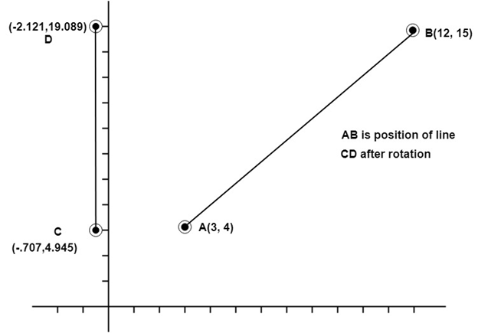

Example3: Rotate line AB whose endpoints are A (2, 5) and B (6, 12) about origin through a 30° clockwise direction.
Solution: For rotation in the clockwise direction. The matrix is
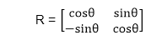
Step1: Rotation of point A (2, 5). Take angle 30°
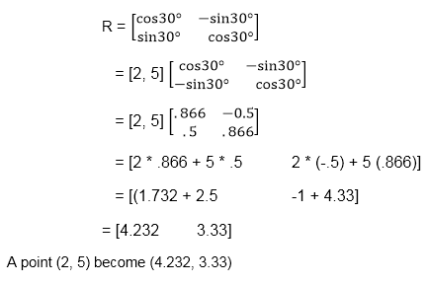

Step2: Rotation of point B (6, 12)
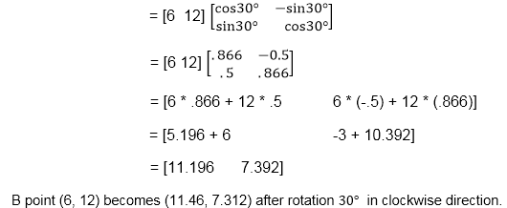
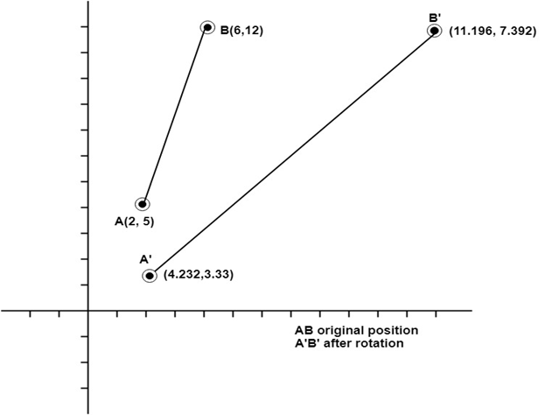

Reflection:
It is a transformation which produces a mirror image of an object. The mirror image can be either about x-axis or y-axis. The object is rotated by180°.

Types of Reflection:
- Reflection about the x-axis
- Reflection about the y-axis
- Reflection about an axis perpendicular to xy plane and passing through the origin
- Reflection about line y=x
1. Reflection about x-axis: The object can be reflected about x-axis with the help of the following matrix-
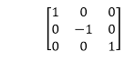
In this transformation value of x will remain same whereas the value of y will become negative. Following figures shows the reflection of the object axis. The object will lie another side of the x-axis.
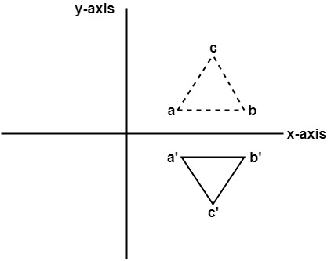
- Reflection about y-axis: The object can be reflected about y-axis with the help of following transformation matrix.
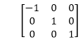
Here the values of x will be reversed, whereas the value of y will remain the same. The object will lie another side of the y-axis.
The following figure shows the reflection about the y-axis
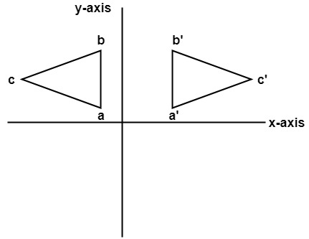

- Reflection about an axis perpendicular to xy plane and passing through origin:
In the matrix of this transformation is given below-
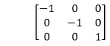
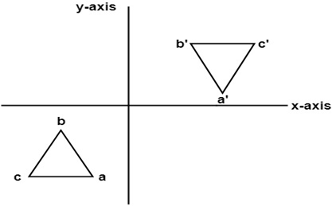
In this value of x and y both will be reversed. This is also called as half revolution about the origin.
4. Reflection about line y=x: The object may be reflected about line y = x with the help of following transformation matrix
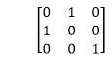
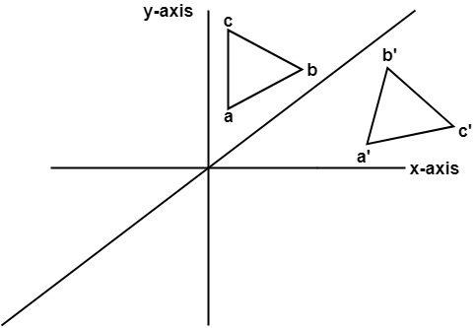
First of all, the object is rotated at 45°. The direction of rotation is clockwise. After it reflection is done concerning x-axis. The last step is the rotation of y=x back to its original position that is counterclockwise at 45°.

Example: A triangle ABC is given. The coordinates of A, B, C are given as
A (3 4)
B (6 4)
C (4 8)
Find reflected position of triangle i.e., to the x-axis.
Solution:
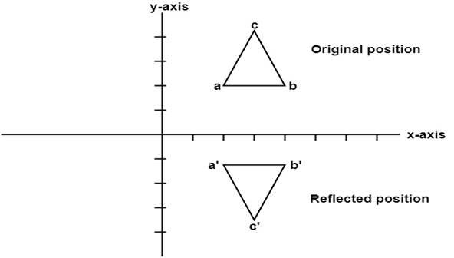
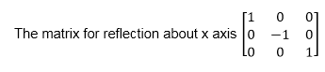
The a point coordinates after reflection
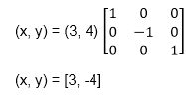
The b point coordinates after reflection
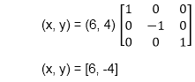
The coordinate of point c after reflection
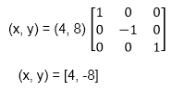
a (3, 4) becomes a¹ (3, -4)
b (6, 4) becomes b¹ (6, -4)
c (4, 8) becomes c¹ (4, -8)

Shearing:
It is transformation which changes the shape of object. The sliding of layers of object occur. The shear can be in one direction or in two directions.
Shearing in the X-direction: In this horizontal shearing sliding of layers occur. The homogeneous matrix for shearing in the x-direction is shown below:
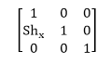
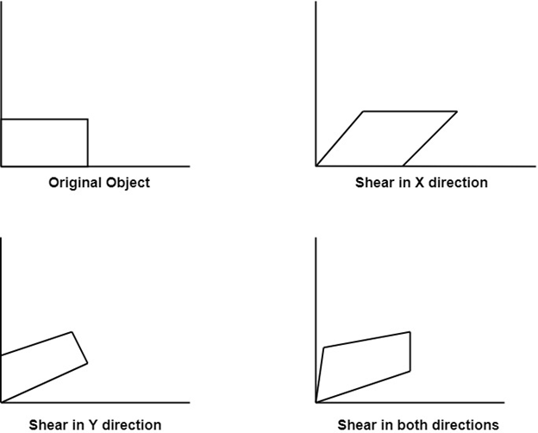

Shearing in the Y-direction: Here shearing is done by sliding along vertical or y-axis.
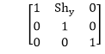
Shearing in X-Y directions: Here layers will be slide in both x as well as y direction. The sliding will be in horizontal as well as vertical direction. The shape of the object will be distorted. The matrix of shear in both directions is given by:
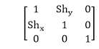

Matrix Representation of 2D Transformation

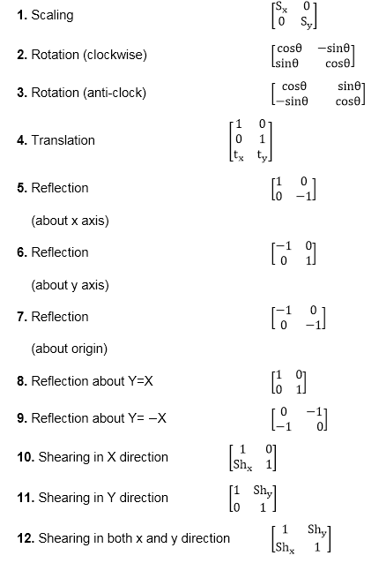

Homogeneous Coordinates
The rotation of a point, straight line or an entire image on the screen, about a point other than origin, is achieved by first moving the image until the point of rotation occupies the origin, then performing rotation, then finally moving the image to its original position.
The moving of an image from one place to another in a straight line is called a translation. A translation may be done by adding or subtracting to each point, the amount, by which picture is required to be shifted.
Translation of point by the change of coordinate cannot be combined with other transformation by using simple matrix application. Such a combination is essential if we wish to rotate an image about a point other than origin by translation, rotation again translation.
To combine these three transformations into a single transformation, homogeneous coordinates are used. In homogeneous coordinate system, two-dimensional coordinate positions (x, y) are represented by triple-coordinates.
Homogeneous coordinates are generally used in design and construction applications. Here we perform translations, rotations, scaling to fit the picture into proper position.
Example of representing coordinates into a homogeneous coordinate system:
For two-dimensional geometric transformation, we can choose homogeneous parameter h to any non-zero value. For our convenience take it as one. Each two-dimensional position is then represented with homogeneous coordinates (x, y, 1).
Following are matrix for two-dimensional transformation in homogeneous coordinate:
