UNIT-1

INTRODUCING FINANCIAL ACCOUNTING
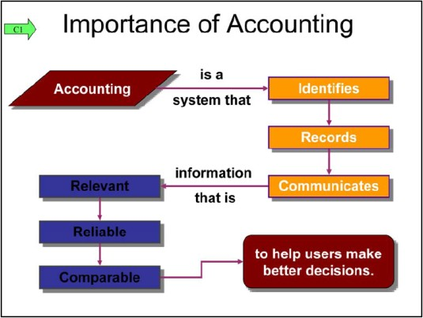
- IMPORTANCE OF ACCOUNTING

  - Accounting is the language of business and is called this because all organizations set up an accounting information system to communicate data to help people make better decisions.

  - Accounting is a system that→Indentifies→Records→Communicates
relevant, reliable, and comparable information about an organization’s business activities.

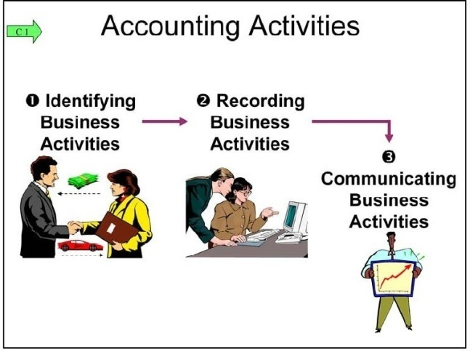
  - Identifying means selecting transactions and events relevant to an organization.

  - Example: sale of iPods by Apple, receipt of ticket money by TicketMaster.

  - Recording means keeping a chronological log of transactions and events measured in dollars and classified and summarized in a useful format.

  - Communicating means preparing accounting
reports such as financial statements, and analyzing and interpreting these reports.

  - Management Accounting provides information for decision-making activities of management WITHIN the business.

  - Financial Accounting is concerned with providing useful information to those parties OUTSIDE of the business.

  - Financial accountants are concerned with the preparation of Financial Statements, which are distributed to outside parties in an annual report.

  - Most common experience with accounting is through: credit approvals, checking accounts, tax forms, and payroll.

  - These common experiences are limited and tend to focus on the recordkeeping parts of accounting.

  - Recordkeeping/Bookkeeping—is recording of transactions and events, either manually or electronically of an organization’s day-to-day activities. Recordkeeping is only ONE part of accounting.

  - Accounting—is the process of analyzing and drawing conclusions from this information.

  - Example: bookkeeper of a shoe store keeps the day-to-day records as to how many shoes are sold and what bills need to be paid; accountant analyzes this data to evaluate the profitability and health of the business.

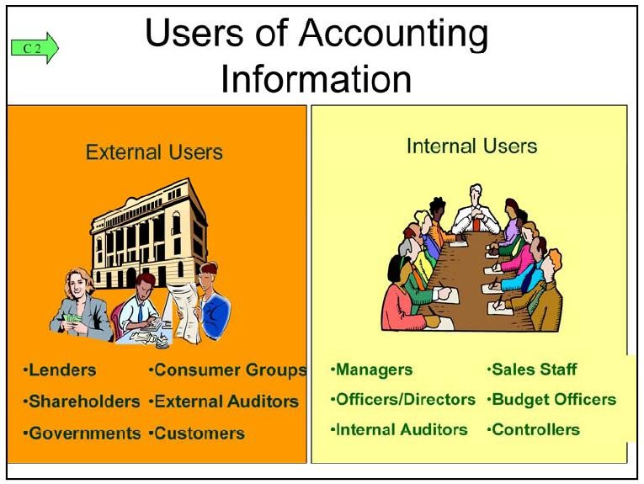
- Users of Accounting Information
  - External Information Users

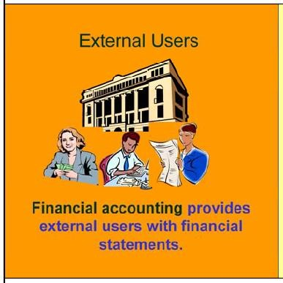
    - External Users—are NOT directly involved in running the organization.

    - Examples: shareholders (investors), lenders,
directors, customers, suppliers, regulators, lawyers, brokers, and the press.

    - External users have limited access to an organization’s information.

    - External users business decisions depend on information that is reliable, relevant, and comparable.

    - These financial statements are called general-purpose financial statements.

- Lenders (creditors)

  - Loan money or other resources to an organization.

  - They look for information to help them assess whether an organization is likely to repay its loans with interest.

  - Examples: banks, savings and loans, co-ops, and mortgage and finance companies.

- Shareholders (investors)

  - Owners of a corporation.

  - Use accounting reports in deciding whether to buy, hold, or sell stock.

- Board of Directors

  - oversees stockholders interests in an organization.

- External (Independent) Auditors

  - Examine financial statements to verify that they are prepared according to generally accepted accounting principles (GAAP).

- Employees and Labor Unions

  - Use financial statements to judge the fairness of wages, assess job prospects, and bargain for better wages.

- Regulators

  - Often have legal authority over certain activities of organizations.

  - IRS who requires organizations to file accounting reports in computing taxes.

  - Utility boards use accounting information to set utility rates.

- Voters, Legislators, and Government Officials

  - Use accounting information to monitor and evaluate government receipts and expenses.

- Contributors

  - Use accounting information to evaluate the use and impact of their donations.

- Suppliers

  - Use accounting information to judge the soundness of a customer before making sales on credit.

- Customers

  - Use financial reports to assess the staying power of potential suppliers.

  - Internal Information Users

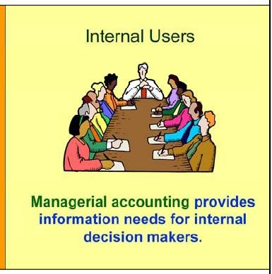
    - Internal Users—are those directly involved in managing and operating an organization.

    - Managerial Accounting—area of accounting that serves the needs of internal users.

    - Internal Controls—are procedures set up to protect company property and equipment,
ensure reliable accounting reports, promote efficiency, and encourage adherence to company policies.

    - Examples: good records, physical controls (locks, passwords, guards), and independent reviews

- Research and Development Managers

  - Need information about projected costs and revenues of any proposed changes in products and services.

- Purchasing Managers

  - Need to know what, when, and how much to purchase.

- Human Resource Managers

  - Need information about employees’ payroll, benefits, performance, and compensation.

- Production Managers

  - Depend on information to monitor costs and ensure quality.

- Distribution Managers

  - Need reports for timely, accurate, and efficient delivery of products and services.

- Marketing Managers

  - Use reports about sales and costs to target consumers, set prices, and monitor consumer needs, tastes, and price concerns.

- Service Managers

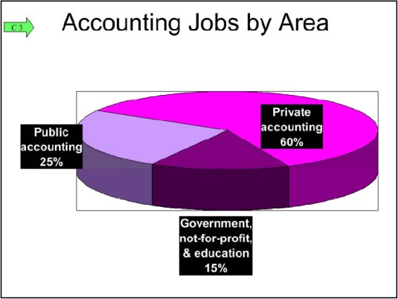
  - Require information on the costs and benefits of looking after products and services.
- Opportunities in Accounting
- We are influenced by accounting when we earn money, pay taxes, invest savings, budget earnings, and plan for the future.

- There are accounting jobs in private accounting, public accounting, and government (and non-for-profit) agencies.
- Majority of the jobs are in private accounting, followed by public accounting.
- Accounting specialists are highly regarded.
- People with accounting knowledge are always in demand as they can help with financial analysis, strategic planning, e-commerce, product feasibility analysis, information
technology, and financial management.

- Demand for accounting specialists is boosting salaries, and can vary because of location, company size, professional designation, experience, etc.
- Accountants can possibly have great benefit packages that can include: flexible work schedules, telecommuting options, career path alternatives, casual work environments, extended vacation time, and child and elder care.
- Examples of Accounting Specialists: Certified public accountant (CPA), certified
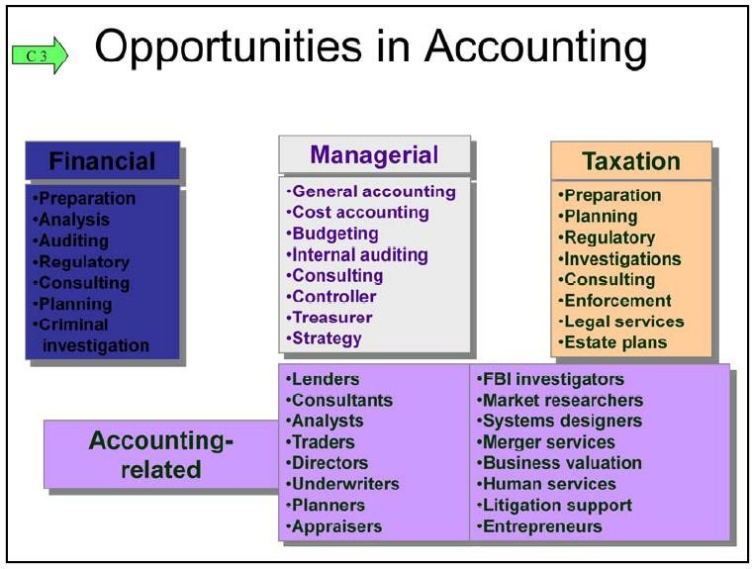
b o o k k e e p e r

( C B
)
,

c e r t i f i

ed payroll professional (CPP),personal financial specialist (PFS), certified fraud examiner (CFE), certified forensic accountant (CrFA)
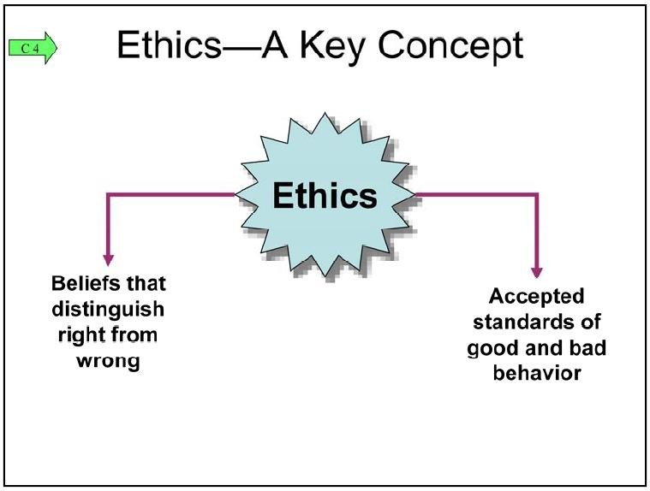
- FUNDAMENTALS OF ACCOUNTING

- Ethics—A Key Concept
  - Ethics—are beliefs that distinguish right from wrong; they are accepted standards of good and bad behavior.
  - Goal of accounting is to provide useful information for decisions.

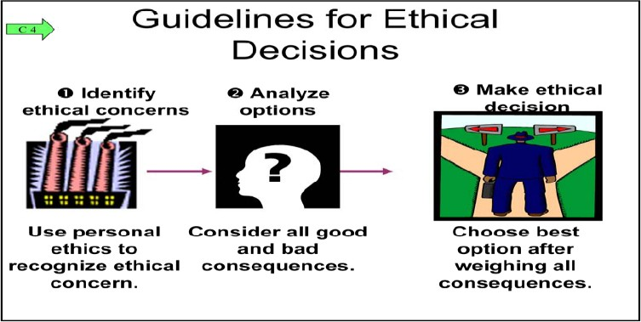
  - So there must be ethics in accounting.
  - Old saying: “Good ethics are good business”
  - Providers of accounting information often face ethical choices as they prepare financial reports.
  - For example, these choices can affect the price a buyer pays and the wages paid to workers
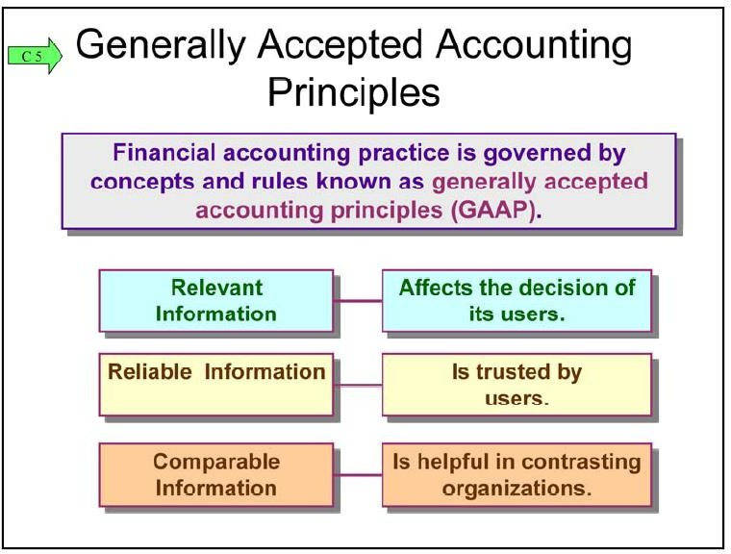
- Generally Accepted Accounting Principles (GAAP)
  - GAAP—are rules that specify acceptable accounting practices.
  - GAAP aims to make information in financial statements relevant, reliable, and comparable.
- Setting Accounting Principles
  - Two main groups establish GAAP in the US:
- Financial Accounting Standards Board (FASB)

  - Private group that sets both broad and specific principles.

- Securities and Exchange Commission (SEC)
  - Government group that establishes reporting requirements for companies that issue stock to the public.
  - International Accounting Standards Board (IASB)—issues International Financial Reporting Standards (IFRS) that identify preferred accounting practices, for example, when companies wish to raise money from lenders and investors in different countries.
- Principles and Assumptions of Accounting

  - Two types:
- General Principles—the basic assumptions, concepts, and guidelines for preparing financial statements.
- Specific Principles—detailed rules used in reporting business transactions and events.
- Accounting Principles

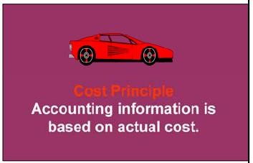
  - Cost Principle
    - Means that accounting information is based on actual cost.
    - Cost is measure on a cash or equal-to-cash basis.
    - Cash Example: cash is given for a service, its cost is measured as the amount of cash paid.
    - Equal to Cash Example: if something besides cash is exchanged (i.e. truck), cost is measured as the cash value of what is given up or received.
    - It emphasizes reliability and verifiability, and information based on cost is considered objective.
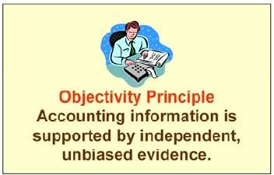
    - Objectivity—information is supported by
independent, unbiased evidence; it demands more than a person’s opinion.

  - Revenue Recognition Principle
    - Revenue (sales)—is the amount received from selling products and services.
    - Revenue Recognition Principle—provides guidance on when a company must recognize revenue.
    - Recognize—means to record it.
    - If revenue is recorded too early, then a company would look more profitable than it is.
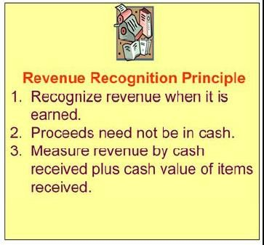
    - If revenue is recorded too late, a company would look less profitable than it is.
    - Three important concepts:
- Revenue is recognized when earned.
- Proceeds from selling products and services need not be in cash (can be credit sale).
- Revenue is measured by the cash received plus the cash value of any other items received.
  - Matching Principle

    - A company must record its expenses incurred to generate the revenue reported.
  - Full Disclosure Principle
    - Requires a company to report the details
behind financial statements that would impact users’ decisions.
- Accounting Assumptions

  - Going-Concern Assumption
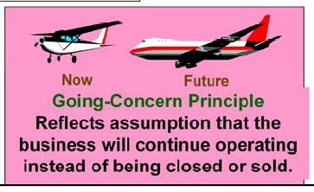
    - Accounting information reflects a presumption that the business will continue operating instead of being closed or sold.

    - Think Energizer Bunny, it keeps going and going.
  - Monetary Unit Assumption
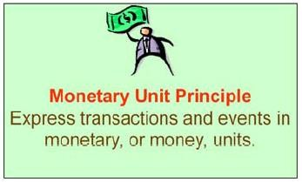
    - We can express transactions and events in monetary, or money units.
    - Money is the most common denominator in business.
  - Time Period Assumption
    - Presumes that the life of a company can be
divided into time periods, such as months and years, and that useful reports can be prepared for those periods.
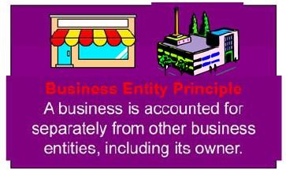
  - Business Entity Assumption
    - A business is accounted for separately from other business entities, including its owner.
    - Separate information about each business is necessary for good decisions.
  - Conservatism

    - By being conservative with the numbers.
- Sarbanes-Oxley (SOX)
  - Congress passed this act to help curb financial abuses at companies that issue their stock to the public.
  - It requires that the public companies apply other accounting oversight and stringent internal controls.
  - Failure to comply can lead to financial penalties, stock market delisting, and criminal prosecution of executives.
  - Management and Auditors must verify the effectiveness of internal controls.

Management Accounting Definition:-

Management accounting also is known as managerial accounting and can be defined as a process of providing financial information and resources to the managers in decision making. Management accounting is only used by the internal team of the organization, and this is the only thing which makes it different from financial accounting. In this process, financial information and reports such as invoice, financial balance statement is shared by finance administration with the management team of the company. Objective of management accounting is to use this statistical data and take a better and accurate decision, controlling the enterprise, business activities, and development.
Financial accounting is the recording and presentation of information for the benefit of the various stakeholders of an organization. Management accounting, on the other hand, is the presentation of financial data and business activities for the internal management of the organization. In this article, we will learn what is management accounting and its functions.

Advantages and Objectives of Management Accounting

There are many objectives of but the prime objective is to assist the management team of an organization in improving the quality of their decisions. Purpose of management accounting is to help the managerial team with financial information so that they can execute business operations and activities more efficiently. Following is the list of all benefits of management accounting –
- Decision Making
- Planning
- Controlling business operations
- Organizing
- Understanding financial data
- Identifying business problem areas
- Strategic Management

Decision Making
This is the most important benefit of the process of management accounting. In fact, it is the main purpose of it. In this form of accounting, we use techniques from all fields like costing, economics, statistics, etc.
It provides us with charts, tables, forecasts and various such analysis that makes the process of decision making easier and more justified.
Read Costing – An Aid to Management here in detail

Planning
Managerial accounting does not have any strict timelines like financial accounting. It is, in fact, a continuous and ongoing process.
So financial and other information is presented to the management at regular intervals like weekly, monthly or sometimes even daily.
Hence managers can use this analysis and data to plan the activities of the organization. For example, if the recent data shows a dip in the sales for a certain region, then the sales manager can advise his team and plan some action to rectify the situation.

Identifying Business Problem Areas
If some product is not performing well, or some department is running into unexpected losses, etc. managerial accounting can help us identify the underlying cause.
Actually, if the management is diligent and their data and reports are frequent, they can identify the problem very early on. This will allow the management to get ahead of the problem.

Strategic Management
Concept of management accounting is not mandatory by any law. So it can have its own structure according to the company’s requirements. So if the company feels certain areas need more in-depth analysis or investigation it can do so freely.
This allows them to focus on some core areas. The information presented to them allows them to make strategic management decisions.
Like if the company wishes to launch a new product line, or discontinue an existing one, management accounting will play a huge part in this strategy.

Limitations of Management Accounting

- Data based on Financial accounting – Decisions taken by the management team are based on the data provided by Financial Accounting
- Less knowledge – Management has insufficient knowledge of economics, finance, statistics, etc.
- Outdated data – Management team receives historical data, which may change eventually when management is taking the decisions.
- Expensive – Setting up a management accounting system requires a lot of investment.

Difference between Management Accounting and Financial Accounting
Sr.No. | Management Accounting | Financial Accounting
1 | Only used for internal purposes of the firm | For external reporting to various stakeholders and mandatory by law in most cases
2 | Is not under the regulation of any law or regulations | Is governed by Standards, Laws, regulations, etc
3 | The main purpose is to help internal management take decisions | Helps investors, creditors, etc. take investment decisions
4 | Includes both financial and non-financial information | Is only concerned with financial information
5 | Not subject to any audits or investigation | Financial records are audited as per the norms

