Linear Programming Problem
Sometimes one seeks to optimize (maximize or minimize) a known function (could be profit/loss or any output), subject to a set of linear constraints on the function. Linear Programming Problems (LPP) provide the method of finding such an optimized function along with/or the values which would optimize the required function accordingly.
Formulation of LPP
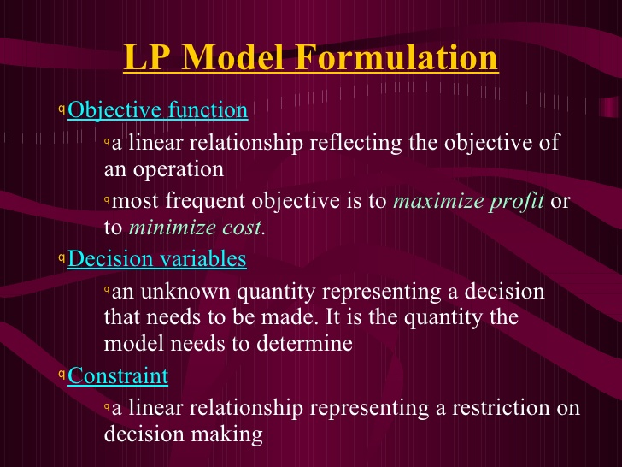
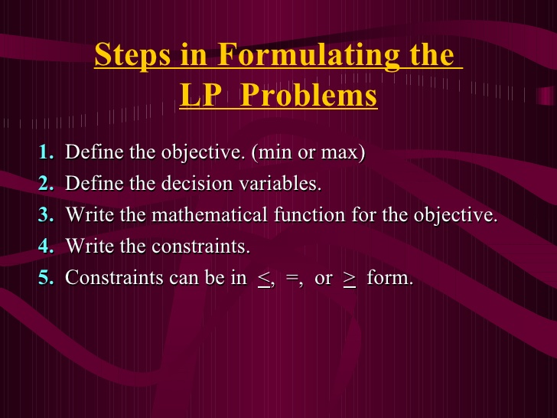
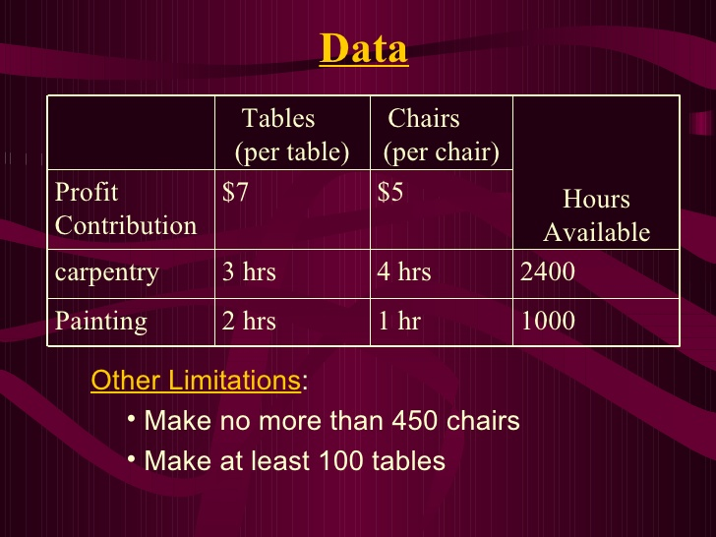
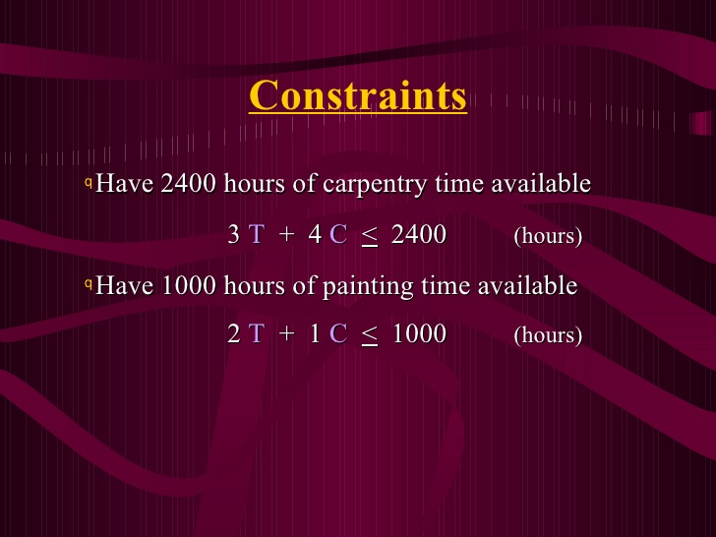
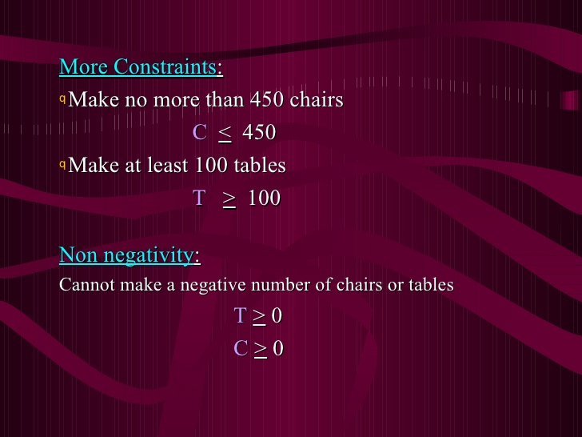
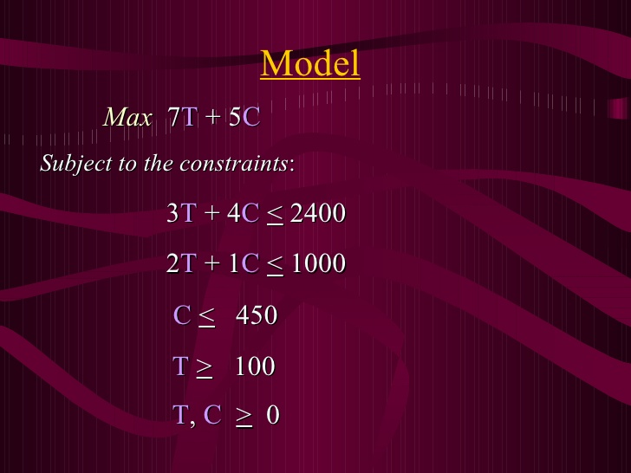
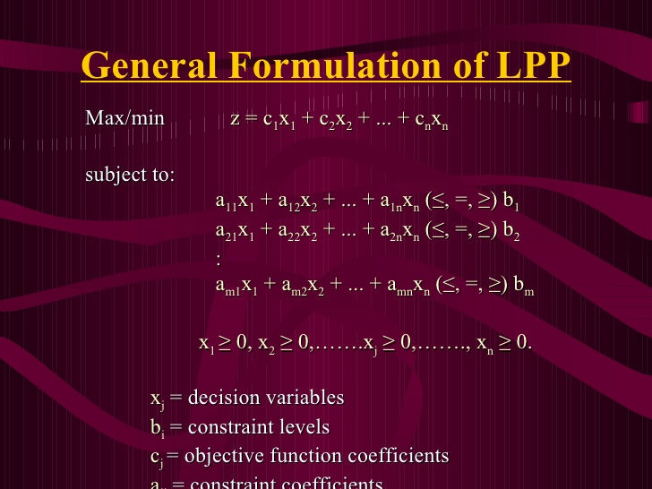
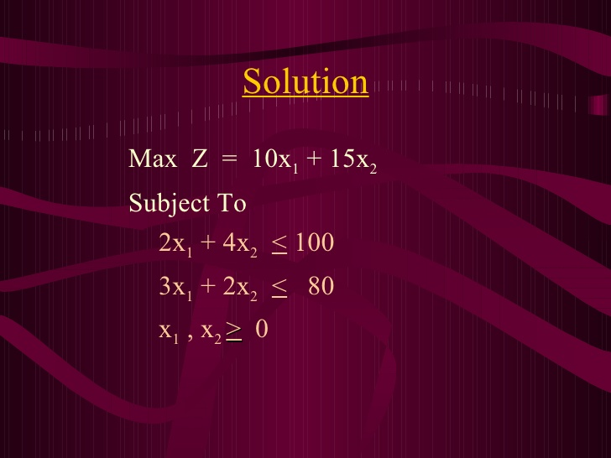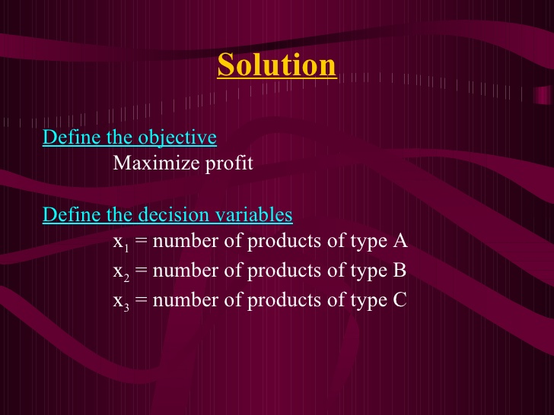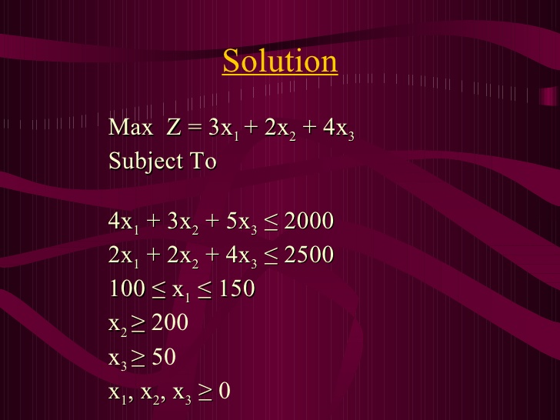

The Graphical Method
- Step 1: Formulate the LP (Linear programming) problem. ...
- Step 2: Construct a graph and plot the constraint lines. ...
- Step 3: Determine the valid side of each constraint line. ...
- Step 4: Identify the feasible solution region. ...
- Step 5: Plot the objective function on the graph. ...
- Step 6: Find the optimum point

Maximize | Z = f(x,y) = 3x + 2y
subject to: | 2x + y ≤ 18
 | 2x + 3y ≤ 42
 | 3x + y ≤ 24
 | x ≥ 0 , y ≥ 0
- Initially the coordinate system is drawn and each variable is associated to an axis (generally 'x' is associated to the horizontal axis and 'y' to the vertical one), as shown in figure 1.
- A numerical scale is marked in axis, appropriate to the values that variables can take according to the problem constraints. In order to do this, for each variable corresponding to an axis, all variables are set to zero except the variable associated to the studied axis in each constraint.
- The following step is to represent the restrictions. Beginning with the first, the line obtained by considering the constraint as an equality is drawn. In the example, this line is the segment connecting A and B points, and the region delimiting this restriction is indicated by the color YELLOW. This process is repeated with the other restrictions, BLUE and RED regions correspond to the second and third constraint respectively.
- The feasible region is the intersection of the regions defined by the set of constraints and the coordinate axis (conditions of non-negativity of variables). This feasible region is represented by the O-F-H-G-C polygon in PURPLE color.
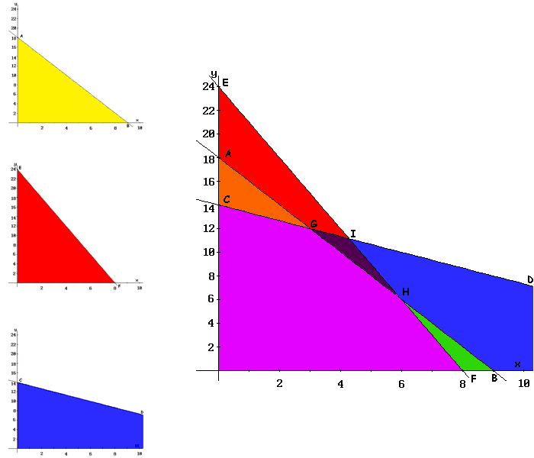
- As a feasible region exists, extreme values (or polygon vertices) are calculated. These vertices are the points candidate as optimal solutions. In the example, these points are O, F, H, G, and C, as shown in the figure.
- Finally, the objective function (3x + 2y) is evaluated in each of these points (results are shown in the tableau below). Since G-point provides the greatest value to the Z-function and the objective is to maximize, this point is the optimal solution: Z = 33 with x = 3 and y = 12.
Extreme point | Coordinates (x,y) | Objective value (Z)
O | (0,0) | 0
C | (0,14) | 28
G | (3,12) | 33
H | (6,6) | 30
F | (8,0) | 24

