Legal Aspect of Business

Unit-4 (I)

Sales and Good Act, 1930

Meaning and Essential Elements of Contract of Sale:-
Till 1930, transactions relating to sale and purchase of goods were regulated by the Indian Contract Act, 1872.In 1930,Sections 76 to 123 of the Indian Contract Act, 1872 were repealed and a separate Act called ‘The Indian Sale of Goods Act,1930 was passed. It came into force on 1st July,1930.With effect from 22ndSeptember,1963,the word ‘Indian’ was also removed. Now, the present Act is called’ The sales of goods act,1930’. This Act extends to the whole of India except the State of Jammu and Kashmir.
Scope of the Act:
The sale of Goods Act deals with ‘Sale of Goods Act,1930,’contract of sale of goods is a contract whereby the seller transfers or agrees to transfer the property in goods to the buyer for a price.” ‘Contract of sale’ is a generic term which includes both a sale as well as an agreement to sell.

Essential elements of Contract of sale
- Seller and buyer
There must be a seller as well as a buyer. ’Buyer’ means a person who buys or agrees to buy goods[Section 2910].’Seller’ means a person who sells or agrees to sell goods [Section 29(13)].
- Goods
There must be some goods. ’Goods’ means every kind of movable property other than actionable claims and money includes stock and shares, growing crops, grass and things attached to or forming part of the land which are agreed to be severed before sale or under the contract of sale[Section 2(7)].
- Transfer of property
Property means the general property in goods, and not merely a special property[Section 2(11)]. General property in goods means ownership of the goods. Special property in goods means possession of goods. Thus, there must be either a transfer of ownership of goods or an agreement to transfer the ownership of goods. The ownership may transfer either immediately on completion of sale or sometime in future in agreement to sell.
- Price
There must be a price. Price here means the money consideration for a sale of goods[Section 2(10)].When the consideration is only goods, it amounts to a ‘barter’ and not sale. When there is no consideration ,it amounts to gift and not sale.
- Essential elements of a valid contract
In addition to the aforesaid specific essential elements, all the essential elements of a valid contract as specified under Section 10 of Indian Contract Act,1872 must also be present since a contract of sale is a special type of a contract.

Conditions and Warranties
It is usual for both seller and buyer to make representations to each other at the time of entering into a contract of sale. Some of these representations are mere opinions which do not form a part of contract of sale. Whereas some of them may become a part of contract of sale. Representations which become a part of contract of sale are termed as stipulation which may rank as condition and warranty e.g. a mere commendation of his goods by the seller doesn’t become a stipulation and gives no right of action to the buyer against the seller as such representations are mere opinion on the part of the seller. But where the seller assumes to assert a fact of which the buyer is ignorant, it will amount to a stipulation forming an essential part of the contract of sale.

Meaning of Conditions [Section 12(2)]
A condition is a stipulation
- Which is essential to the main purpose of the contract
- The breach of which gives the aggrieved party a right to terminate the contract.

Meaning of Warranty [Section 12(3)]
A warranty is a stipulation
- Which is collateral to the main purpose of the contract
- The breach of which gives the aggrieved party a right to claim damages but not a right to reject goods and to terminate the contract.
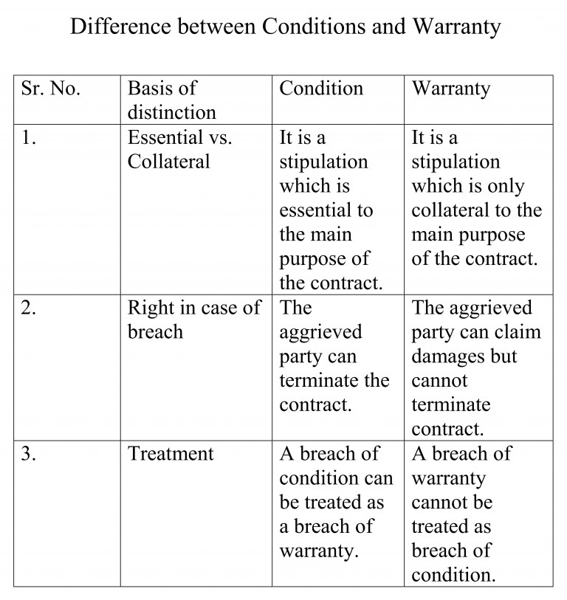

Conditions to be treated as Warranty [Section 13]
In the following three cases a breach of a condition is treated as a breach of a warranty:
- Where the buyer waives a conditions; once the buyer waives a conditions, he cannot insist on its fulfillment e.g. accepting defective goods or beyond the stipulated time amount to waiving a conditions.
- Where the buyer elects to treat breach of the condition as a breach of warranty; e.g. where he claims damages instead of repudiating the contract.
- Where the contract is not severable and the buyer has accepted the goods or part thereof, the breach of any condition by the seller can only be treated as breach of warranty. It can not be treated as a ground for rejecting the goods unless otherwise specified in the contract. Thus, where the buyer after purchasing the goods finds that some condition is not fulfilled, he cannot reject the goods. He has to retain the goods entitling him to claim damages.

Express and Implied Conditions and Warranties
In a contract of sale of goods, conditions and warranties may be express or implied.
- Express Conditions and Warranties.
These are expressly provided in the contract. For example, a buyer desires to buy a Sony TV Model No. 2020.Here,model no. is an express condition. In an advertisement for Khaitan fans, guarantee for 5 years is an express warranty.
- Implied Conditions and Warranties
These are implied by law in every contract of sale of goods unless a contrary intention appears from the terms of the contract. The various implied conditions and warranties have been shown below:

Implied Conditions
- Conditions as to title [ Section 14 (a)]
There is an implied condition on the part of the seller that
- In the case of a sale, he has a right to sell the goods, and
- In the case of an agreement to sell, he will have a right to sell the goods at the time when the property is to pass.
- Condition in case of sale by description [Section 15]
Where there is a contract of sale of goods by description, there is an implied condition that the goods shall correspond with description. The main idea is that the goods supplied must be same as were described by the seller. Sale of goods by description include many situations as under:
- Where the buyer has never seen the goods and buys them only on the basis of description given by the seller.
- Where the buyer has seen the goods but he buys them only on the basis of description given by the seller.
iii. Where the method of packing has been described.
- Condition in case of sale by sample [Section 17]
A contract of sale is a contract for sale by sample when there is a term in the contract, express or implied, to that effect. Such sale by sample is subject to the following three conditions:
- The goods must correspond with the sample in quality.
- The buyer must have a reasonable opportunity of comparing the bulk with the sample.
- The goods must be free from any defect which renders them un merchantable and which would not be apparent on reasonable examination of the sample. Such defects are called latent defects and are discovered when the goods are put to use.
- Condition in case of sale by description and sample [Section 15]
If the sale is by sample as well as by description, the goods must correspond with the sample as well as the description.
- Condition as to quality or fitness [Section 16(1)]
There is no implied condition as to the quality or fitness for any particular purpose of goods supplied under a contract of sale. In other words, the buyer must satisfy himself about the quality as well as the suitability of the goods.
Exception to this rule:
There is an implied condition that the goods shall be reasonably fit for a particular purpose described if the following three conditions are satisfied:
- The particular for which goods are required must have been disclosed (expressly or impliedly) by the buyer to the seller.
- The buyer must have relied upon the seller’s skill or judgment.
- The seller’s business must be to sell such goods.
- Condition as to merchantable quality[Section 16(2)]
Where the goods are bought by description from a seller who deals in goods of that description, there is an implied condition that the goods shall be of merchantable quality. The expression ‘ merchantable quality’ means that the quality and condition of the goods must be such that a man of ordinary prudence would accept them as the goods of that description. Goods must be free from any latent or hidden defects.
- Condition as to wholesomeness
In case of eatables or provisions or foodstuffs, there is an implied condition as to wholesomeness. Condition as to wholesomeness means that the goods shall be fit for human consumption.
- Conditions implied by custom [Section 16(3)]
Condition as to quality or fitness for a particular purpose may be annexed by the usage of trade.
Implied warranties
a) Warranty as to quiet possession [Section14(b)]
There is an implied warranty that the buyer shall have and enjoy quiet possession of the goods. The reach of this warranty gives buyer a right to claim damages from the seller.
b) Warranty of freedom from encumbrances [Section 14(c)]
There is an implied warranty that the goods are free from any charge or encumbrance in favour of any third person if the buyer is not aware of such charge or encumbrance. The breach of this warranty gives buyer a right to claim damages from the seller.
- Warranty as to quality or fitness for a particular purpose annexed by usage of trade[Section 16(3)]
- Warranty to disclose dangerous nature of goods
In case of goods of dangerous nature the seller fails to do so, the buyer may make him liable for breach of implied warranty.

Rights of Unpaid Seller

Unpaid seller and his rights
Meaning of an Unpaid Seller [Sec 45(1)(2)]
The seller of goods is deemed to be an ‘unpaid seller’
- When the whole of the price has not been paid or tendered
- When a bill of exchange or other negotiable instrument (such as cheque) has been received as conditional payment, and it has been dishonored [Section 45(1)].
- The term ‘seller’ includes any person who is in the position of a seller(for instance, an agent of the seller to whom the bill of lading has been endorsed, or a consignor or agent who has himself paid, or is directly responsible for the price) [Section 4592)].
Rights of an Unpaid Seller [Section 46-52,54-56,60-61]
The rights of an unpaid seller can broadly be classified under the following two categories:
- Rights against the goods
Rights against the buyer personally
The various rights of an unpaid seller have been shown in Fig.
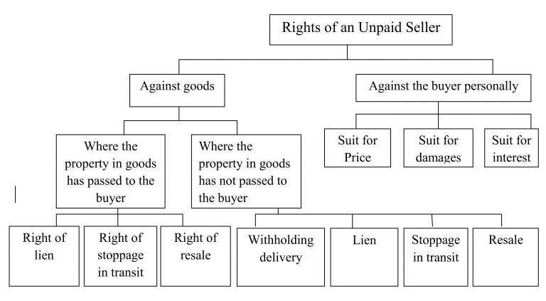

Meaning of Right of Lien:
The right of lien means the right to retain the possession of the goods until the full price is received.
Three circumstances under which right of lien can be exercised [Section 47(1)]
- Where the goods have been sold without any stipulation to credit;
- Where the goods have been sold on credit, but the term of credit has expired;
- Where the buyer becomes insolvent.
Other provisions regarding right of lien [Sections 47(2), 48, 49(2)]
- The seller may exercise his right of lien, even if he possesses the goods as agent or Bailee for buyer[Section 47(2)]
- Where an unpaid seller has made part delivery of the goods, he may exercise his right of lien on the remainder, unless such part delivery has been made under such circumstances as to show agreement to waive the lien [Section 48].
- The seller may exercise his right of lien even though he has obtained a decree for the price of the goods [Section 49(2)].
Circumstances under which right of lien in the following cases:
- When he delivers the goods to a carrier or other Bailee for the purpose of transmission to the buyer without reserving the right of disposal of the goods [Section 49(1)(a)].
- When the buyer or his agent lawfully obtains possession of the goods [Section 49(1)(b)]
- When the seller waives his right of lien [Section 49(1) (c)].
- When the buyer disposes of the goods by sale or in any other manner with the consent of the seller [Section 53(1)].
- Where document of title to goods has been issued or lawfully transferees to any person as buyer or owner of the goods and that person transfers the document by way of sale, to a person who takes the document in good faith and for consideration.[Proviso to Section 53(1)].
B) Right of Stoppage of Goods in Transit
The right of stoppage of goods means the right of stopping the goods while they are in transit, to regain possession and to retain them till the full price is paid.
Conditions under which right of stoppage in transit can be exercised [Section 50]
The unpaid seller can exercise the right of stoppage in transit only if the following conditions are fulfilled:
- The seller must have parted with the possession of goods,i.e. the goods must not be in the possession of seller.
- The goods must be in the course of transit.
- The buyer must have become insolvent.
c) Right of Resale[Section 46(1) and 54]
An unpaid seller can resell the goods under the following three circumstance:
- Where the goods are of a perishable nature.
- Where the seller expressly reserves a right of resale if the buyer commits a default in making payment.
- Where the unpaid seller who has exercised his right of lien or stoppage in transit gives a notice to the buyer about his intention to resell an dbuyer does not pay or tender within a reasonable time.
(II) Rights against the goods where the property in the goods has not passed to the buyer
Right of withholding delivery [Section 46(2)]
Where the property in the goods has not been passed to the buyer, the unpaid seller, cannot exercise right of lien, but get a right of withholding the delivery of goods, similar to and co-extensive with lien and stoppage in transit where the property has passed to the buyer.
Rights of Unpaid Seller against the Buyer Personally
The unpaid seller, in addition to his rights against the goods as discussed above, has the following three rights of action against the buyer personally:
- Suit for price (Sec. 55). Where property in goods has passed to the buyer; or where the sale price is payable ‘on a day certain’, although the property in goods has not passed; and the buyer wrongfully neglects or refuses to pay the price according to the terms of the contract, the seller is entitled to sue the buyer for price, irrespective of the delivery of goods. Where the goods have not been delivered, the seller would file a suit for price normally when the goods have been manufactured to some special order and thus are unsaleable otherwise.
- Suit for damages for non-acceptance (Sec. 56). Where the buyer wrongfully neglects or refuses to accept and pay for the goods, the seller may sue him for damages for non-acceptance. The seller’s remedy in this case is a suit for damages rather than an action for the full price of the goods.
- Suit for Interest [Section 61(2)]
In case of breach of the contract on the part of seller, the buyer may sue the seller for interest from the date on which the payment was made.

