Unit 1

Production Concept

Difference between Production and Operations Management

Production Management
E.S.Buffa defines production management as follows: ‘Production management deals with decision-making related to production processes so that the resulting goods or services are produced according to specifications, in the amount and by the schedule demanded and out of minimum cost’.
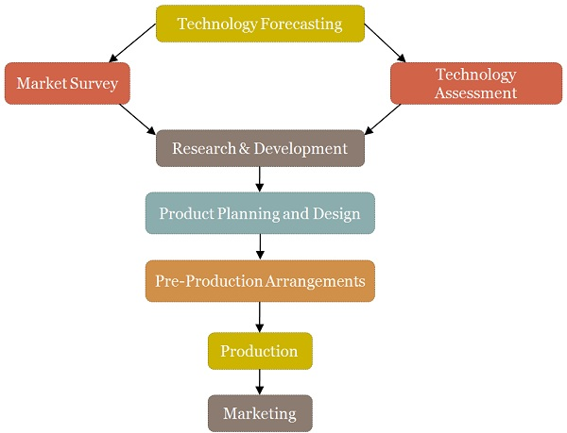
Areas of Production Management

Operations Management
Joseph G .Monks defines Operations Management as the process whereby resources, flowing with in a defined system, are combined and transformed by a controlled manner to add value in accordance with policies communicated by management.

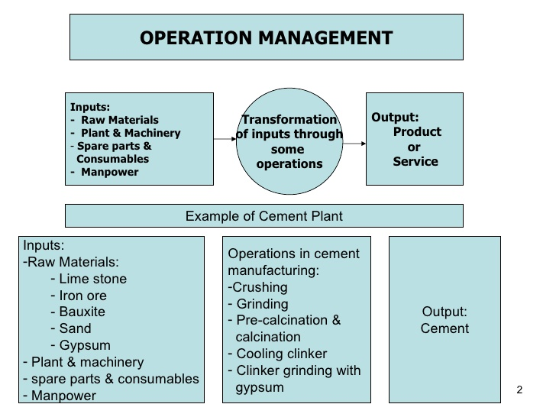

Key Differences Between Production and Operation Management
- Production Management can be defined as the administration of the set of activities concerning the creation of goods or transformation of raw material into finished goods. Conversely, Operations Management is used to mean that branch of management which deals with the administration both production of goods and provision of services to the customers.
- In production management, the manager has to make decisions regarding the design, quality, quantity and cost of the product manufactured by the department. On the contrary, the scope of operations management is larger in comparison to the production management wherein the operations manager looks after the product design, quality, quantity, process design, location, manpower required, storing, maintenance, logistics, inventory management, waste management, etc.
- Production Management can only be found in the firms where production of goods is undertaken. Unlike, one can find operations management in every organization, i.e. manufacturing concerns, service-oriented firms, banks, hospitals, agencies, etc.
- The basic objective of production management is to provide the right quality goods in the right quantity at right time and best price. In contrast, operations management aims at making the best possible use of organization’s resources, in order to fulfill the customer’s wants.

Production and Operations Management are so closely intertwined, that it is quite difficult to differentiate the two. Production management covers administer all the activities which are involved in the process of production. On the other hand, operations management entails all the activities involved in the production of goods and delivery of services such as material management, quality management, maintenance management, process management, process design, product design and so on.

Productivity, Work Study, Productivity Measurement, Factors affecting Productivity

PRODUCTIVITY
Productivity is an overall measure of the ability to produce a good or service. More specifically, productivity is the measure of how specified resources are managed to accomplish timely objectives as stated in terms of quantity and quality. Productivity may also be defined as an index that measures output (goods and services) relative to the input (labor, materials, energy, etc., used to produce the output). As such, it can be expressed as:
Hence, there are two major ways to increase productivity: increase the numerator (output) or decrease the denominator (input). Of course, a similar effect would be seen if both input and output increased, but output increased faster than input; or if input and output decreased, but input decreased faster than output.
Organizations have many options for use of this formula, labor productivity, machine productivity, capital productivity, energy productivity, and so on. A productivity ratio may be computed for a single operation, a department, a facility, an organization, or even an entire country.
Productivity is an objective concept. As an objective concept it can be measured, ideally against a universal standard. As such, organizations can monitor productivity for strategic reasons such as corporate planning, organization improvement, or comparison to competitors. It can also be used for tactical reasons such as project control or controlling performance to budget.
Productivity is also a scientific concept, and hence can be logically defined and empirically observed. It can also be measured in quantitative terms, which qualifies it as a variable. Therefore, it can be defined and measured in absolute or relative terms. However, an absolute definition of productivity is not very useful; it is much more useful as a concept dealing with relative productivity or as a productivity factor.

FACTORS AFFECTING PRODUCTIVITY
Factors influencing productivity can be classified broadly into two categories:
- Controllable (or internal) factors
- Un-controllable (or external) factors.
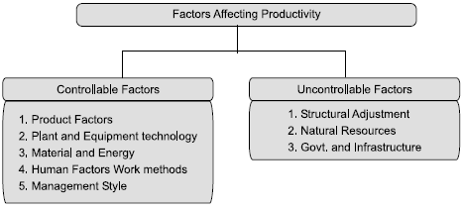

Controllable or Internal Factors
(I) Product factor: In terms of productivity means the extent to which the product meets output requirements product is judged by its usefulness. The cost benefit factor of a product can be enhanced by increasing the benefit at the same cost or by reducing cost for the same benefit.
(II) Plant and equipment: These play a prominent role in enhancing the productivity. The increased availability of the plant through proper maintenance and reduction of idle time increases the productivity. Productivity can be increased by paying proper attention to utilization, age, modernization, cost, investments etc.
(III) Technology: Innovative and latest technology improves productivity to a greater extent. Automation and information technology helps to achieve improvements in material handling, storage, communication system and quality control. The various aspects of technology factors to be considered are:
- Size and capacity of the plant,
- Timely supply and quality of inputs,
- Production planning and control,
- Repairs and maintenance,
- Waste reduction, and
- Efficient material handling system.
(IV) Material and energy: Efforts to reduce materials and energy consumption brings about considerable improvement in productivity.
- Selection of quality material and right material.
- Control of wastage and scrap.
- Effective stock control.
- Development of sources of supply.
- Optimum energy utilization and energy savings.
(V) Human factors: Productivity is basically dependent upon human competence and skill. Ability to work effectively is governed by various factors such as education, training, experience aptitude etc., of the employees. Motivation of employees will influence productivity.
(VI) Work methods: Improving the ways in which the work is done (methods) improves productivity, work study and industrial engineering techniques and training are the areas which improve the work methods, which in term enhance the productivity.
(VII) Management style: This influence the organizational design, communication in organization, policy and procedures. A flexible and dynamic management style is a better approach to achieve higher productivity.

Uncontrollable (Or) External Factors
(I) Structural adjustments: Structural adjustments include both economic and social changes. Economic changes that influence significantly are:
- Shift in employment from agriculture to manufacturing industry,
- Import of technology, and
- Industrial competitiveness.
(II) Natural resources: Manpower, land and raw materials are vital to the productivity improvement.
(III) Government and infrastructure: Government policies and program are significant to productivity practices of government agencies, transport and communication power, fiscal policies (interest rates, taxes) influence productivity to the greater extent.

Work Study
“Work study is a generic term for those techniques, method study and work measurement which are used in the examination of human work in all its contexts. And which lead systematically to the investigation of all the factors which affect the efficiency and economy of the situation being reviewed, in order to effect improvement.”
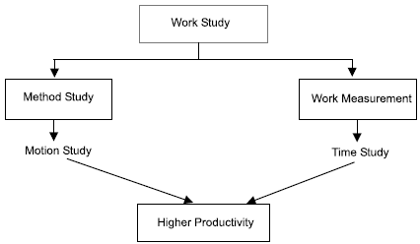
Advantages of Work Study
- It helps to achieve the smooth production flow with minimum interruptions.
- It helps to reduce the cost of the product by eliminating waste and unnecessary operations.
- Better worker-management relations.
- Meets the delivery commitment.
- Reduction in rejections and scrap and higher utilization of resources of the organization.
- Helps to achieve better working conditions.
- Better workplace layout.
- Improves upon the existing process or methods and helps in standardization and simplification.
- Helps to establish the standard time for an operation or job which has got application in manpower planning, production planning.

PRODUCTIVITY MEASUREMENT
- Total Productivity Measure (TPM)
It is based on all the inputs. The model can be applied to any manufacturing organization or service company.

Total productivity =Total tangible output +Total tangible input

Total tangible output = Value of finished goods produced + Value of partial units produced + Dividends from securities + Interest+ Other income
Total tangible input = Value of (human + material + capital + energy+ other inputs) used. The word tangible here refers to measurable.
The output of the firm as well as the inputs must be expressed in a common measurement unit. The best way is to express them in rupee value.
- Partial Productivity Measures (PPM)
Depending upon the individual input partial productivity measures are expressed as
Partial productivity =Total output% Individual input
Labor productivity =Total output%Labour input (in terms of man hours)
Capital productivity =Total output% Capital input
Material productivity =Total output% Material input
Energy productivity =Total output% Energy input
One of the major disadvantages of partial productivity measures is that there is an over emphasis on one input factor to the extent that other input are underestimated or even ignored.

Production Technology:

Types of Manufacturing Processes

Production Technology
In the simplest sense, production technology is the machinery that makes creating a tangible physical product possible for a business. To the small business, this means a workshop at the very least, with more elaborate operations making use of machines and assembly lines. Choosing a production scale model within a company’s capital means is important; simpler workshops tend to lead to lower production volume but cost less to assemble, while higher output operations require more complex and costly machines, which are sometimes cost prohibitive.

Components of Production Technology
- The Modern Artisan Workshop
The artisan workshop represents the basic minimum effective level of modern production technology. An artisan workshop builds upon the traditional workshops of craftsmen from before the industrial revolution and replaces most of the simple hand tools used with time-saving electrically driven tools. These tools offer the skilled tradesperson the advantage he needs in order to more quickly produce goods to the same level of quality he would otherwise make with hand tools. The tablesaw, drill press and belt sander are all examples of modern variations on simple hand tools used to save the modern craftsman time. Artisan workshops focus on low or medium output of higher than average quality goods to maintain a competitive advantage over large-scale factory-produced items of similar type.
- CNC Machining and Extending the Artisan Workshop
A computer number-controlled or CNC machine – also referred to as computer-aided manufacturing – further extends the capability of an artisan workshop, allowing the skilled craftsman to program the device to perform highly detailed repetitive tasks such as router and drill operation. CNC machines are expensive investments; however, when used to address the more time-consuming steps of producing an item in the standard artisan workshop, they can significantly improve the overall profitability of that manufacturing business. Because of their high initial cost when compared to manually operated shop tools, CNC machines are generally unavailable to all but the most successful small business. Investing in a CNC machine is a pivotal decision for a small business and should be done with careful consideration of how much the machine will actually boost profits when compared to continuing with the manual method.
- Automated Assembly Line-Style Mass Production
Automated assembly-line mass production represents the apex of modern industrial production, and is the driving force behind industrial titans such as automobile manufacturers and the makers of household appliances. The higher the degree of mechanization and use of robotics in the assembly line process, the fewer human workers are required to produce a product; however, in replacing human laborers with robots, the initial investment cost rises dramatically. The extremely high initial cost of automated assembly line mass production places such production methods far beyond the grasp of small business owners as far as practicality is concerned. Maintaining advanced automated assembly lines also requires the professional services of highly skilled robotics technicians, again making practical implementation difficult for the small business owner.
- Practicality Considerations for Small Business
When it comes to investing in production technology, a small business’s focus should be on generating the best dollar return on capital investment within the confines of the company’s reasonable budget. The IRS states that small businesses are a success when they generate profit at least three out of every five years. This general rule means that for the small business person, if it takes more than two years to pay off the initial capital investment in production technology, the businesses likely exceeded its ideal maximum production technology budget. This doesn’t mean that smaller to medium businesses have to abandon advanced production methods entirely; instead, they can adapt some practices from larger-scale industry that suit their own needs and capabilities. For example, small and medium businesses looking to capitalize upon the mass production method of industrial manufacturing can take a page out of Henry Ford’s book and use a simple conveyor belt line along with labor division to simplify and speed up the production process while still using artisan shop-style manually operated tools.

TYPES OF MANUFACTURING PROCESS
The four main types of manufacturing are casting and molding, machining, joining, and shearing and forming.
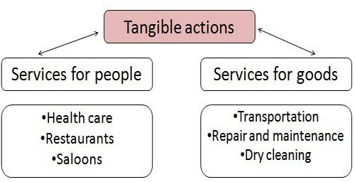
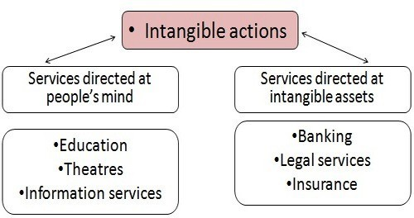

- Molding in Manufacturing
If the products you’re creating start out as liquid, chances are the manufacturer uses molding. One popular type of molding is casting, which involves heating plastic until it becomes liquid, then pouring it into a mold. Once the plastic cools, the mold is removed, giving you the desired shape. You can also use casting to make plastic sheeting, which has a wide variety of applications. There are four other types of molding: injection molding, which melts plastic to create 3-D materials such as butter tubs and toys; blow molding, used to make piping and milk bottles; compression molding, used for large-scale products like car tires; and rotational molding, used for furniture and shipping drums.
- Machining in Manufacturing
It would be difficult to make products like metal parts without the use of some type of machine. Manufacturers use tools like saws, sheers and rotating wheels to achieve the desired result. There are also tools that use heat to shape items. Laser machines can cut a piece of metal using a high-energy light beam, and plasma torches can turn gas into plasma using electricity. Erosion machines apply a similar principle using water or electricity, and computer numerical control machines introduce computer programming into the manufacturing mix.
- Joining in Manufacturing
You can only get so far with molds and machines. At some point you need to be able to put multiple parts together to make one piece. Otherwise, just about all you can create is IKEA-like furniture that needs to be assembled, part by part. Joining uses processes like welding and soldering to apply heat to combine materials. Pieces can also be joined using adhesive bonding or fasteners.
- Shearing and Forming in Manufacturing
When dealing with sheet metal, shearing comes into play. Shearing uses cutting blades to make straight cuts into a piece of metal. Also known as die cutting, you’ll often see shearing used on aluminum, brass, bronze and stainless steel. Another metal-shaping process is forming, which uses compression or another type of stress to move materials into a desired shape. Although forming is often used with metal, it also can be used on other materials, including plastic.

