Unit 2
Operations Concept

Difference between Product and Service
- Products Are Tangible: They are physical in nature such that they can be touched, smelled, felt and even seen. Services are intangible and they can only be felt not seen.
- Need vs. Relationship: A product is specifically designed to satisfy the needs and wants of the customers and can be carried away. However, with a service, satisfaction is obtained but nothing is carried away. Essentially, marketing of a service is primarily concerned with creation of customer relationship.
- Perish-Ability: Services cannot be stored for later use or sale since they can only be used during that particular time when they are offered. On the other hand, it can be seen that products are perishable. For example, fresh farm and other food products are perishable and these can also be stored for later use or sale.
- Quantity: Products can be numerically quantified and they come in different forms, shapes and sizes. However, services cannot be numerically quantified. Whilst you can choose different service providers, the concept remains the same.
- Inseparability: Services cannot be separated from their providers since they can be consumed at the same time they are offered. On the other hand, a product can be separated from the owner once the purchase has been completed.
- Quality: Quality of products can be compared since these are physical features that can be held. However, it may be difficult to compare the quality of the services rendered by different service providers.
- Return-Ability: It is easier to return a product to the seller if the customer is not satisfied about it. In turn, the customer will get a replacement of the returned product. However, a service cannot be returned to the service provider since it is something that is intangible.
- Value Perspective: The value of a service is offered by the service provider while the value of the product is derived from using it by the customer. Value of a service cannot be separated from the provider while the value of a product can be taken or created by the final user of the product offered on the market.
- Shelf Line: A service has a shorter shelf line compared to a product. A product can be sold at a later date if it fails to sell on a given period. This is different with regard to a service that has a short shelve line and should be sold earlier.

Differences between a product and service

Product | Service
A product is tangible, it is physical and can be held, seen and movable | A service is intangible, can only be felt and not touched
Product value is derived by the customer | Value of service is offered by the service provider
Customer care of the product is limited | Customer care forms critical component of marketing a service
A product can be stored for future use | A service is perishable and cannot be stored for later use or sale
product can be owned | A service cannot be owned by the consumer once payment has been made
The quality of a product depends its nature | Quality of a service depends on the service provider who shapes it
A product can be returned to the seller | A service cannot be returned to the seller
It is easy to compare quality of products | It is difficult to compare the quality of services offered
Products can be quantified numerically | Services cannot be quantified in terms of numbers

Though the terms product and service are often used interchangeably, it can be observed that they significantly differ. The major difference noted between the two is that a product is physical in nature and it is tangible. On the other hand, it can be seen that a service is intangible and it cannot be held therefore cannot be separated from the provider. Quality of the product is determined by the customer while the quality of a service is determined by the provider. A product can be stored for future use or sale and it can be returned to the buyer if the need arises. However, a service can be consumed the moment it is offered and cannot be stored for future use. A service cannot be returned to the service provider for any reason since it is jot tangible.

Product and Service Design
The starting point for any business or organization is to cater to the desires or wants of humans (like us), which keep changing with time, cultural changes and any developments in a country. For example, demand for different cell phones or choice of network connectivity. Human wants are characterized with wants or desires which are multiple and grow continuously, while businesses cater to these wants, can provide (potential) satisfaction, can create employment opportunities and can improve the standard of living. Accordingly, organizations conduct thorough planning on producing or servicing a product or service thus preparing a suitable design reflective of their customers’ wants or desires. Key basic principles followed by organizations which translate customers’ wants or desires that can cater to or create demand for product or service includes the following:
- Refine existing products/services: Based on recommendations or changes suggested by customers’ in accordance to the changing tastes and preferences could lead businesses to change or improve existing products
- Develop new products/services: Businesses can develop new products or services in accordance to changes in technology, tastes and preferences and develop or create new products/services (Refer to Demand-pull and Invention-Push Innovations)
- Formulate quality goals: Organizations should plan quality standards, assurances and specifications to create quality-driven products/services
- Construct prototypes for trials and tests: To target towards the right audience, specifications for trials and testing of products/services should be maintained (and mentioned)
- Create document specifications: Documentation of production and operations related activities should be maintained by the organization
- Translate product/service specification into process specifications: Documentation of product/services in accordance to their usage and utility should be provided by the organizations
- Formulate Cost targets: With reference to the above mentioned points, organizations should take costs into consideration for identifying relevant risks, benefits or consequences.
Design for a product and service can be created innovatively based on “Demand-Pull” or “Invention-Push” theories. Demand-pull theories emerged from innovation studies conducted in Europe during the 1960s. Demand-pull studies have characterized with conducting Research and Development (R&D) and improving project management. These two characteristics enabled understanding the needs of the customers and implementing manageable and measurable business practices, which encouraged efficiency during production (or provisions) and were further marketed as per the needs of the market. Alternatively, invention-push (also known as technology push) pushed a new invention through R&D, production, sales functions onto the market without considering whether it satisfies a customer’s need. The origins of technology push can be linked with the Austrian economist, Joseph Schumpeter who argued that development was the result of innovative ability of the entrepreneur and the introduction of new methods of production. (Identify real-life examples for demand-pull and invention-push)

Design Choices
There are significant differences between product and service design. Service design is an intangible aspect while product design is tangible. Services are generally created and delivered at the same time and cannot be held in inventory like actual products. Also, services are relatively visible to customers than products (with reference to actual production). Based on the requirements or innovations introduced in the market there are multiple design choices in products and services available for entrepreneur/s.

Choices in Product Design include
- Standardization: The process of developing and implementing standards to produce or provide a particular product or service is called standardization. Accordingly, standardization involves establishing and formalizing guidelines to interact with people and/or to bring about modernization, centralization and/or homogenization of products/services
- Customization: A process involved to make or alter something as per the customers’ needs and requirements is called customization. In addition, a large-scale system that produces these customized products/services is called mass customization (Are Apple products mass customized or simply customized?). These processes include producing multiple product items in large-scale to cater to needs of different customers. (Any resemblance with the automobile or food industry?)
- Delayed Differentiation: A generic or family product that is later differentiated into a specific end-product is called delayed differentiation or postponement. For example, knitted sweaters by Benetton were initially white and then dyed into different colours only as per changes in seasons or customer preferences. Another example, colour of iPods, different apps in existing mobile phones, etc.
- Modular Design: Modular design is to organise a complex system as a set of distinct components that can be developed independently and then plugged together. For example, a personal computer consists of a monitor, CPU, keyboard, mouse and other accessories whose functionalities are different but are connected together for its relevant use. Similarly, an organisational set up can also have complex systems like a hydro-electric set up has complex components like the dam with water-run turbines generating heat in generators, transformed into transformers (that are separate units placed at a designated place away from the turbines) to create electricity in different voltages.
- Robust Design: This design was formulated by Dr. Genichi Taguchi who defined it as a process that reduces variation in a product without eliminating the causes of the variation (also referred to as noise). There are three types of variations – Internal, external and unit-to-unit variations. Internal variation can be caused due to wear and tear of a machine and aging of materials whereas external variation can be caused by factors relating to environmental conditions such as temperature, humidity and dust and unit-to-unit variation are variations caused in between certain processes like variations in material, processes and equipment. (Identify examples from your projects and explain?)
Choices in service design are based on communication and interaction with individuals supported by relevant media tools like newspapers, television, radio, Internet, face-to-face interactions, etc. Key factors that influence communication and interaction in services are the degree of variation and degree of customer contact. Degree of variation refers to the potential deviations in requirements of customers while degree of customer contact determines the level of standardization required in a service to be able cater to the needs of diverse type of customers (in terms of demographic characteristics, socio-economic environment, technology adaptation, etc).

Characteristics of Service

Classification of Service

7 Important Characteristics of Services

(i) Perish-Ability
Service is highly perishable and time element has great significance in service marketing. Service if not used in time is lost forever. Service cannot stored.
(ii) Fluctuating Demand
Service demand has high degree of fluctuations. The changes in demand can be seasonal or by weeks, days or even hours. Most of the services have peak demand in peak hours, normal demand and low demand on off-period time.

(iii) Intangibility
Unlike product, service cannot be touched or sensed, tested or felt before they are availed. A service is an abstract phenomenon.
(iv) Inseparability
Personal service cannot be separated from the individual and some personalised services are created and consumed simultaneously.
For example hair cut is not possible without the presence of an individual. A doctor can only treat when his patient is present.
(v) Heterogeneity
The features of service by a provider cannot be uniform or standardised. A Doctor can charge much higher fee to a rich client and take much low from a poor patient.
(vi) Pricing of Services
Pricing decision about services are influenced by perish-ability, fluctuation in demand and inseparability. Quality of a service cannot be carefully standardised. Pricing of services is dependent on demand and competition where variable pricing may be used.
(vii) Service quality is not statistically measurable
It is defined in form of reliability, responsiveness, empathy and assurance all of which are in control of employee’s direction interacting with customers. For service, customer’s satisfaction and delight are very important. Employees directly interacting with customers are to be very special and important. People include internal marketing, external marketing and interactive marketing.

Classifications of Services
In order to be able to make a clear and relevant classification of services, we would first need to understand the concept of the word itself. Services usually refer to processes and not physical products. To understand more, read this article on difference between goods and services. Some services may include people whereas other services (like online services) may including objects which are managed by people.
Examples of services which include people can be a hair salon, education, theater, restaurants, public transportation. On the other hand services that include objects include repairs and maintenance, dry cleaning, banking, legal services, insurance, etc.
1. Classification of service based on Tangible Action
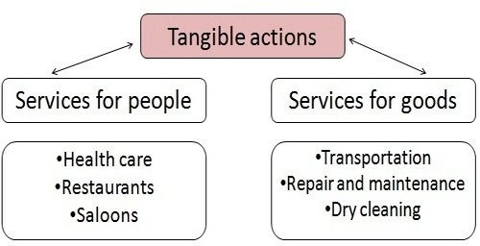
Wherever people or products are involved directly, the service classification can be done based on tangibility.
(i) Services for people – Like Health care, restaurants and saloons, where the service is delivered by people to people.
(ii) Services for goods – Like transportation, repair and maintenance and others. Where services are given by people for objects or goods.

2. Classification of services based on Intangibility
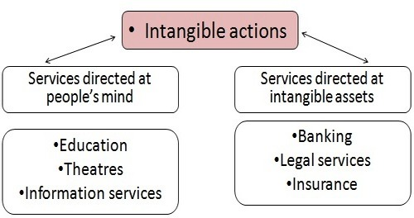
There are objects in this world which cannot be tangibly quantified. For example – the number of algorithms it takes to execute your banking order correctly, or the value of your life which is forecasted by insurance agents. These services are classified on the basis of intangibility.
(i) Services directed at people’s mind – Services sold through influencing the creativity of humans are classified on the basis of intangibility.
(ii) Services directed at intangible assets – Banking, legal services, and insurance services are some of the services most difficult to price and quantify.
The most intangible form of service output is represented by information processing. The customer’s involvement in this type is service is not required. Generally, customers have a personal desire to meet face to face but there is no actual need in terms of the operational process. Consultancy services can be an example of this type of services where the relationship can be built or sustained on trust or telephone contact. However, it is more indicated to have a face-to-face relationship in order to fully understand the needs of the customer.
A more general classification of services based on the type of function that is provided through them can be as follows:
- Business services.
- Communication services.
- Construction and related engineering services.
- Distribution services.
- Educational services.
- Environmental services.
- Financial services.
- Health-related and social services.
- Tourism and travel-related services.
- Recreational, cultural, and sporting services.
- Transport services.
- Other services not included elsewhere.

Service Capacity Planning
Ability of a service system to deliver the intended service and to match customer demand. Service capacity is perishable and can be intangible. Service capacity cannot be inventoried & hence cannot be transferred from one customer to other. We cannot prepare the service package in advance to deliver it at the later point of time.
Service capacity has to be managed in a highly dynamic environment where service organizations face more personalized demand due to the presence of customer than in manufacturing sector. Meeting personalized demand directly affects the service quality perceived by the customer.
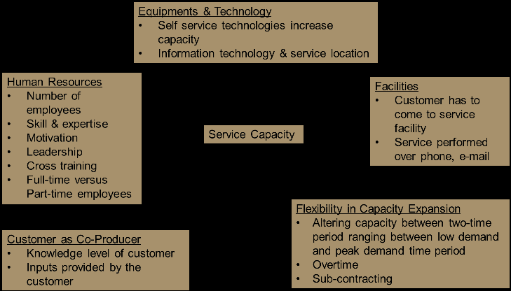
Capacity of a service is also attributed to the highest possible amount of output that may be obtained in a specified period of time with a predefined level of staff, installations and equipment (Lovelock, 1992). Managing capacity can be viewed as minimizing waiting time while avoiding idle capacity to meet the demand in the most efficient way.

Elements of Service Capacity
Capacity of service organization effectively and to provide a good quality service. Many strategies can be proposed to manage capacity in services if some organization understands the importance of all the elements presented. Altering human resources can be good capacity management strategy provided what kind of demand an organization is targeting to meet, whether demand is seasonal or cyclical. Are there any opportunities to automate the service where customers can utilize the technology from anywhere by avoiding personal visits to the service organizations. It is equally important to understand the knowledge level of customer. For example the internet penetration in India especially in rural India is very low. So, providing service through online mode may not help in such situations. The number of facilities, their locations and the possible considerations of facility expansion helps in managing the demand fluctuations.

SERVQUAL Model of Measuring Service Quality

The SERVQUAL Model is an empiric model by Zeithaml, Parasuraman and Berry to compare service quality performance with customer service quality needs. It is used to do a gap analysis of an organization’s service quality performance against the service quality needs of its customers. That’s why it’s also called the GAP model.
It takes into account the perceptions of customers of the relative importance of service attributes. This allows an organization to prioritize.
There are five core components of service quality:
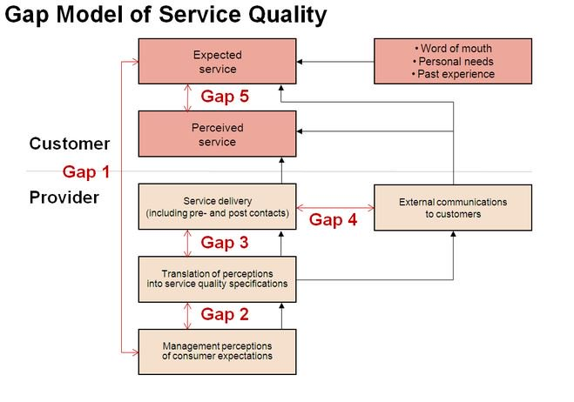

- Tangibles: physical facilities, equipment, staff appearance, etc.
- Reliability: ability to perform service dependably and accurately.
- Responsiveness: willingness to help and respond to customer need.
- Assurance: ability of staff to inspire confidence and trust.
- Empathy: the extent to which caring individualized service is given.
The four themes that were identified by the SERVQUAL developers were numbered and labelled as:

Consumer expectation – Management Perception Gap (Gap 1):
Management may have inaccurate perceptions of what consumers (actually) expect. The reason for this gap is lack of proper market/customer focus. The presence of a marketing department does not automatically guarantee market focus. It requires the appropriate management processes, market analysis tools and attitude.

Service Quality Specification Gap (Gap 2):
There may be an inability on the part of the management to translate customer expectations into service quality specifications. This gap relates to aspects of service design.

Service Delivery Gap (Gap 3):
Guidelines for service delivery do not guarantee high-quality service delivery or performance. There are several reasons for this. These include: lack of sufficient support for the frontline staff, process problems, or frontline/contact staff performance variability.

External Communication Gap (Gap 4):
Consumer expectations are fashioned by the external communications of an organization. A realistic expectation will normally promote a more positive perception of service quality. A service organization must ensure that its marketing and promotion material accurately describes the service offering and the way it is delivered
- These four gaps cause a fifth gap (Gap 5)
Which is the difference between customer expectations and perceptions of the service actually received Perceived quality of service depends on the size and direction of Gap 5, which in turn depends on the nature of the gaps associated with marketing, design and delivery of services. So, Gap 5 is the product of gaps 1, 2, 3 and 4. If these four gaps, all of which are located below the line that separates the customer from the company, are closed then gap 5 will close.

How to measure Service Quality?
- Mystery Shopping
This is a popular technique used for retail stores, hotels, and restaurants, but works for any other service as well. It consists out of hiring an ‘undercover customer’ to test your service quality – or putting on a fake moustache and going yourself, of course.
The undercover agent then assesses the service based on a number of criteria, for example those provided by SERVQUAL. This offers more insights than simply observing how your employees work. Which will probably be outstanding — as long as their boss is around.
- Post Service Rating
This is the practice of asking customers to rate the service right after it’s been delivered.
With Userlike’s live chat, for example, you can set the chat window to change into a service rating view once it closes. The customers make their rating, perhaps share some explanatory feedback, and close the chat.
Something similar is done with ticket systems like Help Scout, where you can rate the service response from your email inbox.
It’s also done in phone support. The service rep asks whether you’re satisfied with her service delivery, or you’re asked to stay on the line to complete an automatic survey. The latter version is so annoying, though, that it kind of destroys the entire service experience.
Different scales can be used for the post service rating. Many make use of a number-rating from 1 – 10. There’s possible ambiguity here, though, because cultures differ in how they rate their experiences.
- Follow-Up Survey
With this method you ask your customers to rate your service quality through an email survey – for example via Google Forms. It has a couple advantages over the post-service rating.
For one, it gives your customer the time and space for more detailed responses. You can send a SERVQUAL type of survey, with multiple questions instead of one. That’d be terribly annoying in a post-service rating.
It also provides a more holistic overview of your service. Instead of a case-by-case assessment, the follow-up survey measures your customers’ overall opinion of your service.
It’s also a useful technique if you didn’t have the post service rating in place yet and want a quick overview of the state of your service quality.
- In-App Survey
With an in-app survey, the questions are asked while the visitor is on the website or in the app, instead of after the service or via email. It can be one simple question – e.g. ‘how would you rate our service’ – or it could be a couple of questions.
Convenience and relevance are the main advantages. SurveyMonkey offers some great tools for implementing something like this on your website.
- Customer Effort Score (CES)
This metric was proposed in an influential Harvard Business Review article. In it, they argue that while many companies aim to ‘delight’ the customer – to exceed service expectations – it’s more likely for a customer to punish companies for bad service than it is for them to reward companies for good service.
While the costs of exceeding service expectations are high, they show that the payoffs are marginal. Instead of delighting our customers, so the authors argue, we should make it as easy as possible for them to have their problems solved.
That’s what they found had the biggest positive impact on the customer experience, and what they propose measuring.
- Social Media Monitoring
This method has been gaining momentum with the rise of social media. For many people, social media serve as an outlet. A place where they can unleash their frustrations and be heard.
And because of that, they are the perfect place to hear the unfiltered opinions of your customers – if you have the right tools. Facebook and Twitter are obvious choices, but also review platforms like TripAdvisor or Yelp can be very relevant. Buffer suggests to ask your social media followers for feedback on your service quality.
Two great tools to track who’s talking about you are Mention and Google Alerts.
- Documentation Analysis
With this qualitative approach you read or listen to your respectively written or recorded service records. You’ll definitely want to go through the documentation of low-rated service deliveries, but it can also be interesting to read through the documentation of service agents that always rank high. What are they doing better than the rest?
The hurdle with the method isn’t in the analysis, but in the documentation. For live chat and email support it’s rather easy, but for phone support it requires an annoying voice at the start of the call: “This call could be recorded for quality measurement”.
- Objective Service Metrics
These stats deliver the objective, quantitative analysis of your service. These metrics aren’t enough to judge the quality of your service by themselves, but they play a crucial role in showing you the areas you should improve in.
- Volume per channel. This tracks the amount of inquiries per channel. When combined with other metrics, like those covering efficiency or customer satisfaction, it allows you to decide which channels to promote or cut down.
- First response time. This metric tracks how quickly a customer receives a response on her inquiry. This doesn’t mean their issue is solved, but it’s the first sign of life – notifying them that they’ve been heard.
- Response time. This is the total average of time between responses. So let’s say your email ticket was resolved with 4 responses, with respective response times of 10, 20, 5, and 7 minutes. Your response time is 10.5 minutes. Concerning reply times, most people reaching out via email expect a response within 24 hours; for social channels it’s 60 minutes. Phone and live chat require an immediate response, under 2 minutes.
- First contact resolution ratio. Divide the number of issues that’s resolved through a single response by the number that required more responses. Forrester research showed that first contact resolutions are an important customer satisfaction factor for 73% of customers.
- Replies per ticket. This shows how many replies your service team needs on average to close a ticket. It’s a measure of efficiency and customer effort.
- Backlog Inflow/Outflow. This is the number of cases submitted compared to the number of cases closed. A growing number indicates that you’ll have to expand your service team.
- Customer Success Ratio. A good service doesn’t mean your customers always finds what they want. But keeping track of the number that found what they looked for versus those that didn’t, can show whether your customers have the right ideas about your offerings.
- ‘Handovers’ per issue. This tracks how many different service reps are involved per issue. Especially in phone support, where repeating the issue is necessary, customers hate HBR identified it as one of the four most common service complaints.
- Things Gone Wrong. The number of complaints/failures per customer inquiry. It helps you identify products, departments, or service agents that need some ‘fixing’.
- Instant Service / Queuing Ratio. Nobody likes to wait. Instant service is the best service. This metric keeps track of the ratio of customers that were served instantly versus those that had to wait. The higher the ratio, the better your service.
- Average Queueing Waiting Time. The average time that queued customers have to wait to be served.
- Queueing Hang-ups. How many customers quit the queueing process. These count as a lost service opportunity.
- Problem Resolution Time. The average time before an issue is resolved.
- Minutes Spent Per Call. This can give you insight on who are your most efficient operators.
Some of these measures are also financial metrics, such as the minutes spent per call and number of handovers. You can use them to calculate your service costs per service contact. Winning the award for the world’s best service won’t get you anywhere if the costs eat up your profits.
Some service tools keep track of these sort of metrics automatically, like Talkdesk for phone and User like for live chat support. If you make use of communication tools that aren’t dedicated to service, tracking them will be a bit more work.
One word of caution for all above mentioned methods and metrics: beware of averages, they will deceive you. If your dentist delivers a great service 90% of the time, but has a habit of binge drinking and pulling out the wrong teeth the rest of the time, you won’t stick around long.
A more realistic image shapes up if you keep track of the outliers and standard deviation as well. Measure your service, aim for a high average, and improve by diminishing the outliers.

