VISION INSTITUTE OF MANAGEMENT
MANAGEMENT INFORMATION SYSTEM
BBA 3rd YEAR/6th SEM
UNIT 2 (Planning & Decision Making)

The concept of corporate planning
Corporate planning is a total system of planning which involves the determination of the objectives for the company as a whole and for each department of the it; formulation of strategies for the attainment of these objectives (all this being done against the background of SWOT analysis); conversion of strategies into tactical plans (or operational plans); implementation of tactical plans and a review of the progress of tactical plans against the corporate planning objectives.
Analysis of the above definition:
On the basis of the above definition, we can state the following main features of corporate planning:
(i) Corporate planning is a total system of planning, under which concept objectives are determined for the company as a whole and for each department of it. This means that under the concept of corporate planning, no department of company is allowed to have its own independent planning. All departmental plans are a part of corporate planning, in a unified structure.
(ii) To realize the objectives of corporate planning, strategy formulation is done. Strategy formulation is the core aspect of corporate planning. Success of corporate planning depends on the success of strategy formulation
(iii) Determination of objectives of corporate planning and strategy formulation – both are done against the background of SWOT analysis.
(iv) Strategies are translated (or converted) into tactical plans (or operational plans), which are detailed in nature.
(v) Tactical plans are put to action at the right time, as decided by management. This is the practical aspect of corporate planning.
(vi) Performance of tactical plans is judged in the light of the objectives of corporate planning; so that necessary modifications might be made in the corporate planning process and better corporate planning might be done in future.
(vii) Corporate planning has a long-term perspective; while operational plans have a short-term prospective.
David Hussey (Corporate Planning: Theory and Practice) defines corporate planning as follows:
“Corporate planning includes the setting of objectives, organizing the work, people and systems to enable those objectives to be achieved, motivating through the planning process and through the plans, measuring performance and so controlling progress of the plans and developing people through better decision-making, clearer objectives, more involvement, and awareness of progress.”

Process of Corporate Planning:

(i) Environmental Analysis and Diagnosis:
The first steps (which is, in fact, the background step), involved in corporate planning is environmental analysis and diagnosis. (A detailed account of this step is attempted subsequently, in the discussion about corporate planning).

(ii) Determination of Objectives:
All planning starts with a determination of the objectives for the plan; and corporate planning is no exception to this generality. In corporate planning, after environmental analysis and diagnosis, the planners determine objectives for the company as a whole and for each department of it; which become the beginning point of corporate planning.
All objectives of corporate planning must represent an integrated or coordinated system of objectives. In order to make corporate planning a realistic approach to attaining objectives; objective setting for corporate planning is done in the light of environmental analysis and diagnosis.

(iii) Strategy Formulation:
Strategy formulation is the core aspect of corporate planning. Strategy is, in fact, the weapon of the planner devised for attaining objectives of corporate planning. It is easier to set objectives; it is difficult to realize them. Strategies facilitate the attainment of objectives.
There is no doubt about it that success of strategies is the success of corporate planning; and vice-versa. Strategy formulation is also done in the light of environmental analysis and diagnosis.

(iv) Development of Tactical Plans:
Strategies are translated into action plans called tactical plans or operational plans. Tactical plans are necessary for implementation of strategies leading to the attainment of corporate planning objectives. For example, if the strategy of a company is to develop the skills and talents of manpower for realizing objectives; then designing of suitable training programmes would amount to making tactical plans.
Corporate planning and strategy formulation have a long-term perspective; while tactical plans have a short-term perspective, as the latter are to be implemented immediately, in the usual course of organisational life.

(v) Implementation of Tactical Plans:
Mere paper planning is no planning; unless and until it is put into practice. As such, tactical plans are put into a process of implementation, just at the right time, as decided by management. For implementation purposes, necessary communications are made to the operating staffing; who are also provided with necessary facilities to implement the tactical plans.

(vi) Follow-Up-Action:
After the tactical plans have been put into practice; a review of progress is done i.e. an examination of what results are following from the implementation of the plan and what feedback action is necessary, for the betterment of the corporate planning process.

Strategic Planning, Tactical Planning and Operational Planning

STRATEGIC PLANNING
Strategic planning is an organizational management activity that is used to set priorities, focus energy and resources, strengthen operations, ensure that employees and other stakeholders are working toward common goals, establish agreement around intended outcomes/results, and assess and adjust the organization’s direction in response to a changing environment. It is a disciplined effort that produces fundamental decisions and actions that shape and guide what an organization is, who it serves, what it does, and why it does it, with a focus on the future. Effective strategic planning articulates not only where an organization is going and the actions needed to make progress, but also how it will know if it is successful.

Steps in Strategic Planning & Management
There are many different frameworks and methodologies for strategic planning and management. While there are no absolute rules regarding the right framework, most follow a similar pattern and have common attributes. Many frameworks cycle through some variation on some very basic phases:
(i) Analysis or assessment, where an understanding of the current internal and external environments is developed.
(ii) Strategy formulation, where high level strategy is developed and a basic organization level strategic plan is documented.
(iii) Strategy execution, where the high level plan is translated into more operational planning and action items, and
(iv) Evaluation or sustainment / management phase, where ongoing refinement and evaluation of performance, culture, communications, data reporting, and other strategic management issues occurs.

The purpose of Strategic Planning
The purpose of strategic planning is to set your overall goals for your business and to develop a plan to achieve them. It involves stepping back from your day-to-day operations and asking where your business is headed and what its priorities should be.
Taking the decision actively to grow a business means embracing the risks that come with growth. Spending time on identifying exactly where you want to take your business – and how you will get there – should help you reduce and manage those risks.
As your business becomes larger and more complex, so strategy formulation will need to become more sophisticated, both to sustain growth and to help you muster the leadership and resources you need to keep your business developing.
To do this, you will also need to start collecting and analysing a wider range of information about your business – both about how it operates internally and about how conditions are developing in your current and potential markets.

The Three key Elements of Strategic Planning
Developing a strategy for business growth requires you to deepen your understanding of the way your business works and its position relative to other businesses in your markets. As a starting point, you need to ask yourself the following three questions:
- Where is your business now? This involves understanding as much about your business as possible, including how it operates internally, what drives its profitability, and how it compares with competitors. Keep your review separate from day-to-day work and be realistic, detached and critical in distinguishing between the cause and effect of how your business operates. You should also write it down and review it periodically.
- Where do you want to take it? Here you need to set out your top-level objectives. Work out your vision, mission, objectives, values, techniques and goals. Where do you see your business in five or ten years? What do you want to be the focus of your business and your source of competitive advantage over your rivals in the marketplace? This step should be the foundation for the final plan and motivate change.
- What do you need to do to get there? What changes will you need to make in order to deliver on your strategic objectives? What is the best way of implementing those changes – what changes to the structure and financing of your business will be required and what goals and deadlines will you need to set for yourself and others in the business? Think about the business as a whole, for example consider diversification, existing growth, acquisition plans, as well as functional matters in key areas.

TACTICAL PLANNING
Tactical planning takes a company’s strategic plan and sets forth specific short-term actions and plans, usually by company department or function. The tactical planning horizon is shorter than the strategic plan horizon. If the strategic plan is for five years, tactical plans might be for a period of one to three years, or even less, depending on what kind of market the business serves and the pace of change.
Tactical planning is such an important part of a company’s strategic planning process that management consulting companies are often hired to assist companies in preparing tactical plans. A company usually begins with its objectives and then develops strategies for how to carry out their objectives. Tactical plans are the specific action steps necessary to get results.
Tactical Marketing Plan Example
Assume for a moment your company sells insurance products in a large metropolitan area. The tactical marketing plan for your insurance company must outline, step by step, each marketing component needed to meet the goals and vision of your company’s strategic plan.
For example, if you decide one of the best ways to reach your target consumer is TV advertising, then the tactical plan needs to carefully spell out the specifics of the TV campaign. Steps in developing this plan include, but are not restricted to, deciding on an appropriate message; arranging for the production of the commercial; deciding what channels to air the commercial on and when; and following up with potential customers who respond to the campaign.
Strategies Vs. Tactics
One of the biggest challenges in tactical planning is knowing the difference between a strategy and tactic. These are sometimes confused. A strategy is essentially a framework or plan, but it provides no tangible results on its own. Tactics are steps for implementing your strategies and are actionable and have a purpose and a measurable result. If you cannot see or discern the result of the action or task it is likely not a tactic.

OPERATIONAL PLANNING
Operational planning is the process of planning strategic goals and objectives to tactical goals and objectives. It describes milestones, conditions for success and explains how, or what portion of, a strategic plan will be put into operation during a given operational period, in the case of commercial application, a fiscal year or another given budgetary term. An operational plan is the basis for, and justification of an annual operating budget request. Therefore, a five-year strategic plan would typically require five operational plans funded by five operating budgets.
Operational plans should establish the activities and budgets for each part of the organization for the next 1 – 3 years. They link the strategic plan with the activities the organization will deliver and the resources required to deliver them.
An operational plan draws directly from agency and program strategic plans to describe agency and program missions and goals, program objectives, and program activities. Like a strategic plan, an operational plan addresses four questions:
- Where are we now?
- Where do we want to be?
- How do we get there?
- How do we measure our progress?
The operations plan is both the first and the last step in preparing an operating budget request. As the first step, the operations plan provides a plan for resource allocation; as the last step, the OP may be modified to reflect policy decisions or financial changes made during the budget development process.
Operational plans should be prepared by the people who will be involved in implementation. There is often a need for significant cross-departmental dialogue as plans created by one part of the organization inevitably have implications for other parts.
Operational plans should contain:
- Clear objectives of them
- Activities to be delivered
- Quality standards
- Desired outcomes
- Staffing and resource requirements
- Implementation timetables
- A process for monitoring progress

Types of Strategies used in Strategic Planning for achieving global Competitive advantage

1. Make time for Marketing Research and Planning
The most important quality that an organization needs if it wants to make understanding its customers a key part of its long term strategic planning is the development of a deep understanding of those customers real needs.
You will have to get to know these needs so well that your long term strategies become not just adaptive but also downright anticipatory of what the people you’re serving will want and respond to. This in essence is the antithesis of being reactive or behind the competitive curve and it can be achieved by digging deeply into the information you gain from your target market so that you instinctively learn what makes them tick and click with regards to your brand. In other words, you want to know your buyers enough so that you can accurately anticipate what they’ll want to buy and why.
Following this core process of strategic planning will put public perception of your company to a level that’s at least a cut above that of your competitors. Most fundamentally, achieving this requires asking questions which will define your long term company goals and then finding answers to those same questions through careful study of your customers behavior, effective viewing mediums (for marketing) and the market dynamic as a whole in your niche. Doing this will let you get to know your customers not just as superficial consumers but also as fully fleshed out human beings.

2. Know your Customers better than any competitor
Understanding your customers is a continuous process that your organization will have to start living and breathing on a daily basis, as part of its internal culture. As this quote from David Ogilvy shows, you must go further than simple surveys or basic client-related facts such as their age and spending budgets. Creating quality marketing research to fully understand customers is involved. You have to dig much deeper through the use of an assortment of tools on the web and in human resources so that you can create an integral customer profile which is constantly added to and made to evolve.
With this grade of in depth research, you will be much more adept at anticipating your buyers wishes and emotional trigger much more effectively than your competition. Achieving this will then let you then market strategically instead of reactively. And if you want an excellent example of a real world company that follows through on this exact philosophy and process, look no further than Apple Computer and its cult-like loyal following of buyers. Here are some of the more useful customer information metrics you might want to start looking at:
- Daily online and even offline habits
- Information about your buyers professional, personal and family lives
- Their interests, personal passions, hobbies and assorted worries
- Their communications, social media and online browsing preferences
- Awareness of advertising and different marketing platforms you might use or want to use
- The dynamics of your customers buying, shopping and desire related habits.
These are just some obvious examples and the more you flesh them out while also finding other information points to investigate, the better you’ll be able to make strategic predictions about what your consumers will respond to. Fleshing out this information and other, related metrics will let you better grasp your buyers’ emotional triggers.

3. Avoid Reactiveness at all Costs
Being purely reactive means playing a game of catch-up, and when you’re constantly trying to catch up, you’ll have no time to create any kind of long term strategic plan. This will make you fall behind your competitors and disappoint your existing customers eventually. More importantly still, a reactive marketing response will ruin your breathing space for guiding a clear course to the future of your company. While you’re busy reeling from surprises in your target market, your competitors are going to move ahead of you inexorably, particularly if they are actually implementing their own strategic planning process. Strategic planning concepts are covered in much greater detail within the pages of this Business guide to strategic planning from Insights into Marketing.

Different Strategies Used

1. Balanced Scorecard
The Balanced Scorecard is a strategy management framework created by Drs. Robert Kaplan and David Norton. It takes into account your:
- Objectives, which are high-level organizational goals.
- Measures, which help you understand if you’re accomplishing your objective strategically.
- Initiatives, which are key action programs that help you achieve your objectives.
There are many ways you can create a Balanced Scorecard, including using a program like Excel, Google Sheets, or PowerPoint or using reporting software. For the sake of example, the screenshot below is from ClearPoint’s reporting software.
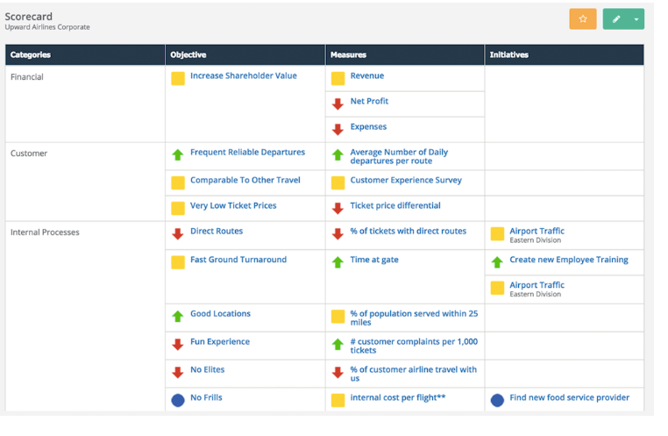
This is just one of the many “views” you’d be able to see in scorecard software once your BSC was complete. It gives you high-level details into your measures and initiatives and allows you to drill down into each by clicking on them. At a glance, you can tell what the RAG status of each objective, measure, or initiative is. (Green indicates everything is going as planned, while yellow and red indicate that there are various degrees of trouble with whatever is being looked at.)
All in all, a Balanced Scorecard is an effective, proven way to get your team on the same page with your strategy.

2. Strategy Map
A strategy map is a visual tool designed to clearly communicate a strategic plan and achieve high-level business goals. Strategy mapping is a major part of the Balanced Scorecard (though it isn’t exclusive to the BSC) and offers an excellent way to communicate the high-level information across your organization in an easily-digestible format.
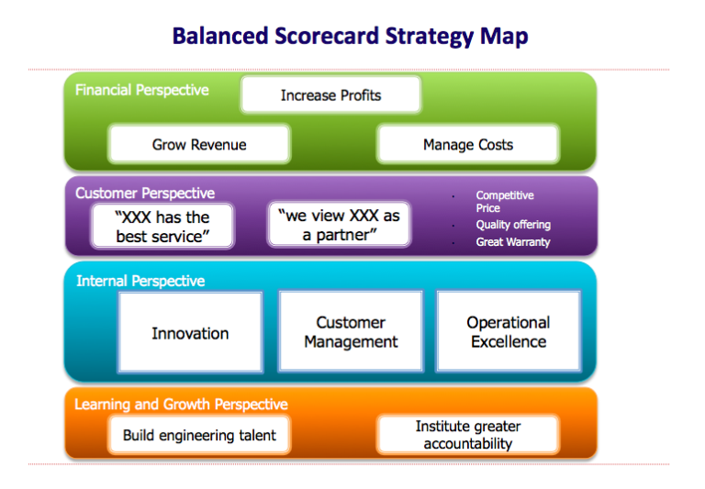
A strategy map offers a host of benefits:
- It provides a simple, clean, visual representation that is easily referred back to.
- It unifies all goals into a single strategy.
- It gives every employee a clear goal to keep in mind while accomplishing tasks and measures.
- It helps identify your key goals.
- It allows you to better understand which elements of your strategy need work.
- It helps you see how your objectives affect the others.

3. SWOT Analysis
A SWOT analysis (or SWOT matrix) is a high-level model used at the beginning of an organization’s strategic planning. It is an acronym for “strengths, weaknesses, opportunities, and threats.” Strengths and weaknesses are considered internal factors, and opportunities and threats are considered external factors.
Below is an example SWOT analysis from the Queensland, Australia, government:
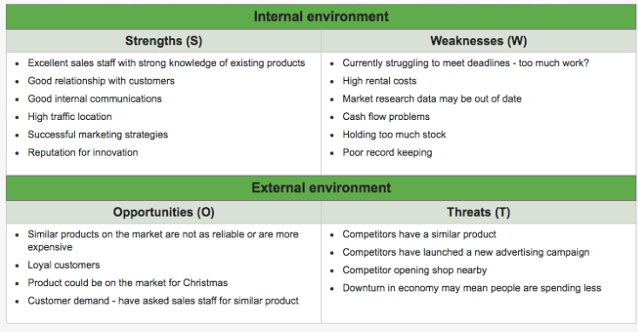
Using a SWOT analysis helps an organization identify where they’re doing well and in what areas they can improve. If you’re interested in reading more, this Business News Daily article offers some additional details about each area of the SWOT analysis and what to look for when you create one.

4. Gap Planning
Gap planning is also referred to as a “Need-Gap Analysis,” “Need Assessment,” or “the Strategic-Planning Gap.” It is used to compare where an organization is now, where it wants to be, and how to bridge the gap between. It is primarily used to identify specific internal deficiencies.
In your gap planning research, you may also hear about a “change agenda” or “shift chart.” These are similar to gap planning, as they both take into consideration the difference between where you are now and where you want to be along various axes. From there, your planning process is about how to ‘close the gap.’
The chart below, for example, demonstrates the difference between the projected and desired sales of a mock company:
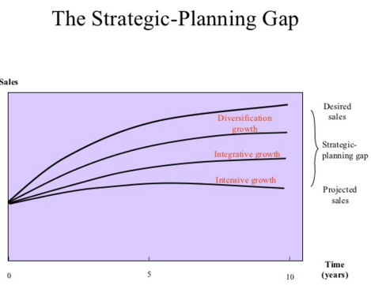

5. Blue Ocean Strategy
Blue Ocean Strategy is a strategic planning model that emerged in a book by the same name in 2005. The book—titled Blue Ocean Strategy: How to Create Uncontested Market Space and Make Competition Irrelevant—was written by W. Chan Kim and Renée Mauborgne, professors at the European Institute of Business Administration (INSEAD).
The idea behind Blue Ocean Strategy is for organizations to develop in “uncontested market space” (e.g. a blue ocean) instead of a market space that is either developed or saturated (e.g. a red ocean). If your organization is able to create a blue ocean, it can mean a massive value boost for your company, its buyers, and its employees.
For example, Kim and Mauborgne explain via their 2004 Harvard Business Review article how Cirque du Soleil didn’t attempt to operate as a normal circus, and instead carved out a niche for itself that no other circus had ever tried.
Below is a simple comparison chart from the Blue Ocean Strategy website that will help you understand if you’re working in a blue ocean or a red ocean:
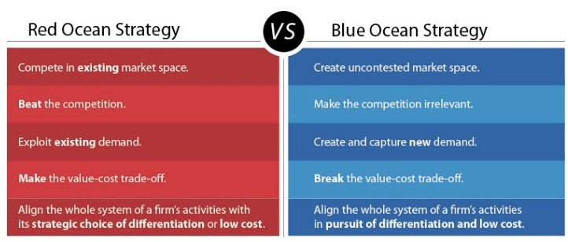

7. Porter’s Five Forces
Porter’s Five Forces is an older strategy execution framework (created by Michael Porter in 1979) built around the forces that impact the profitability of an industry or a market. The five forces it examines are:
- The threat of entry. Could other companies enter the marketplace easily, or are there numerous entry barriers they would have to overcome?
- The threat of substitute products or services. Can buyers easily replace your product with another?
- The bargaining power of customers. Could individual buyers put pressure on your organization to, say, lower costs?
- The bargaining power of suppliers. Could large retailers put pressure on your organization to drive down the cost?
- The competitive rivalry among existing firms. Are your current competitors poised for major growth? If one launches a new product or files a new patent—could that impact your company?
The amount of pressure on each of these forces can help you determine how future events will impact the future of your company.
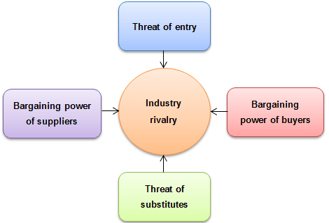

8. VRIO Framework
The VRIO framework is an acronym for “value, rarity, imitability, organization.” This framework relates more to your vision statement than your overall strategy. The ultimate goal in implementing the VRIO model is that it will result in a competitive advantage in the marketplace.
Here’s how to think of each of the four VRIO components:
- Value: Are you able to exploit an opportunity or neutralize an outside threat using a particular resource?
- Rarity: Is there a great deal of competition in your market, or do only a few companies control the resource referred to above?
- Imitability: Is your organization’s product or service easily imitated, or would it be difficult for another organization to do so?
- Organization: Is your company organized enough to be able to exploit your product or resource?

Types of Planning, Planning Process

The 4 Types of Planning
(i) Operational Planning
“Operational plans are about how things need to happen,” motivational leadership speaker Mack Story said at LinkedIn. “Guidelines of how to accomplish the mission are set.”
This type of planning typically describes the day-to-day running of the company. Operational plans are often described as single use plans or ongoing plans. Single use plans are created for events and activities with a single occurrence (such as a single marketing campaign). Ongoing plans include policies for approaching problems, rules for specific regulations and procedures for a step-by-step process for accomplishing particular objectives.
(ii) Strategic Planning
“Strategic plans are all about why things need to happen,” Story said. “It’s big picture, long-term thinking. It starts at the highest level with defining a mission and casting a vision.”
Strategic planning includes a high-level overview of the entire business. It’s the foundational basis of the organization and will dictate long-term decisions. The scope of strategic planning can be anywhere from the next two years to the next 10 years. Important components of a strategic plan are vision, mission and values.
(iii) Tactical Planning
“Tactical plans are about what is going to happen,” Story said. “Basically at the tactical level, there are many focused, specific, and short-term plans, where the actual work is being done, that support the high-level strategic plans.”
Tactical planning supports strategic planning. It includes tactics that the organization plans to use to achieve what’s outlined in the strategic plan. Often, the scope is less than one year and breaks down the strategic plan into actionable chunks. Tactical planning is different from operational planning in that tactical plans ask specific questions about what needs to happen to accomplish a strategic goal; operational plans ask how the organization will generally do something to accomplish the company’s mission.
(iv) Contingency Planning
Contingency plans are made when something unexpected happens or when something needs to be changed. Business experts sometimes refer to these plans as a special type of planning.
Contingency planning can be helpful in circumstances that call for a change. Although managers should anticipate changes when engaged in any of the primary types of planning, contingency planning is essential in moments when changes can’t be foreseen. As the business world becomes more complicated, contingency planning becomes more important to engage in and understand.

Process of Planning

1. Recognizing Need for Action
An important part of the planning process is to be aware of the business opportunities in the firm’s external environment as well as within the firm. Once such opportunities get recognized the managers can recognize the actions that need to be taken to realize them. A realistic look must be taken at the prospect of these new opportunities and a SWOT analysis should be done.
Say for example the government plans on promoting cottage industries in semi-urban areas. A firm can look to explore this opportunity.
2. Setting Objectives
This is the second and perhaps the most important step of the planning process. Here we establish the objectives for the whole organization and also individual departments. Organizational objectives provide a general direction, objectives of departments will be more planned and detailed.
Objectives can be long term and short term as well. They indicate the end result the company wishes to achieve. So objectives will percolate down from the managers and will also guide and push the employees in the correct direction.
3. Developing Premises
Planning is always done keeping the future in mind, however, the future is always uncertain. So in the function of management certain assumptions will have to be made. These assumptions are the premises. Such assumptions are made in form of forecasts, existing plans, past policies etc.
These planning premises are also of two types – internal and external. External assumptions deal with factors such as political environment, social environment, advancement of technology, competition, government policies etc. Internal assumptions deal with policies, availability of resources, quality of management etc.
These assumptions being made should be uniform across the organization. All managers should be aware of these premises and should agree with them.
4. Identifying Alternatives
The fourth step of the planning process is to identify the alternatives available to the managers. There is no one way to achieve the objectives of the firm, there is a multitude of choices. All of these alternative courses should be identified. There must be options available to the manager.
Maybe he chooses an innovative alternative hoping for more efficient results. If he does not want to experiment he will stick to the more routine course of action. The problem with this step is not finding the alternatives but narrowing them down to a reasonable amount of choices so all of them can be thoroughly evaluated.
5. Examining Alternate Course of Action
The next step of the planning process is to evaluate and closely examine each of the alternative plans. Every option will go through an examination where all there pros and cons will be weighed. The alternative plans need to be evaluated in the light of the organizational objectives.
For example, if it is a financial plan. Then it that case its risk-return evaluation will be done. Detailed calculation and analysis are done to ensure that the plan is capable of achieving the objectives in the best and most efficient manner possible.
6. Selecting the Alternative
Finally, we reach the decision making stage of the planning process. Now the best and most feasible plan will be chosen to be implemented. The ideal plan is the most profitable one with the least amount of negative consequences and is also adaptable to dynamic situations.
The choice is obviously based on scientific analysis and mathematical equations. But a manager’s intuition and experience should also play a big part in this decision. Sometimes a few different aspects of different plans are combined to come up with the one ideal plan.
7. Formulating Supporting Plan
Once you have chosen the plan to be implemented, managers will have to come up with one or more supporting plans. These secondary plans help with the implementation of the main plan. For example plans to hire more people, train personnel, expand the office etc. are supporting plans for the main plan of launching a new product
8. Implementation of the Plan
And finally, we come to the last step of the planning process, implementation of the plan. This is when all the other functions of management come into play and the plan is put into action to achieve the objectives of the organization. The tools required for such implementation involve the types of plans- procedures, policies, budgets, rules, standards etc.

MIS: Business Planning
MIS goals and objectives: It is necessary to develop the goals and objectives for the MIS which will support the business goals. The MIS goals and objectives will consider management philosophy, policy constraints, business risks, internal and external environment of the organization and the business.
The goals and the objectives of the MIS would be so stated that they can be measured.
The typical statements of the goals are as under:
- Provide on-line information on the stocks, markets and the accounts balances.
- The query processing should not exceed more than three seconds.
- The focus of the system will be on the end user computing and access facilities.
- Information support will be the first in the strategic areas of management such as marketing or service or technology.
The plan for development and its implementation is a basic necessity for MIS. In MIS the information is recognized as major resource like capital and time. If this resource has to be managed well, it calls upon the management to plan for it and control it, so that the information becomes a vital resource for the system.
The management information system needs good planning. This system should deal with the management information not with data processing alone. It should provide support for the management planning, decision making and action. It should provide support to the changing needs of business management. A long range MIS plan provides direction for the development of the system and provides a basis for achieving the specific targets or tasks against time frame.
Following are the contents of MIS planning:
MIS Goals and Objectives: It is necessary to develop the goal and objectives for the MIS which will support the business goals. The MIS goals and objectives will consider management philosophy, policy constraints, Business risk, internal and external environment of the organization and business. The goals and objectives of the MIS would be so stated that they can be measured. The typical statements of the goals can be providing online information on the stock and market; the query processing should not exceed more than three seconds and the like.
Strategy for Plan Achievement: The designer has to take a number of strategic decisions for the achievement of MIS goals and objectives. They are
a) Development Strategy: an online, batch, a real time.
b) System Development Strategy: Designer selects an approach to system development like operational verses functional, accounting verses analysis.
c) Resources for the Development: Designer has to select resources. Resources can be in-house verses external, customized or use of package.
d) Manpower Composition: The staff should have the staffs of an analyst, and programmer.
The Architecture of MIS: The architecture of the MIS plan provides a system and subsystem structure and their input, output and linkage. It spells out in details the subsystem from the data entry to processing, analysis to modeling and storage to printing.
The System Development Schedule: A schedule is made for development of the system. While preparing a schedule due consideration is given to importance of the system in the overall information requirements. This development schedule is to be weighed against the time scale for achieving certain information requirements.
Hardware and Software Plan: Giving due regards to the technical and operational feasibility, the economics of investment is worked out. Then the plan of procurement is made after selecting the hardware and software. One can take the phased approach of investing starting from the lower configuration of hardware going to the higher as development take place. The process needs matching the technical decisions with the financial decisions.

Decision making concepts
Decision-making is common to all of us, in our daily lives. In fact, every action of an individual is based on the decisions taken by him/her-concerning various matters.
Sometimes we take major decisions and are highly conscious about them. Minor or routine decisions, however, are taken by us; without ourselves realising the fact that a decision is being taken by us.
For example, the decision of a person to buy a bottle of soft-drink on a scorching summer day is a decision; without the person, being aware of the fact, that a decision is being taken by him/her. For major decisions, however, one is very conscious, careful and alert; and takes them in a planned manner.
In the context of business management also, decision-making is a common phenomenon, characterizing the ‘organisational lives’ of all managers. All managers take decisions-major or minor – within the limits of their authority, concerning their work field. In fact, whatever a manager does; he does so through decision-making. It is the thread that runs through the whole fabric of management.
Point of comment:
Sound decisions by managers lead to sound actions on their part; and, accordingly, better and efficient attainment of organizational objectives is facilitated.

Concept of Decision-making:
Decision-making might be defined as follows:
Decision-making is the process of selecting a best alternative course of action; from among a number of alternatives given to management or developed by it after carefully and critically examining each alternative.
Following are given a few popular definitions of decision-making:
“Decision-making is the selection based on some criteria from two or more possible alternatives.” -G.R. Terry
“Decision-making is a course of action chosen by a manager as the most effective means at his disposal for achieving goals and solving problems.” – Theo Haimann

Relationship between decision and decision-making:
From the definitions of decision and decision-making, it follows that decision making is a process; a decision is the outcome of this process. Accordingly, the better the decision-making process; the better would be the decisions emerging out of it leading to an efficient commitment of precious organisational resources.

Features of Decision-Making:
Following are the major features or characteristics of managerial decision-making:

(i) Decision-Making is Goal-Oriented:
Each and every decision of management major or minor must make, at least, some contribution towards the attainment of organisational objectives. In case otherwise, decision-making is a wasteful activity; involving only a sheer wastage of the time, energy and efforts of managers, and precious organisational resources.

(ii) Decision-Making is Pervasive:
There are three dimensions of the pervasiveness of decision-making; viz:
(a) All managers in the management hierarchy take decisions, within the limits of their authority, pertaining to their areas of functioning.
(b) Decision-making is done in all functional areas of management e.g. production, marketing, finance, personnel, research and development etc.
(c) Decision-making is inherent in all functions of management i.e. planning, organising, staffing, directing and controlling.

(iii) Decision-Making is an Intellectual Exercise:
Decision-making calls for creativity and imagination on the part of managers; in that decision-making forces managers to think in terms of developing best objectives and best alternatives for attaining those objectives. In fact, the more intelligent a manager is; the better would be the decision-making done by him.

(iv) Decision-Making Involves a Problem of Choice:
Decision-making is fundamentally a choosing problem i.e. a problem of choosing the best alternative, from out of a number of alternatives, in a rational and scientific manner. If in a managerial decision-making situation, alternatives do not exist; then there is no decision-making problem involved in that situation.
Further, more are the alternatives that are available in a situation; the more complicated the decision-making process is likely to be.

(v) Decision-Making is a Continuous Process:
Decision-making process commences since the inception of business and continues throughout the organisational life. All managers take decisions for organisational purposes; so long as the enterprise is in existence. In fact, decision-making is also involved in the process of liquidating or winding up a business enterprise.

(vi) Decision-Making is the Basis of Action:
All actions of people operating the enterprise are based on the decisions taken by management vis-a-vis organisational issues. In fact, the quality of actions by people well depends on the quality of decisions taken by management.

(vii) Decision-Making Implies a Commitment of Organisational Resources:
Commitment of organisational resources time, efforts, energies, physical resources etc. is implied both during the process of taking decisions and more particularly, at time of implementation of decisions. Right decisions, accordingly, imply a right commitment of resources; and wrong decisions imply a wrong commitment of precious organisational resources.

(viii) Decision-Making is Situational:
Decision-making much depends on the situation facing the management; at the time when a decision-making problem crops up. Whenever the situation changes; decision-making also changes; e.g. decision-making by management on similar issues is radically different during boom conditions and during conditions of recession or depression.

A Major Classification of Types of Decisions:
In fact, is a sort of Herculean task to list out all the decisions which managers take during the course of organisation life; as decisions taken by managers are numberless stretching from tiny to gigantic decisions? Yet, one could attempt the following classifications of managerial decisions – to have an idea of the basic nature and varieties of managerial decisions.

(i) Personal and Organisational Decisions:
Personal decisions are those which are taken by managers concerning their personal life matters. On the other hand, organisational decisions are those which are taken by managers, in the context of organisation and for furthering the objectives of the organisation.
The highlight of the above distinction between personal and organisational decisions is that sometimes, personal decisions of managers have got organisational implications; and then such personal decisions must be taken by managers, in the best interests of the organisation.
For example, the decision of a manager to proceed on a long leave is a personal decision of the manager. But then, in the interest of the organisation, he must appoint some deputy to act on his behalf, till he returns.

(ii) Casual and Routine Decisions:
Casual decisions (whether more significant or less significant) are those which are taken only on some special issues concerning organisational life e.g. a decision to install a new piece of machinery. Casual decisions of a significant nature are taken at upper levels of management. Insignificant casual decisions may, however, be permitted even at lower levels of management.
On the other hand, routine decisions are those which are taken in large numbers during the normal course of organisational life, with repeated frequency. A major number of routine decisions are taken at operational levels of management.
Point of comment:
One should not suppose that routine decisions are not taken at upper levels of management. Top ranking managers also indulge in routine decision-making. However, the number of routine decisions and their frequency at top levels of management is rather restricted.

(iii) Strategic and Tactical Decisions:
Decisions relating to designing of strategies are strategic decisions i.e. decisions of utmost significance for the organisation. Such decisions are taken at uppermost levels of management. For implementation purposes, strategies are translated into operational plans or tactical decisions. Such tactical decisions are taken at middle and lower levels of management.

(iv) Policy and Operative Decisions:
A policy decision is a decision in the nature of guidance and instruction; which defines and confines the area of discretion of subordinates, in matters of decision-making. Naturally policies are decided by superiors for the guidance of subordinates. Decisions of subordinates taken within the prescribed limits and guidance of policies are, in management terminology, called operative decisions.

(v) Programmed and Non-Programmed Decisions:
Programmed decisions are those which are taken within the framework of the existing plans of the organisation; and for taking which prescribed policies, rules, procedures and methods are available with the organisation. Such decisions do not pose much problem for managers.
On the other hand, non-programmed decisions are those for taking which there is no provision in the existing planning framework of the organisation. Such decisions are warranted by extraordinary exceptional or emergency situations.
For example, if workers are on strike on a particular day; such a situation will call for an un-programmed decision as to how to deal with the work- situation on that day. Non-programmed decisions are taken by managers confronting emergency situations, in consultation with higher levels of management.

(vi) Individual and Collective Decisions:
This classification of decisions rests on the manner of decision-making. An individual (not personal) decision is one which is taken by a manager in his individual capacity, without being in consultation with any other person, whatsoever. Such decisions are dictatorial or authoritarian in nature, and are taken by ‘big bosses’ of the organisation.
On the other hand, collective decisions are those which are jointly taken by a group of managers and other persons – through a process of mutual consultations – in meetings or committees or other joint forum. Such decisions are democratic in nature.

(vii) Financial and Non-financial Decisions:
Financial decisions are those which involve financial implications or commitment of organisational finances. In fact, most of the management decisions are financial in nature. On the other hand, non-financial decisions are those which do not involve financial implications; e.g. a decision-asking people to be punctual for the organisation or a decision-asking people not to accept gifts from suppliers or others.
In a way, non-financial decisions may also be very significant for the organisation.

Decision Making: Methods
(1) Marginal Analysis:
This technique is also known as ‘marginal costing’. In this technique the additional revenues from additional costs are compared. The profits are considered maximum at the point where marginal revenues and marginal costs are equal.” This technique can also be used in comparing factors other than costs and revenues.
For Example: If we try to find out the optimum output of a machine, we have to vary inputs against output until the additional inputs equal the additional output. This will be the point of maximum efficiency of the machine. Modern analysis is the ‘Break-Even Point’ (BEP) which tells the management the point of production where there is no profit and no loss.
(2) Co-Effectiveness Analysis:
This analysis may be used for choosing among alternatives to identify a preferred choice when objectives are far less specific than those expressed by such clear quantities as sales, costs or profits. Koontz, O’Donnell and Weihrich have written that “Cost models may be developed do show cost estimates for each alternative and its effectiveness. Social objective may be to reduce pollution of air and water which lacks precision. Further, he has emphasised for synthesizing model i.e., combining these results, may be made to show the relationships of costs and effectiveness for each alternative.”
(3) Operations Research:
This is a scientific method of analysis of decision problems to provide the executive the needed quantitative information in making these decisions. The important purpose of this is to provide the managers with scientific basis for solving organisational problems involving the interaction of components of the organisation. This seeks to replace the process by an analytic, objective and quantitative basis based on information supplied by the system in operation and possibly without disturbing the operation.
This is widely used in modern business organisations. For Example – (a) Inventory models are used to control the level of inventory, (b) Linear Programming for allocation of work among individuals in the organisation.
Further, some theories have also been propounded by eminent writers of management to analyse the problems and to take decisions. Sequencing theory helps the management to determine the sequence of particular operations. Queuing theory, Games theory, Reliability theory and Marketing theory are also important tools of operations research which can be used by the management to analyse the problems and take decisions.
(4) Linear Programming:
It is a technique applicable in areas like production planning, transportation, warehouse location and utilisation of production and warehousing facilities at an overall minimum cost. It is based on the assumption that there exists a linear relationship between variables and that the limits of variations can be ascertained.
It is a method used for determining the optimum combination of limited resources to achieve a given objective. It involves maximisation or maximisation of a linear function of various primary variables known as objective function subject to a set of some real or assumed restrictions known as constraints.

Decision Making: Tools and Procedures
The following are the five important elements of decision-making:
(1) Concept of good decision.
(2) Environment of decision.
(3) Psychological elements in decision.
(4) Timing of decision.
(5) Communication of decision.
(1) Concept of Good Decision:
The most important task before the manager of any enterprise is to take a good decision. The objectives of an enterprise can be achieved only by a good decision. A good decision is always acceptable to all reasonable persons and is based on sound judgement and factual informations. No decision should be taken without examining the situation, correlating it with the facts and scientifically analysing the facts. Such a decision satisfies the concept of good decision.
(2) Environment of Decision:
The success and failure of the whole enterprise depends on the nature; procedure and standard of a decision taken by its manager. The organisational environment and formal structure decides the relationship between units on the one hand and individuals on the other.
This relationship forms the basis of environment prevailing in an organisation and indirectly affects a decision. Similarly, political, social and economic situation in and outside the organisation affects a decision which the manager takes for implementation by the enterprise.
(3) Psychological Elements is Decision:
Every manager takes decision on the basis of the given facts, information and scientific analysis. But out of many alternatives his choice falls on this element. It is this choice on which his psychological impact is felt. In fact psychologically manager comes closer to the choice and that is why he feels like choosing the one which he feels is in the best interest of the whole enterprise.
The manager’s habits, temperament, social environment, upbringing, domestic life and political leanings all have a trace on his choice of alternative, consequently on his decisions.
(4) Timing of Decisions:
Decision if taken at a time when it is needed helps the management in achieving the objectives more successfully. Any decision taken in time obviously leaves a lasting impression on the minds of those who are affected by the decision. The impact of the decision will have lasting effect on the personnel of the enterprise and its effect will be on the working of the enterprise.
(5) Communication of Decision:
The communication of decision is as important as taking of the decision. Both go together. Decisions if not properly and timely communicated carry no weight howsoever important or good they may be. A good decision is based on scientific analysis of facts and is taken and communicated when it is needed the most.

Principles of Decision Making:
Eminent authors of management are of this opinion that on right and appropriate decisions, the success and failure of the enterprise depend. Therefore, a manager has to take all precautions before arriving at a decision.
Following are the important principles which may be taken into consideration while taking decision:
(1) Marginal Theory of Decision-Making:
Marginal theory of decision-making has been suggested by various economists. Economists believe that a business undertaking works for earning profit. To earn profit is their prime motto. That is why they agree that the manager must take every decision with the aim in view that the profit of his organisation goes on increasing till it reaches its maximum. Therefore, the economists argue that an organisation with sole aim of maximisation of profit needs a marginal analysis of all its profit. Decision-making too should be based on marginal analysis.
According to economists marginal analysis of a problem is based on Law of Diminishing Returns. With extra unit of labour and capital put in production, the production increase but it increases at a proportionately reduced rate. From every extra unit of labour and capital the production diminishes and a time comes when the increase in production stops with ‘zero’ as the production of the last unit used therein.
At this stage further production is discounted. A decision is taken to the effect that no additional unit of labour and capital now is required to be introduced in the production. Production of the last unit is marginal one where – after further introduction of extra unit becomes uneconomical or non-yielding.
The marginal principle can be effectively used while taking decision on matters relating to – (i) production, (ii) sales, (iii) mechanisation, (iv) marketing, (v) advertising, (vi) appointment and other matters where marginal theory can be scientifically and statistically used and a good decision is rendered possible.
(2) Mathematical Theory:
It will be wrong if we say that the decision-making techniques owe too much to the mathematical theory of taking decisions. Venture analysis, game theory, probability theory, waiting theory are a few of the theories on the basis of which a manager analyses a given fact and takes decision accordingly. This has given rise to a scientific approach to the decision-making process.
(3) Psychological Theory:
The nature, size and purpose, of the organisation play an important role in decision-making. Manager’s aspirations, personality, habits, temperament, political leanings and social and organisational status, domestic life, technological skill and bent of mind play a very important role in decision making. They do help in decision-making.
They all in some form or the other leave an impact on the decisions taken by the manager. No doubt the manager is not free to decide whether he wishes to. He is also bound by his responsibilities and answerability. But psychology of the manager has a bearing on the decision he takes and this fact cannot be brushed aside. Decision-making is a mental process and the psychology of those who are deliberating and of the person who take the final decision has a definite say in decision-making.
(4) Principle of Limiting Factors:
The decisions taken are based on limited factors nevertheless they are supposed to be good because of the simple fact that under the circumstances it was the only possibility. From this principle it emerges that though there are numerous alternative available to a decision-making but he takes cognizance to only those alternatives which suit the time, purpose and circumstances and which can be properly and thoroughly analysed considering the human capacity and then finally one of the alternatives is chosen which forms the basis of a decision.
(5) Principle of Alternatives:
Decision is an act of choice. It is a selection process. Out of many available alternatives the manager has to choose the one which he considers best in the given circumstances and purpose.

(6) Principle of Participation:
This principle is based on human behaviour, human relationship and psychology. Every human being wants to be treated as an important person if it is not possible to accord him a V.I.P. treatment. This helps the organisation in getting maximum from every person at least from those who have been given place of importance and honour.
Participation signifies that the sub-ordinates, even if they are not concerned, should be consulted and due weightage should be given to their viewpoint. Japanese do this. Japanese institutions – business or government make decisions by consensus. This makes all of them feel that they are very much part of the decision. The Japanese debate a proposed decision throughout its length and breadth of the organisation until there is an agreement.
A few may disagree with Japanese method of decision-making because they may agree that it is not suited to our conditions. Such a method involves politicking, delays the decisions and sometimes may result into indecisiveness. But worker’s participation in decision-making can be ensured by the Japanese method.
Those favouring Japanese method and workers participation, advance the argument that decisions are important. But according to modern thinking the decision should not be within the purview of only a selected few. Those who are to carry out the decisions must be actively associated with their decision-making also.
Principle of participation – Firstly, aims at the development and research of all possible alternatives. If larger number of people concerned are asked to search for alternatives on the basis of which decisions are expected to be taken then greater participation is assured which is surely an important aim of this principle.
Secondly, this principle asks for debating and deliberating by more and more people so as to know the mind of all and to assess the possible reaction of a particular decision which the manager has in mind.
Further, the principle of participation is becoming popular due to following reasons:
(1) The participants feel that the business is their own of which they are important parts;
(2) Opposition to a decision is considerably reduced, and those who are to carry the decision are gladly accepting even if any change is being introduced;
(3) Guidance and directions function of management are being easily performed;
(4) Decisions are the result of best possible selection of the alternatives, therefore decisions may yield results to the advantage of the organisation on the expected lines;
(5) Increase in the efficiency of workers
(6) Development of co-ordinated efforts
(7) Development of good human relations
(8) Development of team spirit and better understanding because of good human relations; and
(9) Assurance of growth and prosperity to both the organisation as well as the whole working force – managerial, supervisory and operating.
Today the managers are more interested in eliciting the participation of workers with their decisions with a view to get more co-operation and to exercise effective control over them in the accomplishment of the tasks assigned by the objectives of the organisation.

Procedures
In decision-making process steps normally refers to processes, procedures and phases which are usually followed for better decision.
According to Stanley Vance decision-making consists of the following six steps:
- Perception.
- Conception.
- Investigation.
- Deliberation.
- Selection.
- Promulgation
1. Perception:
Perception is a state of awareness. In a man consciousness arises out of perception. Consciousness gives tilt to the decision-making process. The executive first perceives and then moves on to choose one of the alternatives and thus takes a decision. Perception is, therefore, an important and first step without which decisions relating to any of the problems of the organisation cannot be taken. Other steps follow “perception” is the first step in decision-making.
- Conception:
Conception means designs for action or programme for action. Conception relates to that power of mind which develops ideas out of what has been perceived.
- Investigation:
The investigation provides an equipment with the help of which the manager tries to go ahead with a debate either in his mind independently or with his co-workers. Perception is a sort of location of the problem whereas conception is the preparation of design or programme for solving the problem. But only perception and conception cannot offer the solution.
For solution investigation is to be carried out. Information relevant to a particular concept is to be sought, acquired and then analysed. Relative merits and demerits of a different analysed concepts should be measured. Alternative course of action is to be thought, analysed and compared to. This needs investigation with which the manager should be armed.
- Deliberation:
Weighing the consequences of possible course of action is called deliberation. The manager may either weigh the relative merits and demerits and the following consequences in his own mind or share his mental exercise with others to equip himself better. The deliberations remove bias and equip the manager with different ideas and alternatives and help him in arriving at a decision which may safely be ascribed as good decision.
- Selection:
Selection is an act of the choice which in management terminology is known as decision. After deliberations one of the alternatives, the best possible in the circumstances, is selected.
- Promulgation:
Perception, conception, investigation, deliberation and lastly selection will carry weight only when selected – the chosen alternative, that is, the decision – is properly and timely communicated to all those who are concerned and for whom the decision is meant. Only proper promulgation will help its execution.

Organizational Decision making

1. Personal and Organizational Decisions:
Personal decisions are those, which a person takes in his individual capacity but not as a member of his organisation. This affects his personal life. These personal decisions are not delegated, A manager who decides to resign his job and leaves the organizational making a personal decision.
Organizational decisions, on the other hand, are taken by an executive in his/her official capacity and can be delegated to others. Such decisions affect the organisational behavior directly.

2. Long Term Departmental and Non-Economic Decisions:
In case of long-term decisions the period covered is long and the risk involved is more. Departmental decisions art- taken by the departmental heads and relate to the department only. Decisions relating to non-economic factors (such as technical values, moral behavior etc.) may be termed as non-economic decisions.
While taking decisions on these factors, care should be taken to see that justice is done to all and as a result of this decision; no new problem is created for the organization.

3. Individual and Group Decisions:
Another method of classifying decisions is on the basis whether one single individual or a group is involved in making decisions. Most decisions in organizational life are made by individuals. It is for the authority. There are individuals whose authority is supervisory; they make decisions with respect to people. If their authority is operational, they make decisions with respect to things or ideas.
Some decisions are made by groups. Group decision-making is variously known as participate or plural management. If formally authorized, it takes the form of formal committee that is authorized to make specific decisions. Formal committees are becoming increasingly popular in large organizations.

4. Programmed and Non-Programmed Decisions:
Programmed decisions are those, which are routing and repetitive, and have procedures setup to deal with them, and are taken within the board policy structure. In such decision, risk involved is not high and they, therefore, can be more easily delegated. Purchase of raw materials in normal routing is an example for programmed decisions.
Such is an example for programmed decisions. Such purchases can be made by lower-level managers keeping in view the purchase policy decided by the top management.
These decisions have short- run impact on the functioning of the organization. Non- programmed decisions are non-repetitive and are basic in that they result in long-range commitment. For example, the selection of a location for a factory, introducing a new product in the market etc.

5. Routine and Strategic Decisions:
Basic or strategic decisions relate to policy matters and usually involve large investments or expenditure of funds. Routing decisions on the other hand are those, which require little deliberation or those, which are made repetitively.
For instance, sending samples of a product to the Government investigation center is a routine decision, but lowering the price of product or installation of automatic plant are major and strategic decisions.

6. Major and Minor Decisions:
Decisions may be classified as major and minor. For example, if it relates to the purchase of a big machine worth, say a lakh of rupees, it is a major decision. On the other hand, purchase of fountain pen ink or a few reams of paper are minor matters and may be decided by the office superintendent.

7. Policy and Operating Decisions:
Whether to give profit bonus to employees or not a matter of policy to be decided by top management; but calculating the bonus in respect of each employee is an operating decision which can be taken at a much lower level.

