VISION INSTITUTE OF MANAGEMENT
MANAGEMENT INFORMATION SYSTEM
BBA 3rd YEAR/6th SEM
Unit 4 Development of MIS
Development of Long Range Plans of the MIS
- The plan for development and its implementation is a basic necessity for MIS.
- In MIS the information is recognized as a major resource like capital, time and capacity.
- If information (resource) is to be managed well, it calls upon the management to plan for it and control it for the appropriate use in the organization.
- With the advancement of IT, it is possible to recognize information as a valuable resource like money and capacity.
- It is necessary to link its acquisition, storage, use and disposal as per the business needs for meeting the business objectives.
- So we need MIS flexible enough to deal with the changing information needs of the organization. It should be open system. The designing of such an open system is a complex task.
- It can be achieved if MIS is planned, keeping in view, the plan of the business management of the organization.

Contents of the MIS plan
Long range MIS plan provides direction for the development of the systems, and provides a basis for achieving the specific targets or tasks against a time frame.
Business Plan | MIS Plan
Business goals and objectives | MIS objectives, consistent to the business goals and objectives
Business plan and strategy | Information strategy for the business plan implementation playing a supportive role
Strategy planning and decision | Architecture of the MIS to support decisions
Management plan for execution and control | System development schedule, matching the plan execution
Operation plan for the execution | Hardware and software plan for the procurement and the implementation
MIS plan is linked to the Business plan

MIS Goals & Objectives
Goals are to consider management philosophy, policy constraints, business risks, internal and external environment of the organization and the business
The typical goals are as under-
- Provide an online information on the stock, markets and the account balances
- The query processing should not exceed more than 3 sec.
- The focus of the system will be on the end user computing and access facilities
- Information support will be the first in the strategic areas of management such as marketing or service or technology.

Strategy for the Plan achievement
- Development Strategy: An online, a batch, a real time. Technology platform.
- System development strategy: SSAD or OOT. Database VS conventional etc.
- Resources for system development: In house VS external, customised development VS the use of packages.
- Manpower composition: Analyst, programmer skills and know-how.
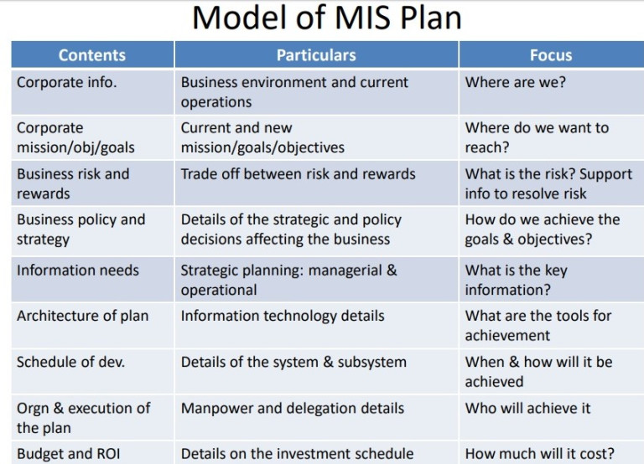

The architecture of the MIS
It provides a system structure and their input, output and linkages. It also provides handling of systems & subsystems by way of simplification, coupling and decoupling of subsystems
The system development schedule
A schedule is made for the development of the system. Unless the systems are fully developed their integration is not possible.
Hardware and software plan
- Giving due regard to the technical and operational feasibility, the economics if investment is worked out. Then the plan of procurement is made after selecting the hardware and software.
- The selection of the architecture, the approach to the development and choice of hardware and software are the strategic decisions and needs to be taken very carefully.

Following points to consider
The organization’s strategic plan should be the basis for the MIS strategic plan
The IS development schedule should match with the implementation schedule of the business plan
The choice of information technology is a strategic business decision and not a financial decision.
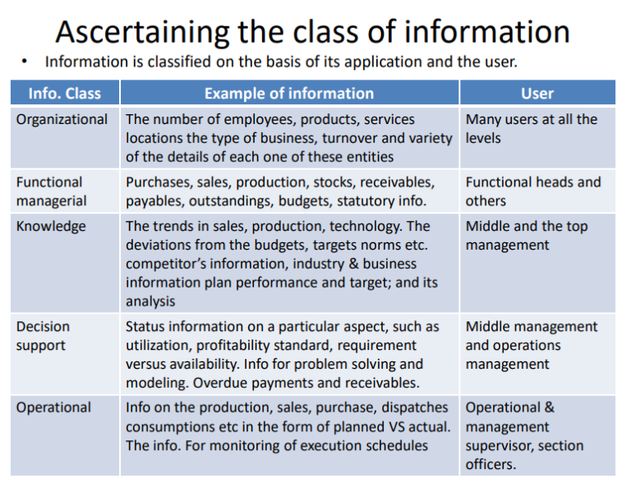

Functional Managerial Information
- The functional information is defined as a set of information required by the functional head in conducting the administration and management of the function.
- Functional information is largely factual, statistical and detailed in multi-dimensions of the function. Such information is used for planning, budgeting and controlling the operations of the function.
- If u take sales information, it can be processed in several ways such as product, product groups, market segment, geographic zone, locations etc.
- The functional information can be assessed on the following three parameters:
- The work design
- The responsibility
- The functional objectives.
Work design
For example, for the customer order scrutiny the available stock, the price, the terms of payment and the probable delivery is an information set evolved out of the work design of customer order processing. The procedure of the order processing requires this information.
Responsibility
The managers in the functional areas of management are responsible for achieving the targets and accomplishing the goals and objectives. So important to inform and update the information on target at regular intervals.
Functional objective
Each function has its own objectives which is derived out of the corporate goals.
Some of the business plan objectives are given below based on which each function is the organization derives its objectives
- The total sales per month is Rs. 10 million
- The finished goods inventory not to exceed Rs. 1 million
- The outstanding more than six months not to exceed Rs. 0.2 million
- The employee attendance per month should be 90 percent

Determining the information requirement
In order to collect information so as to study existing system and to determine information requirement, there are different strategies, which could be used for a purpose. These strategies are discussed below-
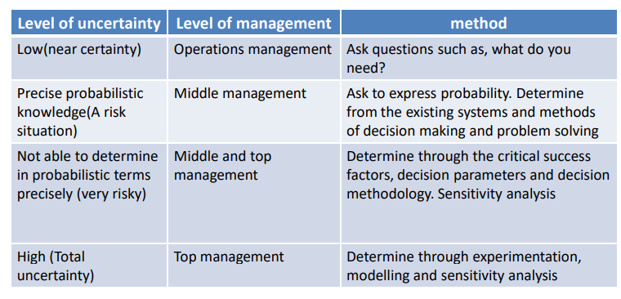

Interview
The interview is a face-to face method used for collecting the required data. In this method, a person (the interviewer) asks questions from the other person being interviewed may be formal or informal and the questions asked may be structured or unstructured. The interviewer must plan the interview and should have clear understanding of issues.
Questionnaire
A questionnaire is a term used for almost used for almost any tool that has questions to which individuals respond. The use of questionnaires allows analysts to collect information about various aspects of a system from a large number of persons. The questionnaire may contain structured or unstructured questions. The use of a standardized questionnaire gives more reliable data than other fact finding techniques.
Record Review
Record review is also known as review of documentation. Its main purpose is to establish quantitative information regarding volumes, frequencies, trends, ratios, etc. In record review, analysts examine information that has been recorded about the system and its users. Procedures, manuals and forms are useful sources for the analyst to study the existing systems. The main limitation of this approach is that the documentation on the existing system may not be complete and up-to-date.
Observation
Another information-gathering tool used in system studies is observation. It is the process of recognizing and noticing people, objects and occurrences to obtain information. Observation allows analysts to get information, which is difficult to obtain by any other fact-finding method. This approach is most useful when analysts need to observe the way documents are handled, processes are carried out and whether the specified steps are actually followed. This technique is time consuming and costly. Electronic observation and monitoring methods are being used these days because of their speed and efficiency.

Development and implementation of the MIS
Development of Information Systems
a) Development and Implementation of the MIS
Once the plan of MIS is made, the development of the MIS calls for determining the strategy of development is discussed earlier, the plan consists of various systems and subsystems. The development strategy determines where to begin and in what sequence the development can take place with the sole objective of assuring the information support. The choice of the system or the subsystem depends on its position in the total MIS plan, the size of the system, the user’s understanding of the systems and the complexity and its interface with other systems. The designer first develops systems independently and starts integrating them with other systems, enlarging the system scope and meeting the varying information needs. Determining the position of the system in the MIS is easy. The real problem is the degree of structure and formalization in the system and procedures which determine the timing and duration of development of the system. Higher the degree of structured and formalization, greater is the stabilization of the rules, the procedures, decision-making and the understanding of the overall business activity. Here, it is observed that the user’s and the designer’s interaction is smooth, and their needs are clearly understood and respected mutually. The development becomes a method of approach with certainty in the input process and outputs.
b) Prototype Approach
When the system is complex, the development strategy is Prototyping of the System. Prototyping is a process of progressively ascertaining the information needs, developing a methodology, trying it out on a smaller scale with respect to the data and the complexity, ensuring that it satisfies the needs of the users, and assess the problems of development and implementation.
This process, therefore, identifies the problem areas, inadequacies in the prototype visa is the fulfilment of the information needs. The designer then takes steps to remove the inadequacies. This may call upon changing the prototype of the system, questioning the information needs, streamlining the operational systems and procedures and move user interaction.
In the prototyping approach, the designer’s task becomes difficult, when there are multiple users of the same system and the inputs they use are used by some other users as well. For example, a lot of input data comes from the purchasing department, which is used in accounts and inventory management.
The attitudes of various users and their role as the originators of the data need to be developed with a high degree of positivism. It requires, of all personnel, to appreciate that the information is a corporate resource, and all have to contribute as per the designated role by the designer to fulfill the corporate information needs. When it comes to information the functional, the departmental, the personal boundaries do not exist. This call upon each individual to comply with the design needs and provide without fail the necessary data inputs whenever required as per the specification discussed and finalized by the designer.
Bringing the multiple users on the same platform and changing their attitudes toward information, as a corporate resource, is the managerial task of the system designer. The qualification, experience, knowledge, of the state of art, and an understanding of the corporate business, helps considerably, in overcoming the problem of changing the attitudes of the multiple users and the originators of the data.
c) Life Cycle Approach
There are many systems or subsystems in the MIS which have a life cycle, that is, they have birth and death. Their emergence may be sudden or may be a part of the business need, and they are very much structured and rule-based. They have 100% clarity of inputs and their sources, a definite set of outputs in terms of the contents and formats. These details more or less remain static from the day the system emerges and remains in that static mode for a long time. Minor modifications or changes do occur but they are not significant in terms of handling either by the designer or the user of the system. Such systems, therefore, have a life and they can be developed in a systematic manner and can be reviewed after a year or two, for significant modification, if any.
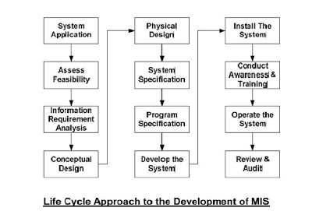
Examples of such systems are payroll, share accounting, basic financial accounting, finished goods accounting and dispatching, order processing, and so on. These systems have a fairly long duration of survival and they contribute in a big way as sources of data to the Corporate MIS. Therefore, their role is important and needs to be designed from the viewpoint as an interface to the Corporate MIS.
d) Implementation of the Management Information System
The implementation of the system is a management process. It brings about organizational change; It affects people and changes their work style. The process evokes a behaviour response which could be either favourable or unfavourable depending upon the strategy of system implementation.
In the process of implementation, the system designer acts as a change agent or a catalyst. For a successful implementation, he has to handle the human factors carefully. The user of the system has a certain fear complex when a certain cultural work change is occurring. The first and the foremost fear are about the security to the person if the changeover from the old to new is not a smooth one. Care has to be taken to assure the user that such fears are baseless and the responsibility, therefore, rests with the designer. The second fear is about the role played by the person in the organization and how the change affects him. On many occasions, the new role may reduce his importance in the organization, the work design may make the new job impersonal, and a fear complex may get reinforced that the career prospects may be affected. There are certain guidelines for the systems designer for the successful implementation of the system. The system designer should not question beyond a limit the information need of the user.
- Not to forget that his role is to offer a service and not to demand terms.
- Remember that the system design is for the use of the user and it is not the designer’s prerogative to dictate the design features. In short, the designer should respect the demands of the user.
- Not to mix up technical needs with the information needs. He should try to develop a suitable design with appropriate technology to meet the information needs. The designer should not recommend modifications of the needs, unless technically infeasible.
- Impress upon the user the global nature of the system design which is required to meet the current and prospective information need.
- Not to challenge the application of the information in decision-making. It is the sole right of the user to use the information the way he thinks proper.
- Impress upon the user that the quality of information depends on the quality of input.
- Impress upon the user that you are one of the users in the organization and that the information is a corporate resource and he is expected to contribute to the development of the MIS.
- Ensure that the user makes a commitment to all the requirements of the system design specifications. Ensure that he appreciates that his commitments contribute largely to the quality of the information and successful implementation of the system.
- Ensure that the overall system effort has the management’s acceptance.
- Enlist the user’s participation from time to time, so that he is emotionally involved in the process of development.
- Realize that through serving the user, he is his best guide on the complex path of development.
- Not to expect perfect understanding and knowledge from the user as he may be the user of a non-computerized system. Hence, the designer should be prepared to change the system specifications or even the design during the course of development.
- Impress upon the user that the change, which is easily possible in a manual system, is not as easy in the computer system as it calls for changes in the programs at cost.
- Impress upon the user that perfect information is nonexistent; His role therefore still has an importance in the organization.
- Ensure that the other organization problems are resolved first before the MIS is taken for development.
- Conduct periodical user meetings on systems where you get the opportunity to know the ongoing difficulties of the users.
- Train the user in computer appreciation and systems analysis as his perception of the computerized information system will fall short of the designer’s expectation. Implementation of the MIS in an organization is a process where organizational transformation takes place. This change can occur in a number of ways. Lewin’s model suggests three steps in this process.
The first step is unfreezing the organization to make the people more receptive and interested in the change.
The second step is choosing a course of action where the process begins and reaches the desired level of stability.
The third step is Refreezing, where the change is consolidated and equilibrium is reinforced. Many times, this process is implemented through an external change agent, such as a consultant playing the role of a catalyst.
The significant problem in this task is the resistance to change. The resistance can occur due to three reasons, viz., the factors internal to the users of information, the factors inherent in the design of the system and the factors arising out of the interaction between the system and its users. The problem of resistance can be handled through education, persuasion, and participation. This can be achieved by improving the human actors, and providing incentives to the users, and eliminating the organizational problems before implementing the system.

Management of quality in the MIS
Success of any organization depends on the quality of information which is very crucial resource. Further future of an organization depends on using and disseminating the information wisely according to their objectives. To run any organisation successfully, when your information is of good quality and when this information is placed in right context in right time according to their needs then it gives the way to find out the about opportunities and problems well in advance.
Good quality information: Quality is a value that would differ according to the users and uses of the information.
According to Wang and Strong, following are the dimensions or elements of Information Quality:
- Intrinsic: Accuracy, Objectivity, Believability, Reputation
- Contextual: Relevancy, Value-Added, Timeliness, Completeness, Amount of information
- Representational: Interpretability, Format, Coherence, Compatibility
- Accessibility: Accessibility, Access security
Various authors propose various lists of metrics for assessing the quality of information. Let us produce a list of the most essential characteristic features for information quality:
- Reliability: It should be verifiable and dependable.
- Timely: It must be timely set and it must reach the users well in current time, so that important decisions can be made in time.
- Relevant: It should be current and valid information which is relevant and it should reduce uncertainties.
- Accurate: It should be free of errors and mistakes, true, and not deceptive.
- Sufficient: It should be adequate in quantity, so that decisions can be made based on the quantity.
- Unambiguous: It should be expressed in clear terms and conditions. In other words, in should be comprehensive.
- Complete: It should meet all the needs in the current context.
- Unbiased: It should be impartial, free from any bias. In other words, it should have integrity.
- Comparable: It should be of uniform collection, analysis, content, and format.
- Reproducible: To achieve better results it is used by documented methods on the same data which is reproducible.
Information is a corporate resource, as important as the capital, labor, know-how, etc. and is being used for decision making. Its quality, therefore, is required to be very high. Low quality information would adversely affect the organizational performance as it affects decision making. The quality of information is the result of the quality of the input data, processing design, system design, system procedure which generate such a data, and the management of the data processing function. Quality, unlike any other product, is not an absolute concept. Its level is determined with reference to the context and its use, and the user. Perfect quality just as perfect information is non-achievable and has cost benefit implications.
However, it is possible to measure the quality of information on certain parameters. All these parameters need not have a very high value in terms of the unit of measure. Some parameters may have lesser importance in the total value on account of their relevance in the information and its use.
The quality of the parameters is assured if the following steps are taken:
- All the input is processed and controlled.
- All updating and corrections are completed before the data processing begins.
- Inputs (transactions, documents, fields and records) are subjected to validity checks.
- The access to the data files is protected and secured through an authorization scheme.
- Intermediate processing checks are introduced to ensure that the complete data is processed right through, I.e., run to run controls.
- Due attention is given to the proper file selection in terms of data, periods and so on.
- Back-up of the data and files are taken to safeguard corruption or loss of data.
- The system audit is conducted from time to time to ensure that the computer system specification is not violated.
- The system modifications are approved by following a set procedure which begins with authorization of a change to its implementation followed by an audit.
- Systems are developed with a standard specification of design and development.
- Computer system processing is controlled through programme control, process control and access control.

Organization for development of the MIS
Following steps are involved in the development of an appropriate MIS for a business organisation:
- Defining and analysing various types of decisions made in the organization:
The MIS designers should thoroughly analyse the existing decisions- making system of the organisation. This requires a study of different levels of decision makers and the priorities of these decision makers. The purpose of this study is to ensure the collection, analysis and dissemination of right information for different decision makers in the organisation.
- Comparison of costs and benefits of the system:
The MIS of the organisations should be designed in such a manner so that the benefits out-weight the cost of collecting, analysing and presenting information. Depending upon the size of the organisation, alternative means of providing information for managerial decision making should be studied and evaluated in terms of their costs and benefits.
An effective MIS not only evaluates information for presentation but also eliminates unnecessary data. The MIS should summarise and condense information so that it can be easily absorbed and used for decision making.
- Pre-Testing of the systems and training of operators:
MIS should be pretested before it is put to use. If the system is not pretested then problems are likely to arise and changes in the system at that time may prove to be very expensive. Also proper training should be imparted to the managers to understand the system so that they can make proper use of the system.
- Proper planning for storage of information:
Proper arrangement should be made for storage of information. Ail information should be stored in disaggregated files. New data should be added to the existing data in a given category as it is received.
Different decision makers with similar information needs should be identified so that they can be grouped together for dissemination of information. This would avoid duplication and waste.
- Mechanism for gathering and processing data:
Proper methods for information processing must be selected. This requires determination of steps for the purpose of collecting, storing, sorting, evaluating, transmitting and retrieving information. A system of controls should also be developed so as to identify and correct any deficiency that might occur in the system.

- Proper arrangement for dissemination of information:
Proper arrangement should be made for the dissemination of information at the right time to various decision makers. Information delayed is information denied. Proper formats should be designed for the dissemination of information to various decision makers having regard to their information needs.
- Review of MIS at periodical intervals:
Functioning of the MIS should be reviewed at periodical intervals. This review helps in identifying deficiencies in the existing MIS and making appropriate changes to overcome such deficiencies.
Essentials of a good management information system (MIS) are as follows:
MIS is designed to provide selected decision oriented information to management to plan, control and evaluate the activities of a business organisation.
(i) The information provided by MIS should help in the evaluation of performance of various managers in relation to the goals of the enterprise.
(ii) MIS should follow systematic procedures for collection, processing and dissemination of information so as to ensure accuracy and consistency.
(iii) Only relevant data should be collected for further processing, collection and processing of unnecessary data should be avoided.
(iv) The MIS should be capable of providing right information at the right time because information delayed is information denied.
(v) The MIS should present information in a manner that it can be used for rational decision making.
(vi) MIS should be flexible so that appropriate changes can be made in the system in case of need.
(vii) MIS should identify and recognise the functional as well as personal relationships within an organisation.
(viii) MIS should be evaluated in terms of benefits and costs. The costs of the system in any case should not exceed its benefits.

MIS: The factors of success and failure
Many organizations use MIS successfully, others do not. Though the hardware and the software is the latest and has appropriate technology, its use is more for the collection and storage of data and its elementary processing. There are some factors which make the MIS a success and some others, which make it a failure. These factors can be summarized as follows:

Factors Contributing to Success
If a MIS is to be success then it should have all the features listed as follows:
- The MIS is integrated into the managerial functions. It sets clear objectives to ensure that the MIS focuses on the major issues of the business.
- An appropriate information processing technology required to meet the data processing and analysis needs of the users of the MIS is selected.
- The MIS is oriented, defined and designed in terms of the user’s requirements and its operational viability is ensured.
- The MIS is kept under continuous surveillance, so that its open system design is modified according to the changing information needs.
- MIS focuses on the results and goals, and highlights the factors and reasons for non-achievement.
- MIS is not allowed to end up into an information generation mill avoiding the noise in the information and the communication system.
- The MIS recognizes that a manager is a human being and therefore, the systems must consider all the human behavioural factors in the process of the management.
- The MIS recognizes that the different information needs for different objectives must be met with. The globalization of information in isolation from the different objectives leads to too much information and information and its non-use.
- The MIS is easy to operate and, therefore, the design of the MIS has such features which make up a user-friendly design.
- MIS recognizes that the information needs become obsolete and new needs emerge. The MIS design, therefore, has a basic potential capability to quickly meet new needs of information.
- The MIS concentrates on developing the information support to manager critical success factors. It concentrates on the mission critical applications serving the needs of the top management.

Factors Contributing to Failures
Many a times MIS is a failures. The common factors which are responsible for this are listed as follows:
- The MIS is conceived as a data processing and not as an information processing system.
- The MIS does not provide that information which is needed by the managers but it tends to provide the information generally the function calls for. The MIS then becomes an impersonal system.
- Underestimating the complexity in the business systems and not recognizing it in the MIS design leads to problems in the successful implementation.
- Adequate attention is not given to the quality control aspects of the inputs, the process and the outputs leading to insufficient checks and controls in the MIS.
- The MIS is developed without streamlining the transaction processing systems in the organization.
- Lack of training and appreciation that the users of the information and the generators of the data are different, and they have to play an important responsible role in the MIS.
- The MIS does not meet certain critical and key factors of its users such as a response to the query on the database, an inability to get the processing done in a particular manner, lack of user-friendly system and the dependence on the system personnel.
- A belief that the computerized MIS can solve all the management problems of planning and control of the business.
- Lack of administrative discipline in following the standardized systems and procedures, wrong coding and deviating from the system specifications result in incomplete and incorrect information.
- The MIS does not give perfect information to all the users in the organization.

