Unit 1
ORGANIZATION BEHAVIOR
Concept and Nature of Organizational Behavior
Organizational Behavior (OB) is the study of human behavior in organizational settings, the interface between human behavior and the organization, and the organization itself.
Organizational Behavior researchers study the behavior of individuals primarily in their organizational roles.
One of the main goals of organizational behavior is to revitalize organizational theory and develop a better conceptualization of organizational life.
“Organizational behavior is directly concerned with the understanding, prediction, and control of human behavior in organizations.” — Fred Luthans.
Organizational behavior is the study of both group and individual performance and activity within an organization.
This area of study examines human behavior in a work environment and determines its impact on job structure, performance, communication, motivation, leadership, etc.
It is the systematic study and application of knowledge about how individuals and groups act within the organizations where they work. OB draws from other disciplines to create a unique field.
For example, when we review topics such as personality and motivation, we will again review studies from the field of psychology. The topic of team processes relies heavily on the field of sociology.
When we study power and influence in organizations, we borrow heavily from political sciences.
Even medical science contributes to the field of Organizational Behavior, particularly in the study of stress and its effects on individuals.
There is increasing agreement as to the components or topics that constitute the subject area of OB.
Although there is still considerable debate as to the relative importance of change, there appears to be general agreement that OB includes the core topics of motivation, leader behavior, and power, interpersonal communication, group structure and processes, learning, attitude development and perception, change processes, conflict, work design, and work stress.
NATURE OF ORGANIZATIONAL BEHAVIOUR
Organizational behaviour has emerged as a separate field of study. The nature it has acquired is identified as follows :
A Separate Field of Study and not a Discipline Only
By definition, a discipline is an accepted science that is based on a theoretical foundation. But, O.B. has a multi-interdisciplinary orientation and is, thus, not based on a specific theoretical background. Therefore, it is better reasonable to call O.B. a separate field of study rather than a discipline only.

An Interdisciplinary Approach
Organizational behaviour is essentially an interdisciplinary approach to study human behaviour at work. It tries to integrate the relevant knowledge drawn from related disciplines like psychology, sociology and anthropology to make them applicable for studying and analysing organizational behaviour.
An Applied Science
The very nature of O.B. is applied. What O.B. basically does is the application of various researches to solve the organizational problems related to human behaviour. The basic line of difference between pure science and O.B. is that while the former concentrates of fundamental researches, the latter concentrates on applied researches. O.B. involves both applied research and its application in organizational analysis. Hence, O.B. can be called both science as well as art.
A Normative Science
Organizational Behaviour is a normative science also. While the positive science discusses only cause effect relationship, O.B. prescribes how the findings of applied researches can be applied to socially accepted organizational goals. Thus, O.B. deals with what is accepted by individuals and society engaged in an organization. Yes, it is not that O.B. is not normative at all. In fact, O.B. is normative as well that is well underscored by the proliferation of management theories.
A Humanistic and Optimistic Approach
Organizational Behaviour applies humanistic approach towards people working in the organization. It, deals with the thinking and feeling of human beings. O.B. is based on the belief that people have an innate desire to be independent, creative and productive. It also realizes that people working in the organization can and will actualize these potentials if they are given proper conditions and environment. Environment affects performance or workers working in an organization.
A Total System Approach
The system approach is one that integrates all the variables, affecting organizational functioning. The systems approach has been developed by the behavioural scientists to analyse human behaviour in view of his/her socio-psychological framework. Man’s socio-psychological framework makes man a complex one and the systems approach tries to study his/her complexity and find solution to it.
Importance, Challenges and Opportunities of OB

- Importance of Organizational Behavior
- It builds better relationship by achieving people’s, organizational, and social objectives.
- It covers a wide array of human resource like behavior, training and development, change management, leadership, teams etc.
- It brings coordination which is the essence of management.
- It improves goodwill of the organization.
- It helps to achieve objectives quickly.
- It makes optimum utilization of resources.
- It facilitates motivation.
- It leads to higher efficiency.
- It improves relations in the organization.
- It is multidisciplinary, in the sense that applies different techniques, methods, and theories to evaluate the performances.

- Challenges and Opportunities of Organizational Behavior
Challenges and opportunities of organizational behavior are massive and rapidly changing for improving productivity and meeting business goals.
Although the problems with organizations and the solutions over the ages have not really changed, the emphasis and surrounding environmental context certainly have changed.
Although the resulting lean and mean organizations offered some short-run benefits in terms of lowered costs and improved productivity, if they continued to do business, as usual, they would not be able to meet current or future challenges.
Main challenges and opportunities of organizational behavior are;
- Improving Peoples’ Skills
Technological changes, structural changes, environmental changes are accelerated at a faster rate in the business field.
Unless employees and executives are equipped to possess the required skills to adapt those changes, the targeted goals cannot be achieved in time. These two different categories of skills – managerial skills and technical skills.
Some of the managerial skills include listening skills, motivating skills, planning and organizing skills, leading skills, problem-solving skill, decision-making skills etc.
These skills can be enhanced by organizing a series of training and development programs, career development programs, induction, and socialization etc.
- Improving Quality and Productivity
Organizational Behavior Opportunities for Improving Quality and Productivity
Quality is the extent to which the customers or users believe the product or service surpasses their needs and expectations.
For example, a customer who purchases an automobile has a certain expectation, one of which is that the automobile engine will start when it is turned on.
- Total Quality Management (TQM)
It is a philosophy of management that is driven by the constant attainment of customer satisfaction through the continuous improvement of all organizational process.
The components of TQM are;
(a) An intense focus on the customer,
(b) Concern for continual improvement,
(c) Improvement in the quality of everything the organization does,
(d) Accurate measurement and,
(e) Empowerment of employees.
- Managing Workforce Diversity
This refers to employing different categories of employees who are heterogeneous in terms of gender, race, ethnicity, relation, community, physically disadvantaged, elderly people etc.
The primary reason to employ heterogeneous category of employees is to tap the talents and potentialities, harnessing the innovativeness, obtaining synergetic effect among the divorce workforce.
In general, employees wanted to retain their individual and cultural identity, values and life styles even though they are working in the same organization with common rules and regulations.
The major challenge for organizations is to become more accommodating to diverse groups of people by addressing their different life styles, family needs, and work styles.
Responding to Globalization
Today’s business is mostly market driven; wherever the demands exist irrespective of distance, locations, climatic Conditions, the business
Operations are expanded to gain their market share and to remain in the top rank etc. Business operations are no longer restricted to a particular locality or region.
Company’s products or services are spreading across the nations using mass communication, the internet, faster transportation etc. More than 95% of Nokia (Now Microsoft) hand phones are being sold outside of their home country Finland.
Japanese cars are being sold in different parts of the globe. Sri Lankan tea is exported to many cities around the globe
Garment products of Bangladesh are exporting in USA and EU countries. Executives of Multinational Corporation are very mobile and move from one subsidiary to another more frequently.
Empowering People
The main issue is delegating more power and responsibility to the lower level cadre of employees and assigning more freedom to make choices about their schedules, operations, procedures and the method of solving their work-related problems.
Encouraging the employees to participate in work related decision will sizable enhance their commitment to work.
Empowerment is defined as putting employees in charge of what they do by eliciting some sort of ownership in them.
Managers are doing considerably further by allowing employees full control of their work.
Due to the implementation of empowerment concepts across all the levels, the relationship between managers and the employees is reshaped.
Managers will act as coaches, advisors, sponsors, facilitators and help their subordinates to do their task with minimal guidance.
Coping with Temporariness
In recent times, the product life cycles are slimming, the methods of operations are improving, and fashions are changing very fast. In those days, the managers needed to introduce major change programs once or twice a decade.
Today, change is an ongoing activity for most managers.
The concept of continuous improvement implies constant change.
In yesteryears, there used to be a long period of stability and occasionally interrupted by a short period of change, but at present, the change process is an ongoing activity due to competitiveness in developing new products and services with better features.
Everyone in the organization faces today is one of permanent temporariness. The actual jobs that workers perform are in a permanent state of flux.
So, workers need to continually update their knowledge and skills to perform new job requirements.
Stimulating Innovation and Change
Today’s successful organizations must foster innovation and be proficient in the art of change; otherwise, they will become candidates for extinction in due course of time and vanished from their field of business.
Victory will go to those organizations that maintain flexibility, continually improve their quality, and beat the competition to the market place with a constant stream of innovative products and services.
For example, Compaq succeeded by creating more powerful personal computers for the same or less money than EBNM or Apple, and by putting their products to market quicker than the bigger competitors.
Amazon.com is putting a lot of independent bookstores out of business as it proves you can successfully sell books from an Internet website.
Emergence of E-Organization & E-Commerce
It refers to the business operations involving the electronic mode of transactions. It encompasses presenting products on websites and filling the order.
The vast majority of articles and media attention given to using the Internet in business are directed at online shopping.
In this process, the marketing and selling of goods and services are being carried out over the Internet.
In e- commerce, the following activities are being taken place quite often – the tremendous numbers of people who are shopping on the Internet, business houses are setting up websites where they can sell goods, conducting the following transactions such as getting paid and fulfilling orders.
It is a dramatic change in the way a company relates to its customers. At present e-commerce is exploding. Globally, e-commerce spending was increasing at a tremendous rate.
Improving Ethical Behavior
The complexity in business operations is forcing the workforce to face ethical dilemmas, where they are required to define right and wrong conduct in order to complete their assigned activities.
For example,
Should the employees of chemical company blow the whistle if they uncover the discharging its untreated effluents into the river are polluting its water resources?
Do managers give an inflated performance evaluation to an employee they like, knowing that such an evaluation could save that employee’s job?
Improving Customer Service
OB can contribute to improving an organizational performance by showing drat how employees’ attitude and behavior are associated with customer satisfaction.
In that case, service should be the first production oriented by using technological opportunities like a computer, the internet etc.
To improve the customer service need to provide sales service and also the after sales service.
Organization Goals
Organizational goals are strategically set objectives that outline expected results and guide employees’ efforts.
Strategic goals are set by and for top management of the organization. Tactical goals are for middle managers to focus on the actions necessary to achieve goals. Operational goals are for lower-level managers to tackle shorter-term issues.
Goals are critical to organizational effectiveness as they serve as an objective for the employees and they work to achieve it.
3 Types of organizational goals are :
strategic, tactical, and operational goals.
Purposes of organizational goals are to provide direction to employees of the organization.
Organizational goals differ in three different criteria;
level, area, and time frame.
Time Frame
Organizations have many goals across different time frames. “Open 500 branch across the country” is a suitable long-term goal for a bank; “LC issue should increase by 50% within six months” short-term goal for a bank.
The difference in goals required because of the organization’s level, area or department, and time frame.
Area
Organizations set different goals for different areas more specifically different departments.
An organization may have many departments within its structure; marketing, finance, operations, accounts, human resource, legal and more.
Each department should have a different goal; which specifies the departments about their task but is in line with the whole organization’s goal.
Level
Organizational goal differs in the level of the organization structure or hierarchy.
The organization structure consist of there part; top-level, mid-level and lower-level or first-line managers.
For each level, the goals should be different and more specific; suitable for the level.
“Increase profit and market share” is a suitable goal for top-level managers but not for the lower-level managers. “Increase output by 12%” is a suitable goal for lower-level managers.
Types of Organizational Goals
Based on 3 three criteria’s goals can be categorized into three types.
3 types of organizational goals are;
Strategic Goals.
Tactical Goals.
Operational Goals.
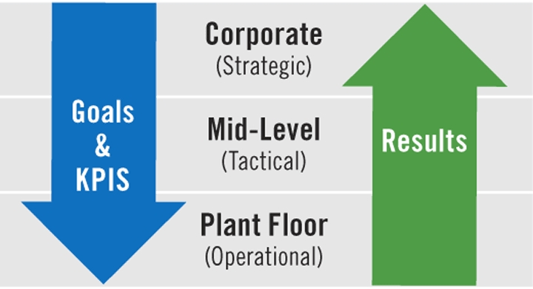

Strategic Goals
Strategic goals are goals set by and for top management of the organization. These goals are made by focusing on broad general issues.
Strategic goals or strategies are usually long-term and from this goal, other goals are made and set for different time-frames and areas.
Tactical Goals
Tactical goals are set for middle managers. These goals focus on how to operationalize actions necessary to achieve the strategic goals.
Middle managers of various departments are usually responsible for their attainment.
Tactical goals are set by the middle managers, but often top-managers set tactical goals for the middle managers.
Operational Goals
Operational goals are set by and for lower-level managers. Operational goals are usually made to tackle shorter-term issues associated with the tactical goals and lower-managers are responsible for their attainment.
The 3 levels of goals within an organization form a hierarchy of goals, with lower-level goals forming a means-end chain with the next level of goals.
Importance and purpose of organizational goals
Organizational goals, often used interchangeably, are the ends toward which activity is aimed. Goals are the desired outcomes for individuals, groups, or entire organizations.
They represent not only the endpoint of planning but also the end toward which all other managerial functions are aimed.
Objectives are set to a particular time and thus the same objective is not repeated year after year, month after month or day after day.
Goals are critical to organizational effectiveness as they serve several purposes.
Organizations have several different kinds of goals, all of which must be appropriately managed.
4 reasons why goals are important:-
- Goals Provide Guidance and Direction.
- Goals Intensely Planning and Actions
- Goals Motivate.
- Goals Help in Control.
These are explained below;
Goals Provide Guidance and Direction
Goals provide guidance and a unified direction for people in the organization.
They show the employees where the organization is going and why getting it is important.
Goals simply define what the organization wants.
Goals Intensely Planning and Actions
Goal-setting does intensely affect aspects of planning. Effective goal setting facilitates good planning and good planning facilitates future goal setting
.Goals are desired outcomes for organizations and plans are the best-perceived ways to reach them. So a proper goal helps set a proper plan.
Goals Motivate
Goals also can serve as a motivational source for employees. Goals should be specific and moderately difficult can inspire people to work harder, especially if attaining the goal is going to result in rewards.
For goals to be a tool of motivation; the organization requires an effective reward system and a friendly work environment.
Goals Help in Control
Goals act as a mechanism for control and evaluation. Performance can be measured and evaluated in the future in terms of how successfully today’s goals are accomplished.
Goals can serve these purposes and much more; if people in charge of setting goals can overcome the barriers and set them properly and effectively.
OB Models and Approaches
OB Models
Organizational behavior reflects the behavior of the people and management all together, it is considered as field study not just a discipline. A discipline is an accepted science that is based upon theoretical foundation, whereas OB is an inter-disciplinary approach where knowledge from different disciplines like psychology, sociology, anthropology, etc. are included. It is used to solve organizational problems, especially those related to human beings.
There are four different types of models in OB. We will throw some light on each of these four models.
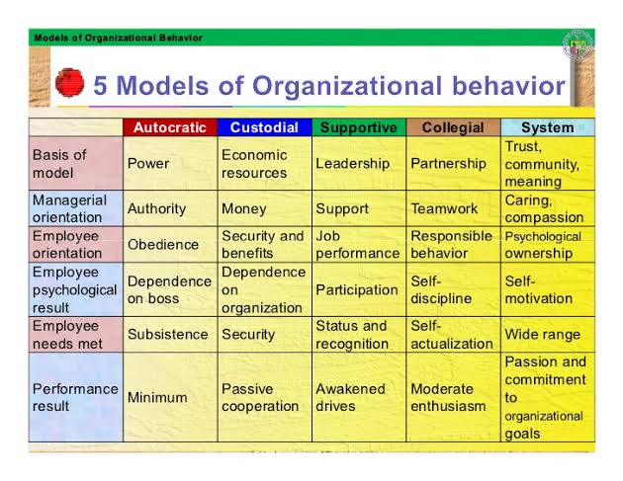

Autocratic Model
The root level of this model is power with a managerial orientation of authority. The employees in this model are oriented towards obedience and discipline. They are dependent on their boss. The employee requirement that is met is subsistence. The performance result is less.
The major drawbacks of this model are people are easily frustrated, insecurity, dependency on the superiors, minimum performance because of minimum wage.
Custodial Model
The root level of this model is economic resources with a managerial orientation of money. The employees in this model are oriented towards security and benefits provided to them. They are dependent on the organization. The employee requirement that is met is security.
This model is adapted by firms having high resources as the name suggest. It is dependent on economic resources. This approach directs to depend on firm rather than on manager or boss. They give passive cooperation as they are satisfied but not strongly encouraged.
Supportive Model
The root level of this model is leadership with a managerial orientation of support. The employees in this model are oriented towards their job performance and participation. The employee requirement that is met is status and recognition. The performance result is awakened drives.
This model is dependent on leadership strive. It gives a climate to help employees grow and accomplish the job in the interest of the organization. Management job is to assist the employee’s job performance. Employees feel a sense of participation.
Collegial Model
The root level of this model is partnership with a managerial orientation of teamwork. The employees in this model are oriented towards responsible behavior and self-discipline. The employee requirement that is met is self-actualization. The performance result is moderate zeal.
This is an extension of supportive model. The team work approach is adapted for this model. Self-discipline is maintained. Workers feel an obligation to uphold quality standard for the better image of the company. A sense of “accept” and “respect” is seen.

OB Approaches
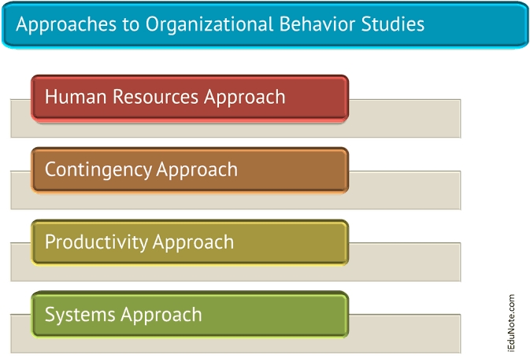

Human Resources Approach
This approach recognizes the fact that people are the central resource in any organization and that they should be developed towards higher levels of competency, creativity, and fulfillment.
People thus contribute to the success of the organization.
The human resources approach is also called as the supportive approach in the sense that the manager’s role changes from control of employee to active support of their growth and performance.
The supportive approach contrasts with the traditional management approach.
In the traditional approach, managers decided what employees should do and closely monitored their performance to ensure task accomplishment.
In the human resources approach, the role of managers changes from structuring and controlling to supporting.
Contingency Approach
The contingency approach (sometimes called the situational approach) is based on the premise that methods or behaviors which work effectively in One situation fail in another.
For example; Organization Development (OD) programs, way work brilliantly in one situation but fail miserably in another situation.
Results differ because situations differ, the manager’s task, therefore, is to identify which method will, in a particular situation, under particular circumstances, and at a particular time, best contribute to the attainment of organization’s goals.
The strength of the contingency approach lies in the fact it encourages analysis of each situation prior to action while at the same time discourages the habitual practice of universal assumptions about methods and people.
The contingency approach is also more interdisciplinary, more system – oriented and more research-oriented titan any other approach.
Productivity Approach
Productivity which is the ratio of output to input is a measure of an organization’s effectiveness. It also reveals manager’s efficiency in optimizing resource utilization.
The higher the numerical value of this ratio, the greater the efficiency.
Productivity is generally measured in terms of economic inputs and outputs, but human and social inputs and outputs also are important.
For example, if better organizational behavior can improve job satisfaction, a human output or benefit occurs.
In the same manner, when employee development programs lead to better citizens in a community, a valuable social output occurs.
Organizational behavior decisions typically involve human, social, and/or economic issues, and so productivity usually a significant part of these decisions is recognized and discusses extensively in the literature on OB.
Systems Approach
The Systems Approach to OB views the organization as a united, purposeful system composed of interrelated parts.
This approach gives managers a way of looking at the organization as a whole, whole, person, whole group, and the whole social system.
In so doing, systems approach tells us that the activity of any segment of an organization affects, in varying degrees the activity of every other segment. A systems view should be the concern of every person in an organization.
The clerk at a service counter, the machinist, and the manager all work with the people and thereby influence the behavioral quality of life in an organization and its inputs.
Managers, however, tend to have a larger responsibility, because they are the ones who make majority are people oriented.
The role of managers, then, is to use organizational behavior to help build an organizational culture in which talents are utilized and further developed, people are motivated, teams become productive, organizations achieve their goals and society reaps the reward.
Inter-Disciplinary Approach
Organizational behavior is an integration of all other social sciences and disciplines such as psychology, sociology, organizational theories etc.
They all are interdependent and influence each other. The man is studied as a whole and therefore, all disciplines concerning man are integrated.
Impact of Global and Cultural diversity on OB
Due to globalization, economic changes, and the ever-growing population, organizational behavior tends to reflect the culture and diversity present in society. Unless you work alone or with an isolated demographic of people, it’s quite likely that you will encounter someone who has a different background and culture than you in the workplace. This can be a co-worker, business associate, or client. In any case, it carries the potential that it will play a role in the organizational behavior of your business.
The presentation and establishment of culture in the workplace is not always in control of the management or the employees, as workplace culture tends to develop based on the factors present. In that regard, there is more value on directing existing culture in the workplace to foster a positive impact than there is in creating the desired culture from scratch. The cultural traits of a business’ staff members, customers, location, and the economy, amongst other factors, are going to impact the cultural atmosphere of the business whether management wants it to or not. Typically, management has control over the culture of the workplace through policies and documents like the company mission statement. These paradigms present as the roots of the business’ office culture and shift the way the staff works together and individually in their tasks. Likewise, the and organizational structure of the business is going to set the business’ culture as well since there is a division of power throughout its hierarchical setup. The cultural backgrounds of those who carry power is going to impact their decision making for the business, which can shift its cultural dynamics any which way.
Culture in organizational behavior tends to apply to two different areas: the culture of the staff, and the culture of the workplace. One does influence the other and both can be forces of change and momentum for the business. For many years, culture did not hold the same value in the workplace that it does today. Experts who were researching organizational behavior in the 1980s began to notice that the culture backgrounds of the employees often impacted the culture of their work environment with successful outcomes, so long as the two were nourished and kept healthy.2 They stressed the importance of culture in organizational behavior, claiming that its influence could prove wildly successful for businesses and companies that apply the concepts correctly. Since then, many businesses have taken this advice to heart and work to create a professional culture within their working environment that is as beneficial as possible to productivity and employees.
The Impact of Diversity
Diversity is a word that gets tossed around in society without any real explanation as to what it is and what it can do for an environment. In short, diversity is defined as the different traits and backgrounds of the people present in a group. This can apply to age, gender, educational background, religion, language and culture, political beliefs, socioeconomic status, and orientation. The diversity of a business’ staff members will often depend on the business’ location, size, and industry.
Managing diversity is going to be dependent on any of those factors, which means that businesses need to be able to handle things on a case by case basis. There are significant benefits and challenges to diversity in the workplace, and management needs to be trained properly in order to handle either. When properly addressed, diversity does present some advantages for businesses:
Learning: Diversity in any situation is a chance for others to learn about people who are different from themselves. In business, this can aid in the growth of individual employees and for the business as a whole by exposing them to new ideas and perspectives. Interactions between co-workers of different backgrounds can help reduce prejudice and make it easier for them to work together.
Experience and Knowledge: The experiences a person has often are impacted by their background and cultural traits, which allows each employee to bring a unique set of skills and strengths into the business. Teams that have members with different skill sets tend to be able to combine their strengths to offset any weaknesses that prevent them from being efficient. Together, this can boost their productivity and make them adaptable to changes.
International Skills: With globalization become an integral part of business, it’s more important than ever for companies to be able to interact in the global market.The diversity in a business may include employees who speak other languages and can work on customers and business partners directly. Diversity can also help when a company has multiple branches throughout the world, as the traits of an employee’s cultural background can help them navigate in those locations.
Reputation: Since the diversity of the workforce is increasing, job seekers want to know that the businesses they are looking to work with can effectively handle issues of diversity. Employers who have a reputation for being fair to workers from all walks of life and having no tolerance for discrimination are far more appealing than employers who do not. It should be noted that those are also traits that other companies look for when the want to collaborate with another business, both locally and abroad.
Unfortunately, there can be some disadvantages for businesses when it comes to diversity:
Discrimination: Despite the business’ best efforts, instances of discrimination can still occur with diversity. They are often based in prejudices, stereotyping, and misinformation and can have serious consequences for both those involved and the company itself.It is the business’ responsibility to establish what the policies are in regards to discrimination and to ensure that they follow any and all anti-discrimination laws.
Poor Interaction: It is not unheard of for workers of different backgrounds to clash culturally. A lack of understanding or misconceptions about a particular demographic can generate a ton of issues between the affected employees and their interactions. It damages communication and brings productivity and group cohesiveness down. In serious cases, it can create a hostile environment that damages the workplace culture and the business’ organizational behavior regardless of if it’s isolated to a few people.
Authority and Training: While it’s a good that business take the initiate in training their staff on diversity, it can be problematic if mishandled. There may be some resistance to diversity from staffers and they may see training as forcing them to accept unnecessary (to them) changes. This may result in backlash and a breakdown in the relationship between staff and management. There’s also no guarantee that those in places of authority will follow through on what they learned in training-strong-held beliefs and prejudices can be difficult to break through. As a result, diversity issues like discrimination can be left unresolved or worsened by someone with authority abusing their power.
Encouraging Culture and Diversity in the Workplace
Culture and diversity is not something that simple springs up overnight. Yes you can have a new employee who has a different cultural background than the rest of the office, but as mentioned it’s still a gradual development. Even then, there’s no guarantee that it will have any impact on the business if that bit of diversity that the person brings isn’t encouraged. As with other aspects of organizational behavior, culture and diversity cannot play a role in a business if they’re not actively participating.
Encouraging culture and diversity amongst the staff often falls to those in management, via their policies and leadership. If you want to encourage diversity in your business amongst your employees, then they need to know that in the first place as well as what, if any, restrictions or limitations are in place per company policies. Making that information available through an accessible source like the employee handbook or through the company’s human resources department is a good idea. You also can do some of the following:
Practicing Inclusion: Inclusion involves looking at individual needs and trying to make sure that those needs are met, supported, and respected. This often means that businesses need to make sure that they are offering the right resources for their staffers, taking into account their backgrounds and capabilities. It allows for employees to know that they are welcomed at work regardless of whatever differences they may have from their peers. Practicing inclusion tends to put everyone on a level playing field, which can prevent delays in production or inhibit group cohesion. Businesses that practice inclusion tend to need to look at what they currently offer for their employees and figure out what can be improved. This may mean that policies have to be updated or that new resources need to be made available. The business will should also consider reevaluating themselves regularly to ensure that they are continuing to meet the needs of their employees and customers.
Education: People may be unfamiliar with the culture of their peers at work and some questions may be raised. As the diversity of a workplace increases, this may happen and it may become an issue if there are misunderstandings. Opening up the pathways for education about other cultures can be a great way to encourage cultural expression and diversity. Doing so can ease some of the tension for those trying to avoid cultural faux pas, satisfy some curiosity, and improve intrapersonal relations and teamwork. There is also the possibility that the business’ clients will also have a diverse background as well, with the same concerns applying during interactions. This can help avoid any negative or harmful interactions that can reflect poorly on the business. There should also be some means of educating staff on what policies there are should a harmful or negative interaction relating to an aspect of someone’s culture occur. Such information, for example, should be made available via the employee handbook.
Communication: Regardless of its purpose or what it is being applied to, communication is a necessary component for any kind of organization to function. In the matter of culture and diversity, it’s key for any kind of knowledge and understanding to spread throughout the staff members. Diversity is a major component of today’s society, so it’s not uncommon for a business to have staff and customers that come from a variety of different backgrounds. People may be hesitant to express their culture even when they make adjustments for a work environment, or there may be concerns that there may be a clash of cultural ideals with co-workers of different backgrounds. To encourage culture and diversity in the workplace means that the staff needs to communicate with each other about what’s going on. Create a dialogue that will encourage discussion and education between employees of different cultures. Be open with what the rules are in regards to cultural expression and what avenues can be taken if there are cases of clashing cultures or discrimination.

