Production Management

Unit-5

Quality Control
Production planning cannot be properly ac system of production control. Production control is primarily concerned with orderly flow of materials in the manufacturing process from the beginning (raw state) to the end (the finished products). The following definitions clearly explain the meaning of production control.
Present era is the ‘Era of Quality’. In this age of cutthroat competition and large scale production, only that manufacturer can survive who supplies better quality goods and renders service to-the consumers. In fact quality control has become major consideration before establishing an industrial undertaking. Proper quality control ensures most effective utilisation of available resources and reduction in cost of production.
The word quality control comprises of two words viz., quality and control. It would be appropriate to explain these two words separately to understand clearly the meaning of quality control.
According to Dr. W.K. Spriegel “The quality of a product may be defined as the sum of a number of related characteristics such as shape, dimension, composition, strength, workmanship, adjustment, finish and colour”.
In the words of John D. McIIellan, “Quality is the degree to which a product conforms to specifications and workmanship standards”.

Importance
- The brand products build up goodwill or image which ultimately increases sales.
- It helps the manufacturers/ entrepreneurs in fixing responsibility of workers in the production process.
- Quality control also helps in minimizing the costs by increasing efficiency, standardization, working conditions, etc.
- It also enables the entrepreneur to know the cost of his / her product quite in advance which helps him in determining competitive prices of his product.
- Last but not the least; the entrepreneur can confirm whether the product manufactured by him / her is in accordance with the standard set by the Government. It further facilitates the entrepreneur to take necessary actions to comply with the standard set.

Phases of quality control
Quality control is a process employed to ensure a certain level of quality in a product or service. It may include whatever actions a business deems necessary to provide for the control and verification of certain characteristics of a product or service. The basic goal of quality control is to ensure that the products, services, or processes provided meet specific requirements and are dependable, satisfactory, and fiscally sound. Essentially, quality control involves the examination of a product, service, or process for certain minimum levels of quality. The goal of a quality control team is to identify products or services that do not meet a company‘s specified standards of quality. If a problem is identified, the job of a quality control team or professional may involve stopping production temporarily. Depending on the particular service or product, as well as the type of problem identified, production or implementation may not cease entirely.

Phases of Quality Control Process

1. Planning for Review
In this phase the main focus is on collection of data. Data is the main input requirement of any successful project information system and therefore the project.
The steps to follow in this phase include:
- Preparing a suitable plan for data analysis after the data has been gathered.
- Obtaining necessary commitment from management and team members to participate actively and take actions on findings.
- Ensuring that every project member gives his or her commitment to participate and deliver the service/product in the project.
- Ensuring that review is planned for every stage of the project.
- Preparing schedule for each project review.
- Conducting the Review
In this phase, the review is conducted as a planned in the preceding phase. The review leader is the project manager. The steps to conduct the review include:
- Preparing an agenda before the review. The agenda should be well structured in terms of time and content.
- Making necessary arrangements to gather inputs for the review.
- Incorporating points, which are external to the project. These external points have to be well structured to be reviewed.
- Documenting key points of the meeting. A reporter should be designated for this job.
- Formulating an automated checklist for the session. Make use of flipcharts to collect data from participants.
- Taking actions on findings
In this phase, a project team takes actions on the findings of the review meeting. The steps to follow in this phase include:
- Determining the points which are critical to the project and its performance.
- Having brain storming sessions to discuss critical points.
- Making a list of all such items discussed and items suggested.
- Grouping the data into categories and then prioritise, either by group discussion or voting.
- Identifying action items
- Assigning the task to a project member or a team.
- Setting expectations of scope, investment, time, for each item and send a copy to the team
- Following up all the actions.
- Placing review reports in the project documents file, in the quality/productivity departments and in the library.
- Making reports available to managers of the life process for similar projects.
- Do continuous improvement
Continual improvement is one of the management mantras. Every organisation wants to improve continuously. It is not possible to achieve improvement unless sufficient measures are adopted to calculate improvement. The steps to ensure continuous improvement include:Encouraging the quality managers to look for quality themes that emerge from review meetings. The quality managers should highlight trends and de-escalate chronic problems.
- Acting on recommendations from previous projects as reviews are a continuous check process in the ―Plan-Do-Check-Act‖ cycle of a quality management cycle.
- Capturing project data to check do a retrospective analysis of the progress and improvement.
- Doing periodic project reviews that will trigger mid-project corrections.
- Conducting immediate and informal retrospective analysis after solving unexpected obstacles
- Understanding any impact on the remainder of the project.
- Recognising people for extra efforts and noteworthy contributions.
- Being open to attend reviews for other projects.
- Learning from similar ventures, warranty failures, customer surveys and experiences of other divisions and companies.
- Being a part of continuous organisational learning program that includes experimentation, evaluation and documentation with easy access and retrieval.
- Identifying Critical Success Factors
It is necessary that a company identifies critical factors in a project. These factors may slacken the project if not focused. Some of these success factors are discussed below.
Routine tasks may be assigned to lower level team members as this may relieve the project team from wasting their skill set on routine matters. In terms of project delivery, the project office can relieve project managers of tasks, like filling forms and templates, getting these forms signed off, mailing, receiving and checking items.
The project office can also help the project manager in the project scope definition, project kick-off preparation and planning tasks, through mentoring and coaching services.Regarding project quality reviews, the project management office adds value providing processes, tools and project management experience but any quality review process can be implemented by the team without sponsorship from the management level.
These are the combining strengths that make the project manager move forward and achieve the project success. It is necessary to identify all the critical success factors. One of the critical success factors for the project quality review process implementation is to convince and sell the benefits to the management team of the organisation. The team should exhibit better control of their project portfolio a and then demonstrate better control about business profitability.
- Results and Benefits of the Project Quality Reviews
The main benefits of the project quality review are that project status is formally visible to the whole organisation. It creates awareness and room for improvement. Through reviewing, in a detailed manner, we can have a clear idea about the lack of knowledge mistakes, errors, deviations, and their reasons.
The project quality reviews help the project manager to make the necessary adjustments and take the actions needed to finish the project on time, scope and budget. The entire project team including the project manager, the customer and the sponsor benefit from project quality reviews.

Quality Assurance
Quality is extremely hard to define, and it is simply stated: “Fit for use or purpose.” It is all about meeting the needs and expectations of customers with respect to functionality, design, reliability, durability, & price of the product.
Assurance is nothing but a positive declaration on a product or service, which gives confidence. It is certainty of a product or a service, which it will work well. It provides a guarantee that the product will work without any problems as per the expectations or requirements.
Quality Assurance (QA) is defined as an activity to ensure that an organization is providing the best possible product or service to customers. QA focuses on improving the processes to deliver Quality Products to the customer. An organization has to ensure, that processes are efficient and effective as per the quality standards defined for software products. Quality Assurance is popularly known as QA Testing
Quality assurance has a defined cycle called PDCA cycle or Deming cycle. The phases of this cycle are:
- Plan
- Do
- Check
- Act
These above steps are repeated to ensure that processes followed in the organization are evaluated and improved on a periodic basis. Let’s look into the above steps in detail:
- Plan: Organization should plan and establish the process related objectives and determine the processes that are required to deliver a high Quality end product.
- Do: Development and testing of Processes and also “do” changes in the processes
- Check: Monitoring of processes, modify the processes, and check whether it meets the predetermined objectives
- Act: Implement actions that are necessary to achieve improvements in the processes
An organization must use Quality Assurance to ensure that the product is designed and implemented with correct procedures. This helps reduce problems and errors, in the final product.

Quality Circles
A quality circle is a volunteer group composed of workers, usually under the leadership of their supervisor, who are trained to identify, analyze and solve work-related problems and present their solutions to management in order to improve the performance of the organization, and motivate and enrich the work of employees. When matured, true quality circles become self-managing, having gained the confidence of management.
Participative management technique within the framework of a company wide quality system in which small teams of (usually 6 to 12) employees voluntarily form to define and solve a quality or performance related problem. In Japan (where this practice originated) quality circles are an integral part of enterprise management and are called quality control circles.
“A Quality Circle is volunteer group composed of members who meet to talk about workplace and service improvements and make presentations to their management with their ideas.” (Prasad, L.M, 1998).
Quality circles enable the enrichment of the lives of the workers or students and creates harmony and high performance. Typical topics are improving occupational safety and health, improving product design, and improvement in the workplace and manufacturing processes.

Objectives of Quality Circle
The perception of Quality Circles today is ‘Appropriateness for use1 and the tactic implemented is to avert imperfections in services rather than verification and elimination. Hence the attitudes of employees influence the quality. It encourages employee participation as well as promotes teamwork. Thus it motivates people to contribute towards organizational effectiveness through group processes. The following could be grouped as broad intentions of a Quality Circle:
- To contribute towards the improvement and development of the organization or a department.
- To overcome the barriers that may exist within the prevailing organizational structure so as to foster an open exchange of ideas.
- To develop a positive attitude and feel a sense of involvement in the decision making processes of the services offered.
- To respect humanity and to build a happy work place worthwhile to work.
- To display human capabilities totally and in a long run to draw out the infinite possibilities.
- To improve the quality of products and services.
- To improve competence, which is one of the goals of all organizations?
- To reduce cost and redundant efforts in the long run.
- With improved efficiency, the lead time on convene of information and its subassemblies is reduced, resulting in an improvement in meeting customers due dates.
- Customer satisfaction is the fundamental goal of any library. It will ultimately be achieved by Quality Circle and will also help to be competitive for a long time.

BENEFITS OF QUALITY CIRCLES
There are no monetary rewards in the QC’s. However, there are many other gains, which largely benefit the individual and consecutively, benefit the business. These are:
(i) Self-development: QC’s assist self-development of members by improving self-confidence, attitudinal change, and a sense of accomplishment.
(ii) Social development: QC is a consultative and participative programme where every member cooperates with others. This interaction assists in developing harmony.
(iii) Opportunity to attain knowledge: QC members have a chance for attaining new knowledge by sharing opinions, thoughts, and experience.
(iv) Potential Leader: Every member gets a chance to build up his leadership potential, in view of the fact that any member can become a leader.
(v) Enhanced communication skills: The mutual problem solving and presentation before the management assists the members to develop their communication skills.
(vi) Job-satisfaction: QC’s promote creativity by tapping the undeveloped intellectual skills of the individual. Individuals in addition execute activities diverse from regular work, which enhances their self-confidence and gives them huge job satisfaction.
(vii) Healthy work environment: QC’s creates a tension-free atmosphere, which each individual likes, understands, and co-operates with others.
(viii) Organizational benefits: The individual benefits create a synergistic effect, leading to cost effectiveness, reduction in waste, better quality, and higher productivity.

Quality Cost
Cost of Quality (COQ) is a measure that quantifies the cost of control/conformance and the cost of failure of control/non-conformance. In other words, it sums up the costs related to prevention and detection of defects and the costs due to occurrences of defects.
Definition by ISTQB
Cost of quality: The total costs incurred on quality activities and issues and often split into prevention costs, appraisal costs, internal failure costs and external failure costs.
Definition by QAI
Money spent beyond expected production costs (labor, materials, equipment) to ensure that the product the customer receives is a quality (defect free) product. The Cost of Quality includes prevention, appraisal, and correction or repair costs.
Quality costs are categorized into four main types. Theses are:
- Prevention costs
- Appraisal costs
- Internal failure costs and
- External failure costs.
These four types of quality costs are briefly explained below:
(i) Prevention costs
It is much better to prevent defects rather than finding and removing them from products. The costs incurred to avoid or minimize the number of defects at first place are known as prevention costs. Some examples of prevention costs are improvement of manufacturing processes, workers training, quality engineering, statistical process control etc.
(ii) Appraisal costs
Appraisal costs (also known as inspection costs) are those cost that are incurred to identify defective products before they are shipped to customers. All costs associated with the activities that are performed during manufacturing processes to ensure required quality standards are also included in this category. Identification of defective products involve the maintaining a team of inspectors. It may be very costly for some organizations.
(iii) Internal failure costs
Internal failure costs are those costs that are incurred to remove defects from the products before shipping them to customers. Examples of internal failure costs include cost of rework, rejected products, scrap etc.
(iv) External failure costs
If defective products have been shipped to customers, external failure costs arise. External failure costs include warranties, replacements, lost sales because of bad reputation, payment for damages arising from the use of defective products etc. The shipment of defective products can dissatisfy customers, damage goodwill and reduce sales and profits.
FORMULA / CALCULATION
Cost of Quality (COQ) = Cost of Control + Cost of Failure of Control
where
Cost of Control = Prevention Cost + Appraisal Cost
and
Cost of Failure of Control = Internal Failure Cost + External Failure Cost

NOTES:-
- In its simplest form, COQ can be calculated in terms of effort (hours/days).
- A better approach will be to calculate COQ in terms of money (converting the effort into money and adding any other tangible costs like test environment setup).
- The best approach will be to calculate COQ as a percentage of total cost. This allows for comparison of COQ across projects or companies.
- To ensure impartiality, it is advised that the Cost of Quality of a project/product be calculated and reported by a person external to the core project/product team (Say, someone from the Accounts Department).
- It is desirable to keep the Cost of Quality as low as possible. However, this requires a fine balancing of costs between Cost of Control and Cost of Failure of Control. In general, a higher Cost of Control results in a lower Cost of Failure of Control. But, the law of diminishing returns holds true here as well.

Total Quality Management (TQM)
Total Quality Management (TQM) is the continual process of detecting and reducing or eliminating errors in manufacturing, streamlining supply chain management, improving the customer experience, and ensuring that employees are up to speed with their training. Total quality management aims to hold all parties involved in the production process accountable for the overall quality of the final product or service.
A total approach to quality is the current thinking of today; which is popularly called total quality management (TQM).
TQM is a philosophy that believes in a company-wide responsibility toward quality via fostering a quality culture throughout the organization; involving continuous improvement in the quality of work of all employees with a view to best meeting the requirements of customers.
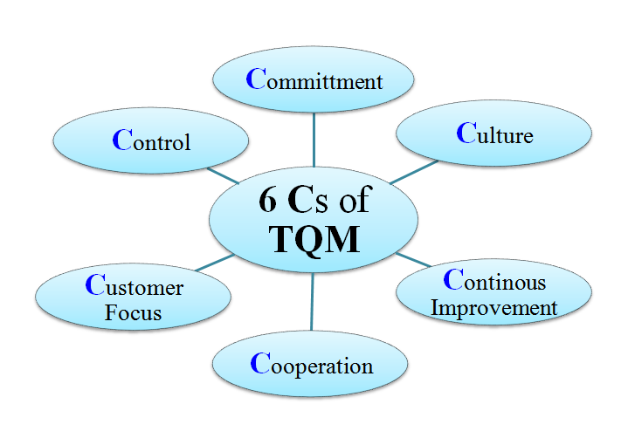

Advantages of TQM
(i) Sharpens Competitive Edge of the Enterprise
TQM helps an organization to reduce costs through elimination of waste, rework etc. It increases profitability and competitiveness of the enterprise; and helps to sharpen the organization’s competitive edge, in the globalized economy of today.
(ii) Excellent Customer Satisfaction
By focusing on customer requirements, TQM makes for excellent customer satisfaction. This leads to more and more sales, and excellent relations with customers.
(iii) Improvement in Organisational Performance
Through promoting quality culture in the organization, TQM lead to improvements in managerial and operative personnel’s performance.
(iv) Good Public Image of the Enterprise
TQM helps to build an image of the enterprise in the minds of people in society. This is due to stress on total quality system and customers’ requirements, under the philosophy of TQM.
(v) Better Personnel Relations
TQM aims at promoting mutual trust and openness among employees, at all levels in the organization. This leads to better personnel relations in the enterprise.

Limitations of TQM
The philosophy of TQM suffers from the following major limitations
(i) Waiting for a Long Time
TQM requires significant change in organization; consisting of:
- Change in methods, processes etc. of organization.
- Change in attitude, behaviour etc. of people
Launching of TQM and acceptance of the philosophy of TQM requires a long waiting for the organization. It is not possible to accept and implement TQM overnight.
(ii) Problem of Labour Management Relations
Success of TQM depends on the relationships between labour and management; because participation of people at all levels is a pre-requisite for TQM programme implementation. In many organizations, here and abroad, labour-management relations are quite tense. As such, launching, acceptance and implementation of TQM programme is nothing more than a dream for such organizations.

Basic Principles of TQM
In TQM, the processes and initiatives that produce products or services are thoroughly managed. By this way of managing, process variations are minimized, so the end product or the service will have a predictable quality level.
Following are the key principles used in TQM
(i) Top management – The upper management is the driving force behind TQM. The upper management bears the responsibility of creating an environment to rollout TQM concepts and practices.
(ii) Training needs – When a TQM rollout is due, all the employees of the company need to go through a proper cycle of training. Once the TQM implementation starts, the employees should go through regular trainings and certification process.
(iii) Customer orientation – The quality improvements should ultimately target improving the customer satisfaction. For this, the company can conduct surveys and feedback forums for gathering customer satisfaction and feedback information.
(iv) Involvement of employees – Pro-activeness of employees is the main contribution from the staff. The TQM environment should make sure that the employees who are proactive are rewarded appropriately.
(v) Techniques and tools – Use of techniques and tools suitable for the company is one of the main factors of TQM.
(vi) Corporate culture – The corporate culture should be such that it facilitates the employees with the tools and techniques where the employees can work towards achieving higher quality.
(vii) Continues improvements – TQM implementation is not one time exercise. As long as the company practices TQM, the TQM process should be improved continuously.

Lean Management and Just in Time Production
Lean management is an approach to running an organization that supports the concept of continuous improvement, a long-term approach to work that systematically seeks to achieve small, incremental changes in processes in order to improve efficiency and quality.
Lean management seeks to eliminate any waste of time, effort or money by identifying each step in a business process and then revising or cutting out steps that do not create value. The philosophy has its roots in manufacturing.
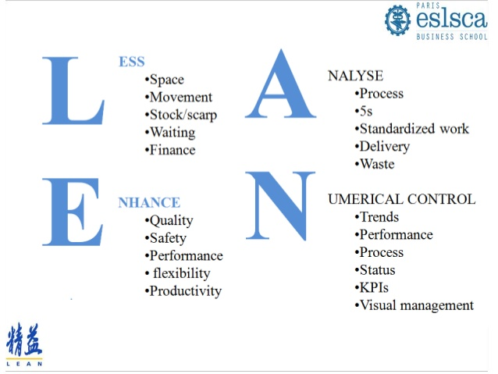

Guiding principles for lean management include:-
(1) Defining value from the standpoint of the end customer.
(2) Identifying each step in a business process and eliminating those steps that do not create value.
(3) Making the value-creating steps occur in tight sequence.
(4) Repeating the first three steps on a continuous basis until all waste has been eliminated.

The Lean Management Tools
Many elements within the concept of the lean manufacturing stand out and each of these presents a particular method:
- 5S
- Kanban (pull systems)
- Value Stream Mapping
- SMED
- Poka-yoke (error-proofing)
- Elimination of Time Batching
- Total Productive Maintenance
- Mixed Model Processing
- Single Point Scheduling
- Rank Order Clustering
- Multi-process Handling
- Redesigning Working Cells
- Control Charts (for checking mura)
Some of these methods claim to be an independent manufacturing concept (such as kaizen and kanban).

Kaizen 5S
One way to cope with wastes and effectively increase profitability is a 5s. The name of this method uses a list of five words, which all start with the letter “S”: straighten, sort, standardize, shine, and sustain. It is translation from original Japanese words: seiton, seiri, seiketsu, seiso, and shitsuke. These words describe ways of workspace organisation for achieving the most effectiveness and efficiency. It include identifying and storing of the used items, maintaining the items and area, and sustaining the new order.
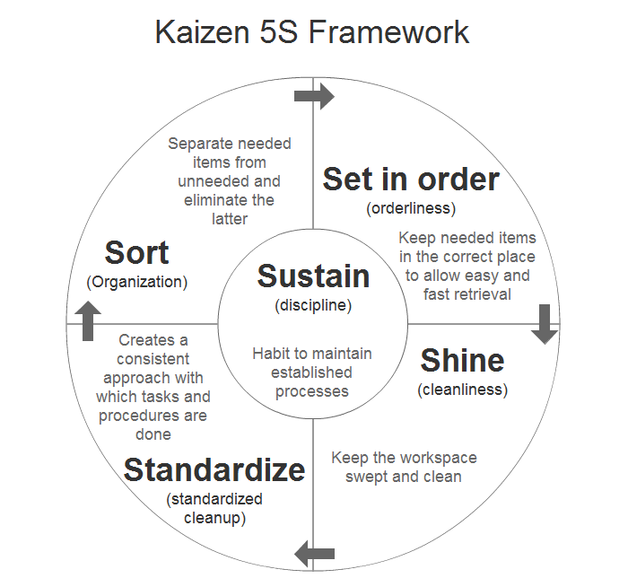
KAIZEN 5S FRAMEWORK

The 5 Steps are as follows:
Sort: Sort out and separate what is needed and not needed within the area.
Straighten: Arrange items that are needed so that they are ready and easy to use. Clearly identify locations for all items so that anyone can find them and return them once the task is completed.
Shine: Clean the workplace and equipment on a regular basis in order to maintain standards and identify defects.
Standardise: Revisit the first three of the 5S on a frequent basis and confirm the condition of the Gemba using standard procedures.
Sustain: Keep to the rules in order to maintain the standard and continuously improve every day.

Kanban
The other way to waste reduction was a kanban. In 1952, Taiichi Ohno invented a kanban system at Toyota, as a system to improve and maintain a high level of production.
Kanban became an effective tool to support running a production system as a whole, and an excellent way to promote improvement. One of the main benefits of kanban system is to establish an upper limit to the work in progress inventory, avoiding overloading of the manufacturing system. The concept of “to do” – “doing” – “done” became the cornerstone of many online tools used for managing projects and control workflows. Kanbanchi is one of such tools that supports kanban methodology.

Value Stream Mapping
Value stream mapping is a method of lean management which is applicable for almost any value chain. It is used for analysing the current stage and designing of its further stages for the series of events that take a service or product from the beginning through to the client. This method can be used also in:
- Logistics
- Supply Chain
- Service Related Industries
- Healthcare
- Software Development
- Product Development
- Administrative or Office Processes

Six Sigma
Sigma is a mathematical term that measures a process deviation from perfection. Like Kaizen, Six Sigma is a management philosophy focused on making continuous improvements and bringing improvements into various processes. It was first introduced in 1986 by Bill Smith at Motorola.
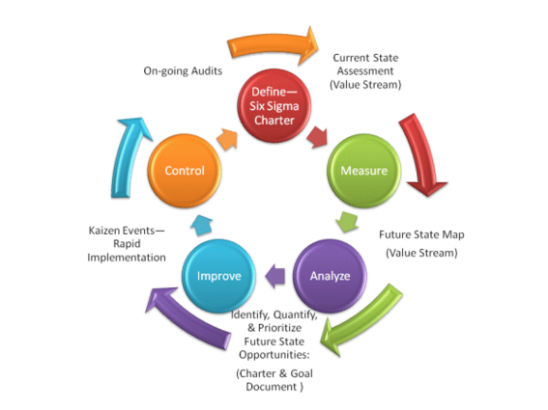
SIX SIGMA
Unlike Kaizen, which has the primary goal of increasing efficiency of all aspects of processes, Six Sigma focuses on improving quality of the final product by finding and eliminating causes of defects. Six Sigma uses more statistical analyses than Kaizen and aims for as close to zero defects as possible. A sigma rating describes the maturity of a manufacturing process by indicating its percentage or yield of defect-free products it creates. Organizations need to determine an appropriate sigma level for each of their most important processes and strive to achieve these.
The Six Sigma concept asserts:
- Achieving sustained quality improvement requires commitment from the entire organization, particularly from top-level management.
- Manufacturing and business processes have characteristics that can be measured, analyzed, controlled and improved.
- Continuous efforts to achieve stable and predictable process results (i.e., reduce process variation) are of vital importance to business success.

JUST IN TIME PRODUCTION
Just in Time (JIT), as the name suggests, is a management philosophy that calls for the production of what the customer wants, when they want it, in the quantities requested, where they want it, without it being delayed in inventory.
So instead of building large stocks of what you think the customer might want you only make exactly what the customer actually asks for when they ask for it. This allows you to concentrate your resources on only fulfilling what you are going to be paid for rather than building for stock.
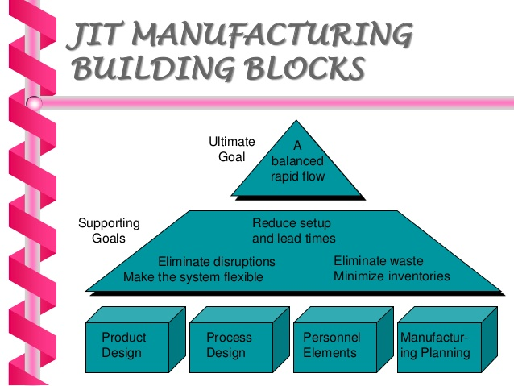
How does JIT differ from traditional manufacturing?
In traditional manufacturing we try to predict what the customer will want and we will create a forecast (or guess) against which we will produce our products. We will also try to produce those products in large batches as the belief is that will make machines and processes more efficient, especially if those machines require a long time to setup. This will typically result in long lead times through our processes, huge amounts of Work In Process (WIP) stocks and also large quantities of finished goods stocks that have
not yet been ordered by our customers. This is what many now call “Just in Case” manufacturing.
If the customer does order something that is not in our current stocks they will either have to wait many weeks or even months for the product to be manufactured or work will be hurried through the system by progress chasers causing a huge amount of disruption to the production schedule.
These systems are often run by Manufacturing Resource Planning (MRP2) programs that will try to schedule each and every process within the facility. These software packages will seek to control every step and everything requires careful and often complex planning.
A Just in Time system on the other hand will seek to use simple visual tools known as Kanbans to pull production through the processes according to what the customer actually takes. It massively reduces the amount of stock held and will reduce lead times by a significant amount, often from weeks to just a few hours or days.
The benefits of a JIT system
The following are some of the many benefits that you could gain through the implementation of just in time:-
(1) Reduction in the order to payment timeline; cash, as they say is king in business. Many businesses will suffer with cash flow problems as they will often have to purchase large amounts of raw materials prior to manufacturing and subsequent payment by the customer. Often this gap is many months. Through implementing JIT you are able to considerably reduce that time period.
(2) Reduction in Inventory costs; one of the main aims with any JIT implementation is to improve stock turns and the amount of stock being held. Personal experience has seen reductions of more than 90% stock in some industries. Along with the reduction in the stock come many other associated benefits.
(3) Reduction in space required; by removing large amounts of stock from the system and moving processes closer together we will often see a significant reduction in the amount of floor space being used. Results from 100’s of projects run within companies in the UK through the Manufacturing Advisory Service saw average reductions of 33% for simple 5 day implementation projects.
(4) Reduction in handling equipment and other costs; if you don’t have to move large batches there is less need for complex machinery to move them and all of the associated labour and training.
(5)Lead time reductions; one of the most significantly impacted areas is that of the time it takes for products to flow through the process. Instead of weeks or months most JIT implementations result in lead times of hours or a few days.
(6)Reduced planning complexity; the use of simple pull systems such as Kanban, even with your suppliers, can significantly reduce the need for any form of complex planning. With many implementations the only planning is the final shipping process.
(7)Improved Quality; the removal of large batch manufacturing and reduction in handling often results in significant quality improvements; often in the region of 25% or more.
(8)Productivity increases; to achieve JIT there are many hurdles that must be overcome with regards to how the process will flow. These will often result in productivity improvements of 25% upwards.
(9)Problems are highlighted quicker; often this is cited as being a negative aspect of JIT in that any problems will often have an immediate impact on your whole production process. However this is the perfect way to ensure that problems are highlighted and solved immediately when they occur.
(10)Employee empowerment; one requirement of JIT as with most other aspects of Lean manufacturing is that employees are heavily involved in the design and application of your system.

Statistical Quality Control, Variable & Attribute

STATISTICAL QUALITY CONTROL
Statistical quality control refers to the use of statistical methods in the monitoring and maintaining of the quality of products and services. One method, referred to as acceptance sampling, can be used when a decision must be made to accept or reject a group of parts or items based on the quality found in a sample. A second method, referred to as statistical process control, uses graphical displays known as control charts to determine whether a process should be continued or should be adjusted to achieve the desired quality.
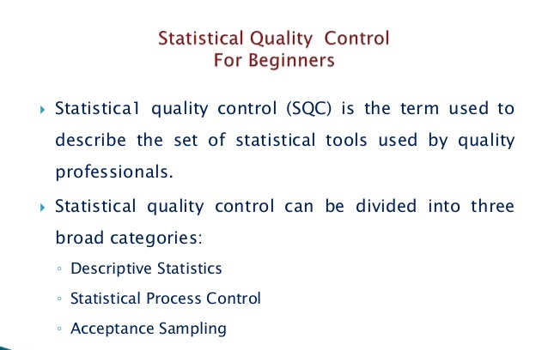
All the tools of SQC are helpful in evaluating the quality of services. SQC uses different tools to analyze quality problem.
(1) Descriptive Statistics: – Descriptive statistics are brief descriptive coefficients that summarize a given data set, which can be either a representation of the entire population or a sample of it. Descriptive statistics are broken down into measures of central tendency and measures of variability, or spread. Measures of central tendency include the mean, median and mode, while measures of variability include the standard deviation or variance, the minimum and maximum variables
(2) Statistical Process Control (SPC) : – Statistical process control (SPC) is a method of quality control which employs statistical methods to monitor and control a process. This helps ensure the process operates efficiently, producing more specification-conforming product with less waste (rework or scrap). SPC can be applied to any process where the “conforming product” (product meeting specifications) output can be measured. Key tools used in SPC include run charts, control charts, a focus on continuous improvement, and the design of experiments. An example of a process where SPC is applied is manufacturing lines.
SPC must be practiced in 2 phases: The first phase is the initial establishment of the process, and the second phase is the regular production use of the process. In the second phase, a decision of the period to be examined must be made, depending upon the change in 5M&E conditions (Man, Machine, Material, Method, Movement, Environment) and wear rate of parts used in the manufacturing process (machine parts, jigs, and fixtures).
(3) Acceptance Sampling achieve the desired quality: – Acceptance sampling uses statistical sampling to determine whether to accept or reject a production lot of material. It has been a common quality control technique used in industry. It is usually done as products leaves the factory, or in some cases even within the factory. Most often a producer supplies a consumer a number of items and a decision to accept or reject the items is made by determining the number of defective items in a sample from the lot. The lot is accepted if the number of defects falls below where the acceptance number or otherwise the lot is rejected.

VARIABLE & ATTRIBUTE
Both variable data and attribute data measure the state of an object or a process, but the kind of information that each describes differs. Variable data involve numbers measured on a continuous scale, while attribute data involve characteristics or other information that you can’t quantify. Each has its own benefits over the other.
In science and research, attribute is a characteristic of an object (person, thing, etc.). Attributes are closely related to variables. A variable is a logical set of attributes. Variables can “vary” – for example, be high or low.[1] How high, or how low, is determined by the value of the attribute (and in fact, an attribute could be just the word “low” or “high”). (For example see: Binary option)
While an attribute is often intuitive, the variable is the operationalized way in which the attribute is represented for further data processing. In data processing data are often represented by a combination of items (objects organized in rows), and multiple variables (organized in columns).
Examples
Age is an attribute that can be operationalized in many ways. It can be dichotomized so that only two values – “old” and “young” – are allowed for further data processing. In this case the attribute “age” is operationalized as a binary variable. If more than two values are possible and they can be ordered, the attribute is represented by ordinal variable, such as “young”, “middle age”, and “old”. Next it can be made of rational values, such as 1, 2, 3…. 99.
Benefits of Variable Data
Variable data provide detailed and concrete information about a product. In contrast, attribute data may be obscure or unhelpful. For example, if nails need to be made to a one-inch specification, with a leeway of 0.1-inches either way, variable data about each nail would provide the exact length. Attribute data would only state whether each nail fit the specification or not. It wouldn’t state whether the nail was too long or too short.
Benefits of Attribute Data
Attribute data are often more helpful when qualitative information is needed. Examples include the state of an object, non-numerical characteristics and customer feedback. For example, the attribute data might count the number of people who shop at a specific store, or the size of a product, such as a small or large serving of food. Attribute data are useful for analysis as you can use attribute data to create ratios, percentages or charts, whereas variable data don’t lend itself as freely to this.

