Production & Operation Management
Unit-1

Introduction
Production function is that part of an organization, which is concerned with the transformation of a range of inputs into the required outputs (products) having the requisite quality level. Production may be understood as “the step-by-step conversion of one form of material into another form through chemical or mechanical process to create or enhance the utility of the product to the user. Thus production is a value addition process.

Meaning of Production

As discussed earlier, production refers to the transformation of inputs into finished goods/ or creation of services in order to satisfy the customer needs. This uses different inputs mainly including 6M’s namely, man, material, machine, money, method and management. Production involves application of processes by which the inputs can be transformed into desired product (output) of potential utility while improving properties and adding economic values through the best method without compromising on quality.

Different forms of production based on the processes used:

- Production by extraction or separation: like petrol, kerosene, sugar etc
- Production by assembly: car, television, furniture

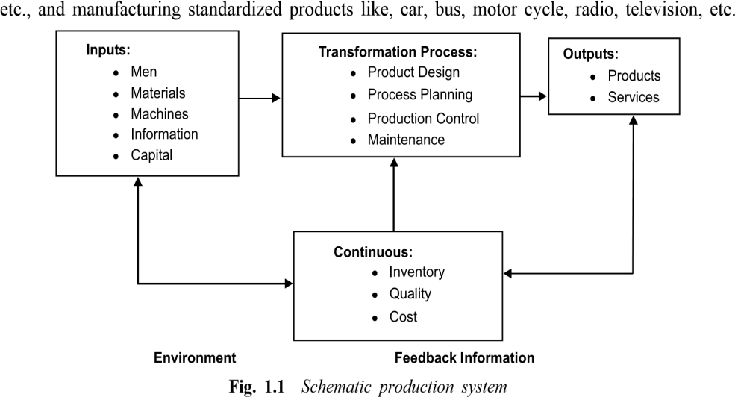

Types of Production systems

There are mainly three types of production systems mentioned as below:

- Continuous/Mass production
- Job or unit production
- Intermittent/Batch production

- Continuous/Mass production: It is used when we need to produce standardized products with a standard set of process and operation sequence in anticipation of demand. This ensures continuous production of output. It is also termed as mass flow production or assembly line production. This system results in less work in process (wip) inventory and high product quality but involves high capital investment in machinery and equipment. This ensures very high rate of production as we need not to intervene once the production has begun. The system is appropriate in plants where large volume of small variety of output is produced. e.g. oil refineries, cement manufacturing and sugar factory etc.

Characteristics of Continuous/Mass production:

  - As same product is manufactured for sufficiently long time, machines can be laid down in order of processing sequence.
  - Standard methods and machines are used during part manufacture.
  - Most of the equipment’s are semi automatic or automatic in nature.
  - Material handling is also automatic (such as conveyors).
  - Semi-skilled workers are normally employed as most of the facilities are automatic.
  - As product flows along a pre-defined line, planning and control of the system is much easier.
  - Cost of production per unit is very low owing to the high rate of production.
  - In process inventories are low as production scheduling is simple and can be implemented with ease.

- Job or Unit production: It involves production as per customer's specifications. This ensures the simultaneous production of large number of batches/orders. Each batch or order comprises of a small lot of identical products and is different from other batches. It requires comparatively smaller investment in machines and equipment. It is flexible and can be adapted to changes in product design and order size without much inconvenience. This system is most suitable where heterogeneous products are produced against specific orders. In this system products are made to satisfy a specific order.

However that order may be produced- only once or at irregular time intervals as and when new order arrives or at regular time intervals to satisfy a continuous demand.
Characteristics of Job or Unit Production:

  - Machines and methods employed should be general purpose as product changes are quite frequent.
  - Man power should be skilled enough to deal with changing work conditions.
  - Schedules are actually nonexistent in this system as no definite data is available on the product. In process inventory will usually be high as accurate plans and schedules do not exist.
  - Product cost is normally high because of high material and labor costs.
  - Grouping of machines is done on functional basis (i.e. as lathe section, milling section etc.) This system is very flexible as management has to manufacture varying product types. Material handling systems are also flexible to meet changing product requirements.

- Intermittent/Batch Production: This is concerned with the production of different types of products in small quantities usually termed as batches. A batch contains the similar products but in small quantity. This is used to meet a specific order or to meet a continuous demand. Batch can be manufactured either- only once or repeatedly at irregular time intervals as and when demand arise or repeatedly at regular time intervals to satisfy a continuous demand. Under this system the goods may be produced partly for inventory and partly for customer's orders. For example, components are made for inventory but they are combined differently for different customers. e.g. automobile plants, printing presses, electrical goods plant are examples of this type of manufacturing.

Characteristics of Intermittent/ Batch Production:

  - As final product is somewhat standard and manufactured in batches, economy of scale can be availed to some extent.
  - Machines are grouped on functional basis similar to the job shop manufacturing.
  - In process inventory is usually high owing to the type of layout and material handling policies adopted.
  - Semi-automatic material handling systems are most appropriate in conjunction with the semi-automatic machines.

In addition to the above, a large number of manufacturing plants include both intermittent and continuous processes and are classified as composite or combination operations .Such a plant may have sub assembly departments making parts in a continuous operation, while the final assembly department works on an intermittent basis.(as in the furniture and custom packaging industries)

Types of Manufacturing Processes

The above mentioned production systems require different types of manufacturing process and require different conditions for their working. Selection of manufacturing process is a strategic decision as any change in the same is very costly and time consuming affair. Therefore the manufacturing process is selected at the stage of planning a business venture. This must be selected keeping in view two important parameters (1) meeting the specification of the final product and (2) to be cost effective.

The manufacturing process is classified into four types.

- Jobbing manufacturing process
- Batch manufacturing process
- Mass or flow manufacturing process
- Process type manufacturing process

  - Jobbing manufacturing process: This is used to produce one or few units of the products as per the requirement and specification of the customer. Production is to meet the delivery schedule and costs are fixed prior to the contract made with the customer.
  - Batch manufacturing process: This is used to produce limited quantities of each of the different types of products in the form of batches. These batches of different products are manufactured on same set of machines. Different batches/products are produced separately one after the other.
  - Mass or flow manufacturing process: This is used to produce a large quantity of same product at a time that is stocked for sale. All machines and required equipments are arranged according to the sequence of operations; termed as line arrangement/flow. This ensures very high rate of production. One line arrangement can produce only one type of product, therefore, a different line arrangement is needed for a different product.
  - Process type manufacturing process: This is used to produce the products which need a particular process/definite sequence of operations. E.g. petroleum. In this, production run is conducted for an indefinite period.
Factors affecting the Choice of Manufacturing Process

Following factors need to be considered before making a choice of manufacturing process.

- Effect of volume/variety: This is one of the major considerations in selection of manufacturing process. When the volume is low and variety is high, intermittent process is most suitable and with increase in volume and reduction in variety continuous process become suitable. The following figure indicates the choice of manufacturing process as a function of volume and variety.

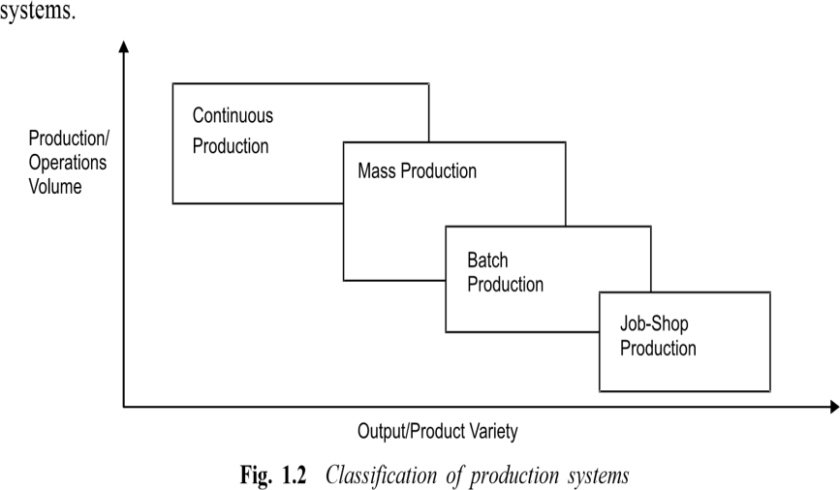

- Capacity of the plant: Predicted sales volume is the key factor to make a choice between batch and line process. In case of line process, fixed costs are substantially higher than variable costs. The reverse is true for batch process thus at low volume it would be cheaper to install and maintain a batch process and line process becomes economical at higher volumes.
- Lead time: The continuous process normally results faster deliveries as compared to batch process. Therefore lead-time and level of competition certainly influence the choice of production process.
- Flexibility and Efficiency: The manufacturing process needs to be flexible enough to adapt contemplated changes and volume of production should be large enough to lower costs.

Hence it is very important for entrepreneur to consider all above mentioned factors before taking a decision pertaining to the type of manufacturing process to be adopted. As far as Small Scale Enterprises are concerned, they usually adopt batch processes due to less volume of production and low investment.

Once the entrepreneur has made a final choice pertaining to the product design, production system and process, his next critical decision is the production and planning control (PPC) decision.

Meaning of Production Planning and Control:

PPC is a very critical decision which is necessarily required to ensure an efficient and economical production. Planned production is an important feature of any manufacturing industry. Production planning and control (PPC) is a tool to coordinate and integrate the entire manufacturing activities in a production system. This essentially comprises of planning production before actual production activities start and then exercising control over those activities sto ensure that the planned production is realized in terms of quantity, quality, delivery schedule and cost of production.

According to Gorden and Carson, PPC usually involve the organization and planning of manufacturing process. Principally, it includes entire organization. The various activities involved in production planning are designing the product, determining the equipment
and capacity requirement, designing the layout of physical facilities and material and material handling system, determining the sequence of operations and the nature of the operations to be performed along with time requirements and specifying certain production and quantity and quality levels.
Production planning also includes the plans of routing, scheduling, dispatching inspection, and coordination, control of materials, methods machines, tools and operating times. Its ultimate objective is the to plan and control the supply and movement of materials and labour, machines utilization and related activities, in order to bring about the desired manufacturing results in terms of quality, quantity, time and place. This provides a physical system together with a set of operating guidelines for efficient conversion of raw materials, human skills and other inputs to finished product.

Procedure of Production Planning and Control

The PPC is entirely based on the pre-design format. It attempts to execute and implement all activities/operations according to the set plan. All operations should be executed in a proper manner with a close vigil on all facts ensuring that the time period and the stipulated costs should not go beyond the reach and it should be done under the excepted/agreed policies. These costs are including the cost of assets, capital cost of the facility, and labour. The PPC consists of the following steps.

- Forecasting the demands of the customers for the products and services.
- In advance preparing the production budget.
- Design the facility layout.
- Specify the types of machines and equipment.
- Appropriate production requirements of the raw materials, labour, and machinery.
- Drawing the apt schedule of the production.
- Confirming the shortage or any excess of the end product.
- Future plans are drawn for any sudden surge in the demand for the product.
The rate and scale of production is setup. Which needs to be broken into realistic time periods and scheduling. The specified job needs to be done in the amount of time provided so that the production can move to next step.
PPC essentially consists of three Stages:

  - Planning stage
  - Action stage
  - Monitoring stage

All these three stages are very important from the point of view to production because without planning no production work can take off at all. The foremost thing which is required for any production is a proper planning.
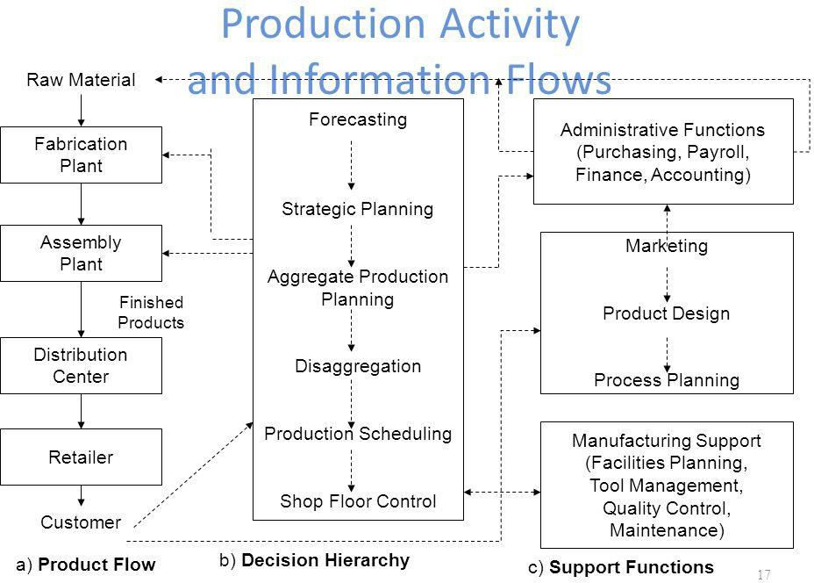

Elements of Production Planning and Control

This is important to note that production plan is the first and the foremost element of PPC. Planning refers to deciding in advance what is to be done in future. A separate planning department is established in the organization which is responsible for the preparation of policies and plans with regard to production to be undertaken in due course. The planning department prepares various charts, manuals production budgets etc., on the basis of information received from management. These plans and charts or production budgets are given practical shape by carrying various elements under production control. If production planning is defective, production control is bound to be
adversely affected. For achieving the production targets, production planning provides sound basis for production control.

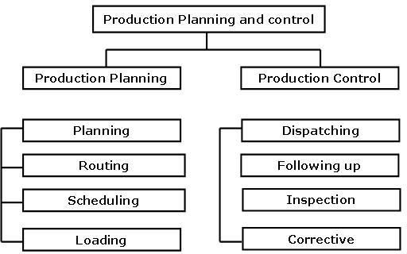
One needs to remember that production plans are prepared in advance at top level whereas, production control is exercised at machine shop floor (bottom level) where actual production is taking place. Some important elements of PPC have been depicted in the figure as below:

The important elements may be listed as following:

- Materials: planning for procurement of raw material, component and spare parts in the right quantities and specifications at the right time from the right source at the right place. Purchasing, storage, inventory control, standardization, variety reduction, value analysis and inspection are the other activities associated with material.
- Method: choosing the best method of processing form several alternatives. It also includes determining the best sequence of operations (process plan) and planning for tooling, jigs and fixtures etc.
- Machines and equipment: manufacturing methods are related to production facilities available in production systems. It involves facilities planning, capacity planning, allocations, and utilization of plant and equipment, machines etc.
- Manpower: planning for manpower (labour and managerial levels) having appropriate skills and expertise.
- Routing; determining the flow of work material handling in the plant, and sequence of operations or processing steps. This is related to consideration of appropriate shop layout plant layout, temporary storage location for raw materials, component and semi-finished goods, and of materials handling system.

Route Sheet: a route sheet is a document providing information and instructions for converting the raw material in finished part or product. It defines each step of the production operations and lay down the precise path or route through which the product will flow during the conversion process. Route sheet contains following information:

- The operation required at their desired sequence
- Machines or equipment to be used for each operations
- Estimated set-up time and operation time per piece
- Tools, jigs, and fixtures required for operations
- Detailed drawings of the part, sub-assemblies and final assemblies
- Specification, dimensions, tolerances, surface finishes and quality standard to be achieved
- Specification of raw material to be used
- Speed, feed etc. to be used in machines tools for operations to be carried on.
- Inspection procedure and metrology tools required for inspection
  - Packing and handling instructions during movement of parts and subassemblies through the operation stages.
- Estimating: Establishing operation times leading to fixations of performance standards both for worker and machines. Estimating involves deciding the quantity of the product which needs to be produced and cost involved in it on the basis of sale forecast.
Estimating manpower, machine capacity and material required meeting the planned production targets are like the key activities before budgeting for resources.

- Loading: machine loading is the process of converting operation schedule into practices in conjunctions with routing. Machine loading is the process assigning specific jobs to machines, men, or work centers based on relative priorities and capacity utilization. Loading ensures maximum possible utilization of productive facilities and avoid bottleneck in production. It’s important to either overloading or under loading the facilities, work centers or machines to ensure maximum utilization of resources.
- Scheduling: scheduling ensure that parts and sub-assemblies and finished goods are completed as per required delivery dates. It provides a timetable for manufacturing activities.

Purpose of scheduling:

  - To prevent unbalance use of time among work and centers and department.
  - To utilize labour such a way that output is produced within established lead time or cycle time so as to deliver the products on time and complete production in minimum total cost.

- Dispatching: This is concerned with the execution of the planning functions. It gives necessary authority to start a particular work which has already planned under routing and scheduling functions. Dispatching is release of orders and instructions for starting of production in accordance with routing sheet and scheduling charts.
- Inspection: This function is related to maintenance of quality in production and of evaluating the efficiency of the processes, methods and labours so that improvement can be made to achieve the quality standard set by product design.
- Evaluating: The objective of evaluating is to improve performance. Performance of machines, processes and labour is evaluated to improve the same.
- Cost control: Manufacturing cost is controlled by wastage reduction, value analysis, inventory control and efficient utilization of all resources.

Requirements for an effective Production Planning and Control
In an organization, PPC system can be effective only if the following aspects are given due considerations before implementation:

    - Appropriate organization structure with sufficient delegation of authority and responsibility at various levels of manpower.
    - Right person should be deputed at right place for right job.
    - Maximum level of standardization of inventory, tooling, manpower, job, workmanship, equipment, etc.
    - Appropriate management decision for production schedule, materials controls, inventory and manpower turnover and product mix.
    - Flexible production system to adjust any changes in demand, any problem in production or availability of materials maintenance requirements, etc
    - Estimation of accurate leads times for both manufacturing and purchase.
    - Management information system should be reliable, efficient and supporting.
    - Capacity to produce should be sufficient to meet the demand.
    - The facility should be responsive enough to produce new products change of products mix and be able to change the production rates.

The above elements are very important and necessary to make the production planning system effective and efficient.

Scope of Production Planning and Control

  - Nature of Inputs

To manufacture a product, different types of inputs are used. The quality of the product depends upon the nature of the inputs are used. Hence the planning is done to determine the nature of various types of inputs which is a complicated process.

  - Quantity of Inputs

To achieve a level of production, determination of quantity of the inputs and their composition is very important. A product can be prepared only when there is an estimate of the required composition of inputs.

  - Proper Coordination

It ensures the proper coordination among the workforce, machines and equipment. This leads to avoidance of wastages and smooth flow of production
Better Control:
Production planning is the method of control. For a better control, planning is a precondition. Only then, one can compare the performance and calculate the deviations which lead control of the production.

  - Ensure Uninterrupted Production

The planning of materials ensures the regular supply of raw materials and other components. The regular flow of materials and supplies are helpful in the uninterrupted production.

  - Capacity Utilization
There is a need to use the available resources effectively. It is helpful in bringing down various costs of production.

  - Timely Delivered

If there is good production planning and control, there will be timely production and the finished product will be rushed to the market in time. This also ensures the better relationship with the customers.

Factors affecting Production Planning and control

    - Use of Computers: Modern factories are using office automation equipment like PC, punch cards etc. It helps accurate computation of required of men and machine.
    - Seasonal Variations: Demand of certain products is affected by seasons, for instance umbrellas and raincoats during the monsoons and outputs. Production planning and control must take such changes into consideration while planning and control activities of inputs and outputs.
    - Test Marketing: In an aggressive marketing strategy new products are to be test marketed in order to know the trends. This is a short- cycle operation, intermittent in nature and often upsets regular production.
    - After Sales Service: This has become an important parameter for success. In after sales services, many items are returned for repair. These are unscheduled Work and also overload the production line.
    - Losses due to Unpredictable Factors: Losses occur due to accidents, fire and theft of production inputs, mainly materials and Components. These are unpredictable. Shortage of input due to such factors upset the planned production schedule in time and quantity.
    - Losses due to Predictable Factors: There are losses of inputs, due to natural engineering phenomena like production losses and changes in consumption of materials and occurrence of defectives.

