Unit 3 (Replacement Theory)

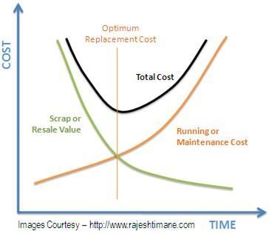
The Replacement Theory in Operations Research is used in the decision making process of replacing a used equipment with a substitute; mostly a new equipment of better usage. The replacement might be necessary due to the deteriorating property or failure or breakdown of particular equipment. The „Replacement Theory‟ is used in the cases like; existing items have out-lived, or it may not be economical anymore to continue with them, or the items might have been destroyed either by accident or otherwise. The above discussed situations can be solved mathematically and categorized on some basis like:

- Items that deteriorate with time e.g. machine tools, vehicles, equipment buildings etc.
- Items becoming out-of-date due to new developments like ordinary weaving looms by automatic, manual accounting by tally etc.
- Items which do not deteriorate but fail completely after certain amount of use like electronic parts, street lights etc (Group Replacement) and
- The existing working staff in an organization gradually diminishing due to death, retirement, retrenchment & otherwise (Staff Replacement).

Replacement Policy for Equipment which Deteriorate Gradually

Let us see the fiUSDt case of gradual failure of items with time. Consider the example of a Motor Vehicle; the pattern of failure here is progressive in nature i.e. as the life of vehicle increases; its efficiency decreases. This results in additional expenditure in running or maintaining this vehicle and at the same time its resale value (also called as scrap value) also keeps on decreasing. The above case makes this situation a typical case for applying „Replacement Theory‟.

Example:

A transport company purchased a motor vehicle for rupees 80000/-. The resale value of the vehicle keeps on decreasing from USD 70000/- in the fiUSDt year to USD 5000/- in the eighth year while, the running cost in maintaining the vehicle keeps on increasing with USD. 3000/- in the fiUSDt year till it goes to USD. 20000/- in the eighth year as shown in the below table. Determine the optimum replacement policy?
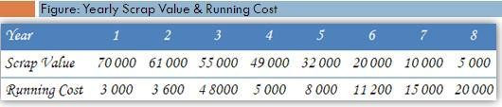

The MS-Excel Files of this Algorithm can be downloaded from the links provided further in this post. The cost of the equipment is to be entered in the cell B1 (as shown by the green cell with 80000). Now, enter the scrap values and the running costs as entered in the green columns C5 to C12 and D5 to D12. The algorithm will now automatically calculate the solution which is as shown in the below figure.
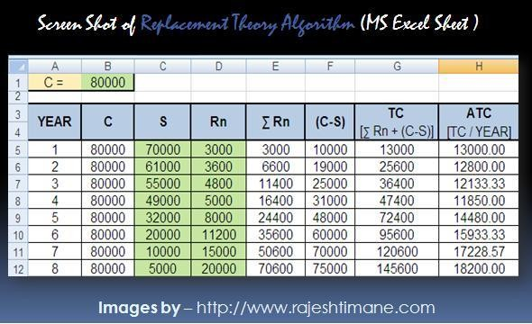

The answer can be fetched from the last column. See the pattern; the average total cost (ATC) at first starts dipping from USD. 13000/- till it reaches USD. 11850/- in the cell H8. From H9 it again starts increasing. This cost at which the ATC is lowest in a particular year (after which it starts increasing again) gives the optimum replacement period and cost of the vehicle.

Solution: The vehicle needs to be replaced after four years of its purchase wherein the cost of maintaining that vehicle would be lowest at an average of USD 11850/- per year.

Clarification on the Methodology

There are two considerations here. First, the running cost (Rn) is increasing every year at the same time the vehicle is depreciating in its value. This depreciation is
„(C-S)‟ i.e. in the first year the scrap value of the vehicle is USD. 70000/- which was purchased for USD. 80000/- . So, the vehicle is depreciated by USD. 10000/- in year one and so on (see column F).

Thus the total cost in keeping this vehicle is this depreciation and its maintenance. The maintenance is made cumulative by adding previous years running cost to it every successive year. Let‟s make this simple!

The depreciation is USD. 10000/- in the first, 19000/- in the second, 25000/- in the third and so on. See here, the vehicle is depreciated by USD. 25000/- “by” the third year and not “in” the third year. Note that the non-cumulative cost of depreciation “in” the third year would be USD. 6000/- [USD. 25000/ minus USD. 19000/, see the cells F6 and F7]

As, the depreciation in itself is a cumulative function here, we make the running cost cumulative also. That means the cost of maintaining the vehicle “by” the particular years. So, the cost of maintaining the vehicle “by” the third year is USD. 11400/- (D5+D6+ D7 or 3000+3600+4800).

Hence the total cost incurred by the third year would be USD. 25000 + USD. 11400
= USD. 36400 (see cell G7). Finally, the “average cost” of keeping this vehicle for three years would be 36400 divided by 3 years i.e. USD. 12133.33 as can be seen from cell H7 and so on.

Notations Used:

- C – (Capital) Cost of Equipment
- S – Scrap (or Resale) Value
- Rn – Running (or Maintenance) Cost
- E Rn – Cumulative Running Cost
- (C-S) – Depreciation
- TC – Total Cost
- ATC – Average Total Cost

Group Replacement Theory

Replacement of items that fail suddenly

There are certain items which do not deteriorate but fail completely after certain amount of use. These kinds of failures are analyzed by the method called as group replacement theory. Here, large numbers of items are failing at their average life expectancy. This kind of items may not have maintenance costs as such but they fail suddenly without any prior warning. Also, in case of sudden breakdowns immediate replacement may not be available. Few examples are fluorescent tubes, light bulbs, electronic chips, fuse etc.
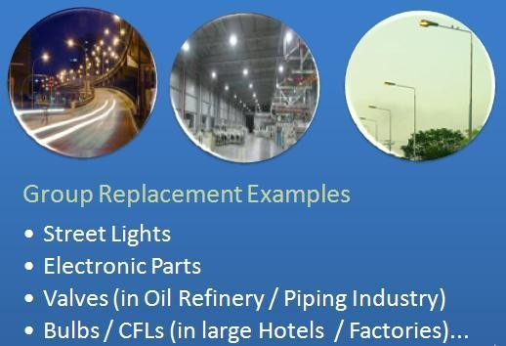

Let‟s consider the example of street lights. We often see street-lights being repaired by the corporation staff using extendable ladders. If a particular light is beyond repairs, then it is replaced. This kind of policy of replacement is called as
„replacement of items as-and-when they fail‟ or ‘Individual Replacement’. On the other hand, if all the street lights in a particular cluster are replaced as and when they fail and also simultaneously in groups, then the policy is called as ‘Group Replacement’. It should be noted that, group replacement does involve periodic simultaneous replacements along with individual replacements in between.

It is found that replacing these random failing items simultaneously at specific intervals is economical as compared to replacing them only when an item fails. A long period between group replacements results in increase in cost of individual replacements, while frequent group replacements are definitely costly. There lies the need to balance this and find an optimum replacement time for optimum cost of replacement.

Problem:

A factory has 1000 bulbs installed. Cost of individual replacement is USD. 3/- while that of group replacement USD 1/-per bulb respectively. It is decided to replace all the bulbs simultaneously at fixed interval & also to replace the individual bulbs that fail in between. Determine optimal replacement policy. Failure probabilities are as given below:
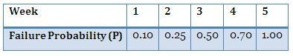

Solution:

The probabilities given in the problem are cumulative i.e. till week 1, till week 2 etc. Individual probabilities would be 0.10 in 1st week, 0.15 (0.25-0.10) in 2nd week, and so on. (as shown in the below table)

Policy-I: Individual Replacement

Step 1) Cost of Individual Replacements
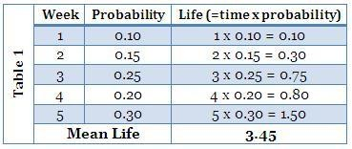

Individual Failures/week = Total Quantity / Mean Life = 1000 / 3.45 = 289.9

Individual Replacement Cost = (Individual Failures per week) x (Individual replacement cost)

= 289.9 x 3 = USD. 869.6

Policy-II: Group Replacement

Step 2) Individual failures per week

In the first week: 10 % (0.10) of the bulbs will fail out of 1000 bulbs i.e. 100

In the second week: 15 % of the bulbs will fail out of 1000 bulbs i.e. 150. Also, 10% of 100 replaced in the first week i.e. 10. TOTAL bulbs failed until second week = 160 (150+10)

Rest of the calculation is as shown in the below table:
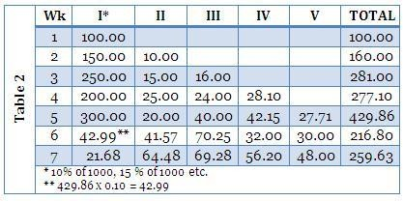

Step 3) Calculating the total cost & time of replacement:
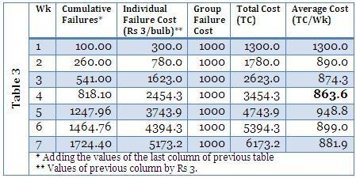

Thus, replacing all the bulbs simultaneously at fixed interval & also to replace the individual bulbs that fail in between will be economical or optimal after 4 weeks (optimal interval between group replacements).

Interpretation:

- The cost of only individual replacements id USD. 869.6 (As seen in the Policy- I)
- The cost of combine policy i.e. group and individual replacement id USD.
863.6 (see last column of table 3)
- Hence the Policy-II is the optimum replacement policy

Hence, the bulbs shall be replaced every four weeks individually as well as in groups which combine would cost USD. 863.6 per week (lesser than individual cost of USD.
  - per week)

Click the following link to Download the Excel Solver

Group Replacement Algorithm

Practice Problem:

The following mortality rates have been observed for a special type of light bulbs. There are 1000 such bulbs in the concerned unit of the industry.
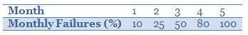

It costs USD 10 to replace an individual bulb that has burnt out. If the bulbs were replaced simultaneously, it would cost USD. 2.50 per bulb. It is proposed to replace all the bulbs at fixed interval, whether are not they have burnt out, and to continue replacing the burnt out bulbs as they fail. At what intervals of time should the manager replace all the bulbs? Decide the optimum replacement policy.

REPLACEMENT OF ITEMS DETERIORATING WITH TIME
13.1 Introduction
In any establishment, sooner or later equipment needs to be replaced, particularly when new equipment gives more efficient or economical service than the old one. In some cases, the old equipment might fail and work no more or is worn out. In such situations it needs more expenditure on its maintenance than before. The problem in such situation is to determine the best policy to be adopted with respect to replacement of the equipment. The replacement theory provides answer to this question in terms of optimal replacement period. Replacement theory deals with the analysis of materials and machines which deteriorate with time and fix the optimal time of their replacement so that total cost is the minimum.
13.2 Replacement Decisions
The problem is to decide the best policy to adopt with regard to replacement. The need for replacement arises in a number of different following situations so that different types of decisions may have to be taken.
� It may be necessary to decide whether to wait for a certain item to fail which might cause some loss or to replace earlier at the expense of higher cost of the item.
� The item can be considered individually to decide whether to replace now or if not when to reconsider the item in question.
� It is necessary to decide whether to replace by the same item or by a different type of item.
13.3 Types of Replacement Problems
i) Replacement policy for items, efficiency of which declines gradually with time without change in money value.
ii) Replacement policy for items, efficiency of which declines gradually with time but with change in money value.
iii) Replacement policy of items breaking down suddenly
a) Individual replacement policy
b) Group replacement policy
iv) Staff replacement
In this lesson we confine ourselves to first two situations only
13.4 Replacement of Items that Deteriorate with Time
There are certain items which deteriorate gradually with usage and such items decline in efficiency over a period of time. Generally, the maintenance cost of certain items always increase gradually with time and a stage comes when the maintenance cost becomes so large that it is better and economical to replace the item with a new one. There may be number of alternatives and we may have a comparison between various alternatives by considering the costs due to waste, scrap, loss of output, damage to equipment and safety risks etc.
13.4.1 Replacement of items whose maintenance cost increases with time and the value of money remains same during the period
The following costs are considered in such decisions:
C: Capital cost of a certain item say a machine
s(t): The selling or scrap value of the item after t years
f(t): Operating (or maintenance) cost of the item at time t
n: Optimal replacement period of the item
The operating cost function f(t) is assumed to be strictly positive. It may be continuous or discrete.
13.4.2 When t is a continuous variable
Now the annual cost of the machine at time t is given by C � S(t) + f(t) and since the total maintenance cost incurred on the machine during n years is .
Total cost T incurred on machine during n years is given by
��������������� 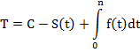
Thus the average annual cost incurred on the machine per year during n years is given by
�����������
To determine the value of optimal period (n), the principle of minima will be employed.
����������� 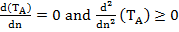
��������������� 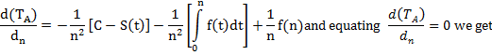
�����������
Clearly
����������� 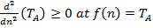
Therefore, it can be seen that A(n) or T_{A} = f(n) is a minimum for T provided that f(t) is non�decreasing and f(0) = 0. Hence, if time is measured continuously, then the average annual cost will be minimized by replacing the item when the average cost becomes equal to the current maintenance cost.
13.4.3 When time is a discrete variable
Here the period of time is considered as fixed and n takes values 1,2,3, � then
�����������
By using finite differences, A(n) will be a minimum for that value of n for which
���������������
or
����������� �
For this, we write
�����������
�����������
����������� 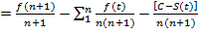
�����������
�����������
Similarly, it can be shown
�����������
This suggests the replacement policy that if time is measured in discrete units, then the average annual cost will be minimized by replacing item when the next period�s maintenance cost become greater than the current average cost. Hence, replace the equipment at the end of n years, if the maintenance cost in the (n+1)^{th} year is more than the average total cost in the (n)^{th} year and the (n)^{th} year�s maintenance cost is less than the previous year�s average total cost. The following examples will illustrate this methodology
Example 1 A milk plant is considering replacement of a machine whose cost price is Rs. 12,200 and the scrap value Rs. 200. The running (maintenance and operating) costs in Rs. are found from experience to be as follows:
Year: | 1 | 2 | 3 | 4 | 5 | 6 | 7 | 8
Running Cost: | 200 | 500 | 800 | 1200 | 1800 | 2500 | 3200 | 4000
When should the machine be replaced?
Solution The computations can be summarized in the following tabular form:
Table 13.1 Calculations for average cost of machine
 | (In Rupees)
Year  (1) | Running Cost  (2) | Cumulative Running Cost  (3) | Depreciation Cost  (4) | Total Cost TC  (5) = (3) + (4) | Average Cost  (6) = (5)/(1)
1 | 200 | 200 | 12000 | 12200 | 12200
2 | 500 | 700 | 12000 | 12700 | 6350
3 | 800 | 1500 | 12000 | 13500 | 4500
4 | 1200 | 2700 | 12000 | 14700 | 3675
5 | 1800 | 4500 | 12000 | 16500 | 3300
6 | 2500 | 7000 | 12000 | 19000 | 3167
7 | 3200 | 10200 | 12000 | 22200 | 3171
8 | 4000 | 14200 | 12000 | 26200 | 3275

From the table it is noted that the average total cost per year, A(n) is minimum in the 6th year (Rs. 3167). Also the average cost in 7th year (Rs.3171) is more than the cost in 6th year. Hence the machine should be replaced after every 6 years.
Example 2
A Machine owner finds from his past records that the maintenance costs per year of a machine whose purchase price is Rs. 8000 are as given below:
Year: | 1 | 2 | 3 | 4 | 5 | 6 | 7 | 8
Maintenance Cost: | 1000 | 1300 | 1700 | 2200 | 2900 | 3800 | 4800 | 6000
Resale Price: | 4000 | 2000 | 1200 | 600 | 500 | 400 | 400 | 400
Determine at which time it is profitable to replace the machine.
Solution C = Rs. 8000. Table 13.2 shows the average cost per year during the life of machine. Here, The computations can be summarized in the following tabular form:
Table 13.2 Calculations for average cost of machine
Year | f(t) | Cumulative maintenance cost | Scrap value | Total cost
1 | 1000 | 1000 | 4000 | 5000 | 5000
2 | 1300 | 2300 | 2000 | 8300 | 4150
3 | 1700 | 4000 | 1200 | 10800 | 3600
4 | 2200 | 6200 | 600 | 13600 | 3400
5 | 2900 | 9100 | 500 | 16600
6 | 3800 | 12900 | 400 | 20500 | 3417
7 | 4800 | 17700 | 400 | 25300 | 3614
8 | 6000 | 23700 | 400 | 31300 | 3913

The above table shows that the value of T_{A} during fifth year is minimum. Hence the machine should be replaced after every fifth year.
Example 3
The cost of a machine is Rs. 6100 and its scrap value is only Rs.100. The maintenance costs are found to be
Year: | 1 | 2 | 3 | 4 | 5 | 6 | 7 | 8
Maintenance Cost (in Rs.): | 100 | 250 | 400 | 600 | 900 | 1250 | 1600 | 2000
When should the Machine be replaced?
Solution
C = 6100, s(t) = 100 The computations can be summarized in the following tabular form:
Table 13.3 Calculations for average cost of machine
Replace at the end of year |  | Cumulative maintenance cost  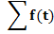 | Total cost  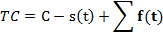
1 | 100 | 100 | 6100 | 6100
2 | 250 | 350 | 6350 | 3175
3 | 400 | 750 | 6750 | 2250
4 | 600 | 1350 | 7350 | 1737.50
5 | 900 | 2250 | 8250 | 1650
6 | 1250 | 3500 | 9500
7 | 1600 | 5100 | 11100 | 1585.7
8 | 2000 | 7100 | 13100 | 1637.50

It is now observed that the machine should be replaced at the end of sixth year otherwise the average cost per year will start to increase.
13.4.4 Replacement of items whose maintenance cost increases with time and the money value changes at a constant rate
To understand this let us define the following terms:
Money Value
Since money has a value over time, therefore the explanation of the statement: �Money is worth 10% per year� can be given in two ways:
(a) In one way, spending Rs.100 today would be equivalent to spend Rs.110 in year�s time. In other words if we plan to spend Rs.110 after a year from now, we could spend Rs.100 today and an investment which would be worth Rs.110 next year.
(b) Alternatively if we borrow Rs.100 at the interest of 10% per year and spend Rs.100 today, we have to pay Rs.100 after one year (next year).
Thus, we conclude that Rs.100 is equal to Rs.110 a year from now. Consequently Rs. 1 from a year now is equal to (1+0.1)⁻¹ rupee today.
Present Worth Factor
As we have seen, a rupee a year from now will be equivalent to (1+0.1)⁻¹ rupee today at the discount rate of 10% per year. So, one rupee in n years from now will be equal to (1+0.1)^{-n}. Therefore, the quantity (1+0.1)^{-n} is called the Present Worth Factor (PWF) or Present Value (PV) of one rupee spent in n years from now. In general, if r is the rate of interest, then (1+r)^{-n} is called PWF or PV of one rupee spent in n years from now onwards. The expression (1+r)^{-n} is known as compound amount factor of one rupee spent in n years.
Discount Rate
Let r be the rate of interest. Therefore present worth factor of unit amount to be spent after one year is .
Then v is known as the discount rate. The optimum replacement policy for replacement of item where maintenance costs increase with time and money value changes with constant rate can be determined by following method:
Suppose that the item (which may be machine or equipment) is available for use over a series of time periods of equal intervals (say one year). Let
C = Purchase price of the item to be replaceds
R_{t} = Running (or maintenance) cost in the t^{th} year
R = Rate of interest
�is the present worth of a rupee to be spent in a year hence.
Let the item be replaced at the end of every n^{th} year. The year wise present worth of expenditure on the item in the successive cycles of n years can be calculated as follows:

Year | 1 | 2---- | n | n+1 | n+2 | ---- | 2n | 2n+1
Present worth | C+R₁ | R₂v | R_{n}v^{n-1} | (C+R₁)v^{n} | R₂v^{n+1} |  | R_{n}v^{2n-1} | (C+R₁)v^{2n}

Assuming that machines has no resale value at the time of replacement, the present worth of the machine in n years will be given by
��������������� 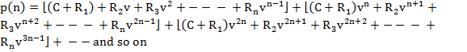
Summing up the right-hand side, column-wise
�����������
���������������
����������� ,
using sum of an infinite G.P.
�����������
����������� 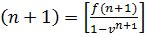
f(n) and f(n+1) given above at n = 0,1,2�, are called the weighted average cost of previous n years with weights 1,v, v², ----v^{n-1}respectively. P(n) is the amount of money required now to pay all the future costs of acquiring and operating the equipment when it is renewed every n years. However, if P (n) is less than P (n+1) then replacing the equipment each n year is preferable to replacing each n years is preferable to replacing each (n+1) years. Further, if the best policy is replacing every n years, then the two inequalities P (n+1) � P (n) > 0 and P (n-1) - P (n) < 0 must hold, without giving the proof we shall state the following two inequalities which holds good at n, the optimal replacement interval.
����������� 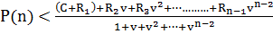
����������� 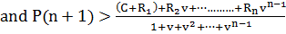
As a result of these two inequalities, rules for minimizing costs may be stated as follows:
1. Do not replace if the operating cost of next period is less than the weighted average of previous costs.
2. Replace if the operating cost of the next period is greater than the weighted average of the previous costs.
Working Procedure
The step-by-step procedure for solving the problem is stated as under:
1. Write in a column the running/maintenance costs of machine or equipment for different years, R_{n}.
2. In the next column write the discount factor indicating the present value of a rupee received after (i-1) years,
3. The two column values are multiplied to get present value of the maintenance costs, i.e.,.
4. These discounted maintenance costs are then cumulated to the i^{th} year to get.
5. The cost of machine or equipment is added to the values obtained in Step 4 above to
Obtain C+ .
6. The discount factors are then cumulated to get .
7. The total costs obtained in (Step 5) are divided by the corresponding value of the accumulated discount factor for each of the years.
8. Now compare the column of maintenance costs which is constantly increasing with the last column. Replace the machine in the latest year that the last column exceeds the column of maintenance costs.
Example 4
A milk plant is offered an equipment A which is priced at Rs.60,000 and the costs of operation and maintenance are estimated to be Rs.10,000 for each of the first 5 years, increasing every year by Rs. 3000 per year in the sixth and subsequent years. If money carries the rate of interest 10% per annum what would the optimal replacement period?
Solution
Table 13.4 Determination of optimal replacement period
At the end of year  (n) | Operating & maintenance cost  R_{n} | Discounted factor | Discounted operation & maintenance cost | Cumulative  Discounted operation & maintenance cost | Discounted total cost  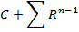 | Cumulative discounted factor  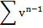 | Weighted average annual cost  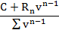
(1) | (2) | (3) | (4)=(2)x(3) | (5) | (6)=(5)+60000 | (7) | (8)=(6)+(7)
1 | 10000 | 1.0000 | 10000.00 | 10000.00 | 70000.00 | 1.00 | 70000.00
2 | 10000 | 0.9091 | 9091.00 | 19091.00 | 79091.00 | 1.91 | 41428.42
3 | 10000 | 0.8264 | 8264.00 | 27355.00 | 87355.00 | 2.74 | 31933.83
4 | 10000 | 0.7513 | 7513.00 | 34868.00 | 94868.00 | 3.49 | 27207.75
5 | 10000 | 0.6830 | 6830.00 | 41698.00 | 101698.00 | 4.17 | 24389.18
6 | 13000 | 0.6209 | 8071.70 | 49769.70 | 109769.70 | 4.79 | 22913.08
7 | 16000 | 0.5645 | 9032.00 | 58801.70 | 118801.70 | 5.36 | 22184.36
8 | 19000 | 0.5132 | 9750.80 | 68552.50 | 128552.50 | 5.87 | 21905.89
9 | 22000 | 0.4665 | 10263.00 | 78815.50 | 138815.50 | 6.33 | 21912.82
10 | 25000 | 0.4241 | 10602.50 | 89418.00 | 149418.00 | 6.76 | 22106.52

From Table 13.4 we find the weighted cost is minimum at the end of 8th year, hence the equipment should be replaced at the end of 8th year.
Example 5
A Manufacturer is offered two machines A and B. Machine A is priced at Rs. 5000 and running cost is estimated at Rs. 800 for each of the first five years, increasing by Rs. 200 per year in the sixth and subsequent years. Machine B, with the same capacity as A, costs Rs. 2500, but has running cost of Rs. 1200 per year for six years, thereafter increasing by Rs. 200 per year. If money is worth 10% per year, which machine should be purchased? (Assume that the machines will eventually be sold for scrap at a negligible price).
Solution
Since money is worth 10% per year, therefore discount rate is 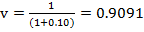
Table 13.5 Computation of weighted average cost for machine A
At the end of year  (n) | Operating & maintenance cost  R_{n} | Discounted factor | Discounted operation & maintenance cost | Cumulative  Discounted operation & maintenance cost | Discounted total cost | Cumulative discounted factor | Weighted average annual cost
(1) | (2) | (3) | (4)=(2)x(3) | (5) | (6)=(5)+  5000 | (7) | (8)=(6)+(7)
1 | 800 | 1.0000 | 800 | 800 | 5800 | 1 | 5800
2 | 800 | 0.9091 | 727 | 1527 | 6527 | 1.9091 | 3419.035
3 | 800 | 0.8264 | 661 | 2188 | 7188 | 2.7355 | 2627.819
4 | 800 | 0.7513 | 601 | 2789 | 7789 | 3.4868 | 2233.98
5 | 800 | 0.6830 | 546 | 3336 | 8336 | 4.1698 | 1999.098
6 | 1000 | 0.6209 | 621 | 3957 | 8957 | 4.7907 | 1869.61
7 | 1200 | 0.5645 | 677 | 4634 | 9634 | 5.3552 | 1799.025
8 | 1400 | 0.5132 | 718 | 5353 | 10353 | 5.8684 | 1764.13
9 | 1600 | 0.4665 | 746 | 6099 | 11099 | 6.3349 | 1752.043
10 | 1800 | 0.4241 | 763 | 6862 | 11862 | 6.759 | 1755.053

From table 13.5 we conclude that for machine A 1600<1752.043<1800. Since the running cost of 9th year is 1600and that of 10th year is 1800 and 1800>1752.043, it would be economical to replace machine A at the end of nine years.
Table 13.6 Computation of weighted average cost for machine B
At the end of year  (n) | Operating & maintenance cost  R_{n} | Discounted factor | Discounted operation & maintenance cost | Cumulative  Discounted operation & maintenance cost | Discounted total cost | Cumulative discounted factor | Weighted average annual cost
(1) | (2) | (3) | (4)=(2)x(3) | (5) | (6)=(5)+  2500 | (7) | (8)=(6)+(7)
1 | 1200 | 1.0000 | 1200.00 | 1200.00 | 3700.00 | 1.00 | 3700.00
2 | 1200 | 0.9091 | 1090.92 | 2290.92 | 4790.92 | 1.91 | 2509.52
3 | 1200 | 0.8264 | 991.68 | 3282.60 | 5782.60 | 2.74 | 2113.91
4 | 1200 | 0.7513 | 901.56 | 4184.16 | 6684.16 | 3.49 | 1916.99
5 | 1200 | 0.6830 | 819.60 | 5003.76 | 7503.76 | 4.17 | 1799.55
6 | 1200 | 0.6209 | 745.08 | 5748.84 | 8248.84 | 4.79 | 1721.84
7 | 1400 | 0.5645 | 790.30 | 6539.14 | 9039.14 | 5.36 | 1687.92
8 | 1600 | 0.5132 | 821.12 | 7360.26 | 9860.26 | 5.87 | 1680.23
9 | 1800 | 0.4665 | 839.70 | 8199.96 | 10699.96 | 6.33 | 1689.05
10 | 2000 | 0.4241 | 848.20 | 9048.16 | 11548.16 | 6.76 | 1708.56

In table13.6 we find that 1800<1689<2300 so it is better to replace the machine B after 8th year. The equivalent yearly average discounted value of future costs is Rs. 1748.60 for machine A and it is 1680.23for machine B. Hence, it is more economical to buy machine B rather than machine A.

