NOTES-BUSINESS ENVIRONMENT
UNIT-2

VAISHNAVI VERMA
ASSISTANT PROFESSOR
VISION GROUP OF INSTITUTIONS
KANPUR
UNIT -2

Role of government in Business

Permission to Form
Most businesses need to register with a state government to operate. Corporations need a charter, and other forms of businesses, such as limited liability companies or partnerships, need other forms of registration. The function of this registration is usually to define the financial liability the owners of the company have. It limits their risk to the amount they have invested in that particular organization. Registration also allows the government to monitor companies to execute its other functions in the business world.

Contract Enforcement
Businesses contract with other businesses. These contracts may be complex, such as mergers, or they may be as simple as a warranty on supplies purchased. The government enforces these contracts. Companies bring one another to court just as individuals do. An oral agreement can constitute a contract, but usually only a written agreement is provable. If one party fails or refuses to meet its obligation under a contract, a company will turn to the legal system for enforcement.

Consumer Protection
The government’s role in business includes protecting the consumer or customer. When a vendor fails to honor the guarantee, the purchaser has recourse in the law. Likewise, when a product causes harm to an individual, the courts may hold the vendor or manufacturer responsible. Labeling is another requirement the government imposes on marketers. Many foods, for example, must display nutritional content on the packaging. The government has been making advances in consumer rights for decades. However, the consumer movement still needs considerable development to protect the public.

Employee Protection
Many state and federal agencies work to protect the rights of employees. The Occupational Health and Safety Administration, for example, is an agency under the Department of Labor. Its mission is to ensure a safe and healthful work environment. The Equal Opportunity Commission protects employees from discrimination.

Environmental Protection
When a marketing transaction impacts a third party–others besides the marketer and purchaser–the effect is called an “externality.” The third party is often the environment. Thus, it is the government’s role to regulate industry and thereby protect the public from environmental externalities. Whether the government is effective in this role is a matter of much discussion. The Gulf oil spill of 2010 has been cited as evidence of lax oversight.

Taxation
Governments at all levels tax businesses, and the resulting revenue is an important part of government budgets. Some revenue is taxed at the corporate level, then taxed as personal income when distributed as dividends. This is in no way inappropriate, since it balances the tax burden between the company and individual and allows the government to tax more equitably.

Investor Protection
Government mandates that companies make financial information public, thereby protecting the rights of investors and facilitating further investment. This is generally done through filings with the Securities and Exchange Commission. Whether federal regulation has been adequate is a matter of much debate.

What is Economic Environment?

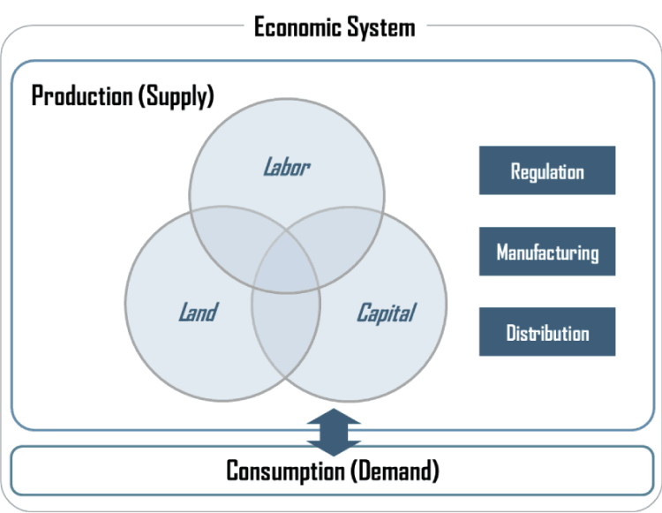
The economic environment relates to all the economic determinants that influence commercial and consumer compliance. ‘The term economic environment indicates to all the external economic circumstances that affect purchasing practices of customers and markets and hence influence the production of the business.’
As a component of economic reformations, the Government of India declared a new industrial system in July 1991. The extensive characteristics of this system were as follows:
- The Government decreased the number of enterprises below mandatory licensing to six
- Many of the businesses held for the public sector under the initial policy, were justified. The purpose of the public sector was defined only to 4 industries of vital importance
- Disinvestment was conducted in case of many public sector industrial companies
- Policy towards foreign funds was expanded. The percentage of foreign equity partnership was extended and in many ventures, 100 percent Foreign Direct Investment (FDI) was allowed
- Automatic approval was now given for technology transactions with foreign firms
- Foreign Investment Promotion Board (FIPB) was established to support and channelise foreign financing in India

Liberalisation:
The economic reforms that were presented were directed at liberalising the Indian business and trade from all redundant restrictions and limitations. They indicated the end of the licence-permit-quota raj. The liberalisation of the Indian business has taken place with respect to:
- Eliminating licensing terms in most of the industries excluding a shortlist
- Freedom in determining the range of marketing activities i.e., no constraints on development or consolidation of business pursuits
- Dismissal of restraints on the transportation of commodities and services
- Freedom in deciding the cost prices of commodities and services

Privatisation:
The new set of economic changes intended at proffering a prominent position to the private sector in the nation-building rule and a diminished role to the public sector. This was a withdrawal of the growth policy attempted so far by Indian directors. To accomplish this, the administration redefined the role of the public sector in the New Industrial Policy of 1991, approved the policy of proposed disinvestments of the public sector and determined to the loss-making and weak industries to the Board of Industrial and Financial Reconstruction (BIFR).
Also Check: What are the objectives of Privatisation?

Globalisation:
Globalisation implies the combination of the different economies of the world heading towards the development of a united (closely-knitted) global marketplace. Till 1991, the Government of India had followed a course of stringently controlling imports in price and quantity terms. These laws were with respect to:
- Licensing of imports
- Tariff limitations
- Quantitative constraints
The new economic reforms directed at business liberalisation were focused towards import liberalisation, export improvement through rationalisation of the tax structure and changes with respect to foreign exchange so that the nation does not remain separate from the rest of the world.

Concept of Capitalism, Socialism and Mixed Economy

Capitalism
Capitalism is an economic system where private entities own the factors of production. The four factors are entrepreneurship, capital goods, natural resources, and labor. The owners of capital goods, natural resources, and entrepreneurship exercise control through companies. The individual owns his or her labor. The only exception is slavery, where someone else owns a person’s labor. Although illegal throughout the entire world, slavery is still widely practiced.
Characteristics of Capitalism
Capitalistic ownership means two things. First, the owners control the factors of production. Second, they derive their income from their ownership. That gives them the ability to operate their companies efficiently. It also provides them with the incentive to maximize profit.
Capitalism requires a free market economy to succeed. It distributes goods and services according to the laws of supply and demand. The law of demand says that when demand increases for a particular product, price rises. When competitors realize they can make a higher profit, they increase production. The greater supply reduces prices to a level where only the best competitors remain.
The owners of supply compete against each other for the highest profit. They sell their goods at the highest possible price while keeping their costs as low as possible. Competition keeps prices moderate and production efficient.
That means the laws of supply and demand set fair prices for stocks, bonds, derivatives, currency, and commodities. Capital markets allow companies to raise funds to expand. Companies distribute profits among the owners. They include investors, stockholders, and private owners.
Advantages of Capitalism
Capitalism results in the best products for the best prices. That’s because consumers will pay more for what they want the most. Businesses provide what customers want at the highest prices they’ll pay. Prices are kept low by competition among businesses. They make their products as efficient as possible to maximize profit.
Most important for economic growth is capitalism’s intrinsic reward for innovation. This includes innovation in more efficient production methods. It also means the innovation of new products. As Steve Jobs said, “You can’t just ask customers what they want and then try to give that to them. By the time you get it built, they’ll want something new.”
Disadvantages of Capitalism
Capitalism doesn’t provide for those who lack competitive skills. This includes the elderly, children, the developmentally disabled, and caretakers. To keep society functioning, capitalism requires government policies that value the family unit.
Despite the idea of a “level playing field,” capitalism does not promote equality of opportunity. Those without the proper nutrition, support, and education may never make it to the playing field.
In the short term, inequality may seem to be in the best interest of capitalism’s winners. They have fewer competitive threats. They may also use their power to “rig the system” by creating barriers to entry. For example, they will donate to elected officials who sponsor laws that benefit their industry. They could send their children to private schools while supporting lower taxes for public schools.
In the long term, inequality will limit diversity and the innovation it creates. For example, a diverse business team is more able to identify market niches. It can understand the needs of society’s minorities, and target products to meet those needs.

Socialism
Socialism is an economic system where everyone in society equally owns the factors of production. The ownership is acquired through a democratically elected government. It could also be a cooperative or a public corporation where everyone owns shares. The four factors of production are labor, entrepreneurship, capital goods, and natural resources.
Socialism’s mantra is, “From each according to his ability, to each according to his contribution.” Everyone in society receives a share of the production based on how much each has contributed.
Workers receive their share after a percentage has been deducted for the common good. Examples are transportation, defense, and education. Some also define the common good as caring for those who can’t directly contribute to production. Examples include the elderly, children, and their caretakers.
Socialism assumes that the basic nature of people is cooperative. That nature hasn’t yet emerged in full because capitalism or feudalism has forced people to be competitive. Therefore, a basic tenet of socialism is that the economic system must support this basic human nature for these qualities to emerge.
These factors are valued for their usefulness to people. This includes individual needs and greater social needs. That might include the preservation of natural resources, education, or health care. That requires most economic decisions to be made by central planning, as in a command economy.
Advantage of Socialism
Under socialism, workers are no longer exploited, since they own the means of production. All profits are spread equitably among all workers, according to his or her contribution. The cooperative system realizes that even those who can’t work must have their basic needs met, for the good of the whole.
The system eliminates poverty. Everyone has equal access to health care and education. No one is discriminated against.
Everyone works at what one is best at and what one enjoys. If society needs jobs to be done that no one wants, it offers higher compensation to make it worthwhile.
Disadvantage of Socialism
The biggest disadvantage of socialism is that it relies on the cooperative nature of humans to work. It negates those within society who are competitive, not cooperative. Competitive people tend to seek ways to overthrow and disrupt society for their own gain.
A second related criticism is that it doesn’t reward people for being entrepreneurial and competitive. As such, it won’t be as innovative as a capitalistic society.
A third possibility is that the government set up to represent the masses may abuse its position and claim power for itself.

Mixed Economy
A mixed economic is a system that combines aspects of both capitalism and socialism. A mixed economic system protects private property and allows a level of economic freedom in the use of capital, but also allows for governments to interfere in economic activities in order to achieve social aims. According to neoclassical theory, mixed economies are less efficient than pure free markets, but proponents of government interventions argue that the base conditions such as equal information and rational market participants cannot be achieved in practical application.
Most modern economies feature a synthesis of two or more economic systems, with economies falling at some point along a continuum. The public sector works alongside the private sector, but may compete for the same limited resources. Mixed economic systems do not block the private sector from profit-seeking, but do monitor profit levels and may nationalize companies that are deemed impediments to the public good. The United States is mostly a free market economy, but it incorporates elements such as protection for agriculture and manufacturing through trade restrictions and subsidies. This makes the United States a mixed economy by definition.
Advantages and Disadvantages of a Mixed Economy
Many of the advantages of a mixed economy are found in a market economy. Goods and services are distributed where they are most needed, while allowing prices to measure supply and demand. Secondly, it rewards the producers who are the most efficient with the biggest profits, meaning consumers get the most value for their dollar. A mixed economy promotes innovation and improvement, and gives capital to those producers who are most efficient.
But if the market has too much freedom and liberty, it can make the environment less competitive sans support from the government. Furthermore, the country could accumulate more debt by creating government-subsidized industries — like defense or military — slowing down the economy.

Competition Act and FEMA

Competition Act
The competition act of 2002 was passed by the parliament of India so as to form a commission to oversee the business operations of companies and individuals in the country following fair practices of competition and economic growth of the country. This act applies to the whole of republic of India except for Jammu and Kashmir. It applies for agreement, acquisition or any cartel involving business transactions that has an economic impact for the country.
Objectives of Competition Act
(I) The first and foremost duty of the commission is to exercise control over the practices in competition, which are having adverse effect on competition.
(II) In addition to this, the commission also targets to introduce healthy measure for promotion and sustenance of competition.
(III) It largely targets to protect the interests of the consumers and give fair trade practices their due place.
(IV) The Commission has also kept the target to place its opinion on the issues about competition prevailing in India.
(V) It would also act on a reference received from a statutory authority, if the same has been undertaken by any law in order to promote competition and create awareness in public, and inculcate training on majors issues in competition.
Functions of Competition Act
The Act establishes a Commission which is duty bound to protect the interests of the free and fair competition (including the process of competition), and as a consequence, protect the interests of consumers. Broadly, the Commission’s duty is:-
- To prohibit the agreements or practices that have or are likely to have an appreciable adverse effect on competition in a market in India, (horizontal and vertical agreements / conduct)
- To prohibit the abuse of dominance in a market
- To prohibit acquisitions, mergers, amalgamations etc. between enterprises which have or are likely to have an appreciable adverse effect on competition in market(s) in India.

The Foreign Exchange Management Act, 1999 (FEMA)
The Foreign Exchange Management Act, 1999 (FEMA) is an Act of the Parliament of India “to consolidate and amend the law relating to foreign exchange with the objective of facilitating external trade and payments and for promoting the orderly development and maintenance of foreign exchange market in India”.[1] It was passed in the winter session of Parliament in 1999, replacing the Foreign Exchange Regulation Act (FERA). This act makes offences related to foreign exchange civil offenses. It extends to the whole of India.,[2] replacing FERA, which had become incompatible with the pro-liberalization policies of the Government of India. It enabled a new foreign exchange management regime consistent with the emerging framework of the World Trade Organization (WTO). It also paved the way for the introduction of the Prevention of Money Laundering Act, 2002, which came into effect from 1 July 2005.
Features of FEMA
- Activities such as payments made to any person outside India or receipts from them, along with the deals in foreign exchange and foreign security is restricted. It is FEMA that gives the central government the power to impose the restrictions.
- Without general or specific permission of the MA restricts the transactions involving foreign exchange or foreign security and payments from outside the country to India – the transactions should be made only through an authorized person.
- Deals in foreign exchange under the current account by an authorized person can be restricted by the Central Government, based on public interest generally.
- Although selling or drawing of foreign exchange is done through an authorized person, the RBI is empowered by this Act to subject the capital account transactions to a number of restrictions.
- Residents of India will be permitted to carry out transactions in foreign exchange, foreign security or to own or hold immovable property abroad if the currency, security or property was owned or acquired when he/she was living outside India, or when it was inherited by him/her from someone living outside India.

Monetary and Fiscal Policies
Monetary policy and fiscal policy refer to the two most widely recognized tools used to influence a nation’s economic activity. Monetary policy is primarily concerned with the management of interest rates and the total supply of money in circulation and is generally carried out by central banks such as the RBI. Fiscal policy is the collective term for the taxing and spending actions of governments. In the United States, the national fiscal policy is determined by the executive and legislative branches of the government.
Monetary Policy
Central banks have typically used monetary policy to either stimulate an economy or to check its growth. The theory is that, by incentivizing individuals and businesses to borrow and spend, monetary policy can spur economic activity. Conversely, by restricting spending and incentivizing savings, monetary policy can act as a brake on inflation and other issues associated with an overheated economy.
The Reserve bank, also known as the “RBI,” has frequently used three different policy tools to influence the economy: opening market operations, changing reserve requirements for banks and setting the discount rate. Open market operations are carried out on a daily basis where the GoI buys and sells government bonds to either inject money into the economy or pull money out of circulation. By setting the reserve ratio, or the percentage of deposits that banks are required to keep in reserve, the RBI directly influences the amount of money created when banks make loans. The RBI can also target changes in the discount rate (the interest rate it charges on loans it makes to financial institutions), which is intended to impact short-term interest rates across the entire economy.

Fiscal Policy
Generally speaking, the aim of most government fiscal policies is to target the total level of spending, the total composition of spending, or both in an economy. The two most widely used means of affecting fiscal policy are changes in government spending policies or in government tax policies.
If a government believes there is not enough business activity in an economy, it can increase the amount of money it spends, often referred to as “stimulus” spending. If there are not enough tax receipts to pay for the spending increases, governments borrow money by issuing debt securities such as government bonds and, in the process, accumulate debt; this is referred to as deficit spending.
By increasing taxes, governments pull money out of the economy and slow business activity. But typically, fiscal policy is used when the government seeks to stimulate the economy. It might lower taxes or offer tax rebates, in an effort to encourage economic growth. Influencing economic outcomes via fiscal policy is one of the core tenets of Keynesian economics.
When a government spends money or changes tax policy, it must choose where to spend or what to tax. In doing so, government fiscal policy can target specific communities, industries, investments, or commodities to either favor or discourage production – and sometimes, its actions based on considerations that are not entirely economic. For this reason, the numerous fiscal policy tools are often hotly debated among economists and political observers.
Similarities and differences between Fiscal and Monetary Policy
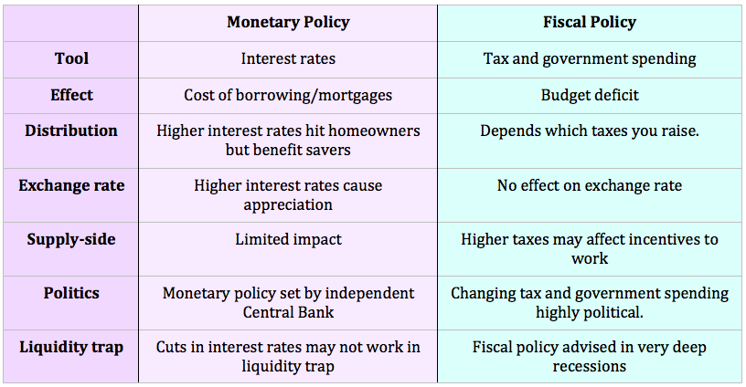

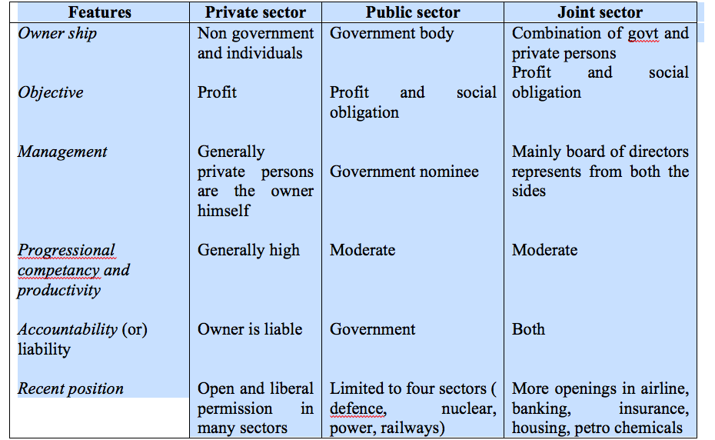

RBI: Role and functions
The Reserve Bank of India is the central bank of India, was established on April 1, 1935 during the British-Raj in accordance with the provisions of the Reserve Bank of India Act, 1934. The Reserve Bank of India was set up on the recommendations of the Hilton Young Commission. The commission submitted its report in the year 1926, though the bank was not set up for nine years. The Central Office of the Reserve Bank was initially established in Kolkata, Bengal, but was permanently moved to Mumbai in 1937. Though originally privately owned, the RBI has been fully owned by the Government of India since nationalization in 1949. The Preamble of the Reserve Bank of India describes the basic functions of the Reserve Bank as to regulate the issue of Bank Notes and keeping of reserves with a view to securing monetary stability in India and generally to operate the currency and credit system of the country to its advantage.
The Reserve Bank of India performs various traditional central banking functions as well as undertakes different promotional and developmental measures to meet the dynamic requirements of the Indian economy.
Role of RBI in Economic Development
- Development of banking system
- Development of financial institutions
- Development of backward areas
- Economic stability
- Economic growth
- Proper interest rate structure
Promotional Role of RBI
- Promotion of commercial banking
- Promotion of cooperative banking
- Promotion of industrial finance
- Promotion of export finance
- Promotion of credit to weaker sections
- Promotion of credit guarantees
- Promotion of differential rate of interest scheme
- Promotion of credit to priority sections including rural & agricultural sector
Functions of Reserve Bank of India
- Monetary Authority: It controls the supply of money in the economy to stabilize exchange rate, maintain healthy balance of payment, attain financial stability, control inflation, strengthen banking system
- The issuer of currency: The objective is to maintain the currency and credit system of the country to maintain the reserves. It has the sole authority in India to issue currency. It also takes action to control the circulation of fake currency.
- The issuer of Banking License: As per Sec 22 of Banking Regulation Act, every bank has to obtain a Banking license from RBI to conduct banking business in India.
- Banker’s to the Government: It acts as banker both to the central and the state governments. It provides short-term credit. It manages all new issues of government loans, servicing the government debt outstanding and nurturing the market for government’s securities. It advises the government on banking and financial subjects.
- Banker’s Bank: RBI is the bank of all banks in India as it provides the loan to banks/bankers, accept the deposit of banks, and rediscount the bills of banks.
- Lender of last resort: The banks can borrow from the RBI by keeping eligible securities as collateral at the time of need or crisis.
- Banker and debt manager of government: RBI keeps deposits of Governments free of interest, receives and makes payment, carry exchange remittances, and help to float new loans and manage public debt, act as an advisor to Government.
- Money supply and Controller of Credit: To control demand and supply of money in Economy by Open Market Operations, Credit Ceiling, etc. RBI has to meet the credit requirements of the rest of the banking system. It needs to maintain price stability and a high rate of economic growth.
- Act as clearinghouse: For settlement of banking transactions, RBI manages 14 clearing houses. It facilitates the exchange of instruments and processing of payment instructions.
- Manager of foreign exchange: It acts as a custodian of FOREX. It administers and enforces the provision of Foreign Exchange Management Act (FEMA), 1999. RBI buys and sells foreign currency to maintain the exchange rate of Indian rupee v/s foreign currencies.
- Regulator of Economy: It controls the money supply in the system, monitors different key indicators like GDP, Inflation, etc.
- Managing Government securities: RBI administers investments in institutions when they invest specified minimum proportions of their total assets/liabilities in government securities.
- Regulator and Supervisor of Payment and Settlement systems: The Payment and Settlement systems Act of 2007 (PSS Act) gives RBI oversight authority for the payment and settlement systems in the country. RBI focuses on the development and functioning of safe, secure and efficient payment and settlement mechanisms.
- Developmental Role: This role includes the development of the quality of banking system in India and ensuring that credit is available to the productive sectors of the economy. It provides a wide range of promotional functions to support national objectives. It also includes establishing institutions designed to build the country’s financial infrastructure. It also helps in expanding access to affordable financial services and promoting financial education and literacy
- Publisher of monetary data and other data: RBI maintains and provides all essential banking and other economic data, formulating and critically evaluating the economic policies in India. RBI collects, collates and publishes data regularly.
- Exchange manager and controller: RBI represents India as a member of the International Monetary Fund [IMF]. Most commercial banks are authorized dealers of RBI
- Banking Ombudsman Scheme: RBI introduced the Banking Ombudsman Scheme in 1995. Under this scheme, the complainants can file their complaints in any form, including online and can also appeal to the RBI against the awards and the other decisions of the Banking Ombudsman
- Banking Codes and Standards Board of India: To measure the performance of banks against Codes and standards based on established global practices, the RBI set up the Banking Codes and Standards Board of India (BCSBI).

Regulations Related to Capital Markets
Regulations are very important for the growth of capital markets all through the world. The development of a market economy is dependent on the growth of the capital market. The regulation of a capital market encompasses the regulation of securities. These rules enable the capital market to function more competently and fairly.
A well regulated market has the prospective to boost additional investors to participate, and contribute in, promoting the development of the economy.
Capital Market Regulatory Authorities Worldwide: The chief capital market regulatory authorities worldwide are as follows:
- Securities and Exchange Board of India
- U.S. Securities and Exchange Commission
- Canadian Securities Administrators, Canada
- Australian Securities and Investments Commission
- Securities and Exchange Commission, Pakistan
- Securities and Exchange Commission, Bangladesh
- Securities and Exchange Surveillance Commission
- Securities and Futures Commission, Hong Kong
- Financial Supervision Authority, Finland
- Financial Supervision Commission, Bulgaria
- Financial Services Authority, UK
- Commission Nacional del Mercado de Valores, Spain
- Authority of Financial Markets
It has been well established that there is a growing network of financial intermediaries that operate in a highly competitive environment while being directed by strict norms. India has one of the most refined new equity issuance markets. Disclosure requirements and the accounting policies followed by listed companies to offer financial information are comparable to the best systems in the world. In Indian scenario, the securities market is regulated by various agencies such as department of economic affairs, department of company affairs, and the reserve bank of India. The capital markets and protection of investor’s interest is now primarily the responsibility of the Securities and Exchange Board of India (SEBI), which is located in Bombay. The activities of these agencies are coordinated by high level committee on capital and financial market. The high level coordinated committee for financial market discusses various policy level issues which require inter regularity coordination between the regulators in financial market such as RBI, SEBI, insurance, regulatory and development authority (IRDA) and pension regulatory and development authority. The committee is chaired by Governor, RBI, secretary minister of finance, chairman SEBI, chairman IRDA, and chairman, PRDA are members of committee.
The capital market is market of equity and debt securities is regulated by Securities and Exchange Board of India (SEBI). Securities and Exchange Board of India (SEBI) has full autonomy and authority to regulate and develop capital market. The government has framed rules under securities controls act, the SEBI act and depositories act.
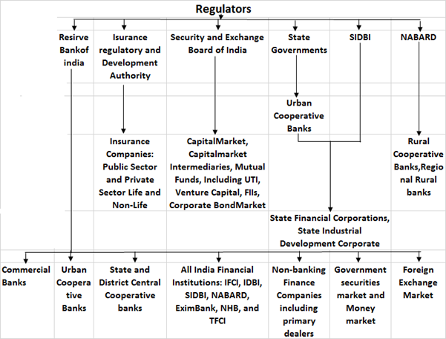

SEBI’s functions include:
- Regulating the business in stock exchange and any other securities markets.
- Registering and regulating the working of collective investment schemes, including mutual funds.
- Barring fraudulent and unfair trade practices relating to securities markets.
- Promoting investor’s education and training of intermediaries of securities markets.
- Prohibiting insider trading in securities, with the imposition of monetary penalties, on erring market intermediaries.
- Regulating substantial acquisition of shares and takeover of companies.
- Calling for information from, carrying out inspection, conducting inquiries and audits of the stock exchanges and intermediaries and self-regulatory organizations in the securities market.
To summarize, Capital market is controlled by financial supervisors and their own governance organization. Major grounds of regulation are to keep investors away from scam and deception. Financial regulatory organizations are also charged with decreasing the losing rate of financial, providing licenses to financial service providers, and executing applicable regulations.

Role of SEBI and working of stock Exchange
The Securities and Exchange Board of India (SEBI) is the regulator for the securities market in India. It was established in 1988 and given statutory powers on 30 January 1992 through the SEBI Act, 1992.
Initially SEBI was a non statutory body without any statutory power. However, in 1992, the SEBI was given additional statutory power by the Government of India through an amendment to the Securities and Exchange Board of India Act, 1992. In April 1988 the SEBI was constituted as the regulator of capital markets in India under a resolution of the Government of India.
Its main objective was to promote orderly and healthy growth of securities and to provide protection to the investors.

Role of SEBI
The main objective is to create such an environment which facilitates efficient mobilization and allocation of resources through the securities market. This environment consists of rules and regulations, policy framework, practices and infrastructures to meet the needs of three groups which mainly constitute the market i.e. issuers of securities (companies), the investors and the market intermediaries.
(i) To the Issuers
SEBI aims to provide a market place to the issuers where they can confidently look forward to raise the required amount of funds in an easy and efficient manner.
(ii) To the Investors
SEBI aims to protect the right and interest of the investors by providing adequate, accurate and authentic information on a regular basis.
(iii) To the Intermediaries
In order to enable the intermediaries to provide better service to the investors and the issuers, SEBI provides a competitive, professionalized and expanding market to them having adequate and efficient infrastructure.

Stock Exchanges
The secondary tier of the capital market is what we call the stock market or the stock exchange. The stock exchange is a virtual market where buyers and sellers trade in existing securities. It is a market hosted by an institute or any such government body where shares, stocks, debentures, bonds, futures, options etc are traded.
A stock exchange is a meeting place for buyers and sellers. These can be brokers, agents, individuals. The price of the commodity is decided by the rules of demand and supply. In India, the most prominent stock exchange is the Bombay Stock Exchange. There are a total of twenty-one stock exchanges in India.
How Does the Stock Market Work?
If the thought of investing in the stock market scares you, you are not alone. Individuals with very limited experience in stock investing are either terrified by horror stories of the average investor losing 50% of their portfolio value – for example, in the two bear markets that have already occurred in this millennium – or are beguiled by “hot tips” that bear the promise of huge rewards but seldom pay off. It is not surprising, then, that the pendulum of investment sentiment is said to swing between fear and greed.
The reality is that investing in the stock market carries risk, but when approached in a disciplined manner, it is one of the most efficient ways to build up one’s net worth. While the value of one’s home typically accounts for most of the net worth of the average individual, most of the affluent and very rich generally have the majority of their wealth invested in stocks. In order to understand the mechanics of the stock market, let’s begin by delving into the definition of a stock and its different types.
Functions of the Stock Exchange
Liquidity and Marketability: One of the main drawing factors of the stock exchange is that it enables high liquidity. The securities can be sold at a moments notice and be converted to cash. It is a continuous market and the investors can divest and reinvest with ease as per their wishes.
Price Determination: In a secondary market, the only way to determine the price of securities in via the rules of supply and demand. A stock exchange enables this process via constant valuation of all the securities. Such prices of shares of various companies can be tracked via the index we call the Sensex.
Safety: The government strictlt governs and regulates the stock exchanges. In case of the BSE, the Securities Board of India is the governing body. All the transactions occur within the legal framework. This provides the investor with assurances and a safe place to transact in securities.
Contribution to the Economy: As we know the stock exchange deals in already issued securities. But these securities are continuously sold and resold and so on. This allows the funds to be mobilized and channelised instead of sitting idle. This boosts the economy.
Spreading of Equity: The stock exchange ensures wider ownership of securities. It actually educates the public about the safety and the benefits of investing in the stock market. It ensures a better quality of transactions and smooth functioning. The idea is to get more public investors and spread the ownership of securities for the benefit of everyone.
Speculation: One often hears that the stock exchange is a speculative market. And while this is true, the speculation is kept within the legal framework. For the stake of liquidity and price determination, a healthy dose of speculative trading is necessary, and the stock exchange provides us with such a platform.

