UNIT- 3 (Designing Software Solution)
Software design is a process to transform user requirements into some suitable form, which helps the programmer in software coding and implementation.
For assessing user requirements, an SRS (Software Requirement Specification) document is created whereas for coding and implementation, there is a need of more specific and detailed requirements in software terms. The output of this process can directly be used into implementation in programming languages.
Software design is the first step in SDLC (Software Design Life Cycle), which moves the concentration from problem domain to solution domain. It tries to specify how to fulfill the requirements mentioned in SRS.
Software Design Levels
Software design yields three levels of results:
- Architectural Design - The architectural design is the highest abstract version of the system. It identifies the software as a system with many components interacting with each other. At this level, the designers get the idea of proposed solution domain.
- High-level Design - The high-level design breaks the ‘single entity- multiple component’ concept of architectural design into less-abstracted view of sub-systems and modules and depicts their interaction with each other. High-level design focuses on how the system along with all of its components can be implemented in forms of modules. It recognizes modular structure of each sub-system and their relation and interaction among each other.
- Detailed Design- Detailed design deals with the implementation part of what is seen as a system and its sub-systems in the previous two designs. It is more detailed towards modules and their implementations. It defines logical structure of each module and their interfaces to communicate with other modules.

Objectives of Software Design
Following are the purposes of Software design:
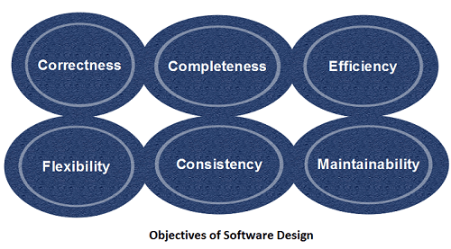

- Correctness:Software design should be correct as per requirement.
- Completeness:The design should have all components like data structures, modules, and external interfaces, etc.
- Efficiency:Resources should be used efficiently by the program.
- Flexibility:Able to modify on changing needs.
- Consistency:There should not be any inconsistency in the design.
- Maintainability: The design should be so simple so that it can be easily maintainable by other designers

Software Design Principles
Software design principles are concerned with providing means to handle the complexity of the design process effectively. Effectively managing the complexity will not only reduce the effort needed for design but can also reduce the scope of introducing errors during design. Or Guidelines for good design

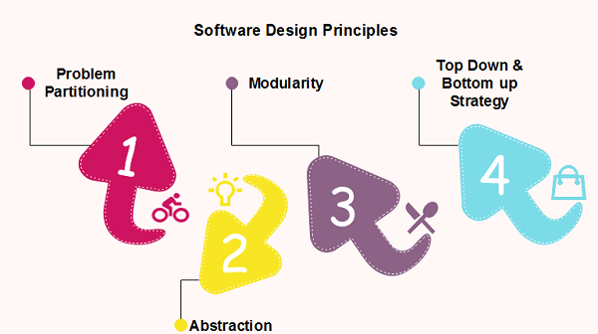

Problem Partitioning
For small problem, we can handle the entire problem at once but for the significant problem, divide the problems and conquer the problem it means to divide the problem into smaller pieces so that each piece can be captured separately.
For software design, the goal is to divide the problem into manageable pieces.

Abstraction
An abstraction is a tool that enables a designer to consider a component at an abstract level without bothering about the internal details of the implementation. Abstraction can be used for existing element as well as the component being designed.
Here, there are two common abstraction mechanisms
- Functional Abstraction
- Data Abstraction

Functional Abstraction
- A module is specified by the method it performs.
- The details of the algorithm to accomplish the functions are not visible to the user of the function.
Functional abstraction forms the basis for Function oriented design approaches.

Data Abstraction
Details of the data elements are not visible to the users of data. Data Abstraction forms the basis for Object Oriented design approaches

Modularization
Modularization is a technique to divide a software system into multiple discrete and independent modules, which are expected to be capable of carrying out task(s) independently. These modules may work as basic constructs for the entire software. Designers tend to design modules such that they can be executed and/or compiled separately and independently.
Modular design unintentionally follows the rule of ‘divide and conquer’ problem- solving strategy, this is because there are many other benefits attached with the modular design of a software.
Advantage of modularization:
- Smaller components are easier to maintain
- Program can be divided based on functional aspects
- Desired level of abstraction can be brought in the program
- Components with high cohesion can be re-used again
- Concurrent execution can be made possible
- Desired from security aspect
Concurrency
Back in time, all software are meant to be executed sequentially. By sequential execution, we mean that the coded instruction will be executed one after another implying only one portion of program being activated at any given time. Say, a software has multiple modules, then only one of all the modules can be found active at any time of execution.
In software design, concurrency is implemented by splitting the software into multiple independent units of execution, like modules and executing them in parallel. In other words, concurrency provides capability to the software to execute more than one part of code in parallel to each other.
It is necessary for the programmers and designers to recognize those modules, which can be made parallel execution.

Example
The spell check feature in word processor is a module of software, which runs along side the word processor itself.

Coupling and Cohesion
When a software program is modularized, its tasks are divided into several modules based on some characteristics. As we know, modules are set of instructions put together in order to achieve some tasks. They are though, considered as a single entity but, may refer to each other to work together. There are measures by which the quality of a design of modules and their interaction among them can be measured. These measures are called coupling and cohesion.
Cohesion
Cohesion is a measure that defines the degree of intra-dependability within elements of a module. The greater the cohesion, the better is the program design.
There are seven types of cohesion, namely –
- Co-incidental cohesion - It is unplanned and random cohesion, which might be the result of breaking the program into smaller modules for the sake of modularization. Because it is unplanned, it may serve confusion to the programmers and is generally not-accepted.
- Logical cohesion - When logically categorized elements are put together into a module, it is called logical cohesion.
- Emporal Cohesion - When elements of module are organized such that they are processed at a similar point of time, it is called temporal cohesion.
- Procedural cohesion - When elements of module are grouped together, which are executed sequentially in order to perform a task, it is called procedural cohesion.
- Communicational cohesion - When elements of module are grouped together, which are executed sequentially and work on same data (information), it is called communicational cohesion.
- Sequential cohesion - When elements of module are grouped because the output of one element serves as input to another and so on, it is called sequential cohesion.
- Functional cohesion - It is considered to be the highest degree of cohesion, and it is highly expected. Elements of module in functional cohesion are grouped because they all contribute to a single well-defined function. It can also be reused.

Coupling
Coupling is a measure that defines the level of inter-dependability among modules of a program. It tells at what level the modules interfere and interact with each other. The lower the coupling, the better the program.
There are five levels of coupling, namely -
- Content coupling - When a module can directly access or modify or refer to the content of another module, it is called content level coupling.
- Common coupling- When multiple modules have read and write access to some global data, it is called common or global coupling.
- Control coupling- Two modules are called control-coupled if one of them decides the function of the other module or changes its flow of execution.
- Stamp coupling- When multiple modules share common data structure and work on different part of it, it is called stamp coupling.
- Data coupling- Data coupling is when two modules interact with each other by means of passing data (as parameter). If a module passes data structure as parameter, then the receiving module should use all its components.
Ideally, no coupling is considered to be the best.
Design Verification
The output of software design process is design documentation, pseudo codes, detailed logic diagrams, process diagrams, and detailed description of all functional or non-functional requirements.
The next phase, which is the implementation of software, depends on all outputs mentioned above.
It is then becomes necessary to verify the output before proceeding to the next phase. The early any mistake is detected, the better it is or it might not be detected until testing of the product. If the outputs of design phase are in formal notation form, then their associated tools for verification should be used otherwise a thorough design review can be used for verification and validation.
By structured verification approach, reviewers can detect defects that might be caused by overlooking some conditions. A good design review is important for good software design, accuracy, and quality

Software analysis and design includes all activities, which help the transformation of requirement specification into implementation. Requirement specifications specify all functional and non-functional expectations from the software. These requirement specifications come in the shape of human readable and understandable documents, to which a computer has nothing to do.
Software analysis and design is the intermediate stage, which helps human- readable requirements to be transformed into actual code.
Let us see few analysis and design tools used by software designers:
Data Flow Diagram
Data Flow Diagram (DFD) is a graphical representation of flow of data in an information system. It is capable of depicting incoming data flow, outgoing data flow, and stored data. The DFD does not mention anything about how data flows through the system.
There is a prominent difference between DFD and Flowchart. The flowchart depicts flow of control in program modules. DFDs depict flow of data in the system at various levels. It does not contain any control or branch elements.

Types of DFD
Data Flow Diagrams are either Logical or Physical.
- Logical DFD - This type of DFD concentrates on the system process, and flow of data in the system. For example in a banking software system, how data is moved between different entities.
- Physical DFD - This type of DFD shows how the data flow is actually implemented in the system. It is more specific and close to the implementation.

DFD Components
DFD can represent source, destination, storage, and flow of data using the following set of components -

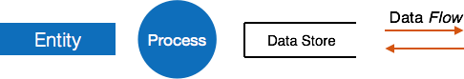

- Entities - Entities are sources and destinations of information data. Entities are represented by rectangles with their respective names.
- Process - Activities and action taken on the data are represented by Circle or Round-edged rectangles.
- Data Storage - There are two variants of data storage - it can either be represented as a rectangle with absence of both smaller sides or as an open-sided rectangle with only one side missing.
- Data Flow - Movement of data is shown by pointed arrows. Data movement is shown from the base of arrow as its source towards head of the arrow as destination.

Levels of DFD
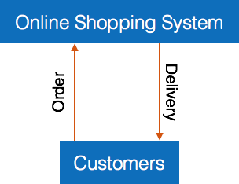
- Level 0 - Highest abstraction level DFD is known as Level 0 DFD, which depicts the entire information system as one diagram concealing all the underlying details. Level 0 DFDs are also known as context level DFDs.

- Level 1 - The Level 0 DFD is broken down into more specific, Level 1 DFD. Level 1 DFD depicts basic modules in the system and flow of data among various modules. Level 1 DFD also mentions basic processes and sources of information.

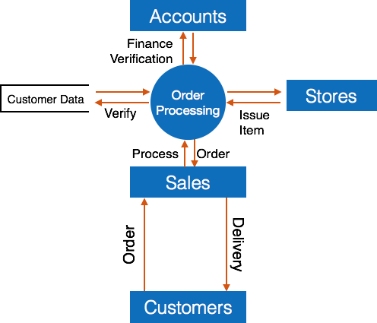

- Level 2 - At this level, DFD shows how data flows inside the modules mentioned in Level 1.
Higher level DFDs can be transformed into more specific lower level DFDs with deeper level of understanding unless the desired level of specification is achieved.
Structure Charts
Structure chart is a chart derived from Data Flow Diagram. It represents the system in more detail than DFD. It breaks down the entire system into lowest functional modules, describes functions and sub-functions of each module of the system to a greater detail than DFD.
Structure chart represents hierarchical structure of modules. At each layer a specific task is performed.
Here are the symbols used in construction of structure charts -
- Module - It represents process or subroutine or task. A control module branches to more than one sub-module. Library Modules are re-usable and invokable from any module.

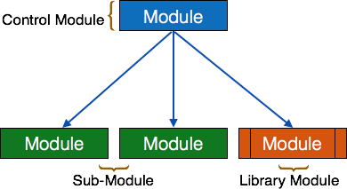

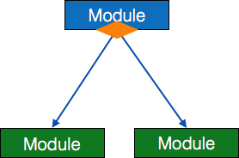
- Condition - It is represented by small diamond at base of the module. It depicts that control module can select any of sub-routine based on some condition.

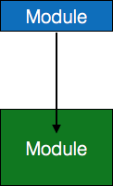
- Jump - An arrow is shown pointing inside the module to depict that the control will jump in the middle of the sub-module.

- Loop - A curved arrow represents loop in the module. All sub-modules covered by loop repeat execution of module.

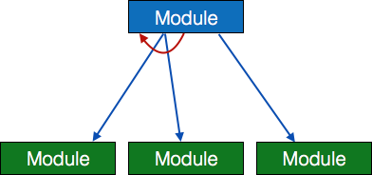

- Data flow - A directed arrow with empty circle at the end represents data flow.
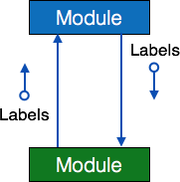

- Control flow - A directed arrow with filled circle at the end represents control flow.
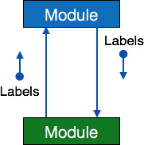

Structured English
Most programmers are unaware of the large picture of software so they only rely on what their managers tell them to do. It is the responsibility of higher software management to provide accurate information to the programmers to develop accurate yet fast code.
Different methods, which use graphs or diagrams, at times might be interpreted in a different way by different people.
Hence, analysts and designers of the software come up with tools such as Structured English. It is nothing but the description of what is required to code and how to code it. Structured English helps the programmer to write error-free code. Here, both Structured English and Pseudo-Code tries to mitigate that understanding gap.
Structured English uses plain English words in structured programming paradigm. It is not the ultimate code but a kind of description what is required to code and how to code it. The following are some tokens of structured programming:
IF-THEN-ELSE,
DO-WHILE-UNTIL
Analyst uses the same variable and data name, which are stored in Data Dictionary, making it much simpler to write and understand the code.

Example
We take the same example of Customer Authentication in the online shopping environment. This procedure to authenticate customer can be written in Structured English as:
Enter Customer_Name
SEEK Customer_Name in Customer_Name_DB file IF Customer_Name found THEN
Call procedure USER_PASSWORD_AUTHENTICATE() ELSE
PRINT error message
Call procedure NEW_CUSTOMER_REQUEST() ENDIF

The code written in Structured English is more like day-to-day spoken English. It can not be implemented directly as a code of software. Structured English is independent of programming language

Example
Program to print Fibonacci up to n numbers.
void function Fibonacci Get value of n;
Set value of a to 1; Set value of b to 1; Initialize I to 0 for (i=0; i< n; i++)
{
if a greater than b
{
Increase b by a; Print b;
}
else if b greater than a
{
increase a by b; print a;
}
}
Decision Tables

A Decision table represents conditions and the respective actions to be taken to address them, in a structured tabular format.
It is a powerful tool to debug and prevent errors. It helps group similar information into a single table and then by combining tables it delivers easy and convenient decision-making.

Creating Decision Table
To create the decision table, the developer must follow basic four steps:
- Identify all possible conditions to be addressed
- Determine actions for all identified conditions
- Create Maximum possible rules

- Define action for each rule
Decision Tables should be verified by end-users and can lately be simplified by eliminating duplicate rules and actions.

Example
Let us take a simple example of day-to-day problem with our Internet connectivity. We begin by identifying all problems that can arise while starting the internet and their respective possible solutions.
We list all possible problems under column conditions and the prospective actions under column Actions.

 | Conditions/Actions | Rules
Conditions | Shows Connected | N | N | N | N | Y | Y | Y | Y
 | Ping is Working | N | N | Y | Y | N | N | Y | Y
 | Opens Website | Y | N | Y | N | Y | N | Y | N
Actions | Check network cable | X
 | Check internet router | X |  |  |  | X | X | X
 | Restart Web Browser |  |  |  |  |  |  | X
 | Contact Service provider |  | X | X | X | X | X | X
 | Do no action
Table : Decision Table – In-house Internet Troubleshooting
Entity-Relationship Model
Entity-Relationship model is a type of database model based on the notion of real world entities and relationship among them. We can map real world scenario onto ER database model. ER Model creates a set of entities with their attributes, a set of constraints and relation among them.

ER Model is best used for the conceptual design of database. ER Model can be represented as follows :
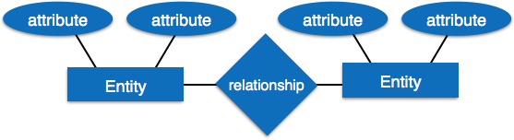

- Entity - An entity in ER Model is a real world being, which has some properties called attributes. Every attribute is defined by its corresponding set of values, called domain.
For example, Consider a school database. Here, a student is an entity. Student has various attributes like name, id, age and class etc.
- Relationship - The logical association among entities is called relationship. Relationships are mapped with entities in various ways. Mapping cardinalities define the number of associations between two entities.
Mapping cardinalities:
- one to one
- one to many
- many to one
- many to many
Data Dictionary
Data dictionary is the centralized collection of information about data. It stores meaning and origin of data, its relationship with other data, data format for usage, etc. Data dictionary has rigorous definitions of all names in order to facilitate user and software designers.
Data dictionary is often referenced as meta-data (data about data) repository. It is created along with DFD (Data Flow Diagram) model of software program and is expected to be updated whenever DFD is changed or updated.

Requirement of Data Dictionary
The data is referenced via data dictionary while designing and implementing software. Data dictionary removes any chances of ambiguity. It helps keeping

work of programmers and designers synchronized while using same object reference everywhere in the program.
Data dictionary provides a way of documentation for the complete database system in one place. Validation of DFD is carried out using data dictionary.

Contents
Data dictionary should contain information about the following:
- Data Flow
- Data Structure
- Data Elements
- Data Stores
- Data Processing
Data Flow is described by means of DFDs as studied earlier and represented in algebraic form as described.

= | Composed of
{} | Repetition
() | Optional
+ | And
[ / ] | Or

Example
Address = House No + (Street / Area) + City + State
Course ID = Course Number + Course Name + Course Level + Course Grades

Data Elements
Data elements consist of Name and descriptions of Data and Control Items, Internal or External data stores etc. with the following details:
- Primary Name
- Secondary Name (Alias)
- Use-case (How and where to use)

- Content Description (Notation etc. )
- Supplementary Information (preset values, constraints etc.)

Data Store
It stores the information from where the data enters into the system and exists out of the system. The Data Store may include -

Files
  - Internal to software.
  - External to software but on the same machine.
  - External to software and system, located on different machine.

Tables
  - Naming convention
  - Indexing property

Data Processing
There are two types of Data Processing:
- Logical: As user sees it
- Physical: As software sees it

Software Design Strategies

Software design is a process to conceptualize the software requirements into software implementation. Software design takes the user requirements as challenges and tries to find optimum solution. While the software is being conceptualized, a plan is chalked out to find the best possible design for implementing the intended solution.
There are multiple variants of software design. Let us study them briefly:
Structured Design
Structured design is a conceptualization of problem into several well-organized elements of solution. It is basically concerned with the solution design. Benefit of structured design is, it gives better understanding of how the problem is being solved. Structured design also makes it simpler for designer to concentrate on the problem more accurately.
Structured design is mostly based on ‘divide and conquer’ strategy where a problem is broken into several small problems and each small problem is individually solved until the whole problem is solved.
The small pieces of problem are solved by means of solution modules. Structured design emphasis that these modules be well organized in order to achieve precise solution.
These modules are arranged in hierarchy. They communicate with each other. A good structured design always follows some rules for communication among multiple modules, namely -
- Cohesion - grouping of all functionally related elements.
- Coupling - communication between different modules.
A good structured design has high cohesion and low coupling arrangements.

Function Oriented Design
In function-oriented design, the system comprises of many smaller sub-systems known as functions. These functions are capable of performing significant task in the system. The system is considered as top view of all functions.
Function oriented design inherits some properties of structured design where divide and conquer methodology is used.
This design mechanism divides the whole system into smaller functions, which provides means of abstraction by concealing the information and their operation. These functional modules can share information among themselves by means of information passing and using information available globally.
Another characteristic of functions is that when a program calls a function, the function changes the state of the program, which sometimes is not acceptable by other modules. Function oriented design works well where the system state does not matter and program/functions work on input rather than on a state.

Design Process
- The whole system is seen as how data flows in the system by means of data flow diagram.
- DFD depicts how functions change data and state of the entire system.
- The entire system is logically broken down into smaller units known as functions on the basis of their operation in the system.
- Each function is then described at large.
Object Oriented Design
Object Oriented Design (OOD) works around the entities and their characteristics instead of functions involved in the software system. This design strategies focuses on entities and its characteristics. The whole concept of software solution revolves around the engaged entities.
Let us see the important concepts of Object Oriented Design:
- Objects - All entities involved in the solution design are known as objects. For example, person, banks, company, and customers are treated as objects. Every entity has some attributes associated to it and has some methods to perform on the attributes.

- Classes - A class is a generalized description of an object. An object is an instance of a class. Class defines all the attributes, which an object can have and methods, which defines the functionality of the object.
In the solution design, attributes are stored as variables and functionalities are defined by means of methods or procedures.
- Encapsulation - In OOD, the attributes (data variables) and methods (operation on the data) are bundled together is called encapsulation. Encapsulation not only bundles important information of an object together, but also restricts access of the data and methods from the outside world. This is called information hiding.
- Inheritance - OOD allows similar classes to stack up in hierarchical manner where the lower or sub-classes can import, implement and re-use allowed variables and methods from their immediate super classes. This property of OOD is known as inheritance. This makes it easier to define specific class and to create generalized classes from specific ones.
- Polymorphism - OOD languages provide a mechanism where methods performing similar tasks but vary in arguments, can be assigned same name. This is called polymorphism, which allows a single interface performing tasks for different types. Depending upon how the function is invoked, respective portion of the code gets executed.

Design Process
Software design process can be perceived as series of well-defined steps. Though it varies according to design approach (function oriented or object oriented, yet It may have the following steps involved:
- A solution design is created from requirement or previous used system and/or system sequence diagram.
- Objects are identified and grouped into classes on behalf of similarity in attribute characteristics.
- Class hierarchy and relation among them is defined.
- Application framework is defined.

Software Design Approaches
Here are two generic approaches for software designing:

Top Down Design
We know that a system is composed of more than one sub-systems and it contains a number of components. Further, these sub-systems and components may have their own set of sub-systems and components, and creates hierarchical structure in the system.
Top-down design takes the whole software system as one entity and then decomposes it to achieve more than one sub-system or component based on some characteristics. Each sub-system or component is then treated as a system and decomposed further. This process keeps on running until the lowest level of system in the top-down hierarchy is achieved.
Top-down design starts with a generalized model of system and keeps on defining the more specific part of it. When all the components are composed the whole system comes into existence.
Top-down design is more suitable when the software solution needs to be designed from scratch and specific details are unknown.

Bottom-up Design
The bottom up design model starts with most specific and basic components. It proceeds with composing higher level of components by using basic or lower level components. It keeps creating higher level components until the desired system is not evolved as one single component. With each higher level, the amount of abstraction is increased.
Bottom-up strategy is more suitable when a system needs to be created from some existing system, where the basic primitives can be used in the newer system.
Both, top-down and bottom-up approaches are not practical individually. Instead, a good combination of both is used.

