UNIT-5

Industrial Buying Behaviour: Participants
The Purchasing department is influential in straight re-buy and modified re-buy situations. Engineering personnel usually have a major influence in selecting product components and purchasing managers dominate in selecting suppliers.
Thus in new buy situations, the industrial marketer must first direct his product information to the engineering personnel. In re-buy situations and at supplier-selection time, communication must be directed at the purchasing department personnel.
A buying centre is comprised of all those individuals and groups who participate in the buying decision-making process, who share some common goals and the risks arising from these decisions. Before identifying the individuals and groups involved in the buying decision process, a marketer must understand the roles of buying centre members. Understanding the buying centre roles helps industrial marketers to develop an effective promotion strategy.
Within any organisation, the buying centre will vary in the number and type of participants for different classes of products.
But on an average a buying center of an organisation has the following seven members or a group of members who play these roles:

1. Initiators:
Usually the need for a product/item and in turn a supplier arises from the users. But there can be occasions when the top management, maintenance or the engineering department or any such recognise or feel the need. These people who “initiate” or start the buying process are called initiators.

2. Users:
Under this category come users of various products. If they are technically sound like the R&D, engineering who can also communicate well. They play a vital role in the buying process. They also act as initiators.

3. Buyers:
They are people who have formal authority to select the supplier and arrange the purchase terms. They play a very important role in selecting vendors and negotiating and sometimes help to shape the product specifications.
The major roles or responsibilities of buyers are obtaining proposals or quotes, evaluating them and selecting the supplier, negotiating the terms and conditions, issuing of purchase orders, follow up and keeping track of deliveries. Many of these processes are automated now with the use of computers to save time and money.

4. Influencers:
Technical personnel, experts and consultants and qualified engineers play the role of influencers by drawing specifications of products. They are, simply put, people in the organisation who influence the buying decision. It can also be the top management when the cost involved is high and benefits long term. Influencers provide information for strategically evaluating alternatives.

5. Deciders:
Among the members, the marketing person must be aware of the deciders in the organisation and try to reach them and maintain contacts with them. The organisational formal structure might be deceptive and the decision might not even be taken in the purchasing department.
Generally, for routine purchases, the purchase executive may be the decider. But for high value and technically complex products, senior executives are the deciders. People who decide on product requirements/specifications and the suppliers are deciders.

6. Approvers:
People who authorise the proposed actions of deciders or buyers are approvers. They could also be personnel from top management or finance department or the users.

7. Gate Keepers:
A gatekeeper is like a filter of information. He is the one the marketer has to pass through before he reaches the decision makers.
Understanding the role of the gatekeeper is critical in the development of industrial marketing strategies and the salesperson’s approach. They allow only that information favourable to their opinion to flow to the decision makers.
By being closest to the action, purchasing managers or those persons involved in a buying centre may act as gatekeepers. They are the people whom our industrial marketer would first get in touch with. Hence, it so happens that information is usually routed through them.
They have the power to prevent the sellers or information from reaching members of the buying centre. They could be at any level and even be the receptionists and telephone operators.
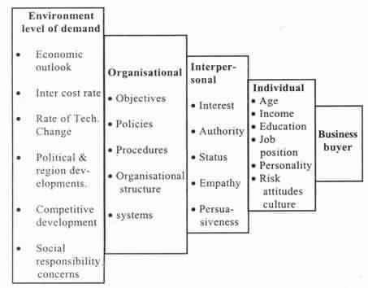
When a buying centre includes many participants, the industrial/ business marketer will not have the time or resources to reach all of them. Small sellers could concentrate on reaching the key buying influences. Large sellers on the other hand go for multi-level in-depth selling to reach as many buying participants as possible.
It is important to note, that functional responsibilities and job titles are often not true indicators of the relative influence of buying center members in a purchase decision task.

Characteristics of Industrial Markets

Industrial marketing truly is all about is to highlight the most distinctive features of it.

It’s extremely complex
A great analogy for industrial marketing follows; consumer marketing is a candy shop selling candy to a single customer. Industrial marketing is a candy manufacturer selling thousands of pieces of candy to a candy store. Obviously, the latter is much more appealing, but this obviously means that it is a little more complicated.
Industrial marketing requires large orders, long-term relationships which makes the first pitch and sale often more complex. This revolves around the simple fact that businesses are made up of several individuals, which means you have to impress multiple people, with numerous different bits of information.

Longer sales cycle
A result of industrial marketing being more complicated is a longer sales cycle. When you pitch to a business, the whole process revolves around calculated decisions, reviewing, analyzing.
This shouldn’t be seen as a negative, the outcome of industrial marketing, as you probably imagined, is worth any complexity or lengthy process.

The variety of marketing
Industrial marketing can mean that you have a wide range of products. Every single product requires a different marketing strategy, sometimes the difference can be extreme.
To put this into perspective, it is much different to sell, say, a standard motor to a known business, compared to selling capital equipment to various companies.
The strategies that you may use for the motors won’t be successful in selling large custom machines. Ultimately, the variety of marketing can be boundless.

Low market information
Consumer products have a lot of database information available for them, including customer demographics. In comparison, information revolving around industrial market niches are hard to come by. It actually requires a considerable amount of industrial experience to gather useful market information.
That being said, it isn’t impossible; to gather the information you will need to analyze the niche in-depth. Information like the number of employees, line speeds, shifts, sizes, and so on, will all be acquired and you will be able to discover prospective buyers.

Advertising generally doesn’t follow trends
When it comes to industrial marketing, advertising and promotion are a bit different. You see, in the grand scheme of things, it is comparatively simple to develop newspaper adverts, billboards, and videos for impulsive consumers.
“With industrial marketing, because of the lengthy sales cycle, advertisements can’t be focused on trends. Instead, they have to address the product’s benefits and applications directly.” — Jennifer Watts, CMO at The Word Point.

The buyers and their behaviors
As mentioned earlier, industrial marketing is aimed at a team of people, rather than an individual. Thus, the behaviors are varied, follows a specific process and, ultimately, you need to impress multiple people, all of which may have different opinions.
Communication with your potential buyers is crucial; email, phone, and one-to-one conversations help to secure a business relationship. The good news? This relationship will be long-term, rather than a one-time buy relationship. Just like any successful relationship, communication is vital…many manufacturers choose to send samples too.

Bidding is customary
An individual consumer will buy, or they won’t. Bidding isn’t a daily scenario in for the average consumer. On the other hand, industrial marketing rarely doesn’t revolve around quotes and bids.
Quotations and specifications can sometimes be hundreds of pages long, specifying the product and the prices right down to the itty-bitty details. This will ultimately help secure a deal.

The geographical and demographical distribution
The average consumer market research generally doesn’t work for industrial markets, purely because the samples are just too small. Industrial market research almost has to be simultaneously niche and broad.
The most important part of industrial market research is to acquire information on market shares and market sizes. These can be found using qualitative techniques, unstructured interviewing techniques, and field research.

Conclusion
Suffice to say, industrial marketing is hard work but has high rewards. Once you secure a client/customer, it’s a long-term, secure relationship. There’s a tiny bit of a knowledge gap when it comes to industrial marketing, which makes the process more challenging, but completely worth it.
The fact is, manufacturers of industrial products need to find new customers in order to grow. The best way to develop this growth is to use industrial marketing techniques.

Factors influencing industrial markets

The potential Indian population is a target that industrial marketers cannot overlook. Their population expansion provides a range of opportunities and threats.
Opportunities in terms of cheap labour for the industries and threats in terms of poverty, illiteracy which is to be given attention in addition to brain drain and stigma of “developing nation” to India.
The Industrial marketers must cash in on potential opportunities for example; the IT industry has been competitive due to a large number of techno savvy people. They are sent to offshore assignments thus satisfying their hunger for foreign jaunts and avoiding brain drain.
No individual firm should be caught unrepresented by the changing demographic conditions. Trends develop slowly and are easy to monitor and reliable data are available for short and intermediate range planning.

1. Economic Factors:
The economic conditions of the market determine how much an industry can buy and sell. Thus, emerging changes in the economic environment which shall affect industrial marketing both in India and internationally must be closely monitored.
As noted earlier, the industrial demand is a delivered demand and depends on the consumers’ purchasing power, income, taxes, fashion etc. When the country was passing through a recession in the late 1990s the consumers had tightened their belts and had limited their purchases.
The consumer durable industry, for example, television, fridge, microwave oven, washing machine etc. was badly hit which in turn had hit the component suppliers of these goods. Hence the demand for raw materials, components parts and associated services also tightened.

2. Natural Factors:
India is a country of extremes. When one part of the country is having heavy rainfall some other parts endures drought. The drought like situation in Northern India has affected many a industry. The earth quakes and floods in the northern states of India like Orissa and Gujarat have had direct impact on the industries. The industrial marketers must have an alternate strategy or a contingency plan during calamities that are forecast-able or those that could be predicted.

3. Technological Factors:
Technological developments and changes affect the profitability and market acceptance of a company. The electric car “Reva” by Maini group of companies is a technological innovation. It is yet to catch up in India due to reasons like there are no stations on either highways or in the city for recharging and it is a very small car. But Mr. Chetan Maini, the man behind the electric car is leaving no stones unturned.
They have already ventured into some North Indian cities and have exported to Europe. This technology is successful and would revolutionise the automobile industry. This industry is also being revolutionised by some car makers who are still working on a prototype which has buttons to change gears and increase acceleration instead of clutch and gear box. No industry today whatever is printing and packaging industry or an. It firm can ignore technological changes. As a marketer, he must be aware of the changes and make flexible strategies to adapt to these changes.

4. Social /Cultural Factors:
Cultural customs, habits, norms and traditions greatly influence the structure and function of an organisation as well as interpersonal relationships of organisational members. In India it is “Durability” that is important whereas in USA it is “style” that is appealing. Say product whether industrial or targeted to the consumer must be careful when appealing to customers with respect to the cultural values and representations.

5. Political/Legal Factors:
Government influence on the Industrial marketing environment. From the time of Jawaharlal Nehru to the time of Mr. Atal Behari Vajapayee there has been major influence of the Government in the industry to protect the Indian industries’ foreign investment or for that matter, foreign participation of any kind has not been allowed in the areas of defence, steel, drugs, fertilisers, machine tools etc.
More encouragement was given to small scale and cottage industry. Even the banks were nationalised, the multinationals which were present in India till about 1980s were engaged in commerce, trade and finance or export of tea. Indian Government felt that in areas where adequate Indian skills and capital are available, there was no need for foreign collaboration.
In fact, in 1977 Coca-Cola was asked to wind up operations in India, and IBM was to dilute equity to stay. Some companies like Alkali Chemicals, Dunlop, Goodyear and Asbestos Cement were allowed to remain as they were operating in non-priority areas. Today the Government having realised the importance has liberalised in many areas.
Still controls the industries do not contribute to an extent the effective and fair functioning of the economy. The Government acts as a regulatory agency in import and export matters. It controls the tax and interest rates. It provides economic stabilisation through control of inflation. It is environmentally and socially conscious. It passes rules, regulations and laws from time to time to ensure that general public interest is not compromised.
The Government has placed a large number of drugs with dubious justification under the scanner. Doubts persist about safety of a host of drugs including CISAPRIDE, the drug for night heart burn, and PPA, an ingredient in certain paediatric preparations. The review of iron preparations containing zinc, amino acids and vitamins decision could be of grave concern to many leading MNCs as these drugs are high margin products.
The Government can also change the marketing environment by making changes to its procedures for example Mr. Chandra Babu Naidu, Ex-Chief Minister of Andhra Pradesh, has decided to experiment with online procurement in four of its government departments.
Department | E-purchase
Andhra Pradesh Technology Services (APTS) | All IT related procurement for the State Government
Andhra Pradesh State Road Transport Corporations | Spares, Oil, Lubricants, bus body building services and office products
Commissionerate of Tenders | All tenders of value more than Rs 1 crore, projects relating to irrigation, roads and building
Andhra Pradesh Housing Infrastructure | Drugs, All civil and medicare related products and services
The impact of this decision is that the industries supplying to the Government are hoping to supply must gear up for IT invasion and must be able to bid and make tenders through a computer. The marketing strategies will have to be adjusted to accommodate these changes.
Since Government transcends all levels of the industrial environment, it is capable of influencing and being influenced by environmental elements at all levels. Thus industrial marketers must keep careful watch pending regulations to ensure that their respective business plans will meet the government’s approval. Industrial marketers must be constantly in touch with the laws, regulations and sanctions of the Government.

Consumer and Organization Buying Behavior

Consumer Buying Behavior
Consumer buying behavior is the result of the attitudes, preferences, intentions and decisions made by the consumer s in a market place before buying a product. The study of consumer buying behavior is an interdisciplinary subject area drawing widely from sociology, psychology, anthropology etc.

Standard Buying Process
The buying behaviour can be broken down into a series of tasks.
- Problem recognition:
During this stage, the consumer becomes aware of an unfulfilled need or want. For example, his old laptop may be broken and a need arises for a new laptop.
- Information search:
in this stage, the consumer gathers information relevant to solving his problem. Example, collection of information about various laptop models.
- Evaluation:
The various alternatives are evaluated against the consumer’s wants needs, preferences, financial resources etc.
- Purchase:
In this stage, the consumer will commit to a particular choice and make the final decision. The choice maybe influenced by price and availability.
- Post purchase evaluation:
In this stage, the consumer evaluates whether the purchase actually satisfied her need or not.
Types of Buying Behaviour
- Complex: High degree of consumer involvement with significant brand differences. Eg: – Cars.
- Dissonance Reducing: High degree of involvement with little brand differences. Eg: – Carpeting
- Habitual: Low involvement with little brand difference. Eg:- Salt
- Variety seeking: Low involvement with significant perceived brand difference. Eg:-Chocolates

Organizational Buying Behavior
Organization buying behavior is defined as the rational decision-making process in which organization buys goods and services when they have need of any goods or service for their organization. The purchased products and services get identified, evaluated, and chosen among alternative brands and suppliers. Organizational buying is similar to the consumer buyer behavior without any major differences. Organizations buy the products and services for the betterment of organizational objectives such as manufacture and deliver goods and services to members, customers or the community. Three types of buying situation have been distinguished: the straight rebuy, the modified rebuy, and the new task.
The straight rebuy:
It is the buying condition in which the buyers buy the product frequently. Buying of those products will be a routine task for the organization.
The modified rebuy:
A business buying condition in which the buyer wants to change the product specification, its price as well as terms or suppliers.
The new task:
When the organization buys any products or services for the first time then it is called new task. In this cases, the larger the cost, there will be more decision participants and also there will be more efforts for collecting information. The new task situation creates more opportunity as well as challenges.

Participants in the business buying process:
The buying center who actually participates in buying the products and services, their roles will play a significant role while making a decision to purchase any products for the organization.
- Users:
The members who uses the products or services. In various cases, users start off with buying proposal and also help in defining the product specification.
- Influencer
The people who affect the buying decision in an organization are called influencers. They help to define specifications and they also provide information for evaluating alternatives.
- Buyers
In organizational buying center, the person who actually purchases the goods and services are called buyers.
- Decider
The people who have formal or informal power in order to select or approve the final supplier in organizational buying center are called decider.
- Gatekeepers
The person who controls the flow of information to others in organizational buying is called gatekeepers.

Major influence on Organization Buyers
Business buyers are subject to many influences when they make their buying decisions. Some marketers assume that the major influences are economic. However, business buyers actually respond to both economic and personal factors.
- Environmental Factors:
Business buyers are mostly influenced by the current economy and future economy of the state or the world while making any decision. Economic environment consists level of primary demand, the economic outlook and the cost of money. They are also affected by technological, political and competitive developments in the environment.
- Organizational factors:
The major organizational factors like objectives, policies, procedures, structure and system must be understood well.
- Interpersonal factors:
There are many participants who influence each other so interpersonal skills also matter in the business buying process. However, it will be difficult to implement such interpersonal factors and group dynamics.
- Individual factors
The people who participate in business buying decision process bring in personal motives, perceptions, and preferences. These individual factors are affected by individual characteristics such as age, income, education, professional identification, personality and attitudes towards risk.

The Organization buying process:
There are total eight stages and by going through these stages an organization will be able to make a rational decision. If the desired result is not achieved then the steps will be repeated again until they meet their goals and objectives.
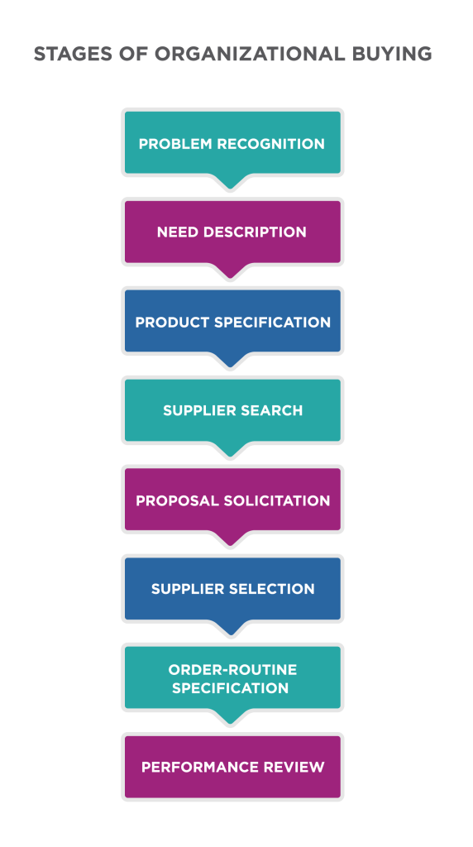
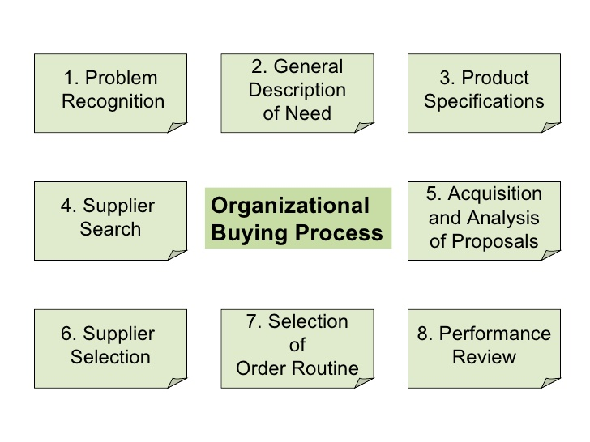
- Problem Recognition:
The first stage of the business buying process in which people identify the need of the organization which will be met by purchasing any goods or services. Problem recognition can result from internal or external stimuli. Internally , the company may take a decision to launch a new product that requires new production equipment and materials. Or, a machine may break down and need another new part. Externally, the buyer gets some new ideas at a trade show, see an ad, or receive a call from a seller who offers best products at low price.
- General Need Description:
After the need is recognized, the buyers prepare a general need description which reports both characteristics and quantity needed and item for the organization. For standard items, this process presents very few problems but for complex problems the buyer needs to work with the other engineers, users, consultants in order to define the item.
- Product Specification:
In this stage, the buying organization decides and specifies the technical product features for the needed item. Product value analysis is the approach that helps to reduce the cost in which the components are studied. After studying it carefully they can be redesigned, standardized or made by fewer cost methods of production. The team will decide best product features and specifies them accordingly.
- Supplier Search:
In this stage, the buyer conducts supplier search to find the best sellers. The buyer can assemble a list of qualified suppliers by analyzing trade directories, doing computer searches or contacting other companies for recommendation letters.
- Proposal Solicitation:
The stage of the business buying in which the buyer ask qualified suppliers to submit proposals is called proposal solicitation. After this supplier will send only a catalogue or a salesperson. However, when the item is complex or expensive, the buyer ask for the detailed written proposals or formal presentations for each potential supplier.
- Supplier Selection:
In this stage, the buyer reviews proposals and choose a supplier or suppliers. During supplier selection, the buying center often will prepare up a list of the desired supplier trait and their relative importance. Such trait includes product and service quality, reputation, on-time delivery, ethical corporate behavior, honest communication and competitive prices.
- Order- Routine Specification:
This is the stage of buying process in which the buyer choose the final supplier by listing various things like technical specifications, quantity needed, expected time of delivery, return policies, and warranties.
- Performance Review:
The stage of buying process in which the buyer analyze the supplier’s performance on the basis of different criteria and decides to continue, modify or drop the arrangement. The seller’s job is to observe and examine the same factors used by the buyer to make sure that the seller is giving the expected satisfaction.

Definition, Characteristics and Classification of Services

A service is an act or performance offered by one party to another. Although the process may be tied to a physical product, the performance is essentially intangible and does not normally result in ownership of any of the factors of production.
Services are economic activities that create value and provide benefits for customer’s specific times and places, as a result of bringing about a desired change in – or on behalf of – the recipient of the service. Service is those separately identifiable, essentially intangible activities which provide want-satisfaction, and that are not necessarily tied to the sale of a product or another service. To produce a service may or may not require the use of tangible goods. However when such use is required, there is no transfer of title (permanent ownership) to these tangible goods.
One common method of defining a service is to distinguish between the ‘core’ and ‘peripheral’ elements of that service. The ‘core’ service offering is the ‘necessary outputs of an organisation which are intended to provide the intangible benefits customers are looking for’. Peripheral services are those which are either ‘indispensable for the execution of the core service or available only to improve the overall quality of the service bundle.
Services include all economic activities whose output is not a physical product or construction, is generally consumed at the time it is produced, and provides added value in forms (such as convenience, amusement, timeliness, comfort or health) that are essentially intangible concerns of its first purchaser.
Examples of services are-
Transportation & public utilities, Hotels and other lodging places, Rail-road transportation, Personal services, Local and inter-urban passenger transit, Business services, Trucking and warehousing, Auto repair, services and garages, Water transportation, Miscellaneous repair services, Air transportation, Motion pictures, Pipelines except natural gas, Amusement and recreation services, Health service, Communication, Legal services, Telephone and telegraph, Educational services, Radio and television broadcasting, Social services and membership organizations, Electricity, Gas, Sanitary services, Miscellaneous professional services, Wholesale trade, Private household services, Retail trade, Finance, insurance, and real estate, Banking, Military, Credit agencies other than banks, Government enterprises Security & commodity brokers, Local government, Real estate, Education, Holding and other investment companies and Other services.

7 Important Characteristics of Services
(i) Perish-Ability
Service is highly perishable and time element has great significance in service marketing. Service if not used in time is lost forever. Service cannot stored.
(ii) Fluctuating Demand
Service demand has high degree of fluctuations. The changes in demand can be seasonal or by weeks, days or even hours. Most of the services have peak demand in peak hours, normal demand and low demand on off-period time.
(iii) Intangibility
Unlike product, service cannot be touched or sensed, tested or felt before they are availed. A service is an abstract phenomenon.
(iv) Inseparability
Personal service cannot be separated from the individual and some personalised services are created and consumed simultaneously.
For example hair cut is not possible without the presence of an individual. A doctor can only treat when his patient is present.
(v) Heterogeneity
The features of service by a provider cannot be uniform or standardised. A Doctor can charge much higher fee to a rich client and take much low from a poor patient.
(vi) Pricing of Services
Pricing decision about services are influenced by perish-ability, fluctuation in demand and inseparability. Quality of a service cannot be carefully standardised. Pricing of services is dependent on demand and competition where variable pricing may be used.
(vii) Service quality is not statistically measurable
It is defined in form of reliability, responsiveness, empathy and assurance all of which are in control of employee’s direction interacting with customers. For service, customer’s satisfaction and delight are very important. Employees directly interacting with customers are to be very special and important. People include internal marketing, external marketing and interactive marketing.

Classifications of Services
In order to be able to make a clear and relevant classification of services, we would first need to understand the concept of the word itself. Services usually refer to processes and not physical products. To understand more, read this article on difference between goods and services. Some services may include people whereas other services (like online services) may including objects which are managed by people.
Examples of services which include people can be a hair salon, education, theater, restaurants, and public transportation. On the other hand services that include objects include repairs and maintenance, dry cleaning, banking, legal services, insurance, etc.
- Classification of service based on Tangible Action
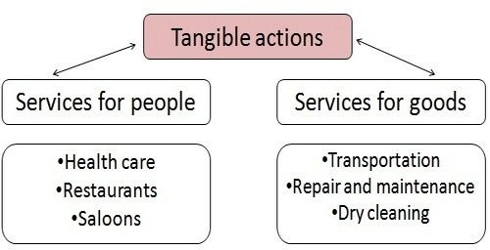
Wherever people or products are involved directly, the service classification can be done based on tangibility.
(i) Services for people: Like Health care, restaurants and saloons, where the service is delivered by people to people.
(ii) Services for goods: Like transportation, repair and maintenance and others. Where services are given by people for objects or goods.
- Classification of services based on Intangibility
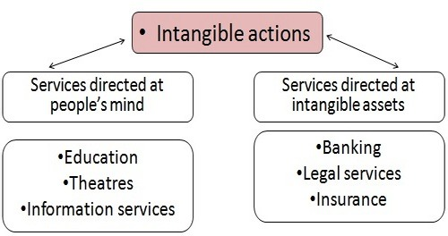
There are objects in this world which cannot be tangibly quantified. For example – the number of algorithms it takes to execute your banking order correctly, or the value of your life which is forecasted by insurance agents. These services are classified on the basis of intangibility.
(i) Services directed at people’s mind: Services sold through influencing the creativity of humans are classified on the basis of intangibility.
(ii) Services directed at intangible assets: Banking, legal services, and insurance services are some of the services most difficult to price and quantify.
The most intangible form of service output is represented by information processing. The customer’s involvement in this type is service is not required. Generally, customers have a personal desire to meet face to face but there is no actual need in terms of the operational process. Consultancy services can be an example of this type of services where the relationship can be built or sustained on trust or telephone contact. However, it is more indicated to have a face-to-face relationship in order to fully understand the needs of the customer.
A more general classification of services based on the type of function that is provided through them can be as follows:
- Business services.
- Communication services.
- Construction and related engineering services.
- Distribution services.
- Educational services.
- Environmental services.
- Financial services.
- Health-related and social services.
- Tourism and travel-related services.
- Recreational, cultural, and sporting services.
- Transport services.
- Other services not included elsewhere.

