UNIT:I

Meaning of Research
THESTREAK19 FEB 2019 3 COMMENTS
Research is a scientific and systematic search for various information about a specific topic. It is just like a search for truth and knowledge. The English Dictionary meaning of Research is “a careful investigation or inquiry especially through search for new facts in any branch of knowledge.” information about a subject can be collected by deliberate effort and it is presented in a new form after analyzing thoroughly in research work.
Research is an academic activity. It is a movement from the known to the unknown, which may be called a discovery. Different definitions of research are given by the experts.
According to Redman and Mory, “Research is a systematized effort to gain new knowledge.”
- Slesinger and M Stephenson define research as, “the manipulation of things, concepts or symbols for the purpose of generalizing to extend correct or verify knowledge whether that knowledge aids in construction of theory or in the practice of an art ”
According to P.M. Cook, “Research is an honest, exhaustive, intelligent searching for facts and their meanings or implications with reference to a given problem.”
J.M. Francis Rumel defines, “Research is an endeavour to discover, develop and verify knowledge.”
Clifford Woody, defines “Research is a careful enquiry or examination in seeking facts or principles a diligent investigation to ascertain something.”

Objectives
The main purpose of research is to discover answers to the meaningful questions through scientific procedures and systematic attempt. The hidden truths which are not discovered yet can easily come to light by research.
The main objectives of Research are
- To gain familiarity or to achieve new insights into a phenomenon. This is known as Exploratory or Formularize Research studies.
- To describe the accurate characteristics of a particular individual, situation or a group. This is known as Descriptive Research studies.
- To determine the frequency with which something occurs or with which it is associated with other things. This is known as Diagnostic Research studies.
- To test a hypothesis of a casual relationship between variables. Such studies are known as Hypothesis-testing Research studies.

Characteristics of Research
- Research is directed towards the solution of a problem.
- Research gathers new knowledge or data from primary sources.
- Research is based upon observable experience or experimental evidence.
- Research is logical and objective, applying every possible test to verify the data collected and the procedures employed.
- Research is expert, systematic and accurate investigation.
- Research demands accurate observation and description.
- Research requires patience and courage. The researcher should courageously face the unpleasant consequences of his finding if any.
- Research is highly purposive. It deals with a significant problem which must be solved.
- Research is carefully recorded and reported. Everything must be carefully defined and described in detail.
- Research activity is characterized by carefully designed procedures which are to be analyzed thoroughly.

Research Methods
All those methods which are used by the researcher during the course of studying his research problems are called as Research Methods. Methods of research may be classified from different points of view.
These are:
- The fields to which applied-Education, Philosophy, Psychology.
- Purpose-Description, Prediction. Determination of status and causes.
- Place where it is to be conducted-in the field or in the laboratory.
- Application-Pure research or applied research
- Data gathering devices employed-Testing, rating scales, questionnaires etc.
- Character of the data collected-Objective, Subjective, Quantitative, and Qualitative.
- Forms of thinking-Deductive and Inductive.
- Control of factors-Controlled and Uncontrolled.

Objectives of Research
The research problems often get mixed up or compared to the research objectives in general business reports. This is because both the research problems and the general objectives are outlined in the basic report overview and introduction. However, there is a large difference in the two terms and both play important roles in the business research reports. The problem outlines what is wrong or not working well, since the research needs to take place. For example, the problem could be that one of the company’s products has dropped in sales. The research objective is a list of things that the report will discuss that could be potential research routes or goals. To use the same example above, research objectives could be to collect research from direct customers, get product feedback and develop new products that are in demand as replacements.
Reasons for Objectives
Research objectives for a business serve as a method of keeping the project on track. During the research, employees may find alternative routes or answers that appear to be more interesting than the goals or objectives outlined in the report. Although these new discoveries should not be ignored, they should be compared to the original objectives and see how they impact the original goals. If company executives are interested in the new findings, another research project may be launched with new objectives. Thus, the objectives are outlined and used to keep the research and project in question on the right track and direction.
Before conducting a market research, your research objectives needs to be defined. Research objectives quite simply answer a simple question – Why are you conducting this market research? Off course, that question does not have a simple answer. The answer can go down in depth and become 10 more questions.
The reason a marketer needs to pay attention to research objectives, is because these objectives define the scope of the study. If the objective is too large, then you spend a lot of time on collecting information which is ultimately not useful to you. If on the other hand, if the research objective is narrow, then you do not get adequate information in one go. Thus, the challenge is to set the right research objective.
Aims and Objectives of Research Methodology
- To gain familiarity with a phenomenon or to achieve new insights into it (studies with this object in view are termed as exploratory or formulative research studies);
- To portray accurately the characteristics of a particular individual, situation or a group(studies with this object in view are known as descriptive research studies);
- To determine the frequency with which something occurs or with which it is associated with something else (studies with this object in view are known as diagnostic research studies);
- To test a hypothesis of a causal relationship between variables (such studies are known as hypothesis-testing research studies).

Research Objectives
1) Exploratory research objectives:
4The purpose of such a type of market research is to explore the market. Thus, the research objectives are defined accordingly. If the research objective was to find out competition sales, then the market research questionnaire needs to ask questions as follows – How many brands are present in the market? What are the number of products of each brand? How many dealers are present for each product? What is the average sales per dealer for each product? Where is the sales more – in urban or rural? What is the quantity purchased per month and sold per month? So on and so forth. Thus, this kind of exploratory research objective prepares you for a quantitative market research process.
2) Descriptive research objectives:
Descriptive research objectives help you to find out WHY an action is being taken. Thus, this is more of a qualitative research objective. Continuing the above example, why are the dealers promoting that particular product in the locality? Why are the customers purchasing or prefering that product? What are the features of the product which attract the customers? How is the cost of the product controlled? Thus, these are more descriptive questions. Asking the question of why a customer buys a product, warrants a long answer because there are many reasons a customer might prefer a product, and each customer’s preference will be for a separate reason. Thus, designing the market research questionnaire when the research objective is descriptive, becomes a difficult job. The marketer needs to be as specific as possible so that he gets the correct answers. At the same time, the right questions need to be asked otherwise there would be a lot of clutter in the market research report.
3) Causal research objectives:
A market research which wants to observe cause and effect, is known to have a causal research objective. So, if you now know the different reasons that customers are buying a product, and you decide to launch a new product of your own, then it will become a causal market research. If you introduce a new product, what will be the effect in the market? Will the market accept the product? Or will it reject the same? If the product can be rejected, then what can be the causes? Thus, the causal research will find all causes for the success or failure of a plan. Hence a causal research objective incorporates various elements of cause and effect in the marketing questionnaire.

Business Research, Types Of Research and Process of Research

BUSINESS RESEARCH
Business research is a field of practical study in which a company obtains data and analyzes it in order to better manage the company. Business research can include financial data, consumer feedback, product research and competitive analysis. Executives and managers who use business research methods are able to better understand their company and the position it holds in the market.
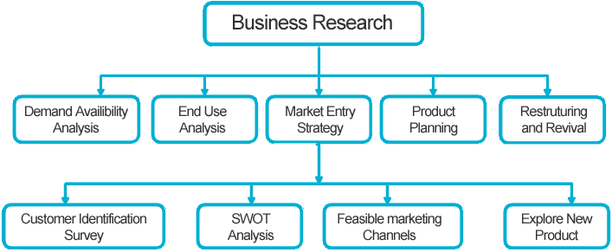
Fig. Business Research
HOW TO IMPROVE THE POSITION OF ANY COMPANY?
- Financial Data
Financial data takes qualitative information–such as sales reports, revenues and cost reports–to see what areas make money and what costs money. By reviewing data, managers can find the products, staff and departments that are most efficient and determine areas of unnecessary costs.
- Consumer Feedback
Understanding what the public says about the products and services a company provides is essential to making sure the company is meeting consumer needs. Customer feedback includes case studies, focus groups, customer surveys and questionnaires.
- Product Research
Product research seeks to improve the product to meet the needs of consumers. This may include technological advancements, improved customer service or access to the product through a variety of distribution channels.
- Competitive Analysis
Competitive analysis is when one company compares its products and services to those of another company. This can be done to improve the product, create a niche or determine a more attractive price point to lure customers.
- Industry Data
Using research tools such as the information compiled by Dun & Bradstreet can help a company to understand how the industry as a whole is doing. This can help executives make decisions based on economic factors affecting their industry that are not limited to their own products.

RESEARCH:-
Systematic investigative process employed to increase or revise current knowledge by discovering new facts.

Types of research:-

(1)Applied Research
Applied research “aims at finding a solution for an immediate problem facing a society, or an industrial/business organization. Applied research is considered to be non-systematic inquiry and it is usually launched by a company, agency or an individual in order to address a specific problem.
ex:-Improve agricultural crop production, treat or cure specific disease.
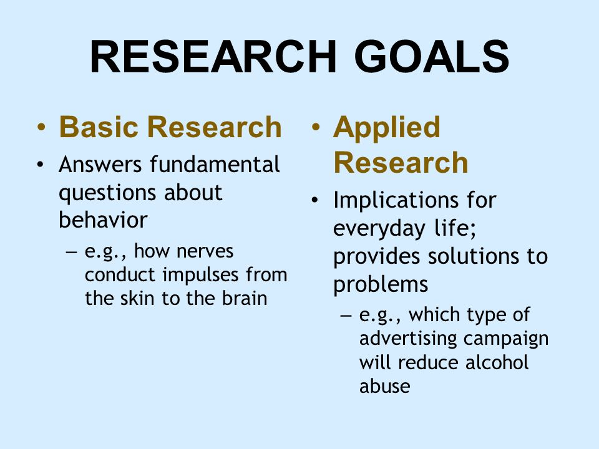
Fg. Basic and Applied research

(2) Basic Research
Basic research, also called pure research or fundamental research, is scientific research aimed to improve scientific theories for improved understanding or prediction of natural or other phenomena.Applied research, in turn, uses scientific theories to develop technology or techniques to intervene and alter natural or other phenomena. Though often driven by curiosity, basic research fuels applied science’s innovations. The two aims are often coordinated in research and development.
Ex:- how did the universe begin?
What are protons , neutron , etc.

(3) Correlational Research
In general, a co-relational study is a quantitative method of research in which you have 2 or more quantitative variables from the same group of participants, & you are trying to determine if there is a relationship (or co-variation) between the 2 variables (that is, a similarity in pattern of scores between the two variables, not a difference between their means). Theoretically, any 2 quantitative variables from the same group of participants can be correlated.
For example:- midterm scores & final exam scores, or midterm scores and number of body piercings!) as long as you have numerical scores on these variables from the same participants; however, it is usually a waste of time to collect & analyze data when there is little reason to think these two variables would be related to each other.
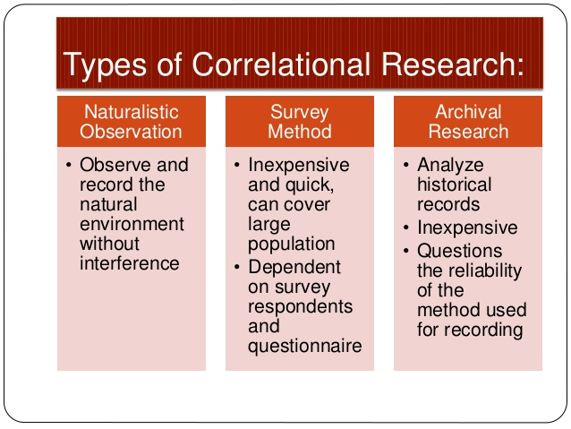
Fig. Correlational Research

(4) Experimental Research
This is an experiment where the re-searcher manipulates one variable, and control/randomizes the rest of the variables. It has a control group, the subjects have been randomly assigned between the groups, and the researcher only tests one effect at a time. It is also important to know what variable(s) you want to test and measure.

Aims of Experimental Research:-
Experiments are conducted to be able to predict phenomenon. Typically, an experiment is constructed to be able to explain some kind of causation. Experimental research is important to society – it helps us to improve our everyday lives.
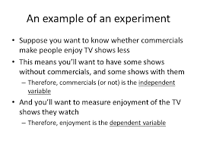 Fig. Experimental Research

(5) Exploratory Research
Exploratory research is research conducted for a problem that has not been studied more clearly, intended to establish priorities, develop operational definitions and improve the final research design.[1] Exploratory research helps determine the best research design, data-collection method and selection of subjects. It should draw definitive conclusions only with extreme caution. Given its fundamental nature, exploratory research often concludes that a perceived problem does not actually exist.
Exploratory research often relies on techniques such as:-
- Secondary research – such as reviewing available literature and/or data
- Informal qualitative approaches, such as discussions with consumers, employees, management or competitors
- Formal qualitative research through in-depth interviews, focus groups, projective methods, case studies or pilot studies.

Aims of Research
The general aims of research are:-
- Observe and Describe
- Predict
- Determination of the Causes
- Explain
Purpose of Research – Why do we conduct research? Why is it necessary?

(6) Ground Theory Research
Grounded theory (GT) is a systematic methodology in the social sciences involving the construction of theory through methodic gathering and analysis of data. Grounded theory is a research methodology which operates inductively, in contrast to the hypothetico-deductive approach. A study using grounded theory is likely to begin with a question, or even just with the collection of qualitative data. As researchers review the data collected, repeated ideas, concepts or elements become apparent, and are tagged with codes, which have been extracted from the data. As more data is collected, and re-reviewed, codes can be grouped into concepts, and then into categories. These categories may become the basis for new theory. Thus, grounded theory is quite different from the traditional model of research, where the researcher chooses an existing theoretical framework, and only then collects data to show how the theory does or does not apply to the phenomenon under study.
Stages of analysis:-
- Codes – Identifying anchors that allow the key points of the data to be gathered
- Concepts – Collections of codes of similar content that allows the data to be grouped
- Categories – Broad groups of similar concepts that are used to generate a theory
- Theory – A collection of categories that detail the subject of the research.

ALL RESEARCH CAN BE CLASSIFIED INTO TWO GROUPS:-

Qualitative Research

Quantitative Research

Qualitative Research:
Qualitative research is a method of inquiry employed in many different academic disciplines, including in the social sciences and natural sciences[citation needed], but also in non-academic contexts including market research, business, and service demonstrations by non-profits.
Qualitative research is a broad methodological approach that encompasses many research methods. The aim of qualitative research may vary with the disciplinary background, such as a psychologist seeking to gather an in-depth understanding of human behavior and the reasons that govern such behavior. Qualitative methods examine the why and how of decision making, not just what, where, when, or “who”, and have a strong basis in the field of sociology to understand government and social programs. Qualitative research is popular among political science, social work, and special education and education researchers.

Methods of Qualitative Research:-
Qualitative researchers use their own eyes, ears, and intelligence to collect in-depth perceptions and descriptions of targeted populations, places, and events. Their findings are collected through a variety of methods, and often, a researcher will use at least two or several of the following while conducting a qualitative study.

Direct observation
With direct observation, a researcher studies people as they go about their daily lives without participating or interfering. This type of research is often unknown to those under study, and as such, must be conducted in public settings where people do not have a reasonable expectation of privacy. For example, a researcher might observe the ways in which strangers interact in public as they gather to watch a street performer.

Open-ended surveys
While many surveys are designed to generate quantitative data, many are also designed with open-ended questions that allow for the generation and analysis of qualitative data. For example, a survey might be used to investigate not just which political candidates voters chose, but why they chose them, in their own words.

Focus group
In a focus group, a researcher engages a small group of participants in a conversation designed to generate data relevant to the research question. Focus groups can contain anywhere from 5 to 15 participants. Social scientists often use them in studies that examine an event or trend that occurs within a specific community. They are common within market research too.

In-depth interviews
Researchers conduct in-depth interviews by speaking with participants in a one-on-one setting. Sometimes a researcher approaches the interview with a predetermined list of questions or topics for discussion but allows the conversation to evolve based on how the participant responds. Other times, the researcher has identified certain topics of interest but does not have a formal guide for the conversation, but allows the participant to guide it.
- Oral history
The oral history method is used to create a historical account of an event, group, or community, and typically involves a series of in-depth interviews conducted with one or multiple participants over an extended period of time.
Participant observation: This method is similar to observation, however with this one, the researcher also participates in the action or events in order to not only observe others but to gain first-hand experience in the setting.
- Ethnographic observation
Ethnographic observation is the most intensive and in-depth observational method. Originating in anthropology, with this method, a researcher fully immerses herself into the research setting and lives among the participants as one of them for anywhere from months to years.

Quantitative Research:
In natural sciences and social sciences, quantitative research is the systematic empirical investigation of observable phenomena via statistical, mathematical or computational techniques.[1] The objective of quantitative research is to develop and employ mathematical models, theories and hypotheses pertaining to phenomena. The process of measurement is central to quantitative research because it provides the fundamental connection between empirical observation and mathematical expression of quantitative relationships. Quantitative data is any data that is in numerical form such as statistics, percentages, etc.
Quantitative research is generally made using scientific methods, which can include:-
- The generation of models, theories and hypotheses.
- The development of instruments and methods for measurement.
- Experimental control and manipulation of variables.
- Collection of empirical data.
- Modeling and analysis of data.

PROCESS OF RESEARCH:-
Research involves a systematic process that focuses on being objective and gathering a multitude of information for analysis so that the researcher can come to a conclusion. This process is used in all research and evaluation projects, regardless of the research method (scientific method of inquiry, evaluation research, or action research). The process focuses on testing hunches or ideas in a park and recreation setting through a systematic process. In this process, the study is documented in such a way that another individual can conduct the same study again. This is referred to as replicating the study. Any research done without documenting the study so that others can review the process and results is not an investigation using the scientific research process. The scientific research process is a multiple-step process where the steps are interlinked with the other steps in the process.

Step 1: Identify the Problem
The first step in the process is to identify a problem or develop a research question. The research problem may be something the agency identifies as a problem, some knowledge or information that is needed by the agency, or the desire to identify a recreation trend nationally. In the example in table 2.4, the problem that the agency has identified is childhood obesity, which is a local problem and concern within the community. This serves as the focus of the study.

Step 2: Review the Literature
Now that the problem has been identified, the researcher must learn more about the topic under investigation. To do this, the researcher must review the literature related to the research problem. This step provides foundational knowledge about the problem area. The review of literature also educates the researcher about what studies have been conducted in the past, how these studies were conducted, and the conclusions in the problem area. In the obesity study, the review of literature enables the programmer to discover horrifying statistics related to the long-term effects of childhood obesity in terms of health issues, death rates, and projected medical costs. In addition, the programmer finds several articles and information from the Centers for Disease Control and Prevention that describe the benefits of walking 10,000 steps a day. The information discovered during this step helps the programmer fully understand the magnitude of the problem, recognize the future consequences of obesity, and identify a strategy to combat obesity (i.e., walking).

Step 3: Clarify the Problem
Many times the initial problem identified in the first step of the process is too large or broad in scope. In step 3 of the process, the researcher clarifies the problem and narrows the scope of the study. This can only be done after the literature has been reviewed. The knowledge gained through the review of literature guides the researcher in clarifying and narrowing the research project. In the example, the programmer has identified childhood obesity as the problem and the purpose of the study. This topic is very broad and could be studied based on genetics, family environment, diet, exercise, self-confidence, leisure activities, or health issues. All of these areas cannot be investigated in a single study; therefore, the problem and purpose of the study must be more clearly defined. The programmer has decided that the purpose of the study is to determine if walking 10,000 steps a day for three days a week will improve the individual’s health. This purpose is more narrowly focused and researchable than the original problem.

Step 4: Clearly Define Terms and Concepts
Terms and concepts are words or phrases used in the purpose statement of the study or the description of the study. These items need to be specifically defined as they apply to the study. Terms or concepts often have different definitions depending on who is reading the study. To minimize confusion about what the terms and phrases mean, the researcher must specifically define them for the study. In the obesity study, the concept of “individual’s health” can be defined in hundreds of ways, such as physical, mental, emotional, or spiritual health. For this study, the individual’s health is defined as physical health. The concept of physical health may also be defined and measured in many ways. In this case, the programmer decides to more narrowly define “individual health” to refer to the areas of weight, percentage of body fat, and cholesterol. By defining the terms or concepts more narrowly, the scope of the study is more manageable for the programmer, making it easier to collect the necessary data for the study. This also makes the concepts more understandable to the reader.

Step 5: Define the Population
Research projects can focus on a specific group of people, facilities, park development, employee evaluations, programs, financial status, marketing efforts, or the integration of technology into the operations. For example, if a researcher wants to examine a specific group of people in the community, the study could examine a specific age group, males or females, people living in a specific geographic area, or a specific ethnic group. Literally thousands of options are available to the researcher to specifically identify the group to study. The research problem and the purpose of the study assist the researcher in identifying the group to involve in the study. In research terms, the group to involve in the study is always called the population. Defining the population assists the researcher in several ways. First, it narrows the scope of the study from a very large population to one that is manageable. Second, the population identifies the group that the researcher’s efforts will be focused on within the study. This helps ensure that the researcher stays on the right path during the study. Finally, by defining the population, the researcher identifies the group that the results will apply to at the conclusion of the study. In the example in table 2.4, the programmer has identified the population of the study as children ages 10 to 12 years. This narrower population makes the study more manageable in terms of time and resources.

Step 6: Develop the Instrumentation Plan
The plan for the study is referred to as the instrumentation plan. The instrumentation plan serves as the road map for the entire study, specifying who will participate in the study; how, when, and where data will be collected; and the content of the program. This plan is composed of numerous decisions and considerations that are addressed in chapter 8 of this text. In the obesity study, the researcher has decided to have the children participate in a walking program for six months. The group of participants is called the sample, which is a smaller group selected from the population specified for the study. The study cannot possibly include every 10- to 12-year-old child in the community, so a smaller group is used to represent the population. The researcher develops the plan for the walking program, indicating what data will be collected, when and how the data will be collected, who will collect the data, and how the data will be analyzed. The instrumentation plan specifies all the steps that must be completed for the study. This ensures that the programmer has carefully thought through all these decisions and that she provides a step-by-step plan to be followed in the study.

Step 7: Collect Data
Once the instrumentation plan is completed, the actual study begins with the collection of data. The collection of data is a critical step in providing the information needed to answer the research question. Every study includes the collection of some type of data—whether it is from the literature or from subjects—to answer the research question. Data can be collected in the form of words on a survey, with a questionnaire, through observations, or from the literature. In the obesity study, the programmers will be collecting data on the defined variables: weight, percentage of body fat, cholesterol levels, and the number of days the person walked a total of 10,000 steps during the class.
The researcher collects these data at the first session and at the last session of the program. These two sets of data are necessary to determine the effect of the walking program on weight, body fat, and cholesterol level. Once the data are collected on the variables, the researcher is ready to move to the final step of the process, which is the data analysis.

Step 8: Analyze the Data
All the time, effort, and resources dedicated to steps 1 through 7 of the research process culminate in this final step. The researcher finally has data to analyze so that the research question can be answered. In the instrumentation plan, the researcher specified how the data will be analyzed. The researcher now analyzes the data according to the plan. The results of this analysis are then reviewed and summarized in a manner directly related to the research questions. In the obesity study, the researcher compares the measurements of weight, percentage of body fat, and cholesterol that were taken at the first meeting of the subjects to the measurements of the same variables at the final program session. These two sets of data will be analyzed to determine if there was a difference between the first measurement and the second measurement for each individual in the program. Then, the data will be analyzed to determine if the differences are statistically significant. If the differences are statistically significant, the study validates the theory that was the focus of the study. The results of the study also provide valuable information about one strategy to combat childhood obesity in the community.

Research Process: An Overview, Problem Identification and Definition
Research Process involves identifying, locating, assessing, and analyzing the information you need to support your research question, and then developing and expressing your ideas. These are the same skills you need any time you write a report, proposal, or put together a presentation.
Library research involves the step-by-step process used to gather information in order to write your paper, create a presentation, or complete a project. As you progress from one step to the next, it is often necessary to rethink, revise, add additional material or even adjust your topic. Much will depend on what you discover during your research.
The research process can be broken down into seven steps, making it more manageable and easier to understand. This module will give you an idea of what’s involved at each step in order to give you a better overall picture of where you are in your research, where you will be going, and what to expect at each step.
Steps involved in Research Process in Research Methodology
At times, the first step determines the nature of the last step to be undertaken.If subsequent procedures have not been taken into account in the early stages, serious difficulties may arise which may even prevent the completion of the study. One should remember that the various steps involved in a research process are not mutually exclusive; nor they are separate and distinct.
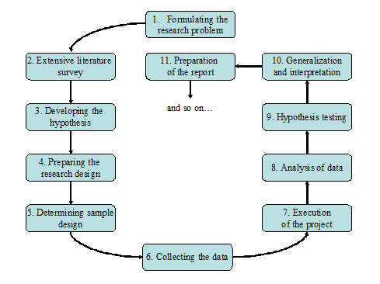
They do not necessarily follow each other in any specific order and the researcher has to be constantly anticipating at each step in the research process the requirements of the subsequent steps. However, the following order concerning various steps provides a useful procedural guideline regarding the research process:
- Formulating the research problem.
- Extensive literature survey.
- Developing the hypothesis.
- Preparing the research design.
- Determining sample design.
- Collecting the data.
- Execution of the project.
- Analysis of data.
- Hypothesis testing.
- Generalizations and interpretation, and
- Preparation of the report or presentation of the results, i.e., formal write-up of conclusions reached.
- Formulating the research problem: There are two types of research problems, vi., those which relate to states of nature and those which relate to relationships between variables. At thievery outset the researcher must single out the problem he wants to study, i.e., he must decide the general area of interest or aspect of a subject-matter that he would like to inquire into. Initially the problem may be stated in a broad general way and then the ambiguities, if any, relating to the problem be resolved. Then, the feasibility of a particular solution has to be considered before a working formulation of the problem can be set up. The formulation of a general topic into a specific research problem, thus, constitutes the first step in a scientific enquiry. Essentially two steps are involved in formulating the research problem, vi., understanding the problem thoroughly, and rephrasing the same into meaningful terms from an analytical point of view.
- Extensive literature survey: Once the problem is formulated, a brief summary of it should be written down. It is compulsory for a research worker writing a thesis for a Ph.D. degree to write synopsis of the topic and submit it to the necessary Committee or the Research Board for approval.At this juncture the researcher should undertake extensive literature survey connected with the problem.
For this purpose, the abstracting and indexing journals and published or unpublished bibliographies are the first place to go to. Academic journals, conference proceedings, government reports, books etc., must be tapped depending on the nature of the problem. In this process, it should be remembered that one source will lead to another. The earlier studies, if any, which are similar to the study in and should be carefully studied. A good library will be a great help to the researcher at this stage.
- Development of working hypotheses: After extensive literature survey, researcher should state in clear terms the working hypothesis or hypotheses. Working hypothesis is tentative assumption made in order to draw out and test its logical or empirical consequences. As such the manner in which research hypotheses are developed is particularly important since they provide the focal point for research.
- Preparing the research design: The research problem having been formulated in clear cut terms, the researcher will be required to prepare a research design, i.e., he will have to state the conceptual structure within which research would be conducted. The preparation of such a design facilitates research to be as efficient as possible yielding maximal information.
In other words, the function of research design is to provide for the collection of relevant evidence with minimal expenditure of effort, time and money. But how all these can be achieved depends mainly on the research purpose. Research purposes may be grouped into four categories, vi.,
- Exploration,
- Description,
- Diagnosis, and
- Experimentation
- Determining sample design: All the items under consideration in any field of inquiry constitute ‘universe’ or ‘population’. A complete enumeration of all the items in the ‘population’ is known asa census inquiry. It can be presumed that in such an inquiry when all the items are covered no element of chance is left and highest accuracy is obtained. But in practice this may not be true.
Even the slightest element of bias in such an inquiry will get larger and larger as the number of observations increases. Moreover, there is no way of checking the element of bias or its extent except through are survey or use of sample checks. Besides, this type of inquiry involves a great deal of time, money and energy. Not only this, census inquiry is not possible in practice under many circumstances. For instance, blood testing is done only on sample basis. Hence, quite often we select only a few items from the universe for our study purposes. The items so selected constitute what is technically called sample.
The researcher must decide the way of selecting a sample or what is popularly known as the sample design. In other words, a sample design is a definite plan determined before any data are actually collected for obtaining a sample from a given population. Thus, the plan to select 12 of a city’s 200 drugstores in a certain way constitutes a sample design. Samples can be either probability samples or non-probability samples.
With probability samples each element has a known probability of being included in the sample but the non-probability samples do not allow the researcher to determine this probability. Probability samples are those based on simple random sampling, systematic sampling, stratified sampling, cluster/area sampling whereas non-probability samples are those based on convenience sampling, judgment sampling and quota sampling techniques.
- Collecting the data: In dealing with any real life problem it is often found that data at hand are inadequate, and hence, it becomes necessary to collect data that are appropriate. There are severing always of collecting the appropriate data which differ considerably in context of money costs, time and other resources at the disposal of the researcher.
Primary data can be collected either through experiment or through survey. If the researcher conducts an experiment, he observes some quantitative measurements, or the data, with the help of which he examines the truth contained in his hypothesis.
- Execution of the project: Execution of the project is a very important step in the research process. If the execution of the project proceeds on correct lines, the data to be collected would be adequate and dependable. The researcher should see that the project is executed in a systematic manner and in time. If the survey is to be conducted by means of structured questionnaires, data can be readily machine-processed. In such a situation, questions as well as the possible answers may be coded. If the data are to be collected through interviewers, arrangements should be made for proper selection and training of the interviewers.
- Analysis of data: After the data have been collected, the researcher turns to the task of analyzing them. The analysis of data requires a number of closely related operations such as establishment of categories, the application of these categories to raw data through coding, tabulation and then drawing statistical inferences. The unwieldy data should necessarily be condensed into a few manageable groups and tables for further analysis. Thus, researcher should classify the raw data into some purposeful and usable categories. Coding operation is usually done at this stage through which the categories of data are transformed into symbols that may be tabulated and counted.
- Hypothesis-testing: After analyzing the data as stated above, the researcher is in a position to test the hypotheses, if any, he had formulated earlier. Do the facts support the hypotheses or they happen to be contrary? This is the usual question which should be answered while testing hypotheses .Various tests, such as Chi square test, t-test, F-test, have been developed by statisticians for the purpose. The hypotheses may be tested through the use of one or more of such tests, depending upon the nature and object of research inquiry. Hypothesis -testing will result in either accepting the hypothesis or in rejecting it. If the researcher had no hypotheses to start with, generalizations established on the basis of data may be stated as hypotheses to be tested by subsequent researches in times to come.
- Generalizations and interpretation: If a hypothesis is tested and upheld several times, it maybe possible for the researcher to arrive at generalization, i.e., to build a theory. As a matter of fact,the real value of research lies in its ability to arrive at certain generalizations. If the researcher had no hypothesis to start with, he might seek to explain his findings on the basis of some theory. It is known as interpretation. The process of interpretation may quite often trigger off new questions which in turn may lead to further researches.
- Preparation of the report or the thesis: Finally, the researcher has to prepare the report of what has been done.
PROBLEM IDENTIFICATION AND DEFINITION
The first stage is to develop a clear and precise understanding of the research problem, to permit effective conduct of the research process. It is very important to analyse the problems to conduct the research effectively. In this scenario, a veteran market researcher wants to enter into the business of operating a coffee shop and the problem is to identify the potential market and to find the appropriate outlet and product mix for the products and services of the business. The determination of product line and the price to be charged for the product is the identified problem. At the same time, the business is also facing problems with the positioning of the shop in the relevant market.

Formulation of the Research problem

5 WAYS TO FORMULATE THE RESEARCH PROBLEM

Specify the Research Objectives
A clear statement defining your objectives will help you develop effective research.
It will help the decision makers evaluate the research questions your project should answer as well as the research methods your project will use to answer those questions. It’s critical that you have manageable objectives. (Two or three clear goals will help to keep your research project focused and relevant.)

Review the Environment or Context of the Research Problem
As a marketing researcher, you must work closely with your team of researchers in defining and testing environmental variables. This will help you determine whether the findings of your project will produce enough information to be worth the cost.
In order to do this, you have to identify the environmental variables that will affect the research project and begin formulating different methods to control these variables.

Explore the Nature of the Problem
Research problems range from simple to complex, depending on the number of variables and the nature of their relationship. Sometimes the relationship between two variables is directly related to a problem or questions, and other times the relationship is entirely unimportant.
If you understand the nature of the research problem as a researcher, you will be able to better develop a solution for the problem.
To help you understand all dimensions, you might want to consider focus groups of consumers, sales people, managers, or professionals to provide what is sometimes much needed insight into a particular set of questions or problems.

Define the Variable Relationships
Marketing plans often focus on creating a sequence of behaviors that occur over time, as in the adoption of a new package design, or the introduction of a new product.
Such programs create a commitment to follow some behavioral pattern or method in the future.

Studying such a process involves:
- Determining which variables affect the solution to the research problem.
- Determining the degree to which each variable can be controlled and used for the purposes of the company.
- Determining the functional relationships between the variables and which variables are critical to the solution of the research problem.
- During the problem formulation stage, you will want to generate and consider as many courses of action and variable relationships as possible.

The Consequences of Alternative Courses of Action
There are always consequences to any course of action used in one or more projects. Anticipating and communicating the possible outcomes of various courses of action is a primary responsibility in the research process.

