UINT-II

Research Design, and it’s Function

RESEARCH DESIGN
A research design is the set of methods and procedures used in collecting and analysing measures of the variables specified in the research problem. The design is the structure of any scientific work. It gives direction and systematizes the research. Different types of research designs have different advantages and disadvantages.

Design types and sub-types:
There are many ways to classify research designs, but sometimes the distinction is artificial and other times different designs are combined. Nonetheless, the list below offers a number of useful distinctions between possible research designs. A research design is an arrangement of conditions or collections.
- Descriptive (e.g., case-study, naturalistic observation, survey)
- Correlational (e.g., case-control study, observational study)
- Semi-experimental (e.g., field experiment, quasi-experiment)
- Experimental (experiment with random assignment)
- Review (literature review, systematic review)
- Meta-analytic (meta-analysis)

Function of Research Design:
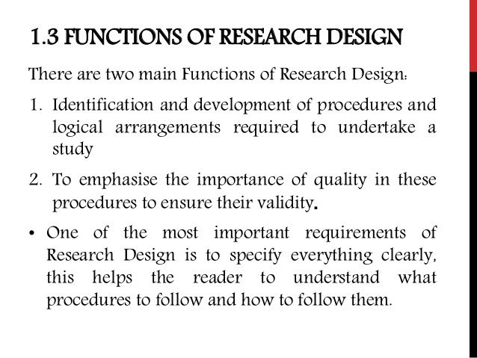

Research Design, Feature of a Good Research Design

Research Design is defined as a framework of methods and techniques chosen by a researcher to combine various components of research in a reasonably logical manner so that the research problem is efficiently handled. It provides insights about “how” to conduct research using a particular methodology.

Types of Research Design
A researcher must have a clear understanding of the various types of research design to select which type of research design to implement for a study. Research design can be broadly classified into quantitative and qualitative research design.
- Qualitative Research Design
Qualitative research is implemented in cases where a relationship between collected data and observation is established on the basis of mathematical calculations. Theories related to a naturally existing phenomenon can be proved or disproved using mathematical calculations. Researchers rely on qualitative research design where they are expected to conclude “why” a particular theory exists along with “what” respondents have to say about it.
- Quantitative Research Design
Quantitative research is implemented in cases where it is important for a researcher to have statistical conclusions to collect actionable insights. Numbers provide a better perspective to make important business decisions. Quantitative research design is important for the growth of any organization because any conclusion drawn on the basis of numbers and analysis will only prove to be effective for the business.

Further, research design can be divided into five types :
(I) Descriptive Research Design: In a descriptive research design, a researcher is solely interested in describing the situation or case under his/her research study. It is a theory-based research design which is created by gather, analyze and presents collected data. By implementing an in-depth research design such as this, a researcher can provide insights into the why and how of research.
(II) Experimental Research Design: Experimental research design is used to establish a relationship between the cause and effect of a situation. It is a causal research design where the effect caused by the independent variable on the dependent variable is observed. For example, the effect of an independent variable such as price on a dependent variable such as customer satisfaction or brand loyalty is monitored. It is a highly practical research design method as it contributes towards solving a problem at hand. The independent variables are manipulated to monitor the change it has on the dependent variable. It is often used in social sciences to observe human behavior by analyzing two groups – effect of one group on the other.
(III) Correlational Research Design: Correlational research is a non-experimental research design technique which helps researchers to establish a relationship between two closely connected variables. Two different groups are required to conduct this research design method. There is no assumption while evaluating a relationship between two different variables and statistical analysis techniques are used to calculate the relationship between them.
Correlation between two variables is concluded using a correlation coefficient, whose value ranges between -1 and +1. If the correlation coefficient is towards +1, it indicates a positive relationship between the variables and -1 indicates a negative relationship between the two variables.
(IV) Diagnostic Research Design: In the diagnostic research design, a researcher is inclined towards evaluating the root cause of a specific topic. Elements that contribute towards a troublesome situation are evaluated in this research design method.
There are three parts of diagnostic research design:
- Inception of the issue
- Diagnosis of the issue
- Solution for the issue
(V) Explanatory Research Design: In exploratory research design, the researcher’s ideas and thoughts are key as it is primarily dependent on their personal inclination about a particular topic. Explanation about unexplored aspects of a subject is provided along with details about what, how and why related to the research questions.

Features of a Good Research Design
The features of good research design is often characterized by adjectives like flexible, appropriate, efficient, economical and so on. Generally, the design which minimizes bias and maximizes the reliability of the data collected and analyzed is considered a good design. The design which gives the smallest experimental error is supposed to be the best design in many investigations. Similarly, a design which yields maximal information and provides an opportunity for considering many different aspects of a problem is considered most appropriate and efficient design in respect of many research problems. Thus, the question of good design is related to the purpose or objective of the research problem and also with the nature of the problem to be studied. A design may be quite suitable in one case, but may be found wanting in one respect or the other in the context of some other research problem. One single design cannot serve the purpose of all types of research problems.
A research design appropriate for a particular research problem, usually involves the consideration of the following factors:
- The means of obtaining information;
- The availability and skills of the researcher and his staff, if any;
- The objective of the problem to be studied;
- The nature of the problem to be studied; and
- The availability of time and money for the research work.

Research Design: Meaning, Classification and elements

Research design is defined as a framework of methods and techniques chosen by a researcher to combine various components of research in a reasonably logical manner so that the research problem is efficiently handled. It provides insights about “how” to conduct research using a particular methodology. Every researcher has a list of research questions which need to be assessed – this can be done with research design.
The sketch of how research should be conducted can be prepared using research design. Hence, the market research study will be carried out on the basis of research design.
The design of a research topic is used to explain the type of research (experimental, survey, correlational, semi-experimental, review) and also its sub-type (experimental design, research problem, and descriptive case-study). There are three main sections of research design: Data collection, measurement, and analysis.
The type of research problem an organization is facing will determine the research design and not vice-versa. Variables, designated tools to gather information, how will the tools be used to collect and analyze data and other factors are decided in research design on the basis of a research technique is decided.
An impactful research design usually creates minimum bias in data and increases trust on the collected and analyzed research information. Research design which produces the least margin of error in experimental research can be touted as the best. The essential elements of research design are:
- Accurate purpose statement of research design
- Techniques to be implemented for collecting details for research
- Method applied for analyzing collected details
- Type of research methodology
- Probable objections for research
- Settings for research study
- Timeline
- Measurement of analysis

Research Design Characteristics
Neutrality: The results projected in research design should be free from bias and neutral. Understand opinions about the final evaluated scores and conclusion from multiple individuals and consider those who agree with the derived results.
Reliability: If a research is conducted on a regular basis, the researcher involved expects similar results to be calculated every time. Research design should indicate how the research questions can be formed to ensure the standard of obtained results and this can happen only when the research design is reliable.
Validity: There are multiple measuring tools available for research design but valid measuring tools are those which help a researcher in gauging results according to the objective of research and nothing else. The questionnaire developed from this research design will be then valid.
Generalization: The outcome of research design should be applicable to a population and not just a restricted sample. Generalization is one of the key characteristics of research design.

Types of Research Design
A researcher must have a clear understanding of the various types of research design to select which type of research design to implement for a study. Research design can be broadly classified into quantitative and qualitative research design.
Qualitative Research Design: Qualitative research is implemented in cases where a relationship between collected data and observation is established on the basis of mathematical calculations. Theories related to a naturally existing phenomenon can be proved or disproved using mathematical calculations. Researchers rely on qualitative research design where they are expected to conclude “why” a particular theory exists along with “what” respondents have to say about it.
Quantitative Research Design: Quantitative research is implemented in cases where it is important for a researcher to have statistical conclusions to collect actionable insights. Numbers provide a better perspective to make important business decisions. Quantitative research design is important for the growth of any organization because any conclusion drawn on the basis of numbers and analysis will only prove to be effective for the business.
Further, research design can be divided into five types:
- Descriptive Research Design: In a descriptive research design, a researcher is solely interested in describing the situation or case under his/her research study. It is a theory-based research design which is created by gather, analyze and presents collected data. By implementing an in-depth research design such as this, a researcher can provide insights into the why and how of research.
- Experimental Research Design: Experimental research design is used to establish a relationship between the cause and effect of a situation. It is a causal research design where the effect caused by the independent variable on the dependent variable is observed. For example, the effect of an independent variable such as price on a dependent variable such as customer satisfaction or brand loyalty is monitored. It is a highly practical research design method as it contributes towards solving a problem at hand. The independent variables are manipulated to monitor the change it has on the dependent variable. It is often used in social sciences to observe human behavior by analyzing two groups – affect of one group on the other.
- Correlational Research Design: Correlational research is a non-experimental research design technique which helps researchers to establish a relationship between two closely connected variables. Two different groups are required to conduct this research design method. There is no assumption while evaluating a relationship between two different variables and statistical analysis techniques are used to calculate the relationship between them.
Correlation between two variables is concluded using a correlation coefficient, whose value ranges between -1 and +1. If the correlation coefficient is towards +1, it indicates a positive relationship between the variables and -1 indicates a negative relationship between the two variables.
- Diagnostic Research Design: In the diagnostic research design, a researcher is inclined towards evaluating the root cause of a specific topic. Elements that contribute towards a troublesome situation are evaluated in this research design method.
There are three parts of diagnostic research design:
- Inception of the issue
- Diagnosis of the issue
- Solution for the issue
- Explanatory Research Design: In exploratory research design, the researcher’s ideas and thoughts are key as it is primarily dependent on their personal inclination about a particular topic. Explanation about unexplored aspects of a subject is provided along with details about what, how and why related to the research questions.

Elements of Research Design
A research design can be described as a conceptual structure within which research is going to be carried out. It comprises the blueprint for the collection, measurement and analysis of data. Decisions with regards to what, where, when, how much, by what means concerning an enquiry or a research design are taken.
A research design is the arrangement of conditions for collection and evaluation of data in a fashion which is designed to combine relevance to the research purpose with economy in process.
The key elements of a good research design are as under :
- Research Design is a plan which identifies the sources and kinds of information strongly related to the research problem.
- It is a strategy indicating which method is going to be employed for collecting and analyzing the data.
- Additionally, it consists of the time and cost budgets because most research is done under these two constraints. In a nutshell a research design must contain:
- A clear statement of the research problem.
- Methods and techniques to be utilized for gathering information from the population to be researched.
- Approach to be utilized in processing and analyzing data.

Purpose of the Study
- Exploratory study: Carried out when not much is known about the problem at hand, or no details are available on how similar problems or research issues have been solved in the past.
- Descriptive study: Carried out as a way to determine and be able to describe the characteristics of the variables of interest in a situation characteristics of the variables of interest in a situation.
- Studies which engage in hypotheses testing generally explain the nature of certain relationships, or establish the differences among groups or the independence of two or more factors in a situation.

Type of Investigation
- Causality Research Design: A causal study is an inquiry to understand the cause of one or more problems.
- A correlational study: Is an inquiry to find out the key variables linked to the problem.
A causal study question:
Does cigarette smoking cause cancer?
A correlational study question:
Are cigarette smoking and cancer associated?
Or
Are cigarette smoking, consuming alcohol, and chewing tobacco related to cancer?
If so, which of these contributes most to the variance in the dependent variable?
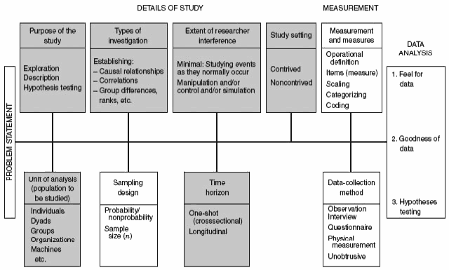
Figure: Main Elements of Research Design

Researcher Interference
The extent of interference by the researcher with the normal flow of work at the workplace has a direct effect on whether the study performed is causal or correlational. A correlational study is carried out in the natural environment of the corporation with minimal interference by the researcher with the normal flow of work.
In studies carried out to determine cause-and-effect relationships, the investigator attempts to adjust specific variables in order to study the outcomes of such manipulation on the dependent variable of interest. Put simply, the researcher intentionally changes certain variables in the setting and disrupts the events as they normally happen in the business.

Study Setting
Correlational research is carried out in noncontrived settings (normal settings), as opposed to most causal studies are carried out in contrived settings.
Unit of Analysis
The unit of analysis means the degree of aggregation of the data gathered through the subsequent data analysis.
- Individual
- Dyads
- Groups
- Organizations
- Cultures

Time Horizon
Cross-Sectional Studies: A study can be carried out in which data are collected only once, perhaps during a period of days or weeks or months, to be able to answer a research question.
Longitudinal Studies: Researching people or phenomena at several point in time to be able to answer the research question. Due to the fact that data are collected at two different points in time, the study is not cross-sectional kind, but is carried longitudinally across a period of time. Longitudinal studies take a longer period and energy and cost a lot more than cross-sectional studies. Having said that, well-planned longitudinal studies can help you to recognize cause-and-effect relationships.
For example, you can study the product sales before and after an advertising campaign, and provided other environmental changes haven’t influenced on the results, you can attribute the increase in the sales volume, if any, to the advertisement.
A good research design must contain: a clear statement, Methods and techniques for data collection, processing and analyzing data.

Problem in Measurement in Management Research: Validity And Reliability
Problems in Measurement should be precise and unambiguous in an ideal research study. This objective, however, is often not met with in entirety. As such the researcher must be aware about the sources of error in measurement. The following are the possible sources of error in measurement.
- Respondent: At times the respondent may be reluctant to express strong negative feelings or it is just possible that he may have very little knowledge but may not admit his ignorance. All this reluctance is likely to result in an interview of ‘guesses.’ Transient factors like fatigue, boredom, anxiety, etc. may limit the ability of the respondent to respond accurately and fully.
- Situation: Situational factors may also come in the way of correct measurement. Any condition which places a strain on interview can have serious effects on the interviewer-respondent rapport. For instance, if someone else is present, he can distort responses by joining in or merely by being present. If the respondent feels that anonymity is not assured, he may be reluctant to express certain feelings.
- Measurer: The interviewer can distort responses by rewording or reordering questions. His behaviour, style and looks may encourage or discourage certain replies from respondents. Careless mechanical processing may distort the findings. Errors may also creep in because of incorrect coding, faulty tabulation and/or statistical calculations, particularly in the data-analysis stage.
- Instrument: Error may arise because of the defective measuring instrument. The use of complex words, beyond the comprehension of the respondent, ambiguous meanings, poor printing, inadequate space for replies, response choice omissions, etc. are a few things that make the measuring instrument defective and may result in measurement errors. Another type of instrument deficiency is the poor sampling of the universe of items of concern.
- Researcher must know that correct measurement depends on successfully meeting all of the problems listed above. He must, to the extent possible, try to eliminate, neutralize or otherwise deal with all the possible sources of error so that the final results may not be contaminated.

RELIABILITY
A test must also be reliable. Reliability is “Self-correlation of the test.” It shows the extent to which the results obtained are consisted when the test is administered. Once or more than once on the same sample with a reasonable gap. Consistency in results obtained in a single administration is the index of internal consistency of the test and consistency in results obtained upon testing and retesting is the index of temporal consistency. Reliability thus, includes both internal consistency as well as temporal consistency. A test to be called sound must be reliable because reliability indicates the extent to which the scores obtained in the test are free from such internal defects of standardization, which are likely to produce errors of measurement.

Types of Reliability:
(i) Internal reliability
(ii) External reliability
- Internal Reliability; Internal reliability assesses the consistency of results across items within a test.
- External Reliability; External reliability refers to the extent to which a measure varies from one use to another.
Errors in Reliability:
At a time scores are not consistent because some other factors also affect reliability e.g.
Noise
Health
Time
There is always a chance of 5% error in reliability which is acceptable.

VALIDITY
Validity is another prerequisite for a test to be sound. Validity indicates the extent to which the test measure what it intends to measure, when compared with some outside independent criteria. In other words it is the correlation of the test with some outside criteria. The criteria should be independent one and should be regarded as the best index of trait or ability being measured by the test. Generally, validity of a test is dependent upon the reliability because a test which yields inconsistent results (poor reliability) is ordinarily not expected to correlate with some outside independent criteria.
TYPES OF ERRORS
(i) Random error
(ii) Systematic error
(i) Random error
Random error exists in every measurement and is often major source of uncertainty. These errors have no particular assignable cause. These errors can never be totally eliminated or corrected. These are caused by many uncontrollable variables that are inevitable part of every analysis made by human being. These variables are impossible to identified, even if we identify some they cannot be measured because most of them are so small.
(ii) Systematic error
Systematic error is caused due to instruments, machines, and measuring tools. It is not due to individuals. Systematic error is acceptable we can fix and handled it.
WAYS OF FINDING RELIABILITY:
Following are the methods to check reliability
- Test-retest
- Alternate form
- Split –half method
TEST-RETEST METHOD
It is the oldest and commonly used method of testing reliability. The test retest method assesses the external consistency of a test. Examples of appropriate tests include questionnaires and psycho metric tests. It measures the stability of a test over time.
A typical assessment would involve giving participants the same test on two separate occasions. Each and every thing from start to end will be same in both tests. Results of first test need to be correlated with the result of second test. If the same or similar results are obtained then external reliability is established.
The timing of the test is important if the duration is to brief then participants may recall information from the first test which could bias the results. Alternatively, if the duration is too long it is feasible that the participants could have changed in some important way which could also bias the results.
Utility and worth of a psychological test decreases with time so the test should be revised and updated. When tests are not revised systematic error may arise.
ALTERNATE FORM
In alternate form two equivalent forms of the test are administered to the same group of examinees. An individual has given one form of the test and after a period of time the person is given a different version of the same test. The two form of the rest are then correlated to yield a coefficient of equivalence.
Positive point
In alternate form no deal to wait for time.
Negative point
It is very hectic and risky task to make two test of equivalent level.
SPLIT-HALF METHOD
The split half method assesses the internal consistency of a test. It measures the extent to which all parts of the test contribute equally to what is being measured. The test is technically spitted into odd and even form. The reason behind this is when we making test we always have the items in order of increasing difficulty if we put (1,2,—-10) in one half and (11,12,—-20) in another half then all easy question/items will goes to one group and all difficult questions/items will goes to the second group.
When we split the test we should split it with same format/theme e.g. Multiple questions – multiple questions or blanks – blanks.

Methods of Data Collection-Primary and secondary sources

Methods of Data Collection
Data are the special type of information generally obtained through observations, surveys, inquiries, or are generated as a result of human activity. Methods of data collection are essential for anyone who wish to collect data. Data collection is a fundamental aspect and as a result, there are different methods of collecting data which when used on one particular set will result in different kinds of data. Collection of data refers to a purpose gathering of information and relevant to the subject-matter of the study from the units under investigation. The method of collection of data mainly depends upon the nature, purpose and the scope of inquiry on one hand and availability of resources, and the time to the other. The statistical Data may be classified into primary and secondary depending upon the nature and mode of collection.
Data collection is a very important part of science. Meteorologists data related to weather over time to keep a record and makes forecasts on basis of it. Other example include Oceanographers collecting data on the salinity (saltiness) of seawater studying changes in trends of our Earth’s oceans. Although have been collected by hand for thousands of years, the technology to collect data electronically has been around for fewer than 80 years and made significant development in this time period. Only in the last 20 years this technology and advanced methods have been available to us.

Data Collection Methods:
Data collection is a process of collecting information from all the relevant sources to find answers to the research problem, test the hypothesis and evaluate the outcomes. Data collection methods can be divided into two categories: secondary methods of data collection and primary methods of data collection.

Methods of data collection for primary and secondary Data
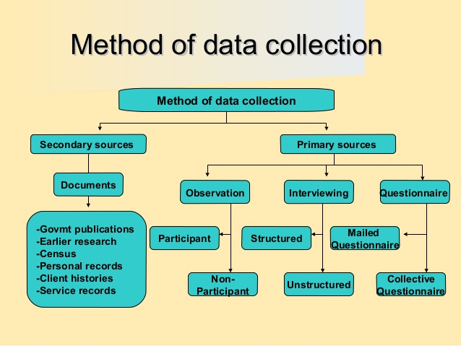

(1) PRIMARY DATA
Primary data are original observations collected by the researcher or his agent for the first time for any investigation and used by them in the statistical analysis.
The primary data is the one type of important data. It is collection of data from first hand information.
This information published by one organization for some purposes. This type of primary data is mostly pure and original data.
The primary data collection is having three different data collection methods are:-
- Data Collection through Investigation:
In this method, trained investigators are working as employees for collecting the data. The researchers will use the tools like interview and collect the information from the individual persons.
- Personal Investigation Methods:
The researchers or the data collectors will conduct the survey and hence they collect the data. In this method we have to collect more accurate data and original data. This method is useful for small data collection only not big collection of data projects.
- Data Collection through Telephones:
The data researcher uses the tools like telephones, mobile phones to collect the information or data. This is accurate and very quick process for data collection. But information collected is not accurate and true.

(2) SECONDARY DATA
The secondary data is the other type of data, which is collection of data from second hand information. This information is known as, given data is already collected from any one persons for some purpose, and it has available for the present issues. And mostly these secondary data’s are not relevant and pure or original data
TWO IMPORTANT METHODS:
a) Official methods:
Data collecting from the ministry of finance, Agriculture, Industry and etc. These data collection methods are official methods. This methods are used the tools of phone calls and surveys.
b) Semi–official methods:
This is the method of data collection from Railway boards, banks, population committee etc. This methods only used for the focusing groups, and interviews, and electronic mail surveys.

Ways of Collections
In this case the data’s are already available, it means the data’s are already collected and analyzed by someone else. It can be either published or unpublished data. When using the secondary data, the following characteristics must be followed:
- Reliability
- Suitability
- Adequate data
These data’s can be collected from the following places:-
- a) Official
- b) Newspapers and journals
- c) Research organizations like universities.

Secondary sources are data that already exist
- Previous research
- Official statistics
- Mass media products
- Diaries
- Letters
- Government reports
- Web information
- Historical data and information

Types Of Error

- In statistical hypothesis testing, a type I error is the incorrect rejection of a true null hypothesis (also known as a “false positive” finding), while a type II error is incorrectly retaining a false null hypothesis (also known as a “false negative” finding).[1] More simply stated, a type I error is to falsely infer the existence of something that is not there, while a type II error is to falsely infer the absence of something that is.
- A type I error (or error of the first kind) is the incorrect rejection of a true null hypothesis. Usually a type I error leads one to conclude that a supposed effect or relationship exists when in fact it doesn’t. Examples of type I errors include a test that shows a patient to have a disease when in fact the patient does not have the disease, a fire alarm going on indicating a fire when in fact there is no fire, or an experiment indicating that a medical treatment should cure a disease when in fact it does not.
- A type II error (or error of the second kind) is the failure to reject a false null hypothesis. Examples of type II errors would be a blood test failing to detect the disease it was designed to detect, in a patient who really has the disease; a fire breaking out and the fire alarm does not ring; or a clinical trial of a medical treatment failing to show that the treatment works when really it does.
- When comparing two means, concluding the means were different when in reality they were not different would be a Type I error; concluding the means were not different when in reality they were different would be a Type II error. Various extensions have been suggested as “Type III errors”, though none have wide use.
- All statistical hypothesis tests have a probability of making type I and type II errors. For example, all blood tests for a disease will falsely detect the disease in some proportion of people who don’t have it, and will fail to detect the disease in some proportion of people who do have it. A test’s probability of making a type I error is denoted by α. A test’s probability of making a type II error is denoted by β. These error rates are traded off against each other: for any given sample set, the effort to reduce one type of error generally results in increasing the other type of error. For a given test, the only way to reduce both error rates is to increase the sample size, and this may not be feasible.
- 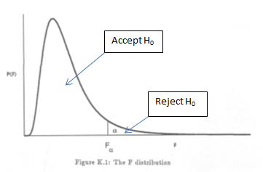
- Type I error
- A type I error occurs when the null hypothesis (H0) is true, but is rejected. It is asserting something that is absent, a false hit. A type I error may be likened to a so-called false positive (a result that indicates that a given condition is present when it actually is not present).
- In terms of folk tales, an investigator may see the wolf when there is none (“raising a false alarm”). Where the null hypothesis, H0, is: no wolf.
- The type I error rate or significance level is the probability of rejecting the null hypothesis given that it is true.[5][6] It is denoted by the Greek letter α (alpha) and is also called the alpha level. Often, the significance level is set to 0.05 (5%), implying that it is acceptable to have a 5% probability of incorrectly rejecting the null hypothesis.[5]
- Type II error
- A type II error occurs when the null hypothesis is false, but erroneously fails to be rejected. It is failing to assert what is present, a miss. A type II error may be compared with a so-called false negative (where an actual ‘hit’ was disregarded by the test and seen as a ‘miss’) in a test checking for a single condition with a definitive result of true or false. A Type II error is committed when we fail to believe a true alternative hypothesis.[
- In terms of folk tales, an investigator may fail to see the wolf when it is present (“failing to raise an alarm”). Again, H0: no wolf.
- The rate of the type II error is denoted by the Greek letter β (beta) and related to the power of a test (which equals 1−β).

