UNIT-IV

Group Behavior
People may underestimate the importance of society and group memberships on their lives. Whilst people sometimes undertake solo journeys yet by and large much of our experiences of life involves being engaged with others and groups.
Within an organization we do find number of groups. Individuals joining group (s) is a reality – may be formal or informal groups. People work in groups quite frequently and in many different areas of their life e.g. at work, school/college, sport, hobbies. The managers need to understand Group Dynamics that can enable managers to adopt the right approach of interacting with them.

Group Dynamics
Group dynamics deals with the attitudes and behavioral patterns of a group. Group dynamics concern how groups are formed, what is their structure and which processes are followed in their functioning. Thus, it is concerned with the interactions and forces operating between groups.
Group dynamics is relevant to groups of all kinds – both formal and informal. If the UPA government has set up Group of Ministers for every governance issue, the Supreme Court of India has 27 Group of Judges committees overseeing all manner of non-judicial work in the apex court. In an organizational setting, the term groups are a very common and the study of groups and group dynamics is an important area of study.

What is A Group?
Every organization is a group unto itself. A group refers to two or more people who share a common meaning and evaluation of themselves and come together to achieve common goals. In other words, a group is a collection of people who interact with one another; accept rights and obligations as members and who share a common identity.

Characteristics of a Group:
Regardless of the size or the purpose, every group has similar characteristics:
(a) 2 or more persons (if it is one person, it is not a group)
(b) Formal social structure (the rules of the game are defined)
(c) Common fate (they will swim together)
(d) Common goals (the destiny is the same and emotionally connected)
(e) Face-to-face interaction (they will talk with each other)
(f) Interdependence (each one is complimentary to the other)
(g) Self-definition as group members (what one is who belongs to the group)
(h) Recognition by others (yes, you belong to the group).

Process/Stages of Group Development/Evolution:
Group Development is a dynamic process. How do groups evolve? There is a process of five stages through which groups pass through. The process includes the five stages: forming, storming, forming, performing, and adjourning.

Forming:
The first stage in the life of a group is concerned with forming a group. This stage is characterized by members seeking either a work assignment (in a formal group) or other benefit, like status, affiliation, power, etc. (in an informal group). Members at this stage either engage in busy type of activity or show apathy.

Storming:
The next stage in this group is marked by the formation of dyads and triads. Members seek out familiar or similar individuals and begin a deeper sharing of self. Continued attention to the subgroup creates a differentiation in the group and tensions across the dyads / triads may appear. Pairing is a common phenomenon. There will be conflict about controlling the group.

Norming:
The third stage of group development is marked by a more serious concern about task performance. The dyads/triads begin to open up and seek out other members in the group. Efforts are made to establish various norms for task performance.
Members begin to take greater responsibility for their own group and relationship while the authority figure becomes relaxed. Once this stage is complete, a clear picture will emerge about hierarchy of leadership. The norming stage is over with the solidification of the group structure and a sense of group identity and camaraderie.

Performing:
This is a stage of a fully functional group where members see themselves as a group and get involved in the task. Each person makes a contribution and the authority figure is also seen as a part of the group. Group norms are followed and collective pressure is exerted to ensure the Process of Group effectiveness of the group.
The group may redefine its goals Development in the light of information from the outside environment and show an autonomous will to pursue those goals. The long-term viability of the group is established and nurtured.

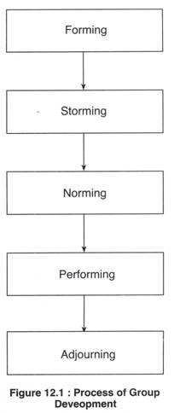

Adjourning:
In the case of temporary groups, like project team, task force, or any other such group, which have a limited task at hand, also have a fifth stage, This is known as adjourning.
The group decides to disband. Some members may feel happy over the performance, and some may be unhappy over the stoppage of meeting with group members. Adjourning may also be referred to as mourning, i.e. mourning the adjournment of the group.
The readers must note that the four stages of group development mentioned above for permanent groups are merely suggestive. In reality, several stages may go on simultaneously.

Types of Groups:
One way to classify the groups is by way of formality – formal and informal. While formal groups are established by an organization to achieve its goals, informal groups merge spontaneously. Formal groups may take the form of command groups, task groups, and functional groups.

1. Command Groups:
Command groups are specified by the organizational chart and often consist of a supervisor and the subordinates that report to that supervisor. An example of a command group is a market research firm CEO and the research associates under him.

2. Task Groups:
Task groups consist of people who work together to achieve a common task. Members are brought together to accomplish a narrow range of goals within a specified time period. Task groups are also commonly referred to as task forces. The organization appoints members and assigns the goals and tasks to be accomplished.
Examples of assigned tasks are the development of a new product, the improvement of a production process, or designing the syllabus under semester system.
Other common task groups are ad hoc committees, project groups, and standing committees. Ad hoc committees are temporary groups created to resolve a specific complaint or develop a process are normally disbanded after the group completes the assigned task.

3. Functional Groups:
A functional group is created by the organization to accomplish specific goals within an unspecified time frame. Functional groups remain in existence after achievement of current goals and objectives. Examples of functional groups would be a marketing department, a customer service department, or an accounting department.
In contrast to formal groups, informal groups are formed naturally and in response to the common interests and shared values of individuals. They are created for purposes other than the accomplishment of organizational goals and do not have a specified time frame. Informal groups are not appointed by the organization and members can invite others to join from time to time.
Informal groups can have a strong influence in organizations that can either be positive or negative. For example, employees who form an informal group can either discuss how to improve a production process or how to create shortcuts that jeopardize quality. Informal groups can take the form of interest groups, friendship groups, or reference groups.
- Interest Group:
Interest groups usually continue over time and may last longer than general informal groups. Members of interest groups may not be part of the same organizational department but they are bound together by some other common interest.
The goals and objectives of group interests are specific to each group and may not be related to organizational goals and objectives. An example of an interest group would be students who come together to form a study group for a specific class.
- Friendship Groups:
Friendship groups are formed by members who enjoy similar social activities, political beliefs, religious values, or other common bonds. Members enjoy each other’s company and often meet after work to participate in these activities. For example, a group of employees who form a friendship group may have a yoga group, a Rajasthani association in Delhi, or a kitty party lunch once a month.
iii. Reference Groups:
A reference group is a type of group that people use to evaluate themselves. The main objectives of reference groups are to seek social validation and social comparison. Social validation allows individuals to justify their attitudes and values while social comparison helps individuals evaluate their own actions by comparing themselves to others. Reference groups have a strong influence on members’ behavior. Such groups are formed voluntarily. Family, friends, and religious affiliations are strong reference groups for most individuals.
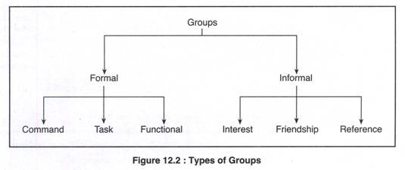

Factors Affecting Group Behaviour:
The success or failure of a group depends upon so many factors. Group member resources, structure (group size, group roles, group norms, and group cohesiveness), group processes (the communication, group decision making processes, power dynamics, conflicting interactions, etc.) and group tasks (complexity and interdependence).

1. Group Member Resources:
The members’ knowledge, abilities, skills; and personality characteristics (sociability, self- reliance, and independence) are the resources the group members bring in with them. The success depends upon these resources as useful to the task.

2. Group Structure:
Group Size:
Group size can vary from 2 people to a very large number of people. Small groups of two to ten are thought to be more effective because each member has ample opportunity to take part and engage actively in the group. Large groups may waste time by deciding on processes and trying to decide who should participate next.
Evidence supports the notion that as the size of the group increases, satisfaction increases up to a certain point. Increasing the size of a group beyond 10-12 members’ results in decreased satisfaction. It is increasingly difficult for members of large groups to identify with one another and experience cohesion.
Group Roles:
In formal groups, roles are always predetermined and assigned to members. Each role shall have specific responsibilities and duties. There are, however, emergent roles that develop naturally to meet the needs of the groups.
These emergent roles will often substitute the assigned roles as individuals begin to express themselves and become more assertive. Group roles can then be classified into work roles, maintenance roles, and blocking roles.
Work roles are task-oriented activities that involve accomplishing the group’s goals. They involve a variety of specific roles such as initiator, informer, clarifier, summarizer, and reality tester.
Maintenance roles are social-emotional activities that help members maintain their involvement in the group and raise their personal commitment to the group. The maintenance roles are harmonizer, gatekeeper, consensus tester, encourager, and compromiser.
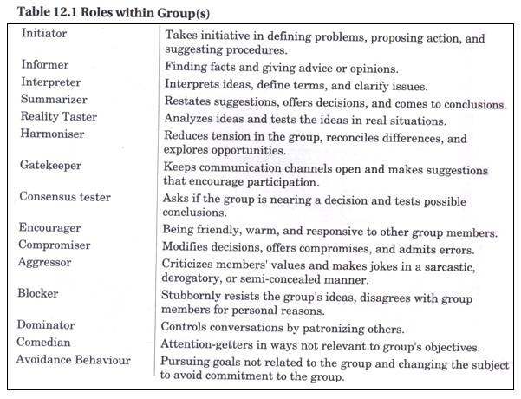
Blocking roles are activities that disrupt the group. Blockers will stubbornly resist the group’s ideas, disagree with group members for personal reasons, and will have hidden agendas. They may take the form of dominating discussions, verbally attacking other group members, and distracting the group with trivial information or unnecessary humour.
Often times the blocking behaviour may not be intended as negative. Sometimes a member may share a joke in order to break the tension, or may question a decision in order to force group members to rethink the issue. The blocking roles are aggressor, blocker, dominator, comedian, and avoidance behaviour.
Role conflicts arise when there is ambiguity (confusion about delegation and no specific job descriptions) between the sent role and the received role which leads to frustration and dissatisfaction, ultimately leading to turnover; inconsistency between the perceived role and role behaviour (conflict between work roles and family roles); and conflicting demands from different sources while performing the task.
Group Norms:
Norms define the acceptable standard or boundaries of acceptable and unacceptable behaviour, shared by group members. They are typically created in order to facilitate group survival, make behaviour more predictable, avoid embarrassing situations, and express the values of the group.
Each group will create its own norms that might determine from the work performance to dress to making comments in a meeting. Groups exert pressure on members to force them to conform to the group’s standards and at times not to perform at higher levels. The norms often reflect the level of commitment, motivation, and performance of the group.
The majority of the group must agree that the norms are appropriate in order for the behaviour to be accepted. There must also be a shared understanding that the group supports the norms. It should be noted, however, that members might violate group norms from time to time.
If the majority of members do not adhere to the norms, then they will eventually change and will no longer serve as a standard for evaluating behaviour. Group members who do not conform to the norms will be punished by being excluded, ignored, or asked to leave the group.
Group Cohesiveness:
Cohesiveness refers to the bonding of group members or unity, feelings of attraction for each other and desire to remain part of the group. Many factors influence the amount of group cohesiveness – agreement on group goals, frequency of interaction, personal attractiveness, inter-group competition, favourable evaluation, etc.
The more difficult it is to obtain group membership the more cohesive the group will be. Groups also tend to become cohesive when they are in intense competition with other groups or face a serious external threat to survival. Smaller groups and those who spend considerable time together also tend to be more cohesive.
Cohesiveness in work groups has many positive effects, including worker satisfaction, low turnover and absenteeism, and higher productivity. However, highly cohesive groups may be detrimental to organizational performance if their goals are misaligned with organizational goals.
Highly cohesive groups may also be more vulnerable to groupthink. Groupthink occurs when members of a group exert pressure on each other to come to a consensus in decision making. Groupthink results in careless judgments, unrealistic appraisals of alternative courses of action, and a lack of reality testing.
Evidence suggests that groups typically outperform individuals when the tasks involved require a variety of skills, experience, and decision making. Groups are often more flexible and can quickly assemble, achieve goals, and disband or move on to another set of objectives.
Many organizations have found that groups have many motivational aspects as well. Group members are more likely to participate in decision-making and problem-solving activities leading to empowerment and increased productivity. Groups complete most of the work in an organization; thus, the effectiveness of the organization is limited by the effectiveness of its groups.
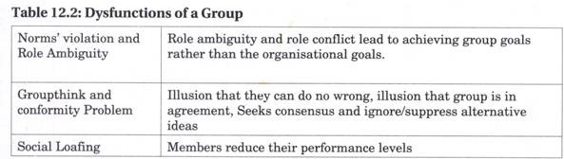

3. Group Processes:
Decision-making by a group is superior, because group generates more information and knowledge, generates diverse alternatives, increases acceptance of a solution, and increases legitimacy. But it is also true, that decision making is like ‘munde munde matirbhinna’.
Decisions take longer time, minority is dominated, pressure is applied to conform to group decisions, and none is responsible for the decisions. Group processes also include communication, conflict management, and leadership that we shall discuss in details in the chapters to follow hereafter.

Turning Groups into Effective Teams:
All teams are groups but not all groups are teams. Teams often are difficult to form because it takes time for members to learn how to work together. People in every workplace talk about building the team, working as a team, and my team, but few understand how to create the experience of team work or how to develop an effective team. Belonging to a team, in the broadest sense, is a result of feeling part of something larger than oneself. It has a lot to do with your understanding of the mission or objectives of your organization.
In a team-oriented environment, one contributes to the overall success of the organization. One works with fellow members of the organization to produce these results. Even though you have a specific job function and you belong to a specific department, you are unified with other organization members to accomplish the overall objectives. The bigger picture drives your actions; your function exists to serve the bigger picture.
It is on record that teams are better than groups, because they are more flexible and responsive to dynamic environment. A work group has no opportunity to involve in collective works.
It is the work team whose members ‘work intensely on a specific, common goal using their positive synergy, individual and mutual accountability, and complementary skills’.
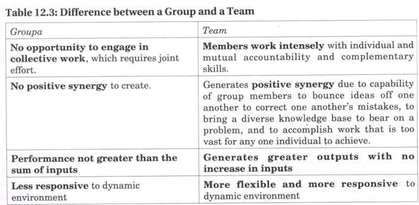
Team-building helps to increase intra-group and inter-group effectiveness to bring members together, make them share their perception of each other and understand each other’s point of view.
Thus, resolve problems and work together in a cooperative and collaborative mode. Teams can be of four types – problem-solving teams (only making suggestion), self-managed, teams (operate without a manager), cross-functional teams (a group of experts from different specialities), and virtual team (members collaborate online). In terms of size, teams may be institutional (comprising of hundreds of members) and operational (a small, cooperative group, in regular contact and contributes responsibly to achieve task at hand).

Eight Cs for Team Building:
To show business results and profitability, ways are explored by the executives to improve their productivity.
Successful team building, that creates effective, focused work teams, requires attention to each of the following:

1. Clear Expectations:
The managers must clearly tell the team members of the expected performance and the team members must understand the reason for its creation. For it the organization must support the team with resources of people, time and money.

2. Commitment:
Team members must participate in the team, feel that the team mission is important, and show commitment to accomplishing the team mission and expected outcomes. Commitment will come if team members perceive their service as valuable to the organization and to their own careers.

3. Competence:
Team members must have the knowledge, skill and capabilities, the resources, strategies and support needed to accomplish its mission to address the issues for which the team was formed.

4. Control:
The team must have not only enough freedom and empowerment to feel the ownership necessary to accomplish its charter, but also the accountability. There has to be a defined review process.
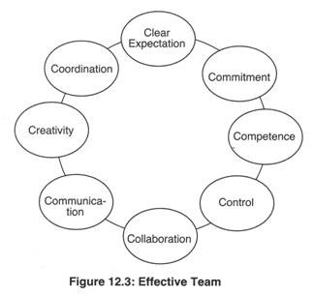

5. Collaboration:
The team should understand group processes and work effectively and cooperatively with other members of the team. For it they have to understand the roles and responsibilities of team members, team leaders, and team recorders.

6. Communication:
To make team members clear about the priority of their tasks, and receive regular feedback, team members must clearly and honestly with each other. Diverse opinions be welcome and conflicts be taken up positively.

7. Creativity:
The team should value creative thinking, unique solutions, and new ideas; and reward members who take reasonable risks to make improvements. If necessary, it should provide the training, education, access to books and films, and field trips to stimulate new thinking.
The creative development of new products, new technologies, new services, or new organizational structures is possible because teams may have variety of skills needed for successful innovation.
Team members can uncover each other’s flaws and balance each other’s strengths and weaknesses. Managers should empower the team and make it accountable for the innovation process.

8. Coordination:
Teams should understand the concept of internal customer to whom they provide a product or a service. Team efforts need to be coordinated by a central leadership team that assists the groups to obtain what they need for success.
The cross- functional and multi-department teams must work together effectively. The organization should develop a customer-focused and process-focused orientation and move away from traditional departmental thinking.
Spend time and attention on each of these eight tips to ensure your work teams contribute most effectively to your business success. Your team members would love you, your business will see new heights, and empowered people will “own” and be responsible to their work processes

Informal Group:
In every organisation along with formal groups there exists informal groups which emerge naturally due to the response and common interests of the members who can easily identify with the goals or independent activities of the informal groups.
Sometimes the efforts may be driven by a common goal that may compliment or work against the goals of the formal group. An informal group can be defined as a group that evolves spontaneously, not shown in the organization’s structure, with the objective of fulfilling personal and social need of its members.
Informal Group Vs Informal Organisation:
An informal group is a voluntary group of people casually acquainted with each other for their own personal fulfillment because they have some common and shared backgrounds, characteristics and concerns (values / interests / hobbies / friendship).
Whilst it is easy to differentiate between a formal group and a formal organisation, the differences between informal group and informal organisation tend to be difficult. The difference between informal organization and informal group is that informal organisation is a larger entity consisting of all informal groups in an organization.
Informal Organisation= Sigma Informal Groups:
An informal group is the nucleus of informal organization. When an informal group adopts a formally defined structure and group processes, it no longer remains an informal group.
Informal Group vs. Formal Group:
The two are different in very many ways.
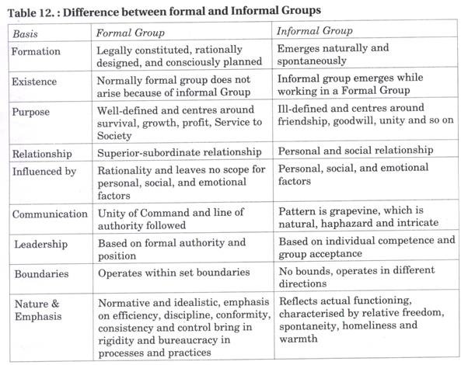

Characteristics of Informal Groups:
- Creation:
It is not created by the organisation but springs up spontaneously.
- Satisfaction of Needs:
The needs which cannot be satisfied within the framework of formal organisation, like social and psychological needs of people, such people create informal groups.
- Voluntary Membership:
Nobody is compelled to join an informal organization.
- Multi-Group Membership:
A member of an informal group can be a member of more than one informal group to pursue different interests.
- Systems and Processes:
Members of such groups follow their own norms, leadership, communication, etc. to remain cohesive. The communication channels are referred to as ‘Grapevine’. Grapevine i.e., informal channel runs very fast to spread the information across the organization.
- Leadership:
Every informal group has a leader, selected by the group, and who is capable of helping to realize their goals. The moment it is realized that the leader is incapable, (s) he is replaced with a new leader.

Reasons for the Emergence of Informal Groups:
- People working together may come together.
- People with similar values, beliefs, attitudes, and interests often feel attraction to come together.
- Need satisfaction – to belong, to associate, etc.
- Removal of monotony of routine tasks – to get rid of monotony and psychological fatigue, job-related boredom and frustration provides an opportunity to behave in a natural and relaxed manner.
- Promotion of other interests and pursuit of goals – People join Rotary or Lions Club to expand their contacts which may help them to satisfy their personal goals.

Benefits of Informal Groups:
The benefits of an informal group are as follows:
- Blending with formal group allows people to work for the formal organisation.
- Informal work group lightens the workload for the formal manager.
- Brings satisfaction and stability to the organisation as a whole.
- Provides a useful channel of communication.
- Encourages managers to plan and act more carefully.

Limitations of Informal Groups:
The limitations are as follows:
- Resistance to Change because they do not want to deviate from existing norms and learn new ways.
- Informal group provides most fertile ground for Rumour Mongering because of maliciousness, lack of proper communication systems and processes and ambiguous circumstances.
- Since a member of an informal group is also a member of a formal group, at times it creates role conflict.
- Creativity of group member (s) is restricted because of strong pressure for conformity applied by the group.

Forms of Group Decision Making in Organizations

There are 6 Forms of Group Decision Making in Organizations
Decision-making is one of the toughest parts of any innovation process, especially when working on complex challenges in a group context.
A leader can substantially ease this process by specifying the decision-making process that he or she is planning to use. To do this, that leader announces at the beginning of the discussion how the decision will be reached, as well as how much and what kind of participation is expected from the rest of the group.
Below are six different kinds of group decision-making processes and the pros and cons for each.
- Unanimous
Unanimous decisions occur when all agree without reservation. They are easier for trivial matters, but very difficult for important and/or higher-pressure situations. Be careful not to confuse unanimity with consensus.
- Consensus
In a consensus, each person agrees to support the decision, though all may not agree, and gives his or her consent. Despite differing perspectives, all agree that they can live with the decision. Consensus is the process most likely to ensure that each person’s input is valued, heard and considered.
- Majority Rule
Majority rule decisions are made when more than half the group votes in favor. This process is used frequently in democracies, and rarely in organizations. Majority decisions, as with any voting situation, risk that you won’t have full support and that those not in agreement with the majority may do something less than helpful later. It also carries the possibility of establishing an “us” versus “them” mentality.
- Expert
In this scenario, the group delegates the decision-making responsibility to an expert or small subgroup. This type of process is good for situations that do not require the entire group’s participation.
- Executive
In an executive decision, the leader makes the call. Most decisions are executive, and should be. The big mistake is that often the kind and amount of participation leading up to this kind of decision-making isn’t what it should be. The best decision-making is typically a highly participative executive decision. This approach is critical when dealing with issues such as team vision and mission.
- Default
In this scenario, a decision is made by action, or more likely, inaction that forces a conclusion. It is a powerless form of decision-making and is best avoided.

Concept of Team v/s Group

Nowadays, group or team concept is adopted by the organization, to accomplish various client projects. When two or more individuals are classed together either by the organization or out of social needs, it is known as a group. On the other hand, a team is the collection of people, who are linked together to achieve a common objective.
Most of the work in a business entity is performed in groups. Although the individual personality of an employee is important, their effectiveness depends on the teams in which they are working collectively to achieve any objective. In a particular team, there can be several groups in which the group members individually help their leader to accomplish the goals.

Comparison Chart
BASIS FOR COMPARISON | GROUP | TEAM
Meaning | A collection of individuals who work together in completing a task. | A group of persons having collective identity joined together, to accomplish a goal.
Leadership | Only one leader | More than one
Members | Independent | Interdependent
Process | Discuss, Decide and Delegate. | Discuss, Decide and Do.
Work Products | Individual | Collective
Focus on | Accomplishing individual goals. | Accomplishing team goals.
Accountability | Individually | Either individually or mutually

Group
A group is an assemblage of persons who work, interact and cooperate with one another in achieving a common goal in a specified time. The identity of the group members is taken individually. The members share information and resources with other group members.
In an organisation, the groups are made on the basis of common interests, beliefs, experience in common fields and principles, so that they can easily coordinate with each other. There are two kinds of groups:
- Formal Group: These groups are created by the management of the organisation for performing a specific task.
- Informal Group: The formation of these groups is done naturally in an organisation, to satisfy the social or psychological human needs.
For example: Ethnic groups, trade unions, friendship circles, airline flight crew, etc.

Team
A group of people who are joined for achieving a common goal within a stipulated period, having collective accountability is known as the team. The agenda of the team is “one for all and all for one”. Apart from sharing information, the team members also share the responsibility of the team task. The team is always responsible for the outcome (i.e. Result of the collective efforts of the team members).
The team members have a mutual understanding with other members. They work jointly to maximise the strengths and minimise the weakness by complementing each other. The most important feature of a team is “synergy” i.e. the team can achieve much more as the members can achieve individually. The three key features of team functioning are:
- Cohesion
- Confrontation
- Collaboration
For example: Cricket team, team for accomplishing a project, team of doctors, management team etc.

Key Differences between Group and Team
The difference between group and team in the workplace can be drawn clearly on the following grounds:
- There is only one head in a group. A team can have more than one head.
- The group members do not share responsibility, but team members share the responsibility.
- The group focuses on achieving the individual goals. Conversely, the team members focus on achieving the team goals.
- The group produces individual work products. As opposed to, the team who produces collective work products.
- The process of a group is to discuss the problem, then decide and finally delegate the tasks to individual members. On the other hand, a team discusses the problem, then decide the way of solving it and finally do it collectively.
- The group members are independent. Unlike a group, the team members are interdependent.

Contemporary issues in Managing Teams

Reinvigorating Mature Teams
Mature teams are particularly prone to suffer from groupthink .Members begin to believe they can read everyones mind so they know what everyone is thinking. As a result, team members become reluctant to express their thoughts and less likely to challenge each other.
Another source of problem for mature teams is that their early success are often due to having taken on easy tasks. Is normal for new teams to begin by taking on those issues and problems that they can handle most easily. But as time passes, the easy problems become solved and the team has to begin to confront more difficult issues. At this point, the team has typically developed entrenched processes and routines, and members are reluctant to change the perfect system they have already worked out. The results can often be disasterous .Internal team processes no longer work smoothly. Communication bogs down .Conflicts increase because problems are less likely to have obvious solutions. And team performance can drop dramatically.
What can be done to reinvigorate mature teams? We offer four suggestion:
- Prepare members to deal with the problems of maturity .Remind team members that they are not unique all successful teams have to confront maturity issues. They shouldn’t feel let down or lose their confidence in the team concept when the initial euphoria subsides and conflicts surface.
2. Offer refresher training. When teams get into ruts, it may help to provide them with refresher training in communication, conflict resolution, team processes, and similar skills. This can help members regain confidence and trust in one another.
3. Offer advanced training. The skills that worked with easy problems may be insufficient for more difficult ones. So mature teams can often benefit from advanced training to help members develop stronger problem-solving, interpersonal and technical skills.
4. Encourage teams to treat their development as a constant learning experience .Like TQM, teams should approach their own development as part of a search for continuous improvement. Teams should look for ways to improve, to confront member fears and frustrations, and to use conflict as a learning opportunity.

Teams And Total Quality Management
One of the central characteristics of total quality management (TQM) is the use of teams.
The essence of TQM is process improvement, and employee involvement is the linchpin of process improvement .In other words, TQM requires management to give employees the encouragement to share ideas and act on what they suggest. As one author put it, None of the various TQM processes and techniques will catch on and be applied except in work teams. All such techniques and processes require high levels of communication and contact, response and adaptation, and coordination and sequencing. They require, in short, the environment that can be supplied only by superior work teams.
Ford began its TQM efforts in the early 1980s with teams as the primary organizing mechanism. Because this business is so complex, you can’t make an impact on it without a team approach, noted one ford manager. In designing its quality problem-solving teams, Management identified five goals. The teams should
1.Be small enough to be efficient and effective.
2. Be properly trained in the skills their members will need.
3. Be allocated enough time to work on the problems they plan to address.
4. Be given the authority to resolve the problems and implement corrective action.
5. Each have a designated champion whose job it is to help the team get around roadblocks that arise.
At Amana, cross-functional task forces made up of people from different levels within the company are used to deal with quality problems that cut across departmental lines .The various task forces Each have a unique area of problem-solving responsibility. For instance, one handles in-plant products, another deals with items that arise outside the production facility, and still another focuses its attention specifically on supplier problems. Amana claims the use of these teams has improved vertical and horizontal communication within the company and substantially reduced both the number of units that donate meet company specifications and the number of service problems in the field.

Teams and workforce diversity
Managing diversity on teams is a balancing act .Diversity typically provides fresh perspectives on issues, but it makes it more difficult to unify the team and reach agreements.
The strongest case for diversity on work teams is when these teams are engaged in problem-solving and decision-making tasks. Heterogeneous teams bring multiple perspectives to the discussion, thus increasing the likelihood that the team will identify creative or unique solutions. Additionally ,the lack of a common perspective usually means diverse teams spend more time discussing issues, which decreases the chances that a weak alternative will be chosen .However ,keep in mind that the positive contribution that diversity makes to decision-making teams undoubtedly declines over time. Diverse groups have more difficulty working together and solving problems, but this dissipates with time. Expect the value-added component of diverse teams to decrease as members become more familiar with each other and the team becomes more cohesive.
Studies tell us that members of cohesive teams have greater satisfaction, lower absenteeism, and lower attrition from the group. Yet cohesiveness is likely to be lower on diverse teams .So here is a potential negative of diversity. It is detrimental to group cohesiveness.
The relationship between cohesiveness and group productivity was moderated by performance related norms .we suggest that if the norms of the team are supportive of diversity, then a team can maximize the value of heterogeneity while, at the same time, achieving the benefits of high cohesiveness .This makes a strong case for team members to participate in diversity training.

Conflict Process
The conflict process consists of five stages are:
- Potential opposition or incompatibility.
- Cognition and personalization.
- Intentions.
- Behavior.
- Outcomes.
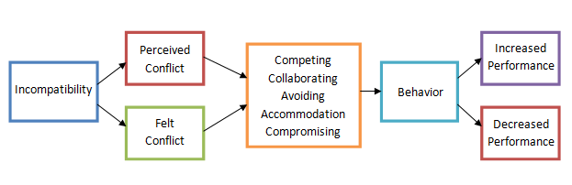
- Potential Opposition or Incompatibility
It includes the presence of a condition that creates opportunities for conflicts to arise. The conditions that can cause conflict are of 3 types.
(a) Communication: Insufficient exchange of information and noise in the communication channel are all barriers of communication and create conditions for conflicts. Potential for conflict increases when either too little or too much communication takes place. The channel for communication also has an influence on the conditions causing conflict.
(b) Structure: Size and specialization act as a force to stimulate conflict. The larger the group, the more specialized their activities, the greater the likelihood of conflict. Tenure and conflict have been found to be inversely related. There is increased conflict when group members are younger and when turnover is high.
Groups within the organizations have diverse goals. E.g.: Quality control department is concerned with improving the quality of products while marketing department is concerned with selling large no of goods and increasing the revenue. This diversity of goals also is a source of conflict.
(c) Personal variables: This includes the value systems each person has and personality characteristics each possess. Difference in value systems are a source of conflict, as they result in disagreement between members of the group.
- Cognition and Personalization
This step in the conflict process is important because it is in the step the parties decide what the conflict is done. Awareness by one or more parties about the existence of conditions that create opportunities for conflict to arise is called perceived conflict. Emotional involvement in the conflict creating anxiety, frustration and enimity is called felt conflict. Positive emotions help in finding solutions to solve conflicts while a negative emotion enhances the conflict.
- Intensions
These are the decisions to act during conflict. There are five conflict handing intensions. They are:
(a) Competing: (assertive and unco-operative): It is a desire to satisfy ones own interest regardless of its impact on the other party. It includes desire to achieve ones own goal at the sacrifice of others goal, attempting to convince others that your conclusion is correct and attempting to make someone else accept the blame for the problem.
(b) Collaborating (assertive and co-operative): It is a desire to satisfy all the parties. It includes attempting to find a win-win situation that allows both parties goals to be achieved.
(c) Avoiding (unassertive and uncooperative): It is a desire to suppress a conflict. It includes ignoring the conflict and avoiding others with whom one disagrees.
(d) Accommodating (unassertive and cooperative): It is a willingness to place the opponent’s interest above ones own. It includes sacrificing ones goal to maintain other party’s goals.
(e) Compromising: It is situation in which each party conflict is willing to give up something. There is no clear loser or winner.
- Behavior
In this stage, each party’s intentions are implemented. This is an interactive stage.
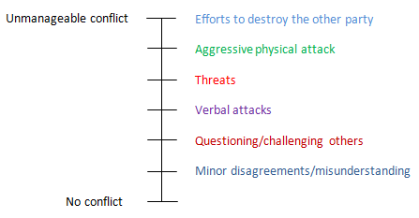
Conflict at the lower part continuum is small conflicts. Conflicts in the upper part of the continuum are highly destructive. Strikes, riots, and wars fall in upper range.
- Outcome
The action-reaction between conflicting parties results in two kinds of outcomes.
(a) Functional outcomes: Conflict results in improved performance of the group. It improves the quality of decisions, brings about creativity and innovations, encourage interests and curiosity among group members.
(b) Dysfunctional outcomes: It reduces the effectiveness of the group. It is as a result of uncontrolled opposition. It leads to destruction of the group. It reduces group communication and group coordination.

Management of Conflict Resolution & Stimulation Techniques

CONFLICT RESOLUTION MANAGEMENT
Effective conflict resolution can save money: Although conflict can be healthy, destructive conflict can be costly unless you have the right human resources expertise when things go wrong.
Most organizations experience conflict at some time. Conflict can arise within teams or with individual colleagues. Disputes resolved in the right way is a healthy part of working with others. Professional HR Expertise is essential if an organization has a culture of conflict. An organization adopting good conflict resolution management can be a purposeful way to highlight and solve problems in the workplace. Precious time, energy and wasted costs can be saved if the conflict can be resolved quickly and effectively.
The dynamics of conflict resolution: When considering the components of conflict resolution, there are two dynamics to take into account. The first is about conflict resolution styles. The second is around differences in personality type. If we aren’t sure how people tick, then personality clashes can get in the way of effective conflict resolution.
Thomas-Kilmann Conflict Mode Instrument: The Thomas-Kilman Conflict Model sets out 5 different styles of conflict resolution. and the way different people operate. By understanding these two ways of approaching conflict, you can empower staff and managers to handle differences in a completely new way.
Everyone has a way of dealing with conflict that is unique to them. An organization has a “culture” of dealing with conflict that often has nothing to do with the policies and values of the company. It is very powerful for an organization to understand how they can use different styles of conflict resolution in different situations to get a win/win result.
Personality and conflict: Understanding personality types can identify the causes of conflict. Myers-Briggs personality type instrument ( MBTI ) is a powerful and effective tool which can be used to identify those differences. MBTI can help individuals and teams to understand differences, by helping people understand how they themselves and others, operate. The result can be less conflict and greater harmony in the workplace. A good Human Resources or an MBTI practitioner can help your organization navigate through the maze of conflict by:
- Helping raise awareness of conflict and solutions
- Supporting managers to build a framework of their style
- Helping teams and individuals to understand different personality types and raising awareness of the benefits of difference
- Offer mediation where any conflicts have become formal
- Help organizations to have effective policies and processes to deal with conflict in a timely and effective way
- Help Managers to understand their legislative obligations, particularly around the Equality Act 2010
- Understanding conflict resolution styles and personality types, organizations are well equipped to pivot conflict to create a healthy culture of airing differences.

Approaches to Conflict Stimulation
Conflict stimulation is also a measure to solve conflict. In traditional concept, conflict was taken as dangerous factor. But in modern concept, conflict is not taken as dangerous all time. Nowadays, some institutes create conflict to find new way and for innovation. If there is not created conflict in institute, manager should think that there is some mistake. That’s why conflict is index of development. So that while solving the conflict, it is necessary to create the conflict. While creating conflict, following methods should be applied;
(i) Use of Communication: Communication encourages and discourages the conflict. So that, while creating conflict in required level unclear message should be sent. Threatened and challenge to the workers also a measure to create conflict.
(ii) Bringing in Outsider: Conflict also can be created by entering members with different background, value, view and managerial skill. The discussion with the person with different background helps to find new way. In this way, orientation with different members from outsides provides creative way at last.
(iii) Restructuring the Organization: By changing current design of organization, functional conflict can be created. With the help of restructure, the size of organization is changed. In this way with the help of restructure different difficulties and problems are solved in current situation.
(iv) Appointing a Devil’s Advocate: Appointing a Devil’s Advocate, the organization also can create the conflict. This types of person solves the problems differently of the members of organization. He works as conflict motivator. If he has good skill, knowledge and mind, can be good advocator of organization.
There are other many methods to create conflict for eg. Removing the person from work, making disagreement with group, Organization and Helpers and Changing the rules, regulation and policy, conflict can be created. In this way, while managing conflict, organization should create conflict in required level.

