UNIT-V

Significance, Types and Construction of Diagrams and Graphs

Significance of Diagrams and Graphs:
Diagrams and graphs are extremely useful because of the following reasons.
- They are attractive and impressive.
- They make data simple and intelligible.
- They make comparison possible
- They save time and labour.
- They have universal utility.
- They give more information.
- They have a great memorizing effect.

Types of Diagrams and Graphs
One of the most effective and interesting alternative ways to present statistical data is through diagrams and graphs. There are several ways in which statistical data may be displayed pictorially, such as different types of graphs and diagrams. The most commonly used diagrams and graphs shall be discussed in subsequent posts, as listed below.

Types of Diagrams/Charts
- Simple Bar Chart
- Multiple Bar Chart or Cluster Chart
- Stacked Bar Chart or Sub-Divided Bar Chart or Component Bar Chart
  - Simple Component Bar Chart
  - Percentage Component Bar Chart
  - Sub-Divided Rectangular Bar Chart
  - Pie Chart

Types of Diagrams/Charts
- Histogram
- Frequency Curve and Polygon
- Lorenz Curve
- Historgram

Construction of Diagrams and Graphs
The following general rules should be observed while constructing diagrams:
- Title: Every diagram must be given a suitable title. The title should convey in as few a words as possible the main idea that the diagrams intent to portray. However, the brevity should not be secured at the cost of clarity or omission of essential details. The title may be given either at the top of the diagram or below it.
- Proportion between width and height: A proper proportion between the height and width of the diagram should be maintained. If either the height and width is too short or too long in proportion, the diagram would given an ugly look. While there are no fixed rules about the dimensions, a convenient standard as suggested by Lutz in the book entitled “Graphic Presentation” may be adopted for general use. It is known as “Root-two”, that is, a ratio of 1 (short side) to 1.414 (long side). Modifications may, no doubt, be made to accommodate a diagram in the space available.
- Selection of scale: The scale showing the values may be in even numbers or in multiples of five or ten, eg. 25, 50, 75, or 20, 40, 60. Odd values like 1, 3, 5, 7 may be avoided.
- Footnotes: In order to clarify certain points about the diagram, footnote may be given at the bottom of the diagram.
- Index: An index illustrating different types of lines or different shades, colours should be given so that the reader can easily make out the meaning of the diagram.
- Neatness and cleanliness: Diagrams should be absolutely neat and clean.
- Simplicity: Diagrams should be as simple as possible so that the reader can understand their meaning clearly and easily. For the sake of simplicity, it is important that too much material should not be loaded in a single diagram otherwise it may become too confusing and prove worthless. Several simple charts are often better and more effective than one or two complex ones which may present the same material in a confusing way.

Graphical Representation of Data: Appropriate Usages of Bar Chart, Pie Charts, Histogram

Graphic representation is another way of analyzing numerical data. A graph is a sort of chart through which statistical data are represented in the form of lines or curves drawn across the coordinated points plotted on its surface.
Graphs enable us in studying the cause and effect relationship between two variables. Graphs help to measure the extent of change in one variable when another variable changes by a certain amount.
Graphs also enable us in studying both time series and frequency distribution as they give clear account and precise picture of problem. Graphs are also easy to understand and eye catching.
General Principles of Graphic Representation
There are some algebraic principles which apply to all types of graphic representation of data. In a graph there are two lines called coordinate axes. One is vertical known as Y axis and the other is horizontal called X axis. These two lines are perpendicular to each other. Where these two lines intersect each other is called ‘0’ or the Origin. On the X axis the distances right to the origin have positive value (see fig. 7.1) and distances left to the origin have negative value. On the Y axis distances above the origin have a positive value and below the origin have a negative value.
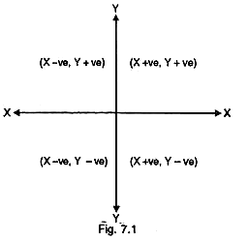

BAR CHART
A bar chart or bar graph is a chart or graph that presents categorical data with rectangular bars with heights or lengths proportional to the values that they represent. The bars can be plotted vertically or horizontally. A vertical bar chart is sometimes called a line graph.
A bar graph shows comparisons among discrete categories. One axis of the chart shows the specific categories being compared, and the other axis represents a measured value. Some bar graphs present bars clustered in groups of more than one, showing the values of more than one measured variable.
A vertical bar graph is shown below:
Number of students went to different states for study:
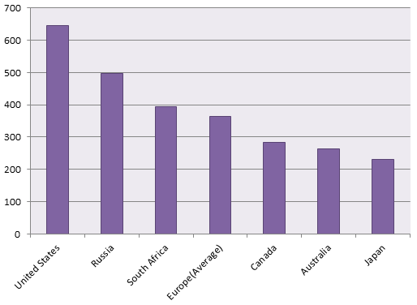
The rectangular bars are separated by some distance in order to distinguish them from one another. The bar graph shows comparison among the given categories.
Mostly, horizontal axis of the graph represents specific categories and vertical axis shows the discrete numerical values.

PIE CHART
A pie chart (or a circle chart) is a circular statistical graphic, which is divided into slices to illustrate numerical proportion. In a pie chart, the arc length of each slice (and consequently its central angle and area), is proportional to the quantity it represents. While it is named for its resemblance to a pie which has been sliced, there are variations on the way it can be presented. The earliest known pie chart is generally credited to William Playfair’s Statistical Breviary of 1801.
Pie charts are very widely used in the business world and the mass media. However, they have been criticized, and many experts recommend avoiding them, pointing out that research has shown it is difficult to compare different sections of a given pie chart, or to compare data across different pie charts. Pie charts can be replaced in most cases by other plots such as the bar chart, box plot or dot plots.
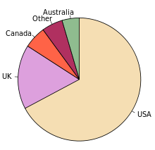
Fig. – Pie chart of populations of English native speakers

HISTOGRAM
Histogram is a non-cumulative frequency graph, it is drawn on a natural scale in which the representative frequencies of the different class of values are represented through vertical rectangles drawn closed to each other. Measure of central tendency, mode can be easily determined with the help of this graph.
How to draw a Histogram?
Step—1
Represent the class intervals of the variables along the X axis and their frequencies along the Y-axis on natural scale.
Step—2
Start X axis with the lower limit of the lowest class interval. When the lower limit happens to be a distant score from the origin give a break in the X-axis n to indicate that the vertical axis has been moved in for convenience.
Step—3
Now draw rectangular bars in parallel to Y axis above each of the class intervals with class units as base: The areas of rectangles must be proportional to the frequencies of the corresponding classes.
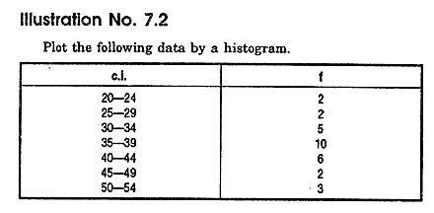
Solution
In this graph we shall take class intervals in the X axis and frequencies in the Y axis. Before plotting the graph we have to convert the class into their exact limits.
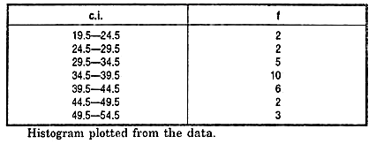
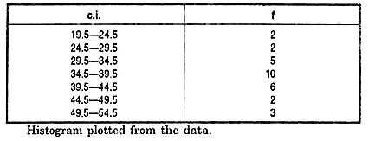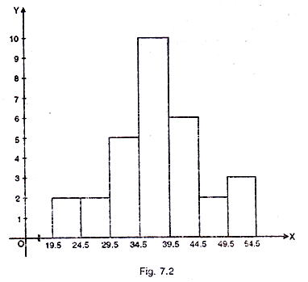
Advantages of histogram
- It is easy to draw and simple to understand.
- It helps us to understand the distribution easily and quickly.
- It is more precise than the polygene.
Limitations of histogram
- It is not possible to plot more than one distribution on same axes as histogram.
- Comparison of more than one frequency distribution on the same axes is not possible.
- It is not possible to make it smooth.
Uses of histogram
- Represents the data in graphic form.
- Provides the knowledge of how the scores in the group are distributed. Whether the scores are piled up at the lower or higher end of the distribution or are evenly and regularly distributed throughout the scale.
- Frequency Polygon. The frequency polygon is a frequency graph which is drawn by joining the coordinating points of the mid-values of the class intervals and their corresponding frequencies.

Report Structure: Preliminaries Section, Main Report
Simple Report Sections
- Introduction, including aims and objectives
- Methodology
- Findings/results
- Discussion
- Conclusions and recommendations
- References

The Sections of a Simple Report-
(i) Introduction
State what your research/project/enquiry is about. What are you writing about, why and for whom? What are your objectives? What are you trying to show or prove (your hypothesis)?
(ii) Methodology
State how you did your research/enquiry and the methods you used. How did you collect your data? For example, if you conducted a survey, say how many people were included and how you selected them. Say whether you used interviews or questionnaires and how you analyzed the data.
(iii) Findings/Results
Give the results of your research. Do not, at this stage, try to interpret the results – simply report them. This section may include graphs, charts, diagrams etc. (clearly labelled). Be very careful about copyright if you are using published charts, tables, illustrations etc.
(iv) Discussion
Interpret your findings. What do they show? Were they what you expected? Could your research have been done in a better way?
(v) Conclusions and Recommendations
These should follow on logically from the Findings and Discussion sections. Summarise the key points of your findings and show whether they prove or disprove your hypothesis. If you have been asked to, you can make recommendations arising from your research.
(vi) References
List all your sources in alphabetical order, using the appropriate University of Hull style. You might find our referencing pages useful.
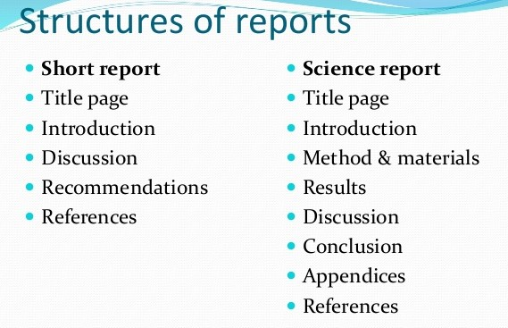
Preliminaries
- Title page
- Terms of reference, including scope of report
- Contents
- List of tables and diagrams
- Acknowledgements, i.e. thanks to those who helped with the report
- Summary, i.e. key points of the report
Main part
- Introduction
- Methodology
- Findings/results
- Discussion
- Conclusions and recommendations
Supplementary
- References/bibliography
- Appendices
- Glossary

Types of Report
Type 1. Formal or Informal Reports
Formal reports are carefully structured; they stress objectivity and organization, contain much detail, and are written in a style that tends to eliminate such elements as personal pronouns. Informal reports are usually short messages with natural, casual use of language. The internal memorandum can generally be described as an informal report.
Type 2. Short or Long Reports
This is a confusing classification. A one-page memorandum is obviously short, and a twenty page report is clearly long. But where is the dividing line? Bear in mind that as a report becomes longer (or what you determine as long), it takes on more characteristics of formal reports.
Type 3. Informational or Analytical Reports
Informational reports (annual reports, monthly financial reports, and reports on personnel absenteeism) carry objective information from one area of an organization to another. Analytical reports (scientific research, feasibility reports, and real-estate appraisals) present attempts to solve problems.
Type 4. Proposal Report
The proposal is a variation of problem-solving reports. A proposal is a document prepared to describe how one organization can meet the needs of another. Most governmental agencies advertise their needs by issuing “requests for proposal” or RFPs. The RFP specifies a need and potential suppliers prepare proposal reports telling how they can meet that need.
Type 5. Vertical or Lateral Reports
This classification refers to the direction a report travels. Reports that more upward or downward the hierarchy are referred to as vertical reports; such reports contribute to management control. Lateral reports, on the other hand, assist in coordination in the organization. A report traveling between units of the same organization level (production and finance departments) is lateral.
Type 6. Internal or External Report
Internal reports travel within the organization. External reports, such as annual reports of companies, are prepared for distribution outside the organization.
Type 7. Periodic Reports
Periodic reports are issued on regularly scheduled dates. They are generally upward directed and serve management control. Preprinted forms and computer-generated data contribute to uniformity of periodic reports.
Type 8. Functional Reports
This classification includes accounting reports, marketing reports, financial reports, and a variety of other reports that take their designation from the ultimate use of the report. Almost all reports could be included in most of these categories. And a single report could be included in several classifications.
Although authorities have not agreed on a universal report classification, these report categories are in common use and provide a nomenclature for the study (and use) of reports. Reports are also classified on the basis of their format. As you read the classification structure described below, bear in mind that it overlaps with the classification pattern described above.
(i) Preprinted Form
Basically for “fill in the blank” reports. Most are relatively short (five or fewer pages) and deal with routine information, mainly numerical information. Use this format when it is requested by the person authorizing the report.
(ii) Letter
Common for reports of five or fewer pages that are directed to outsiders. These reports include all the normal parts of a letter, but they may also have headings, footnotes, tables, and figures. Personal pronouns are used in this type of report.
(iii) Memo
Common for short (fewer than ten pages) informal reports distributed within an organization. The memo format of “Date,” “To,” “From,” and “Subject” is used. Like longer reports, they often have internal headings and sometimes have visual aids. Memos exceeding ten pages are sometimes referred to as memo reports to distinguish them from shorter ones.
(iv) Manuscript
Common for reports that run from a few pages to several hundred pages and require a formal approach. As their length increases, reports in manuscript format require more elements before and after the text of the report. Now that we have surveyed the different types of reports and become familiar with the nomenclature, let us move on to the actual process of writing the report.

Mechanism of Report Writing
There are very definite and set rules which should be followed in the actual preparation of the research report or paper. Once the techniques are finally decided, they should be scrupulously adhered to, and no deviation permitted. The criteria of format should be decided as soon as the materials for the research paper have been assembled. The following points deserve mention so far as the mechanics of writing a report are concerned:

Size and physical design
The manuscript should be written on unruled paper 81/2× 11in size. If it is to be written by hand, then black or blue-black ink should be used. A margin of at least one and one-half inches should be allowed at the left hand and of at least half an inch at the right hand of the paper. There should also be one-inch margins, top and bottom. The paper should be neat and legible. If the manuscript is to be typed, then all typing should be double-spaced on one side of the page only except for the insertion of the long quotations.

Procedure
Various steps in writing the report should be strictly adhered (All such steps have already been explained earlier in this chapter).

Layout
Keeping in view the objective and nature of the problem, the layout of the report should be thought of and decided and accordingly adopted (The layout of the research report and various types of reports have been described in this chapter earlier which should be taken as a guide for report-writing in case of a particular problem).

Treatment of Quotations
Quotations should be placed in quotation marks and double spaced, forming an immediate part of the text. But if a quotation is of a considerable length (more than four or five type written lines) then it should be single-spaced and indented at least half an inch to the right of the normal text margin.

The footnotes
Regarding footnotes one should keep in view the followings:
- The footnotes serve two purposes viz., the identification of materials used in quotations in the report and the notice of materials not immediately necessary to the body of the research text but still of supplemental value. In other words, footnotes are meant for cross references, citation of authorities and sources, acknowledgement and elucidation or explanation of a point of view. It should always be kept in view that footnote is not an end nor a means of the display of scholarship. The modern tendency is to make the minimum use of footnotes for scholarship does not need to be displayed.
- Footnotes are placed at the bottom of the page on which the reference or quotation which they identify or supplement ends. Footnotes are customarily separated from the textual material by a space of half an inch and a line about one and a half inches long.
- Footnotes should be numbered consecutively, usually beginning with 1 in each chapter separately. The number should be put slightly above the line, say at the end of a quotation. At the foot of the page, again, the footnote number should be indented and typed a little above the line. Thus, consecutive numbers must be used to correlate the reference in the text with its corresponding note at the bottom of the page, except in case of statistical tables and other numerical material, where symbols such as the asterisk (*) or the like one may be used to prevent confusion.
- Footnotes are always typed in single space though they are divided from one another by double space.

Documentation Style
Regarding documentation, the first footnote reference to any given work should be complete in its documentation, giving all the essential facts about the edition used. Such documentary footnotes follow a general sequence. The common order may be described as under:
(i) Regarding the single-volume reference
- Author’s name in normal order (and not beginning with the last name as in a bibliography) followed by a comma;
- Title of work, underlined to indicate italics;
- Place and date of publication;
- Pagination references (The page number).
Example
John Gassner, Masters of the Drama, New York: Dover Publications, Inc. 1954, p. 315.
(ii) Regarding multivolume reference
- Author’s name in the normal order;
- Title of work, underlined to indicate italics;
- Place and date of publication;
- Number of volume;
- Pagination references (The page number).
(iii) Regarding works arranged alphabetically
For works arranged alphabetically such as encyclopedias and dictionaries, no pagination reference is usually needed. In such cases the order is illustrated as under:
Example 1
“Salamanca,” Encyclopaedia Britannica, 14th Edition.
Example 2
“Mary Wollstonecraft Godwin,” Dictionary of national biography.
But if there should be a detailed reference to a long encyclopedia article, volume and pagination reference may be found necessary.
(iv) Regarding periodicals reference
- Name of the author in normal order;
- Title of article, in quotation marks;
- Name of periodical, underlined to indicate italics;
- Volume number;
- Date of issuance;

(v) Regarding anthologies and collections reference Quotations from anthologies or collections of literary works must be acknowledged not only by author, but also by the name of the collector.

Regarding Second-Hand Quotations Reference
In such cases the documentation should be handled as follows:
Original author and title;
“quoted or cited in,”;
Second author and work.
Example
J.F. Jones, Life in Ploynesia, p. 16, quoted in History of the Pacific Ocean area, by R.B. Abel, p. 191.

Case of Multiple Authorship
If there are more than two authors or editors, then in the documentation the name of only the first given and the multiple authorship is indicated by “et al.” or “and others”. Subsequent references to the same work need not be so detailed as stated above. If the work is cited again without any other work intervening, it may be indicated as ibid, followed by a comma and the page number. A single page should be referred to as p., but more than one page be referred to as pp. If there are several pages referred to at a stretch, the practice is to use often the page number, for example, pp. 190ff, which means page number 190 and the following pages; but only for page 190 and the following page ‘190f’. Roman numerical is generally used to indicate the number of the volume of a book. Op. cit. (opera citato, in the work cited) or Loc. cit. (loco citato, in the place cited) are two of the very convenient abbreviations used in the footnotes. Op. cit. or Loc. cit. after the writer’s name would suggest that the reference is to work by the writer which has been cited in detail in an earlier footnote but intervened by some other references.

Punctuation and abbreviations in footnotes
The first item after the number in the footnote is the author’s name, given in the normal signature order. This is followed by a comma. After the comma, the title of the book is given: the article (such as “A”, “An”, “The” etc.) is omitted and only the first word and proper nouns and adjectives are capitalized. The title is followed by a comma. Information concerning the edition is given next. This entry is followed by a comma. The place of publication is then stated; it may be mentioned in an abbreviated form, if the place happens to be a famous one such as Lond. for London, N.Y. for New York, N.D. for New Delhi and so on. This entry is followed by a comma. Then the name of the publisher is mentioned and this entry is closed by a comma. It is followed by the date of publication if the date is given on the title page. If the date appears in the copyright notice on the reverse side of the title page or elsewhere in the volume, the comma should be omitted and the date enclosed in square brackets [c 1978], [1978]. The entry is followed by a comma. Then follow the volume and page references and are separated by a comma if both are given. A period closes the complete documentary reference. But one should remember that the documentation regarding acknowledgements from magazine articles and periodical literature follow a different form as stated earlier while explaining the entries in the bibliography.

Use of statistics, charts and graphs
A judicious use of statistics in research reports is often considered a virtue for it contributes a great deal towards the clarification and simplification of the material and research results. One may well remember that a good picture is often worth more than thousand words. Statistics are usually presented in the form of tables, charts, bars and line-graphs and pictograms. Such presentation should be self explanatory and complete in itself. It should be suitable and appropriate looking to the problem at hand. Finally, statistical presentation should be neat and attractive.

The final draft
Revising and rewriting the rough draft of the report should be done with great care before writing the final draft. For the purpose, the researcher should put to himself questions like: Are the sentences written in the report clear? Are they grammatically correct? Do they say what is meant’? Do the various points incorporated in the report fit together logically? “Having at least one colleague read the report just before the final revision is extremely helpful. Sentences that seem crystal-clear to the writer may prove quite confusing to other people; a connection that had seemed self evident may strike others as a non-sequitur. A friendly critic, by pointing out passages that seem unclear or illogical, and perhaps suggesting ways of remedying the difficulties, can be an invaluable aid in achieving the goal of adequate communication.

Bibliography
Bibliography should be prepared and appended to the research report as discussed earlier.

Preparation of the index
At the end of the report, an index should invariably be given, the value of which lies in the fact that it acts as a good guide, to the reader. Index may be prepared both as subject index and as author index. The former gives the names of the subject-topics or concepts along with the number of pages on which they have appeared or discussed in the report, whereas the latter gives the similar information regarding the names of authors. The index should always be arranged alphabetically. Some people prefer to prepare only one index common for names of authors, subject-topics, concepts and the like ones.

Precaution for Writing Report

Research report is a channel of communicating the research findings to the readers of the report. A good research report is one which does this task efficiently and effectively. As such it must be prepared keeping the following precautions in view:
- While determining the length of the report (since research reports vary greatly in length), one should keep in view the fact that it should be long enough to cover the subject but short enough to maintain interest. In fact, report-writing should not be a means to learning more and more about less and less.
- A research report should not, if this can be avoided, be dull; it should be such as to sustain reader’s interest.
- Abstract terminology and technical jargon should be avoided in a research report. The report should be able to convey the matter as simply as possible. This, in other words, means that report should be written in an objective style in simple language, avoiding expressions such as “it seems,” “there may be” and the like.
- Readers are often interested in acquiring a quick knowledge of the main findings and as such the report must provide a ready availability of the findings. For this purpose, charts, graphs and the statistical tables may be used for the various results in the main report in addition to the summary of important findings.
- The layout of the report should be well thought out and must be appropriate and in accordance with the objective of the research problem.
- The reports should be free from grammatical mistakes and must be prepared strictly in accordance with the techniques of composition of report-writing such as the use of quotations, footnotes, documentation, proper punctuation and use of abbreviations in footnotes and the like.
- The report must present the logical analysis of the subject matter. It must reflect a structure wherein the different pieces of analysis relating to the research problem fit well.
- A research report should show originality and should necessarily be an attempt to solve some intellectual problem. It must contribute to the solution of a problem and must add to the store of knowledge.
- Towards the end, the report must also state the policy implications relating to the problem under consideration. It is usually considered desirable if the report makes a forecast of the probable future of the subject concerned and indicates the kinds of research still needs to be done in that particular field.
- Appendices should be enlisted in respect of all the technical data in the report.
- Bibliography of sources consulted is a must for a good report and must necessarily be given.
- Index is also considered an essential part of a good report and as such must be prepared and appended at the end.
- Report must be attractive in appearance, neat and clean, whether typed or printed.
- Calculated confidence limits must be mentioned and the various constraints experienced in conducting the research study may also be stated in the report.
Objective of the study, the nature of the problem, the methods employed and the analysis techniques adopted must all be clearly stated in the beginning of the report in the form of introduction.
A research report forms a channel of communication between the research findings given by researcher on the one hand and the readers of the report on the other hand and effective communication of research findings to the readers is the basic task of the research report.
Hence researcher should keep in mind the following precautions while preparing the research report:
- The length of the report should be kept keeping in view the fact that it should cover the subject in length but it should be short enough to maintain the interest of readers.
- The report should not be dull. It should be such as to sustain one’s interest.
- The report should possess the features of simplicity and avoiding vagueness.
- Readers of the report are more interested in acquiring a quick knowledge of the main findings and the report should provide a ready availability of the findings with the help of charts, graphs and statistical tables.
- The contents of the report should be well thought out keeping in view the objective of the research problem.
- The grammatical mistakes should be avoided and the report should be prepared strictly in accordance with the techniques of composition of report. Writing such as the use of quotations, foot notes, proper punctuations and the use of abbreviations in the foot notes etc.
- Logical analysis should be the very basis of preparing a research report.
- The report should also suggest the policy implication relating to the problem under consideration and should help us in future forecasting.
- All the technical data should be appended in the report.
- A list of bibliography of various sources consulted for the research study should be prepared and be given in the report.
- A good report should also possess an index of subjects and authors as well. It should be appended at the end of the report.
- Report should be attractive in shape, neat and clean whether typed or printed.
- Calculated confidence limits must also be mentioned in the report and the various limitations experienced by the researcher in his study should be stated in the report.
- A good report should also mention the objective of the study the nature of the problem the methods and analysis techniques used. All these things should be given in the form of introduction in the report.
Thus after describing all the things related with the interpretation and report writing, we should always keep in view the fact that the process of writing a report is an art which is learnt by practice and experience.

