Unit 2 | Human Resource Planning and Employee Hiring
1 | Nature of Job Analysis
2 | Job Design
3 | Human Resource Planning
4 | Demand forecasting for Manpower Planning, HR Supply forecasting
5 | Factors Influencing HRP
6 | Employee Hiring- Nature of Recruitment, Sources of Recruitment
7 | Employee Selection, Process of Employee Selection
8 | Recent Trends in Recruitment

Nature of job Analysis
Job analysis is the process of determining the duties of various positions at an organizations and also the specific KSA’s (Knowledge, Skill, Abilities) required to perform these duties and hence the characteristics of the employee that is to be hired for that position. the information collected through job analysis is used to prepare job descriptions and job specifications.
Job Analysis is a process to identify and determine in detail the particular job duties and requirements and the relative importance of these duties for a given job. Job Analysis is a process where judgements are made about data collected on a job.
The Job; not the person An important concept of Job Analysis is that the analysis is conducted of the Job, not the person. While Job Analysis data may be collected from incumbents through interviews or questionnaires, the product of the analysis is a description or specifications of the job, not a description of the person.

Nature of Job Analysis
- Job analysis is a process of gathering relevant information about various aspects of a job and is concerned with the identification of tasks required to be performed as part of it.
- It approaches the task of defining the role, context, conditions, human behavior, performance standards and responsibilities of a job systematically.
- It helps in establishing the job’s worth to an organization. In other words, it measures the value and contribution of a job to the growth of the organization.
- It establishes job relatedness, which is a crucial input for HR decisions involving recruitment, selection, compensation, training, health and safety.
- It facilitates the process of understanding the impact of environmental changes on individual jobs.

Uses of Job Analysis
(i) Provide Base for different jobs Job analysis provides the base for identifying the contents of different jobs, their interrelationship and interdependence, responsibility involved in a job, and authority that may be required to perform the job.
(ii) Helps in organisational design Job analysis provides all the required information to get the framework of organisational design. Organisational design is building a network of relationships among various functions and positions. In organisational design various jobs to be perform are identified and grouped together on the basis of similarity. This process can only be done with the help of job analysis.
(iii) Human resource planning Job analysis proves to be of great help in case of Human Resource Planning by providing information for forecasting human resource needs in terms of knowledge, skills and experience. Job analysis also helps in planning for promotions and transfers by showing relationships among different jobs laterally as well as vertically.
(iv) Recruitment and selection Job analysis provides the basic ingredient required for recruitment and selection. It is well understood that recruitment and selection, taken together, is a process of identifying the source from where the personnel can be hired, motivating them, analysing them and selecting the ones who match the concerned job. We can say that matching jobs and individuals is the whole process of recruitment and selection. And both the types of information in the form of job description and job specification are provided through job analysis.
(v) Orientation and placement job analysis also helps in orientation and placement by providing complete information about job requirements. It further helps when an individual is selected to perform number of jobs and not a specific job.
(vi) Career planning Job analysis helps in career planning by providing information about the opportunities in terms of career paths and jobs availability in the organization with the help of this information, both individuals and organisation are able to chart out their plan for career planning and development.
(vii) Training Job analysis provides valuable information to identify training and development needs of various individuals. It is obvious that training and development needs can only be determined by job analysis. It is very important for every organization to put its endeavor in the form of training and development so that the individuals are equipped to meet the requirements of their jobs.
(viii) Job evaluation Job analysis plays an important role in evaluating the job and compensating it according to its worth in comparison to other jobs in an organization. The worth of a job is determined on the basis of job characteristics and job-holder characteristics. Job analysis provides both in the forms of job description and job specification.
(ix) Performance appraisal Job analysis helps in evaluating the performance of any individual in the organization. Performance appraisal is done by comparing the individual’s actual job performance with what is expected of him and job analysis decides what is expected of an employee and hence, it helps in determining performance standards against which the actual job performance is measured.
(x) Employee safety Job analysis helps in taking precautions to save the employees from the hazardous environmental and operational conditions in various jobs. It is obvious that all such kind of information related to a particular job will be provided by job analysis.
(xi) Counselling Job analysis also helps in providing counselling to employees in different areas. Sometimes, employees are unable to bear the stress of a particular job, then they are advised to opt for another job, but this is only possible with the information provided by job analysis.

Job Design
Job Design is the process of Work arrangement (or rearrangement) aimed at reducing or overcoming job dissatisfaction and employee alienation arising from repetitive and mechanistic tasks. Through job design, organizations try to raise productivity levels by offering non-monetary rewards such as greater satisfaction from a sense of personal achievement in meeting the increased challenge and responsibility of one’s work. Job enlargement, job enrichment, job rotation, and job simplification are the various techniques used in a job design exercise.
Although job analysis, as just described, is important for an understanding of existing jobs, organizations also must plan for new jobs and periodically consider whether they should revise existing jobs. When an organization is expanding, supervisors and human resource professionals must help plan for new or growing work units. When an organization is trying to improve quality or efficiency, a review of work units and processes may require a fresh look at how jobs are designed.
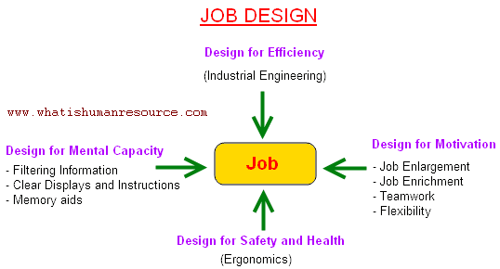
These situations call for job design, the process of defining the way work will be performed and the tasks that a given job requires, or job redesign, a similar process that involves changing an existing job design. To design jobs effectively, a person must thoroughly understand the job itself (through job analysis) and its place in the larger work unit’s work flow process (through work flow analysis). Having a detailed knowledge of the tasks performed in the work unit and in the job, a manager then has many alternative ways to design a job. As shown in Figure , the available approaches emphasize different aspects of the job: the mechanics of doing a job efficiently, the job’s impact on motivation, the use of safe work practices, and the mental demands of the job
Job design is the process of:
(a) Deciding the contents of the job.
(b) Deciding methods to carry out the job.
(c) Deciding the relationship which exists in the organization.
Job analysis helps to develop job design and job design matches the requirements of the job with the human qualities required to do the job

Human Resource Planning
Human resource is the most important asset of an organization. Human resources planning are the important managerial function. It ensures the right type of people, in the right number, at the right time and place, who are trained and motivated to do the right kind of work at the right time, there is generally a shortage of suitable persons.
According to E.W. Vetter, human resource planning is “the process by which a management determines how an organization should make from its current manpower position to its desired manpower position.
Through planning a management strives to have the right number and the right kind of people at the right places, at the right time to do things which result in both the organization and the individual receiving the maximum long range benefit.”
Dale S. Beach has defined it as “a process of determining and assuring that the organization will have an adequate number of qualified persons available at the proper times, performing jobs which meet the needs of the enterprise and which provide satisfaction for the individuals involved.”
In the words of Leon C. Megginson, human resource planning is “an integration approach to performing the planning aspects of the personnel function in order to have a sufficient supply of adequately developed and motivated people to perform the duties and tasks required to meet organisational objectives and satisfy the individual’s needs and goals of organisational members.”

Features of Human Resource Planning
- Well Defined Objectives
Enterprise’s objectives and goals in its strategic planning and operating planning may form the objectives of human resource planning. Human resource needs are planned on the basis of company’s goals. Besides, human resource planning has its own objectives like developing human resources, updating technical expertise, career planning of individual executives and people, ensuring better commitment of people and so on.
- Determining Human Resource Reeds
Human resource plan must incorporate the human resource needs of the enterprise. The thinking will have to be done in advance so that the persons are available at a time when they are required. For this purpose, an enterprise will have to undertake recruiting, selecting and training process also.
- Keeping Manpower Inventory
It includes the inventory of present manpower in the organization. The executive should know the persons who will be available to him for undertaking higher responsibilities in the near future.
- Adjusting Demand and Supply
Manpower needs have to be planned well in advance as suitable persons are available in future. If sufficient persons will not be available in future then efforts should be .made to start recruitment process well in advance. The demand and supply of personnel should be planned in advance.
- Creating Proper Work Environment
Besides estimating and employing personnel, human resource planning also ensures that working conditions are created. Employees should like to work in the organization and they should get proper job satisfaction.

Demand forecasting for manpower planning, HR supply forecasting
Based on the organization’s strategic plan, the first step in the strategic HR planning process is to assess the current HR capacity of the organization. The knowledge, skills and abilities of your current staff need to be identified. This can be done by developing a skills inventory for each employee.
The skills inventory should go beyond the skills needed for the particular position. List all skills each employee has demonstrated. For example, recreational or volunteer activities may involve special skills that could be relevant to the organization. Education levels and certificates or additional training should also be included.
An employee’s performance assessment form can be reviewed to determine if the person is ready and willing to take on more responsibility and to look at the employee’s current development plans.

Forecasting HR Requirements
The next step is to forecast HR needs for the future based on the strategic goals of the organization. Realistic forecasting of human resources involves estimating both demand and supply. Questions to be answered include:
- How many staff will be required to achieve the strategic goals of the organization?
- What jobs will need to be filled?
- What skill sets will people need?
When forecasting demands for HR, you must also assess the challenges that you will have in meeting your staffing need based on the external environment. To determine external impacts, you may want to consider some of the following factors:
- How does the current economy affect our work and our ability to attract new employees?
- How do current technological or cultural shifts impact the way we work and the skilled labour we require?
- What changes are occurring in the Canadian labour market?
- How is our community changing or expected to change in the near future?
- Why diversity at work matters

Gap Analysis
The next step is to determine the gap between where your organization wants to be in the future and where you are now. The gap analysis includes identifying the number of staff and the skills and abilities required in the future in comparison to the current situation. You should also look at all your organization’s HR management practices to identify practices that could be improved or new practices needed to support the organization’s capacity to move forward. Questions to be answered include:
- What new jobs will we need?
- What new skills will be required?
- Do our present employees have the required skills?
- Are employees currently in positions that use their strengths?
- Do we have enough managers/supervisors?
- Are current HR management practices adequate for future needs?
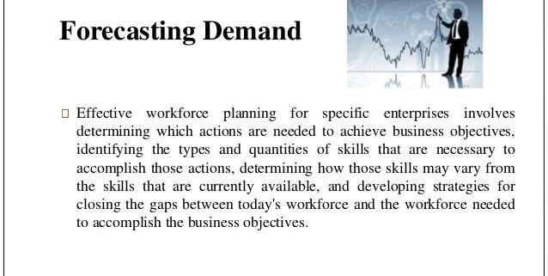
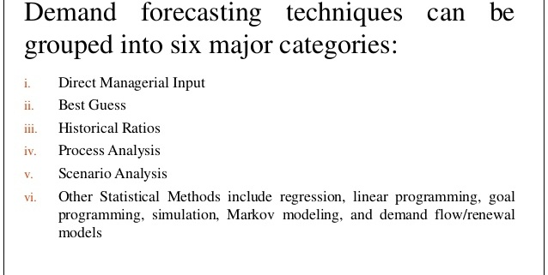
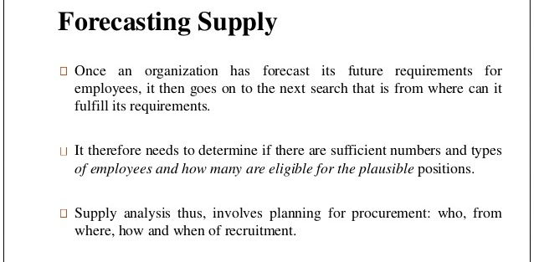
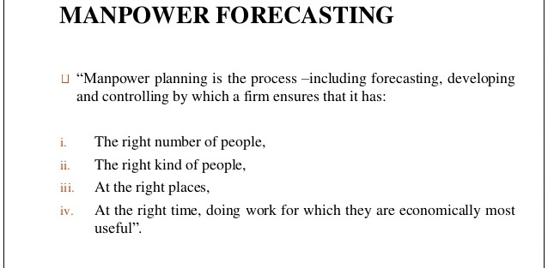
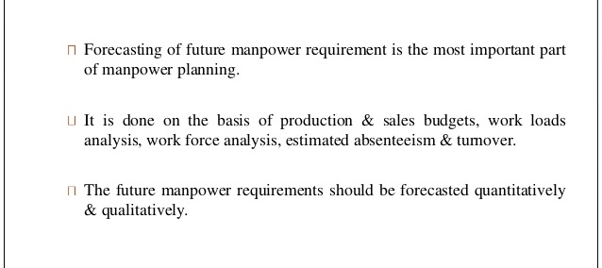
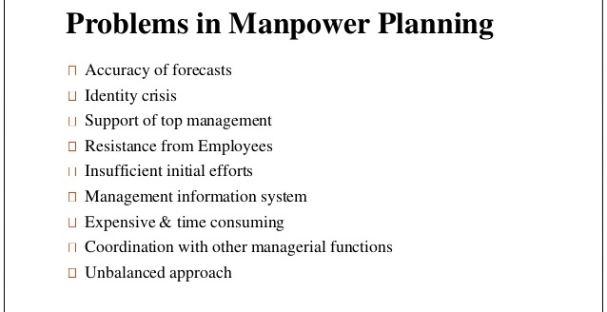
Advertisements

Factors Influencing HRP

Human Resource Planning (HRP) is influenced by several considerations. The more important of them are:
(i) Type and strategy of organization
(ii) Organizational growth cycles and planning
(iii) Environmental uncertainties
(iv) Time horizons
(v) Type and quality of forecasting information
(vi) Labor market.

Type and Strategy of Organization
The type of organization is an important consideration because it determines the production processes involved, number and type of staff needed, and the supervisory and managerial personnel required. Manufacturing organizations are more complex in this respect than those that render services.
The strategic plan of the organization defines the organization’s HR needs. For example, a strategy of organic growth means that additional employees must be hired. Acquisitions or mergers, on the other hand, probably mean that the organization will need to plan for layoffs, since mergers tend to create, duplicate or overlapping positions that can be handled more efficiently with fewer employees.
Primarily, the organization decides either to be proactive or reactive in human resource planning. It can either decide to carefully anticipate the needs and systematically plan them to fill them far in advance, or it can simply react to needs as they arise. Of course, careful planning to fill HR needs better helps ensure that the organization obtains the right number of HR people with proper skills and competencies when they are needed.
Similarly, the organization must determine the breadth of the plan. Essentially, the organization can choose a narrow focus by planning in only one or two HR areas, such as recruitment or selection, or it can choose a broad focus by planning in all areas including training, remuneration and so on.
Finally, the organization must make a decision on flexibility- the ability of the HR plan to anticipate and deal with contingencies. No organization likes high levels of uncertainty. Organizations seek to reduce uncertainty by planning, which includes forecasting and predicting possible future conditions and events. Human resource planning can contain many contingencies, which reflect different scenarios thereby assuring that the plan is flexible and adaptable.

Organizational Growth Cycles and Planning
The stage of an organization’s growth can have considerable influence on human resource planning. Small organizations in the embryonic stage may not have personnel planning.
Need for planning is felt when the organization enters the growth stage. HR forecasting becomes essential. Internal development of people also begins to receive attention in order to keep up with the growth.
A mature organization experiences less flexibility and variability. Growth slows down. The workforce becomes old as few younger people are hired. Planning becomes more fonnalised and less flexible and innovative. Issues like retirement and possible retrenchment dominate planning.
Finally, in the declining stage, human resource planning takes a different focus. Planning is done for layoff, retrenchment and retirement. Since decisions are often made after serious financial and sales shocks are experienced by the organization, planning is often reactive in nature.

Environmental Uncertainties
HR managers rarely have the privilege of operating in a stable and predictable environment. Political, social and economic changes affect all organizations. Personnel planners deal with environmental uncertainties by carefully formulating recruitment, selection, and training and development policies and programmes. Balancing mechanisms are built into the HRM programme through succession planning, promotion channels, layoffs, flexitime, job sharing, retirement, VRS and other personnel related arrangements.

Time Horizons
Yet another major factor affecting personnel planning is the time horizon. A plan cannot be for too long on a time horizon as the operating environment itself may undergo charges. On one hand, there are short-term plans spanning six months to one year. On the other hand, there are long-term plans -which spread over three to twenty years. The exact time span, however, depends on the degree of uncertainty prevailing in an organization’s environment.
Plans for companies operating in an unstable environment, computers for example, must be for a short period. Plans for others where environment is fairly stable, for example a university plan, may be long-term. In general, the greater the uncertainty, the shorter the plan’s time horizon and vice-versa.

Type and Quality of Information
The information used to forecast personnel needs originates from a multitude of sources. A major issue in personnel planning is the type of information which should be used in making forecasts.
Closely related to the type of information is the quality of data used. The quality and accuracy of information depend upon the clarity with which the organizational decision makers have defined their strategy, organizational structure, budgets, production schedules and so forth. In addition, the HR department must maintain well-developed job-analysis information and HR information systems (HRIS) that provide accurate and timely data. Generally speaking, organizations operating in stable environments are in a better position to obtain comprehensive, timely and accurate information because of longer planning horizons, clearer definition of strategy and objectives, and fewer disruptions.
Labor Market
Labor market comprises people with skills and abilities that can be tapped as and when the need arises. Thanks to the mushrooming of educational, professional and technical institutions adequately trained human resource is always available on the market. Nevertheless, shortages do occur. For example, the Confederation of Indian Industry (CII) estimates that by 2015, India will be requiring 30 million additional skilled workers in sectors such as health care, banking and financial services, retail, auto and construction. It is doubtful whether so many skilled workers would be available in the country.

Employee Hiring: Nature of Recruitment, Sources of Recruitment

Employee Hiring
Hiring employees is a process crucial to the success of a business, and as most successful small business owners know, the hiring process does not begin with the interview and end with the job offer. Rather, it involves planning and considering the job prior to an interview, recruiting and interviewing wisely to bring in the right person, and providing new workers with an orientation that enables them to get off to a strong start with the company.

RECRUITMENT
Recruitment is a process of identifying, screening, shortlisting and hiring potential resource for filling up the vacant positions in an organization. It is a core function of Human Resource Management.
Recruitment is the process of choosing the right person for the right position and at the right time. Recruitment also refers to the process of attracting, selecting, and appointing potential candidates to meet the organization’s resource requirements.

Nature of Recruitment
- Determine the present and future requirements of the organization on conjunction with its personnel planning and job analysis activities.
- Increase the pool of job candidates at minimum cost.
- Help increase the success rate of the selection process by reducing the number of visibly under qualified or overqualified job applicants.
- Help reduce the probability that job applicants, once recruited and selected, will leave the organization only after a short period of time.
- Meet the organization’s legal and social obligations regarding the composition of its work force.
- Begin identifying and preparing potential job applicants who will be appropriate candidates.
- Increase organizational and individual effectiveness in the short term and long term.
- Evaluate the effectiveness of various recruiting techniques and sources for all types of job applicants.

Sources of Recruitment
The eligible and suitable candidates required for a particular job are available through various sources. These sources can be divided into two categories, as shown in Figure 5.5.
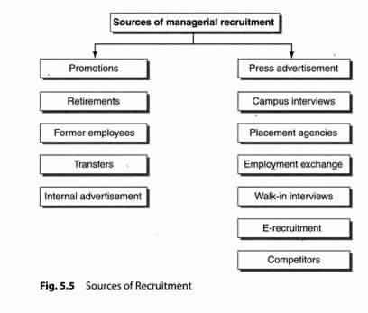
- Internal Sources of Recruitment
(a) Promotions
The promotion policy is followed as a motivational technique for the employees who work hard and show good performance. Promotion results in enhancements in pay, position, responsibility and authority. The important requirement for implementation of the promotion policy is that the terms, conditions, rules and regulations should be well-defined.
(b) Retirements
The retired employees may be given the extension in their service in case of non-availability of suitable candidates for the post.
(c) Former employees
Former employees who had performed well during their tenure may be called back, and higher wages and incentives can be paid to them.
(d) Transfer
Employees may be transferred from one department to another wherever the post becomes vacant.
(e) Internal advertisement
The existing employees may be interested in taking up the vacant jobs. As they are working in the company since long time, they know about the specification
and description of the vacant job. For their benefit, the advertisement within the company is circulated so that the employees will be intimated.

Benefits of Internal Sources of Recruitment
(i) The existing employees get motivated.
(ii) Cost is saved as there is no need to give advertisements about the vacancy.
(iii) It builds loyalty among employees towards the organization.
(iv) Training cost is saved as the employees already know about the nature of job to be performed.
(v) It is a reliable and easy process.
- External Sources of Recruitment
(a) Press advertisement
A wide choice for selecting the appropriate candidate for the post is available through this source. It gives publicity to the vacant posts and the details about the job in the form of job description and job specification are made available to public in general.
(b) Campus interviews
It is the best possible method for companies to select students from various educational institutions. It is easy and economical. The company officials personally visit various institutes and select students eligible for a particular post through interviews. Students get a good opportunity to prove themselves and get selected for a good job.
(c) Placement agencies
A databank of candidates is sent to organizations for their selection purpose and agencies get commission in return.
(d) Employment exchange
People register themselves with government employment exchanges with their personal details. According to the needs and request of the organization, the candidates are sent for interviews.
(e) Walk in interviews
These interviews are declared by companies on the specific day and time and conducted for selection.
(f) E-recruitment
Various sites such as jobs.com, naukri.com, and monster.com are the available electronic sites on which candidates upload their resume and seek the jobs.
(g) Competitors
By offering better terms and conditions of service, the human resource managers try to get the employees working in the competitor’s organization.

Benefits of External Sources of Recruitment
(i) New talents get the opportunity.
(ii) The best selection is possible as a large number of candidates apply for the job.
(iii) In case of unavailability of suitable candidates within the organization, it is better to select them from outside sources.

Employee Selection, Process of Employee Selection

Employee Selection is the process of picking or choosing the right candidate, who is most suitable for a vacant job position in an organization. In others words, selection can also be explained as the process of interviewing the candidates and evaluating their qualities, which are required for a specific job and then choosing the suitable candidate for the position.
The selection of a right applicant for a vacant position will be an asset to the organization, which will be helping the organization in reaching its objectives.

The Employee Selection Process
- Announcing the Job
The employee selection process usually starts with a manager or boss commissioning human resources to fill a new or vacant position. The manager must first decide what qualifications she desires in a job candidate. For example, should the person have a college degree, or how many years of relevant experience is necessary? Once the manager establishes the job requirements, the human resources department places ads in the local newspaper and online. Sometimes, human resources uses a headhunter find candidates, someone who often specializes in a certain field, such as sales.
- Reviewing Applications
Review resumes and match each candidate’s background to the job requirements. Companies sometimes receive hundreds of resumes for an ad. However, human resources may only consider a half dozen. During bad economic periods, a number of candidates may have an education and experience that exceed the qualifications for the job. Contrarily, it may be tougher to find qualified candidates during good economic times. Nevertheless, human resources and the hiring manager must determine how many candidates they can realistically bring in for an interview.
- Initial Screening
To save time and money, interviewing may start with a screening interview, especially if a job candidate lives out of town. Human resources will usually conduct the screening interview over the telephone to help narrow the field of candidates. A telephone interview also helps a company determine if the candidate has the necessary qualifications to warrant flying him in for an interview.
- In-Person Interviewing
Those who make the cut after the screening interview are asked to come in for face-to-face interviews. Companies have different procedures for personal interviews. Some companies prefer to have all-day interviewing sessions, where job candidates meet with a different person each hour. During this time, companies may have the candidates meet with human resources, the hiring manager and other employees. Another option is is having candidates meet with key personnel one day, then inviting them back for second to meet with some executives.
- Final Selection
The hiring manager will usually ask for feedback from human resources and other employees who interviewed the job candidates. She may also review her notes and decide which candidate would fit best in the open position. Qualifications are only one consideration when filling a job opening. The hiring manager will usually select someone with whom she can work, whether it is the candidate’s personality or work ethic.
- Testing
Before a candidate is actually hired, many companies require a drug test. Typically, candidates notify the tester of any prescription drugs he is taking, because these will show up in the results. If he tests positively for any other drugs, it could jeopardize his being hired. Employees who work in the insurance industry may need to take a psychological test to determine if insurance is the appropriate career choice for them. After the drug or personality test, the company makes an offer to the chosen candidate.

Recent Trends in Recruitment
The following are the latest and current trends are being seen in recruitment-

OUTSOURCING
In India, the HR processes are being outsourced from more than a decade now. A company may draw required personnel from outsourcing firms. The outsourcing firms help the organization by the initial screening of the candidates according to the needs of the organization and creating a suitable pool of talent for the final selection by the organization.
Outsourcing firms develop their human resource pool by employing people for them and make available personnel to various companies as per their needs. In turn, the outsourcing firms or the intermediaries charge the organizations for their services.
Advantages of outsourcing are-
Know the Internal Sources of Recruitment
- Company need not plan for human resources much in advance.
- Value creation, operational flexibility and competitive advantage
- Turning the management’s focus to strategic level processes of HRM
- Company is free from salary negotiations, weeding the unsuitable resumes/candidates.
- Company can save a lot of its resources and time

POACHING/RAIDING
“Buying talent rather than developing it) is the latest mantra being followed by the organizations today. Poaching means employing a competent and experienced person already working with another reputed company in the same or different industry; the organization might be a competitor in the industry. A company can attract talent from another firm by offering attractive pay packages and other terms and conditions, better than the current employer of the candidate. But it is seen as an unethical practice and not openly talked about. Indian software and the retail sector are the sectors facing the most severe brunt of poaching today. It has become a challenge for human resource managers to face and tackle poaching, as it weakens the competitive strength of the firm.
Know the External Sources of Recruitment

E-RECRUITMENT
Many big organizations use Internet as a source of recruitment. E- recruitment is the use of technology to assist the recruitment process. They advertise job vacancies through worldwide web. The job seekers send their applications or curriculum vitae i.e. CV through e mail using the Internet. Alternatively job seekers place their CVÂ’s in worldwide web, which can be drawn by prospective employees depending upon their requirements.
Advantages of recruitment are:
- Low cost.
- No intermediaries
- Reduction in time for recruitment.
- Recruitment of right type of people.
- Efficiency of recruitment process.

