NOTES-BE
UNIT-3

VAISHNAVI VERMA
ASSISTANT PROFESSOR
VISION INSTITUTE OF MANAGEMENT
KANPUR

Unit-3

Social and Cultural Environment Nature

The social environment consists of the sum total of a society’s beliefs, customs, practices and behaviors. It is, to a large extent, an artificial construct that can be contrasted with the natural environment in which we live.
Every society constructs its own social environment. Some of the customs, beliefs, practices and behaviors are similar across cultures, and some are not. For example, an American traveling to Britain will find many familiar practices but not so much if traveling to China.
This social environment created by a society-at-large in which a business functions can be referred to as its external social environment. If a business operates in a multicultural society, then the social external social environment is even more complicated because the environment will consist of diverse sub-populations with their own unique values, beliefs, and customs.
A business also has its own social environment. We can refer to this as its internal social environment, which is simply the customs, beliefs, practices, and behaviors within the confines of the business. A business has much more control over its internal social environment than it does with its external social environment.

Nature of social environment
The social environment, social context, socio-cultural context or milieu refers to the immediate physical and social setting in which people live or in which something happens or develops. It includes the culture that the individual was educated or lives in, and the people and institutions with whom they interact.
The physical and social environment is a determining factor in active and healthy aging in place, being a central factor in the study of environmental gerontology.
The interaction may be in person or through communication media, even anonymous or one-way, and may not imply equality of social status. Therefore, the social environment is a broader concept than that of social class or social circle.

Cultural environment
A cultural environment is a set of beliefs, practices, customs and behaviors that are found to be common to everyone that is living within a certain population. Cultural environments shape the way that every person develops, influencing ideologies and personalities. Cultural environments are determined by the culmination of many different aspects of culture that influence personal choices and behaviors.
Religious beliefs are an important building block of a specific cultural environment. For many cultures, a certain religion has been a critical part of everyday living for generations. Outsiders need to be aware of the customs and traditions related to specific religion in order to respectfully navigate a certain cultural environment.
Family and the relationship within the family are additional factors that determine a cultural environment. Many cultures are structured around families, while others promote individuality and self-sustainability. Like religion and family, language is the third most important element of a cultural environment. Outside of these components, educational and social systems affect the structure of a cultural environment. Social systems may determine customs or taboos that are important to a particular region, while education may determine what types of ideologies are publicly shared. When visiting a new country or region, it is important for visitors to understand the cultural environment in order to protect themselves from shame, embarrassment or the act of offending a stranger.

Characteristics of Culture
(1) Culture is social
Culture does not exist in isolation. It is a product of society. It develops through social interaction. No man can acquire culture without association with others. Man becomes a man only among men.
(2) Culture is shared
Culture is not something that an individual alone can possess. Culture in sociological sense is shared. For example, customs, traditions, beliefs, ideas, values, morale etc. are all shared by people of a group or society.
(3) Culture is learnt
Culture is not inborn. It is learnt. Culture is often called “learned ways of behaviour”. Unlearned behaviour is not culture. But shaking hands, saying thanks’ or ‘namaskar’, dressing etc. are cultural behaviour.
(4) Culture is transmissive
Culture is transmissive as it is transmitted from one generation to another. Language is the main vehicle of culture. Language in different form makes it possible for the present generation to understand the achievement of earlier generations. Transmission of culture may take place by imitation as well as by instruction.
(5) Culture is continuous and cumulative
Culture exists as a continuous process. In its historical growth it tends to become cumulative. Sociologist Linton called culture ‘the social heritage’ of man. It becomes difficult for us to imagine what society would be like without culture.
(6) Culture varies from society to society
Every society has a culture of its own. It differs from society to society. Culture of every society is unique to itself. Cultures are not uniform. Cultural elements like
customs, traditions, morale, values, beliefs are not uniform everywhere. Culture varies from time to time also.
(7) Culture is dynamic
No culture ever remains constant or changeless. It is subject to slow but constant change. Culture is responsive to the changing conditions of the physical world. Hence culture is dynamic.
(8) Culture is gratifying
Culture provides proper opportunities for the satisfaction of our needs and desires. Our needs both biological and social are fulfilled in the cultural ways. Culture determines and guides various activities of man. Thus, culture is defined as the process through which human beings satisfy their wants.
Conclusion- From the above discussion we are clear that each and every society has a culture of its own. Culture is not only diverse but also unequal, but is found in societies throughout the world.

Impact of foreign culture on Business

Doing business on the international plane presents many challenges because of a variety of factors which differ from one market to the other. These differences are basically informed by the environment of the host country, which is often times different from that at home. One of the environmental factors that present such a challenge is culture.
Culture can be defined as complex construct that embodies a people’s knowledge, morals, art, beliefs, customs, laws and other capabilities gathered by a community over time. The culture of the host country strongly impacts on the performance of a firm that engages in international business. Notable aspects of culture central to the conduct of international business include the social structure, religion, language and education. G4S, a company that has established itself in international business has had its fair share of challenges in this area.
Social Structure has to do with how society is socially organized. It could be looked at from the individual-group dimension, or from the social stratification dimension. Some societies consider an individual the pillar of social organization This is the scenario G4S encountered when it entered the American and most Western markets.
The challenge here was how to instill a sense of teamwork among employees. It was an uphill task for managers who had been socialized to believe in the superiority of teamwork, as individuals compete against each other for results. On the Japanese market however, the firm found that emphasis was on group, rather than individual performance. Though this is said to be the driving force behind the company’s success in Japan, it is vilified for imbedding creativity, and is touted as a stumbling block to dynamism. This, indeed, is a challenge the firm has had to deal with.
Social stratification has to do with placing members of society in certain classes. There are those in the lower, middle and upper classes. Many times, this is borne out of one’s family background, income or occupation. Those from the lower class only hope to move from that class to the upper one through a process called social mobility, which is in most cases done through education and job opportunities.
When opportunities for mobility are suffocated, there is likely to be conflict between the classes; and in the job situation, between management and employees. Some societies have room for social mobility, while others do not. A country like Britain has less social mobility. As a result, there is always simmering tension between management and workers, which the firm has had to deal with from time to time. When industrial disputes become frequent, the firm finds doing business in the country quite expensive. Such a problem is not common in America, where social mobility is easy.

Traditional Values and its Impact

Introduction to Values in Business:
The value systems in societies differ considerably because the value systems are built through centuries. Japanese and Chinese ethical values differ considerably to Indian ones.
The main issues in ethics are:
(1) The academic discipline of business ethics requires approval and support of industry in those countries.
(2) Equal treatment of technical and human resources in management. In Japan human resource is given more weightage.
(3) Social justice and efficiency should go hand in hand.
(4) In Japan ethical managements already in place since last two decades with emergence of large business houses and MNCs. In China the importance of business ethics is felt and being practiced under the conditions of contemporary market economy.
(5) Japanese consumers are more willing to support business that were identified as socially more responsible than Chinese.
(6) Chinese value economic aspects of business organisation whereas Japanese considered more about business conforming to legal and ethical standards.
(7) The culture has profound base on ethical management in each country.
Table 10.1 below gives the cultural differences between US, Japan and Indian in a tabular form.
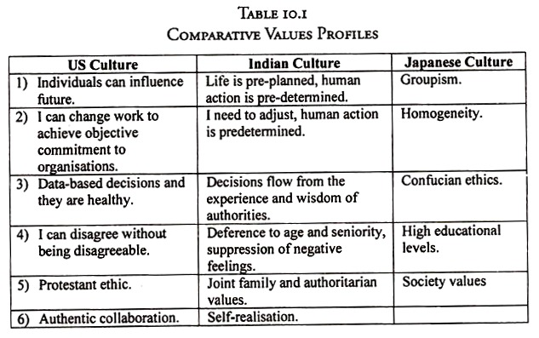
Some of the ethical values noticed in different countries are:
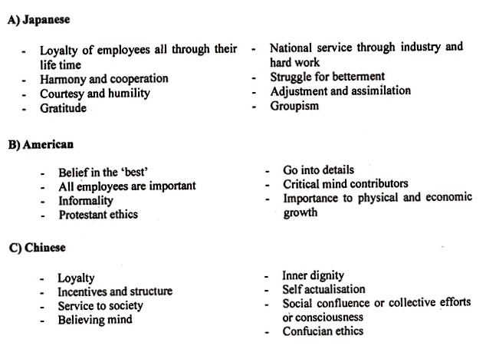

Indian Value System:
India has a place of pride in a strong ethical base. It needs to be rekindled by proper education to our young and budding managers. Indian ethico-moral discussions go back to three and half millennia when Vedas specified the ground rules of human existence and living. The ethical discussions and teaching continued all through Indian history though India was ruled by different emperors and foreign rulers.
The Upanishads, Puranas and Smritis continued the traditions. The values were put for popular use in great epics of Mahabharata and Ramayana. Bhagavad-Gita puts ethics in a clear and concise way.
The epics give human dilemmas in every walk of life and attach importance to values in dealing all such issues. Kautilya’s Arthashastra, Vishnu Sharma’s Panchatantra, Hitopadesha, Neetishastra, Katha Saritsagar, Neeti Shataka, Somadev Neeti Sootra and many more works stress Indian ethos in different ways.
Perhaps to attract readers these works are in story form, ornate, colourful and poetic giving an unparalled practical ethical values in them. The current ethical behaviour of Indian is an intimate mix of good textures of values taken from Vedantic, Jaina, Buddhist, Sikh and Sufi traditions. In recent past we have also added western values.
About 2½ millennia ago the roots of western ethical values started in Greece from Socrates, Plato and Aristotle. At about the same time Chinese got ethical base in Confucius. The Vedantic ethical values are spiritual, sacred and simple. The entire value system is put as ‘Dharma’ or righteousness in all what one does.
Some of ethical Vedantic principles as applied to modern business are:
- Treat people decently. Respect all stakeholders’ opinions, background, privacy dignity and desire to grow.
- All people are having egos and selfish nature. Respect diversity.
- Companies or business is created to serve people and all stakeholders.
- Some are more intelligent and powerful but protect the weak.
- Look inside sitting alone and think is it right? Is it fair? Will it do good to all?
- Be good, do good to as many and as much.
- Mahabharata sums up importance of ethical behaviour in a sloka.
Ethical behaviour is important for a man. When a man goes down in ethical values, he will have no use of his money or his relatives and he has no reason to live.
As noted above, ethics was and is a traditional subject in India. Vedantic ethics had spiritual approach, which is summed up in its entirety (what you do not wish unto you do not do it to others). Business ethics is a new branch of study giving ethic plus business combination in decision making processes in industry and commerce.
Indian ethos was introduced in daily walk of life for everyone by various methods. Religious teachings, listening to Puranas, Kathas, Bhajans, Yoya, Pooja, Yajyas and the like are some examples where these remind time and again the essence of ethical behavior in a society. Over the centuries many of these became mechanical and ritualistic and lost the ethical touch in them.
The ethical standards set by emperor Ashoka is given in Box 10.1:
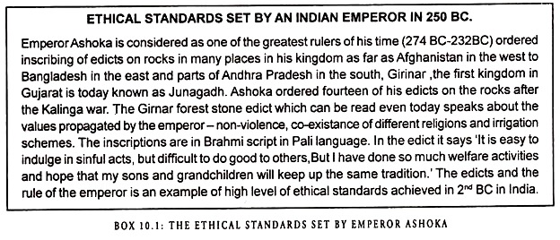
Two other religions which had their origins in India are Jainism and Buddhism. Buddhism and Jainism stress the ethical behavior and non-violence in more stringent manner to the society. In fact ‘The Digambar’ sect of Jainism advocated no attachments of possession to any worldly goods.
Indian ancient texts give guidelines to ethical behaviour of a man in his daily life since days of Veda. The same principles apply to modern day business.
Some of the important ethical lessons are:
- Foundation for a healthy business is sound morals and ethics.
- For managers to be good decision makers and to stand up to temptation and pressures, he should have his own peace of mind, strength of will and ethics.
- Selfishness and greed are source of evil that reduces ethical standards in an organisation.
- Ethical levels should be built up from top down to curb lies, hurting, cheating or unethical acts.
The Table 10.2 below gives the difference between western management concepts and Indian ethos:
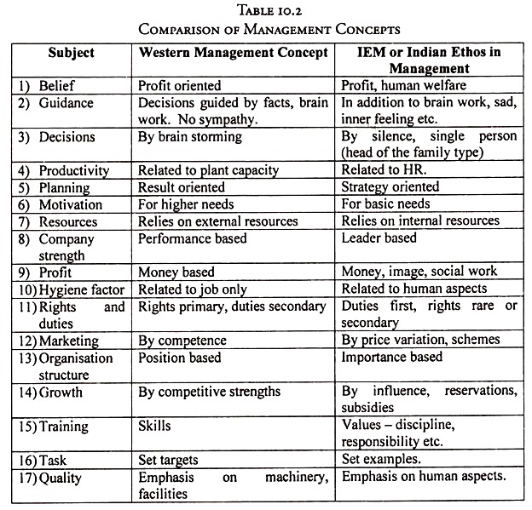

Indian Values:
Indian culture is much diversified because of varieties of customs, beliefs and many gods. It is difficult to find single culture at one place. Hinduism has much type of worship and festivals.
In tradition Indian has Vedantic, Buddhist, Jaina and Sikh traditions. India has also welcomed and absorbed good ethical lessons from Christian, Islamic and Parsi religions. The culture has enriched with diversity of outsiders. It is now a unity in diversity.
The important Vedantic values in Indian society valid even today are:
- Showing respect to elders specially teachers
- Not showing emotion outward
- God fear in all walks of life. In any function Pooja or offering to God is made first before the work begins.
- Marriage is made in heaven and is considered lifelong bond. Some consider it as bond even after death.
- In recent years Indian household look western. These are outward looks, whereas the Vedantic culture flews in hearts and actions. Similarly Indian ethos had many changes when foreigners ruled India for many centuries but Vedantic identify and ethos remained intact.
- Indian ethos were built and perfected long before others evolved them. Hence India contributed immensely in teaching ethical lessons to outside world with its classical books. The ethical thought process in Vedantic ethos starts with Vedas, Upanishads, Smritis and Puranas. These were told in many ways with day to day life in epics Ramayana, Mahabharata and Gita. The ethical values were told in story form in Panchatantra, Hitopdesha, Katha- Saritsagaf, Bhoja prabhand, Chanakya Neeti, Bliagavata, Sooktimuktavali, Neeti Shastra, Neeti Shataka Manusmuti and the like.
- Sacred simplicity of four goals to a man.
a) Dharma – Righteousness
b) Artha – Creation of wealth
c) Kama – Desires and needs
d) Moksha – Liberation of the spiritual core.
8. The ethos in work life are:
a) Man’s inner strength. Simple living
b) Holistic relationship between man and nature
c) Cooperation with each other
d) Yoga and meditation. That is excellence and concentration.
e) Spirit of sacrifice.
Internal orientation towards work as worship.
A holistic grasp of Indian values is stated by great Poet Kalidasa as Satyam-Shivam-Sundaram. The meaning and connection is shown in Fig. 10.1 below.
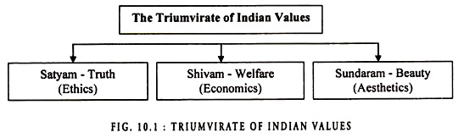
In Indian Vedantic system personality types have been suggested based on set of attributes.
The classification are:
- a) Daivi or good attributes give Sattwa type of personality.
- b) Rajas personality shows an angry and always busy type.
- c) Tamas is always thinking negative doing such harmful work.
The classification of three types of personalities show hereunder the attributes of each type at Table 10.3.
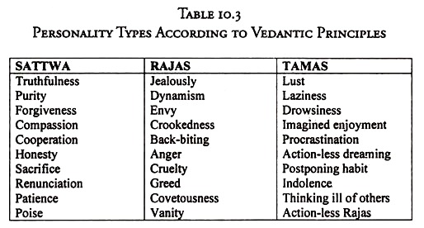
Indian army has set itself high ethical standards in its policies and operations. These are built and perfected over for centuries. These apply to business environment. An article on the subject is given in box 10.2.
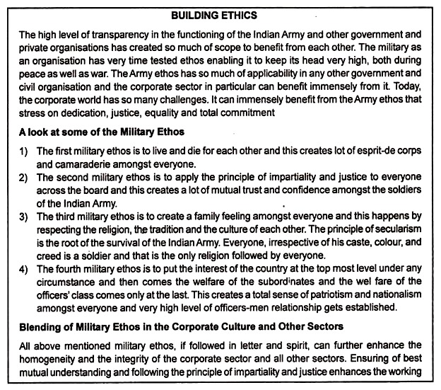

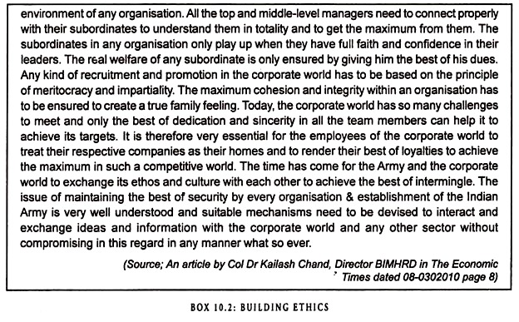

Social Audit and Social Responsibility of Business

Social Audit
A social audit is a formal review of a company’s endeavors in social responsibility. A social audit looks at factors such as a company’s record of charitable giving, volunteer activity, energy use, transparency, work environment, and worker pay and benefits, to evaluate what kind of social and environmental impact a company is having in the locations where it operates.
Social audits are optional. Companies can choose whether to perform them and whether to release the results publicly or only use them internally.
A social audit is an internal examination of how a particular business is affecting a society. It serves as a way for a business to see if the actions being taken are being positively or negatively received and relates that information to the company’s overall public image.
A social audit examines issues regarding internal practices or policies and how they affect the identified society. The activities included tend to pertain to the concepts of social responsibility. This can include activities affecting the financial stability of a region, any environmental impact resulting from standard operations and issues of transparency in reporting.
There is no standard regarding what must be considered as the society during the audit. This allows a business to expand or contract the scope based on its goals. While one company may wish to understand the impact it has on a small-scale society, such as a particular city, others may choose to expand the range to include an entire state, country or the world as a whole.

Social Responsibility of Business
Social responsibility of business implies the obligations of the management of a business enterprise to protect the interests of the society.
According to the concept of social responsibility the objective of managers for taking business decisions is not merely to maximize profits or shareholders’ value but also to serve and protect the interests of other members of a society such as workers, consumers and the community as a whole.
Thus, Sachar Committee on Companies and MRTP Acts appointed by Government of India states, “In the development of corporate ethics we have reached a stage where the question of social responsibility of business to the community can no longer be scoffed at or taken lightly. In the environment of modern corporate economic development, the corporate sector no longer functions in isolation. If the plea of the companies that they are performing a social purpose is to be accepted, it can only be judged by the test of social responsiveness shown to the needs of the society”.
But in today’s world the interest of other stakeholders, community and environment must be protected and promoted. Social responsibility of business enterprises to the various stakeholders and society in general is considered to be the result of a social. Responsibility of Business Enterprises towards Stakeholders and Society in General contract.
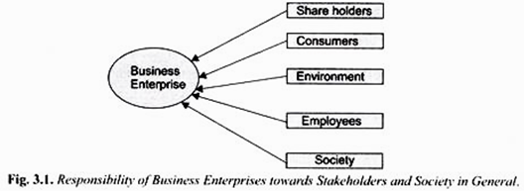
Social contract is a set of rules that defines the agreed interrelationship between various elements of a society. The social contract often involves a quid pro quo (i.e. something given in exchange for another). In the social contract, one party to the contract gives something and expects a certain thing or behaviour pattern from the other.
In the present context the social contract is concerned with the relationship of a business enterprise with various stakeholders such as shareholders, employees, consumers, government and society in general. The business enterprises happen to have resources because society consisting of various stakeholders has given them this right and therefore it expects from them to use them to for serving the interests of all of them.
Though all stakeholders including the society in general are affected by the business activities of a corporate enterprise, managers may not acknowledge responsibility to them. Social responsibility of business implies that corporate managers must promote the interests of all stakeholders not merely of shareholders who happen to be the so called owners of the business enterprises.
1. Responsibility to Shareholders
In the context of good corporate governance, a corporate enterprise must recognise the rights of shareholders and protect their interests. It should respect shareholders’ right to information and respect their right to submit proposals to vote and to ask questions at the annual general body meeting.
The corporate enterprise should observe the best code of conduct in its dealings with the shareholders. However, the corporate Board and management try to increase profits or shareholders’ value but in pursuing this objective, they should protect the interests of employees, consumers and other stakeholders. Its special responsibility is that in its efforts to increase profits or shareholders’ value it should not pollute the environment.
2. Responsibility to Employees
The success of a business enterprise depends to a large extent on the morale of its employees. Employees make valuable contribution to the activities of a business organization. The corporate enterprise should have good and fair employment practices and industrial relations to enhance its productivity. It must recognise the rights of workers or employees to freedom of association and free collective bargaining. Besides, it should not discriminate between various employees.
The most important responsibility of a corporate enterprise towards employees is the payment of fair wages to them and provides healthy and good working conditions. The business enterprises should recognise the need for providing essential labour welfare activities to their employees, especially they should take care of women workers. Besides, the enterprises should make arrangements for proper training and education of the workers to enhance their skills.
However, it may be noted that very few companies in India follow many of the above good practices. While the captains of Indian industries generally complain about low productivity of their employees, little has been done to address their problems. Ajith Nivard Cabraal rightly writes, “It should perhaps be realised that corporations can only be as effective and efficient as its employees and therefore steps should be taken to implement such reforms in a pro-active manner, rather than merely attempting to comply with many labour laws that prevail in the country. This is probably one area where good governance practices could make a significant impact on the country’s business environment.”
3. Responsibility to Consumers:
Some economists think that consumer is a king who directs the business enterprises to produce goods and services to satisfy his wants. However, in the modern times this may not be strictly true but the companies must acknowledge their responsibilities to protect their interests in undertaking their productive activities.
Invoking the notion of social contract, the management expert Peter Drucker observes, “The customer is the foundation of a business and keeps it in existence. He alone gives employment. To meet the wants and needs of a consumer, the society entrusts wealth-producing resources to the business enterprise”. In view of above, the business enterprises should recognise the rights of consumers and understand their needs and wants and produce goods or services accordingly.
The following responsibilities of business enterprises to consumers are worth mentioning:
- They should supply goods or services to the consumers at reasonable prices and do not try to exploit them by forming cartels. This is more relevant in case of business enterprises producing essential goods such as life-saving drugs, vegetable oil and essential’ services such as electricity supply and telephone services.
- They should not supply to the consumers’ shoddy and unsafe products which may do harm to them.
- They should provide the consumers the required after-sales services.
- They should not misinform the consumers through inappropriate and misleading advertisements.
- They should make arrangements for proper distribution system of their products so as to ensure that black-marketing and profiteering by traders do not occur.
- They should acknowledge the rights of consumers to be heard and take necessary measures to redress their genuine grievances.

Competitive Environment: Meaning, Michael Porter’s Five Forces Analysis

Competitive Environment
A competitive environment is the dynamic external system in which a business competes and functions. The more sellers of a similar product or service, the more competitive the environment in which you compete. Look at fast food restaurants – there are so many to choose from; the competition is high. However, if you look at airlines servicing Hawaii, very few actually fly to the islands.
Direct competitors are businesses that are selling the same type of product or service as you. For example, McDonalds is a direct competitor with Burger King. Indirect competitors are businesses that still compete even though they sell a different service or product. The products or services offered by indirect competitors tend to be those that can be substituted for one another. Again, considering travel, you have the option to travel by plane, train, or car. Therefore, airlines are also competing with train lines and buses (assuming the travel does not go overseas).
Examples
There are several examples of competitive business environments. The first that comes to mind is smart phones. How many choices do you have when it comes to buying a smart phone? They seemed to have multiplied overnight! That is an extremely competitive business environment.
Companies are constantly trying to one-up the latest best-selling model – a good indication of a competitive environment. Additionally, prices of comparable smart phone models are relatively close.
Another competitive business environment is the automobile industry. Again, almost every company produces a car in every category. Therefore, when someone is looking at buying a new hybrid sedan or full-size truck, they have so many options to choose from. Obviously, the automobile industry can be segmented in economical and luxury brands, but when comparing within the same segment, there is significant competition.

Michael Porter’s Five Forces
Michael Porter’s analysis of the competitive environment isn’t complex. On the contrary, it’s straightforward and easily understood. He proposes that competition in a given industry depends upon the interaction of five separate forces. How profitable or difficult the competitive environment may be varies widely among given industries. Producers of steel cans, for example, operate in a competitive environment which ensures that profits remain generally low. Other industries, such as manufacturers of soft drinks and toiletries, exist in competitive environments “where there is room for quite high returns.”
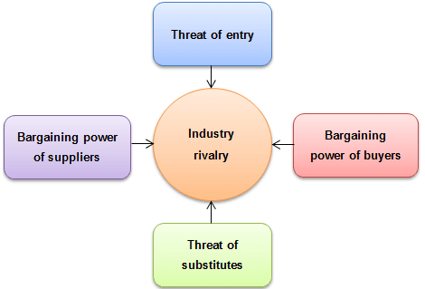
(i) Threat of Entry
Competitors can arise from more than one area. In an industrialized economy, a company can make a strategic decision to enter an area for any number of reasons, among them: because the area is under-served, because profit margins are unusually high or because the entering company benefits from a patented process or product that gives them a unique advantage. It should be noted that these advantages aren’t permanent. The shape of the competition changes nearly continuously. Porter observes that when Polaroid’s instant photography patents expired, Kodak was well-equipped to enter the market. Writing in 1979, Porter couldn’t have known that in a few years digitization would drive one company out of business and the other into Chapter 11. As it turned out, the most significant competition was a company that in 1979 sold a grand total of 35,000 relatively inexpensive hobby products worldwide. By 2017, Apple was the world’s ninth largest company, with annual sales of $217 billion. Porter’s analysis indicates that Apple’s security is no greater than Polaroid’s. Threats can come from anywhere, and are difficult to anticipate. In fact, Porter maintains that concentrating on future sources of competition rather than on present products is key for company survival.
(ii) Supplier Power
Porter points out that when there are only a few sources of supply but many buyers, suppliers will dominate and command a greater share of profits. China’s strategy for solar panel cells is an example of a business strategy based on the expectation of driving prices down far enough that suppliers in countries with higher labor costs can’t compete, eventually leaving China’s solar industries as the predominating major supplier, at which point China will be able to control profits throughout the industry.
(iii) Buyer Power
In the reverse situation, where there are only a few buyers and many suppliers, buyers will dominate and will control supplier’s profits. Apple, for instance, has more than 200 Chinese component suppliers for its iPhone. Competition among these suppliers for a single buyer has repeatedly driven down supplier prices to the point where workers have been mistreated and forced to work long hours without breaks under difficult conditions. Even FoxConn (Hon Hai Precision Industry) Apple’s largest Asian supplier, has been caught using student interns and forcing them to work overtime without overtime pay in an effort to maintain market share. Apple has been criticized for the situation and has made some attempts to ensure equitable working conditions for workers in these factories, but as Porter might have predicted, when the supplier/buyer imbalance shifts in favor of the buyer to such an extreme, the resulting competition will drive prices down to a point where suppliers may believe that their survival depends on lowering prices below the point at which keeping the workplace equitable and humane for its workers is possible.
(iv) Threat of Substitutes
Another competitive threat comes from the availability of substitutes for a company’s existing product. The pharmaceutical industry’s attempts to devise strategies that hold off the entrance into the marketplace of generic drugs are an instance of a strategy opposing this threat.
Sometimes, however, the substitute can come from an unpredictable place. The volume of first-class mail the U.S. Postal Service handles has declined dramatically since the introduction of email. Suppliers of components for gasoline and diesel-powered automobile engines may soon find that the coming proliferation of electric cars over the next decade or so threatens their industries with substitution of components for electric vehicles, whereas other suppliers have more experience and are better equipped to compete.
(v) Competitor Rivalry
Porter’s fifth force is the cumulative effect of the first four. Competition can come from anywhere, from innovative new products, from the emergence of powerful new suppliers or buyers who control the marketplace, or from product substitutions made possible by deregulation, innovation or more cost efficient industrial processes, relying on innovative technology, a lower-cost labor force, or both.

Competitive Strategies

Competitive Strategy
Competitive Strategy is defined as the long term plan of a particular company in order to gain competitive advantage over its competitors in the industry. It is aimed at creating defensive position in an industry and generating a superior ROI (Return on Investment). Such type of strategies play a very important role when industry is very competitive and consumers are provided with almost similar products. One can take example of mobile phone market.

Types of Competitive Strategies by Porter
According to Michael Porter, competitive strategy is devised into 4 types:
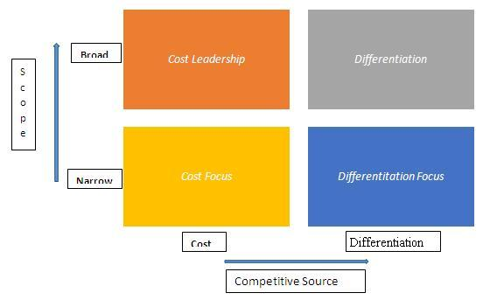
- Cost Leadership
Here, the objective of the firm is to become the lowest cost producer in the industry and is achieved by producing in large scale which enables the firm to attain economies of scale. High capacity utilization, good bargaining power, high technology implementation are some of factors necessary to achieve cost leadership. e.g Mi phones
- Differentiation Leadership
Under this strategy, firm maintains unique features of its products in the market thus creating a differentiating factor. With this differentiation leadership, firms target to achieve market leadership. And firms charge a premium price for the products (due to high value added features). Superior brand and quality, major distribution channels, consistent promotional support etc. are the attributes of such products.E.g. BMW, Apple
- Cost focus
Under this strategy, firm concentrates on specific market segments and keeps its products low priced in those segments. Such strategy helps firm to satisfy sufficient consumers and gain popularity. E.g. Sonata watches
- Differentiation focus
Under this strategy, firm aims to differentiate itself from one or two competitors, again in specific segments only. This type of differentiation is made to meet demands of border customers who refrain from purchasing competitors’ products only due to missing of small features. It is a clear niche marketing strategy. E.g. Titan watches
Without following anyone of above mentioned competitive strategies, it becomes very difficult for firms to sustain in competitive industry.
Examples of competitive strategy
There can be several examples based on the four parameters given by Michael Porter. Some examples are given below:
- Cost Leadership: Mi smart phones and mobile phones are giving good quality products at an affordable price which contain all the features which a premium phone like Apple or Samsung offers
- Differentiation Leadership: BMW offers cars which are different from other car brands. BMW cars are more technologically advanced, have better features and have got personalized services
- Cost focus: Sonata watches are focused towards giving wrist watches at a low cost as compared to competitors like Rolex, Titan, Omega etc
- Differentiation focus: Titan watches concentrates on premium segment which includes jewels in its watches.

Introduction to Industrial Policy Resolutions

Industrial Policy Resolution of 1956 is a resolution adopted by the Indian Parliament in April 1956. It was the first comprehensive statement on industrial development of India. The 1956 policy continued to constitute the basic economic policy for a long time. This fact has been confirmed in all the Five-Year Plans of India. According to this resolution the objective of the social and economic policy in India was the establishment of a socialistic pattern of society. It provided more powers to the governmental machinery. It laid down three categories of industries which were more sharply defined. These categories were:
Main Features of Industrial Policy Resolution of 1956
In a short period of operation of the 1948 Industrial Policy, some significant changes took place in the economic and political spheres that called for changes in industrial policy as well. The country hand launched a programme of planned economic development with the first five-year plan.
The second five- year plan gave high priority to industrial development aimed at setting up a number of heavy industries such as steel plants, capital goods industries, etc., for which direct government participation and state involvement was needed.
Further in December 1954, the Parliament adopted the ‘Socialistic Pattern of Society’ as the goal of economic policy which called for the state or the public sector to increase its sphere of activity in industrial sector and thus prevent concentration of economic power in private hands. In view of ail these developments, a new industrial policy was announced in April 1956. The main features of this Industrial Policy Resolution of 1956 were as follows:
- New Classification of industries
The Industrial Policy of 1956 adopted the classification of industries into three categories viz.,
(i) Schedule A, which contained 17 Industries. All new units in these industries, such where their establishment in the private sector has ready been approved, would be set up only be the state.
(ii) Schedule В, which contained 12 industries, such industries would be progressively state owned, but private enterprise is expected to supplement the efforts of the state in these fields.
(iii) Schedule C, All remaining industries fell in this category; the future development of these industries had been left to the initiative and enterprise of the private sector.
- Assistance to Private Sector
While the Industrial Policy of 1956 sought to give a dominant role to public sector, at the same time it assured a fair treatment to the private sector. The ‘policy’ said that the state would continue to strengthen and expand financial institutions that extend financial assistance to private industry and cooperative enterprises. The state would also strengthen infrastructure (power, transport etc.) to help private sector.
- Expanded role of Cottage and Small-Scale Industries
The Industrial Policy of 1956 laid stress on the role of cottage and small scale industries for generating larger employment opportunities, making use of local manpower and resources and reducing- regional inequalities in industrial development. It stated that the Government would continue pursuing a policy of supporting such industries through tax concessions and subsidies.
- Balanced Industrial Growth among Various Regions
The Industrial Policy, 1956 helped to reduce regional disparities in industrial development. The policy stated that facilities for development will be made available to industrially backward areas. The state, apart from setting up more public sector industries in these backward areas, will provide incentives such as tax concessions, subsidized loans etc., to the private sector to start industries in these backward regions.
- Role of Foreign Capital
The industrial Policy 1956 recognized the important role of foreign capital in country’s development. The foreign capital supplements domestic savings. Provides more resources for investment and relieves pressure on Balance of payments.
The country therefore welcomed inflow of foreign capital. But the ‘Policy’ made it clear that inflow of foreign capital will be permitted subject to the condition that major share in management, ownership and control should be in the hands of Indians.
6. Development of managerial and Technical Cadres
The Industrial Policy, 1956 notes that the programme of rapid industrialization in India will create large demand for managerial and technical personnel. Therefore, the policy emphasized the setting up and strengthening of institutions that Trans and provide such personnel. It was also announced that proper technical and managerial cadres in the public services are also being established.
- Incentives to labour
The Industrial Policy, 1956 recognized the important role of labour as a partner in the task of development. The ‘policy’ therefore put emphasis on the provision of adequate incentives to workers and improvement in their working and service conditions. It laid down that wherever possible the workers should be progressively associated with that management so that they are enthusiastically involved in the development process.
CONCLUSION:
The Industrial Policy 1956 thus provided a comprehensive framework for industrial development in India. However, this policy has been criticised on the grounds that by enormously expanding the field of public sector it had drastically reduced the area of activity for the private sector.
This was expected to adversely affect the industrial growth of India by reducing private initiative and enterprise. The supporters of the 1956 Industrial Policy, however felt that there were no undue restrictions or Curbs on the private sector.
Except for 17 industries in schedule A, all other industries remained open for the private sector. Even in the case of schedule A industries, the state could permit private entrepreneurs to set up undertakings if in the interest of development it was thought to be desirable.
The expansion in the sphere of public sector was made with a view to ensuring larger state participation for achieving rapid industrial development, and for achieving the ideals of the socialistic pattern of society such as preventing concentration of economic power and protecting common people from capitalist exploitation.
The ‘Policy’ did not see any clash between public and private enterprises. The public sector, by developing basic and heavy industries, infrastructural services and capital goods industries was to help in creating an environment where private sector could expand and prosper.
The policy thus visualised a more cordial rather than the competition between public and private sectors. It aimed at better со-ordination between the two sectors and to make them work together towards achieving the goal of rapid and harmonious industrial development.

