Decision making under Uncertainty & Risk ( UNIT 4)

Decision making under Uncertainty example problems
A decision problem, where a decision-maker is aware of various possible states of nature but has insufficient information to assign any probabilities of occurrence to them, is termed as decision-making under uncertainty. A decision under uncertainty is when there are many unknowns and no possibility of knowing what could occur in the future to alter the outcome of a decision.
We feel uncertainty about a situation when we can't predict with complete confidence what the outcomes of our actions will be. We experience uncertainty about a specific question when we can't give a single answer with complete confidence.
Launching a new product, a major change in marketing strategy or opening your first branch could be influenced by such factors as the reaction of competitors, new competitors, technological changes, changes in customer demand, economic shifts, government legislation and a host of conditions beyond your control. These are the type of decisions facing the senior executives of large corporations who must commit huge resources.
The small business manager faces, relatively, the same type of conditions which could cause decisions that result in a disaster from which he or she may not be able to recover.
A situation of uncertainty arises when there can be more than one possible consequences of selecting any course of action. In terms of the payoff matrix, if the decision-maker selects A₁, his payoff can be X₁₁, X₁₂, X₁₃, etc., depending upon which state of nature S₁, S₂, S₃, etc., is going to occur.

Methods of Decision Making under Uncertainty
The methods of decission making under certainity are.There are a variety of criteria that have been proposed for the selection of an optimal course of action under the environment of uncertainty. Each of these criteria make an assumption about the attitude of the decision-maker.
- Maximin Criterion: This criterion, also known as the criterion of pessimism, is used when the decision-maker is pessimistic about future. Maximin implies the maximisation of minimum payoff. The pessimistic decision-maker locates the minimum payoff for each possible course of action. The maximum of these minimum payoffs is identified and the corresponding course of action is selected. This is explained in the following example :
Example : Let there be a situation in which a decision-maker has three possible alternatives A₁, A₂ and A₃, where the outcome of each of them can be affected by the occurrence of any one of the four possible events S₁, S₂, S₃ and S₄. The monetary payoffs of each combination of A_{i} and S_{j} are given in the following table:
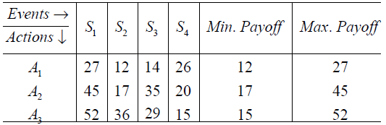
Solution: Since 17 is maximum out of the minimum payoffs, the optimal action is A₂.
- Maximax Criterion: This criterion, also known as the criterion of optimism, is used when the decision-maker is optimistic about future. Maximax implies the maximisation of maximum payoff. The optimistic decision-maker locates the maximum payoff for each possible course of action. The maximum of these payoffs is identified and the corresponding course of action is selected. The optimal course of action in the above example, based on this criterion, is A₃.
- Regret Criterion: This criterion focuses upon the regret that the decision-maker might have from selecting a particular course of action. Regret is defined as the difference between the best payoff we could have realised, had we known which state of nature was going to occur and the realised payoff. This difference, which measures the magnitude of the loss incurred by not selecting the best alternative, is also known as opportunity loss or the opportunity cost.
From the payoff matrix (given in § 12.6), the payoffs corresponding to the actions A₁, A₂, ...... An under the state of nature S_{j} are X_{1i}, X_{2j}, ...... X_{nj} respectively. Of these assume that X_{2j} is maximum. Then the regret in selecting A_{i}, to be denoted by R_{ij} is given by X_{2j} - X_{ij}, i = 1 to m. We note that the regret in selecting A₂ is zero. The regrets for various actions under different states of nature can also be computed in a similar way.
The regret criterion is based upon the minimax principle, i.e., the decision-maker tries to minimise the maximum regret. Thus, the decision-maker selects the maximum regret for each of the actions and out of these the action which corresponds to the minimum regret is regarded as optimal. The regret matrix of example can be written as given below:
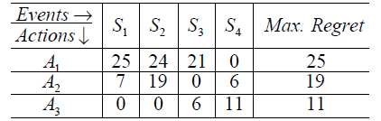
From the maximum regret column, we find that the regret corresponding to the course of action is A₃ is minimum. Hence, A₃ is optimal.
- Hurwicz Criterion: The maximax and the maximin criteria, discussed above, assumes that the decision-maker is either optimistic or pessimistic. A more realistic approach would, however, be to take into account the degree or index of optimism or pessimism of the decision-maker in the process of decision-making. If a, a constant lying between 0 and 1, denotes the degree of optimism, then the degree of pessimism will be 1 - a. Then a weighted average of the maximum and minimum payoffs of an action, with a and 1 - a as respective weights, is computed. The action with highest average is regarded as optimal.
We note that a nearer to unity indicates that the decision-maker is optimistic while a value nearer to zero indicates that he is pessimistic. If a = 0.5, the decision maker is said to be neutralist.
We apply this criterion to the payoff matrix of example 17. Assume that the index of optimism a = 0.7.
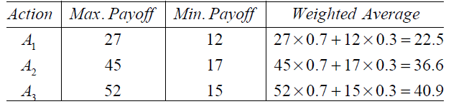
Since the average for A₃ is maximum, it is optimal.
- Laplace Criterion: In the absence of any knowledge about the probabilities of occurrence of various states of nature, one possible way out is to assume that all of them are equally likely to occur. Thus, if there are n states of nature, each can be assigned a probability of occurrence = 1/n. Using these probabilities, we compute the expected payoff for each course of action and the action with maximum expected value is regarded as optimal.

Decision making under risk and Uncertainty example
In case of decision-making under uncertainty the probabilities of occurrence of various states of nature are not known. When these probabilities are known or can be estimated, the choice of an optimal action, based on these probabilities, is termed as decision making under risk.
Risk implies a degree of uncertainty and an inability to fully control the outcomes or consequences of such an action. Risk or the elimination of risk is an effort that managers employ. However, in some instances the elimination of one risk may increase some other risks. Effective handling of a risk requires its assessment and its subsequent impact on the decision process. The decision process allows the decision-maker to evaluate alternative strategies prior to making any decision. The process is as follows:
- The problem is defined and all feasible alternatives are considered. The possible outcomes for each alternative are evaluated.
- Outcomes are discussed based on their monetary payoffs or net gain in reference to assets or time.
- Various uncertainties are quantified in terms of probabilities.
- The quality of the optimal strategy depends upon the quality of the judgments. The decision-maker should identify and examine the sensitivity of the optimal strategy with respect to the crucial factors.
Whenever the decision maker has some knowledge regarding the states of nature, he/she may be able to assign subjective probability estimates for the occurrence of each state. In such cases, the problem is classified as decision making under risk. The decision-maker is able to assign probabilities based on the occurrence of the states of nature.
The decision making under risk process is as follows:
- Use the information you have to assign your beliefs (called subjective probabilities) regarding each state of the nature, p(s),
- Each action has a payoff associated with each of the states of nature X(a,s),
- We compute the expected payoff, also called the return (R), for each action R(a) = Sums of [X(a,s) p(s)],
- We accept the principle that we should minimize (or maximize) the expected payoff,
- Execute the action which minimizes (or maximize) R(a)
The choice of an optimal action is based on The Bayesian Decision Criterion according to which an action with maximum Expected Monetary Value (EMV) or minimum Expected Opportunity Loss (EOL) or Regret is regarded as optimal.
Example : The payoffs (in Rs) of three Acts A₁, A₂ and A₃ and the possible states of nature S₁, S₂ and S₃ are given below :
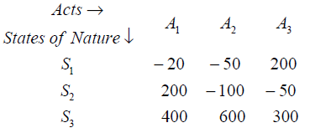
The probabilities of the states of nature are 0.3, 0.4 and 0.3 respectively. Determine the optimal act using the Bayesian Criterion.
Solution:
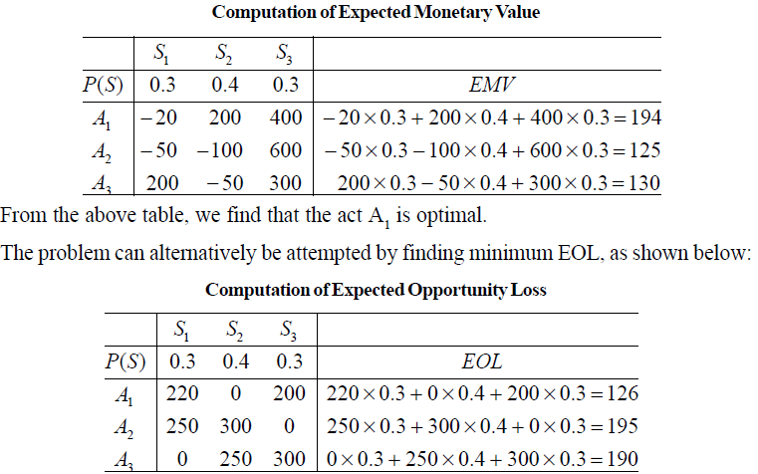
This indicates that the optimal act is again A₁.

Evpi Formula
EVPI helps to determine the worth of an insider who possesses perfect information. The expected value with perfect information is the amount of profit foregone due to uncertain conditions affecting the selection of a course of action. Given the perfect information, a decision-maker is supposed to know which particular state of nature will be in effect. Thus, the procedure for the selection of an optimal course of action, for the decision problem given in example 18, will be as follows:
If the decision-maker is certain that the state of nature S₁ will be in effect, he would select the course of action A₃, having maximum payoff equal to Rs 200.
Similarly, if the decision-maker is certain that the state of nature S₂ will be in effect, his course of action would be A₁ and if he is certain that the state of nature S₃ will be in effect, his course of action would be A₂. The maximum payoffs associated with the actions are Rs 200 and Rs 600 respectively.
The weighted average of these payoffs with weights equal to the probabilities of respective states of nature is termed as Expected Payoff under Certainty (EPC).
Thus, EPC = 200 * 0.3 + 200 * 0.4 + 600 *0.3 = 320
The difference between EPC and EMV of optimal action is the amount of profit foregone due to uncertainty and is equal to EVPI.
Thus, EVPI = EPC - EMV of optimal action = 320 - 194 = 126
It is interesting to note that EVPI is also equal to EOL of the optimal action.
Cost of Uncertainty
This concept is similar to the concept of EVPI. Cost of uncertainty is the difference between the EOL of optimal action and the EOL under perfect information.
Given the perfect information, the decision-maker would select an action with minimum opportunity loss under each state of nature. Since minimum opportunity loss under each state of nature is zero, therefore,
EOL under certainty = 0 *0.3 + 0 *0.4 + 0 * 0.3 = 0
Thus, the cost of uncertainty = EOL of optimal action = EVPI

Expected value of Perfect information solved examples
The expected values of perfect information solved examples are given below
Example : A group of students raise money each year by selling souvenirs outside the stadium of a cricket match between teams A and B. They can buy any of three different types of souvenirs from a supplier. Their sales are mostly dependent on which team wins the match. A conditional payoff (in Rs.) table is as under:
Type of Souvenir I II III
Team A wins 1200 800 300
Team B Wins 250 700 1100
(i) Construct the opportunity loss table.
(ii) Which type of souvenir should the students buy if the probability of team A's winning is 0.6?
(iii) Compute the cost of uncertainty.
Solution:
(i) The Opportunity Loss Table
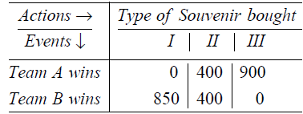
(ii) EOL of buying type I Souvenir = 0 * 0.6 + 850 * 0.4 = 340
EOL of buying type II Souvenir = 400 *0.6 + 400 * 0.4 = 400.
EOL of buying type III Souvenir = 900 *0.6 + 0* 0.4 = 540.
Since the EOL of buying Type I Souvenir is minimum, the optimal decision is to buy Type I Souvenir.
(iii) Cost of uncertainty = EOL of optimal action = Rs. 340
Example : The following is the information concerning a product X :
(i) Per unit profit is Rs 3.
(ii) Salvage loss per unit is Rs 2.
(iii) Demand recorded over 300 days is as under:
Units demanded : 5 6 7 8 9
No. of days : 30 60 90 75 45
Find : (i) EMV of optimal order.
(ii) Expected profit presuming certainty of demand.
Solution:
(i) The given data can be rewritten in terms of relative frequencies, as shown below:
Units demanded: 5 6 7 8 9
No of days : 0.1 0.2 0.3 0.25 0.15
From the above probability distribution, it is obvious that the optimum order would lie between and including 5 to 9.
Let A denote the number of units ordered and D denote the number of units demanded per day.
If D ≥A, profit per day = 3A, and if D < A, profit per day = 3D – 2(A – D) = 5D – 2A.
Thus, the profit matrix can be written as
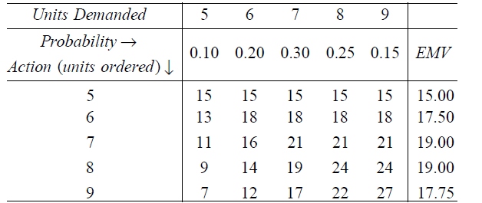
From the above table, we note that the maximum EMV = 19.00, which corresponds to the order of 7 or 8 units. Since the order of the 8th unit adds nothing to the EMV, i.e., marginal EMV is zero, therefore, order of 8 units per day is optimal.
(ii) Expected profit under certainty
= (5* 0.10+ 6*0.20+ 7 * 0.30+8* 0.25+ 9 * 0.15)* 3 = Rs 21.45

Decision Tree Approach & its Application
