Unit 1 | Essentials of HRM
1 | Nature and Scope of HRM
2 | Functions and Importance of HRM
3 | HRM vs. HRD
4 | SHRM- Introduction, Characteristics and Scope of SHRM
5 | SHRM vs. Conventional HRM
6 | Barriers to Strategic HRM
7 | Linking HR Strategy with Business Strategy
8 | HRM linkage with TQM & Productivity

Nature and Scope of HRM
According to Leon C. Megginson “From the national point of view human resources are knowledge, skills, creative abilities, talents, and attitudes obtained in the population; whereas from the view-point of the individual enterprise, they represent the total of the inherent abilities, acquired knowledge and skills as exemplified in the talents and aptitude of its employees”.
In simple words, HRM is a process of making the efficient and effective use of human resources so that the set goals are achieved. Let us also consider some important definitions of HRM.
The National Institute of Personnel Management (NIPM) of India has defined human resource/personnel management as “that part of management which is concerned with people at work and with their relationship within an enterprise. Its aim is to bring together and develop into an effective organisation of the men and women who make up an enterprise and having regard for the well-being of the individuals and of working groups, to enable them to make their best contribution to its success”.
According to Decenzo and Robbins “HRM is concerned with the people dimension in management. Since every organization is made up of people, acquiring their services, developing their skills, motivating them to higher levels of performance and ensuring that they continue to maintain their commitment to the organization are essential to achieving organisational objectives. This is true, regardless of the type of organization-government, business, education, health, recreation, or social action”.
Thus, HRM can be defined as a process of procuring, developing and maintaining competent human resources in the organization so that the goals of an organization are achieved in an effective and efficient manner. In short, HRM is an art of managing people at work in such a manner that they give their best to the organization for achieving its set goals.

Nature of Human Resource Management
- A part of Management Discipline
HRM is a part of management discipline. It is not a discipline in itself but is only a field of study. HRM, being a part of management process, draws heavily from management concepts, principles and techniques and apply these in the management of human resources.
- Universal Existence
HRM is pervasive in nature. It is present in all enterprises. It permeates all levels of management in an organization.
- Concerned with People
HRM is all about people at work, both as individuals and groups. It tries to put people on assigned job in order to produce goods results. The resultant gains are used to reward people and motivate them towards further improvement is productivity.
- Action oriented
HRM focuses attention on action, rather than on record keeping, written procedures or rules. The problems of employees are solved through rational policies.
- Directed towards Achievement of Objectives
HRM is directed towards achievement of organisational objectives by providing tools and techniques of managing people in the organisation effectively.
- Integrating Mechanism
HRM tries to build and maintain cordial relation between people working at different levels in the organization. It tries to integrate human assets in the best possible manner for achieving organisational goals.
- Development Oriented
HRM intends to develop the full potential of employees. The reward structure is turned to the needs of employees. Training is provided to improve the skill of employees. Every attempt is made to use their talents fully in the service of organisational goals.
- Continuous Process
HRM is not a one short deal. It cannot be practised only one hour each day or one day a week. It requires constant alertness and awareness of human relations and their importance in every day operations.
- Comprehensive Function
HRM is concerned with managing people at work. It covers all types of people at all levels in the organization. It applies to workers, supervisors, officers, manager and other types of personnel.

SCOPE
The scope of HRM is, indeed, very vast and wide. It includes all activities starting from manpower planning till employee leaves the organization. Accordingly, the scope of HRM consists of acquisition, development, maintenance/retention, and control of human resources in the organization (see figure 1.1). The same forms the subject matter of HRM. As the subsequent pages unfold, all these are discussed, in detail, in seriatim.
The National Institute of personnel Management, Calcutta has specified the scope of HRM as follows:
- The Labour or Personnel Aspect
This is concerned with manpower planning, recruitment, selection, placement, transfer, promotion, training and development, lay-off and retrenchment, remuneration, incentives, productivity, etc.
- Welfare Aspect
It deals with working conditions, and amenities such as canteen, creches, rest and lunch rooms, housing, transport, medical assistance, education, health and safety, recreation facilities, etc.
- Industrial Relations Aspects
This covers union-management relations, joint consultation, collective bargaining, grievance and disciplinary actions, settlement of disputes, etc.

Functions and Importance of HRM

Functions of HRM
We have already defined HRM. The definition of HRM is based on what managers do. The functions performed by managers are common to all organizations. For the convenience of study, the function performed by the resource management can broadly be classified into two categories, viz.
(1) Managerial functions, and
(2) Operative functions
These are discussed in turn.

(1) MANAGERIAL FUNCTIONS
(a) Planning
Planning is a predetermined course of actions. It is a process of determining the organizational goals and formulation of policies and programmed for achieving them. Thus planning is future oriented concerned with clearly charting out the desired direction of business activities in future. Forecasting is one of the important elements in the planning process. Other functions of managers depend on planning function.
(b) Organizing
Organizing is a process by which the structure and allocation of jobs are determined. Thus organizing involves giving each subordinate a specific task establishing departments, delegating authority to subordinates, establishing channels of authority and communication, coordinating the work of subordinates, and so on.
(c) Staffing
TOs is a process by which managers select, train, promote and retire their subordinates This involves deciding what type of people should be hired, recruiting prospective employees, selecting employees, setting performance standard, compensating employees, evaluating performance, counseling employees, training and developing employees.
(d) Directing/Leading
Directing is the process of activating group efforts to achieve the desired goals. It includes activities like getting subordinates to get the job done, maintaining morale motivating subordinates etc. for achieving the goals of the organization.
(e) Controlling
It is the process of setting standards for performance, checking to see how actual performance compares with these set standards, and taking corrective actions as needed.

(2) Operative Functions
The operative, also called, service functions are those which are relevant to specific department. These functions vary from department to department depending on the nature of the department Viewed from this standpoint, the operative functions of HRM relate to ensuring right people for right jobs at right times. These functions include procurement, development, compensation, and maintenance functions of HRM.
A brief description of these follows
(a) Procurement
It involves procuring the right kind of people in appropriate number to be placed in the organization. It consists of activities such as manpower planning, recruitment, selection placement and induction or orientation of new employees.
(b) Development
This function involves activities meant to improve the knowledge, skills aptitudes and values of employees so as to enable them to perform their jobs in a better manner in future. These functions may comprise training to employees, executive training to develop managers, organization development to strike a better fit between organisational climate/culture and employees.
(c) Compensation
Compensation function involves determination of wages and salaries matching with contribution made by employees to organisational goals. In other words, this function ensures equitable and fair remuneration for employees in the organization. It consists of activities such as job evaluation, wage and salary administration, bonus, incentives, etc.
(d) Maintenance
It is concerned with protecting and promoting employees while at work. For this purpose virus benefits such as housing, medical, educational, transport facilities, etc. are provided to the employees. Several social security measures such as provident fund, pension, gratuity, group insurance, etc. are also arranged.
It is important to note that the managerial and operative functions of HRM are performed in conjunction with each other in an organization, be large or small organizations. Having discussed the scope and functions of HRM, now it seems pertinent to delineate the HRM scenario in India.

Importance of Human Resource Management
Human resources are the valuable assets of the corporate bodies. They are their strength. To face the new challenges on the fronts of knowledge, technology and changing trends in global economy needs effective human resource management. Significance of HRM can be seen in three contexts: organisational, social and professional.
(i) Organization Significance
HRM is of vital importance to the individual organization as a means for achieving their objectives.
It contributes to the achievement of organisational objectives in the following ways:
(i) Good human resource practice can help in attracting and retaining the best people in the organization.
(ii) Developing the necessary skills and right attitudes among the employees through training, development, performance appraisal, etc.
(iii) Securing willing cooperation of employees through motivation, participation, grievance handling, etc.
(iv) Effective utilization of available human resources.
(v) Ensuring that enterprise will have in future a team of competent and dedicated employees.
(ii) Social Significance
Social significance of HRM lies in the need satisfaction of personnel in the organization. Since these personnel are drawn from the society, their effectiveness contributes to the welfare of the society. Society, as a whole, is the major beneficiary of good human resource practice.
(i) Employment opportunities multiply.
(ii) Eliminating waste of human resources through conservation of physical and mental health.
(iii) Scare talents are put to best use. Companies that pay and treat people well always race ahead of others and deliver excellent results.
(iii) Professional Significance
Professional significance of HRM lies in developing people and providing healthy environment for effective utilization of their capabilities.
This can be done by:
(i) Developing people on continuous basis to meet challenge of their job.
(ii) Promoting team-work and team-spirit among employees.
(iii) Offering excellent growth opportunities to people who have the potential to rise.
(iv) Providing environment and incentives for developing and utilizing creativity

HRM vs. HRD

BASIS FOR COMPARISON | HRM | HRD
Meaning | Human Resource Management refers to the application of principles of management to manage the people working in the organization. | Human Resource Development means a continuous development function that intends to improve the performance of people working in the organization.
What is it? | Management function. | Subset of Human Resource Management.
Function | Reactive | Proactive
Objective | To improve the performance of the employees. | To develop the skills, knowledge and competency of employees.
Process | Routine | Ongoing
Dependency | Independent | It is a subsystem.
Concerned with | People only | Development of the entire organization.

HRM
Human Resource Management, shortly known as HRM refers to a systematic branch of management that is concerned with managing people at work so that they can give best results to the organization. It is the application of management principles to the people working in the organization. It aims at improving the performance and productivity of the organization by finding out the effectiveness of its human capital. Therefore, HRM is an art of placing the right person at the right job, to ensure the best possible use of organization’s manpower.
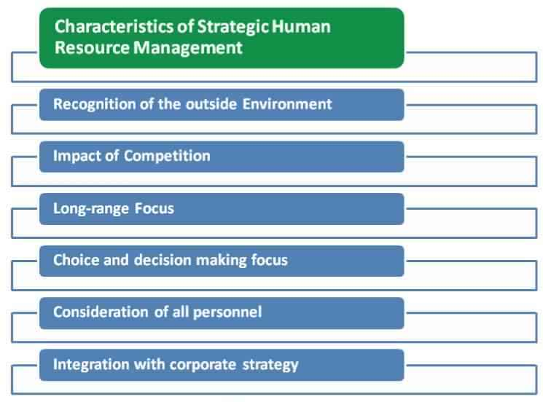
The process involves an array of activities that begins with the recruitment, selection, orientation, & induction, training & development, performance appraisal, incentives & compensation, motivation, maintaining workplace safety, health & welfare policies, managing relationship with the organization, managing change.

HRD
The term Human Resource Development or HRD refers to the development of people working in an organization. It is a part of HRM; that aims at improving skills, knowledge, competencies, attitude and behaviour of employees of the organization. The purpose of the HRD is to empower and strengthen the abilities of the employees so that their performance will get better than before.
Human Resource Development involves providing such opportunities to the employees that will prove beneficial in their all around development. Such opportunities include training & development, career development, performance management, talent management, coaching & mentoring, key employee identification, succession planning and so on. Nowadays, there are many organizations work for the human resource development of employees from the day they join the enterprise, and the process continues, until the end of their employment term.

Key Differences between HRM and HRD
The significant differences between HRM and HRD are discussed in the following points
- Human Resource Management refers to the application of principles of management to manage the people working in the organization. Human Resource Development means a continuous development function that intends to improve the performance of people working in the organization.
- HRM is a function of management. Conversely, HRD falls under the umbrella of HRM.
- HRM is a reactive function as it attempts to fulfill the demands that arise while HRD is a proactive function that meets the changing demands of the human resource in the organization and anticipates it.
- HRM is a routine process and a function of administration. On the other hand, HRD is an ongoing process.
- The basic objective of HRM is to improve the efficiency of employees. In contrast to HRD, this aims at developing the skill, knowledge and competency of workers and the entire organization.
- HRD is an organizationally oriented process; that is a subsystem of a big system. As opposed to HRM where there are separate roles to play, which makes it an independent function.
- Human Resource Management is concerned with people only. Unlike Human Resource Development, that focus on the development of the entire organization.

Conclusion
HRM differs with HRD in a sense that HRM is associated with management of human resources while HRD is related to the development of employees. Human Resource Management is a bigger concept than Human Resource Development. The former encompasses a range of organisational activities like planning, staffing, developing, monitoring, maintaining, managing relationship and evaluating whereas the latter covers in itself the development part i.e. training, learning, career development, talent management, performance appraisal, employee engagement and empowerment.

SHRM: Introduction, Characteristics and Scope of SHRM
Before we try to explain the meaning of strategic HRM, let us first define the terms ‘strategy’ and ‘strategic management’. The term ‘strategy’ is widely used in and presupposes importance. In the words of the Oxford Concise Dictionary, strategy means ‘generalship’. Thus, strategy is associated with the long-term decisions taken at the top of the enterprise. The original literary meaning of strategy is ‘the art and science of directing military forces’.
The term strategy is frequently being used in the present-day corporate world. It envisages thinking ahead to survive and grow in a highly competitive environment’. Strategy is concerned with determining which option will provide maximum benefits. According to Jauch and Glueck.
“Strategy is a unified, comprehensive and integrated plan that relates the strategic advantages of the firm to the challenges of the environment. It is designed to ensure that the basic objectives of the enterprise are achieved through proper execution by the organization”.

Characteristics of Strategic Human Resource Management(SHRM)
- Recognition of the outside Environment: Outside environment presents some opportunities and threats to the organization in the form of-
- Laws
- Economic conditions
- Social and demographic change
- Domestic and international political forces
- Technology and so on.
Strategic human resource strategy explicitly recognizes the threats and opportunities in each area and attempts to capitalize on the opportunities while minimizing or deflecting the effect of threats.
- The impact of Competition: The forces of competition in attracting, rewarding, and using employees have a major effect on corporate human resource strategy. Forces play out in local, regional and national labor markets. Labor market dynamics of wage rates, unemployment rates, working conditions, benefits levels minimum wages legislation and competition reputation all have an impact on and are affected by strategic human resource decisions.
- Long-Range Focus: A strategic human resource management should be long-range focus cause this is not easy to change the strategic human resource policy.
- Choice and Decision-making focus: In other words, the strategy has a problem solving or problem preventing focus. Strategy concentrates on the question, “what should the organization do and why?” this action orientation requires that decisions be made and carried out.
- Consideration of all Personnel: A strategic approach to human resources is concerned with all of the firm’s employees, not just its hourly or operational personnel. Traditionally, human resource management focuses on hourly employees, with most clerical exempt employees also included.
- Integration with the Corporate Strategy: Human resource strategy adopted by a firm should be integrated with the firm’s corporate strategy.
The key idea behind overall strategic mgt is to coordinate all of the company’s resources, including human resources; in such a way that everything a company does contribute to carrying out its strategy.
Synergy means the extra benefit or value realized when resources have been combined and coordinated effectively. This concept often referred to as economies of scope, makes the combined whole of the company make valuable than the sum of its parts. It is a true benefit of good strategic management of resources.
Key Features of Strategic Human Resource Management

The key features of SHRM are
- There is an explicit linkage between HR policy and practices and overall organizational strategic aims and the organizational environment
- There is some organizing schema linking individual HR interventions so that they are mutually supportive
- Much of the responsibility for the management of human resources is devolved down the line

Approaches of the SHRM
- Attempts to link Human Resource activities with competency based performance measures
- Attempts to link Human Resource activities with business surpluses or profit

SHRM vs. Conventional HRM
SHRM is about managing employees within an organization whereas in Strategic HRM there are different people who are skilled in specific areas. It is not that the same persons will handle recruitment, training, and employee appraisal.
As the term itself denotes, Strategic HRM deals with strategic aspects of HRM. Unlike SHRM, Strategic HRM mainly focuses on the programs with long-term objectives. Though SHRM and Strategic HRM focus on increasing employee productivity, Strategic HRM uses many strategic methods.
Unlike SHRM, Strategic HRM uses more sophisticated methods for improving overall employee motivation and productivity. Unlike the SHRM, Strategic HRM uses more systematic tools.
Strategic HRM expresses about company objectives, plans and the ways in which the business goals need to be achieved through people, Strategic HRM focuses on partnerships with internal and external customers. When HRM has only short-term goals, Strategic HRM has long-term goals.
When considering job design, Implementing the strategic plan through people in SHRM. On the other hand, the job division in Strategic HRM is flexible. When HRM has staff specialists, Strategic HRM has line managers.
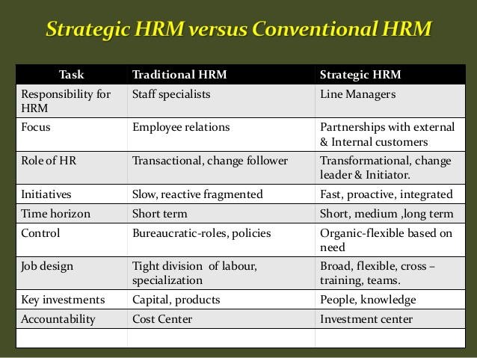

Summary:
- SHRM involves the process of employing people, developing their skills/capacities, and utilizing their services. Strategic HRM can be termed as a branch of HRM.
- While SHRM focuses mainly on employee relations, Startegic HRM focuses on partnerships with internal and external customers.
- When SHRM has only short-term goals, Strategic HRM is for long-term goals.
- When SHRM has staff specialists, Strategic HTM has line managers.
- When considering job design, there is a tight division of labor and independence specialization in SHRM. On the other hand, job division in Strategic HRM is flexible.

Barriers to Strategic HRM
Nothing is free from obstacles. SHRM also suffers from some barriers. These barriers are related to mentality, strategy and outcomes Barriers are classified into seven main types. All these barriers to strategic human resource management are briefly discussed below:

Barriers to Strategic Human Resource Management
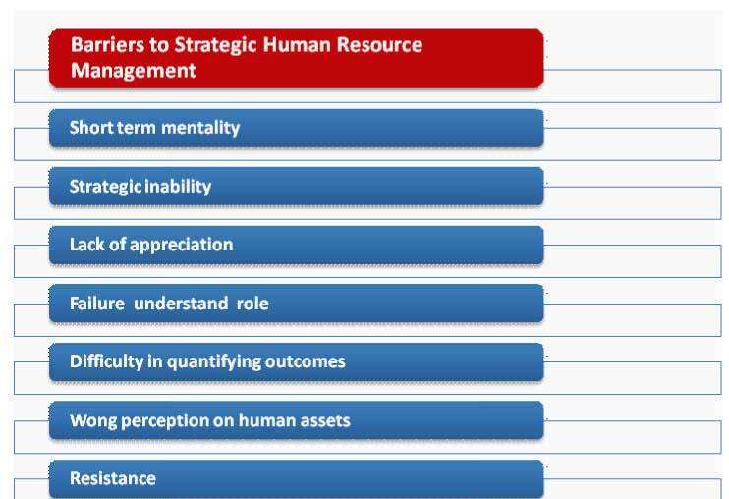
- Short term mentality: Short-term mentality and focus on the current performance of SFIRM is the first barrier. Every manager act, long-term focus, because the organization has been established with long-terms objectives/focus.
- Strategic inability: Very often SHRM does not think strategically and he cannot think it to due in capability. This type of inability may arise for many reasons as lack of technical knowledge, insufficient training and the like.
- Lack of appreciation: Sometimes top managers do not recognize the activities of strategic human resource management. So SHR manager does not get interested in doing any innovative venture. A few appreciations may get them a substantial mental boost up.
- Failure understands role: General managerial roles may not be fully understood by be managers. This failure is due to lack of knowledge about the specialty of a degree of responsibility. This failure may create distance between these managers.
- Difficulty in quantifying outcomes: Many outcomes may not be quantified. But SHRM tries to enjoy the contribution. This is not always possible. Participation, work etc. type function cannot be quantified because of their intangibility.
- Wong perception on human assets: Investment in human assets may be regarded as high risk than that of technology and information. Though these technologies are run by the human resources. This wrong perception may inhibit the progress.
- Resistance: SHR Managers may be resisted because of the incentives for change that might arise. The change implemented demand some incentives for efforts to execute the changed program. If these incentives are not given reasonable, they may create barriers SHRM.

Linking HR strategy with Business Strategy
When business owners and managers formulate business plans and strategies, they often leave out an important component of these plans. Human resources staff are often not consulted nor invited to participate in the planning process. When marketing, sales, manufacturing or finance are asked to implement their strategies and tactics for the coming year, they may find themselves short-handed, or worse, with people with the wrong aptitudes. Aligning HR with business strategies makes sense and helps ensure the company can realize goals.

Function
With HR at the planning table, HR can forecast how many people will be needed and with what skills. HR can inventory the current workforce to see who can be promoted to new positions, who should be trained and how and what recruitment and outsourcing strategies might be necessary to fulfill the plan.

Significance
HR should take the lead in driving change management. Change is a given in today’s competitive world, and the company that manages change best will most likely best its competitors. The HR staff should train the company workforce to figure out how to capitalize on a changing business environment and train company leaders to embrace the opportunities change can bring.

Potential
If employees are connected to company strategy and goals and are acknowledged for high performance, the goals are more easily met. Engaged employees are vital to company productivity. HR can be a key player at the strategy table if it develops performance management goals based on company objectives.

Considerations
HR has a delicate balancing act to develop compensation strategies that balance company finances with employee expectations. If compensation is too low, employees leave for greener pastures. If it is too high, the company income statement can be adversely affected. HR must be included in product development efforts and ensure the right staff is on hand for this function, even if it means paying a premium in the short term for freelance or contract employees with the right skills and experience for the tasks at hand.

Effects
HR departments typically track data on the success of recruitment efforts or how many people received what kind of training. But this is not sufficient. The better metrics are those that establish the long-term links of HR to company success. A more important metric might be how well the company does at retaining key personnel, those who contribute most to the bottom line.

HRM linkage with TQM & Productivity

HRM Linkage with TQM
Link is very much clear when Human resources of the company are satisfy they work with their full extent through this the productivity of the company rises and reaches to a higher point and if Human resources are dissatisfy, the productivity decreases.
Making quality improvements was once thought to be the sole responsibility of specialists (quality engineers, product designers, and process engineers). Today, developing quality across the entire firm can be an important function of the human resource management (HRM) department. A failure on HRM’s part to recognize this opportunity and act on it may result in the loss of TQM implementation responsibilities to other departments with less expertise in training and development. The ultimate consequence of this loss is an ineffective piecemealing of the TQM strategy. Thus, HRM act as the pivotal change agent necessary for the successful implementation of TQM.

HRM linkage with Productivity
As the business world continues on a ruthless drive to pick up the pace on a consistent level, the notion of productivity becomes a greater cause for debate and concern.
With reports that most workforces run at about 9% capacity, there’s a real spotlight on how we can stimulate greater productivity in order to keep in step with today’s faster and more dynamic world.
It’s almost an irony that despite the plethora of new world technology making it increasingly easy to keep in touch and connect with our co-workers, that in actual fact, the majority of people consider themselves disconnected from the organization they’re a part of. With this in mind, reinstating people as active contributors to a company has to be the key in a demand for increased productivity.
Human resources teams are in a unique position to reach out to the workforce and design measures to increase a sense of inclusion. Working towards bigger goals that relate back to their own jobs along with appropriate reward, can effectively combat the problem of poor productivity.
Numerous studies have focused on these points in recent years, and most come to the same conclusion; that a combination of methods and incentives are required to really tackle this issue. Having a great rewards scheme in place as an example, may be effective to a point and may appeal to a percentage of people, but on its own the cut-through will be limited.
Recruitment and training is undoubtedly another significant part of the puzzle, appropriately, sourcing the right people for the roles and for the culture of the company in question, but also placing serious emphasis on continual development.
