UNIT-3

HR Strategy

A Human Resource strategy is a business’s overall plan for managing its human capital to align it with its business activities. The Human Resource strategy sets the direction for all the key areas of HR, including hiring, performance appraisal, development, and compensation.
The HR strategy is thus a long-term plan that dictates HR practices throughout the organization.
An HR strategy has a set of characteristics:
- It requires an analysis of the organization and the external environment
- It takes longer than one year to implement
- It shapes the character and direction of Human Resources Management activities
- Helps in the deployment and allocation of organizational resources (i.e. money, time, personnel)
- Is revised on a yearly basis
- It incorporates the expert judgment of senior (HR) management
- It is number-driven
- It results in a specific behavior
A very useful model here is the standard causal model of HRM, one of the key HR models. This model shows where HR strategy originates from and how it influences HR execution and business performance.
The model shows that the HR strategy is a result of the broader (business) strategy. It shows that HR activities create value when they are aligned with what the organization tries to achieve. When there is alignment (fit) between the two, HR will contribute to the performance of the organization.
The overall business strategy is formulated based on the past and the present. It is a result of what the company has been doing in the past and its current internal capabilities. An often used tool to arrive at this strategy is the SWOT analysis.
In the SWOT analysis, the organization’s internal Strength and Weaknesses, and its external Threats and Opportunities are mapped. Strengths include the company’s core know-how and know-what. These are its production capacity, existing brand, marketing channels, sales capabilities, R&D expertise, and other human capital factors.

SWOT Analysis
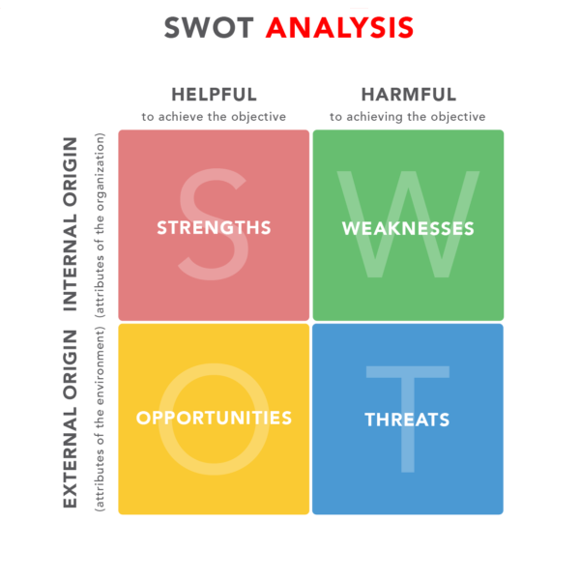
The company’s strategy leverages its Strengths to capitalize on the Opportunities in the market. At the same time, it tries to circumvent Threats and minimize the impact of Weaknesses.
The result of this strategy-setting is the company’s value proposition. For example, the value proposition of Walmart, a discount retailer, is “every day low prices”. This explains a number of internal HR practices, especially the ones related to worker compensation.
The HR strategy is based on the organizational strategy. The HR strategy touches on all the key areas in HR. These include recruitment, learning & development, performance appraisal, compensation, and succession planning.
An example of an HR strategy is an HR mission statement and HR vision, with concrete, high-level actions about how to execute on this mission and vision

Components of Strategic HRM

No matter the size of a business, the human resource department, even if just one person, is tasked with caring for and managing a company’s most important resource – its people. The department’s daily workload might include recruiting talent, hiring workers, onboarding new hires, managing payroll and benefits, along with many other personnel tasks. As a means of improving efficiency and streamlining duties, many HR departments utilize human resource management systems (HRMS). These clusters of software solutions allow HR departments to automate routine tasks and free up time for staff members to focus on areas that require more personalized attention.

Serve Core HR Functions
The most basic component of a HRMS serves the core HR needs – such as payroll, benefits and workforce management – made up of activities and processes for managing large numbers of hourly employees. It can involve programs that handle tasks such as:
- Scheduling shifts
- Recording attendance
- Tracking absences and sick days
- Clocking time worked
Some programs can also differentiate between union and non-union workers or employees and freelance workers, and make appropriate payroll calculations based on these distinctions. Benefits and employee contributions can also be easily tracked. All of an employee’s vital information is organized in one easy-to-access file that is managed much more efficiently by the HRMS than by manual processes.

  - Facilitate Talent Management
Other types of programs are designed to help HR departments manage their talent, or the actual employees within the company. This can cover a broad range of tasks including:
- Processes for recruiting new staff
- Onboarding
- Orientation
- Performance management and evaluation
- Training and professional development
In some cases, a system may allow an HR representative to create a job posting online, view incoming applications and track candidates through the hiring process.
Increasingly, orientation materials such as filling out payroll information and other paperwork are being relegated to online applications so HR staff are not required to be physically present to handle some of the basics, freeing them to do other work. Once great employees are on board, other components work to track performance metrics and provide professional development to retain top performers.
  - Encourage Employee Engagement
Some HR departments may extend their HRMS tools by also utilizing social media and online applications to engage their employees and stimulate interaction within the corporate environment. Through these channels, employees can:
- Collaborate on projects
- Learn more about the corporate brand
- Refer qualified friends for job openings
- Respond to company surveys designed to measure job satisfaction
- Make corporate announcements and policy updates
  - Meet Compliance Standards
Industries that operate in financial, health, insurance or public sector capacities are required to follow specific regulations and are subject to reporting and compliance standards. An HRMS component specifically designed to keep track of frequently changing regulations allows HR departments to stay on top of the necessary record-keeping and reporting requirements. Automated maintenance informs the HR department when background checks, licenses or continuing educational requirements need to be updated and assures that the company is operating in compliance.
  - Analyze Corporate HR Trends
Particularly in larger companies, analytics are increasingly important to upper level managers and HR departments. Programs that track the effectiveness of HR initiatives and recruitment methods help key executives pinpoint what works in attracting new talent to the company. They can also compare salary levels within the industry and make adjustments if needed. Data that is compiled from the fluctuating workforce also helps leaders gain a better understanding of turnover trends, such as why employees move on to another company or how to improve worker retention.

Organizational HR Strategies

Organizational strategy is a plan for evolving a business over time. You might want your company to be a leader in “green” technology in five years, or maybe you envision raising sales by 20 percent during the next 24 months. Whatever your plans, you need employees to carry them out and human resources leadership to prepare them for the task.
Profitability
Linking HR strategy to organizational strategy can be profitable. Towers Watson, a company specializing in human capital, reports in the study “Watson Wyatt’s 2002 Human Capital Index” that shareholders’ total returns were 64 percent over five years under progressive HR practices, compared with total returns of 21 percent under weak HR practices. Using a progressive strategy, HR can identify the skills your business wants employees to have and close existing skill gaps through aggressive recruiting and training.
Obstructions
High turnover, excessive absenteeism, low productivity and overall employee dissatisfaction disrupt your business operations. These obstructions not only raise your operating costs — hiring and retraining replacement staff is especially expensive for small businesses — they also derail organizational strategies. As your chief “employee problem-solver,” HR often conducts exit interviews with departing employees to find out why they’re leaving and take corrective action, or the company might make managers more responsible for keeping staff on board by tying their pay to retention rates. To raise productivity and retention, HR can recommend such low-cost incentives as flexible work schedules, performance awards or money-saving discounts from retailers.
Staff Buy-in
Organizational strategy has a better chance of succeeding when employees understand and buy in to your plan. HR is the liaison between management and staff. It can influence employees’ attitudes and behaviors towards your company and gain their support for your strategic plan. The HR strategy that’s focused on developing staff loyalty, for example, can give your organizational strategy the employee support needed to make your company a leader in green technology or increase your product sales.
Workplace Mandates
When HR strategy is linked to organizational strategy, companies have the benefit of HR’s expertise on workplace regulations and employment laws. HR is responsible for keeping organizations in compliance with safety regulations, anti-discrimination laws and other state and federal workplace requirements. When your organizational strategy conflicts with workplace mandates, your business could be sued or fined. For instance, plans for a new manufacturing process that significantly raises temperatures on the plant floor could violate Occupational Health and Safety Administration standards.

Functional HR Strategies

Business Management and Strategy
This is sometimes referred to as “the business of business.” It involves understanding information from inside the organization, and from external sources such as market trends to align the corporation’s human capital with its own needs. People involved in this area develop strategies and actions to best utilize staff and management to meet the corporate response to the information. They analyze data and develop programs that will initiate needed changes, and then evaluate the results.
Workforce Planning and Employment
This area of Functional Human Resource Management deals with staffing. Your Business at Arizona Central includes determining personnel needs as one of the duties of people in this area. Once a need is identified, the manager must not only define the position, but decide where and when to advertise openings. Recruitment involves screening applicants and conducting interviews as well. Sometimes human resource workers will hire directly and other times they simply narrow the applicant field for supervisors. Once staff people are hired, it becomes the responsibility of the human resource department to develop strategies to retain the hiree.
Human Resource Development
This area is important because it benefits both worker and management. Development specialists identify places where skill development is needed. This may be in “soft” areas such as customer service and communications, or in technical skills such as computer or equipment operation. Data indicates that when corporations invest in training staff, the employees are more satisfied, and productivity increases. Development personnel may conduct the trainings themselves or bring in trainers.
Total Rewards or Compensation
This division of Functional Human Resource Management deals with one of the largest expenses of a corporation. It includes direct compensation like wages and bonuses as well as indirect compensation given as benefit packages. Human resource workers in this department work with payroll processing, benefit enrollment and proper handling of insurance claims. Their goal is to meet employee needs at a cost-effective level.
Employee/Labour Relations
Workers in this arena must understand collective bargaining and compliance guidelines. Their goal is to balance corporate and employee needs. This includes morale management such as developing incentive and recognition programs. It also involves the implementation of performance appraisal procedures and routine evaluations.
Risk Management
This area involves working within OSHA guidelines to provide a safe and ergonomic work environment. Professionals in this arena develop safety policies and conduct safety audits of the corporation to assure they are in compliance with state and federal mandates. They also provide safety trainings and assist in accident reporting procedures.
As businesses expand, even go global, there will be increasing demand for professionals working with divergent standards and laws to manage the “human capital” of the corporations. An understanding of Functional Human Resource Management will allow students to select and hone career paths.

Strategic HR in Action

Models of Strategic HRM
The defining features of HRM is popularly known as models. These models provide analytical framework for studying HRM. They provide characterization of HRM that establishes variables and relationship to be researched. Four most common models are :
- The Fombrun Model
- The Harvard Model
- The Guest Model and
- The Warwick Model
All these models serve the following purposes:
- They provide an analytical framework for studying HRM for example, situational factors, stakeholders, strategic choice levels, competence etc.
- They validate certain HRM practices and provide distinctiveness to HRM practices.
- They provide a characterization of HRM that establishes variables and relationship to be researched.
- They help to discover and understand the world for explaining the nature and significance of key HR practices.
- THE FOMBRUN MODEL
This is the model of HRM. It emphasizes four functions of management and their interrelatedness Selection, Appraisal, Development and Rewards. This model is incomplete as it focuses on only four functions of HRM and ignore all other environmental and contingency factors. But, this model is simple and can serve as a heuristic framework for explaining the nature and significance of HR activities.
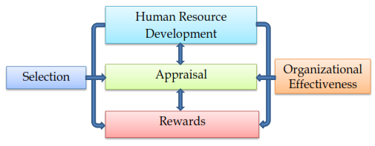
- THE HARVARD MODEL
This model consists six critical components of HRM namely stake holders interests, situational factors, HRM policy choices, HR out comes, long term consequences and a feedback loop through.
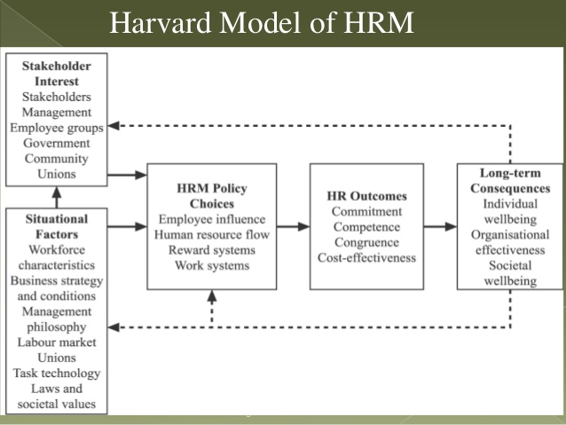
- THE GUEST MODEL
This model was developed by David Guest in 1997. This model emphasizes on the assumption that HR manager has specific strategies to begin with, which demand certain practices and when executed will result in outcomes. These out comes include behavioral performance related and financial rewards. The model emphasizes the logical sequence of six components : HR strategy, HR practices, HR outcomes, Behavioral outcomes, Performance results and financial consequences.
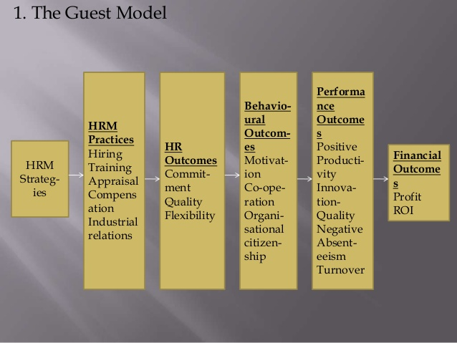
- THE WARWICK MODEL
This model was developed by two researchers, Hendry and Pettigrew of University of Warwick (hence the name Warwick model). Like other human resource management models, the Warwick proposition centers around five elements-
- Outer context (macro environmental forces)
- Inner context (firm specific or micro environmental forces)
- Business strategy content
- HRM context
- HRM content
The strength of this model is that it identifies and classifies important environment influences on HRM. This model takes cognizance of business strategy and HR practices, the external and internal content, in which these activities take place and process by which such changes take place including transactions between changes in both external content and internal content.
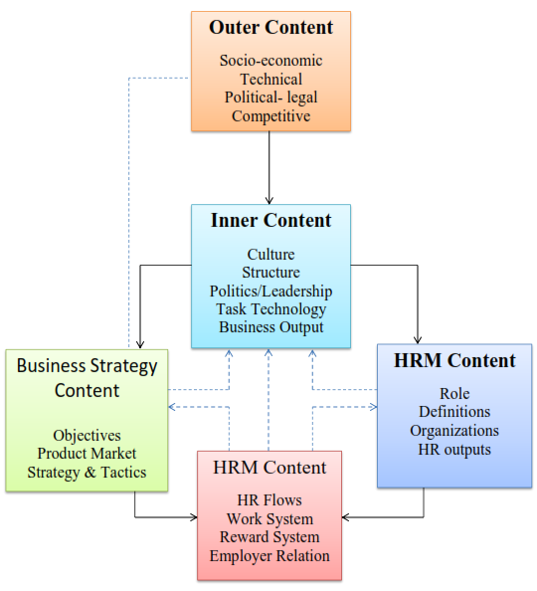
THE 5-P’S MODEL OF HRM
- Philosophy: Expressed in statements defining business values and culture. It expresses how to treat and value people.
- Policies: Expressed as shared values and guidelines. Policies establish guidelines for action on people related business issues and HR programs.
- Programs: Articulated as human resource strategy. These coordinate efforts to facilitate change to address major people related business issues.
- Practices: For leadership managerial and operational role practices motivate needed role behaviors.

Employee Engagement

Employee Engagement
Employee engagement is not the same as employee satisfaction
Employee Satisfaction only indicates how happy or content your employees are. It does not address their level of motivation, involvement, or emotional commitment. For some employees, being satisfied means collecting a paycheck while doing as little work as possible.
When organizations focus on how to improve employee satisfaction, changes won’t necessarily lead to increased performance. Oftentimes, the conditions that make employees “satisfied” with their jobs are the same conditions that frustrate high performing employees. Top performers embrace change, search out ways to improve, and challenge the status quo. They expect all employees be held accountable for delivering results, whereas low performers avoid accountability, cling to the status quo, and resist change.
Employee engagement goes beyond activities, games, and events. Employee engagement drives performance. Engaged employees look at the whole of the company and understand their purpose, where, and how they fit in. This leads to better decision-making. Organizations with an engaged workforce outperform their competition. They have a higher earning per share (EPS) and recover more quickly after recessions and financial setbacks. Engagement is a key differentiator when it comes to growth and innovation. To better understand the needs of your organization, administering an employee engagement survey is key. This is not the same as a satisfaction survey.
Moreover, expectations of employees have changed. Mobile professional careers are much more common than “job for lifers”. Retention of top talent is more difficult than before. A company that has an effective employee engagement strategy and a highly engaged workforce is more likely to retain top performers as well as attract new talent. Successful organizations are value-driven with employee-centric cultures.

How is employee engagement measured?
Measure what matters.
Employee engagement surveys have been developed specifically to measure the performance, strategic alignment, competency and satisfaction of contributors. Engagement surveys must be statistically validated and benchmarked against other organizations if they are going to provide useful results. Without these things, it is difficult to know what you are measuring and whether the results are good or bad.
Engagement can be accurately measured with short surveys that contain just a few questions, but such short surveys can only provide an indication of whether employees are engaged. They have a hard time explaining why employees are engaged or disengaged because they lack detail. Without sufficient information, an organization cannot develop meaningful activities, training programs, strategies, and initiatives to raise levels of engagement.
In order to get a complete picture of employee engagement, a survey needs to include about 50 to 80 questions that cover a complete range of relevant topics. There should also be open ended questions to further diagnose potential engagement problems in a company.

When should an organization measure employee engagement?
The best time to conduct an employee engagement survey is anytime. The timing of an engagement survey will have an effect on survey results, but it is always a good time to have a better understanding of how engaged your employees are.
Create a readiness assessment, communicate the reasons for doing the engagement survey, communicate results, and take action on survey results. These actions give meaning to the survey. Otherwise, a survey ends up being more of a waste of time and de-motivator.

Components of employee engagement
There are two primary factors that drive employee engagement. These factors are based on statistical analysis and widely supported by industry research.
Engagement with The Organization measures how engaged employees are with the organization as a whole, and by extension, how they feel about senior management. This factor has to do with confidence in organizational leadership as well as trust, fairness, values, and respect – i.e. how people like to be treated by others, both at work and outside of work. |  | Engagement with “My Manager” is a more specific measure of how employees relate to their direct supervisors. Topics include feeling valued, being treated fairly, receiving feedback and direction, and generally, having a strong working relationship between employee and manager based on mutual respect.

The two Organization factors deal with how employees relate to and connect with the organization. | The two Manager factors look at whether managers display the essential skills and behaviors needed to be effective.
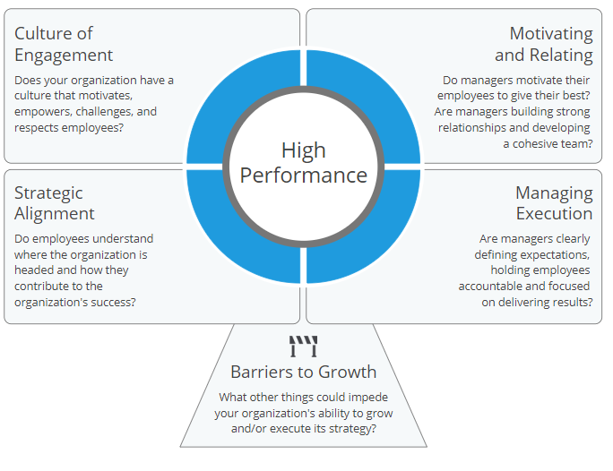

Beyond the Two Core Engagement Factors
High performance organizations, and highly engaged employees, also excel in these areas:
Strategic Alignment: Do employees have clarity of purpose and direction? Do employees understand how the work they do contributes to the organization’s success? Strategic Alignment ensures that employees have clarity of purpose and direction, and that their efforts are focused in the right direction. If those efforts are not focused in the right direction, they could be wasted.
Managing Execution: The most effective managers excel at the people skills, but they also provide clear expectations, hold people accountable, and stay focused on delivering results.
Leader and Manager Competency is measured as part of the employee survey via upward feedback.
For a more complete assessment of manager competency, we recommend using a 360 Degree Feedback Survey.

Who should be involved in employee engagement initiatives?
Research shows that many organizations struggle to bridge engagement survey results to its financial impact on the organization. It is important to understand how engagement affects a company’s bottom line.
A high-performing workforce is necessary to remain competitive, even survive. Developing programs to raise levels of employee engagement must be intentional, have meaning, purpose based on survey results.
HR can lead the charge to create an effective employee engagement strategy, but it needs to be embraced by the entire organization. There is a clear gap between the optimism of upper management and what middle managers experience with their teams. To understand the whole-organization picture, it’s essential to have an effective, multi-directional communication strategy in the organization. Effective communication is one of the most important factors that is most likely to bring company success. Organizations that thrive are able to articulate and communicate what success looks like – as individual employees, teams and departments, and the company as a whole. This increases engagement organization-wide.

Ways of Achieving Employee engagement

Four things are important when we talk about employee engagement; commitment, motivation, loyalty and trust. Their level determines the quality of engagement of an employee. Each one is briefly discussed in the coming paragraphs.
- Commitment: Commitment means the degree to which individuals associate themselves with the job, the responsibilities and the organisational objectives. Engaged employees are those who are fascinated by their work and committed to face every challenge to attain their goals. They are dependable and highly productive and therefore, are accountable for what they do.
- Motivation: Up till recently it was believed that the biggest motivation is achievement. The reverse is also true, which means achievement results in more motivation. If employees put in their 100 percent efforts to take their organisation to the next level, this attained status motivates them more than anything. Proper rewards and recognitions can further motivate them to achieve more and more for their organisation. Motivation and achievement go hand in hand and act as the burning fuels for the success of any organisation.
- Loyalty: Employees who are actively engaged in their work show more loyalty towards the organisation. The best part is that they need less focus and attention of managers to perform their task as they themselves feel accountable for their job responsibilities and results attained. However, it doesn’t take much time for actively engaged employees to turn into disengaged employees if the organisation doesn’t have a well established reward system. Recognition is a basic necessity of individuals to remain steered up towards their job.
- Trust: High levels of employee engagement can be fostered only when trust prevails in the organisation from both the sides. As they share strong emotional bond with the organisation, the latter should also show trust in their abilities. Employees must be given autonomy to perform their tasks their way. They should not be restricted to a specific rules and regulations and therefore, should be motivated to experiment to perform their task in a different and innovative manner.

Phases of Employee Engagement

Attract
The first phase of the employee engagement cycle is attracting the best talent from the industry. This phase involves creating a positive impression about the work culture and employee career as a potential employer. It is all about carefully creating an authentic, genuine and crafted image as an employer. This is although an indirect yet the first impression that attracts a big pool of candidates to apply for the job vacancies in an organisation. The first phase is the most important phase of the employee engagement cycle.
Another aspect spreading the reputation of an organisation is its employees. They are not only the employees but also are regarded as internal customers. Their job and career satisfaction speaks about their workplace. Therefore, they should not be taken for granted. Besides attracting the talent from the outside, it is important to keep the existing employees attracted towards the organisation.

Acquire
The acquire image involves more than one thing. It includes (1) the way the potential candidates are interacted while advertising a position; (2) keeping the promises that were made while hiring them and (3) providing the new joiners a right kind of work culture.
When an organisation advertises a position, interested candidates apply. The way their applications are created, the reaction of the organisation and the manner in which they are approached speak a lot about the image and work culture of an organisation.
Hiring the best talent not only serves the purpose. During their honeymoon or initial period with the organisation, the company must try to keep all the promises that were made during the selection process.
Besides this, they should feel happy and satisfied when their expectations are tested against the reality. Providing the right kind of culture also plays an important role in keeping them engaged.
The whole idea is to prepare them to perform their best by giving them challenging tasks right from the beginning. It’s like developing a habit or culture right from the time they decide to work with the organisation.

Advance
Continuous moving the talent is the last but an unending phase. It not only involves promoting the employees to a higher designation along with salary increments but also growing them in other tangible and intangible ways. Job rotation can help them grow in experience, responsibility and belongingness but only when it is done right. Advancing the employees in every aspect, be it monetary or non-monetary, is the key to retain people and develop their overall personality.

The 3 C’s of Employee Engagement
Career: When individuals join an organisation, they expect to build a career with it. If the top management and immediate managers spend dedicated time in carving out the careers of its employees, they will feel that they belong to the organisation. They feel engaged when they receive support from the management in growing their careers.
An organisation can provide its employees with opportunities to grow professionally through job rotations, indulging them in significant tasks, challenging assignments and promotions. They should also be given a specific level of authority and autonomy to take their decisions on their own. The organisations prepare an entirely new breed of employees if they genuinely invest in developing the careers of their people.
Competence: Competence is all about the ability to grow. Regular workshops and training sessions must be held in order to help employees acquire a higher level of skills and competencies. The focus should be on developing for marketable skills. Most employees after spending a few months look for competence-boosting opportunities with the organisation so that they can grow and move to the next level of their careers. While the career focuses on the actual growth in terms of designation, wages and perks and authority, competence is the ability to grow utilizing the opportunities.
Care: Sitting at the topmost, care is regarded the finest art of the managers by which they can make employees feel an indispensable part of their organisation. The managers need to be empathetic and sensitive towards people and understand their personal problems. Showing small day-to-day caring gestures towards employees make them feel that they belong to the organisation and organisation belongs to them.

Process and outcomes of employee engagement

This is the hardcore fact that the future business performance and revenues and profitability of an organisation no longer depends upon traditional capital management and investment and portfolio management. But the success of any organisation in this constantly changing world of work depends upon human capital management. The companies who understood this fact long before are the most successful and highly productive organisations of the currents times. Those who have just realised it are still struggling to establish a reputation in the industry.
Since the mantra of success of any organisation is the higher involvement, engagement and dedication of employees towards their jobs and their continuous performance to attain more, it is necessary to keep their spirits high, motivate them to perform their best always and generate a breed of satisfied and dedicated employees. Employee Engagement is not a onetime process that can quickly bring results; rather it is an ending process that will go on till the existence of an organisation.
As it is an established fact that there is a clear link between organisational performance and employee engagement, every organisation seeking sustenance and growth in the ever changing world of work quickly respond to the needs of employees along with designing and implementing a customised process to increase the levels of employee engagement. The following are a few basic steps in this process based on the best industry practices.
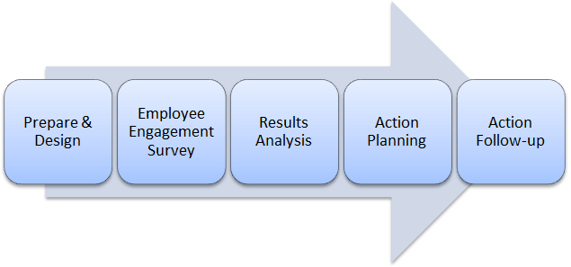
- Prepare and Design: The first step in the process is about discovering the specific requirements of your organisation and deciding the priorities. After that a customised design of carrying the whole process can be designed. It is recommended to seek advice of expert management consultant in order to increase the chances of getting it done right at the first attempt.
- Employee Engagement Survey: Design the questions of the employee engagement survey and deploy it with the help of an appropriate media. It can be either in printed form or set online depending upon the comfort level of the employees and your questionnaire evaluation process.
- Result Analysis: It is the most important step in the entire process. It is time when reports are to be analysed to find out what exactly motivates employees to perform their best and what actually disengages them and finally compels them to leave the organisation. The results and information can then be delivered through presentations.
- Action Planning: ‘How to turn the results of the survey in to an action’ is a challenging question that organisations need to deal with the utmost care. Coaching of line managers as well as HR professionals is very important in order to tell them how to take appropriate actions to engage employees. They should also be told about do’s and don’ts so that they can successfully implement the changes.
- Action Follow-up: Action follow up is necessary in order to find out if the action has been taken in the right direction or not and if it is producing the desired results.

Cost of Disengaged Workforce
The findings of the Gallup Study of 2008 show that while the engaged employees believe they can contribute to company’s growth, the disengaged employee believes otherwise, i.e. his job does not contribute to the organization. This belief of the disengaged employee creates a negative spiral that affects his work, co-workers, customers, productivity, and eventually both happiness of employee and company performance. Some effects are illustrated below:
- Effect on Work: The disengaged employee tries to evade work, struggles to meet deadlines and is reluctant to accept additional responsibility.
- Effect on Co-Workers: The negativity of a disengaged employee, demonstrated either through raves and rants or complete withdrawal from participation, affects the team morale. After all who has not heard of the proverb – one bad apple can spoil the whole bunch.
- Effect on Customers: Every employee, whether an organization likes it or not, becomes its ambassador. And a disengaged employee either by actively de-selling the organization, or by complete apathy towards their work, product, process, organization help create disengaged customers.
- Effects on Productivity: Disengaged employees seldom push themselves to meet organizational goals let alone contribute to innovative practices at workplace. Since, they do not believe that their work contributes to the organization; they evade completing tasks thereby affecting team productivity.
- Effect on Company Performance: In the corporate world, time is money and organizations must innovate to stay relevant. A disengaged workforce by virtue of delayed completion of tasks and inability to improvise and innovate cost the company dollars which ultimately affects bottom line. This has been validated by a Gallup Study whose research showed that costs of disengaged workforce in the United States was upwards of $300bn annually.
- Effect on Personal Life of Employee: A disengaged employee is seldom able to shake off the lethargy and perform in the current organization or land a job of preference. This leads to pent up frustration which may ultimately affect his personal and family life.

Benefits of an Engaged Workforce
An engaged workforce form an emotional connect with the organization that helps them
- Go the Extra Mile to Achieve Individual and Company Success
- Innovate at Workplace
- Attract customers and employees
- Become Evangelists of the company, its product and processes
- Infuse energy and positivity at workplace.

