UNIT – I

Concept of Marketing Mix: Introduction

Marketing Mix is a tool which a marketer uses to formulate a product/service offer for customers. Marketing mix is done using the 4Ps of marketing – Product, Place, Price, Promotion and 7Ps in case of service- Physical Evidence, People, and Process. The term Marketing Mix is attributed to Neil Bordon. The term is named marketing mix because it suggest how a marketer mixes various elements (Product, Price, Place, Promotion etc) in order to make a relevant/just right offering to the customer. The main objective of marketing mix strategy is to make the right product at correct price at the right place with right promotion.
This strategy has been one of the popular marketing topics in business. Let us talk more about the various elements in the marketing mix. There are two types of marketing mix-Product and Service.
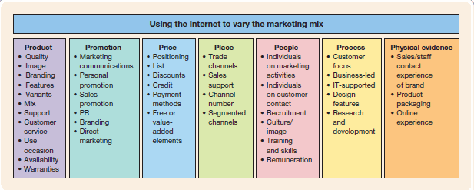

Product Marketing Mix
When a company is offering products or goods, it comes under the purview of the product marketing mix. It talks about the product strategies, pricing strategies, place where the products are distributed and promotional strategies. Elements of a product marketing mix can be explained in detail as below:

1-Product
It is the main part of the offering, the product itself. It is most important aspect of the mix. Product is something which has some functional value and can be used by the customer to achieve something. A marketer needs to define his product very carefully thinking about its value, its USP, features, competition etc.

2-Price
Pricing the second most important element in our marketing mix. This is value we will get in exchange for our product. This is what the customer will pay in return for the utility of the product. Pricing is mainly determined by the cost of the product and also how much the customer would be willing to pay. If we price it too high no one buys, if we price it too low, company makes losses. So we have to devise the right pricing strategy to make our marketing mix perfect.

3- Place
Also called the Distribution. If we are making a product as the right price, that is not enough, we need to make it available at the right place too. The customer mostly would not come to you until and unless our product and price is unbeatable. The product needs to be where customer is likely to buy. If we are soft drink manufacturer and the product is not available in grocery stores, supermarkets, restaurants etc then the first two elements of marketing mix are of no use and the offering fails.

4- Promotion
Also referred to as Communication about the product. This is the 4th element in marketing mix which means the communication done about the product to the customer. Advertising on TV, print and digital media would come under promotion.
Thus, the 4Ps or marketing mix is valid for every company, whether it is a product or a service company
Service Marketing Mix / Extended Marketing Mix
In case of a service brand like a restaurant, telecom service, hospitality etc, there are additional points apart from the 4Ps. The additional Ps i.e. physical evidence, people and processes are collectively known as the service marketing mix. These can be described as below:

1-Physical Evidence
A service is intangible but there has to be a reassurance to the customer that service happened. It can be a receipt of a service or may be an invoice. Physical evidence should be positive meaning that customer should be assured that service completed as expected.

2-People
These are the employees who help deliver the service e.g. delivery boy or a cab driver. They may become the face of the service hence are very important that is why very important to choose right people.

3-Process
The steps taken for the delivery of the service. The process is very crucial. The process should not only consist of the positive path but should also consider the negative paths to address issues in the service delivery.
E.g. Complain management, reverse supply chain etc.
All these help in understand the marketing mix for a service based business.

Traditional Marketing Mix 4Ps,
After successful market analysis, planning, and strategy, marketers must design a marketing mix made up of factors the company can control to influence demand such as, product, price, place, and promotion (the 4Ps). Marketing mix is defined as the set of tactical marketing tools (4Ps) that a business blends to produce the response it wants in the target market (Kotler & Armstrong, 2014). The picture below briefly describes each of the 4Ps.
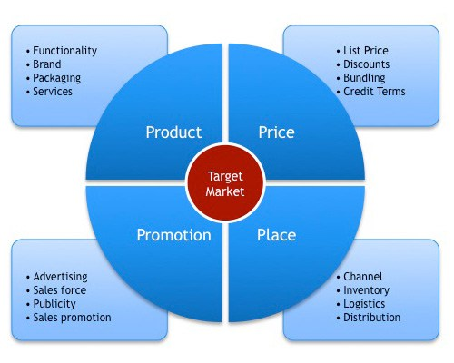
The 4Ps are used when referring to a business’s point of view, instead of the customer’s point of view. There is another part to the marketing mix called the 4Cs. Marketers use the 4Cs in the marketing mix to market in a more customer-centric way, rather than looking at how each aspect of marketing is seen by a business. Each C correlates with one of the P’s. The 4Cs are customer solution/value, customer cost, convenience, and communication (Kotler & Armstrong, 2014).
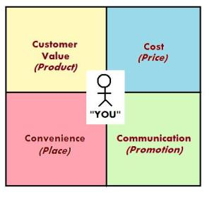
- PRODUCT
The first P, product, is a good or service that satisfies the wants of a company’s target market. When determining what the product will be, it must answer questions such as, what problem this product will solve, is there a consumer need for this product, and/or what will be the components of this product? This includes all items used in production to create the final product or service. However, marketers must also consider who will purchase the product and what the customer wants. Correlating with product is the first C, customer solution/value. Businesses sell products; however, customers are buying value and solutions to problems (Kotler & Armstrong, 2014).
- PRICE
The second P, price, is the amount of money customers must pay to obtain the product. It is the amount charged by a business; for example, a bottle of shampoo that costs $6.99. Prices may be adjusted by the business through discounts, allowances, and/or credit terms. Customers are concerned with more than just the price of the shampoo bottle though. The second C, customer cost, refers to the total costs of obtaining, using, and disposing of a product (Kotler & Armstrong, 2014).
- PLACE
The third P, place, includes company activities that make a product available to target consumers. This includes distribution channels, logistics, transportation, and locations offered. A company could have many stores offering its products across the United States, but there are still locations with consumers who will not be able to access that company’s products. This is most likely a loss to the company. The third C, convenience, is important to consumers. The more convenient a product or service is to the consumer, the better (Kotler & Armstrong, 2014). Consumers will make purchases depending on where, when, and how it is convenient for them; so marketers must take into account the consumer’s point of view here. For example, rather than businesses being concerned with locations of stores, it might be more beneficial to think of consumer convenience and offer online shopping.
- PROMOTION
The last P, promotion, is defined as the activities that communicate the merits of the product and persuade target customers to buy it. Two major factors for promoting are advertising and special promotions. However, consumers want more from businesses than 30 second commercials on television and/or radio to buy products. Consumers want two-way communication and relationships with businesses which is the fourth C, communication. Consumers also want to be engaged and feel a part of the business (Kotler & Armstrong, 2014).

4C’s of Marketing Mix – Modification of 4P’s
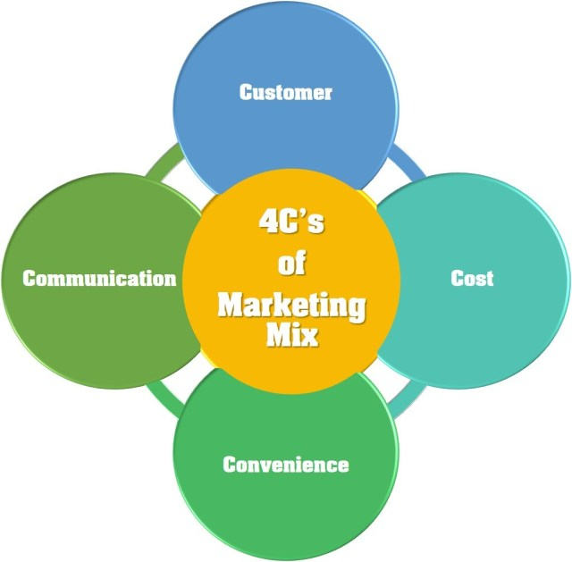
- Customer.
- Cost.
- Convenience.
- Communication.

1. CUSTOMER
Customer or Consumer is the king in the competitive world. In the competitive environment, the product will not create its own demand if it isn’t wanted by the consumer.
First, you must need to study the consumer needs and demands and then develop the product as it satisfies the needs, wants and demands of desired customer or consumer demand.

2. COST
Price is only a subset of the total cost incurred to satisfy the want or need of customer or consumer. Cost is the most important element of marketing mix which affects the decision of the customers.
The marketers must need to give special attention to the cost of a product or services.

3. CONVENIENCE
Convenience is the most important tools for more sales. The convenience of purchase products helps most of customers or consumers to choose that product.
Take an example heavy machineries products like fridge and air cooler.
If the companies sell these products hoand do not give you delivery and installation service.
You may not buy the product as you won’t be ready to pick up the machine and install it yourself. You will be looking for your own convenience product.
4. COMMUNICATION
A marketer should consider the communication instead of promotion.
Promotion is manipulative, it starts from the seller while Communication requires a give and take between the buyer and seller.

Service Marketing Mix
Services marketing is simply strategizing your marketing for the provision of services both in the context of a business serving a consumer and as a business serving another business. These include tax and accounting services, the hotel industry, airlines, telecoms, hairdressers, tailors, dry cleaners, and so on. It may also include services that are contained in what is a traditional physical product’s sales environment, such as tech and customer support.
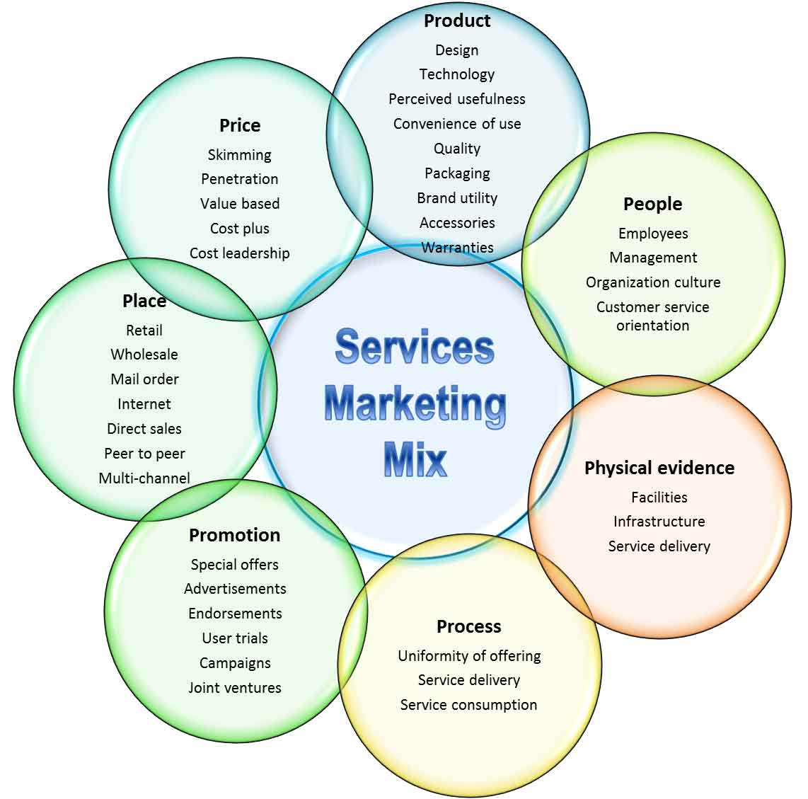
A service is defined as any economic activity that is not tangible, not stored, and does not result in the transfer of ownership. It is consumed immediately where the sale is made. With this definition in mind, the three new Ps added to the traditional marketing mix give it a lot of new depth. Since you it is not tangible and you have to consume it as soon as you buy it, there are a few factors that determine whether the customer walks away satisfied. These are the environment in which the service is delivered, the process through which the service is delivered, and the person who delivers the service
The need for extension is due to high degree of direct contact between the firm and the customer, the highly visible nature of the service production process, and simultaneous production and consumption of services.

The 7Ps of Service Marketing
The Service
1. Product
Physical products can be inspected and tried before buying but pure services are intangible. A customer cannot go to a showroom to see a medical operation that he is considering. This means that customers of services suffer higher perceived risk in their decision-making process.
They do not know whether they have purchased the right service until they have used it and in some cases like medical service and car service, they cannot be sure whether they have received the right service long after they have consumed the service.
The three elements of the extended marketing mix—people, physical evidence and processes provide clues about the quality of the service to the customer, and are crucial in influencing the customers’ perception of service quality.
Brand name of a service can also influence the perception of a service. It is sad that service providers do not expend necessary resources and efforts in building strong brands. In situations where customers are unsure of the quality of their purchases, strong brands provide an assurance to customers that the company has a history of good quality.
Customers spend lot of time, money and effort in ascertaining the likely quality of service they propose to buy and the providers do the same in assuring the customers of high quality of their offering. Both parties would be greatly served if service providers build strong brands.
Customers would be less unsure of the quality that they will get. Besides promoting its service, a provider should provide high quality of services consistently so that customers talk about it favourably. A strong service brand is built by a combination of advertising and positive word-of- mouth publicity. Both are necessary.
Positive word-of-mouth publicity without being supplemented with advertising will create a strong local brand. Customers from distant locations would not be attracted to it. Advertising without being supplemented with positive word-of-mouth publicity will create awareness but customers will still look for affirmation from customers who have actually used the service.
For some services, trial is possible. Some hotels invite key decision makers of communities to visit their hotels free of charge to sample the facilities and services. The hotels hope that they will recommend the hotel to their members.
2. Promotion
The intangible elements of service are difficult to communicate. It may be difficult to represent courtesy, hard work and customer care in an advertisement. The idea then is to use tangible cues that will help customers understand and judge the service.
A hotel can show the building, swimming pool, friendly staff and happy customers. Testimonials from satisfied customers can be used to communicate service benefits. Personal selling can also be effective in services marketing because of the high perceived risk inherent in many service purchases.
A salesperson can explain details of a personal health plan can answer questions and provide reassurance. Because of high perceived risk inherent in buying services, sales people should develop lists of satisfied customers to be used in reference selling. Sales people need to be trained to ask for referrals.
Customers should be asked if they know of other people or organizations that might benefit from the service. The customer can then be used as an entry and point of reference when approaching and selling to the new prospect. Word-of-mouth publicity is critical to success because of the experimental and experiential nature of services. Talking to people who have visited a resort is more convincing than reading holiday brochures.
3. Price
Price is an important tool in marketing of service. Since it is often difficult to evaluate a service before purchase, price acts as an indicator of perceived quality. For example, a patient expects a surgeon to charge high fees, otherwise he cannot be good.
Price is also an important tool in managing demand. Bars charge higher rates in the evenings when they expect a lot of rush. They charge lower price during daytime expecting some customers, who otherwise would have visited in the evenings, to visit during daytime due to the lower prices. Less number of customers have to be turned away in the evening.
Low prices can also attract new customers who cannot afford to or do not want to pay the high prices charged in the evenings. The facility is more evenly utilized throughout the day. Matching demand and supply is critical in services because services cannot be stored.
A less utilized facility at some part of the day or year means lost revenue which cannot be compensated. But the price differential has to be significant to be able to shift customers, as enjoyment of some services is closely related to the time at which they are consumed.
The experience of watching a movie in a theatre at the weekend is very different from watching it on a weekday. People would prefer going to a hill-station in summers than at any other time of the year.
Price sensitivity is a key segmentation variable in service sector. Some customers are willing to pay a much higher price than others. Time is often used to segment price sensitive and insensitive customers. Long-distance phone calls are cheaper at some part of the day than others.
Some customers may be willing to pay more to get the service early or whenever they want it. It is often debatable if a patient willing to pay more than the normal fees should be allowed access to a doctor before another patient who has been waiting for his turn.
But it is slowly being accepted that customers who pay more can have faster access to the service. But the discrimination has to be done in a discreet and subtle manner, especially when both set of customers are in the same place, as it often happens in entertainment parks, where two queues of guests move at different paces toward the rides.
4. Place
Distribution channels for services are more direct. There is no storage of services. Production and consumption is simultaneous, and hence direct contact between customer and service provider is essential for most services. Growth for many service companies means opening new facilities in new locations, due to simultaneous production and consumption. The evaluation of locations is a critical skill for such services.
Expansion often means a multi-point strategy because the whole setup for service production and marketing has to replicate. Success of many service providers has been due to their ability to choose profitable new sites and replicating their operations at the new sites.
New technologies permit service companies to provide services without customers coming to their facility. Information and financial services are leading this revolution. A customer can carry out transactions with a bank through ATMs, Internet, or the phone. Information products can be widely distributed through Internet.
But there are many other services where contact between the provider and the customer is still essential. But service companies should be looking for an alternative to personal contact with customers for at least a part of the service.
5. People
Service quality is inseparable from quality of service providers. The company has to set standards to improve quality of service provided by employees and monitor their performance. Without training and control, employees tend to be variable in their performance leading to variable service quality. Training is crucial so that employees understand the appropriate norms of behavior.
A service provider trains its employees to identify and categorize different personality types of customers, and to modify their behavior accordingly. Employees need to know how much discretion they have to talk informally to customers.
They also need to control their own behavior so that they are not intrusive, noisy or immature. They need to adopt a customer-first attitude rather than putting their own convenience and enjoyment before those of their customers.
Employees of service organizations have to be adept in multiple roles. They have to be good in their primary task and they have to be good in interpersonal skills. They also should have empathy to judge the service requirement and mood of the customer, and modify their service and behavior accordingly.
A service professional has to have the combined skills of an operations man, a marketer and a human resource manager. It is not easy to find employees with such diverse skills.
The service facility’s marketing mix should be such that it attracts customers desiring similar benefits from the provider. The target market has to be very homogeneous and the positioning very precise.
6. Physical Evidence
Physical evidence is about the environment in which the service is delivered and it includes any tangible goods that facilitate the performance and communication of the service. Customers look for cues to have an idea about the likely quality of a service by inspecting the tangible evidence.
Prospective customers may peep through a restaurant window to check the appearance of the waiters, the decor and the furnishings. The layout of a service operation has to balance the operational need for efficiency and marketing desire for effectively serving the customer.
Service providers should research the concerns of the customer regarding the service and also find out the cues that the customer will be searching to get an idea of that part of the service which is of concern to him. The service provider should strengthen those cues.
7. Process
These are the procedures, mechanisms and flow of activities by which a service is delivered to customers. Self-service cafeteria is very different from a restaurant. The company needs to research the requirements of its customers and set its processes accordingly so that the required service is delivered. Since requirements of customers vary widely, processes cannot be standardized.
But if a process is allowed too much flexibility, the efficiency of the facility goes down. Therefore customer requirements should not be allowed to vary widely. Through targeting the smaller segment of customers, tvariations in their requirements can be controlled.
The process is important because in some services, they are visible to customers. Sometimes the effectiveness of a process can be compromised in the effort to make it look good to the customer. Some patients feel good when they are extensively examined by the doctor though it may not be necessary.
Some processes in personal grooming and hair care saloons are not really required but service professionals have to carry them out because customers have come to expect them.

Developing of an Effective Marketing Mix
The marketing mix consists of 4 major elements: product, price, promotion and place. These ‘4-Ps’ are the key decision areas that marketers must manage so that they satisfy or exceeded customer needs better than the competition. In other words, decisions regarding the marketing mix form a major aspect of marketing concept implementation. At this point, it’s useful to examine each element briefly so that we can understand the essence of marketing mix decision-making.
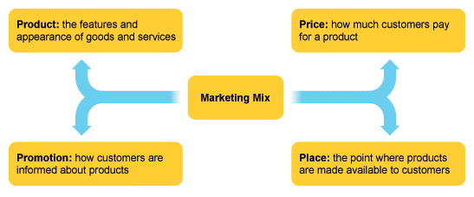

Why is the Marketing Mix Important?
In your day-to-day business activities it’s difficult to turn your attention to the big picture, especially when you’re putting out fires left and right.
Your marketing mix provides a roadmap for your business objectives. It keeps you on track, while keeping your target market in the forefront of your mind.
Your marketing mix will help you make sure your business is marketing the right product, to the right people, at the right price and time.

10 Steps to an Effective Marketing Mix
Use these 10 steps to assist you in building your perfect marketing mix for a successful product offering.

Step 1. Goals and Objectives
To create the right marketing mix you must first clearly define what you want the end result to be – more customers, brand awareness, higher sales, etc.
Every marketing plan has its own marketing goals. Also ensure you have set a specific time frame in which to achieve your goals.

Step 2. Establish Your Budget
How much money are you willing to spend on product innovation, consumer research and product promotion?

Step 3. Determine Your Unique Selling Proposition (USP)
Describe the benefits users will experience from using your product or service. What unique problem are you solving better than anyone else?
For example, Tom Shoes gives a new pair of shoes to a child in need for every pair you purchase.

Step 4. Who is Your Target Market?
In order to communicate effectively with your audience, you need to know who they are and how they prefer to be communicated with.
Create an in depth profile of your ideal customer. Make sure you’ve gathered enough consumer data to develop a complete picture of your ideal buyer.

Step 5. Ask Your Customers Advice
- What do they think of your product?
- How satisfied are they with the quality?
- Are the benefits apparent?
- How is your product effectively or not effectively meeting their needs?
Use their answers and the language they used in your marketing material. You’ll appear more relatable and approachable to your audience.

Step 6. Define Your Product in Detail
Take your time describing the specific qualities and value of your product. Look for the unique features that show your product’s worth.

Step 7. Know Your Distribution Channels
Identify the places your product will be marketed – which distribution channels you’ll make use of.
Your choice of distribution channel will influence your pricing and your promotion decisions.
Depending on your audience and product your main options will be:
- Selling to wholesalers who will sell to retail outlets, who will then sell to the consumer.
- Selling directly to the retail outlet.
- Selling directly to your customers.

Step 8. Create a Pricing Strategy
You need to discover clever ways of differentiating your product on price. Research your competitors and make sure you’re not overcharging your customers.
You will also need to consider what your target audience might be willing to pay and what it costs to actually produce your product.

Step 9. Choose Your Promotional Techniques
Your target audience needs to be made aware of your product offering.
Successful promotion of your product includes various elements, like:
- Direct Marketing: Directly connecting with carefully targeted individuals to cultivate lasting relationships. For example, catalogues, telephone marketing, and mobile marketing. Used for direct outreach to prospects in a database or sales list.

- Public relations: Press releases, exhibitions, sponsorship deals and conferences. Used for getting newsworthy attention.

- Advertising: Television, radio and print media will be your offline focus. Used for introducing your audience to new products and services.

- Personal selling: Personal presentation by your sales force. Demonstrating how your product works is key. Used for selling expensive, specialized and technologically advanced products.

- Sales promotion: Short-term incentives to encourage a purchase. This includes discounts, promotions, and payment terms. Used for getting people to use your product more often and to gain new customers.

- Word of mouth: Creating positive word of mouth via your sale staff, recommendations from buyers and social media. Used for boosting brand awareness.

Step 10. Use Inbound Marketing
The 4Ps of marketing creates the basis of your marketing strategy, but inbound marketing also plays a vital role in developing your marketing mix.
An effective inbound marketing mix should include:
- Your Website: Customers today want to interact with your brand and newly developed products. Use your website to fulfil this need for interaction. Make sure your website is quick loading, impactful and easy to navigate.

- Search Engine Optimization (SEO): In order for customers to interact with your website, they must be able to find it first. Use descriptive keywords to help search engines, like Google, direct users to your website.

- Email Marketing: One of the quickest, most direct ways to communicate with leads and customers. You need to continually collect prospects and customer contact information to grow your database and follow-up on a regular basis.

- Social Media: Besides having a website, you should use popular social networking sites to distribute your message and create brand awareness. Twitter and Facebook are invaluable for describing existing products, introducing new products, offering promotions and announcing sales.

- Blogging: Blogging will help your business stay top of mind by putting out regular content. Host the blog on your website and write good content, making sure to respond to each blog comment.

A well-developed marketing mix will help you develop products and services that better serve the wants and needs of your target market.
Done right, your market mix will help your customers understand why your product or service is better than those of you competitors.
Although the 4Ps should remain core to your marketing mix, inbound marketing should also form part of your overall marketing strategy. Use these 10 steps to help you develop your perfect marketing mix.

Managing and Designing Marketing Mix
Once a firm has defined its target market and identified its competitive advantage, it can create the marketing mix, which is based on the 5Ps discussed earlier, that brings a specific group of consumers a product with superior value. Every target market requires a unique marketing mix to satisfy the needs of the target customers and meet the firm’s goals. A strategy must be constructed for each of the 5Ps, and all strategies must be blended with the strategies of the other elements. Thus, the marketing mix is only as good as its weakest part. For example, an excellent product with a poor distribution system could be doomed to failure. An excellent product with an excellent distribution system but an inappropriate price is also doomed to failure. A successful marketing mix requires careful tailoring. For instance, at first glance you might think that McDonald’s and Wendy’s have roughly the same marketing mix. After all, they are both in the fast-food business. But McDonald’s targets parents with young children through Ronald McDonald, heavily promoted children’s Happy Meals, and in-store playgrounds. Wendy’s is targeted to a more adult crowd. Wendy’s has no playgrounds, but it does have flat-screen TVs, digital menu boards, and comfy leather seating by a fireplace in many stores (a more adult atmosphere), and it has expanded its menu to include more items for adult tastes.

Product Strategy
Marketing strategy typically starts with the product. Marketers can’t plan a distribution system or set a price if they don’t know exactly what product will be offered to the market. Marketers use the term product to refer to goods, services, or even ideas. Examples of goods would include tires, MP3 players, and clothing. Goods can be divided into business goods (commercial or industrial) or consumer goods. Examples of services would be hotels, hair salons, airlines, and engineering and accounting firms. Services can be divided into consumer services, such as lawn care and hair styling, or professional services, such as engineering, accounting, or consultancy. In addition, marketing is often used to “market” ideas that benefit companies or industries, such as the idea to “go green” or to “give blood.” Businesses often use marketing to improve the long-term viability of their industries, such as the avocado industry or the milk industry, which run advertising spots and post social media messages to encourage consumers to view their industries favorably. Thus, the heart of the marketing mix is the good, service, or idea. Creating a product strategy involves choosing a brand name, packaging, colors, a warranty, accessories, and a service program.
Marketers view products in a much larger context than is often thought. They include not only the item itself but also the brand name and the company image. The names Ralph Lauren and Gucci, for instance, create extra value for everything from cosmetics to bath towels. That is, products with those names sell at higher prices than identical products without the names. Consumers buy things not only for what they do, but also for what they mean.
With their computerized profile-matching capabilities, online dating services are a high-tech way to make a love connection. Today’s date-seeking singles want more than automated personals, however. They want advice from experts. At Match.com, popular shrink Dr. Phil guides subscribers toward healthy relationships. At eHarmony.com, Dr. Neil Clark Warren helps the lovelorn find a soulmate. How do internet dating services use various elements of the marketing mix to bolster the effectiveness of their product strategies? (Credit: Bixentro/ Flickr/ Attribution-2.0 Generic (CC BY 2.0))

Pricing Strategy
Pricing strategy is based on demand for the product and the cost of producing that product. However, price can have a major impact on the success of a product if the price is not in balance with the other components of the 5Ps. For some products (especially service products), having a price that is too low may actually hurt sales. In services, a higher price is often equated with higher value. For some types of specialty products, a high price is expected, such as prices for designer clothes or luxury cars. Even costume jewelry is often marked up more than 1000 percent over the cost to produce it because of the image factor of a higher price. Special considerations can also influence the price. Sometimes an introductory price is used to get people to try a new product. Some firms enter the market with low prices and keep them low, such as Carnival Cruise Lines and Suzuki cars. Others enter a market with very high prices and then lower them over time, such as producers of high-definition televisions and personal computers.

Place (Distribution) Strategy
Place (distribution) strategy is creating the means (the channel) by which a product flows from the producer to the consumer. Place includes many parts of the marketing endeavor. It includes the physical location and physical attributes of the business, as well as inventory and control systems, transportation, supply chain management, and even presence on the web. One aspect of distribution strategy is deciding how many stores and which specific wholesalers and retailers will handle the product in a geographic area. Cosmetics, for instance, are distributed in many different ways. Avon has a sales force of several hundred thousand representatives who call directly on consumers. Clinique and Estée Lauder are distributed through selected department stores. Cover Girl and Cotyuse mostly chain drugstores and other mass merchandisers. Redken products sell through hair salons. Revlon uses several of these distribution channels. For services, place often becomes synonymous with both physical location (and attributes of that location such as atmospherics) and online presence. Place strategy for services also includes such items as supply chain management. An example would be that an engineering firm would develop offices with lush interiors (to denote success) and would also have to manage the supplies for ongoing operations such as the purchase of computers for computer-aided drafting.

Promotion Strategy
Many people feel that promotion is the most exciting part of the marketing mix. Promotion strategy covers personal selling, traditional advertising, public relations, sales promotion, social media, and e-commerce. These elements are called the promotional mix. Each element is coordinated with the others to create a promotional blend. An advertisement, for instance, helps a buyer get to know the company and paves the way for a sales call. A good promotional strategy can dramatically increase a firm’s sales.
Public relations plays a special role in promotion. It is used to create a good image of the company and its products. Bad publicity costs nothing to send out, but it can cost a firm a great deal in lost business. Public relations uses many tools, such as publicity, crisis management strategy, and in-house communication to employees. Good publicity, such as a television or magazine story about a firm’s new product, may be the result of much time, money, and effort spent by a public-relations department. Public-relations activities always cost money—in salaries and supplies. Public-relations efforts are the least “controllable” of all the tools of promotion, and a great deal of effort and relationship-building is required to develop the ongoing goodwill and networking that is needed to enhance the image of a company.
Sales promotion directly stimulates sales. It includes trade shows, catalogs, contests, games, premiums, coupons, and special offers. It is a direct incentive for the customer to purchase the product immediately. It takes many forms and must adhere to strict laws and regulations. For example, some types of contests and giveaways are not allowed in all the states within the United States. McDonald’s discount coupons and contests offering money and food prizes are examples of sales promotions.
Social media is a major element of the promotion mix in today’s world. Most businesses have a corporate website, as well as pages on different social media sites such as Facebook, Pinterest, and Twitter. Social media is more powerful as a channel for getting the company’s message out to the target market (or general public) than traditional advertising, especially for some target markets. Companies (and even individuals) can use social media to create instant branding. E-commerce is the use of the company website to support and expand the marketing strategies of the 5Ps. It can include actual “order online” capabilities, create online communities, and be used to collect data from both existing and potential customers. Some e-commerce websites offer free games and other interactive options for their customers. All of this activity helps to build and strengthen the long-term relationships of customers with the company.

Not-for-Profit Marketing
Profit-oriented companies are not the only ones that analyze the marketing environment, find a competitive advantage, and create a marketing mix. The application of marketing principles and techniques is also vital to not-for-profit organizations. Marketing helps not-for-profit groups identify target markets and develop effective marketing mixes. In some cases, marketing has kept symphonies, museums, and other cultural groups from having to close their doors. In other organizations, such as the American Heart Association, marketing ideas and techniques have helped managers do their jobs better. In the private sector, the profit motive is both an objective for guiding decisions and a criterion for evaluating results. Not-for-profit organizations do not seek to make a profit for redistribution to owners or shareholders. Rather, their focus is often on generating enough funds to cover expenses or generating enough funds to expand their services to assist more people. For example, the Methodist Church does not gauge its success by the amount of money left in offering plates. The Museum of Science and Industry does not base its performance evaluations on the dollar value of tokens put into the turnstile. An organization such as the American Red Cross raises funds to provide basic services, but if enough funds are raised (beyond just the amount to cover expenses), those funds are used to expand services or improve current services.

