UNIT – 4

Promotion Management
Promotion is a type of communication between the buyer and the seller. The seller tries to persuade the buyer to purchase their goods or services through promotions. It helps in making the people aware of a product, service or a company. It also helps to improve the public image of a company. This method of marketing may also create interest in the minds of buyers and can also generate loyal customers.
It is one of the basic elements of the market mix, which includes the four P’s: price, product, promotion, and place. It is also one of the elements in the promotional mix or promotional mix or promotional plan. These are personal selling, advertising, sales promotion, direct marketing publicity and may also include event marketing, exhibitions, and trade shows.

Types of Promotion
- Advertising
Advertising means to advertise a product, service or a company with the help of television, radio or social media. It helps in spreading awareness about the company, product or service. Advertising is communicated through various mass media, including traditional media such as newspapers, magazines, television, radio, outdoor advertising or direct mail; and new media such as search results, blogs, social media, websites or text messages.
- Direct Marketing
Direct marketing is a form of advertising where organizations communicate directly to customers through a variety of media including cell phone text messaging, email, websites, online adverts, database marketing, fliers, catalog distribution, promotional letters and targeted television, newspaper and magazine advertisements as well as outdoor advertising. Among practitioners, it is also known as a direct response.
- Sales Promotion
Sales promotion uses both media and non-media marketing communications for a pre-determined, limited time to increase consumer demand, stimulate market demand or improve product availability.
- Personal Selling
The sale of a product depends on the selling of a product. Personal Selling is a method where companies send their agents to the consumer to sell the products personally. Here, the feedback is immediate and they also build a trust with the customer which is very important.
- Public Relation
Public relation or PR is the practice of managing the spread of information between an individual or an organization (such as a business, government agency, or a nonprofit organization) and the public. A successful PR campaign can be really beneficial to the brand of the organization.

INTEGRATED MARKETING COMMUNICATIONS
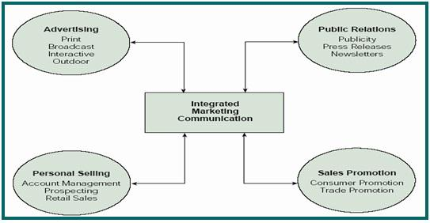
An approach to achieving the objectives of a marketing campaign, through a well-coordinated use of different promotional methods that are intended to reinforce each other.
As defined by the American Association of Advertising Agencies, integrated marketing communications “… recognizes the value of a comprehensive plan that evaluates the strategic roles of a variety of communication disciplines advertising, public relations, personal selling, and sales promotion and combines them to provide clarity, consistency, and maximum communication impact.”
It is essential for organizations to promote their brands well among the end-users not only to outshine competitors but also survive in the long run. Brand promotion increases awareness of products and services and eventually increases their sales, yielding high profits and revenue for the organization.
Integrated marketing communication refers to integrating all the methods of brand promotion to promote a particular product or service among target customers. In integrated marketing communication, all aspects of marketing communication work together for increased sales and maximum cost effectiveness.

Components of Integrated Marketing Communication:
(i) The Foundation: As the name suggests, foundation stage involves detailed analysis of both the product as well as target market. It is essential for marketers to understand the brand, its offerings and end-users. You need to know the needs, attitudes and expectations of the target customers. Keep a close watch on competitor’s activities.
(ii) The Corporate Culture: The features of products and services ought to be in line with the work culture of the organization. Every organization has a vision and it’s important for the marketers to keep in mind the same before designing products and services. Let us understand it with the help of an example.
Organization A‘s vision is to promote green and clean world. Naturally its products need to be eco friendly and biodegradable, in lines with the vision of the organization.
(iii) Brand Focus: Brand Focus represents the corporate identity of the brand.
(iv) Consumer Experience: Marketers need to focus on consumer experience which refers to what the customers feel about the product. A consumer is likely to pick up a product which has good packaging and looks attractive. Products need to meet and exceed customer expectations.
(v) Communication Tools: Communication tools include various modes of promoting a particular brand such as advertising, direct selling, promoting through social media such as facebook, twitter, orkut and so on.
(vi) Promotional Tools: Brands are promoted through various promotional tools such as trade promotions, personal selling and so on. Organizations need to strengthen their relationship with customers and external clients.
(vii) Integration Tools: Organizations need to keep a regular track on customer feedbacks and reviews. You need to have specific software like customer relationship management (CRM) which helps in measuring the effectiveness of various integrated marketing communasications tools.
Integrated marketing communication enables all aspects of marketing mix to work together in harmony to promote a particular product or service effectively among end-users.

Communication Development Process
Marketing communications process consist of integrated activities in which the targeted audience is identified and a well-coordinated promotional program is prepared to generate the desired response from the audience. Most problems of preferences, image and immediate awareness in the target customers is focused by the marketing communication. But there are certain limitations associated with the concept of communication. These limitations include high cost and short term duration that cannot generate the desired results from the targeted customers.
In recent years Marketing Communication is used by most of marketers as building customer relationship at the stages of pre-selling, selling, utilization, and post utilization. Due to differences in customers, different programs of communications are developed for specific segments.
Marketing Communication Development Process Steps
There are certain steps that should be involved in the effective marketing communication process. The marketing and promotional activities should focus on these steps in order to attract a huge portion of long run customers. Following are the steps that make communication process effective.
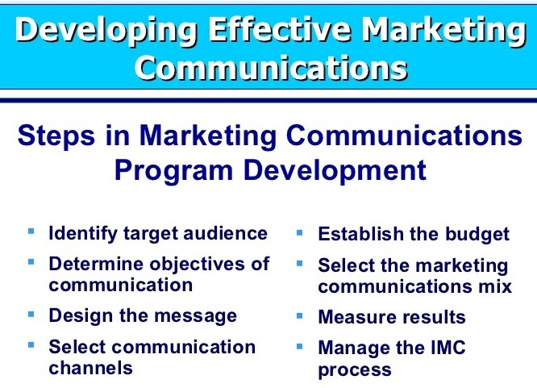
- Identification of the Target audience
- Determination of the communication objectives
- Designing of Message
- Message Content
- Message Structure & Format
- Choosing Media
- Collecting Feedback
- Identification of the Target Audience
The first step in the effective marketing communication process is to identify the target audience. These audiences may be potential customers or other people that can influence the decisions of these customers. The audience may include the individuals, groups, general public or special public. The audience has a direct effect on the decisions of the communication, like what to say? How to say? And when to say? Etc.
- Determination of the Communication Objectives
In this step the marketing communicator should clear the objectives of the communication process. In most of the situations, the purchase is required by the marketing communicator, but purchase is made after a prominent customer decision making process. The communicators should also understand the standing position of the customer. Generally there are six Stages of Customer Readiness through which a customer pass to make a purchase which are as follow.
- Awareness
- Knowledge
- Liking
- Preference
- Conviction
- Purchase
The target group of the marketing communicator is not much familiar with the new product or its silent features. So the marketing communicator should create the awareness and knowledge of its new product and features. But this is not the surety to the success; the new product should also provide superior customer value too.
- Designing of the Message
In this step the marketing communication, communicator focuses upon the design of the message. Any message that can attract the attention, develop the interest, arousal of desire and stimulate the action is the effectively designed message. This procedure is best known as AIDA model that can make any message effective and potential. Besides this the marketing communicator also decides about the content and structure of the message.
- Message Content
In this step of the marketing communication process the content of the message is decided. The theme or an appeal is suggested that can bring the desired response from the audience or receiver. Following are the three appeals that should be used in this regard.
- Rational Appeal: The self-interest of the audience is focused on the rational appeal in which the benefits availed by the usage of the products or services.
- Emotional Appeal: In this case positive or negative emotions are stimulated to encourage the purchase of the product.
- Moral Appeal: In this situation the morality is included in the message to influence the targeted customers.
- Message Structure & Format
In this step the important issues of the message structure together with the message format is analyzed. In marketing communication of a product, it must be decided that the message must include the conclusion or may keep to the audience to get a conclusion from them. Or the massage presents either only the strengths of the product or both the strengths and weaknesses. Moreover the format of the message is also focused on which the size and shape use, eye-catching colors, and headlines etc. are decided in the most effective manner.
- Choosing Media
The channels of communication are decided in this step of a marketing communication process, which may take the following two forms.
- Personal: In this channel of communication two or more persons directly communicate with each other like face to face, through the mail, on the telephone, or through a chat on the internet. Personal Addressing and feedback is allowed in the personal communication.
- Non Personal: Non personal messages are spread through these channels which also excludes the option of feedback. Such channels include print media, display media, broadcast media, online media etc.
- Collecting Feedback
This is the last step of the marketing communication process in which the feedback from the target customers. This can help the marker to alter the promotion program or other marketing activities. For this purpose the buying behavior of targeted customers is analyzed in the light of the new product. Questions may also be asked to the customers to collect their views about the positive and negative aspects of the new product.

Budget Allocation Decisions in Marketing Communications
A marketing communication budget provides a formal process for planning, tracking and measuring the impact of your expenditures on marketing communications activities such as advertising, direct marketing, online or events. The budget sets out the funding required to meet your communications objectives and provides a method of managing the expenditure over a budget year.
Objectives of Marketing Communication Budget
The marketing communication budget is part of the wider marketing planning process. Your marketing strategy establishes how you will achieve your marketing objectives. Marketing communications strategy describes the techniques you will use to deliver key messages to the target audience. The objective of the marketing communication budget is to achieve the communication goals as cost effectively as possible and demonstrate a successful return on investment. Some organizations separate above-the-line expenditures on advertising from below-the-line activities such as product information, social media or direct marketing.
Scope of Marketing Communication Budget
The budget covers the direct and indirect costs of communications programs. A budget for product information, for example, would include costs of copy writing, design, printing and distribution. A budget for an event such as an exhibition would cover rent of exhibition space, booth design and production, client entertainment costs, event publicity and miscellaneous staff costs. Careful planning ensures that there are no surprises when the final bill arrives.
How to Prepare a Marketing Communication Budget?
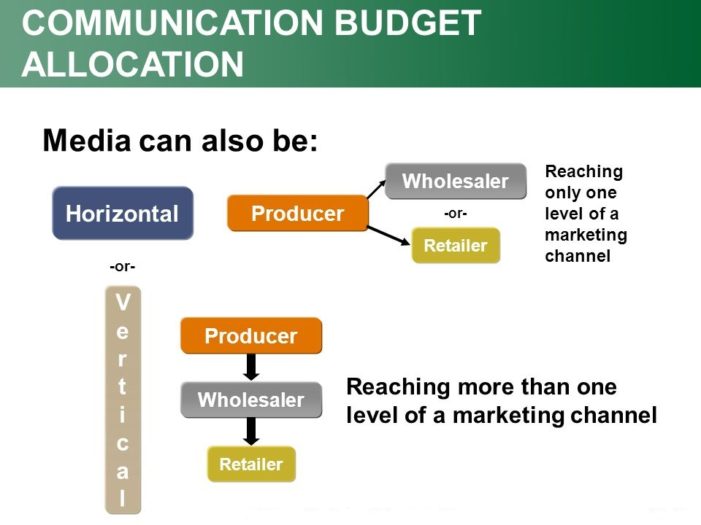
Crafting a marketing communication budget serves as your advertising road map for the course of a year. Having a formal budget laid out lets you carefully evaluate where you are spending your advertising dollars and gives you complete control over your marketing initiatives. By having documentation that clearly outlines what you are spending, you can more easily calculate your return on investment later and identify which marketing campaigns were profitable and which were not.
- Calculate how much your overall marketing budget will total so you can best decide how to divide it among various marketing communication actions. This number can be calculated based on a percentage of the previous year’s sales or can be a set increase over the marketing budget of the previous year, depending on the financial parameters of your company.
- Decide what types of advertising you will do throughout the year so you can begin to calculate how you can divide the budget. Typical segments of a marketing communication budget include print, web, TV, radio and outdoor advertising, though this could vary depending on your advertising needs.
- Review the previous year’s advertising budget and return on investment reports, if applicable, to gauge the costs for advertising campaigns, as well as the most lucrative and effective advertising investments you made.
- Assign a budget to each section of your advertising campaign and break it down by month or week. For example, TV advertising campaigns often work in quarterly or yearly contracts. Divide this sum by the months affected to get a monthly breakdown. A print campaign might change from week to week. Calculate what your weekly plans amount to over a month.
- Set aside some of the marketing budget for new advertising ventures. A last-minute deal might be offered by an advertising sales representative, or you might come across an advertising opportunity you weren’t aware of when calculating your yearly budget. Having a fund for new advertising opportunities can give you the freedom to take advantage of these marketing campaigns without going over budget.
- Include a segment of the advertising budget for marketing materials, such as letterhead, flier printing, T-shirts or giveaway items. Promotional items are an effective branding tool so you need to account for this area of advertising within your budget.

Promotion Mix
The Promotion Mix refers to the blend of several promotional tools used by the business to create, maintain and increase the demand for goods and services.
The fourth element of the 4 P’s of Marketing Mix is the promotion; that focuses on creating the awareness and persuading the customers to initiate the purchase. The several tools that facilitate the promotion objective of a firm are collectively known as the Promotion Mix.
The Promotion Mix is the integration of Advertising, Personal Selling, Sales Promotion, Public Relations and Direct Marketing. The marketers need to view the following questions in order to have a balanced blend of these promotional tools.

Elements of Promotion Mix
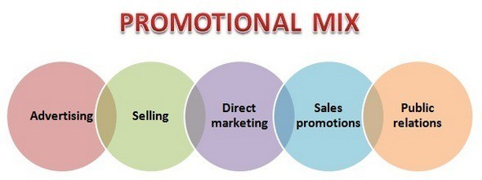1.Advertising
The advertising is any paid form of non-personal presentation and promotion of goods and services by the identified sponsor in the exchange of a fee. Through advertising, the marketer tries to build a pull strategy; wherein the customer is instigated to try the product at least once. The complete information along with the attractive graphics of the product or service can be shown to the customers that grab their attention and influences the purchase decision.
2. Personal Selling
This is one of the traditional forms of promotional tool wherein the salesman interacts with the customer directly by visiting them. It is a face to face interaction between the company representative and the customer with the objective to influence the customer to purchase the product or services.
3. Sales Promotion
The sales promotion is the short term incentives given to the customers to have an increased sale for a given period. Generally, the sales promotion schemes are floated in the market at the time of festivals or the end of the season. Discounts, Coupons, Payback offers, Freebies, etc. are some of the sales promotion schemes. With the sales promotion, the company focuses on the increased short-term profits, by attracting both the existing and the new customers.=

4. Public Relations
The marketers try to build a favorable image in the market by creating relations with the general public. The companies carry out several public relations campaigns with the objective to have a support of all the people associated with it either directly or indirectly. The public comprises of the customers, employees, suppliers, distributors, shareholders, government and the society as a whole. The publicity is one of the form of public relations that the company may use with the intention to bring newsworthy information to the public.
E.g. Large Corporates such as Dabur, L&T, Tata Consultancy, Bharti Enterprises, Services, Unitech and PSU’s such as Indian Oil, GAIL, and NTPC have joined hands with Government to clean up their surroundings, build toilets and support the swatch Bharat Mission.
5. Direct Marketing
With the intent of technology, companies reach customers directly without any intermediaries or any paid medium. The e-mails, text messages, Fax, are some of the tools of direct marketing. The companies can send emails and messages to the customers if they need to be informed about the new offerings or the sales promotion schemes.
E.g. The Shopper stop send SMS to its members informing about the season end sales and extra benefits to the golden card holders.
Thus, the companies can use any tool of the promotion mix depending on the nature of a product as well as the overall objective of the firm.

Advertising
“Advertising consists of all activities involved in presenting to a group a non-personal, oral or visual, openly sponsored identified message regarding a product, service, or idea. The message, called an advertisement, is disseminated through one or more media and is paid for by the identified sponsor”-William Stanton.
theintactone.com can define term ‘advertising’ as: Advertising is a paid form of mass communication that consists of the special message sent by the specific person (advertiser or company), for the specific group of people (listeners, readers, or viewers), for the specific period of time, in the specific manner to achieve the specific goals and objectives.
Philip Kotler: “Advertising is any paid form of non-personal presentation and promotion of goods, services, or ideas by an identified sponsor.”
Frank Presbrey: “Advertising is a printed, written, oral and illustrated art of selling. Its objective is to encourage sales of the advertiser’s products and to create in the mind of people, individually or collectively, an impression in favour of the advertiser’s interest.”

Objectives of Advertising
- To Inform Buyers
This objective includes informing customers regarding product’s availability, price, features, qualities, services, and performance. Besides, it also includes informing them about changes made in the existing product and introduction of new products. Company also highlights its location, achievements, policies, and performance through advertising.
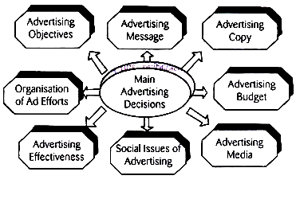
- To Persuade or Convince Buyers
Company uses advertisement to persuade or convince the buyers about superior advantages offered by its product. Company communicates competitive advantages the product offers to induce customers buy it. Comparative advertising is used to prove the additional benefits of product at a given price.
- To Remind Buyers
Marketer uses advertising to remind the buyers regarding existence of company, products, maintenance of quality, superior services, and chasing customer-orientation. Mostly, the existing firms aim their advertising for this objective.
Here, the purpose is to inform that the company is still in existence and serving customers in a better way. Due to huge information bombarded by a number of companies, customers are more likely to forget name of company and/or products and services it offers.
- To Face Competition
Advertising is treated as the most powerful weapon to fight with competitors effectively. Advertising enables the firm to respond the competitors strongly. It helps the firm to distinguish its total offerings from competitors.
In brief, the firm can face competition, can prevent the entry of competitors, or can remove competitors away from the market. In competitive marketing environment, the firm cannot survive without an effective advertisement.
- To Achieve Sales Targets
Increase sales volume is one of the major advertising objectives. A company can advertise its products in various media to attract customers situated in different parts of the world. National and international marketing is the result of advertising. Even, non-users can be converted into users and usage rate can be increased. Thus, company can achieve its sales objectives by advertisement.
- To Build and Improve Brand Image
Advertising is used for brand recognition and acceptance. A company can distinguish its brand by magnifying major benefits the product offers. Advertisement attracts customers toward the brand; they try it and accept it over time. In the same way, bad image related to brand can be changed by systematic presentation of facts and scientific evidences, and removing misunderstanding.
- To Help or Educate People
Advertising is not always used only for company’s benefits. It is meant for helping customers to make the right choice of product. It educates people about availability of new products, its features and qualities, price, services, and other related aspects. Such information is instrumental for purchasing suitable products. Thus, it guides customers to choose the most appropriate product.
- To Build Company Image and Reputation
A company opts for advertisement to build prestige and reputation in the market. Most of the companies, though they are satisfied with the volume of sales, go for advertising to acquire fame in the market. Many companies advertise its policies, activities, and achievements to make a permanent place in the mind of people.
- To Assist Sales Force and Middlemen
Advertising is an aid to middlemen and salesmen. Advertising also popularizes the name of dealers. Likewise, advertising provides necessary information to the buyers. Middlemen and salesmen are not required to do the same. It eases the task of sellers. In the same way, advertising encourages sales force.
- Other Objectives
There are certain minor objectives of advertising, such as:
- To promote new products.
- To build long-term relations.
- To remove misunderstanding.
- To expand of market.
- To gain confidence of buyers.
- To request customers to compromise with unavoidable circumstances.
- To seek apology of the buyers for any undesirable events, etc.
Company has to select one or more objectives based on its situations. It should be clarified that the list is not exhaustive. New advertising objectives may emerge as per change in situations. However, the main objective of advertising is to increase sales and earn profits. Company must define it advertising objectives clearly and precisely.

Advertising Budget
An advertising budget is an estimate of a company’s promotional expenditures over a certain time period. More importantly, it is the money a company is willing to set aside to accomplish its marketing objectives. When creating an advertising budget, a company must weigh the value of spending an advertising dollar against the value of that dollar as recognized revenue.
An advertising budget is part of a company’s overall sales or marketing budget that can be viewed as an investment in a company’s growth. The best advertising budgets—and campaigns—focus on customers’ needs and solving their problems, not company problems such as an overstock reduction.

Advertising Budget and Goals
Before deciding on a specific advertising budget, companies should make certain determinations to ensure that the budget is in line with their promotional and marketing goals:
- Target consumer: Knowing the consumer and having their demographic profile can help guide advertising spend.
- Type of media that is best for the target consumer: Mobile or internet advertising—via social media—may be the answer, although traditional media, such as print, television, and radio may be best for a given product, market, or target consumer.
- Right approach for the target consumer: Depending on the product or service, consider if appealing to the consumer’s emotions or intelligence is a suitable strategy.
- Expected profit from each dollar of advertising spend: This may be the most important question to answer, as well as the most difficult.

Importance of Advertising Budget
The objective of a company which markets its products is to earn profits and increase brand awareness. Advertising objectives of a company is purely dependent on the advertising campaign, type of customers, advertising media and what the company wants to achieve. Hence, for any marketing activity that a company wants to do, it has to spend some money. This is why advertising budget is important. It helps in understanding the objectives. The costs, helps to formulate strategies and generate profits by increasing the overall sales.
Factors Affecting Advertising Budget
Advertising is one of the variables which affect sales and hence the profit earned. It is therefore difficult to calculate the amount to be allocated for advertisement budget. Also the budgeting depends on various other factors like:
- Degree of competitiveness in market: Monopoly/Duopoly/Oligopoly
A monopoly firm does not have to worry about the promotional spends as it is the only player in the market. For duopoly, where market is dominated by two dominant players, the promotional budgets would be high to outperform each other. In an Oligopolistic market, where the market is cluttered and there are many players, promotional spends has to be higher as the frequency of advertisements has to be increased to get noticed among so many players. Thus depending upon the competition the advertising budget is set.
- Market Share: Market leader/Market Follower
The advertising budget for a market follower will be decided by the tactics of the market leader. To improve market share one of the investment is to increase promotional spent. Thus, where a company stands is a deciding factor in advertising budget
- Product life-cycle stage: Introduction/growth/maturity/decline
The advertisement budget would be higher at the introduction and growth stages as it has to introduce the product in the market and establish itself among the competitors so the frequency of advertisements would be high and so would be the budget. As the product reaches maturity and decline stages the promotional spent would be lower.
- Advertising Frequency
An ad can be played only once or can be be multiple times. Also, it can be daily, weekly, fortnightly, monthly etc. Depending upon the requirement, the advertising budget is altered.

Advertising Budget Process
There are certain steps which can be followed in creating an advertising budget. They can be explained as below:
- Understanding advertising objectives based on the goals which have been set by the company.
- Determine the tasks, ad campaigns which could be done.
- Formulating, evaluating and preparing the breakup of advertising budget.
- Taking approvals form the senior management.
- Allocation of funds for different activities under the advertising budget.
- Monitoring and controlling the expenditure and revising it for better profit.

Fundamentals of Sales Promotion
Sales Promotions are a marketing communication tool for stimulating revenue or providing incentives or extra value to distributers, sales staff, or customers over a short time period. Sales promotion activities include special offers, displays, demonstrations, and other nonrecurring selling efforts that aren’t part of the ordinary routine. As an additional incentive to buy, these tools can be directed at consumers, retailers and other distribution partners, or the manufacturer’s own sales force.
Companies use many different forms of media to communicate about sales promotions, such as printed materials like posters, coupons, direct mail pieces and billboards; radio and television ads; digital media like text messages, email, websites and social media, and so forth.
Companies use sales promotions to increase demand for their products and services, improve product availability among distribution channel partners, and to coordinate selling, advertising, and public relations. A successful sales promotion tries to prompt a target segment to show interest in the product or service, try it, and ideally buy it and become loyal customers.
Advantages of sales promotions
The main advantages in using sales promotional activity, either alone or to support mainstream marketing activity and communications, are:
(i) Very flexible and adaptable in terms of tackling specific problems or supporting mainstream marketing communications Bata national or local level
(ii) Capable of specific action through specific focus and structure
(iii) Relatively short lead times to design and implement (compared with media communications)
(iv) Often more easy to monitor the effect or tangible results
(v) Economical and cost saving, possibly with economies of scale
(vi) Can be adapted to large and small markets, major or minor products or brands.

11 Important Techniques of Sales Promotion
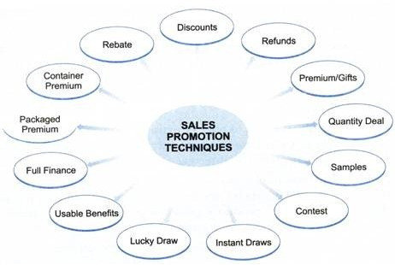
1. Rebate
Under it in order to clear the excess stock, products are offered at some reduced price. For example, giving a rebate by a car manufacturer to the tune of 12,000/- for a limited period of time.
2. Discount
Under this method, the customers are offered products on less than the listed price. For example, giving a discount of 30% on the sale of Liberty Shoes. Similarly giving a discount of 50% + 40% by the KOUTONS.
3. Refunds
Under this method, some part of the price of an article is refunded to the customer on showing proof of purchase. For example, refunding an amount of 5/- on showing the empty packet of the product priced 100/-.
4. Product Combination
Under this method, along with the main product some other product is offered to the customer as a gift. The following are some of the examples:
5. Quantity Gift
Under this method, some extra quantity of the main product is passed on as a gift to the customers. For example, 25% extra toothpaste in a packet of 200 gm tooth paste. Similarly, a free gift of one RICH LOOK shirt on the purchase of two shirts.
6. Instant Draw and Assigned Gift
Under this method, a customer is asked to scratch a card on the purchase of a product and the name of the product is inscribed thereupon which is immediately offered to the customer as a gift. For example, on buying a car when the card is scratched such gifts are offered – TV, Refrigerator, Computer, Mixer, Dinner Set, Wristwatch, T-shirt, Iron Press, etc.
7. Lucky Draw
Under this method, the customers of a particular product are offered gifts on a fixed date and the winners are decided by the draw of lots. While purchasing the product, the customers are given a coupon with a specific number printed on it.
On the basis of this number alone the buyer claims to have won the gift. For example, ‘Buy a bathing soap and get a gold coin’ offer can be used under this method.
8. Usable Benefits
Under this method, coupons are distributed among the consumers on behalf of the producer. Coupon is a kind of certificate telling that the product mentioned therein can be obtained at special discount.
It means that if a customer has a coupon of some product he will get the discount mentioned therein whenever he buys it. Possession of a coupon motivates the consumer to buy the product, even when he has no need of it.
Such coupons are published in newspapers and magazines. Some companies distribute coupons among its shareholders. Sellers collect the coupons from the customers and get the payment from the company that issues the same.

9. Full Finance @ 0%
Under this method, the product is sold and money received in installment at 0% rate of interest. The seller determines the number of installments in which the price of the product will be recovered from the customer. No interest is charged on these installments.
10. Samples or Sampling
Under this method, the producer distributes free samples of his product among the consumers. Sales representatives distribute these samples from door-to-door.
This method is used mostly in case of products of daily-use, e.g., Washing Powder, Tea, Toothpaste, etc. Thus, the consumers willy-nilly make use of free sample. If it satisfies them, they buy it and in this way sales are increased.
11. Contests
Some producers organize contests with a view to popularizing their products. Consumers taking part in the contest are asked to answer some very simple questions on a form and forward the same to the company. The blank form is made available to that consumer who buys the product first

Public Relations
Public relations (PR) is nothing but the practice of protecting as well as enhancing the reputation of any particular organization/firm or for that matter any individual. In today’s world of fierce competition, where every organization strives hard to work toward its brand image, public relations has become the need of the hour. It is essential for every organization to communicate well with its public/target audience. The correct flow of information is essential. Here comes the importance of public relations.
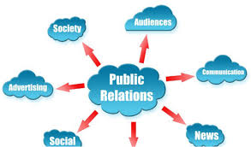

What is Public Relations ?
The practice of maintaining a healthy relationship between organization and its public/employees/stakeholders/investors/partners is called public relations. Public relation activities ensure the correct flow of information between the organization and its public also called its target audience. Public relations goes a long way in maintaining the brand image of an organization in the eyes of its audience, stake holders, investors and all others who are associated with it.
For schools, the target audience would be students and their parents/guardians, for retailers the target audience would be customers and so on.
In the above examples, Public Relations ensures a smooth two way communication between the school authorities and its target audiences (students and their parents).Retailers must address their customers well for a positive word of mouth and a strong brand positioning. It is really important to create a positive image of any particular brand in the minds of consumers for it do well. Public relations experts not only help in the flow of information from the organization to its public but also from the public to the organization.(Two way communication).The flow of information from the public to the organization is generally in the form of reviews, feedback(positive/negative),appreciation and so on. Public relations strengthens the relationship between the organization and its target audience, employees, stakeholders, investors etc.

Public Relation Activities
Here are some ways of enhancing an organization’s brand image:
- Addressing the media
- Speaking at various press conferences, seminars.
- Advertisements to correctly position the brand, Pamphlets, Brochures, magazines notices, newsletters and so on.
- Corporate Social responsibility (CSR Activities)
- Introducing various loyalty schemes for customers like membership cards, premium clubs so as to retain the customers.
- Various events, shows and activities.

Effective Public Relations
Public Relations is said to be effective under all the below circumstances:
- Awareness: To create a positive image of an organization, the message must reach the public. Information must reach in its desired form for effective public relation.
- Acceptance: The audience must understand what the message intends to communicate. They ought to agree with the message.
- Action: The audience ought to give feedback to the organization accordingly.
To conclude public relations is nothing but an effort to present one’s organization in the best light.

Types of Public Relations
According to the functions of the public relations department/agencies, public relations can be divided into 7 types. These are:
(i) Media Relations: Establishing a good relationship with the media organizations and acting as their content source.
(ii) Investor Relations: Handling investors events, releasing financial reports and regulatory filings, and handling investors, analysts and media queries and complaints.
(iii) Government Relations: Representing the brand to the government with regard to fulfilment of policies like corporate social responsibility, fair competition, consumer protection, employee protection, etc.
(iv) Community Relations: Handling the social aspect of the brand and establishing a positive reputation in the social niche like environment protection, education, etc.
(v) Internal Relations: Counselling the employees of the organization with regard to policies, course of action, organization’s responsibility and their responsibility. Cooperating with them during special product launches and events.
(vi) Customer Relations: Handling relationships with the target market and lead consumers. Conducting market research to know more about interests, attitudes, and priorities of the customers and crafting strategies to influence the same using earned media.
(vii) Marketing Communications: Supporting marketing efforts relating to product launch, special campaigns, brand awareness, image, and positioning.

Direct Marketing
Direct Marketing is a form of advertising in which companies provide physical marketing materials to consumers to communicate information about a product or service. Direct marketing does not involve advertisements placed on the internet, on television or over the radio. Types of direct marketing materials include catalogs, mailers and fliers.
Direct marketing removes the “middle man” from the promotion process, as a company provides a message directly to a potential customer. Companies with smaller advertising budgets typically use this type of marketing since they cannot afford to pay for advertisements on television and often do not have the brand recognition of larger firms.
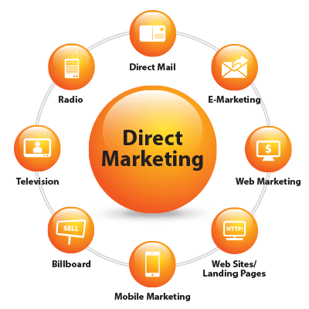

How Direct Marketing Works?
Direct-marketing messages generally include a call to action, encouraging the recipient to respond via a toll-free phone number or a reply card or by clicking on a link in an email promotion. Companies are able to measure the effectiveness of their direct-marketing campaigns by tracking responses. Direct marketing is more effective when companies use targeted lists of prospects developed using available marketing data that can segment them into identifiable groups that are likely to have an interest in a product or service.
Over the years direct marketing has developed a bad reputation for cluttering up people’s mail boxes with junk mail or generating spam in email inboxes. Many companies engage in opt-in or permission marketing, which limits their mailing or emailing to only those willing to receive it. Companies select communication channels they consider most effective for a particular market. For instance, a new gym may find more success distributing flyers, while a new grocery store prefers to mail promotional coupons to the residents of nearby neighborhoods.

Pros and Cons of Direct Marketing
Companies that use direct marketing benefit from being able to focus limited resources on a targeted promotion, which also allows them to personalize the marketing message. Because it is easy to measure responses, companies can test different marketing messages for improving the response rate. Direct marketing can be cost-effective if the customer database is well-managed.
The downside of direct marketing is that response rates can vary widely making the flow of prospects unpredictable. Ineffective campaigns can be costly, especially if they occur frequently. Companies that send blanket direct mail or email promotions have to overcome the negative image of junk mail and email spam. The key to effective direct marketing is an accurate database, which can be expensive to maintain.

