UNIT-1

Strategic HRM

Conceptual framework and context of strategic SHRM

SHRM is an approach of decision making relating to the organizational objectives connecting people rather than employees who are essential to implementing the business strategy of the organization.
At the same time, SHRM sets up a rapport connecting HRM with Strategic management while SHRM aimed to clarify the whole course of action that the organization would like to accomplish its objectives by the concerned people.
Wright (1998) added that as a component of the strategic management, SHRM would consider to handling with all people linked with the business for long-term and integrate inclusive issues of the organizational structure, its culture, managerial effectiveness, performance, resources, as well as changes of management that deals with HR actions applied to support the competitive strategy of the organization.
SHRM as a means and approach of supporting the management of HR connecting with the strategic context of the business while it aimed to endow with an intellect to directing any disorderly environment of the organization towards an ordered and coherent way adopting effectual actions and policies.
Becker and Huselid (2006) explained that the SHRM takes into account those verdicts and course actions to managing the employees of all stages in the way that rooted to the direction of generating sustaining competitive advantage for the organization.
Sheehan (2005) explored that SHRM should make available of guidelines to selecting triumphant action to gaining eventual trial of the authenticity of strategic HRM where HR is considered a strategic issue for overall corporate function and evidence.
To implementing SHRM, it is essential to enlarge the existing strategy of the organization with clear reflection on the HR dimensions and comprehensible guidance for the HR management regarding their responsibility and accountability.
Datta (2007) also mentioned that a great deal of the literature endows with the facts of strategic amalgamation, but it is necessary to address the reasons why strategic incorporation would be advantageous to organizations.
The wider viewpoint of modern business advocates to amplify the input of HR reflections within the strategic planning with an outlook to caring employees as an asset of the organization ensuring their further participation and apprehension through effectual communications, result oriented procedural practices, well aliened training, reward and career expansion opportunities concerned with performance.
Schuler and Jakson (1987) explained the necessity of SHRM arguing that it will provide well-built visionary and captivate leadership at the top of the organisation that dedicated to the exposed missions and values with clear understanding to the business strategies, eager to implementing them effectually, positive focus to the critical success factors, and friendly to working consistent management team.

SHRM: Introduction, Characteristics and Scope of SHRM

Before we try to explain the meaning of strategic HRM, let us first define the terms ‘strategy’ and ‘strategic management’. The term ‘strategy’ is widely used in and presupposes importance. In the words of the Oxford Concise Dictionary, strategy means ‘generalship’. Thus, strategy is associated with the long-term decisions taken at the top of the enterprise. The original literary meaning of strategy is ‘the art and science of directing military forces’.
The term strategy is frequently being used in the present-day corporate world. It envisages thinking ahead to survive and grow in a highly competitive environment’. Strategy is concerned with determining which option will provide maximum benefits. According to Jauch and Glueck.
“Strategy is a unified, comprehensive and integrated plan that relates the strategic advantages of the firm to the challenges of the environment. It is designed to ensure that the basic objectives of the enterprise are achieved through proper execution by the organization”.

Characteristics of Strategic Human Resource Management(SHRM)
- Recognition of the outside Environment: Outside environment presents some opportunities and threats to the organization in the form of-
- Laws
- Economic conditions
- Social and demographic change
- Domestic and international political forces
- Technology and so on.
Strategic human resource strategy explicitly recognizes the threats and opportunities in each area and attempts to capitalize on the opportunities while minimizing or deflecting the effect of threats.
- The impact of Competition: The forces of competition in attracting, rewarding, and using employees have a major effect on corporate human resource strategy. Forces play out in local, regional and national labor markets. Labor market dynamics of wage rates, unemployment rates, working conditions, benefits levels minimum wages legislation and competition reputation all have an impact on and are affected by strategic human resource decisions.
- Long-Range Focus: A strategic human resource management should be long-range focus cause this is not easy to change the strategic human resource policy.
- Choice and Decision-making focus: In other words, the strategy has a problem solving or problem preventing focus. Strategy concentrates on the question, “what should the organization do and why?” this action orientation requires that decisions be made and carried out.
- Consideration of all Personnel: A strategic approach to human resources is concerned with all of the firm’s employees, not just its hourly or operational personnel. Traditionally, human resource management focuses on hourly employees, with most clerical exempt employees also included.
- Integration with the Corporate Strategy: Human resource strategy adopted by a firm should be integrated with the firm’s corporate strategy.
The key idea behind overall strategic mgt is to coordinate all of the company’s resources, including human resources; in such a way that everything a company does contribute to carrying out its strategy.
Synergy means the extra benefit or value realized when resources have been combined and coordinated effectively. This concept often referred to as economies of scope, makes the combined whole of the company make valuable than the sum of its parts. It is a true benefit of good strategic management of resources.
Key Features of Strategic Human Resource Management

The key features of SHRM are
- There is an explicit linkage between HR policy and practices and overall organizational strategic aims and the organizational environment
- There is some organizing schema linking individual HR interventions so that they are mutually supportive
- Much of the responsibility for the management of human resources is devolved down the line

Approaches of the SHRM
- Attempts to link Human Resource activities with competency based performance measures
- Attempts to link Human Resource activities with business surpluses or profit
Advertisements

Impact of Globalization on HRM

When a business expands its operation into other countries, the impact of globalization on human resource development and management is significant. Companies need to consider a diverse range of practical adjustments to be able to hire, train, retain and support a workforce that’s often spread throughout several countries, which often have varying cultural identities. Human Resources departments must adapt their thinking and practices to include cultural differences, foreign regulations and technological developments.

Impact of Globalization on HRM
- Globalization of Human Capital
Perhaps the greatest resource available to any company is the workforce it acquires and retains. As a company extends its base to a foreign shore, the impact of that globalization on HR procedures will extend to current workers and also to new employees. The HR department will need to increase support of its current staff, as they transfer overseas to new positions. Assistance with visas, work permits, and housing will be required, as well as training in cultural issues and perhaps language acquisition. New local talent must be acquired and developed, as well. A company’s ability to move into new markets, will depend on its ability to fill needs with skilled workers. In some situations, local workers may meet the criteria, but in other situations, they may be more looking for skilled and already-trained employees to be transferred to positions in the new overseas location. In this case, the willingness of workers to become mobile could be a key factor to productivity.
- Corporate and Cultural Differences
Another significant impact of globalization on human resource development is the necessity to consider cultural differences, both in and out of the workplace. Businesses tend to have their own corporate cultures or ways of operating, but there are societal and cultural differences between people as well. Cultural norms within a society affect the workforce and how workers view their jobs, especially in relation to time spent with their family and ideas about employment expectations. Some cultures may also have varying mores about gender roles, particularly concerning the role of women in leadership. While a female in a managerial position is not uncommon in American culture, the same many not hold true elsewhere.
Similarly, a manager brought in from the home office may not be the best person to manage an overseas staff, because they do not understand all the nuances of the local culture and what’s considered acceptable business practice. For example, in some countries, the typical work day may be quite different from the traditional 9 to 5 hours. Workers might be accustomed to starting their day earlier in the morning, taking a longer mid-day break for lunch and rest and then returning finishing their work by early evening. A manager who adapts to local culture may find better success among his employees.
- Employment and Tax Laws
Global expansion is also affected by varying tax and labor laws. HR departments need to be prepared to deal with different tax rates, benefit requirements or labor and environmental regulations. These requirements may be in addition to or even in conflict with current corporate policies, so adjustments to maintain compliance with local governments are necessary. HR managers must become experts in issues that not only pertain to their industry, but keep current with issues and government policies within the countries in which their company now operates.
- Long-Distance Communication Challenges
In a small, local business, the HR manager can ask an employee to stop by the HR office to sign a form, discuss an issue with their paycheck or to handle a policy-related issue. When managing employees over great distances and perhaps in several sites spread around the globe, HR departments face a bigger challenge in communicating with their employees. Often, they must rely on technology such as email or conference calling to relay information, thereby eliminating some of the more direct human elements of interaction. Offices are also open during different points in the 24-hour work day, so that even simple issues may take more time to resolve. Although forms and HR management software should be standardized throughout the company, accommodations may have to be made for language differences, as well.

Changing Nature of Workforce

Advances in technology, a more demanding workforce and shifts in priorities are combining to change the shape of traditional business and create a revolution in the workplace.
The way we work, the shape of our company structures and the expectations of our employees have all undergone a fundamental shift in the 21st century. With technology as the catalyst, the momentum of this shift is only going to increase.
Give them flexibility
Employees won’t just be happy doing one job anymore and looking for vertical progression within that job. Climbing the corporate ladder is a thing of the past. Flexible and flat structures allow employees to work across multiple areas of the business. This not only improves their own skills and keeps them engaged but it adds significant value to the company by building a base of employees who are familiar with different aspects of how the business operates. With this increased understanding the employee is then able to perform at a much higher level.
Use technology to create a better experience
Tech isn’t something new to Millennials. They have been raised with technology readily available, especially smart phones which form the hub of the way they communicate, interact and socialise. That’s why integrating key business tools onto a mobile platform is absolutely essential for forward thinking businesses. At Quinyx, our mobile app is used by more than 300,000 users each day, who not only use it to see when they are working next but to also see who they are working with and communicate with them through the app. Their familiarity with mobile technology and expectations of being able to complete any task with their smart phone are all met. In making their lives more simple, it then allows them to focus on doing their job.
Put health and wellbeing first
Employers who manage their employees health and wellbeing successfully will reap the benefits of doing so. This covers everything from nutrition, exercise, mindfulness and even sleep. It also means creating an environment where employees enjoy spending time. Not only does this demonstrate a strong duty of care from the employer but it will also improve employee performance on a purely physical level. For example, an employee who has trouble sleeping won’t be able to perform at their optimum.
BP are using fitness trackers as part of an incentive programme to help employees reduce healthcare costs while UK supermarket Tesco’s use smart armbands as a working aid in their distribution centres.
Just like advances in sport science are helping coaches and athletes improve their performance through data, companies are now looking at ways they can do the same to optimise their employees performance to gain advantage over their competition.
Understanding the needs of your staff, and how these needs change over time, helps you create a business where employees enjoy work. It’s through enjoying work that employees are able to perform to the best of their abilities and deliver results.

Evolution of SHRM

HRM can be seen as part of the wider and longer debate about the nature of management in general and the management of employees in particular. This means that tracing the antecedents of HRM is as elusive an exercise as arriving at its defining characteristics. Certainly there are antecedents in organizational theory, and particularly that of the human relations school, but the nature of HRM has involved important elements of strategic management and business policy, coupled with operations management, which make a simple ‘family tree’ explanation of HRM’s derivation highly improbable.
What can be said is that the origins of HRM lie within employment practices associated with welfare capitalist employers in the United States during the 1930s. Both Jacoby (1997) and Foulkes (1980) argue that this type of employer exhibited an ideological opposition to unionisation and collective relations. As an alternative, welfare capitalists believed the firm, rather than third-party institutions such as the state or trade unions, should provide for the security and welfare of workers. To deter any propensity to unionise, especially once President Roosevelt’s New Deal programme commenced after 1933, welfare capitalists often paid efficiency wages, introduced health care coverage, pension plans and provided lay-off pay.
Equally, they conducted regular surveys of employee opinion and sought to secure employee commitment via the promotion of strong centralised corporate cultures and long-term cum permanent employment. Welfare capitalists pioneered individual performance-related pay, profit-sharing schemes and what is now termed teamworking. This model of employment regulation had a pioneering role in the development in what is now termed HRM but rested on structural features such as stable product markets and the absence of marked business cycles. While the presence of HRM was well established in the American business system before the 1980s, it was only after that period that HRM gained external recognition by academics and practitioners.
There are a number of reasons for its emergence since then, among the most important of which are the major pressures experienced in product markets during the recession of 1980–82, combined with a growing recognition in the USA that trade union influence in collective employment was reaching fewer employees. By the 1980s the US economy was being challenged by overseas competitors, most particularly Japan. Discussion tended to focus on two issues: ‘the productivity of the American worker’, particularly compared with the Japanese worker, ‘and the declining rate of innovation in American industries’ (Devanna et al., 1984: 33).
From this sprang a desire to create a work situation free from conflict, in which both employers and employees worked in unity towards the same goal – the success of the organisation (Fombrun, 1984: 17). Beyond these prescriptive arguments and as a wide-ranging critique of institutional approaches to industrial relations analysis, Kaufman (1993) suggests that a preoccupation with pluralist industrial relations within and beyond the period of the New Deal excluded the non-union sector of the US economy for many years.
In summary, welfare capitalist employers (soft HRM) and antiunion employers (hard HRM) are embedded features within the US business system, whereas the New Deal Model was a contingent response to economic crisis in the 1930s. n the UK in the 1980s the business climate also became conducive to changes in the employment relationship. As in the USA, this was partly driven by economic pressure in the form of increased product market competition, the recession in the early part of the decade and the introduction of new technology.
However, a very significant factor in the UK, generally absent from the USA, was the desire of the government to reform and reshape the conventional model of industrial relations, which provided a rationale for the development of more employer-oriented employment policies on the part of management (Beardwell, 1992, 1996). The restructuring of the economy saw a rapid decline in the old industries and a relative rise in the service sector and in new industries based on ‘high-tech’ products and services, many of which were comparatively free from the established patterns of what was sometimes termed the ‘old’ industrial relations.
These changes were overseen by a muscular entrepreneurialism promoted by the Thatcher Conservative government in the form of privatisation and anti-union legislation ‘which encouraged firms to introduce new labour practices and to re-order their collective bargaining arrangements’ (Hendry and Pettigrew, 1990: 19).
The influence of the US ‘excellence’ literature (e.g. Peters and Waterman, 1982; Kanter, 1984) also associated the success of ‘leading edge’ companies with the motivation of employees by involved management styles that also responded to market changes. As a consequence, the concepts of employee commitment and ‘empowerment’ became another strand in the ongoing debate about management practice and HRM. A review of these issues suggests that any discussion of HRM has to come to terms with at least three fundamental problems:
- That HRM is derived from a range of antecedents, the ultimate mix of which is wholly dependent upon the stance of the analyst, and which may be drawn from an eclectic range of sources;
- That HRM is itself a contributory factor in the analysis of the employment relationship, and sets part of the context in which that debate takes place;
- That it is difficult to distinguish where the significance of HRM lies – whether it is in its supposed transformation of styles of employee management in a specific sense, or whether in a broader sense it is in its capacity to sponsor a wholly redefined relationship between management and employees that overcomes the traditional issues of control and consent at work.
This ambivalence over the definition, components and scope of HRM can be seen when examining some of the main UK and US analyses. An early model of HRM, developed by Fombrun et al. (1984), introduced the concept of strategic human resource management by which HRM policies are inextricably linked to the ‘formulation and implementation of strategic corporate and/or business objectives’. The model is illustrated in Figure(The matching model of HRM).The matching model emphasises the necessity of ‘tight fit’ between HR strategy and business strategy.
This in turn has led to a plethora of interpretations by practitioners of how these two strategies are linked. Some offer synergies between human resource planning (manpower planning) and business strategies, with the driving force rooted in the ‘product market logic’ (Evans and Lorange, 1989). Whatever the process, the result is very much an emphasis on the unitarist view of HRM: unitarism assumes that conflict or at least differing views cannot exist within the organisation because the actors – management and employees – are working to the same goal of the organisation’s success.
What makes the model particularly attractive for many personnel practitioners is the fact that HRM assumes a more important position in the formulation of organisational policies. The personnel department has often been perceived as an administrative support function with a lowly status. Personnel was now to become very much part of the human resource management of the organisation, and HRM was conceived to be more than personnel and to have peripheries wider than the normal personnel function. In order for HRM to be strategic it had to encompass all the human resource areas of the organisation and be practised by all employees.
In addition, decentralisation and devolvement of responsibility are also seen as very much part of the HRM strategy as it facilitates communication, involvement and commitment of middle management and other employees deeper within the organisation. The effectiveness of organisations thus rested on how the strategy and the structure of the organisation interrelated, a concept rooted in the view of the organisation developed by Chandler (1962) and evolved in the matching model.

The Matching Model of HRM
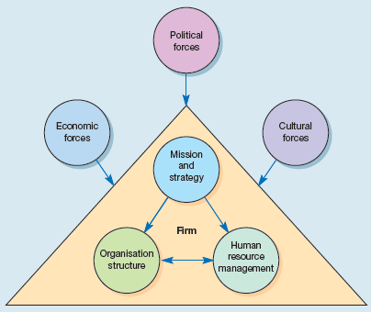
A more flexible model, illustrated in Figure, was developed by Beer et al. (1984) at Harvard University. ‘The map of HRM territory’, as the authors titled their model, recognised that there were a variety of ‘stakeholders’ in the corporation, which included shareholders, various groups of employees, the government and the community. At once the model recognises the legitimate interests of various groups, and that the creation of HRM strategies would have to recognise these interests and fuse them as much as possible into the human resource strategy and ultimately the business strategy.
This recognition of stakeholders’ interests raises a number of important questions for policy-makers in the organisation: The acknowledgement of these various interest groups has made the model much more amenable to ‘export’, as the recognition of different legal employment structures, managerial styles and cultural differences can be more easily accommodated within it.
This neopluralist model has also been recognised as being useful in the study of comparative HRM (Poole, 1990: 3–5). It is not surprising, therefore, that the Harvard model has found greater favour among academics and commentators in the UK, which has relatively strong union structures and different labour traditions from those in the United States. Nevertheless, some academics have still criticised the model as being too unitarist, while accepting its basic premise (Hendry and Pettigrew, 1990).

The Map of the HRM Territory
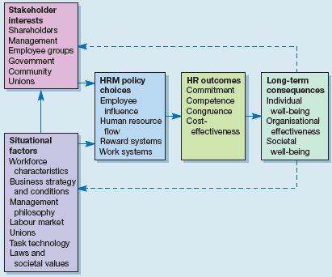
The first two main approaches to HRM that emerged in the UK are based on the Harvard model, which is made up of both prescriptive and analytical elements. Among the most perceptive analysts of HRM, Guest has tended to concentrate on the prescriptive components, while Pettigrew and Hendry rest on the analytical aspect (Boxall, 1992). Although using the Harvard model as a basis, both Guest and Pettigrew and Hendry have some criticisms of the model, and derive from it only that which they consider useful (Guest, 1987, 1989a, 1989b, 1990; Hendry and Pettigrew, 1986, 1990).
As we have seen, there are difficulties of definition and model-building in HRM, and this has led British interpreters to take alternative elements in building their own models. Guest is conscious that if a model is to be useful to researchers it must be useful ‘in the field’ of research, and this means that elements of HRM have to be pinned down for comparative measurement. He has therefore developed a set of propositions that he believes are amenable to testing. He also asserts that the combination of these propositions, which include strategic integration, high commitment, high quality and flexibility, creates more effective organisations (Guest, 1987).
- Strategic integration is defined as ‘the ability of organisations to integrate HRM issues into their strategic plans, to ensure that the various aspects of HRM cohere and for line managers to incorporate an HRM perspective into their decision making’.
- High commitment is defined as being ‘concerned with both behavioural commitment to pursue agreed goals and attitudinal commitment reflected in a strong identification with the enterprise’.
- High quality ‘refers to all aspects of managerial behaviour, including management of employees and investment in high-quality employees, which in turn will bear directly on the quality of the goods and services provided’.
- Finally, flexibility is seen as being ‘primarily concerned with what is sometimes called functional flexibility but also with an adaptable organisational structure with the capacity to manage innovation’ (Guest, 1989b: 42).
The combination of these propositions leads to a linkage between HRM aims, policies and outcomes as shown in Table. Whether there is enough evidence to assess the relevance and efficacy of these HRM relationships will be examined later.

A Human Resource Management Framework
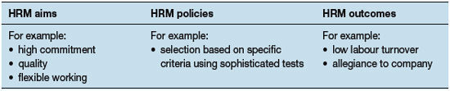
Hendry and Pettigrew (1990) have adapted the Harvard model by drawing on its analytical aspects. They see HRM ‘as a perspective on employment systems, characterised by their closer alignment with business strategy’. This model, illustrated in Figure, attempts a theoretically integrative framework encompassing all styles and modes of HRM and making allowances for the economic, technical and socio-political influences in society on the organisational strategy. ‘It also enables one to describe the “preconditions” governing a firm’s employment system, along with the consequences of the latter’ (Hendry and Pettigrew, 1990: 25). It thus explores ‘more fully the implications for employee relations of a variety of approaches to strategic management’ (Boxall, 1992).

Model of strategic change and human resource management
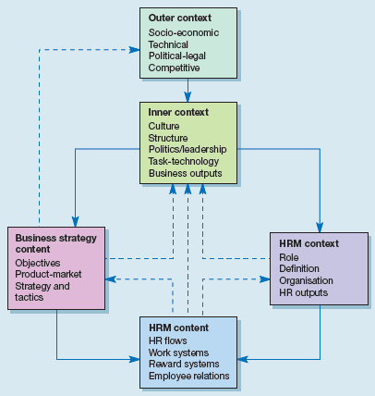
Storey studied a number of UK organisations in a series of case studies, and as a result modified still further the approaches of previous writers on HRM (Storey, 1992). Storey had previously identified two types of HRM – ‘hard’ and ‘soft’ (Storey, 1989) – the one rooted in the manpower planning approach and the other in the human relations school. He begins his approach by defining four elements that distinguish HRM:
- It is ‘human capability and commitment which, in the final analysis, distinguishes successful organisations from the rest’.
- Because HRM is of strategic importance, it needs to be considered by top management in the formulation of the corporate plan.
- ‘HRM is, therefore, seen to have long-term implications and to be integral to the core performance of the business or public sector organisation. In other words it must be the intimate concern of line managers.’
- The key levers (the deployment of human resources, evaluation of performance and the rewarding of it, etc.) ‘are to be used to seek not merely compliance but commitment’.
Storey (1992) approaches an analysis of HRM by creating an ‘ideal type’, the purpose of which ‘is to simplify by highlighting the essential features in an exaggerated way’ (p. 34). This he does by making a classificatory matrix of 27 points of difference between personnel and IR practices and HRM practices. The elements are categorised in a four-part basic outline:
- beliefs and assumptions;
- strategic concepts;
- line management;
- key levers.
This ‘ideal type’ of HRM model is not essentially an aim in itself but more a tool in enabling sets of approaches to be pinpointed in organisations for research and analytical purposes.

Twenty-seven points of difference
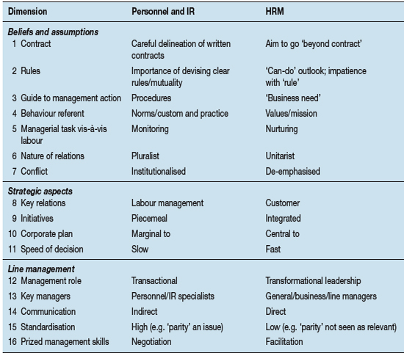
Storey’s theoretical model is thus based on conceptions of how organisations have been transformed from predominantly personnel/IR practices to HRM practices. As it is based on the ideal type, there are no organisations that conform to this picture in reality. It is in essence a tool for enabling comparative analysis.

Models of Strategic HRM

The defining features of HRM is popularly known as models. These models provide analytical framework for studying HRM. They provide characterization of HRM that establishes variables and relationship to be researched. Four most common models are :
- The Fombrun Model
- The Harvard Model
- The Guest Model and
- The Warwick Model
All these models serve the following purposes:
- They provide an analytical framework for studying HRM for example, situational factors, stakeholders, strategic choice levels, competence etc.
- They validate certain HRM practices and provide distinctiveness to HRM practices.
- They provide a characterization of HRM that establishes variables and relationship to be researched.
- They help to discover and understand the world for explaining the nature and significance of key HR practices.

- THE FOMBRUN MODEL
This is the model of HRM. It emphasizes four functions of management and their interrelatedness Selection, Appraisal, Development and Rewards. This model is incomplete as it focuses on only four functions of HRM and ignore all other environmental and contingency factors. But, this model is simple and can serve as a heuristic framework for explaining the nature and significance of HR activities.
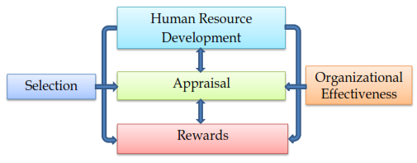

- THE HARVARD MODEL
This model consists six critical components of HRM namely stake holders interests, situational factors, HRM policy choices, HR out comes, long term consequences and a feedback loop through.

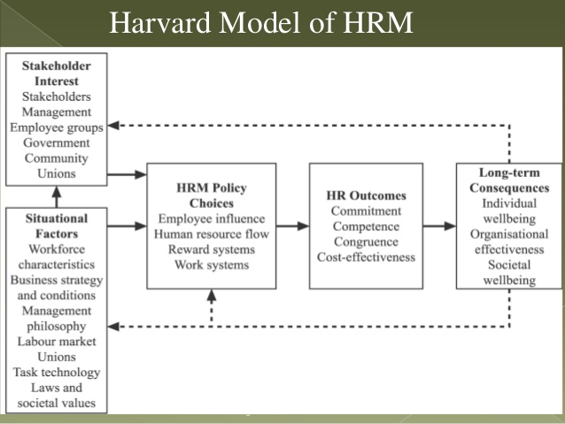

- THE GUEST MODEL
This model was developed by David Guest in 1997. This model emphasizes on the assumption that HR manager has specific strategies to begin with, which demand certain practices and when executed will result in outcomes. These out comes include behavioral performance related and financial rewards. The model emphasizes the logical sequence of six components : HR strategy, HR practices, HR outcomes, Behavioral outcomes, Performance results and financial consequences.
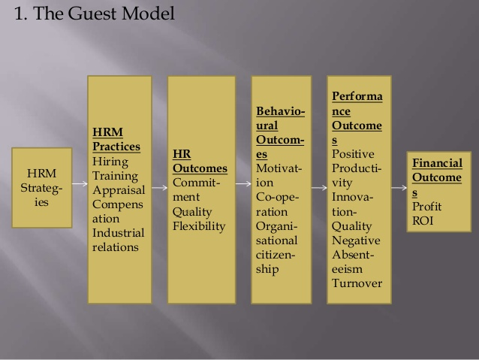

- THE WARWICK MODEL
This model was developed by two researchers, Hendry and Pettigrew of University of Warwick (hence the name Warwick model). Like other human resource management models, the Warwick proposition centers around five elements-
- Outer context (macro environmental forces)
- Inner context (firm specific or micro environmental forces)
- Business strategy content
- HRM context
- HRM content
The strength of this model is that it identifies and classifies important environment influences on HRM. This model takes cognizance of business strategy and HR practices, the external and internal content, in which these activities take place and process by which such changes take place including transactions between changes in both external content and internal content.
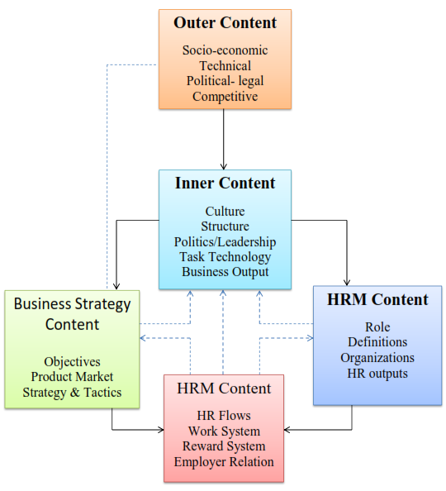

THE 5-P’S MODEL OF HRM
- Philosophy: Expressed in statements defining business values and culture. It expresses how to treat and value people.
- Policies: Expressed as shared values and guidelines. Policies establish guidelines for action on people related business issues and HR programs.
- Programs: Articulated as human resource strategy. These coordinate efforts to facilitate change to address major people related business issues.
- Practices: For leadership managerial and operational role practices motivate needed role behaviors.

Development and Delivery of HR Strategies

Eight key steps in the Development and delivering a successful HR strategy
- Aligning business and HR needs
The business’ goals that is its strategic imperatives – sit at the heart of any HR strategy and in order to align business and HR needs one key question must to be answered, “Can your organization’s internal capability deliver its business goals?”
This is where HR receives most criticism. The function is frequently accused of failing to fully understand its business, goals and strategy for achieving these goals, and its business model and how it delivers to its customers. For those who already understand the demands of their business, it is easy to identify where the business has strong core competencies and where the business is weakest.
Sometimes these weaknesses are related to essential systems or processes, but more often – and significantly for HR – these weaknesses relate to the quality of the workforce, its motivation and ability to deliver organization performance. Taking steps to understand your business and where it has competitive advantage is an essential first step towards determining the key HR interventions that form the basis of an HR strategy.
- Developing your HR strategy
Deeper knowledge and understanding of your business goals and business model can identify potential threats and opportunities in the quantity and quality of human resource required by your organization. This in turn identifies the key components of your HR strategy and the virtuous circle of providing whatever your organization needs for success.
It is also critical that the HR team has a high level of expertise in aligning major HR interventions and their relevance to business performance. This calls for expert HR thinking and identifies the requisite interventions and, equally important, how they fit together to leverage organization performance.
If there is a strong need for the organization to develop its management capability, for instance, should you align your compensation strategy to reinforce this objective? If the organizational structure defines the accountabilities clearly at every level of the organization, is your HR team selecting and developing against them? This is joined-up HR at work.
Another concern for HR is when it should make strategic interventions. Easy, it either follows your business cycle, or is triggered by other key events such as a merger, an acquisition or a change in business direction.
- Organizational performance
Organizational performance is the process by which business goals and objectives are cascaded and managed across and down an organization. It provides a link and rationale for all other HR activity and, in addition, the greatest opportunity to directly impact business success, enhancing HR’s reputation and contribution.
HR needs to create and install a robust performance management process that sets out performance objectives for all levels of staff within a business. This is an opportunity to develop line managers’ skills in being able to disseminate and set stretch targets for their business.
A critical part of this process is a robust performance review process, which gives people feedback about what has been achieved – what people have done well and not so well.
The third element is a personal development review process where individual strengths and weaknesses are identified for the purposes of assessing and meeting organizational development needs.
- Organizational design and structure
Organizational design is the shape, size and structure of the organization required to meet customers’ needs. It reflects the management processes that drive the business model and determines organizational agility and flexibility. These processes can be a source of competitive advantage or sources of frustration, unnecessarily absorbing time, cost and resources.
Decisions affecting the shape, size and cost of the organization will be aligned with the business strategy. It should be relatively easy to see whether an organization invests in marketing, sales or manufacturing, for instance, and whether the organization is maximising its work flow capability.
As people experts, the role of HR is to add value to the structure and operation of the business. Structural weaknesses offer an opportunity to revamp any part of the organization by identifying and making appropriate changes, reductions in size or cost; or improvements to the quality of the operation.
Conversely, structural strengths are a signal to the HR team to reinforce organizational competence.
- Strategic resourcing
Achieving clarity throughout the organization’s structure is critical in order for resourcing strategies to work well. If the organization is transparent about its key roles and accountabilities, this will define the skills and knowledge required to undertake the work and determine strategic resourcing requirements.
Deciding on your resourcing strategy means identifying a number of critical components. These range from the processes needed to determine resourcing needs, the processes to attract the right people and the processes for assessing and selecting the right people. HR has a strong traditional involvement in all of the above. In addition, it is essential to ensure each stage of the resourcing activity is aligned and in direct response to the strategic imperatives.
Another important component determining the effectiveness of any resourcing strategy is the need to create a ‘recruitment brand’ – how the image (or brand) of the organization appears to the recruitment market can either support or undermine the success of a resourcing strategy.
- Organization development
If strategic resourcing is about providing a pipeline for importing external talent, then an organization’s development strategy is the way in which the HR team decides what changes and improvements need to be made to the current workforce.
Usually these responses work at three levels – the individual, team and organization – and all are geared to achieve high levels of organizational performance. It requires a close examination of the strategic imperatives and clarity about the capabilities to execute it.
Development responses will aim to increase business skills, the application of business skills (sometimes called competencies) and the behavioural elements – all of which contribute to an organization’s effective performance. It is important at an individual level, particularly for senior people, that they feel their development needs are agreed and that they are provided with the skills to do their jobs.
At a team level, it defines individuals’ ability to work with others flexibly and align individual and team skills and activity to business goals all of which ensure that the organization is equipped to deliver its goals.
- Compensation and benefits
Often called reward strategy, the purpose of compensation and benefits systems is to align the performance of the organization with the way it rewards its people, providing the necessary incentives and motivation required for an organization to deliver its goals.
Its components are a combination of base pay, bonuses, profit sharing, share options, and a range of appropriate benefits, usually based on market or competitor norms and the organization’s ability to pay. Typically, the components of an organization’s reward strategy will reflect the particular performance culture of a business.
There is evidence that organizations see compensation as a strategic management lever and are increasingly experimenting with new practices – team bonuses, for example, aimed at improving team performance or skills/behaviour payments to upskill the workforce or reinforce culture or behaviour change. A company’s reward policy in particular benefits from clarity about which other elements of the HR strategy it aims to support.
- Organization culture
Culture is usually described as the “way we do things round here” – the way the organization acts, reacts and interacts. The trend in the last 10 to 15 years has been to align organizational behaviour more strongly with customers’ needs, creating customer-facing units and customer-sensitive behaviours. This has been as a direct result of the increased competition around product, quality, prices and packaging. In re-aligning an organization’s culture there can be real benefit and competitive advantage through improved service.
HR teams which are closely involved with the organization’s cultural ambitions can lead these initiatives through their knowledge of organization psychology such as describing new behaviours and work styles; and through their skills in organizational development and being able to provide development solutions to deliver the improvements.

Challenges in Strategic Human Resource Management

It is important to identify what consequences SHRM has on the performance of business. In other words, as HRM is concerned with the people implications of the company, how can it change the vision of the organizations future and how can it help to fulfill the mission.
The key role of strategic HR management is already known and there are some issues that HR strategy may address:
- Structure
The success of the company depends a lot on whether there is a proper management structure in place.
- Team-working
By withdrawing old traditional hierarchies a background of creating a team building is created. In a lot of cases, the less layers there are between the workers and director there are, the more harmonized is the working environment. Also the communication between staff is easier and more effective. In addition to that, it could have far-reaching effects on flexibility and performance and to achieving a better coordination of business.
- Performance
This strategy is based on an analysis of the critical success factors and the performance levels reached in relation to them. The performance can be improved by taking the steps to improve training, development, reorganization, the development of performance management processes, business process re-engineering, etc. A lot of companies have already adopted performance management processes in which the emphasis is on performance improvement and development and not reward. This scheme brings new priorities of involvement, teamwork and self-development.
- Quality and customer care
The aim of most companies is to achieve the competitive advantage. The competitive advantage is often measured by customer satisfaction and hence loyalty and retention. Innovation and cost reduction is still important but the main focus of attention should be the customers because if they reject the product due to it not meeting their expectations then everything else looses the sense. Therefore the strategy for quality should be built into the business strategy.
Achieving a complete integration of HR and business strategies is quite complicated. Partly the reason for that is that in the past HR manager in the company was not considered to be a part of a general management team. Furthermore, the personnel advice was not a part of strategic direction. However, in today’s modern business HR is indispensable.

Impact of Strategic HRM

Strategic management of human resources represents a transformation that is relatively new in the field of human resource management. An important role of strategic human resource management is about focusing the management in employees as a tool to gain competitive advantage. Now, organizations are made aware that successful human resources policies and practices of appropriate can increase performance in various areas such as productivity, quality and financial performance.
Advertisements
Performance management is a planned process in which key elements are different measurement, feedback, positive reinforcement and ongoing dialogue between managers and employees. It has to do with measurement results in the form of performance achieved in comparison with the expectations expressed as objectives. Also, it has to do with the inputs and values. Inputs are the knowledge, skills and behaviors necessary to produce the expected results. Needs are identified by defining these requirements and evaluate the degree to which the expected levels of performance are achieved through effective use of knowledge and skills, appropriate behavior.
Performance management strategy has to do with all the business and not just the managers. So managers are not only responsible for delivering the required performance. Managers should have the confidence to distribute authority and responsibility throughout the organization. In a sense, managers need to collaborate and consider as part of their own people in order to report on achieving the required performance. Managers and their teams are jointly responsible for the results and are both involved in agreeing what they should do and how they should do it. Performance management processes are part of sweeping across the organization. Managers and other employees of the organization should work together to jointly commit to achieving the performance.
Performance management strategy should focus on the development to a continuous and flexible process involving managers and all the organization that operate as a single team. This should determine how they can best work together to achieve the required results. This makes it possible to focus on the planning of future performance and performance improvements existing. HRM Strategy provides the basis for regular dialogue and frequent between managers and other employees about performance needs and further development of the organization. Strategic human resource management may bring a number of benefits to the organization :
- Contributing to the goal accomplishment and the survival of the company,
- Supporting and successfully implementing business strategies of the company,
- Creating and maintaining a competitive advantage for the company,
- Improving the responsiveness and innovation potential of the company,
- Increasing the number of feasible strategic options available to the company,
- Participating in strategic planning and influencing the strategic direction of the company as an equally entitled member of top management
- Improving cooperation between the HRM department and line managers.

SHRM for Competitive Advantage

The resource-based view of the firm (RBV) represents a paradigm shift in SHRM thinking by focusing on the internal resources of the organisation, rather than analyzing performance in terms of the external context. Advocates of the resource-based view of SHRM help us to understand the conditions under which human resources become a scarce, valuable, organisation-specific, difficult-to-imitate resource, in other words key ‘strategic assets’ (Barney and Wright, 1998; Mueller, 1998; Amit and Shoemaker, 1993; Winter, 1987).
Proponents of the resource-based view of the firm (Penrose, 1959; Wernerfelt, 1984; Amit and Shoemaker, 1993) argue that it is the range and manipulation of an organisation’s resources, including human resources, that give an organization its ‘uniqueness’ and source of sustainable competitive advantage. Their work has resulted in an ‘explosion of interest in the Resource-Based perspective’ (Boxall and Purcell, 2003: 72), particularly in seeking ways to build and develop ‘unique bundles’ of human and technical resources that will lead to enhanced organisational performance and sustainable competitive advantage.
Barney (1991, 1995) and Barney and Wright (1998) contribute to the debate on strategic HRM in two important ways. Firstly, by adopting a resource-based view (Barney, 1991; Wernerfelt, 1984), they provide an economic foundation for examining the role of human resource management in gaining sustainable competitive advantage. Secondly, in providing a tool of analysis in the VRIO framework, and by considering the implications for operationalising human resource strategy, they emphasise the role of the HR executive as a strategic partner in developing and sustaining an organisation’s competitive advantage.
The resource-based view therefore recognises the HR function (department) as a key ‘strategic’ player in developing sustainable competitive advantage and an organisation’s human resources (employees) as key assets in developing and maintaining sustainable competitive advantage.

The VRIO framework
The resource-based view of SHRM explores the ways in which an organisation’s human resources can provide sustainable competitive advantage. This is best explained by the VRIO framework:
- Value
- Rarity
- Inimitability
- Organisation

- Value
Organisations need to consider how the human resources function can create value; it is quite common in organisations to reduce costs through HR such as the reduction in headcount and the introduction of flexible working practices etc., but it is also important to consider how they might increase revenue. Reicheld (1996) has identified human resources’ contribution to the business as efficiency, but also as customer selection, customer retention and customer referral, thus highlighting the impact of HR’s contribution through enhanced customer service and customer added value.
This view is reflected by Thompson (2001), in recognising the paradigm shift from traditional added value through economy and efficiency to ensuring that the potential value of outputs is maximized by ensuring that they fully meet the needs of the customers for whom the product or service is intended. The suggestion of the resource-based view is that if Human Resources wishes to be a ‘strategic partner’, they need to know which human resources contribute the most to sustainable competitive advantage in the business, as some human resources may provide greater leverage for competitive advantage than others.
Hamel and Prahalad (1993) therefore identify that productivity and performance can be improved by gaining the same output from fewer resources (rightsizing) and by achieving more output from given resources (leveraging). In order to achieve this, Human Resources may ask themselves the following questions:
- On what basis is the firm seeking to distinguish itself from its competitors? Production efficiency? Innovation? Customer service?
- Where in the value chain is the greatest leverage for achieving differentiation?
- Which employees provide the greatest potential to differentiate a firm from its competitors?
This approach has further implications for the role of human resource managers in a firm, as they need to understand the economic consequences of human resource practices and understand where they fit in the value chain. Barney and Wright (1998: 42) suggest that the Human Resources function needs to be able to explore the following questions:
- Who are your internal customers and how well do you know their part of the business?
- Are there organisational policies and practices that make it difficult for your internal clients to be successful?
- What services do you provide? What services should you provide? What services should you not provide?
- How do these services reduce internal customers’ costs/increase their revenues?
- Can these services be provided more efficiently by outside vendors?
- Can you provide these services more efficiently?
- Do managers in the HR function understand the economic consequence of their jobs?
The value of an organisation’s resources is not sufficient alone, however, for sustainable competitive advantage, because if other organisations possess the same value, then it will only provide competitive parity. Therefore an organisation needs to consider the next stage of the framework: rarity.
- Rarity
The HR Executive needs to consider how to develop and exploit rare characteristics of a firm’s human resources to gain competitive advantage. Nordstrom is an interesting case, because it operates in a highly competitive retail industry where you would usually expect a lower level of skill and subsequently high labour turnover. Nordstrom, however, focused on individual salespeople as a key source of its competitive advantage. It therefore invested in attracting and retaining young collegeeducated people who desired a career in retailing.
To ensure horizontal integration, it also provided a highly incentive-based compensation system (up to twice the industry average), and it encouraged employees to make a ‘heroic effort’ to attend to customers’ needs. Thus, by investing in its human resources, and ensuring an integrated approach to development and reward, Nordstrom has taken a ‘relatively homogeneous labour pool, and exploited the rare characteristics to gain a competitive advantage’ (Barney and Wright, 1998: 34).
- Inimitability
If an organisation’s human resources add value and are rare, they can provide competitive advantage in the short term, but if other firms can imitate these characteristics, then over time competitive advantage may be lost and replaced with competitive parity. The third element of the VRIO framework requires Human Resources to develop and nurture characteristics that cannot be easily imitated by the organisation’s competitors. Barney and Wright (1998) recognise the significance of ‘socially complex phenomena’ here, such as an organisation’s unique history and culture, which can be used to identify nique practices and behaviours which enable organisations to ‘leapfrog’ their competitors.
Alchian and Demsetz (1972) also identified the contribution of social complexity in providing competitive advantage, in their work on the potential synergy that results from effective teamwork. They found that this ensured a rare and difficult-to-copy commodity for two reasons: firstly, it provided competitive advantage through its causal ambiguity, as the specific source of the competitive advantage was difficult to identify; secondly, through its social complexity, as synergy resulted as team members were involved in socially complex relationships that are not transferable across organisations. So characteristics such as trust and good relationships become firm-specific assets that provide value, are rare and are difficult for competitors to copy.
The extract above (Box 2.3) demonstrates the strength of inimitability: SW Airlines exemplifies the role that socially complex phenomena, such as culture, can play in gaining competitive advantage. Top management attribute the company’s success to its ‘personality’, a culture of ‘fun’ and ‘trust’, that empowers employees to do what it takes to meet the customers’ needs. This is reinforced through an extensive selection process, and a culture of trust and empowerment reinforced by the CEO. SW Airlines attributes its strong financial success to its ‘personality’, which CEO Kelleher believes cannot be imitated by its competitors. So the human resources of SW Airlines serve as a source of sustainable competitive advantage, because they create value, are rare and are virtually impossible to imitate.
- Organisation
Finally, to ensure that the HR function can provide sustainable competitive advantage, the VRIO framework suggests that organisations need to ensure that they are organized so that they can capitalise on the above, adding value, rarity and inimitability. This implies a focus on horizontal integration, or integrated, coherent systems of HR practices rather than individual practices, that enable employees to reach their potential (Guest, 1987; Gratton et al., 1999; Wright and Snell, 1991; Wright et al., 1996).
This requires organisations to ensure that their policies and practices in the HR functional areas are coordinated and coherent, and not contradictory. Adopting such a macro-view, however, is relatively new to the field of SHRM, as ‘each of the various HRM functions have evolved in isolation, with little coordination across the disciplines’ (Wright and McMahan, 1992). Thus there is much best-practice literature focusing on the microperspective, for example on identifying appropriate training systems, or conducting performance appraisals, or designing selection systems.
Although this literature has now evolved and recognised the ‘strategic’ nature of the functional areas, it has tended to focus on vertical integration at the expense of horizontal integration, thus there is still limited development in the interplay between employee resourcing, employee development, performance, reward and employee relations strategies. This discussion is explored in more detail in the next section: best-practice SHRM.
So, to conclude on the VRIO framework, if there are aspects of human resources that do not provide value, they can only be a source of competitive disadvantage and should be discarded; aspects of the organisation’s human resources that provide value and are rare provide competitive parity only; aspects that provide value, are rare but are easily copied provide temporary competitive advantage, but in time are likely to be imitated and then only provide parity.
So to achieve competitive advantage that is sustainable over time, the HR function needs to ensure the organisation’s human resources provide value, are rare, are difficult to copy and that there are appropriate HR systems and practices in place to capitalise on this. Mueller (1998), in advocating the resource-based view of SHRM, argues that ‘the existing theorising in strategic HRM needs to be complemented by an evolutionary perspective on the creation of human resource competencies’.
He echoes Mintzberg’s concerns (1987) that an overly-rationalistic approach to strategy-making tends to focus too much attention on past successes and failures, when what is really needed is a level of strategic thinking that is radically different from the past. He identifies a lack of theoretical and empirical evidence to justify the emphasis on rational, codified policies of HRM, and reflects Bamberger and Phillips (1991) in describing human resource strategy as an ‘emergent pattern in a stream of human-resource related decisions occurring over time’.
Thus the strategic planning approach may be viewed by some as a ‘metaphor employed by senior management to “legitimise emergent decisions and actions”’ (Gioia and Chittipeddi, 1991). Unlike contingency and universalist theorists (Schuler and Jackson, 1987; Miles and Snow, 1978; Kochan and Barocci, 1985; Pfeffer, 1994, 1998; Huselid, 1995), Mueller is more wary of the claimed relationship between strategic HRM and the overall financial performance of an organisation. He recognises that enlightened best-practice HR activities do not automatically translate into competitive superiority but rather require more complex and subtle conditions for human resources to become ‘strategic assets’.
He defines these as ‘the social architecture’ or ‘social patterns’ within an organisation which build up incrementally over time and are therefore difficult to copy. The focus on ‘social architecture’ rather than culture is deliberate as it provides an emphasis on developing and changing behaviours rather than values, which are notoriously difficult to change (Ogbonna, 1992). Mueller identifies an organisation’s ‘social architecture’ as a key element in the resource-based view of SHRM, together with an embedded ‘persistent strategic intent’ on the part of senior management and embedded learning in daily work routines, which enable the development of ‘hidden reservoirs’ of skills and knowledge, which in turn can be exploited by the organisation as ‘strategic assets’. The role of Human Resources is then to channel these behaviours and skills so that the organisation can tap into these hidden reservoirs. This thinking is reflected in the work of Hamel and Prahalad (1993, 1994), discussed below.

Applying the Resource-Based view of SHRM
In adopting a focus on the internal context of the business, HR issues and practices are core to providing sustainable competitive advantage, as they focus on how organizations can define and build core competencies or capabilities which are superior to those of their competitors. One key framework here is the work of Hamel and Prahalad (1993, 1994) and their notion of ‘core competencies’ in their ‘new strategy paradigm’. They argue that ‘for most companies, the emphasis on competing in the present, means that too much management energy is devoted to preserving the past and not enough to creating the future’.
Thus it is organisations that focus on identifying and developing their core competencies that are more likely to be able to stay ahead of their competitors. The key point here is not to anticipate the future, but create it, by not only focusing on organisational transformation and competing for market share, but also regenerating strategies and competing for opportunity share. Thus in creating the future, strategy is not only seen as learning, positioning and planning but also forgetting, foresight and strategic architecture, where strategy goes beyond achieving ‘fit’ and resource allocation to achieving ‘stretch’ and resource ‘leverage’.
The level of both tacit and explicit knowledge within the firm, coupled with the ability of employees to learn, becomes crucial. Indeed, Boxall and Purcell (2003) argue that there is little point in making a distinction between the resource-based view and the knowledge-based view of the firm, as both approaches advocate that it is a firm’s ability to learn faster than its competitors that leads to sustainable competitive advantage.Alternatively, Boxall and Purcell present Leonard’s (1998) similar analysis based on ‘capabilities’.
These are ‘knowledge sets’ consisting of four dimensions: employee skills and knowledge, technical systems, managerial systems, and values and norms. In this model, employee development and incentive systems become a key driving force in achieving sustainable competitive advantage through core capability. Interestingly, Leonard emphasises the interlocking, systemic nature of these dimensions and warns organisations of the need to build in opportunities for renewal, to avoid stagnation.
Hamel and Prahalad’s notion of ‘core competency’
When organisations grow through mergers or acquisitions, as they appear increasingly to do (Hubbard, 1999), it has been argued that the resource-based view takes on further significance. When mergers and acquisitions fail, it is often not at the planning stage but at the implementation stage (Hunt et al., 1987) and people and employee issues have been noted as the cause of one-third of such failures in one survey (Marks and Mirvis, 1982). Thus ‘human factors’ have been identified as crucial to successful mergers and acquisitions.
The work of Hamel and Prahalad (1994) indicated that CEOs and directors of multidivisional firms should be encouraged to identify clusters of ‘know-how’ in their organisations which ‘transcend the artificial divisions of Strategic Business Units’ or at least have the potential to do so. Thus the role of Human Resources shifts to a ‘strategic’ focus on ‘managing capability’ and ‘know-how’, and ensuring that organisations retain both tacit and explicit knowledge (Nonaka and Takeuchi, 1995) in order to become more innovative, as organisations move to knowledge- based strategies as opposed to product-based ones.
The resource-based view of SHRM has recognised that both human capital and organizational processes can add value to an organisation; however, they are likely to be more powerful when they mutually reinforce and support one another. The role of Human Resources in ensuring that exceptional value is achieved and in assisting organisations to build competitive advantage lies in their ability to implement an integrated and mutually reinforcing HR system which ensures that talent, once recruited, is developed, rewarded and managed in order to reach their full potential.
This theme of horizontal integration or achieving congruence between HR policies and practices is developed further in the next section, best-practice approach to SHRM.

Limitations of the Resource-Based view
The resource-based view is not without its critics, however, particularly in relation to its strong focus on the internal context of the business. Some writers have suggested that the effectiveness of the resource-based view approach is inextricably linked to the external context of the firm (Miller and Shamsie, 1996; Porter, 1991). They have recognized that the resource-based view approach provides more added value when the external environment is less predictable.
Other writers have noted the tendency for advocates of the resource-based view to focus on differences between firms in the same sector, as sources of sustainable competitive advantage. This sometimes ignores the value and significance of common ‘base-line’ or ‘table stake’ (Hamel and Prahalad, 1994) characteristics across industries, which account for their legitimacy in that particular industry. Thus in the retail sector, there are strong similarities in how the industry employs a mix of core and peripheral labour, with the periphery tending to be made up of relatively low-skilled employees, who traditionally demonstrate higher rates of employee turnover.
Thus in reality, economic performance and efficiency tend to be delivered through rightsizing, by gaining the same output from fewer and cheaper resources, rather than through leverage, by achieving more output from given resources. The example of B&Q in the UK, employing more mature people as both their core and particularly their peripheral workforce, is a good example of how an organisation can partially differentiate themselves from their competitors, by focusing on adding value through the knowledge and skills of their human resources.

