UNIT-4

Knowledge Management

Knowledge management is the systematic management of an organization’s knowledge assets for the purpose of creating value and meeting tactical & strategic requirements; it consists of the initiatives, processes, strategies, and systems that sustain and enhance the storage, assessment, sharing, refinement, and creation of knowledge.
The full scope of knowledge management (KM) is not something that is universally accepted. However, before one looks at the differences in the definitions, let’s the similarities.
KM is about making the right knowledge available to the right people. It is about making sure that an organization can learn, and that it will be able to retrieve and use its knowledge assets in current applications as they are needed. In the words of Peter Drucker it is “the coordination and exploitation of organizational knowledge resources, in order to create benefit and competitive advantage” (Drucker 1999).
Where the disagreement sometimes occurs is in conjunction with the creation of new knowledge. Wellman (2009) limits the scope of KM to lessons learned and the techniques employed for the management of what is already known. He argues that knowledge creation is often perceived as a separate discipline and generally falls under innovation management.
Bukowitz and Williams (1999) link KM directly to tactical and strategic requirements. Its focus is on the use and enhancement of knowledge based assets to enable the firm to respond to these issues. According to this view, the answer to the question “what is knowledge management” would be significantly broader.
A similarly broad definition is presented by Davenport & Prusak (2000), which states that KM “is managing the corporation’s knowledge through a systematically and organizationally specified process for acquiring, organizing, sustaining, applying, sharing and renewing both the tacit and explicit knowledge of employees to enhance organizational performance and create value.”
Under the initiative referred to as “act“, the integrated model outlines a series of knowledge management processes. They will be used as headings for the subsections presented here, and can be accessed through the menu on the left. These are:
- Knowledge Discovery & Detection
- Knowledge Organization & Assessment
- Knowledge Sharing
- Knowledge Reuse
- Knowledge Creation
- Knowledge Acquisition
These form the backbone of knowledge management processes as they outline all aspects involved in the actual management of knowledge.
While the knowledge management processes section dealt with the general ways knowledge can be managed, this section tackles long-term knowledge management strategy. Strategic investments represent the company’s choices/options so as to enable and enhance the processes outlined earlier (e.g. knowledge sharing) and to offer help define which knowledge is relevant (i.e. in line with strategic objectives) and which is not.
This section is based on the strategic part of the integrated knowledge management model, which includes:
- Knowledge management strategic initiatives:
- Invest: Support of existing structures, competencies, knowledge retention mechanisms, culture, external network, and knowledge management systems
- Invest: Implement changes to structures, competencies, knowledge retention mechanisms, culture, external network, and knowledge management systems
- Divest: Remove obsolete knowledge
The articles that follow are based solely on the points under “invest“. Based on that we arrive at the following headings:
- KM and Organizational Structures
- KM and Organizational Culture
- KM and Knowledge Retention
- KM and Core Competencies
- KM and External Knowledge Network
- KM and Knowledge Management Systems
- Summary: Knowledge Management Best Practices

Building Knowledge Management into Strategic framework

KM strategy is a plan that describes how an organization will manage its information and knowledge better for the benefit of that organization and its stakeholders. A good IKM strategy is closely aligned with the organization’s overall strategy and objectives.
A good, clear KM strategy can help to:
- Increase awareness and understanding of KM in your organisation
- Articulate the business case and identify potential benefits
- Gain senior management commitment
- attract resources for implementation
- Communicate good KM practice
- Give a clear, communicable plan about where you are now, where you want to go, and how to plan to get there
- Give you a basis against which to measure your progress,
There are many ways to approach the development of a KM strategy, as well as many ways of presenting the strategy document itself. There is no ‘one size fits all’. Larger organizations will probably need a detailed, formal strategy document whereas for a smaller organization something briefer and less formal might be more appropriate.

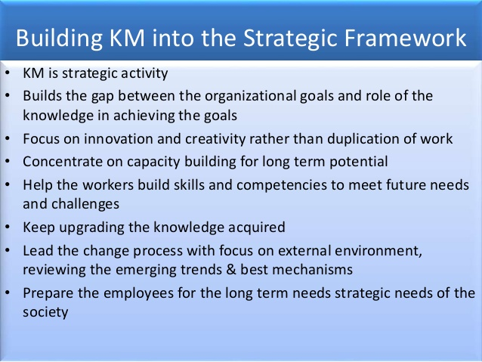
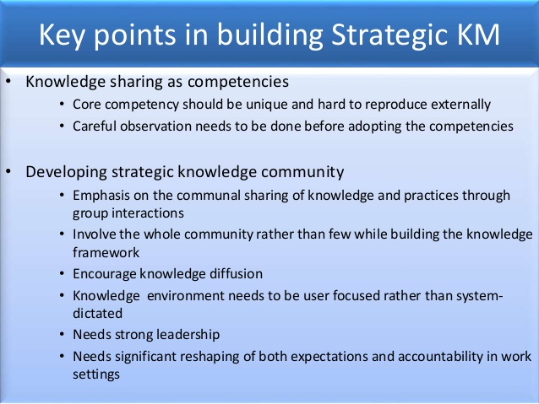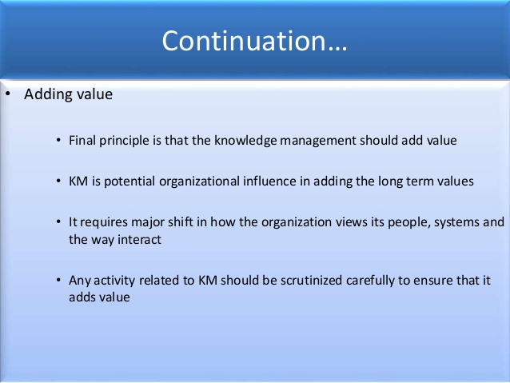

Knowledge Sharing as a Core Competency

The knowledge management definition presented earlier, involved the reuse and creation of relevant knowledge. The word relevant links knowledge management (KM) to the concept of organizational core competencies. Once again, the challenge here is to discuss this subject without diverging too much into related topics that are not directly relevant to KM.
Core competencies: Definitions vary greatly. The term was originally coined by Pralahad and Hamel (1990) who defined it as “the collective learning of the organization, especially how to coordinate different production skills and integrate multiple streams of technologies”. Since then it has been defined in multiple ways, but very generally, core competencies refer to the firm’s primary expertise, which is a source of sustained competitive advantage. Arriving at a more precise definition is not necessary for our purpose here. Suffice it to say, that these are key capabilities, which, from the resource-based perspective of the firm, are the primary drivers of innovation and competitive advantage.
Core competencies thus have a large knowledge component, and managing them is, in the very least, a product of corporate strategy working with KM and innovation management. This simplified model has strategy dictating the overall direction, KM managing the knowledge dynamics, and innovation management turning core competencies into profitable core products.
To understand the role of KM let us look at a brief overview of how core competencies are managed:
- Identifying and assessing core competencies
The firm should map out its key competencies, possibly linking them directly to specific core products. Then, an evaluation must take place, assessing what one has vs. what one needs to have (as determined by strategy and the competitive environment). KM is responsible for identifying where the key knowledge is located, including the tacit expertise and knowledge embedded in products, routines, etc, as well as identifying knowledge gaps.
- Sustaining core competencies
Organizational core competencies, like all knowledge assets, have the virtue of improving rather than depreciating through use. Conversely, lack of use will lead to erosion of any skill set. The role of KM here is twofold, on the one hand, it must keep stock of the state of key knowledge assets and, on the other, it must leverage key knowledge assets across the organization.
- Building core competencies
Building new core competencies involves interplay between knowledge, practice, coordination, and refinement. Knowledge assets must be built, enhanced, combined, and coordinated in an environment that supports experimentation and improvement. Building core competencies can be a complicated endeavor since sustained competitive advantage is derived from assets that are hard to imitate. From a KM perspective, this implies the build up of specific tacit knowledge and expertise (i.e. uncodified knowledge that is generally more valuable, and inherently more difficult to copy and transfer), often across multiple departments or functions.
- Unlearning core competencies
Organizations have a habit of trying to keep doing what they have always been doing. Unlearning a competency when it is no longer useful is one of the key aspects of a successful firm, and history is riddled with examples of companies that have failed to do so. In the process of unlearning, KM again plays an important role by identifying and managing the firm’s knowledge assets in the right direction. This may be done through re-training, restructuring, creating new knowledge flows, external knowledge acquisition, outright removal, etc.
The specific dynamics of the processes of knowledge creation, knowledge acquisition, knowledge sharing, and knowledge reuse, which are central to the management of core competencies, have been discussed earlier. The purpose of this section is to emphasize that KM is not just a collection of individual initiatives. The build up of skills and competencies, involving the coordination of multiple KM disciplines with other organizational functions, must often be managed according to long-term strategic goals and coordinated across the organization.
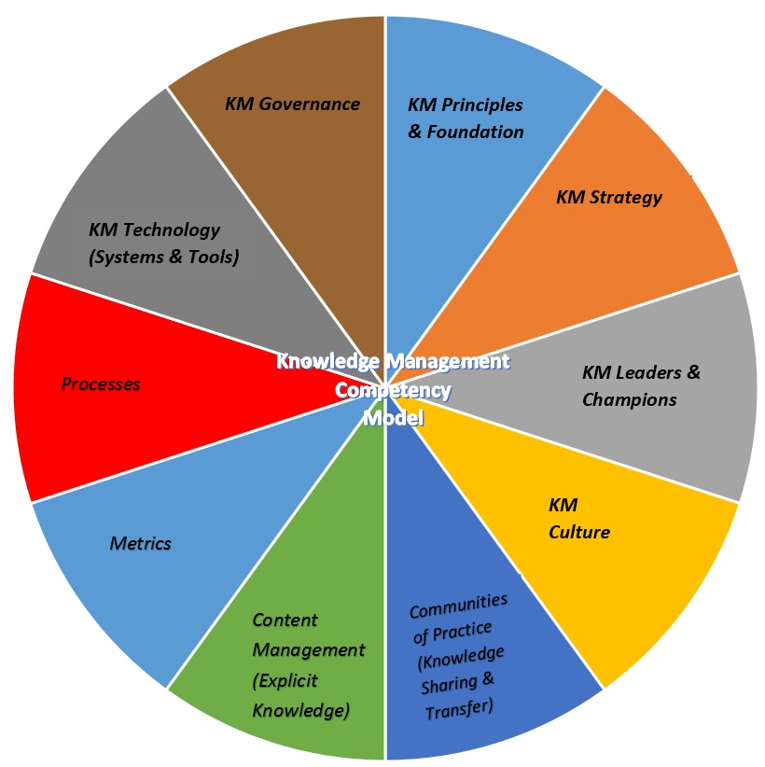

Strategic Approach to Industrial Relations

The Industrial Relations or IR shows the relationship between the management and the workmen within the industry and the role of a regulatory body to resolve the industrial disputes.
IR is perceived differently by a different group of behavioral practitioners and theorists. Some believed that IR is related to the Class Conflict while some perceived it in terms of Mutual Co-operation and still others perceived it in terms of Competing Interests of various groups. On the basis of these perceptions, there are four popular approaches to Industrial Relations. These are:
- Unitary Approach
The unitary approach is based on the notion that all the members of the organization Viz. Managers, workers, and other staff have a common set of objectives, purposes and interests and, therefore, work in unison towards the accomplishment of shared goals. Here, the conflict is seen as a temporary divergence which is caused due to the poor management or the negligence on the part of the employees to understand and mix with the organizational culture.
The unitary approach is based on the assumption that the overall profitability of the firm could be increased if everyone in the organization has the common interest/purpose and works unanimously towards its completion thereby establishing the harmonious relations. Here the strikes are considered as destructive.
- Pluralistic Approach
The pluralistic approach is just the opposite of unitary approach which is based on the assumption that an organization is an alliance of powerful and divergent sub-groups (management and trade unions), having different competing interests are mediated by the management. The management and the trade unions (association of workers) are the powerful sub-groups that may not agree with certain terms and conditions prevailing in the organization and to resolve those management tries to mediate the interest of both the groups.
During mediation, if the management pays less attention to the needs of the workers then they form unions in order to protect their interest and influence the management decision. The unions so formed helps in balancing the power between the management and employees. Thus, it is based on the notion that the conflict between the management and the employees is inevitable and is viewed as instrumental in the innovation and growth.
- Marxist Approach
The Marxist approach is based on the basic assumption that the conflict is regarded as the product of a capitalist society. This means that conflict arises not just because of the rift between the employee and the employer, but also because of the division in the society between those who owns the means of production (capitalists) and the ones who have only labor to offer. The ultimate objective of the capitalists is to increase the productivity by paying possible minimum wages to the workers due to which the latter feels exploited.
To overcome such situation workers form unions so as to safeguard their interests. These trade unions are considered as a weapon to bring about a revolutionary social change that focuses on improving the overall position of the workers in the capitalist system and not to overthrow. Unlike the pluralist approach, the Marxist believes that the state intervention via legislation and industrial tribunals work in the interest of the management and do not ensure a balance between the competing groups. Thus, according to this approach, the pluralist supports the capitalism, and the unitary approach is anathema.
- Human Relations Approach
The Human relations approach is propounded by Elton Mayo, who is a humanist and believes in the positive nature of the employees. According to him, given human initiatives from management, the employees positively listens and responds properly to them and hence there is no room left for the conflict to arise. But however Marxists and Pluralists did not appreciate too much stress on the positive nature of the workers.
Thus, these approaches to industrial relations must be properly understood by the HR managers as these offer a solid foundation for much of the role of human resource management.

Recruitment Process Outsourcing Head Hunting

Recruitment process outsourcing (RPO) is a form of business process outsourcing (BPO) where an employer transfers all or part of its recruitment processes to an external service provider, according to the Recruitment Process Outsourcing Association (RPOA). An RPO provider can provide its own or may assume the company’s staff, technology, methodologies, and reporting. In all cases, RPO differs greatly from providers such as staffing companies and contingent/ retained search providers in that it assumes ownership of the design and management of the recruitment process and the responsibility of results.
Today, the recruiting environment is rather complex. In order to effectively recruit top talent, you need to navigate a tight labor market; become proficient in a set of relevant technologies; and manage and nurture candidates and hiring managers. RPO providers are subject-matter-experts; talent acquisition is their core competency. They know how to navigate the recruiting environment, stay current with the latest recruiting technology and have the resources to scale recruiting capacity to meet hiring demands. RPOs bring people, technology, process, and metrics into a talent acquisition function.
According to RPOA co-founder and Talent Acquisition expert John Younger, “the number one reason companies succeed, struggle, or fail directly correlates with who they hire.”
Depending on what an organization is looking for, an RPO solution can bring an array of many benefits including managing hiring fluctuations throughout the year; reducing total recruiting cost and dependency on staffing agencies; improving hiring manager satisfaction; reducing time-to-fill; elevating employment brand; improving candidate experience; simplifying or streamlining the hiring process; and saving time for other duties among other benefits.
Historically, RPO provided high-volume hiring for large organizations at a lower cost compared to other recruiting options. However, RPO has evolved over the last few years to become a flexible strategic talent acquisition solution with additional benefits that can be adopted by small and medium-size organizations as well.
Over the past few years, RPO has been trickling down into the smaller and middle market domain as outsourced recruiting becomes applicable to these markets. As a result, smaller, agile RPOs are rising into the higher ranks of strategic recruiting partners and carving their unique niche in the talent acquisition marketplace.
Unlike other outsourced recruiting models, recruitment process outsourcing is a strategic partnership that brings additional value-added benefits, including:
Analysis and planning. When run effectively, RPO providers work with their clients to understand the business side of recruitment or business goals. They help clients forecast staffing needs and plan the necessary resources to respond to these needs, which help achieve those business goals.
Extensive job marketing. RPO providers market client jobs through job boards, social media, referrals, and networking to drive candidate exposure to jobs and employer brand (a major differentiator from staffing solutions).
Sourcing and engaging talent. In addition to finding talent, RPO providers build up employment brand and recognition; engage future potential talent through talent communities and talent pipelines; and source candidates in advance and with multiple sourcing assessments.
Candidate assessments. RPO providers assess candidates, guide them through the beginning of the recruitment process, and make sure they have the core skills, competencies, and motivators to do the job.
Candidate care. Managing the candidate experience is very important as it reflects on your employer brand. RPO providers help clients take care of the candidates and manage their experience, whether they are being interviewed, hired, or considered for the job.

Three basic types of RPO engagements
RPO is not a one-size-fits-all. RPO offers different engagement models. John Younger, RPO expert, and RPOA co-founder describes the following three main RPO engagement types:
On-Demand RPO: A contract-based engagement with a qualified provider that knows the company, their messaging, their processes and the results they need. The contract specifies a defined number of roles within a defined period of time.
Function-Based RPO: The RPO provider takes a piece of the company’s recruiting needs entirely off the company’s plate (e.g., the IT department or an entire division of the organization).
Full RPO: When the RPO vendor provides a company’s entire internal recruiting function including access to the provider’s full breadth of resources.

HR Outsourcing: BPO

HR Outsourcing is a process in which the human resource activities of an organization are outsourced so as to focus on the organization`s core competencies. Often HR functions are complex and time consuming that it will create difficulty in managing other important thrust areas. By HR outsourcing, this problem can be avoided which will enhance effectiveness by focussing on what the organization is best at. It will also improve the flexibility of the organization to the rapidly changing business needs. Usually businesses that outsource HR are typically small to midsize firms with number of employees ranging from 25 to 1500.
There are HR outsourcing firms present so as to meet an organization`s HR requirements. Some HR outsourcing firms are generalists, offering a wide variety of services, while others are specialists, focusing on specific areas such as recruitment, payroll etc. Depending on the degree of outsourcing required, we can either outsource the entire HR functions or contract for specific HR functions. Some of the services provided by HR outsourcing firms are:
- Recruiting, training, and development
- Overseeing organizational structure and staffing requirements
- Tracking department objectives, goals, and strategies
- Employee orientation programs
Some of the well-known HR outsourcing companies are Viteb, PeopleStrong, Trinet etc.
HR outsourcing has become a popular solution for organizations to remain competitive and cut costs. It also provides skilled professionals who are focused specifically on HR.
Hence, this concludes the definition of HR Outsourcing along with its overview.
HR outsourcing (also known as HRO) is the process of sub-contracting human resources functions to an external supplier.
Reviews of business processes have led many organisations to decide that it makes business sense to sub-contract some or all non-core activities to specialist providers.
HR, as a non-profit centre, is an obvious candidate for outsourcing.
There are many ways in which outsourcing human resources can be done:
- Business process HR outsourcing (also known as BPO), where an external supplier manages discrete HR activities, such as payroll administration or recruitment, or perhaps the whole human resources function.
- Shared service HR outsourcing, where only the transaction or administrative elements of HR’s activities are subcontracted to an external supplier. This may include the personal interface with employees.
- Application (and facilities) service HR outsourcing, where external providers look after the technological (and physical) infrastructure to support human resources activities.
Outsourcing human resources or some of its processes to an external provider is a major business decision as, while it may be cost-effective, it introduces new elements of risk, including:
- Loss of control
- Impact on the employer/employee relationship
- Loss of flexibility
- Failure to deliver cost benefits
- Legal or regulatory requirements
- Industrial relations issues
The operation of any HR outsourcing arrangement should be governed by a service level agreement. This will define the required standards of performance by both parties and any penalties for non-compliance. A service level agreement is a crucial document and must be negotiated with great care to mitigate the above risks.
People management plays a crucial role in delivering organisational performance. In today’s modern, knowledge economy this is more true than ever before. The decision to outsource human resources is therefore not to be taken lightly.
There are many circumstances in which outsourcing HR services can deliver tangible benefits to the organisation, for example by freeing HR professionals to devote more time to a strategic role supporting organisational performance.
The CIPD identifies a number of strategic drivers for outsourcing HR services:

Advantages and disadvantages of HR outsourcing
Potential benefits of HR outsourcing
- Reduced cost
- Increased efficiency
- Access to improved HR IT systems
- Improved management information (including human capital metrics)
- Access to HR expertise not available internally
- Increased flexibility and speed of response
- Philosophical reasons (for example the organisation is outsourcing a number of its support functions, of which HR is just one part)
- Reduced risk
- To free HR resources to operate more strategically.
Potential pitfalls of HR outsourcing
- Don’t outsource what you don’t understand. The HR outsource provider will only have to subsequently solve the problem (at a cost) and the provider’s solution might not be most suitable from your organisation’s perspective
- HR outsourcing does not absolve the organisation of good people management practices nor of overall responsibility for the provision of HR services
- Increasingly, HR outsourcing arrangements are often long term (five to 10 year contracts are not unusual). An understanding of the organisation’s current and future business strategy and potential changing business (and hence risk) profile is important before entering into any contractual arrangement. This helps to avoid being tied into unfavourable contractual arrangements
- Loss of local knowledge and processes which instead reside with the outsource provider
- Standardisation of processes in line with outsource provider not organisational preferences.

Strategic Decision to Outsourcing

Does strategic outsourcing actually benefit an organization? Or will it backfire in the long run? Here’s how outsourcing has impacted organizations in India, and how it can benefit you. by Soutiman Das Gupta
What do companies like Hero Honda Motors, Bharti Tele-Ventures Limited, the National Stock Exchange (NSE), HDFC Bank, Sony Entertainment Television, Hyatt Services India Pvt. Ltd, and HPCL have in common?
The common thread running through these large organizations is that all of them have chosen outsourcing as a strategic business decision to garner tangible and intangible benefits in the near and long run.
Indeed, it’s difficult to find a successful and growing organization in India, irrespective of size, that does not outsource a certain amount of its IT infrastructure services or management.

Does it work?
Does it make sense for an organization to outsource its IT needs? Most of the CIOs and analysts we spoke to felt that strategic outsourcing helps an organization to save on cost and speed up delivery while focusing on core business needs.
To elaborate on the benefits, let’s look at Infrastructure Strategies (IS 2004), the CIO annual survey conducted by Network Magazine to analyze technology investment patterns in the Indian enterprise. The survey, conducted amongst India’s top corporates, shows that nearly 54 per cent of the CIOs outsource “to reduce costs”.
A similar view is echoed by Michele Caminos, Vice President, Team Manager, IT Services, Asia/Pacific, Gartner. “The most compelling reason why companies get into outsourcing engagements is to save costs,” she agrees.
According to Infrastructure Strategies, other impor-tant drivers for strategic IT outsourcing are focus on core competencies, access to special expertise, higher speed of delivery, and access to new technologies.

Focus on the core
Given the pressures of a competitive market, organizations tend to focus on their core activities — activities that link-up directly with the revenues and hence the profitability. In such a scenario, companies tend to outsource their non-core tasks to focus on business decision-making. And IT infrastructure easily lends itself to outsourcing.
Hero Honda Motors is a good example of an organization that uses strategic outsourcing to focus on core competency. “We wanted to outsource all routine (IT maintenance) tasks so that we could concentrate on the main business issues. With the headache of dealing with routine complaints taken away, our staff focuses on user requirements and is able to deliver services to users on time,” explains SR Balasubramanian, Vice President – Information Systems, Hero Honda Motors Limited.
The IS 2004 survey reports that 46 per cent of the CIOs who outsource or have plans to do so, consider “focus on core competencies” as the second most important reason to outsource.
“There are definite cost savings in terms of resource management and less manpower costs. As an IT team we can focus more on providing new infrastructure solutions to enable various requirements of our core media business rather than get caught up with the daily maintenance requirements of the existing set-up,” explains Aneeta Pankaj, Senior Manager, Information Technology, Sony Entertainment Television (SET) India Private Limited.

Competitive Business Strategy
Outsourcing is best adopted after a careful look at business needs and available options. It is essential that the outsourcing relationship provides strategic business benefits in the future.
“Outsourcing provides a competitive strategy benefit in a number of ways to an organization. It allows ease of management, reduction in cost, lesser manpower, and frees up internal resources,” says Pankaj.
“Outsourcing can, and frequently does, provide both long- and short-term benefits to companies that outsource, provided they have a strategic objective for outsourcing. Medium and long-term gains are best realised by selecting a vendor who brings value to your core business, rather than one who can provide you with the lowest prices,” explains Sharad Sanghi, Managing Director & CEO, Netmagic Solution Pvt. Ltd.

Business-Related
It’s important to understand that outsourcing is a business-related decision and not simply an IT need. The ultimate goal of outsourcing is to bring benefits to the business and subsequently the customer.
Hero Honda’s Balasubramanian says, “We believe an outsourcing service provider could better handle our day-to-day management needs than our own team. We’ve not added numbers to our staffing in spite of increased business activity. Since the outsourcing agency manages the data centre round the clock, our staff has been relieved from working in shifts.”
Bharti Tele-Ventures Limited has cut one of the largest outsourcing deals in Asia on the IT infrastructure and network management areas. Dr Jai Menon, Joint President, Enterprise Business, Bharti Tele-Ventures, says that the outsourcing relationship has brought, “unparalleled value to the company for our customers, employees and shareholders.”
“For customers, it brings innovative and streamlined products and services like billing, CRM and data warehousing. For employees, it brings enhanced performance-critical applications like intranet, e-mail and online collaboration. And at an overall level, the strategic alliance provides predictable IT spends, and additional revenue streams to further enhance shareholder value,” he adds.

The changing landscape
In the past, Indian companies were not very keen to outsource their IT needs, primarily because their enterprise IT environments were relatively less complex, easier to manage, and inexpensive to maintain. Besides, few outsourcing service providers offered a number of outsourcing options under one roof.
But now, IT environments in companies have become more complex. There has been growth in terms of volume of business, range of services, number of employees, number of competitors, nationwide locations, and enterprise applications. This calls for more attention to IT as a service to provide strategic business benefits.
To help organizations get optimum value out IT and use it as a strategic tool to further the cause of business, many CIOs think it worth their while to outsource IT infrastructure management.

Innovative options
Indian enterprises today have a variety of outsourcing options from which they can choose the right fit. Outsourcing solution providers offer services that include desktop client management, server management, cable management, firewall management, patch management, software license management, IT audits, backbone and connectivity, website hosting, and IT infrastructure management.
Thus the available services are innovative, significantly more customised, and better aligned with individual customer requirements. An enterprise can pick-and-chose specific services and build a reliable mode of service delivery. A company can outsource basic desktop management needs, or the management of the entire nationwide IT infrastructure if needed.
To introduce more flexibility, many service providers offer clients hire-purchase schemes, infrastructure on-demand, and pay-as-you-use options.
Hyatt Services India Pvt. Ltd has given a three-year contract to a service provider to outsource network monitoring services. Says Harcharan Singh, the company’s Director of Information Systems, “The service provider has to upgrade and buy back the existing hardware as per the depreciation cost agreed in the SLA. This clause protects us from technology obsolescence, since technology changes rapidly.”
IndusInd bank has entered into an infrastructure-on-demand agreement with IBM India, which includes building an IT infrastructure, implementing server consolidation, and setting up disaster recovery systems. The partnership supports the bank’s goal to become totally customer-centric by providing more secure, responsive and efficient service, in line with its renewed focus on retail banking. It allows the bank to scale up operations and pursue aggressive growth plans.

Before you outsource
All things said, outsourcing is a strategic business decision that should be made only if a company sees true business benefits accruing from it. Badly-planned outsourcing could result in erosion of service value and cost escalation, but a well-planned outsourcing decision can help you sleep better at night, knowing that the responsibility of deliverables is in safe hands.
Michele Caminos of Gartner highlights a few steps that can lead you to take a proper decision in this context.
- What type of a service is it? Identify characteristics of service and the respective type.
- What perspective is driving the effort? Identify decision rights (service owner) and input rights (other stakeholders).
- How are other perspectives affected? Identify conflicts and work them out. Check ‘killer’ factor. Improve solution.
- Check compliance with principles and fit with architecture.
- Who should carry it out? Evaluate different staffing possibilities. Select best from combination.
- Who should participate in the decision? Submit service proposal to specific decision process. Follow it up.
She recommends the following:
- Understand different business perspectives and how they affect sourcing decisions.
- Understand how perspectives must be harnessed to drive sourcing decisions.
- Develop a structured sequence of steps to sourcing decisions.
- Develop evolving governance architecture to support sourcing decisions.
- Develop internal sourcing decision roles.

Human Side of Mergers and Acquisitions

Mergers and acquisitions are a huge business. In 2015 alone, almost $5 trillion dollars were spent on mergers and acquisitions globally. That’s trillion with a T, and this figure eclipsed the previous record established in 2007. A number of major deals continue to be in the works, and while it is unclear how the incoming administration will impact these activities; there is every reason to believe that industry consolidation will likely continue.
There are, of course, a number of reasons why M&As are pursued. There are promises of synergies, more efficient operations, new markets, better consumer practices, improved product innovation, stronger strategic fit, and greater shareholder returns. But what looks good on a financial statement may not translate to actual benefits. In fact, according to McKinsey, 70% of mergers fail to achieve their financial objectives; and so for the activity in 2015, $3.5 trillion did not achieve its expected return. And interestingly, the greatest benefit in M&As often goes to the seller, not the buyer. This phenomenon is known as “the winner’s curse.”
The reasons for this less than stellar record are complex. It can certainly vary by which strategy of brand integration is embraced: assimilation, federation, confederation or metamorphosis (Bouchikhi and Kimberly, 2012). The most commonly attributed reasons for underperformance are that most companies routinely overestimate the value of synergies and underestimate the impact of one-time costs. These technical factors can restrict the new deal right from the beginning, but there are other considerations. The costs of disruption can also be significant for both customers and employees as illustrated by the following data points:
- The average newly created company will see 2 to 5% of their combined customers disappear (McKinsey, 2004).
- There is a 20% rise in actively disengaged employees after a merger/acquisition (Forbes, 2017)
- It can take three years to return to pre-merger engagement levels (Forbes, 2017).
- It is reasonable to expect that at least 20% of executives will leave during the post-merger period.
- Pritchett indicates that a 15% decline in productivity should be expected from middle management during the implementation period.
These talent and cultural impacts have significant ripple effects, but many companies do not get serious about the human side of bringing organizations together. The landscape is littered with examples of failed efforts to create synergies and integrate cultures: AOL-Time Warner and Compaq-HP to name just two. It is assumed to be more about the balance sheet than the hard work of cultural due diligence, communication and integrating two distinct organizations. But according to Deloitte, at least 30% of the reason for the underperformance of mergers and acquisitions is precisely for these “soft” reasons.

Calculating the impact of poorly leveraged HR practices on mergers and acquisitions
1) 70% of M&As fail to achieve their financial objectives (a KPMG study puts the estimate at 83%) and
2) 30% of the reasons that M&As fail is because of “human factors.”
Given the $5 trillion M&A activity from 2015, human factors account for about $1 trillion in lost opportunity.
HR levers in 2015 M&As, therefore, represent a 13-figure upside (i.e., $1 trillion has a lot of zeros). This amount is worthy of our consideration; just to put it in context, a trillion dollars could buy:
- Apple and have $250 billion left over.
- College education for 8.3 million people.
- 769 Yankee stadiums.
- Cover the entire state of Delaware with $100 bills.
Fanciful: certainly, but let’s not forget that an unrealized investment (from poor M&A human factor integration) is quite real to the people affected. “The soft stuff, again, turns out to be the hard stuff.”

Achieving the right balance
There are no simple answers, or one easy formula, to achieving greater success in mergers and acquisitions. So many economic, political, legal, personal and contextual factors pertain, but it is true that if the human-side is ignored or underserved, then success is virtually impossible to achieve. It is important to see M&As as a process, not an event.
People factors need to be addressed throughout all stages, including;
1) Pre-deal analysis
2) Due diligence
3) Integration planning
4) Eventual implementation after the deal is consummated.
HR must be a fearless and continuous advocate to protect and optimize the investment potential of the newly formed organization.

Three stage model of M&A

- Strategy
Under this phase, M&A Advisors assess the changes pertaining to the acquirer’s industry and identify growth opportunities and targets in line with the firm’s corporate strategy.
This encompasses creating a portfolio strategy and an operating model assessment, corporate financing or investment banking and strategic alternatives.
Besides, this stage also covers target screening, deal structuring, readiness review, synergy analysis and modeling.
- Execution
During the execution phase, M&A expert advisors in commercial, financial, HR, IT, operational and tax aspects provide insight into the transition and financing options. The execution phase combines experience and knowledge to bring closure to the complex process.
This stage covers, plan structuring, financial advisory, negotiation support, due diligence, preliminary price allocation, tax structuring and more.
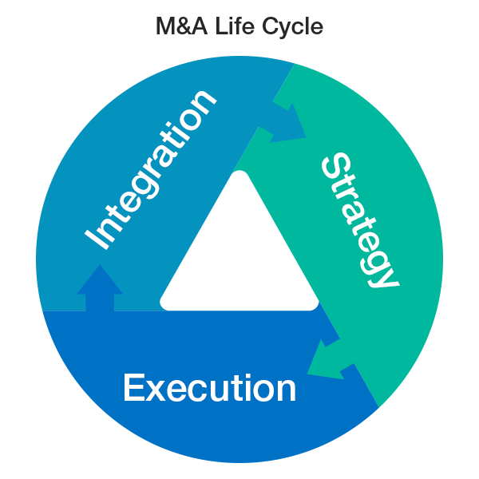
- Integration
In the final phase, integration or separation will present the acquirer with a set of challenges including costs, timelines and business disruptions, among others. This phase spans integration or separation planning support, developing the sales purchase agreement, financial agreement advisory, finalizing valuation and purchase price, completion statement advisory.
Post-deal closure, M&A advisors organize Day 1 Readiness Transition Service Agreement, synergy support, human capital integration, tax integration and restructuring. Technology M&A Advisors assure of a hassle-free process all throughout the integration phase including end-state planning.

