Notes –Project Management
Unit-2

UNIT-2

Project Identification

Project Identification
Project identification is the first step of any project cycle. Entrepreneurs need to identify and zero in on a project that suits their requirements and can help them attain their goals before spending significant time and resources on a project. They also need to study in detail the feasibility of the proposed project well before they start planning the other steps of the project cycle. Usually various aspects are required to be studied before picking a project.
The purpose of project identification is to develop a preliminary proposal for the most appropriate set of interventions and course of action, within specific time and budget frames, to address a specific development goal in a particular region or setting. Investment ideas can arise from many sources and contexts. They can originate from a country’s sector plan, programme or strategy, as follow-up of an existing project or from priorities identified in a multi-stakeholder sector or local development dialogue. Identification involves:
- A review of alternative approaches or options for addressing a set of development problems and opportunities;
- The definition of project objectives and scope of work at the degree of detail necessary to justify commitment of the resources for detailed formulation and respective preparatory studies; and
- The identification of the major issues that must be tackled and the questions to be addressed before a project based on the concept can be implemented.
Sufficient information on project options must be gathered to enable the government and financing agencies to select a priority project and reach agreements among stakeholders on arrangements for preparation work, including setting up steering committees or national preparation teams. The results of identification work should be summarized in a report, project brief or concept document, the format of which will depend upon the government’s and/or financing agencies’ requirement.
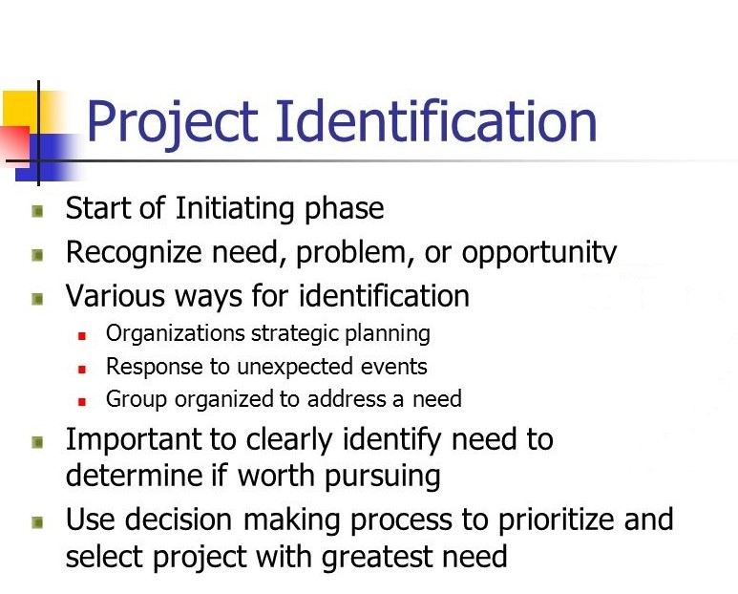
Opportunities in the Environment for Project Identification
Meaningful indication for a successful project can be availed from the following one or more sources for project identification
(a) Five Year Plans
For project identification, the Five Year Plans are indicative enough to reflect the government’s intention, including the policy emphasis on the sectors and—within the sector—particular type of industries.
(b) Imports and Exports
The industry-wise, and also product-wise, detailed statistics of imports and exports are regularly published by the government. These information indicates the possible venture area—What are the products, and the volume of such products as exported to which countries? And similar information of imports as well.
We can get enough idea from these statistics about the possible export industry or project to produce goods for import substitution.
(c) Financial Corporation and Industrial Development Corporation at State level sponsor project feasibility reports with the help of reliable and established consultants for promotion of industries in the State. Such reports can be a very helpful guide to generate ideas for the start of a project.
(d) Departments of SSI and ARI, as mentioned earlier, prepared about 200 project profiles to help and guide small industries for investment up to Rs. 5 crores in a project. These projects are industry-group-wise, and even provide source information of the required plant and machineries with costs updated in 1994.
(e) Council of Scientific and Industrial Research (CSIR)
With their network of laboratories has developed new processes and technologies along with their commercial applications. These know-how are available at less cost and without any foreign exchange involved and can be useful in considering a suitable project.
The selection of the process/product know-how can be made in conjunction with information available from other sources. For example, the CSIR, Jorhat, has the technical know-how for the manufacture of ‘micro-crystalline wax’.
It also appears from the import statistics that this product is regularly imported by many organizations. Such information and the available know-how can give ideas of developing a project for the manufacture of this product provided the availability of the basic raw material—i.e. ‘crude oil-tank-bottom- scrappings’—is ensured.
(f) Analysis of industrial information such as capacity installed, actual productions, market sizes with its growth can be a source of information to indicate opportunities.
(g) Trade Fairs and Industrial Exhibitions including both national and international exhibits, many new products and processes can be a source of information and ideas for a project.
(h) Economic and social trend and the various statistics available in this regard can be analysed to find some opportunities. The band of affluent middle class population with the changes in their pattern of living will indicates the growth of demand for specific range of consumer durables including domestic appliances—big and small.
(i) BIFR can provide a list of endless sick units which are chained by enormous accumulated loss. With careful analysis, a large number of such units may be profitably revived by skilled management and infusion of necessary fund. We have noted earlier that in such cases financial helps can be availed from IIBI and banks as well.

Project Selection

Project Selection is a process to assess each project idea and select the project with the highest priority.
Projects are still just suggestions at this stage, so the selection is often made based on only brief descriptions of the project. As some projects will only be ideas, you may need to write a brief description of each project before conducting the selection process.

Selection of projects is based on
(i) Benefits: A measure of the positive outcomes of the project. These are often described as “the reasons why you are undertaking the project”. The types of benefits of eradication projects include:
- Biodiversity
- Economic
- Social and cultural
- Fulfilling commitments made as part of national, regional or international plans and agreements.
(ii) Feasibility: A measure of the likelihood of the project being a success, i.e. achieving its objectives. Projects vary greatly in complexity and risk. By considering feasibility when selecting projects it means the easiest projects with the greatest benefits are given priority.
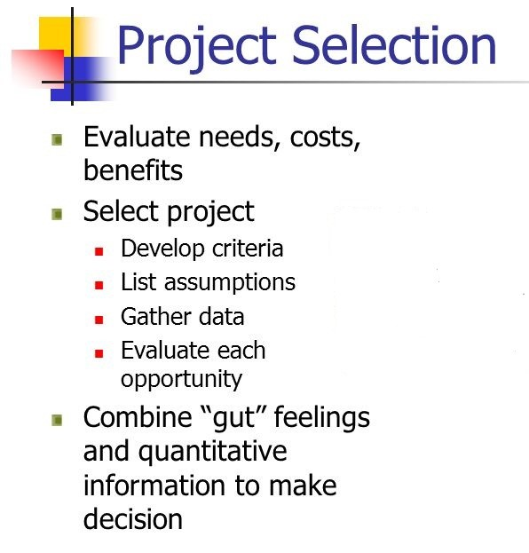

Why Do Project Selection?
Often you will have a number of suggested projects but not enough resources, money or time to undertake all of the projects. The ideas for eradication projects may have come from many sources including: the community, funders, local and national governments and Non-Governmental Organizations (NGOs). You will therefore need a way of deciding on a priority order and choosing a project.
If your organization has limited experience in conducting eradications then it is recommended to concentrate on a small number of projects, ideally one project at a time, until the people in your organization have developed the skills and experience. Grow capacity and build up to undertaking multiple projects at any one time. Do the easy projects first. Work towards the most difficult and rewarding projects. Use the easy projects to help answer questions/solve issues for the more difficult projects. Use the best opportunities to learn.
You may have a mix of straight forward and difficult eradication projects and do not know where to start. The Project Selection Stage will assist you by providing a process to compare the importance of the projects and select the most suitable project to undertake.
By following the Project Selection Stage you will follow a step by step objective method for prioritizing projects – this can be used to explain to stakeholders the reasoning behind why you selected a particular project.
The benefits of completing the Project Selection are-
- A transparent and documented record of why a particular project was selected
- A priority order for projects, that takes into account their importance and how achievable the project is

Who Should Be Involved?
- Agency Management: Set selection criteria to ensure the selection process aligns with agency strategies. Selection processes are often run as a management initiative before the implementing Project Manager is assigned.
- Stakeholders: Stakeholder participation at the start of a project creates strong community ownership and support, and increases the chances of a successful outcome. Stakeholder input should be included at the ideas stage; consult widely as you are developing the ideas for projects as the community will be the source of many of the best project ideas. Stakeholders must be informed of the outcome of the Project Selection Stage.
- Project Manager: Involving the Project Manager in the Project Selection process will help build ownership in the project and support a successful project in the long run.

Process of Project Selection
(i) Identification of Projects
The first step of this process, identification, requires a clearly defined and communicated strategy. The best option would be to set up a strategy development process that contains project identification and project selection as an integral part (cf. “How to Find the Right Projects” in sub-section White Papers). In fact, we observe that most organizations identify investment projects within their strategy development process, but delegate the identification of customer projects to their key account and sales departments.
(ii) Evaluation and Prioritization of Projects
Central part of the project selection process is evaluation and prioritization of identified projects. There are a couple of methods available:
- Net Present Value (NPV)
- Internal Rate of Return (IRR)
- Benefit / Cost Ratio (BCR)
- Opportunity Cost (OC)
- Payback Period (PP)
- Initial Risk Assessment
These methods require a certain minimum level of “planning” for each one of the projects to be evaluated. We need to know
- Project life cycle duration, in number of accounting periods,
- Expected project cost per accounting period,
- Expected project revenue per accounting period,
- Overall risk values of the projects to be evaluated.
(iii) Selection and Initiation of Projects
Project selection and initiation is the step that naturally follows evaluation and prioritization. A particularly delicate step of project initiation turns out to be the staffing of project teams. As mentioned earlier, resources are scarce, and in most organizations appear to be the most limiting factor in project selection. If we take in too many projects we overload our resources, if we do not take in enough we do not utilize them economically enough. As discussed in the sub-section Multi Project Management, having too many staff members working in multi-tasking mode, i.e. on two or more projects at the same time, decreases overall productivity of the organization. On a medium / long term scale, it seems to be the better option to initiate projects in a way so that the teams can focus and work on one project at a time, thus, avoiding disturbances of one project by the others. Of course, that needs clear prioritization of the selected projects, based on evaluation done in the previous step.
(iv) Review of Projects
After project selection we need to regularly review projects that are under way in order to find out if they are still in-line with our strategy. Thus, the first way of checking them is repeating the initial evaluation with more accurate estimates as they become available; the second way is holding regular project management review meetings in order to identify major problems on a per-project basis, via project status reports.

Project Rating Index

The Project Definition Rating Index (PDRI) is a methodology used by capital projects to measure the degree of scope definition, identify gaps, and take appropriate actions to reduce risk during front end planning. PDRI is used at multiple stages in the front end planning process. As a project progresses, identified gaps will continue to be addressed until a sufficient level of definition (measured using the PDRI score) is achieved for the project to successfully proceed to detailed design and construction.
Poor scope definition is recognized as one of the leading causes of project failure, resulting in cost and schedule overruns, and long term operational issues. As a result, front end planning is one of the most important process in the construction and operation of a capital asset. The PDRI methodology is proven to reduce risk in capital project delivery by promoting rigorous scope definition and a collaborative review process during front end planning. Using the PDRI methodology will help your project teams improve scope definition, become better aligned, and provide transparency on identified gaps. This helps to equip all project stakeholders to better mitigate risks identified in PDRI reviews, predict potential issues, and overcome costly problems down the road.
PDRI Structure
The PDRI methodology supports a comprehensive assessment of scope definition. Templates are organized in three sections for systematic assessment of the:
- Basis of project decision – the business objectives and drivers
- Basis of design – processes and technical information required
- Execution approach – for executing the project construction and closeout
Each section is broken down into categories and elements. The element is the lowest level of the index where the assessment of scope definition is conducted.
There are three industry-validated PDRI templates that are each focused on a specific industry sector.
(i) Industrial Projects
The Industrial template is targeted for projects that provide an output in terms of assemblies, sub-assemblies, chemical compounds, electricity, food or other marketable goods. Examples include power plants, chemical plants, oil & gas production, refineries, water and waste treatment, and manufacturing facilities.
(ii) Building Projects
The Building template is designed for commercial building projects. Examples including offices, schools, medical facilities, institutional buildings, warehouses, parking structures and research facilities.
(iii) Infrastructure Projects
The Infrastructure template is targeted for projects that involve linear construction with extensive public interface and environmental impact considerations. Examples include railways, highways, pipelines, transmission and distribution and canals.

Market and Demand Analysis Techniques

Companies use market demand analysis to understand how much consumer demand exists for a product or service. This analysis helps management determine if they can successfully enter a market and generate enough profits to advance their business operations. While several methods of demand analysis may be used, they usually contain a review of the basic components of an economic market.
Market Identification
The first step of market analysis is to define and identify the specific market to target with new products or services. Companies will use market surveys or consumer feedback to determine their satisfaction with current products and services. Comments indicating dissatisfaction will lead businesses to develop new products or services to meet this consumer demand. While companies will usually identify markets close to their current product line, new industries may be tested for business expansion possibilities.
Business Cycle
Once a potential market is identified, companies will assess what stage of the business cycle the market is in. Three stages exist in the business cycle: emerging, plateau and declining. Markets in the emerging stage indicate higher consumer demand and low supply of current products or services. The plateau stage is the break-even level of the market, where the supply of goods meets current market demand. Declining stages indicate lagging consumer demand for the goods or services supplied by businesses.
Product Niche
Once markets and business cycles are reviewed, companies will develop a product that meets a specific niche in the market. Products must be differentiated from others in the market so they meet a specific need of consumer demand, creating higher demand for their product or service. Many companies will conduct tests in sample markets to determine which of their potential product styles is most preferred by consumers. Companies will also develop their goods so that competitors cannot easily duplicate their product.
Growth Potential
While every market has an initial level of consumer demand, specialized products or goods can create a sense of usefulness, which will increase demand. Examples of specialized products are iPods or iPhones, which entered the personal electronics market and increased demand through their perceived usefulness by consumers. This type of demand quickly increases the demand for current markets, allowing companies to increase profits through new consumer demand.
Competition
An important factor of market analysis is determining the number of competitors and their current market share. Markets in the emerging stage of the business cycle tend to have fewer competitors, meaning a higher profit margin may be earned by companies. Once a market becomes saturated with competing companies and products, fewer profits are achieved and companies will begin to lose money. As markets enter the declining business cycle, companies will conduct a new market analysis to find more profitable markets.

Survey Method

Survey method is one of the most common and direct methods of forecasting demand in the short term. This method encompasses the future purchase plans of consumers and their intentions. In this method, an organization conducts surveys with consumers to determine the demand for their existing products and services and anticipate the future demand accordingly.
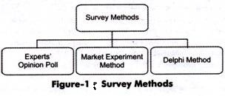
- Experts’ Opinion Poll
Refers to a method in which experts are requested to provide their opinion about the product. Generally, in an organization, sales representatives act as experts who can assess the demand for the product in different areas, regions, or cities.
Sales representatives are in close touch with consumers; therefore, they are well aware of the consumers’ future purchase plans, their reactions to market change, and their perceptions for other competing products. They provide an approximate estimate of the demand for the organization’s products. This method is quite simple and less expensive.
However, it has its own limitations, which are discussed as follows:
(a) Provides estimates that are dependent on the market skills of experts and their experience. These skills differ from individual to individual. In this way, making exact demand forecasts becomes difficult.
(b) Involves subjective judgment of the assessor, which may lead to over or under-estimation.
(c) Depends on data provided by sales representatives who may have inadequate information about the market.
(d) Ignores factors, such as change in Gross National Product, availability of credit, and future prospects of the industry, which may prove helpful in demand forecasting.
- Delphi Method
Refers to a group decision-making technique of forecasting demand. In this method, questions are individually asked from a group of experts to obtain their opinions on demand for products in future. These questions are repeatedly asked until a consensus is obtained.
In addition, in this method, each expert is provided information regarding the estimates made by other experts in the group, so that he/she can revise his/her estimates with respect to others’ estimates. In this way, the forecasts are cross checked among experts to reach more accurate decision making.
Ever expert is allowed to react or provide suggestions on others’ estimates. However, the names of experts are kept anonymous while exchanging estimates among experts to facilitate fair judgment and reduce halo effect.
The main advantage of this method is that it is time and cost effective as a number of experts are approached in a short time without spending on other resources. However, this method may lead to subjective decision making.
- Market Experiment Method
Involves collecting necessary information regarding the current and future demand for a product. This method carries out the studies and experiments on consumer behavior under actual market conditions. In this method, some areas of markets are selected with similar features, such as population, income levels, cultural background, and tastes of consumers.
The market experiments are carried out with the help of changing prices and expenditure, so that the resultant changes in the demand are recorded. These results help in forecasting future demand.
There are various limitations of this method, which are as follows:
(a) Refers to an expensive method; therefore, it may not be affordable by small-scale organizations
(b) Affects the results of experiments due to various social-economic conditions, such as strikes, political instability, natural calamities

Trend Projection Method

The Trend Projection Method is the most classical method of business forecasting, which is concerned with the movement of variables through time. This method requires a long time-series data.
The trend projection method is based on the assumption that the factors liable for the past trends in the variables to be projected shall continue to play their role in the future in the same manner and to the same extent as they did in the past while determining the variable’s magnitude and direction.
In predicting demand for a product, the trend projection method is applied to the long time-series data. A long-standing firm can obtain such data from its departments (such as sales) and the books of accounts. While the new firms can obtain data from the old firms operating in the same industry. The trend projection method includes three techniques based on the time-series data. These are:
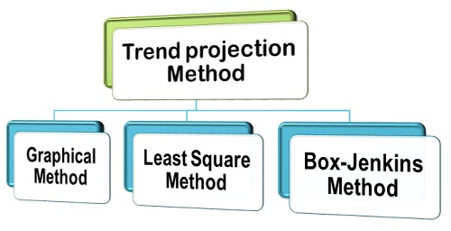
- Graphical Method
It is the most simple statistical method in which the annual sales data are plotted on a graph, and a line is drawn through these plotted points. A free hand line is drawn in such a way that the distance between points and the line is the minimum. Under this method, it is assumed that future sales will assume the same trend as followed by the past sales records. Although the graphical method is simple and inexpensive, it is not considered to be reliable. This is because the extension of the trend line may involve subjectivity and personal bias of the researcher.
- Fitting Trend Equation or Least Square Method
The least square method is a formal technique in which the trend-line is fitted in the time-series using the statistical data to determine the trend of demand. The form of trend equation that can be fitted to the time-series data can be determined either by plotting the sales data or trying different forms of the equation that best fits the data. Once the data is plotted, it shows several trends. The most common types of trend equations are:
(i) Linear Trend: when the time-series data reveals a rising or a linear trend in sales, the following straight line equation is fitted:
S = a + bT
Where S = annual sales; T = time (years); a and b are constants.
(ii) Exponential Trend: The exponential trend is used when the data reveal that the total sales have increased over the past years either at an increasing rate or at a constant rate per unit time.
- Box Jenkins Method
Box-Jenkins method is yet another forecasting method used for short-term predictions and projections. This method is often used with stationary time-series sales data. A stationary time-series data is the one which does not reveal a long term trend. In other words, Box-Jenkins method is used when the time-series data reveal monthly or seasonal variations that reappear with some degree of regularity.
Thus, these are the commonly used trend-projection methods that tell about the trend of demand for a product and are based on a long and reliable time-series data.

Project Risk Management: Introduction

Risk is inevitable in a business organization when undertaking projects. However, the project manager needs to ensure that risks are kept to a minimal. Risks can be mainly divided between two types, negative impact risk and positive impact risk.
Not all the time would project managers be facing negative impact risks as there are positive impact risks too. Once the risk has been identified, project managers need to come up with a mitigation plan or any other solution to counter attack the risk.

Project Risk Management
Managers can plan their strategy based on four steps of risk management which prevails in an organization. Following are the steps to manage risks effectively in an organization:
- Risk Identification
- Risk Quantification
- Risk Response
- Risk Monitoring and Control

Step 1: Risk Identification
Managers face many difficulties when it comes to identifying and naming the risks that occur when undertaking projects. These risks could be resolved through structured or unstructured brainstorming or strategies. It’s important to understand that risks pertaining to the project can only be handled by the project manager and other stakeholders of the project.
Risks, such as operational or business risks will be handled by the relevant teams. The risks that often impact a project are supplier risk, resource risk and budget risk. Supplier risk would refer to risks that can occur in case the supplier is not meeting the timeline to supply the resources required.
Resource risk occurs when the human resource used in the project is not enough or not skilled enough. Budget risk would refer to risks that can occur if the costs are more than what was budgeted.

Step 2: Risk Quantification
Risks can be evaluated based on quantity. Project managers need to analyze the likely chances of a risk occurring with the help of a matrix.
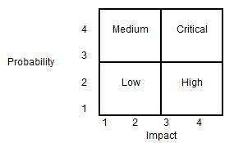
Using the matrix, the project manager can categorize the risk into four categories as Low, Medium, High and Critical. The probability of occurrence and the impact on the project are the two parameters used for placing the risk in the matrix categories. As an example, if a risk occurrence is low (probability = 2) and it has the highest impact (impact = 4), the risk can be categorized as ‘High’.

Step 3: Risk Response
When it comes to risk management, it depends on the project manager to choose strategies that will reduce the risk to minimal. Project managers can choose between the four risk response strategies, which are outlined below.
- Risks can be avoided
- Pass on the risk
- Take corrective measures to reduce the impact of risks
- Acknowledge the risk

Step 4: Risk Monitoring and Control
Risks can be monitored on a continuous basis to check if any change is made. New risks can be identified through the constant monitoring and assessing mechanisms.

Risk Management Process
Following are the considerations when it comes to risk management process:
- Each person involved in the process of planning needs to identify and understand the risks pertaining to the project.
- Once the team members have given their list of risks, the risks should be consolidated to a single list in order to remove the duplications.
- Assessing the probability and impact of the risks involved with the help of a matrix.
- Split the team into subgroups where each group will identify the triggers that lead to project risks.
- The teams need to come up with a contingency plan whereby to strategically eliminate the risks involved or identified.
- Plan the risk management process. Each person involved in the project is assigned a risk in which he/she looks out for any triggers and then finds a suitable solution for it.

Project Risk; an Opportunity or a Threat?
As mentioned above, risks contain two sides. It can be either viewed as a negative element or a positive element. Negative risks can be detrimental factors that can haphazard situations for a project.
Therefore, these should be curbed once identified. On the other hand, positive risks can bring about acknowledgements from both the customer and the management. All the risks need to be addressed by the project manager.
An organization will not be able to fully eliminate or eradicate risks. Every project engagement will have its own set of risks to be dealt with. A certain degree of risk will be involved when undertaking a project.
The risk management process should not be compromised at any point, if ignored can lead to detrimental effects. The entire management team of the organization should be aware of the project risk management methodologies and techniques.
Enhanced education and frequent risk assessments are the best way to minimize the damage from risks.

Types of Project Risk

Complex projects are always fraught with a variety of risks ranging from scope risk to cost overruns. One of the main duties of a project manager is to manage these risks and prevent them from ruining the project. In this post, I will cover the major risks involved in a typical project.
- Scope Risk
This risk includes changes in scope caused by the following factors:
- Scope creep the project grows in complexity as clients add to the requirements and developers start gold plating.
- Integration issues
- Hardware & Software defects
- Change in dependencies
- Scheduling Risk
There are a number of reasons why the project might not proceed in the way you scheduled. These include unexpected delays at an external vendor, natural factors, errors in estimation and delays in acquisition of parts. For instance, the test team cannot begin the work until the developers finish their milestone deliverables and a delay in those can cause cascading delays.
To reduce scheduling risks use tools such as a Work Breakdown Structure (WBS) and RACI matrix (Responsibilities, Accountabilities, Consulting and Information) and Gantt charts to help you in scheduling.
- Resource Risk
This risk mainly arises from outsourcing and personnel related issues. A big project might involve dozens or even hundreds of employees and it is essential to manage the attrition issues and leaving of key personnel. Bringing in a new worker at a later stage in the project can significantly slow down the project.
Apart from attrition, there is a skill related risk too. For instance, if the project requires a lot of website front end work and your team doesn’t have a designer skilled in HTML/CSS, you could face unexpected delays there.
Another source of the risk includes lack of availability of funds. This could happen if you are relying on an external source of funding (such as a client who pays per milestone) and the client suddenly faces a cash crunch.
- Technology Risk
This risk includes delays arising out of software & hardware defects or the failure of an underlying service or a platform. For instance, halfway through the project you might realize the cloud service provider you are using doesn’t satisfy your performance benchmarks. Apart from this, there could be issues in the platform used to build your software or a software update of a critical tool that no longer supports some of your functions.

Risk Identification

Risk identification is the first step in risk management. We need to identify both project and product risk by using certain techniques. Some of the most common techniques which can be applied to identify different risks are using risk templates, interviewing the stakeholders, project retrospectives etc.
You should try to include as many stakeholders as you can to identify different risk because the broadest range of stakeholders will provide the maximum risk items associated to the product.
Several formal techniques like Failure Mode and Effect Analysis (FMEA) and Failure Mode Effect and Criticality Analysis (FMECA) are used to find the risk. These techniques identify the effects of the risk if in case that becomes an outcome. The effects can be on people, society, users, customers etc.

The Importance of Identifying Risks
Once a risk is managed, the mitigation and contingency steps become just one more task on a project manager’s to-do list–or better yet, someone else’s list. Before you can manage risks, though, you need to identify them so that they can be analyzed, discussed and mitigated.
The ability to identify risks should involve the entire project team, but normally the project manager will lead the effort and get the ball rolling. There are many different ways to identify risks that will pertain to the project, and the project manager should work through as many of them as are relevant to the project–and realistic for the project team.
Old Projects: The first step in identifying risks is to look at projects that are already completed. If a project is similar in nature to the present one, then you can review the documentation and the information that was captured about those projects. The risks that were identified for that project can be reviewed to determine if they could also be risks for the current project.
In addition, the issues that occurred will be a great resource for identifying risks that might occur in the present project. You need to identify those issues as risks before they occur and determine how to best mitigate them so that they do not turn into issues. Mitigating these types of risks can provide a great boost to the project from the very beginning; it will not fall into the same problems that have plagued other projects.
At the same time, these sessions should not devolve into predicting every possible dire outcome. After all, the project team is not going to mitigate the risk that an asteroid could strike Earth and wipe out life as we know it. Instead, the project manager should lead the brainstorming effort and concentrate on letting everyone speak to the realistic and manageable risks that the project will face.
Careful Listening: One other tactic to identify risks is to practice careful listening. As a project begins in the planning and designing phases, the project manager should be in meetings and listening carefully to what is going on. By being involved in these meetings, the PM can begin to formulate ideas for risks that need to be mitigated and managed by the project team. If you hear people talk about tasks they are worried about or scope that is not understood well, that is a clue to sit up, pay attention and start writing down risks related to the issues they are talking about. Being able to do this means that you are listening and paying attention to what is going on with the project team.
Templates: In addition to looking through data and information from previous projects, it can be helpful to look at templates. There are many resources available about implementing projects and common risks that occur in projects based on the industry or type of project. The project manager should do the research and make use of anything that may be available. These resources can be found online or in the library or even through your network of project management peers. Whenever you have an available resource to get risks identified for the project, you should make use of it.
Staying Ahead of the Curve: All of these ways of identifying risks are how you can stay ahead of the curve when it comes to managing the project. Most of your time and energy will be spent on creating a schedule and managing work according to that schedule. But risks are a vital part of the project, and they should not be worked on in whatever time is left after everything else is done. Identifying them early in the project and working on them continually–and as often as possible–is a way to stay on top of the risks and potential issues that will affect the project. Identifying risks helps everyone on the project.
Brainstorming: The entire project team should be involved in brainstorming for risks. Key stakeholders can also be polled for the risks that they anticipate on the project. These brainstorming sessions should be open discussions and not limited by any preconceived notions or small lists of risks that the project manager wants to work on. A good brainstorming session involves letting everyone have their say and hearing out the thoughts of the entire project team.

Risk Analysis

Risk analysis is the process of identifying and analyzing potential issues that could negatively impact key business initiatives or critical projects in order to help organizations avoid or mitigate those risks.

Benefits of Risk Analysis
Organizations must understand the risks associated with the use of their information systems to effectively and efficiently protect their information assets.
Risk analysis can help an organization improve its security in a number of ways. Depending on the type and extent of the risk analysis, organizations can use the results to help:
- Identify, rate and compare the overall impact of risks to the organization, in terms of both financial and organizational impacts;
- Identify gaps in security and determine the next steps to eliminate the weaknesses and strengthen security;
- Enhance communication and decision-making processes as they relate to information security;
- Improve security policies and procedures and develop cost-effective methods for implementing these information security policies and procedures;
- Put security controls in place to mitigate the most important risks;
- Increase employee awareness about security measures and risks by highlighting best practices during the risk analysis process; and
- Understand the financial impacts of potential security risks.

Steps in Risk Analysis Process
The risk analysis process usually follows these basic steps:
(i) Conduct a risk assessment survey: This first step, getting input from management and department heads, is critical to the risk assessment process. The risk assessment survey is a way to begin documenting specific risks or threats within each department.
(ii) Identify the risks: The reason for performing risk assessment is to evaluate an IT system or other aspect of the organization and then ask: What are the risks to the software, hardware, data and IT employees? What are the possible adverse events that could occur, such as human error, fire, flooding or earthquakes? What is the potential that the integrity of the system will be compromised or that it won’t be available?
(iii) Analyze the risks: Once the risks are identified, the risk analysis process should determine the likelihood that each risk will occur, as well as the consequences linked to each risk and how they might affect the objectives of a project.
(iv) Develop a risk management plan: Based on an analysis of which assets are valuable and which threats will probably affect those assets negatively, the risk analysis should produce control recommendations that can be used to mitigate, transfer, accept or avoid the risk.
(v) Implement the risk management plan: The ultimate goal of risk assessment is to implement measures to remove or reduce the risks. Starting with the highest-priority risk, resolve or at least mitigate each risk so it’s no longer a threat.
(vi) Monitor the risks: The ongoing process of identifying, treating and managing risks should be an important part of any risk analysis process.

Risk Mitigation Strategies

Risk Mitigation
All organizations face risks. These risks may be internal, such as inaccurate sales projections or insufficient protection of valuable assets such as inventory. Risks may also be external, such as the risk of a natural disaster or an economic crisis. Whatever the cause, managers of organizations should be attentive to potential risks and how they can protect the organization from these risks.
Protecting an organization from the impact of risk events by using different techniques is called mitigating risks. Mitigation techniques aim to lower the potential impact of a risk and decrease the likelihood of the risk event from occurring. There are four primary mitigation techniques that may be used and together form the TARA framework: Transference, Avoidance, Reduction/mitigation, and Acceptance.
Transference
Transference is a risk mitigation technique that involves transferring all, or some, of the risk to another party. Take a minute and think if you can come up with an example of risk transference in your personal life. When do you transfer or share risk with another person or company?
Did you identify insurance, such as automobile insurance or health insurance? Think about what that insurance provides. In exchange for a fee, insurance companies will help you deal with the impact of a risk, such as a car accident or injury. This is exactly what companies and organizations can do with some of the risks they face. Through purchasing insurance, organizations can share exposure to certain risks with an insurance company.
Avoidance
Sometimes, the management can decide that the potential impact of a certain risk is not worth accepting. If the management does not want to deal with the risk, they can simply avoid it. However, note that avoiding the risk is not always an option.
As an example of avoiding risk, imagine a large company that wants to expand their operations into a volatile region of the world. While they may be able to lower costs or access a new market, they know that operating in a volatile region may include risks to their business, their employees, and their brand. After weighing the costs and benefits, if the company decides that the risk is not worth the potential reward and therefore does not expand, they are avoiding the risk. Avoidance occurs whenever something is not done because of the risk involved.
Reduce
This means to reduce the risk exposure probably by carrying out the activity in a different way. For example, this strategy is suitable when the risk does not have significant impact but likely to occur. This is to reduce the likelihood of occurrence by using different method to carry out the activity. However if reduction cannot be done, company might have to accept the risk if it does not have significant impact or avoid it if otherwise.
Accept
This means to accept the risk and do nothing. For example, this strategy is suitable when the risk has a low impact and low probability of occurrence. This is because the risk is not really a matter even if it is realised.

