Notes- Project Management
Unit-3

UNIT-3

Project Costing: Fundamental Components of Project Cost

The project cost is a cost required to procure all the needed products, services and resources to deliver the project successfully.
Example: In an example of a construction project, the cost estimation starts from land acquisition cost, construction cost, materials cost, administration cost, labor cost and other direct and indirect costs.
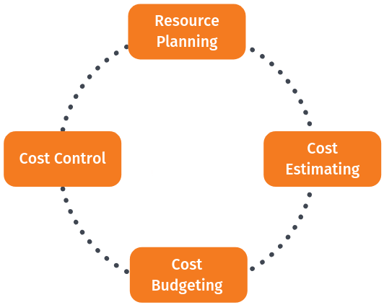
Cost management is concerned with the process of finding the right project and carrying out the project the right way. It includes activities such as planning, estimating, budgeting, financing, funding, managing, controlling, and benchmarking costs so that the project can be completed within time and the approved budget and the project performance could be improved in time.
Step 1: Resource planning
Resource planning is the process of ascertaining future resource requirements for an organization or a scope of work. This involves the evaluation and planning of the use of the physical, human, financial, and informational resources required to complete work activities and their tasks. Most activities involve using people to perform work. Some activities involve materials and consumables. Other tasks involve creating an asset using mainly information inputs (e.g., engineering or software design). Usually, people use tools such as equipment to help them. In some cases, automated tools may perform the work with little or no human effort.
Resource planning begins in the scope and execution plan development process during which the work breakdown structure, organizational breakdown structure (OBS), work packages, and execution strategy are developed. The OBS establishes categories of labor resources or responsibilities; this categorization facilitates resource planning because all resources are someone’s responsibility as reflected in the OBS.
Resource estimating (usually a part of cost estimating) determines the activity’s resource quantities needed (hours, tools, materials, etc.) while schedule planning and development determines the work activities be performed. Resource planning then takes the estimated resource quantities, evaluates resource availability and limitations considering project circumstances, and then optimizes how the available resources (which are often limited) will be used in the activities over time. The optimization is performed in an iterative manner using the duration estimating and resource allocation steps of the schedule planning and development process.
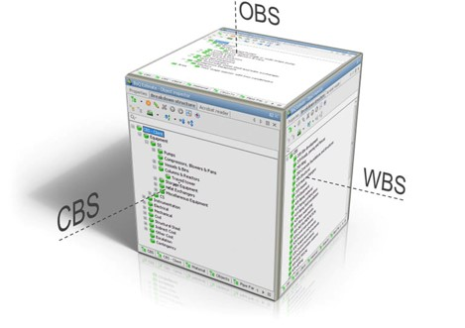
Step 2: Cost estimating
Cost estimating is the predictive process used to quantify, cost, and price the resources required by the scope of an investment option, activity, or project. It involves the application of techniques that convert quantified technical and programmatic information about an asset or project into finance and resource information. The outputs of estimating are used primarily as inputs for business planning, cost analysis, and decisions or for project cost and schedule control processes.
The cost estimating process is generally applied during each phase of the asset or project life cycle as the asset or project scope is defined, modified, and refined. As the level of scope definition increases, the estimating methods used become more definitive and produce estimates with increasingly narrow probabilistic cost distributions.
Cost estimating could be performed by dedicated software systems like Cleopatra Enterprise cost estimating and project cost databases like CESK that are created and maintained to support the various types of estimates that need to be prepared during the life cycle of the asset or project.
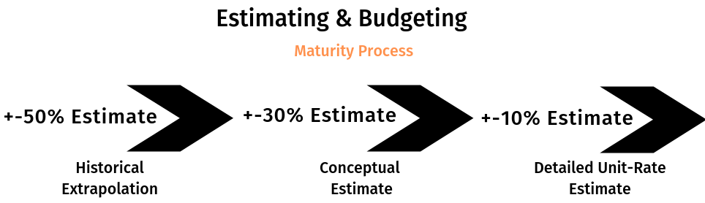
Step 3: Cost budgeting
Budgeting is a sub-process within estimating used for allocating the estimated cost of resources into cost accounts against which cost performance will be measured and assessed. This forms the baseline for cost control. Cost accounts used from the chart of accounts must also support the cost accounting process. Budgets are often time-phased in accordance with the schedule or to address budget and cash flow constraints.
Step 4: Cost control
Cost control is concerned with measuring variances from the cost baseline and taking effective corrective action to achieve minimum costs. Procedures are applied to monitor expenditures and performance against the progress of a project. All changes to the cost baseline need to be recorded and the expected final total costs are continuously forecasted. When actual cost information becomes available an important part of cost control is to explain what is causing the variance from the cost baseline. Based on this analysis corrective action might be required to avoid cost overruns.
Below figure is a process map for project performance measurement. This process should be run in a continuous improvement cycle until project completion:
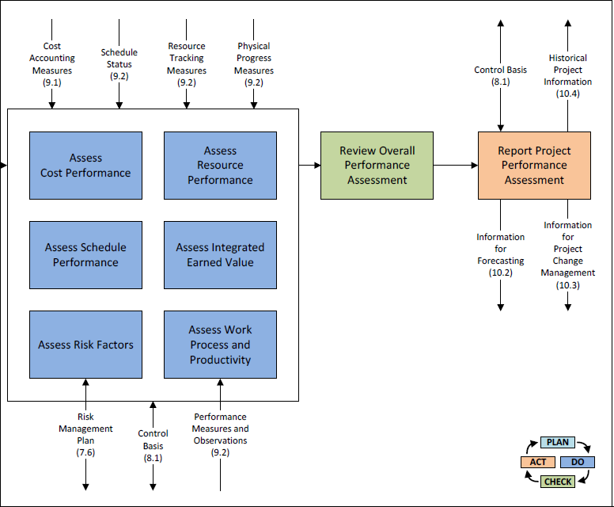
The process for performance assessment starts with planning and having the right tools in place. Dedicated cost control software tools can be valuable to define cost control procedures, track and approve changes and apply analysis. Furthermore, reporting can be enhanced and simplified which makes it easier to inform all stakeholders involved in the project.
Cleopatra Cost Control helps you achieve
- Project cost control and always tracing back cost components to its original budget.
- Scope change management. Estimate costs and add it to your project controls document.
- Project completed? The feedback process will be in place. Send the actuals to your cost models to increase their accuracy and quality for future estimating. Where most tools are limited to either being cost estimating software or a cost control tool, Cleopatra Enterprise is both.
Bonus Step: Benchmarking
As a bonus step, it is wise to add Benchmarking to the project cost management process.
Benchmarking helps close the loop between project A and project B. The knowledge from project A (referring to the running and executed projects) are analyzed and the feedback is reflected in project B (the next projects). That’s how an improvement cycle is created to increase project performance. Benchmarking is widely used by technical industries to improve the performance of the projects. Software systems such as Cleopatra project benchmarking aid estimators and project controllers in answering the complex question: How to use project big data to execute projects within time and budget?
The goal of project benchmarking is to store data from executed and running projects to extract valuable project metrics and to benchmark current estimates. Performing statistical analysis on historical data can result in valuable information on relationships between variables, which can be used to set up a reliable cost knowledgebase or calibrate existing ones.
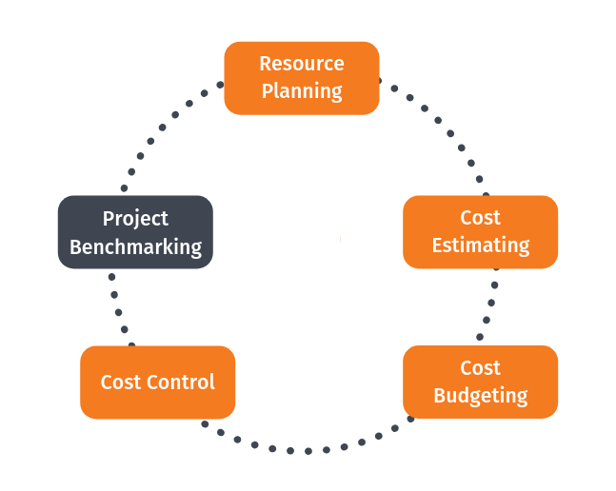
It is important to note that project benchmarking does not only include the comparison between projects, as it is also interesting to compare revisions within a project.
What you can achieve with Cleopatra Benchmarking
- Collect historical project data that can provide valuable analysis and project comparison to make critical business decisions.
- Benchmark your estimates against your previous projects and improve your cost estimate significantly.
- Extract metrics across projects to enhance future cost estimating accuracy.
- Develop meaningful and interactive reports.
- Export & Import data easily from Excel.

Types of Cost

- Direct Cost
A direct cost is a price that can be directly tied to the production of specific goods or services. A direct cost can be traced to the cost object, which can be a service, product, or department. Direct and indirect costs are the two major types of expenses or costs that companies can incur. Direct costs are often variable costs, meaning they fluctuate with production levels such as inventory. However, some costs, such as indirect costs are more difficult to assign to a specific product. Examples of indirect costs include depreciation and administrative expenses.
Direct Costs Examples: Any cost that’s involved in producing a good, even if it’s only a portion of the cost that’s allocated to the production facility, are included as direct costs. Some examples of direct costs are listed below:
- Direct labor
- Direct materials
- Manufacturing supplies
- Wages for the production staff
- Fuel or power consumption
Because direct costs can be specifically traced to a product, direct costs do not need to be allocated to a product, department, or other cost objects. Direct costs usually benefit only one cost object. Items that are not direct costs are pooled and allocated based on cost drivers.
- Indirect cost
Indirect Costs are costs that are not directly accountable to a cost object (such as a particular project, facility, function or product). Indirect costs may be either fixed or variable. Indirect costs include administration, personnel and security costs. These are those costs which are not directly related to production. Some indirect costs may be overhead. But some overhead costs can be directly attributed to a project and are direct costs.
There are two types of indirect costs. One are the fixed indirect costs which contains activities or costs that are fixed for a particular project or company like transportation of labor to the working site, building temporary roads, etc. The other are recurring indirect costs which contains activities that repeat for a particular company like maintenance of records or payment of salaries.
- Recurring Cost
A Recurring Cost is a regularly occurring cost or estimated cost which is documented with one record—a Recurring Cost record—that describes the income or expense and its pattern (how often it occurs, the rate at which it increases or decreases, the time period during which the cost applies, and so forth). Recurring costs are stored in the Recurring Costs table
Recurring Costs provide a means of quickly modeling the major components of your finances. You first establish a series of recurring costs to represent such items as tax expenses, estimated maintenance costs, and monthly income from leases. Once you enter this information, you can use these costs to generate Cost, Cash Flow, and Base Rent reports.
Recurring Cost Examples
Use recurring costs to:
- Record fixed expenses and income, or costs that change at a fixed rate – For costs that are fairly static, enter one Recurring Cost record describing the cost, rather than create individual Scheduled Cost records for each time you encounter this cost. For example, enter one Recurring Cost record describing your monthly rent for a year rather than enter 12 Scheduled Cost records for each rent bill. For costs that change at a fixed rate, complete the Yearly Factor field of the Recurring Costs table.
- Record estimates of your expenses and income – Rather than enter the exact amount of each monthly utility bill as a Scheduled Cost, enter a monthly estimate with a Recurring Cost record by completing the Period field with “Month”, the Amount-Expense with an estimate of the monthly bill, and the Start Date field. Since utilities are ongoing costs do not complete the End Date field.
- Model seasonal costs – If you incur landscaping costs only between April and September, create a Recurring Cost record for landscaping with a Seasonal Start Date of April 01 and a Seasonal End Date of September 01 (the year value is ignored). The system will only consider this recurring cost during the specified time frame.
- Non- Recurring Cost
Unusual charge, expense, or loss that is unlikely to occur again in the normal course of a business. Non recurring costs include write offs such as design, development, and investment costs, and fire or theft losses, lawsuit payments, losses on sale of assets, and moving expenses. Also called extraordinary cost.
- Fixed Cost
A fixed cost is a cost that does not change with an increase or decrease in the amount of goods or services produced or sold. Fixed costs are expenses that have to be paid by a company, independent of any specific business activities. In general, companies can have two types of costs, fixed costs or variable costs, which together result in their total costs. Shutdown points tend to be applied to reduce fixed costs.
- Variable Cost
A variable cost is a corporate expense that changes in proportion to production output. Variable costs increase or decrease depending on a company’s production volume; they rise as production increases and fall as production decreases. Examples of variable costs include the costs of raw materials and packaging.
- A variable cost is a corporate expense that changes in proportion with production output.
- Variable costs are dependent on production output.
- A variable cost can increase or decrease depending on several factors, as opposed to a fixed cost which is one-time or constant.
The total expenses incurred by any business consist of fixed costs and variable costs. Fixed costs are expenses that remain the same regardless of production output. Whether a firm makes sales or not, it must pay its fixed costs, as these costs are independent of output.
Examples of fixed costs are rent, employee salaries, insurance, and office supplies. A company must still pay its rent for the space it occupies to run its business operations irrespective of the volume of product manufactured and sold. Although fixed costs can change over a period of time, the change will not be related to production.
Variable costs, on the other hand, are dependent on production output. The variable cost of production is a constant amount per unit produced. As the volume of production and output increases, variable costs will also increase.
Conversely, when fewer products are produced, the variable costs associated with production will consequently decrease. Examples of variable costs are sales commissions, direct labor costs, cost of raw materials used in production, and utility costs. The total variable cost is simply the quantity of output multiplied by the variable cost per unit of output.
There is also a category of costs that falls in between, known as semi-variable costs (also known as semi-fixed costs or mixed costs). These are costs composed of a mixture of both fixed and variable components. Costs are fixed for a set level of production or consumption and become variable after this production level is exceeded. If no production occurs, a fixed cost is often still incurred.
- Normal Cost
Normal costing is cost allocation method that assigns costs to products based on the materials, labor, and overhead used to produce them. In other words, it’s a way to find the price of an item that is being produced using three different cost factors (which make up the product cost).
The product costs that make up normal costing are actual materials, actual direct costs and manufacturing overhead. The materials and direct costs are the true costs that are associated with producing the item such as raw materials (the materials that make up the product) and labor.
- Expedite Cost
“Expedite Fees” are fees added to another fee, often a fee for service, to ensure that the service provided will be expedited, meaning that it will be provided sooner than the same service would be provided without such a fee.

Project Financing and Budgeting

Developing the project budget is a process for allocating administered and departmental funds necessary to build a financial foundation for producing stated project deliverables. When we talk about the project budget and financial resources we mean the solid framework that helps project managers to deal with the “on budget” part of the project implementation process. This framework involves cost planning and control.
For successful delivery of the project product, the project manager should effectively estimate costs, track expenditure over time and adequately react to situations when the financial resources are over-spent or under-spent, or there are opportunities for savings in the project budget.
A Project Budget is the total amount of authorized financial resources allocated for the particular purpose(s) of the sponsored project for a specific period of time. It is the primary financial document that constitutes the necessary funds for implementing the project and producing the deliverables. The project budget gives a detailed statement of all the direct and overhead costs required to carry out the project goals and objectives.
A project budget template should be designed and managed under supervision and control of the project manager. Also the customer and sponsor should be involved in allocating and managing financial resources. Project budget management is a set of activities for estimating the necessary amount of financial resources for the project, controlling project costs within the approved budget and delivering the expected project goals.

Steps of the Budgeting Process
As an independent process, project budget management includes a series of steps to define and produce a budget sheet. The key steps include:
- Development: estimating a necessary amount of financial resources and creating a project budget sheet.
- Use: utilizing the authorized financial resources and executing the budget.
- Measurement: viewing cost performance and controlling the budget.
- Updating: viewing changes to the cost baseline and making updates to the project budget sheet.
1: Budget Development
The first step of the project budget management process involves the project manager in developing cost estimates and identifying the total amount of money resources necessary for implementation of all the tasks and activities defined and stated in the WBS and the Schedule.
Budget development should cover both capital and operating expenses to ensure successful project completion. The project manager needs to define funding requirements and then send a formal request to the sponsor who reviews the requirements and make a package decision on providing the necessary money and financial resources. The sponsor can use the initiation documents (like Feasibility Study, Business Case and Project Charter) to make that decision.
Such estimation methods as expert judgement, cost baseline measurement and cost aggregation can be used for developing a project budget sheet. The project manager in cooperation with the key stakeholders can use a combination of the methods to estimate a necessary amount of financial resources and develop a project budget template.
2: Budget Use
The second step in project budget management is to allocate the identified financial resources and start executing the budget. The project manager should control and keep track of the budgeted resources in order to make sure that every scheduled task or activity is performed with necessary funding and that there is no lack of money for the implementation of the entire project.
The greatest way to track and control budget use is to develop an investment plan. This formal document includes justifications and approvals for the acquisition of necessary procurement items and services required in support of the project. An investment plan describes the acquisition process with reference to the feasibility study (often in larger projects a feasibility study template serves as a foundation for developing a project investment plan).
The project manager needs to send an investment approval request form to the stakeholders and wait for their approval/rejection. In case the plan is approved, the manager uses it to control the budget execution. In case the document is rejected, the project manager should receive stakeholder suggestions and make necessary amendments to the plan template. Then the process may repeat until the plan is approved.
3: Budget Measurement
The third step in managing the project budget refers to taking actions necessary for providing appropriate cost performance. The manager needs to use work performance data (like status of the deliverables, cost-schedule estimates), the funding requirements request and the cost performance baseline to check the budget appropriateness.
By conducting variance analysis, performance reviews and forecasting, the project manager can compare the current cost performance against the planned amount of financed resources stated in the project budget template. In case of any gaps or deviations it is necessary to make formal change requests and modify the budget accordingly.
The project manager can develop corrective actions and send suggestions for approval to the key stakeholders. The further budget control and measurement should be done with the necessary evaluations and approvals.
4: Budget Updating
Once all the changes have been approved by the key stakeholders, the project manager can proceed with updating the budget sheet and make changes to the existing breakdown structure of financial resources. This will be the forth step of project budget management.
Cost estimates, resource activity estimates, the cost performance baseline and the cost management plan should be updated in accordance with the approved changes.

Top-Down Budgeting

Top-down budgeting is a crucial method of preparing a budget for an organization or a company. Under this method, the senior management prepares a high-level budget on the basis of the company’s objectives. The top management then allocates the amounts for the individual departments, who use those numbers to prepare their own budget.
For the top-down budget, the top management uses past experiences and the current market scenario, including margin pressure, competition, tax legislation, macroeconomic conditions and more.
Also, the management uses past years budget and financial statements as a reference for making an allocation to various departments. Additionally, senior management may also use input from lower-level managers. For instance, if any department accounted for 20% of the overall expenditure last year, then this year it would be allocated 20% of the funds. Any adjustments to these numbers will be based on the input from the managers or the current market scenario.
Process of TOP-DOWN BUDGETING
The top-level management will meet to decide on the targets for sales, expenses, and profits. Next, the finance department will allocate these targets to other business departments. After this, each department prepares its own budget.
Each department will then come up with a detailed budget, indicating how it will hit the revenue target and at what cost. For instance, the number of products they will sell, how much staff they will need, and more.
All such detailed budgets from the individual departments are then sent back to the finance department. The finance department then approves them if they are in-line with the overall objectives of the company. The finance department may also ask for some revisions if they believe the department’s budget is deviating from the set goals.
After the finance department finalizes all the things, the budgets are put in the system. Going forward, monthly reports are generated to compare the actual results from the planned ones.
Advantages
- Such type of budget focuses on the overall growth of the organization.
- It makes departments aware of what the top management expects from them.
- It is a quick way of preparing a budget and helps to overcome interdepartmental issues.
- Saves time for lower management as well. Rather than preparing the budget from scratch, each department gets a set goal. This saves both time and resources.
- Under top-down budgeting, management creates only one budget, rather than allowing the department to create their own budget and combine them later. Hence, it is a less tedious approach.
Disadvantages
- Since managers are not part of the budget-making process, they may not feel much motivation to ensure their success.
- Since senior managers are not much aware of the day-to-day operations of the departments, they may set unrealistic targets. This results in lower-level managers finding it difficult to meet the set numbers.
- Such type of budgeting may often lead to over or under allocation of resources.

Bottom-Up Budgeting
- Bottom up budgeting is a type of budgeting that attempts to determine the underlying costs for each individual department or segment of an organization and then total up each department. This type of budgeting works in contrast to top down budgeting. Here are a few things to consider about bottom up budgeting and how it works.
Start Small
- This process starts out small by looking at the individual components and costs of projects. In order to do this type of budgeting, you will need to start out by identifying all of the projects that you plan on completing as a business. Once you identify the project, you need to figure out what steps you will be taking to complete that project. At that point, you have to figure out the costs for each step of the project and total them up.
Work Your Way up
- After you have come up with a realistic cost estimate of each project, you need to total up all the projects together. During this process, you need to work your way up from one level to the next. For example, you may start out with a project budget for each week. Then total although the to come up with a project budget for each month. You will then total the projects for each month together to come up with an annual budget.
Manager Budgets
- With this type of budgeting, you will also rely on managers to help out in the budgeting process. You need each manager to come up with a realistic budget for all of the projects that they will be taking on. You will then get the information from each manager and total it up in order to come up with a budget for the company as a whole. When it comes to estimating the number of man-hours that will be necessary to complete a particular project, a manager should convert that figure to cash. This will ensure that there is enough money budgeted for payroll as well.
Advantage of Bottom up Budgeting
- One of the primary advantages of bottom-up budgeting is that it is traditionally very accurate. As long as everyone takes care to look at every last detail of a project, it will generally come out with an accurate estimate of costs. This type of budgeting also tends to improve the morale of the employees because most of them will be involved with the budgeting process. Every department will be expected to pitch in to come up with the new budget.
Disadvantage of Bottom up Budgeting
- One of the disadvantages of this strategy is that it can sometimes lead to over budgeting. Every department wants to make sure that they have enough money for the things that they want to do over the course of the year. Because of this, some managers might add a little bit of extra money into the budget so that it will be padded. If this happens often enough, it can throw the whole budget off.

Introduction to Activity Based Costing

ABC costing focuses on identifying activities, or production processes, that are used to process a job. These individual activities are grouped together with similar processes into a cost pool that relates to single activity cost driver.
The cost pools are then analyzed and assigned a predetermined overhead rate that will eventually be assigned to individual jobs and products.
As you can see, this is a multi-step process, but activity-based costing is a much more accurate way of assigning indirect costs. It’s difficult to determine how much electricity or heat one department or job uses over another without some type of methodical allocation process.
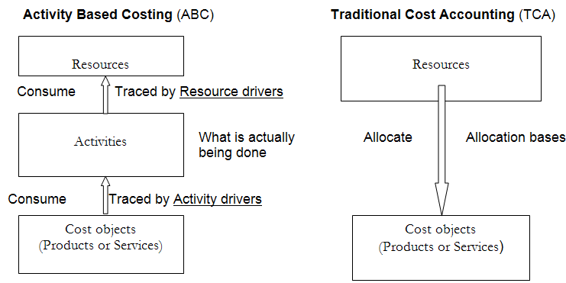
Activity based costing has grown in importance in recent decades because:-
(1) Manufacturing overhead costs have increased significantly,
(2) The manufacturing overhead costs no longer correlate with the productive machine hours or direct labor hours,
(3) The diversity of products and the diversity in customers’ demands have grown, and
(4) Some products are produced in large batches, while others are produced in small batches.
Let’s take a look at an example

Example
Activity based costing helps allocate overhead expenses to jobs and products based on the amount of the activities required to produce the product instead of simply estimating how much each job uses.
Properly assigning indirect costs is extremely important for management, especially in the case of downsizing or outsourcing. Profitable departments can be assigned too much indirect cost causing them to appear unprofitable on paper. Based an evaluation management can choice to discontinue the operations and close a profitable branch because the costs were properly distributed.
To compound the problems, once the profitable branch is closed the only remaining branches are the unprofitable ones. By shutting down the only profitable department, the company may not be able to cover its fixed costs.
The same scenario is true for outsourcing. Management may estimate outsourcing to be a cheaper option because costs have not been allocated properly. In fact, outsourcing might actually be more expensive.

Social Cost Benefit Analysis (SCBA) of Project

A Social cost benefit analysis, also known as economic analysis, is a decision-making strategy which helps in assessing the impact of investment business projects on the society as a complete. It is an organized and cohesive mechanism to contemplate the impact of development projects on society. The objective of analyzing the social cost benefit is to weight the heterogeneous impact of your development project on societal elements such as pollution, real estate, legal prospects, health, environment etc. As a result of the analysis, the project decision maker can precisely elucidate the social welfare impact of the project.
Social cost-benefit analysis is a systematic and cohesive economic tool (method) to survey all the impacts caused by an urban development project. It comprises not just the financial effects (investment costs, direct benefits like tax and fees, et cetera), but all the social effects, like: pollution, safety, indirect (labour) market, legal aspects, et cetera. The main aim of a social cost-benefit analysis is to attach a price to as many effects as possible in order to uniformly weigh the above-mentioned heterogeneous effects. As a result, these prices reflect the value a society attaches to the caused effects, enabling the decision maker to form a statement about the net social welfare effects of a project.
Measured impacts on Social cost benefit analysis
The social cost-benefit analysis calculates the direct (primary), indirect (secondary) and external effects:
- Direct effects are the costs and benefits that can be directly linked to the owners/users of the project properties (e.g., the users and the owner of a building or highway).
- Indirect effects are the costs and benefits that are passed on to the producers and consumers outside the market with which the project is involved (e.g., the owner of a bakery nearby the new building, or a business company located near the newly planned highway).
- External effects are the costs and benefits that cannot be passed on to any existing market because they relate to issues like the environment (noise, emission of CO2 etc.), safety (traffic, external security) and nature (biodiversity, dehydration etc.).
The model engineers try to quantify and monetise as much effects as possible. Effects that cannot be monetised are presented in such a way that they can be compared. This way, policy-makers can include these effects in their final judgement if an urban planning project (or a particular variation) is worth investing in. The method of monetising effects can also influence the outcome of a social cost-benefit analysis and predictions will always remain uncertain. Therefore, the results of a social cost-benefit analysis are not absolute. Nevertheless, it is a sufficient instrument to investigate the strong and weak points of the different alternatives.
Results of a social cost-benefit analysis
- An integrated way of comparing the different effects. All relevant costs and benefits of the different project implementations (alternatives) are identified and monetized as far as possible. Effects that cannot be monetized are described and quantified as much as possible.
- Attention for the distribution of costs and benefits. The benefits of a project do not always get to the groups bearing the costs. A social cost-benefit analysis gives insight in who bears the costs and who derives the benefits.
- Comparison of the project alternatives. A social cost-benefit analysis is a good method to show the differences between project alternatives and provides information to make a well informed decision.
- Presentation of the uncertainties and risks. A social cost-benefit analysis has several methods to take economic risks and uncertainties into account. The policy decision should be based on calculated risk.

Significance of SCBA
- The importance has been explained with the help of the following factors that affect the general masses as a whole.
- Market Failure
- Market failure when a big project is not affecting everyone but only a few. A private firm would only look at profitability and related market prices to take up a deal but the government has to look at other factors. To determine the social cost in case of market failure and when market prices are unable to define them. These social costs are known as shadow prices.
- Savings & Investment
- Impact of the project on general savings and investment level. A project that induces more savings are investment in an economy and not the other way round.
- Distribution & Redistribution of Income
- The project should not lead to accumulating income in the hands of a few but, it should equally distribute the income.
- Employment and Standard of Living
- How a project affects employment and standard of living will be taken into account as well. The deal should lead to increase in employment and standard of living.
- Externalities
- Externalities are impacts of a project which can be both harmful and beneficial. Therefore, both the effects are to be assessed before sanctioning a deal. Positive-externalities could be in the form improvement in technology and negative-externalities could be in the form of increase in pollution and destruction of ecology.
- Taxes and Subsidies
- In a general cost benefit calculation, taxes and subsidies are considered as expenses and income respectively. Though in case of social-cost benefit analysis, taxes and subsidies are considered as transfer payments.
- Social cost benefit analysis enables the government to take up new developments which will benefit everyone and not just a few. Also, it helps in bringing about an overall development in an economy and can help make decisions that will increase employment, investments, saving and consumption, thus, improving the economic activities in an economy.

Approaches to SCBA
- Rationale for SCBA
The society is concern about the distribution of benefits across different group. A rupee of benefit going to an economically poor section is considered more valuable than a rupee of benefit going to an affluent section.
- UNIDO approach
UNIDO approach was first articulated in the Guidelines for Project Evaluation which provides a comprehensive framework for SCBA in developing countries. UNIDO approach is based largely on the latter publication though at places we will draw on the former publication too.
- Measures cost and benefits in terms of domestic rupees
- Measures cost and benefits in terms of consumption.
- Focuses on efficiency, savings and redistribution aspects in different stages.
UNIDO method of project appraisal involves five stages:
(i) Calculation of the financial profitability of the project measured at market prices.
(ii) Obtaining the net benefit of the project measured in terms if economic (efficiency) prices.
(iii) Adjustment for the impact of the project on savings and investment.
(iv) Adjustment for the impact of the project on income and distribution.
(v) Adjustment for the impact of the project on merit goods and demerit goods whose social values differ from their economic values.
- Net benefit in terms of economic prizes
One of the important aspects of shadow pricing is the determination of the numeraire, the unit of account in which the value of inputs or outputs is expressed. To define the nummeraire, the following questions have to be answered:
- What unit of currency, domestic or foreign, should be used to express benefits or costs?
- Should costs and benefits be measured in current values or constant values?
- Should the income of the project is measured in terms of consumption or investment?
- Saving impacts and its value
Its seek to answer fallowing question
- Given the income distribution project what would be its effect on saving?
- What is the value of such saving?
- Income distribution impact
- Adjustment for merit and demerit goods
- Merits good is one for which the social value exceeds the economic value.
- Demerits good is one social value of goods is less than the economic value.
- Little-Mirrlees approach
I.M.D Little and J.A Mirrlees have developed an approach to social cost benefit analysis which became popular as Little-mirrlees approach (L-M approach).
- Shadow prices
- SCBA by financial institutions
- Public sector investment decisions in India

