Notes-Project Management
Unit-1(MBA 2nd year)

UNIT-1

Definition and Characteristics of Project

Project is a great opportunity for organizations and individuals to achieve their business and non-business objectives more efficiently through implementing change. Projects help us make desired changes in an organized manner and with reduced probability of failure.
A Project is a temporary, unique and progressive attempt or endeavor made to produce some kind of a tangible or intangible result (a unique product, service, benefit, competitive advantage, etc.). It usually includes a series of interrelated tasks that are planned for execution over a fixed period of time and within certain requirements and limitations such as cost, quality, performance, others.
Projects differ from other types of work (e.g. process, task, procedure). Meanwhile, in the broadest sense a project is defined as a specific, finite activity that produces an observable and measurable result under certain preset requirements.
Projects differ from other types of work (e.g. process, task, procedure). Meanwhile, in the broadest sense a project is defined as a specific, finite activity that produces an observable and measurable result under certain preset requirements.

Characteristics of a Project
(a) Project has a owner, who, in the private sector, can be an individual or a company etc., in the public sector, a government undertaking or a joint sector organization, representing a partnership between public and private sector.
(b) Project has a set objective to achieve within a distinct time, cost and technical performance.
(c) Project is planned, managed and controlled by an assigned team the project team planted within the owner’s organization to achieve the objectives as per specifications.
(d) Project, in general, is an outcome in response to environments economies and opportunities. As an example, we find that considering the changing pattern of modern living the domestic appliances small e.g. grinders, mixers etc., and large, e.g. refrigerators, washing machines etc. are on ever-increasing demand. This generates responses to avail opportunity to produce such appliances.
(e) Project is an undertaking involving future activities for completion of the project within estimates and involves complex budgeting procedure with a mission.
(f) Implementation of the project involves a co-ordination of works/supervisions by project team/manager.
(g) Project involves activities to be carried out in future. As such, it has some inherent risk and, in reality, the process of implementation may necessitate certain changes in the plan subject to limitations and concurrence of the project owner.
(h) Project involves high-skilled forecasting with sound basis for such forecasting.
(i) Projects have a start and an end a characteristic of a life cycle. The organization of project changes as it passes through this cycle the activities starting from—conception stage, mounting up to the peak during implementation and, then, back to zero level on completion and delivery of the project.

Types of Project
- Construction Projects
The project produces an artifact. The value generated by the project is embedded in the artifact. The artifacts may be a complex system with human and mechanical components.
Examples:
- Warship
- Jubilee line extension
- Millennium dome
- Customer call centre
- Method guidebook
- IT system
- Research Projects
The project produces knowledge. The knowledge may be formally represented as models, patterns or patents. Or the knowledge may be embedded in a working process or artifact.
Examples:
- Business modelling
- Developing a model of the UK economy
- Developing a new species of wheat
- Developing novel approaches to project management.
- Military intelligence/ codebreaking.
- The analysis, testing, QA or evaluation portions of a larger project.
- Reengineering Projects
The project produces a desired change in some system or process.
Examples:
- Taking sterling into the Euro
- Renumbering the UK telephone system
- Implementing PRINCE project management practices into a large organization.
- Designing and installing an Intranet.
- Procurement Projects
The project produces a business relationship contractually based with a selected supplier for a defined product or service based on a fixed specification and/or a defined specification process
Examples:
- Outsourcing a specific construction or research project
- Outsourcing a complete business function (such as IT).
- Imposing new rules and measures on a regulated industry.
- Business Implementation Projects
The project produces an operationally effective process. The value generated by the project is embedded in the process.
- Developing a new business process to repackage and exploit existing assets.
- Installing e-commerce
Some projects are difficult to classify under this scheme.
(i) National symbolic programmes
- Putting a man on the moon by the end of the decade
- Mitterand’s Grandes Projects
- New Labour
(ii) Large medical programmes
- Creating an artificial heart
- Mass inoculation programmes
(iii) Other hybrid or interdisciplinary projects
- Pilot projects
- Moving offices

Project Life Cycle

The project life cycle describes the stages a project goes through as it progresses from start to finish. A well-defined life cycle brings order and structure to the project.
The Project Life Cycle refers to the four-step process that is followed by nearly all project managers when moving through stages of project completion. This is the standard project life cycle most people are familiar with. The Project Life Cycle provides a framework for managing any type of project within a business. Leaders in project management have conducted research to determine the best process by which to run projects. It has been found that following a project life cycle is critical for any services organization.

The Project Life Cycle (Phases)
The project manager and project team have one shared goal: to carry out the work of the project for the purpose of meeting the project’s objectives. Every project has a beginning, a middle period during which activities move the project toward completion, and an ending (either successful or unsuccessful). A standard project typically has the following four major phases (each with its own agenda of tasks and issues): initiation, planning, implementation, and closure. Taken together, these phases represent the path a project takes from the beginning to its end and are generally referred to as the project “life cycle.”
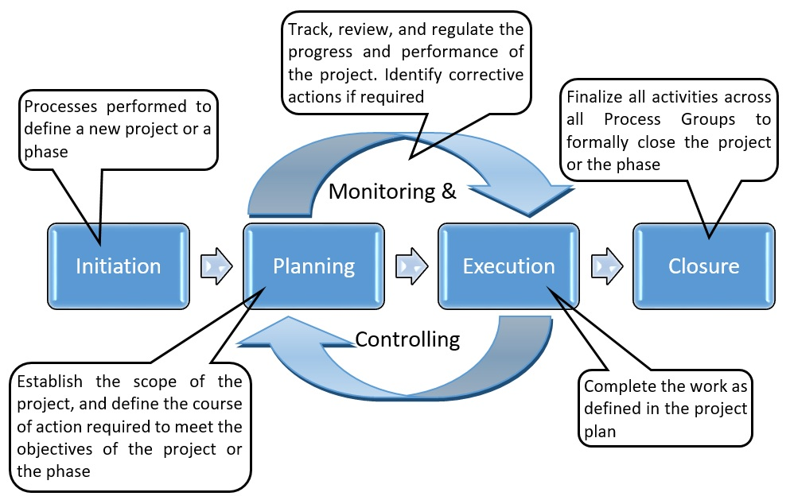

1. Initiation Phase
During the first of these phases, the initiation phase, the project objective or need is identified; this can be a business problem or opportunity. An appropriate response to the need is documented in a business case with recommended solution options. A feasibility study is conducted to investigate whether each option addresses the project objective and a final recommended solution is determined. Issues of feasibility (“can we do the project?”) and justification (“should we do the project?”) are addressed.
Once the recommended solution is approved, a project is initiated to deliver the approved solution and a project manager is appointed. The major deliverables and the participating work groups are identified, and the project team begins to take shape. Approval is then sought by the project manager to move onto the detailed planning phase.
2. Planning Phase
The next phase, the planning phase, is where the project solution is further developed in as much detail as possible and the steps necessary to meet the project’s objective are planned. In this step, the team identifies all of the work to be done. The project’s tasks and resource requirements are identified, along with the strategy for producing them. This is also referred to as “scope management.” A project plan is created outlining the activities, tasks, dependencies, and timeframes. The project manager coordinates the preparation of a project budget by providing cost estimates for the labor, equipment, and materials costs. The budget is used to monitor and control cost expenditures during project implementation.
Once the project team has identified the work, prepared the schedule, and estimated the costs, the three fundamental components of the planning process are complete. This is an excellent time to identify and try to deal with anything that might pose a threat to the successful completion of the project. This is called risk management. In risk management, “high-threat” potential problems are identified along with the action that is to be taken on each high-threat potential problem, either to reduce the probability that the problem will occur or to reduce the impact on the project if it does occur. This is also a good time to identify all project stakeholders and establish a communication plan describing the information needed and the delivery method to be used to keep the stakeholders informed.
Finally, we will want to document a quality plan, providing quality targets, assurance, and control measures, along with an acceptance plan, listing the criteria to be met to gain customer acceptance. At this point, the project would have been planned in detail and is ready to be executed.
3. Implementation (Execution) Phase
During the third phase, the implementation phase, the project plan is put into motion and the work of the project is performed. It is important to maintain control and communicate as needed during implementation. Progress is continuously monitored and appropriate adjustments are made and recorded as variances from the original plan. In any project, a project manager spends most of the time in this step. During project implementation, people are carrying out the tasks, and progress information is being reported through regular team meetings. The project manager uses this information to maintain control over the direction of the project by comparing the progress reports with the project plan to measure the performance of the project activities and take corrective action as needed. The first course of action should always be to bring the project back on course (i.e., to return it to the original plan). If that cannot happen, the team should record variations from the original plan and record and publish modifications to the plan. Throughout this step, project sponsors and other key stakeholders should be kept informed of the project’s status according to the agreed-on frequency and format of communication. The plan should be updated and published on a regular basis.
Status reports should always emphasize the anticipated end point in terms of cost, schedule, and quality of deliverables. Each project deliverable produced should be reviewed for quality and measured against the acceptance criteria. Once all of the deliverables have been produced and the customer has accepted the final solution, the project is ready for closure.
4. Closing Phase
During the final closure, or completion phase, the emphasis is on releasing the final deliverables to the customer, handing over project documentation to the business, terminating supplier contracts, releasing project resources, and communicating the closure of the project to all stakeholders. The last remaining step is to conduct lessons-learned studies to examine what went well and what didn’t. Through this type of analysis, the wisdom of experience is transferred back to the project organization, which will help future project teams.
Example: Project Phases on a Large Multinational Project
A U.S. construction company won a contract to design and build the first copper mine in northern Argentina. There was no existing infrastructure for either the mining industry or large construction projects in this part of South America.
During the initiation phase of the project, the project manager focused on defining and finding a project leadership team with the knowledge, skills, and experience to manage a large complex project in a remote area of the globe. The project team set up three offices. One was in Chile, where large mining construction project infrastructure existed. The other two were in Argentina. One was in Buenos Aries to establish relationships and Argentinian expertise, and the second was in Catamarca—the largest town close to the mine site. With offices in place, the project start-up team began developing procedures for getting work done, acquiring the appropriate permits, and developing relationships with Chilean and Argentine partners.
During the planning phase, the project team developed an integrated project schedule that coordinated the activities of the design, procurement, and construction teams. The project controls team also developed a detailed budget that enabled the project team to track project expenditures against the expected expenses. The project design team built on the conceptual design and developed detailed drawings for use by the procurement team. The procurement team used the drawings to begin ordering equipment and materials for the construction team; develop labor projections; refine the construction schedule; and set up the construction site. Although planning is a never-ending process on a project, the planning phase focused on developing sufficient details to allow various parts of the project team to coordinate their work and allow the project management team to make priority decisions.
The implementation phase represents the work done to meet the requirements of the scope of work and fulfill the charter. During the implementation phase, the project team accomplished the work defined in the plan and made adjustments when the project factors changed. Equipment and materials were delivered to the work site, labor was hired and trained, a construction site was built, and all the construction activities, from the arrival of the first dozer to the installation of the final light switch, were accomplished.
The closeout phase included turning over the newly constructed plant to the operations team of the client. A punch list of a few remaining construction items was developed and those items completed. The office in Catamarca was closed, the office in Buenos Aries archived all the project documents, and the Chilean office was already working on the next project. The accounting books were reconciled and closed, final reports written and distributed, and the project manager started on a new project.

Concepts of Deliverables

The term deliverables is a project management term that’s traditionally used to describe the quantifiable goods or services that must be provided upon the completion of a project. Deliverables can be tangible or intangible in nature. For example, in a project focusing on upgrading a firm’s technology, a deliverable may refer to the acquisition of a dozen new computers.
On the other hand, for a software project, a deliverable might allude to the implementation of a computer program aimed at improving a company’s accounts receivable computational efficiency.
Deliverables:
In addition to computer equipment and software programs, a deliverable may refer to in-person or online training programs, as well as design samples for products in the process of being developed. In many cases, deliverables are accompanied by instruction manuals.
Documentation
Deliverables are usually contractually obligated requirements, detailed in agreements drawn up between two related parties within a company, or between a client and an outside consultant or developer. The documentation precisely articulates the description of a deliverable, as well as the delivery timeline and payment terms.
Milestones
Many large projects include milestones, which are interim goals and targets that must be achieved by stipulated points in time. A milestone may refer to a portion of the deliverable due, or it may merely refer to a detailed progress report, describing the current status of a project.
Film Deliverables
In film production, deliverables refer to the range of audio, visual, and paperwork files that producers must furnish to distributors. Audio and visual materials generally include stereo and Dolby 5.1 sound mixes, music and sound effects on separate files, as well as the full movie in a specified format.
Paperwork deliverables include signed and executed licensing agreements for all music, errors, and omissions reports, performance releases for all on-screen talent, a list of the credit block that will appear in all artwork and advertising, as well as location, artwork, and logo legal releases. Films deliverables also pertain to elements that are ancillary to the movies themselves. These items include the trailer, TV spots, publicity stills photographed on set, and other legal work.
- The word “deliverables” is a project management term describing the quantifiable goods or services that must be provided upon the completion of a project.
- Deliverables can be tangible in nature, such as the acquisition of a dozen new computers, or they can be intangible, like the implementation of a computer program aimed at improving a company’s accounts receivable computational efficiency.
- A deliverable may refer to in-person or online training programs, as well as design samples for products in the process of being developed.
- In many cases, deliverables are accompanied by instruction manuals.
- In film production, deliverables refer to the range of audio, visual, and paperwork files that producers must furnish to distributors.

Scope of Work and Milestones

A scope of work (SOW) document is an agreement on the work you’re going to perform on the project

The document includes
- Deliverables
This is what your project delivers, of course. Whether it’s a product or a service, it’s the reason you’re executing the project for your customer, stakeholder or sponsor. Whatever that deliverable is, and it can be some sort of document or report, software, product, build (or all of the above), you need to have each item clearly identified here.
- Timeline
Think of a timeline as a road leading from the start of a project to its end. It’s a section of the document that delineates the major phases across the schedule of the project’s duration. It should also mark the points in the project when your deliverables are ready. As you can guess, it’s essential to scoping out the overall plan of any project. This is best presented visually, like a rolled-up Gantt chart plan, so the stakeholders can see the high level timeline.
- Milestones
Projects can be very long and complex, which is why they’re laid out over a timeline and broken down into more manageable parts called tasks. Larger phases of the project are marked by what is called a milestone. It’s a way to help you monitor the progress of the project to make sure it’s adhering to your planned schedule. Define your key milestones in the Scope of Work document, including project kickoffs, meetings, hand offs, etc.
- Reports
You’ll be generating these throughout the project, delivered to either you team or customer, stakeholder or sponsor. They’re a formal record of the progress of your project, but they’re also a means of communication beyond whether the project’s on schedule or not. Depending on how you customize them, there’s a wealth of data that can serve a number of different audiences. Define how you’ll be reporting on the project and when the stakeholders can be expecting them and from whom.

Scope of Work Example
To understand a scope of work, let’s create a hypothetical project, nothing too complex but important none the less. A wedding is a project, and depending on the bridezilla (or groomzilla), it could be bigger and more complicated than building a highway or an airport. So, let’s just take one aspect of that larger project, the wedding invitations, and break this down into a scope of work. I’ll outline the deliverables, timeline, milestones and reports in this scope of work example.
Deliverables
- Invite List
- Addresses of Attendees
- Invites
- Addressed Envelopes
- Stamps
- Manage your projects online. Try it free for 30 days
Timeline
- 1 Decided on invite list
- 1 Have addresses collected of attendees
- March 1 Pick invitation style and have printed
- April 1 Address and mail invites
- May 1 Get final count of guests
- June 1 Wedding
Milestones
- Selection of guest and collection of addresses
- Mailing of invitations
- Final count of attendees
Reports
- Check on status of address collection
- Stay in touch with printer for progress on invitations
- Check RSVPs against invitation list

Tools and Techniques of Project Management

Techniques in project management range from traditional to innovative ones. Which one to choose for running a project, depends on project specifics, its complexity, teams involved, and other factors. Most of them can be used in various fields, however, there are techniques that are traditionally used in certain areas of activity, or are developed specifically for certain fields. Below, we’ve listed the most popular techniques that are used in project management.

Classic Technique
The simplest, traditional technique is sometimes the most appropriate for running projects. It includes preparing a plan of upcoming work, estimating tasks to perform, allocating resources, providing and getting feedback from the team, and monitoring quality and deadlines.
Where to use: this technique is ideal for running projects performed by small teams, when it’s not really necessary to implement a complex process.

Waterfall Technique
This technique is also considered traditional, but it takes the simple classic approach to the new level. As its name suggests, the technique is based on the sequential performance of tasks. The next step starts when the previous one is accomplished. To monitor progress and performed steps, Gantt charts are often used, as they provide a clear visual representation of phases and dependencies.
Where to use: this technique is traditionally used for complex projects where detailed phasing is required and successful delivery depends on rigid work structuring.
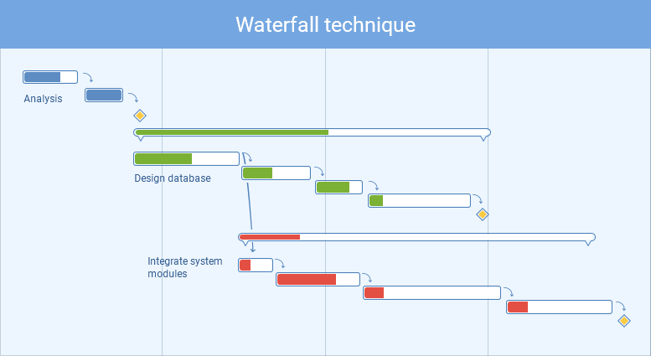

Agile Project Management
Agile project management method is a set of principles based on the value-centered approach. It prescribes dividing project work into short sprints, using adaptive planning and continual improvement, and fostering teams’ self-organization and collaboration targeted to producing maximum value. Agile frameworks include such techniques as Scrum, Kanban, DSDM, FDD, etc.
Where to use: Agile is used in software development projects that involve frequent iterations and are performed by small and highly collaborative teams.
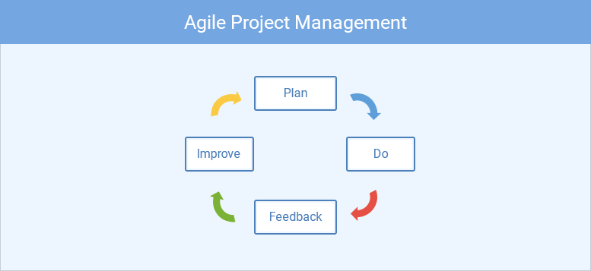

Rational Unified Process
Rational Unified Process (RUP) is a framework designed for software development teams and projects. It prescribes implementing an iterative development process, where feedback from product users is taken into account for planning future development phases.
Where to use: RUP technique is applied in software development projects, where end user satisfaction is the key requirement.

Program Evaluation and Review Technique
Program Evaluation and Review Technique (PERT) is one of widely used approaches in various areas. It involves complex and detailed planning, and visual tracking of work results on PERT charts. Its core part is the analysis of tasks performed within the project. Originally, this technique was developed by the US Navy during the Cold War to increase efficiency of work on new technologies.
Where to use: this technique suits best for large and long-term projects with non-routine tasks and challenging requirements.
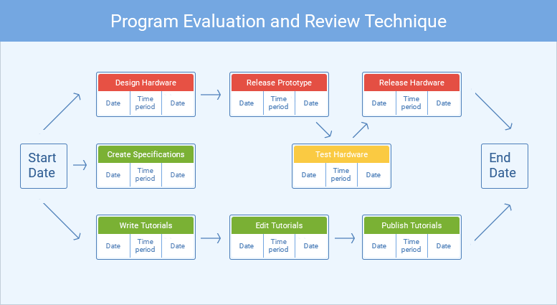

Critical Path Technique
Actually, this technique is an algorithm for scheduling and planning project works that is often used in conjunction with the PERT method discussed above. This technique involves detecting the longest path (sequence of tasks) from the beginning to the end of a project, and defining the critical tasks. Critical are tasks that influence the deadlines of the entire project, and require closer attention and thorough control.
Where to use: Critical Path technique is used for complex projects where delivery terms and deadlines are critical, in such areas as construction, defense, software development, and others.
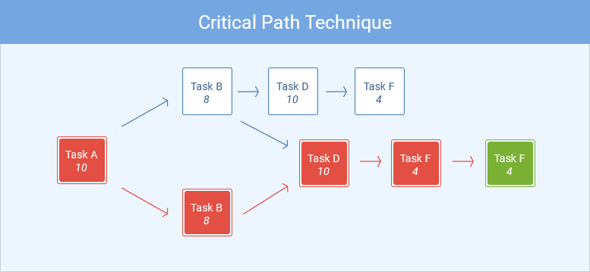

Critical Chain Technique
Critical Chain is a more innovative technique that derives from PERT and Critical Path methods. It is less focused on rigid task order and scheduling, and prescribes more flexibility in resource allocation and more attention to how time is used. This technique emphasizes prioritization, dependencies analysis, and optimization of time expenses.
Where to use: like the previous two techniques, it is used in complex projects. As it is focused on time optimization and wise resource allocation, it suits best for projects where resources are limited.

Extreme Project Management
Extreme project management technique (XPM) emphasizes elasticity in planning, open approach, and reduction of formalism and deterministic management. Deriving from extreme programming methods, it is focused on human factor in project management rather than on formal methods and rigid phases.
Where to use: XPM is used for large, complex and uncertain projects where managing uncertain and unpredictable factors is required.
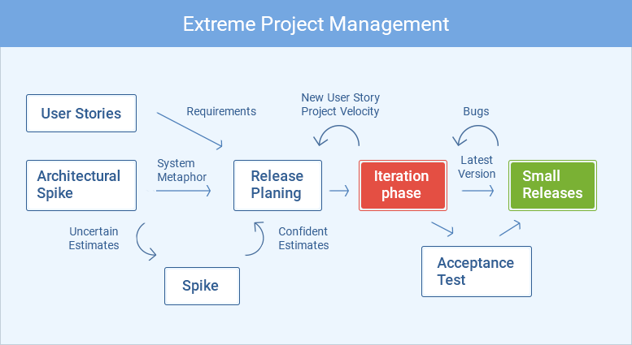

Project Management Tools
When applying any of the techniques to the project you need to accomplish, you also need to use specific tools for successfully implementing the technique. Here’s a list of software tools that are used in project management on different work steps.

Organizing Workflow & Planning
This step is the core part of starting a project: it defines how the project will be performed, and how the quality of its outcome will be ensured. Large companies often use such comprehensive solutions as MS Project. For smaller teams, various alternatives are available. They don’t provide all the rich functionality typical to complex and expensive tools, but they have planning and roadmap features that are sufficient for visualizing future project progress.

Communication
Being the key point in many techniques and methodologies, communication within a project team needs to be properly organized. While using email for formal communication and important messages, it’s also essential to have a corporate messenger – Slack and Skype are the most popular ones. And, if your team members use different tools to communicate, eliminate the pain of having multiple messengers by integrating them.

Scheduling
When allocating resources and planning for future, it’s crucial to know who on the team is available for specific dates. Use scheduling software for that! Such tools as actiPLANS provide a clear visual chart of absences for upcoming dates, and allow to see all necessary details to team members’ leaves and time off.

Time management
Knowing where your team’s time goes not just helps managing current project risks. It also provides valuable information for future planning and estimating. Time management tools, such as actiTIME, help managers understand both individual time expenses and team’s results for any period. Informative reports with time & cost summaries and notes to the logged time provide insights into how time is used and what can be optimized.

Finance & Accounting
For any project manager and business owner, understanding financial outcome of the projects is crucial for analysis and future planning. Most used accounting tools – QuickBooks, Zoho, Freshbooks – help collect this information. For smaller project teams, other accounting solutions can be reasonable. They require less investment, but also provide insights on project profitability, teams’ performance, and estimation accuracy.

Characteristics of Project Team

On this type of team, there is usually a strong trust bond, people work cooperatively together to reach the common project goals, and often the project is even more successful than the project manager and customer could have imagined.
These types of teams generally have some key characteristics in common that help make them the effective, high-performing teams that they are.
Clearly defined goals
Clearly defined goals are essential so that everyone understands the purpose and vision of the team. It’s surprising to learn sometimes how many people do not know the reason they are doing the tasks that make up their jobs, much less what their team is doing. Everyone must be pulling in the same direction and be aware of the end goals. Clear goals help team members understand where the team is going. Clear goals help a team know when it has been successful by defining exactly what the team is doing and what it wants to accomplish. This makes it easier for members to work together – and more likely to be successful.
Clear goals create ownership. Team members are more likely to “own” goals and work toward them if they have been involved in establishing them as a team. In addition, ownership is longer lasting if members perceive that other team members support the same efforts. Clear goals foster team unity, whereas unclear goals foster confusion – or sometimes individualism. If team members don’t agree on the meaning of the team goals, they will work alone to accomplish their individual interpretations of the goals. They may also protect their own goals, even at the expense of the team.
Clearly defined roles
If the team’s roles are clearly defined, all team members know what their jobs are, but defining roles goes beyond that. It means that we recognize individuals’ talent and tap into the expertise of each member – both job-related and innate skills each person brings to the team, such as organization, creative, or team-building skills. Clearly defined roles help team members understand why they are on a team. When the members experience conflict, it may be related to their roles. Team members often can manage this conflict by identifying, clarifying, and agreeing on their individual responsibilities so that they all gain a clear understanding of how they will accomplish the team’s goals. Once team members are comfortable with their primary roles on the team, they can identify the roles they play during team meetings. There are two kinds of roles that are essential in team meetings.
Open and clear communication
The importance of open and clear communication cannot be stressed enough. This is probably the most important characteristic for high-performance teams. Many different problems that arise on projects can often be can be traced back to poor communication or lack of communication skills, such as listening well or providing constructive feedback. Enough books have been written about communication to fill a library. And I’ve personally written several articles on this subject alone for this site over the past few months.
Excellent communication is the key to keeping a team informed, focused, and moving forward. Team members must feel free to express their thoughts and opinions at any time. Yet, even as they are expressing themselves, they must make certain they are doing so in a clear and concise manner. Unfortunately, most of us are not very good listeners. Most of us could improve our communication if we just started to listen better—to listen with an open mind, to hear the entire message before forming conclusions, and to work toward a mutual understanding with the speaker.
Effective decision making
Decision making is effective when the team is aware of and uses many methods to arrive at decisions. A consensus is often touted as the best way to make decisions—and it is an excellent method and probably not used often enough. But the team should also use majority rule, expert decision, authority rule with discussion, and other methods. The team members should discuss the method they want to use and should use tools to assist them, such as force-field analysis, pair-wise ranking matrices, or some of the multi-voting techniques.
Effective decision making is essential to a team’s progress; ideally, teams that are asked to solve problems should also have the power and authority to implement solutions. They must have a grasp of various decision-making methods, their advantages and disadvantages, and when and how to use each. Teams that choose the right decision-making methods at the right time will not only save time, but they will also most often make the best decisions. This completes the four basic foundation characteristics: clear goals, defined roles, open and clear communication, and effective decision making.
Balanced participation
If communication is the most important team characteristic, participation is the second most important. Without participation, you don’t have a team; you have a group of bodies. Balanced participation ensures that everyone on the team is fully involved. It does not mean that if you have five people each is speaking 20 percent of the time. Talking is not necessarily a measure of participation. We all know people who talk a lot and say nothing. It does mean that each individual is contributing when it’s appropriate. The more a team involves all of its members in its activities, the more likely that team is to experience a high level of commitment and synergy.
Leader’s behavior
A leader’s behavior comes as much from attitude as from anything. Leaders who are effective in obtaining participation see their roles as being a coach and mentor, not the expert in the situation. Leaders will get more participation from team members if they can admit to needing help, not power. Leaders should also specify the kind of participation they want right from the start.
Participants’ expectations
Participants must volunteer information willingly rather than force someone to drag it out of them. They should encourage others’ participation as well by asking a question of others, especially those who have been quiet for a while.
Participants can assist the leader by suggesting techniques that encourage everyone to speak, for example, a round robin. To conduct a round robin, someone directs all members to state their opinions or ideas about the topic under discussion. Members go around the group, in order, and one person at a time says what’s on his or her mind. During this time, no one else in the group can disagree, ask questions, or discuss how the idea might work or not work, be good or not good.
Only after everyone has had an opportunity to hear others and to be heard him- or herself, a discussion occurs. This discussion may focus on pros and cons, on clarifying, on similarities and differences, or on trying to reach consensus.
Valued diversity
Valued diversity is at the heart of building a team. Thus, the box is at the center of the model. It means, put simply, that team members are valued for the unique contributions that they bring to the team.
Diversity goes far beyond gender and race. It also includes how people think, what experience they bring, and their styles. The diversity of thinking, ideas, methods, experiences, and opinions helps to create a high-performing team.
Managed Conflict
Conflict is essential to a team’s creativity and productivity. Because most people dislike conflict, they often assume that effective teams do not have it. In fact, both effective and ineffective teams experience conflict. The difference is that effective teams manage it constructively. In fact, effective teams see conflict as positive.
Managed conflict ensures that problems are not swept under the rug. It means that the team has discussed members’ points of view about an issue and has come to see well-managed conflict as a healthy way to bring out new ideas and to solve whatever seems to be unsolvable. Here are some benefits of healthy conflict:
- Conflict forces a team to find productive ways to communicate differences, seek common goals, and gain consensus;
- Conflict encourages a team to look at all points of view, then adopt the best ideas from each;
- Conflict increases creativity by forcing the team to look beyond current assumptions and parameters.
Positive team atmosphere
To be truly successful, a team must have a climate of trust and openness, that is, a positive atmosphere. A positive atmosphere indicates that members of the team are committed and involved. It means that people are comfortable enough with one another to be creative, take risks, and make mistakes. It also means that you may hear plenty of laughter, and research shows that people who are enjoying themselves are more productive than those who dislike what they are doing.
Cooperative relationships
Directly related to having a positive atmosphere are cooperative relationships. Team members know that they need one another’s skills, knowledge, and expertise to produce something together that they could not do as well alone. There is a sense of belonging and a willingness to make things work for the good of the whole team. The atmosphere is informal, comfortable, and relaxed. Team members are allowed to be themselves. They are involved and interested.
Cooperative relationships are the hallmark of top-performing teams. These top teams demonstrate not only cooperative relationships between team members but also cooperative working relationships elsewhere in the organization.
Participative Leadership
The participative leadership block is not at the top of the model because it is the most important.
It is at the top because it is the only block that can be removed without disturbing the rest.
Participative leadership means that leaders share the responsibility and the glory, are supportive and fair, create a climate of trust and openness, and are good coaches and teachers.
In general, it means that leaders are good role models and that the leadership shifts at various times.
In the most productive teams, it is difficult to identify a leader during a casual observation.
In conclusion, a high-performing team can accomplish more together than all the individuals can apart.

Characteristics of Project Leader

The terms project manager and project leader get used interchangeably all the time, and yet there are a couple important differences that can be derived from the respective terms themselves. Managers manage. Leaders lead. What this means in practice is that project leaders are responsible for establishing direction, communicating their vision to management and the workforce, and forging teams that are capable of delivering high-performance. In contrast, project managers focus primarily on short-term goals and are responsible for solving short-term problems.
The project manager implements the project and solves roadblocks as they emerge. Noting that difference, it is easy to argue that project leaders have the most difficult job of all in regard to the implementation of major change initiatives.
After all, project leaders liaise between management and the workforce, and are directly responsible for ensuring the inspired execution of the agreed upon strategy. Here are the five characteristics of highly effective project leaders.
- They are strong communicators
Project leaders need to be particularly strong communicators as they must eventually provide feedback to the management and facilitate the continual improvement efforts of the men and women working under them.
- They are trustworthy
Whether project leaders come from inside or outside the organization, they must have the continued support and trust of the board of directors and management. Without this, micromanagement and inefficiencies are bound to occur over the course of a major transformation.
- They understand people
While the project leader doesn’t necessarily need to be a “people person”, he or she does need to have a strong sense of where the aptitudes and abilities of the team members lie. Putting together a team twith complimentary strengths and weaknesses helps to ensure the eventual success of the chosen project.
- They can see the overall Performance
Being able to take the long-term view is a critical characteristic of project leadership and project leaders need to be able to see the whole as it is in order to make connections that the individual team members cannot see due to their limited scope in the overall project.
- They can see the all level of efforts
While taking the holistic view is critical for project leaders, they need to be able to communicate on a detailed level about all aspects of the project to any level of seniority. Possessing long-term vision will prove insufficient when it comes to managing people and their individual roles within the larger project.

Project Organization

The project organization consists of a number of horizontal organizational units to complete projects of a long duration.
Each project is vitally important to the organization. Therefore, a team of specialist from different areas is created for each project.
The size of the project team varies from one project to another. The activities of a project team are coordinated by the project manager who has the authority to obtain advice and assistance of experts both inside and outside the organization.
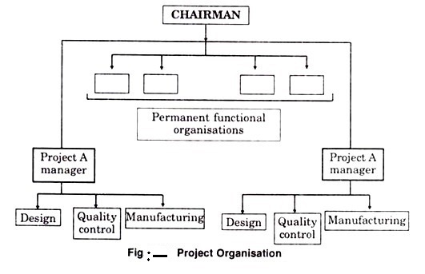
The core concept of project organization is to gather a team of specialists to work on and complete a particular project. The project staff is separate and is independent of the functional departments. Project organization is employed in aerospace, construction, aircraft manufacture and professional areas like management consultancy etc.
Project organization is appropriate when the enterprise is undertaking tasks that have definite goals that are frequent and unfamiliar to the present structure, that are complex because of interdependence of tasks and that are crucial for the success of the firm. A project team is a temporary set up. Once the project is complete, the team is dissolved and the functional specialists are assigned some other projects.
Merits of Project Organization
- It provides concentrated attention that a complex project demands.
- It permits the timely completion of the project without disturbing the normal routine of rest of the organization.
- It provides a logical approach to any challenge in fulfilling a large project with definite beginning, end and clearly defined result.
Demerits of Project Organization
- There is an organizational uncertainly as a project manager has to deal with professionals drawn from diverse fields.
- Organizational uncertainties may lead to interdepartmental conflicts.
- There is a considerable fear among personnel that the completion of the project may result in loss of job. This feeling of insecurity may create considerable worry about career progress.

Importance of Project Management
Strategic Alignment
Project management is important because it ensures what is being delivered, is right, and will deliver real value against the business opportunity.
Every client has strategic goals and the projects that we do for them advance those goals. Project management is important because it ensures there’s rigor in architecting projects properly so that they fit well within the broader context of our client’s strategic frameworks Good project management ensures that the goals of projects closely align with the strategic goals of the business.
In identifying a solid business case, and being methodical about calculating ROI, project management is important because it can help to ensure the right thing is delivered, that’s going to deliver real value.
Of course, as projects progress, it is possible that risks may emerge, that turn into issues or even the business strategy may change. But a project manager will ensure that the project is part of that realignment. Project management really matters here because projects that veer off course, or which fail to adapt to the business needs may end up being expensive and/or unnecessary.
- Leadership
Project management is important because it brings leadership and direction to projects.
Without project management, a team can be like a ship without a rudder; moving but without direction, control or purpose. Leadership allows and enables a team to do their best work. Project management provides leadership and vision, motivation, removing roadblocks, coaching and inspiring the team to do their best work.
Project managers serve the team but also ensure clear lines of accountability. With a project manager in place there’s no confusion about who’s in charge and in control of whatever’s going on in a project. Project managers enforce process and keep everyone on the team in line too because ultimately they carry responsibility for whether the project fails or succeeds.
- Clear Focus & Objectives
Project management is important because it ensures there’s a proper plan for executing on strategic goals.
Where project management is left to the team to work out by themselves, you’ll find teams work without proper briefs, projects lack focus, can have vague or nebulous objectives, and leave the team not quite sure what they’re supposed to be doing, or why.
As project managers, we position ourselves to prevent such a situation and drive the timely accomplishment of tasks, by breaking up a project into tasks for our teams. Oftentimes, the foresight to take such an approach is what differentiates good project management from bad. Breaking up into smaller chunks of work enables teams to remain focused on clear objectives, gear their efforts towards achieving the ultimate goal through the completion of smaller steps and to quickly identify risks, since risk management is important in project management.
Often a project’s goals have to change in line with a materializing risk. Again, without dedicated oversite and management, a project could swiftly falter but good project management (and a good project manager) is what enables the team to focus, and when necessary refocus, on their objectives.
- Realistic Project Planning
Project management is important because it ensures proper expectations are set around what can be delivered, by when, and for how much.
Without proper project management, budget estimates and project delivery timelines can be set that are over-ambitious or lacking in analogous estimating insight from similar projects. Ultimately this means without good project management, projects get delivered late, and over budget.
Effective project managers should be able to negotiate reasonable and achievable deadlines and milestones across stakeholders, teams, and management. Too often, the urgency placed on delivery compromises the necessary steps, and ultimately, the quality of the project’s outcome.
We all know that most tasks will take longer than initially anticipated; a good project manager is able to analyze and balance the available resources, with the required timeline, and develop a realistic schedule. Project management really matters when scheduling because it brings objectivity to the planning.
A good project manager creates a clear process, with achievable deadlines, that enables everyone within the project team to work within reasonable bounds, and not unreasonable expectations.
- Quality Control
Projects management is important because it ensures the quality of whatever is being delivered, consistently hits the mark.
Projects are also usually under enormous pressure to be completed. Without a dedicated project manager, who has the support and buy-in of executive management, tasks are underestimated, schedules tightened and processes rushed. The result is bad quality output. Dedicated project management ensures that not only does a project have the time and resources to deliver, but also that the output is quality tested at every stage.
Good project management demands gated phases where teams can assess the output for quality, applicability, and ROI. Project management is of key importance to Quality Assurance because it allows for a staggered and phased process, creating time for teams to examine and test their outputs at every step along the way.
- Risk Management
Project management is important because it ensures risks are properly managed and mitigated against to avoid becoming issues.
Risk management is critical to project success. The temptation is just to sweep them under the carpet, never talk about them to the client and hope for the best. But having a robust process around the identification, management and mitigation of risk is what helps prevent risks from becoming issues.
Good project management practice requires project managers to carefully analyze all potential risks to the project, quantify them, develop a mitigation plan against them, and a contingency plan should any of them materialize. Naturally, risks should be prioritized according to the likelihood of them occurring, and appropriate responses are allocated per risk. Good project management matters in this regard, because projects never go to plan, and how we deal with change and adapt our plans is a key to delivering projects successfully.
- Orderly Process
Project management is important because it ensures the right people do the right things, at the right time – it ensures proper project process is followed throughout the project lifecycle.
Surprisingly, many large and well-known companies have reactive planning processes. But reactivity – as opposed to proactivity – can often cause projects to go into survival mode. This is a when teams fracture, tasks duplicate, and planning becomes reactive creating inefficiency and frustration in the team.
Proper planning and process can make a massive difference as the team knows who’s doing what, when, and how. Proper process helps to clarify roles, streamline processes and inputs, anticipate risks, and creates the checks and balances to ensure the project is continually aligned with the overall strategy. Project management matters here because without an orderly, easily understood process, companies risk project failure, attrition of employee trust and resource wastage.
- Continuous Oversight
Project management is important because it ensures a project’s progress is tracked and reported properly.
Status reporting might sound boring and unnecessary – and if everything’s going to plan, it can just feel like documentation for documentation’s sake. But continuous project oversight, ensuring that a project is tracking properly against the original plan, is critical to ensuring that a project stays on track.
When proper oversight and project reporting is in place it makes it easy to see when a project is beginning to deviate from its intended course. The earlier you’re able to spot project deviation, the easier it is to course correct.
Good project managers will regularly generate easily digestible progress or status reports that enable stakeholders to track the project. Typically these status reports will provide insights into the work that was completed and planned, the hours utilized and how they track against those planned, how the project is tracking against milestones, risks, assumptions, issues and dependencies and any outputs of the project as it proceeds.
This data is invaluable not only for tracking progress but helps clients gain the trust of other stakeholders in their organization, giving them easy oversight of a project’s progress.
- Subject Matter Expertise
Project management is important because someone needs to be able to understand if everyone’s doing what they should.
With a few years experience under their belt, project managers will know a little about a lot of aspects of delivering the projects they manage. They’ll know everything about the work that their teams execute; the platforms and systems they use, and the possibilities and limitations, and the kinds of issues that typically occur.
Having this kind of subject matter expertise means they can have intelligent and informed conversations with clients, team, stakeholders, and suppliers. They’re well equipped to be the hub of communication on a project, ensuring that as the project flows between different teams and phases of work, nothing gets forgotten about or overlooked.
Without subject matter expertise through project management, you can find a project becomes unbalanced – the creatives ignore the limitations of technology or the developers forget the creative vision of the project. Project management keeps the team focussed on the overarching vision and brings everyone together forcing the right compromises to make the project a success.
- Managing and Learning from Success and Failure
Project management is important because it learns from the successes and failures of the past.
Project management can break bad habits and when you’re delivering projects, it’s important to not make the same mistakes twice. Project managers use retrospectives or post project reviews to consider what went well, what didn’t go so well and what should be done differently for the next project.
This produces a valuable set of documentation that becomes a record of “do and don’t” going forward, enabling the organization to learn from failures and success. Without this learning, teams will often keep making the same mistakes, time and time again. These retrospectives are great documents to use at a project kickoff meeting to remind the team about failures such as underestimating projects, and successes such as the benefits of a solid process or the importance of keeping time sheet reporting up to date!

