Cross Cultural Management

Unit-1

Understanding Culture

Values, World Views and Socio-Cultural Systems
Culture is the characteristic of a particular group of people, defined by language, religion, cuisine, social habits, music, arts, etc. Organizational culture is the behavior of humans, who are part of an organization, and the meanings that the people attach to their actions. Culture includes the organization’s values, visions, norms, working language, systems, symbols, beliefs, and habits. It is also the pattern of such collective behaviors that are taught to new organizational members as a way of perceiving, even thinking and feeling. Organizational culture affects the way people interact with one another and with clients and stakeholders. Each new environment has its own unique characteristics and, if understood, could accelerate the new entrant’s time and effectiveness in integrating into the new culture.
Companies such as IBM, GE, Microsoft, Dell, and Amgen embody their own unique cultures and characteristics. Individuals who quickly adjust to the new culture have a better chance of success than those who choose to push against it. Though cultures define companies and enhance their ability to recruit top candidates, those same cultures will become obsolete if they don’t bend and flex with the changing tide of the workplace. As workplaces are becoming more global, culture becomes shifting sand and requires employees who are flexible and adapt quickly to ambiguity and significant change.
In order to understand what culture is within any organization, its definition has had to be interpreted in many ways. Some scholars define culture as the cumulative deposit of knowledge, experience, beliefs, values, attitudes, hierarchies, religion, notions of time, spatial relations, concepts of the universe, and material objects and possessions acquired by a group of people in the course of generations through individual and group striving. That’s a mouthful, but it is what it is. What a company respects in its employees becomes its culture. Most companies have a set of values and attributes that drive expected behavior.
So this word, “culture,” is all encompassing and sometimes can be difficult to unravel. Many companies create cultural norms such as specialized dress codes, flex work schedules, core hours, job pooling, formalized social networks, etc. These cultural norms will become icons and will establish norms for others to be measured against. Cultural norms also can be effective recruiting tools because the environment is a key consideration for individuals seeking the right culture for new or continued employment.

Cultural Values
A culture’s values are its ideas about what is good, right, fair, and just. Sociologists disagree, however, on how to conceptualize values. Conflict theory focuses on how values differ between groups within a culture, while functionalism focuses on the shared values within a culture. For example, American sociologist Robert K. Merton suggested that the most important values in American society are wealth, success, power, and prestige, but that everyone does not have an equal opportunity to attain these values. Functional sociologist Talcott Parsons noted that Americans share the common value of the “American work ethic,” which encourages hard work. Other sociologists have proposed a common core of American values, including accomplishment, material success, problem‐solving, reliance on science and technology, democracy, patriotism, charity, freedom, equality and justice, individualism, responsibility, and accountability.
A culture, though, may harbor conflicting values. For instance, the value of material success may conflict with the value of charity. Or the value of equality may conflict with the value of individualism. Such contradictions may exist due to an inconsistency between people’s actions and their professed values, which explains why sociologists must carefully distinguish between what people do and what they say. Real culture refers to the values and norms that a society actually follows, while ideal culture refers to the values and norms that a society professes to believe.

World View
A world view or worldview is the fundamental cognitive orientation of an individual or society encompassing the whole of the individual’s or society’s knowledge and point of view. A world view can include natural philosophy; fundamental, existential, and normative postulates; or themes, values, emotions, and ethics.
It is a concept fundamental to German philosophy and epistemology and refers to a wide world perception. Additionally, it refers to the framework of ideas and beliefs forming a global description through which an individual, group or culture watches and interprets the world and interacts with it.
Worldviews are often taken to operate at a conscious level, directly accessible to articulation and discussion, as opposed to existing at a deeper, pre-conscious level, such as the idea of “ground” in Gestalt psychology and media analysis. However, core worldview beliefs are often deeply rooted, and so are only rarely reflected on by individuals, and are brought to the surface only in moments of crises of faith.

SOCIO-CULTURAL SYSTEMS
A sociocultural system is a “human population viewed in its ecological context and as one of the many subsystems of a larger ecological system”
The term “sociocultural system” embraces three concepts: society, culture, and system. A society is a number of interdependent organisms of the same species. A culture is the learned behaviors that are shared by the members of a society, together with the material products of such behaviors. The words “society” and “culture” are fused together to form the word “sociocultural”. A system is “a collection of parts which interact with each other to function as a whole”.
Main components of a sociocultural system:
- Economic system
- Political organization
- Social structure
- Belief system
- Arts and leisure

What is Culture and why is it Important?
Culture is the invisible bond which ties people together. It refers to the pattern of human activity. The art, literature, language, and religion of a community represent its culture. Our cultural values and beliefs manifest themselves through our lifestyle. Our moral values represent our culture. The importance of culture lies in its close association with the ways of thinking and living. Differences in cultures have led to a diversity in the people from different parts of the world.
Culture is related to the development of our attitude. Our cultural values influence how we approach living. According to the behaviorist definition of culture, it is the ultimate system of social control where people monitor their own standards and behavior. Our cultural values serve as the founding principles of our life. They shape our thinking, behavior, and personality.

Importance of Culture
Culture has great importance. Culture is the identity of the nation, without culture the society is impossible. An author says about the importance of culture that “culture is the set of transmitted and learned behavior patterns, beliefs, institutions and all other products of human work and thought that characterize the functioning of particular population, profession, organization or community”, so the only representative of the particular community or population is the culture. Culture is the basic root of any community which gives them the ways of life. The culture provides solution to the critical problem that is faced to community. Culture teach us to think for the whole nation not individually, it provide the concept of family, nation etc.
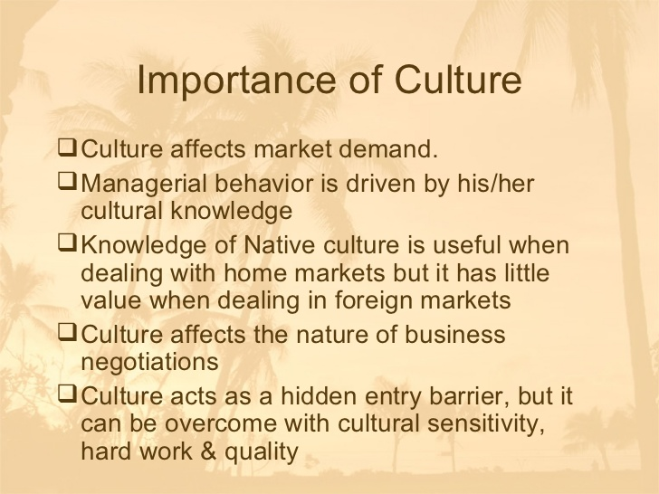

How do People React to Cultural Differences?
All people are innately programmed to think logically. Otherwise, they would in danger eliminating themselves from the gene pool. What culture does, and it’s called socialization, is too within the confines of survivability rear and teaches their children to survive in the culture and environment they will inhabit. This is for both the benefit of the individual and the benefit of that person’s people group.
What is different are the presuppositions of the culture. Often called the world view it is the basic moral and value assumptions of that culture. Ethnocentrism is an example. All people assume their culture is normal and every other culture is strange. The culture is often built upon skills necessary for the individual and culture to survive in its environment.

10 Tips for Responding to Cultural Differences
How to Engage Different Cultures:
- Keep an Open Mind
The ability to keep opinions flexible and receptive to new stimuli is important to intercultural adjustment. Even if you don’t understand why people do a particular thing, be careful not to jump to conclusions.
- Learn to Cope with Failure
Learning to tolerate failure is critical because everyone fails at something overseas!
- Be Flexible
The ability to respond to or tolerate the ambiguity of new situations is very important to intercultural success. Keeping options open and judgmental behavior to a minimum helps you adapt well.
- Maintain a Healthy Curiosity
Curiosity is the demonstrated desire to know about other people, places, ideas, etc. This personality trait is important for intercultural travelers because they need to learn many things in order to adapt to their new environment.
- Hold Positive and Realistic Expectations
There are strong correlations between positive expectations for an intercultural experience and successful adjustment overseas. Being realistic in what to expect will help you feel prepared for any situation.
- Be Tolerant of Differences
A sympathetic understanding of beliefs or practices different from your own is key to successful intercultural adjustment.
- Regard Others Positively
The ability to express warmth, empathy, respect, and positive regard for other persons is an important component of effective intercultural relations. Try to think of things you really enjoy or like about their culture and embrace differences.
- Be Good Guests
As a guest in someone’s home, you would never remark about the “dirty” kitchen, the “terrible” food, or the “crazy” seating arrangement. As a traveler you are, in a broad sense, going into someone’s “home.” Show respect.
- Have a Sense of Humor
A sense of humor is important because in another culture so many things can lead to intense emotions. Sadness, anger, annoyance, embarrassment and discouragement are all common. The ability to laugh in spite of the circumstances will help guard against despair.
- Have Fun
It’s okay to acknowledge cultural differences – don’t take them too seriously and don’t hold an “I’m right/You’re wrong” attitude. Relax, have fun, and enjoy your new friends.

Can we Measure or Graph Cultural Differences?
Identifying cultural differences
There are several cultural differences that we will face in an international negotiation and we conclude that the most important are:
- Communication: Verbal and non-verbal communication
- Culture

Communication
Differences in verbal communication can be caused by different language that the other party speaks., or also can it be that we share the same language but the use of words has a different meaning because it is influenced by the other party culture. However it is important to learn that also non-verbal communication has an important role because it is part of behavior that communicated without words.

Culture
As we had already defined that culture shapes behavior, therefore it is useful to identify the mains such differences in order to decide which one can cause a threat or a weakness in our negotiation process and which can help us as opportunities and strengths. One of the approaches that we identified to be very helpful for the preparation is Richard Lewis Model of cultural types. This model has been based on the Hofstede’s Value Dimensions.

Power distance:
“Is the levels of acceptance by a society of the unequal distribution of power in institutions”.
Therefore where we find a high power distance among individuals means that they have the need for hierarchy and status within their culture. For Example USA vs. Norway

Individualism – Collectivism:
“It refers to the degree to which individuals are integrated into groups“. The first one refers “to the tendency of people to look after themselves and their immediate families only and to neglect the need of society” and the second one if the opposite.
So in the individualistic cultures loyalty among individuals is not as strong as in collectivism cultures. For example Japanese are collectivist and Americans are individualistic.

Masculinity-Femininity
Refers to the distribution of roles between the genders which is another fundamental issue for any society to which a range of solutions are found.
Masculinity is in cultures where the gender roles are clearly defined: Men have to be assertive and concentrate on material success. Women should be humble and affectionate and have to maintain a good quality of life. In femininity represents a society, there is no difference: Men and women are equal and both are responsible for maintaining life quality. An example of masculine culture is Mexican and a feminine culture is Norwegian.

Uncertainty Avoidance
“Refers to the extent to which people in society feel threatened by ambiguous situation.
The degree of uncertainty that individuals allows in the daily lives. For example high level of uncertainty avoidance are Japanese (laws are very strict with formal rules) and with low level of uncertainty like Great Britain; protest are tolerated, manager take more risks)

Long Term Orientation
The extent to which culture programs its members to accept delay gratification of their material, social, and emotional needs.
Short term cultures tend to consider values that are relevant for past and present (traditions and fulfilling social duties). The long term tend to focus on future success and perseverance.

Is it Possible to Change a Culture? If so, how?
Culture change is a term used in public policy making that emphasizes the influence of cultural capital on individual and community behavior. It has been sometimes called repositioning of culture, which means the reconstruction of the cultural concept of a society. It places stress on the social and cultural capital determinants of decision making and the manner in which these interact with other factors like the availability of information or the financial incentives facing individuals to drive behavior.
These cultural capital influences include the role of parenting, families and close associates; organizations such as schools and workplaces; communities and neighborhoods; and wider social influences such as the media. It is argued that this cultural capital manifests into specific values, attitudes or social norms which in turn guide the behavioral intentions that individuals adopt in regard to particular decisions or courses of action. These behavioral intentions interact with other factors driving behavior such as financial incentives, regulation and legislation, or levels of information, to drive actual behavior and ultimately feed back into underlying cultural capital.
In general, cultural stereotypes present great resistance to change and to their own redefinition. Culture, often appears fixed to the observer at any one point in time because cultural mutations occur incrementally. Cultural change is a long-term process. Policymakers need to make a great effort to improve some basics aspects of a society’s cultural traits.
The four main ways to influence culture
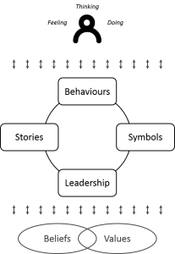
In the centre of THE diagram is a cycle of four elements: behaviours; symbols; leadership; stories. I suspect these are the key “elements” that go to make up a culture. And therefore, if you want to change a culture you need to act on each of these elements. Let’s look at each in turn.
1. Behaviours
The behaviours I’m talking abut here are the “group norms” we see. What time do people get into work? Do they feel compelled to stay late? Is there an assumption that everyone has read an email five minutes after it’s been sent? Do people turn up to meetings on time – or is the culture such that you can come ten minutes late?
But I think they can also include such things as:
- How we speak about people when they’re not there.
- How we speak to people and treat them when they’ve done something wrong.
- Whether we keep silent and do nothing when we see something happening that’s wrong.
Anyway, I suspect you get the idea. “Behaviours” is basically “the way we do things around here”.
So, if you want to change culture you need to start changing the “normed” behaviours. And that’s all about a critical mass of people, it’s about examples, it’s about doing things differently.
2. Symbols
Symbols are profoundly important in our modern life: even as we tell ourselves that we are post-Enlightenment humans and not susceptible to that stuff. (If you doubt me, just notice all the rich iconography in your local shopping mall next time you’re there).
Symbols are the things we see that mean something to us – either deliberate or unintentional. Years ago, I worked at a company that measured your status by the number of ceiling tiles in your office – a great symbol of a hierarchical culture.
Common symbols might include:
- What does the client reception area of your office look like – what message is it trying to deliver?
- What’s highlighted on your intranet site. Eg how easily can I find the values statements compared to how easily I can find this week’s sales report.
What happens to a good sales person if they’re found to breach compliance requirements?
3. Leadership
I almost chose to leave this one out – because I suspect leadership expresses itself in behaviours, stories and symbols. In short, it’s going to be hard to get culture change unless the leadership buys in.
4. Stories
The stories we tell ourselves profoundly influence the culture of our organisation. Those stories can be explicit or more implicit. Overarching stories help us make sense of our world – they can give us a “schema” into which to place things. As such they will help us explain events and make meaning. Helpfully, or unhelpfully.
For example, I wonder what the prevailing story is in traditional newspaper organisations right now? I suspect the story being told is one of industry decline and disruption. That would make for an interesting culture in most newsrooms.

What does Culture have to do with Business?
CULTURE has become one of the most important business topic. CEOs and HR leaders now recognize that culture drives people’s behavior, innovation, and customer service: 82 percent of survey respondents believe that “culture is a potential competitive advantage.” Knowing that leadership behavior and reward systems directly impact organizational performance, customer service, employee engagement, and retention, leading companies are using data and behavioral information to manage and influence their culture.
Culture describes “the way things work around here.” Specifically, it includes the values, beliefs, behaviors, artifacts, and reward systems that influence people’s behavior on a day-to-day basis. It is driven by top leadership and becomes deeply embedded in the company through a myriad of processes, reward systems, and behaviors. Culture includes all the behaviors that may or may not improve business performance. Today, culture is a CEO-level issue and something that can be measured and improved to drive strategy.
Engagement, in contrast, describes “how people feel about the way things work around here.” It is a way of describing employees’ level of commitment to the company and to their work. According to our model, engagement encompasses five broad areas: meaningful work and jobs, management practices and behaviors, the work environment, opportunities for development and growth, and trust in leadership. When engagement is poor, employees feel uneasy or uncommitted, resulting in high turnover, low performance, and low levels of innovation and customer service. New tools are enabling companies to monitor engagement on a detailed, real-time basis, delivering specific, actionable information to continuously improve the work environment.
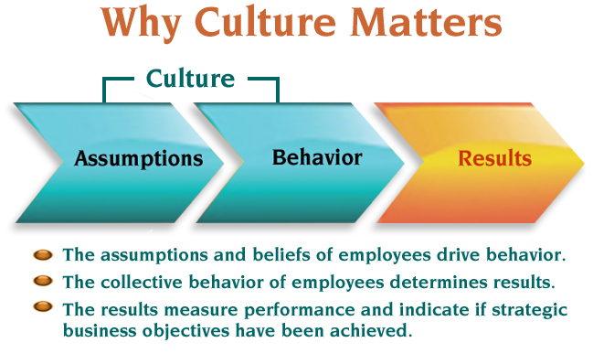

Ways of Describing Cultural Differences Going International
As companies continue to expand across borders and the global marketplace becomes increasingly more accessible for small and large businesses.
Multinational and cross-cultural teams are likewise becoming ever more common, meaning businesses can benefit from an increasingly diverse knowledge base and new, insightful approaches to business problems. However, along with the benefits of insight and expertise, global organizations also face potential stumbling blocks when it comes to culture and international business.
While there are a number of ways to define culture, put simply it is a set of common and accepted norms shared by a society. But in an international business context, what is common and accepted for a professional from one country, could be very different for a colleague from overseas. Recognizing and understanding how culture affects international business in three core areas: communication, etiquette, and organizational hierarchy can help you to avoid misunderstandings with colleagues and clients from abroad and excel in a globalized business environment.

1. Communication
Effective communication is essential to the success of any business venture, but it is particularly critical when there is a real risk of your message getting “lost in translation.” In many international companies, English is the de facto language of business. But more than just the language you speak, it’s how you convey your message that’s important. For instance, while the Finns may value directness and brevity, professionals from India can be more indirect and nuanced in their communication. Moreover, while fluent English might give you a professional boost globally, understanding the importance of subtle non-verbal communication between cultures can be equally crucial in international business.
What might be commonplace in your culture — be it a firm handshake, making direct eye contact, or kiss on the cheek — could be unusual or even offensive to a foreign colleague or client. Where possible, do your research in advance of professional interactions with individuals from a different culture. Remember to be perceptive to body language, and when in doubt, ask. While navigating cross-cultural communication can be a challenge, approaching cultural differences with sensitivity, openness, and curiosity can help to put everyone at ease.
2. Workplace Etiquette
Different approaches to professional communication are just one of the innumerable differences in workplace norms from around the world. CT Business Travel has put together a useful infographic for a quick reference of cultural differences in business etiquette globally.
For instance, the formality of address is a big consideration when dealing with colleagues and business partners from different countries. Do they prefer titles and surnames or is being on the first-name basis acceptable? While it can vary across organizations, Asian countries such as South Korea, China, and Singapore tend to use formal “Mr./Ms. Surname,” while Americans and Canadians tend to use first names. When in doubt, erring on the side of formality is generally safest.
The concept of punctuality can also differ between cultures in an international business environment. Different ideas of what constitutes being “on time” can often lead to misunderstandings or negative cultural perceptions. For example, where an American may arrive at a meeting a few minutes early, an Italian or Mexican colleague may arrive several minutes — or more — after the scheduled start-time (and still be considered “on time”).
3. Organizational Hierarchy
Organizational hierarchy and attitudes towards management roles can also vary widely between cultures. Whether or not those in junior or middle-management positions feel comfortable speaking up in meetings, questioning senior decisions, or expressing a differing opinion can be dictated by cultural norms. Often these attitudes can be a reflection of a country’s societal values or level of social equality. For instance, a country such as Japan, which traditionally values social hierarchy, relative status, and respect for seniority, brings this approach into the workplace. This hierarchy helps to define roles and responsibilities across the organization. This also means that those in senior management positions command respect and expect a certain level of formality and deference from junior team members.
However, Scandinavian countries, such as Norway, which emphasize societal equality, tend to have a comparatively flat organizational hierarchy. In turn, this can mean relatively informal communication and an emphasis on cooperation across the organization. When defining roles in multinational teams with diverse attitudes and expectations of organizational hierarchy, it can be easy to see why these cultural differences can present a challenge.

